# Images

Copyright © 2016 by McGraw-Hill Education (Publisher). All rights reserved. Printed in the United States of America. Except as permitted under the Copyright Act of 1976, no part of this publication may be reproduced or distributed in any form or by any means, or stored in a database or retrieval system, without the prior written permission of publisher, with the exception that the program listings may be entered, stored, and executed in a computer system, but they may not be reproduced for publication.

ISBN: 978-1-25-958753-5

MHID: 1-25-958753-3

The material in this eBook also appears in the print version of this title: ISBN: 978-1-25-958751-1, MHID: 1-25-958751-7.

eBook conversion by codeMantra

Version 1.0

All trademarks are trademarks of their respective owners. Rather than put a trademark symbol after every occurrence of a trademarked name, we use names in an editorial fashion only, and to the benefit of the trademark owner, with no intention of infringement of the trademark. Where such designations appear in this book, they have been printed with initial caps.

McGraw-Hill Education eBooks are available at special quantity discounts to use as premiums and sales promotions or for use in corporate training programs. To contact a representative, please visit the Contact Us page at [www.mhprofessional.com](http://www.mhprofessional.com/).

Information has been obtained by Publisher from sources believed to be reliable. However, because of the possibility of human or mechanical error by our sources, Publisher, or others, Publisher does not guarantee to the accuracy, adequacy, or completeness of any information included in this work and is not responsible for any errors or omissions or the results obtained from the use of such information.

Oracle and Java are registered trademarks of Oracle Corporation and/or its affiliates. All other trademarks are the property of their respective owners, and McGraw-Hill Education makes no claim of ownership by the mention of products that contain these marks.

Screen displays of copyrighted Oracle software programs have been reproduced herein with the permission of Oracle Corporation and/or its affiliates.

Oracle Corporation does not make any representations or warranties as to the accuracy, adequacy, or completeness of any information contained in this Work, and is not responsible for any errors or omissions.

Information has been obtained by Publisher from sources believed to be reliable. However, because of the possibility of human or mechanical error by our sources, Publisher, or others, Publisher does not guarantee to the accuracy, adequacy, or completeness of any information included in this work and is not responsible for any errors or omissions or the results obtained from the use of such information.

TERMS OF USE

This is a copyrighted work and McGraw-Hill Education and its licensors reserve all rights in and to the work. Use of this work is subject to these terms. Except as permitted under the Copyright Act of 1976 and the right to store and retrieve one copy of the work, you may not decompile, disassemble, reverse engineer, reproduce, modify, create derivative works based upon, transmit, distribute, disseminate, sell, publish or sublicense the work or any part of it without McGraw-Hill Education’s prior consent. You may use the work for your own noncommercial and personal use; any other use of the work is strictly prohibited. Your right to use the work may be terminated if you fail to comply with these terms.

THE WORK IS PROVIDED “AS IS.” McGRAW-HILL EDUCATION AND ITS LICENSORS MAKE NO GUARANTEES OR WARRANTIES AS TO THE ACCURACY, ADEQUACY OR COMPLETENESS OF OR RESULTS TO BE OBTAINED FROM USING THE WORK, INCLUDING ANY INFORMATION THAT CAN BE ACCESSED THROUGH THE WORK VIA HYPERLINK OR OTHERWISE, AND EXPRESSLY DISCLAIM ANY WARRANTY, EXPRESS OR IMPLIED, INCLUDING BUT NOT LIMITED TO IMPLIED WARRANTIES OF MERCHANTABILITY OR FITNESS FOR A PARTICULAR PURPOSE. McGraw-Hill Education and its licensors do not warrant or guarantee that the functions contained in the work will meet your requirements or that its operation will be uninterrupted or error free. Neither McGraw-Hill Education nor its licensors shall be liable to you or anyone else for any inaccuracy, error or omission, regardless of cause, in the work or for any damages resulting therefrom. McGraw-Hill Education has no responsibility for the content of any information accessed through the work. Under no circumstances shall McGraw-Hill Education and/or its licensors be liable for any indirect, incidental, special, punitive, consequential or similar damages that result from the use of or inability to use the work, even if any of them has been advised of the possibility of such damages. This limitation of liability shall apply to any claim or cause whatsoever whether such claim or cause arises in contract, tort or otherwise.

*To AJ, Adalyn, and Shannon*

—Edward G. Finegan

*To Ashleigh, Patti, my family, and friends*

—Robert J. Liguori

## **ABOUT THE AUTHORS**



**Edward Finegan** is the founder of Dryrain Technologies. His company specializes in iOS software development supported by enterprise Java backends for the automatic identification and data capture (AIDC) industry. He has previously worked in the casino gaming industry, where he designed and implemented software for gaming machines. He also has previous experience in air traffic management systems and radar protocols.

Finegan has a bachelor’s degree in computer science from Rowan University and a master’s degree in computer science from Virginia Commonwealth University. His thesis, entitled *Intelligent Autonomous Data Categorization*, examined the possibility of using machine-learning algorithms to categorize data intelligently and autonomously.

Finegan is an avid Philadelphia sports fan. He enjoys spending time with his family, especially with his wife, Shannon, daughter, Adalyn, and son, AJ. He spends his free time partaking in outdoor activities and home-improvement projects, as well as tinkering with the latest technologies.

He can be contacted at edward@ocajexam.com.



**Robert Liguori** is the principal of Gliesian, LLC., a software development company. Liguori has a bachelor’s degree in computer science and information technology from Richard Stockton College of New Jersey. He holds various Oracle certifications.

Liguori worked closely with Edward Finegan to produce the predecessors to this OCA book, with the earliest being the *SCJA Sun Certified Java Associate Study Guide (CX-310-019)* (McGraw-Hill Professional, 2009). Liguori and Ryan Cuprak produced the book *NetBeans IDE Programmer Certified Expert Exam Guide (Exam 310-045)* (McGraw-Hill Professional, 2010). Liguori and his wife, Patricia, co-authored a Java reference guide: *Java Pocket Guide* (O’Reilly Media, Inc., 2008). The book has matured through Java 7 and Java 8 versions and is now available in German and Polish.

Liguori enjoys spending time with his family, as well as bicycling and surf fishing. He is a rhythm guitarist for May and the Wandering Minstrels. He also regularly plays Google Ingress as part of the Enlightened team.

**About the Technical Editor**



**Ryan Cuprak** is an e-formulation analyst at Dassault Systèmes, and a co-author of two books: *EJB in Action, Second Edition* (Manning Publications, 2014) and *NetBeans IDE Programmer Certification Expert Exam Guide* (McGraw-Hill Professional, 2010). He has served as president of the Connecticut Java Users Group since 2003 and is a JavaOne Rock Star presenter. At Dassault Systèmes, he works on ENOVIA Enginuity chemical formulation software and is involved in desktop and backend server development as well as client data migrations. Prior to joining Dassault Systèmes, Cuprak worked for a distributed computing company, TurboWorx, and also Eastman Kodak’s Molecular Imaging Systems group, now part of Burker. He earned a BS in computer science and biology from Loyola University Chicago.

He can be contacted at ryan@ocajexam.com.

## **CONTENTS AT A GLANCE**

[1 Packaging, Compiling, and Interpreting Java Code](https://learning.oreilly.com/library/view/oca-java-se/9781259587535/ch01.html#ch01)

[2 Programming with Java Statements](https://learning.oreilly.com/library/view/oca-java-se/9781259587535/ch02.html#ch02)

[3 Programming with Java Operators and Strings](https://learning.oreilly.com/library/view/oca-java-se/9781259587535/ch03.html#ch03)

[4 Working with Basic Classes and Variables](https://learning.oreilly.com/library/view/oca-java-se/9781259587535/ch04.html#ch04)

[5 Understanding Methods and Variable Scope](https://learning.oreilly.com/library/view/oca-java-se/9781259587535/ch05.html#ch05)

[6 Programming with Arrays](https://learning.oreilly.com/library/view/oca-java-se/9781259587535/ch06.html#ch06)

[7 Understanding Class Inheritance](https://learning.oreilly.com/library/view/oca-java-se/9781259587535/ch07.html#ch07)

[8 Understanding Polymorphism and Casts](https://learning.oreilly.com/library/view/oca-java-se/9781259587535/ch08.html#ch08)

[9 Handling Exceptions](https://learning.oreilly.com/library/view/oca-java-se/9781259587535/ch09.html#ch09)

[10 Programming with the Date and Time API](https://learning.oreilly.com/library/view/oca-java-se/9781259587535/ch10.html#ch10)

[11 Understanding Lambda Expressions](https://learning.oreilly.com/library/view/oca-java-se/9781259587535/ch11.html#ch11)

[A Class Relationships](https://learning.oreilly.com/library/view/oca-java-se/9781259587535/ch12_appa.html#ch12_appa)

[B Java SE 8 Packages](https://learning.oreilly.com/library/view/oca-java-se/9781259587535/ch13_app_b.html#ch13_app_b)

[C Java Keywords](https://learning.oreilly.com/library/view/oca-java-se/9781259587535/ch14_app_c.html#ch14_app_c)

[D Bracket Conventions](https://learning.oreilly.com/library/view/oca-java-se/9781259587535/ch15_app_d.html#ch15_app_d)

[E Unicode Standard](https://learning.oreilly.com/library/view/oca-java-se/9781259587535/ch16_app_e.html#ch16_app_e)

[F Pseudo-code Algorithms](https://learning.oreilly.com/library/view/oca-java-se/9781259587535/ch17_app_f.html#ch17_app_f)

[G Unified Modeling Language](https://learning.oreilly.com/library/view/oca-java-se/9781259587535/ch18_app_g.html#ch18_app_g)

[H Functional Interfaces](https://learning.oreilly.com/library/view/oca-java-se/9781259587535/ch19_app_h.html#ch19_app_h)

[I About the Download](https://learning.oreilly.com/library/view/oca-java-se/9781259587535/ch20_app_i.html#ch20_app_i)

[Glossary](https://learning.oreilly.com/library/view/oca-java-se/9781259587535/ch21_glossary.html#ch21_glossary)

[Index](https://learning.oreilly.com/library/view/oca-java-se/9781259587535/ch22_index.html#ch22_index)

## **CONTENTS**

[*Preface*](https://learning.oreilly.com/library/view/oca-java-se/9781259587535/ch00_fm07_pre.html#ch00_fm07_pre)

[*Acknowledgments*](https://learning.oreilly.com/library/view/oca-java-se/9781259587535/ch00_fm08_ack.html#ch00_fm08_ack)

[*Introduction*](https://learning.oreilly.com/library/view/oca-java-se/9781259587535/ch00_fm09_intro.html#ch00_fm09_intro)

[**1 Packaging, Compiling, and Interpreting Java Code**](https://learning.oreilly.com/library/view/oca-java-se/9781259587535/ch01.html#ch01)

[The Java Platform](https://learning.oreilly.com/library/view/oca-java-se/9781259587535/ch01.html#ch01lev1)

[Platform Independence](https://learning.oreilly.com/library/view/oca-java-se/9781259587535/ch01.html#ch01lev2)

[Java’s Object-Oriented Philosophy](https://learning.oreilly.com/library/view/oca-java-se/9781259587535/ch01.html#ch01lev3)

[Robust and Secure](https://learning.oreilly.com/library/view/oca-java-se/9781259587535/ch01.html#ch01lev4)

[Understand Packages](https://learning.oreilly.com/library/view/oca-java-se/9781259587535/ch01.html#ch01lev5)

[Package Design](https://learning.oreilly.com/library/view/oca-java-se/9781259587535/ch01.html#ch01lev6)

[package and import Statements](https://learning.oreilly.com/library/view/oca-java-se/9781259587535/ch01.html#ch01lev7)

[**Exercise 1-1:** Replacing Implicit import Statements with Explicit import Statements](https://learning.oreilly.com/library/view/oca-java-se/9781259587535/ch01.html#ch01exe1)

[Understand Package-Derived Classes](https://learning.oreilly.com/library/view/oca-java-se/9781259587535/ch01.html#ch01lev8)

[Java Utilities API](https://learning.oreilly.com/library/view/oca-java-se/9781259587535/ch01.html#ch01lev9)

[Java Basic Input/Output API](https://learning.oreilly.com/library/view/oca-java-se/9781259587535/ch01.html#ch01lev10)

[The Java Networking API](https://learning.oreilly.com/library/view/oca-java-se/9781259587535/ch01.html#ch01lev11)

[Java Abstract Window Toolkit API](https://learning.oreilly.com/library/view/oca-java-se/9781259587535/ch01.html#ch01lev12)

[Java Swing API](https://learning.oreilly.com/library/view/oca-java-se/9781259587535/ch01.html#ch01lev13)

[JavaFX API](https://learning.oreilly.com/library/view/oca-java-se/9781259587535/ch01.html#ch01lev14)

[Understand Class Structure](https://learning.oreilly.com/library/view/oca-java-se/9781259587535/ch01.html#ch01lev15)

[Naming Conventions](https://learning.oreilly.com/library/view/oca-java-se/9781259587535/ch01.html#ch01lev16)

[Separators and Other Java Source Symbols](https://learning.oreilly.com/library/view/oca-java-se/9781259587535/ch01.html#ch01lev17)

[Java Class Structure](https://learning.oreilly.com/library/view/oca-java-se/9781259587535/ch01.html#ch01lev18)

[Compile and Interpret Java Code](https://learning.oreilly.com/library/view/oca-java-se/9781259587535/ch01.html#ch01lev19)

[Java Compiler](https://learning.oreilly.com/library/view/oca-java-se/9781259587535/ch01.html#ch01lev20)

[Java Interpreter](https://learning.oreilly.com/library/view/oca-java-se/9781259587535/ch01.html#ch01lev21)

[**Exercise 1-2:** Compiling and Interpreting Packaged Software](https://learning.oreilly.com/library/view/oca-java-se/9781259587535/ch01.html#ch01exe2)

 [Two-Minute Drill](https://learning.oreilly.com/library/view/oca-java-se/9781259587535/ch01.html#ch01lev22)

[**Q&A** Self Test](https://learning.oreilly.com/library/view/oca-java-se/9781259587535/ch01.html#ch01lev23)

[Self Test Answers](https://learning.oreilly.com/library/view/oca-java-se/9781259587535/ch01.html#ch01lev24)

[**2 Programming with Java Statements**](https://learning.oreilly.com/library/view/oca-java-se/9781259587535/ch02.html#ch02)

[Understand Assignment Statements](https://learning.oreilly.com/library/view/oca-java-se/9781259587535/ch02.html#ch02lev1)

[The Assignment Expression Statement](https://learning.oreilly.com/library/view/oca-java-se/9781259587535/ch02.html#ch02lev2)

[Create and Use Conditional Statements](https://learning.oreilly.com/library/view/oca-java-se/9781259587535/ch02.html#ch02lev3)

[The if Conditional Statement](https://learning.oreilly.com/library/view/oca-java-se/9781259587535/ch02.html#ch02lev4)

[The if-then Conditional Statement](https://learning.oreilly.com/library/view/oca-java-se/9781259587535/ch02.html#ch02lev5)

[The if-then-else Conditional Statement](https://learning.oreilly.com/library/view/oca-java-se/9781259587535/ch02.html#ch02lev6)

[The Ternary Operator](https://learning.oreilly.com/library/view/oca-java-se/9781259587535/ch02.html#ch02lev7)

[The switch Conditional Statement](https://learning.oreilly.com/library/view/oca-java-se/9781259587535/ch02.html#ch02lev8)

[**Exercise 2-1:** Evaluating the String Class in the switch Statement](https://learning.oreilly.com/library/view/oca-java-se/9781259587535/ch02.html#ch02exe1)

[Create and Use Iteration Statements](https://learning.oreilly.com/library/view/oca-java-se/9781259587535/ch02.html#ch02lev9)

[The for Loop Iteration Statement](https://learning.oreilly.com/library/view/oca-java-se/9781259587535/ch02.html#ch02lev10)

[The Enhanced for Loop Iteration Statement](https://learning.oreilly.com/library/view/oca-java-se/9781259587535/ch02.html#ch02lev11)

[**Exercise 2-2:** Iterating Through an ArrayList While Applying Conditions](https://learning.oreilly.com/library/view/oca-java-se/9781259587535/ch02.html#ch02exe2)

[The while Iteration Statement](https://learning.oreilly.com/library/view/oca-java-se/9781259587535/ch02.html#ch02lev12)

[The do-while Iteration Statement](https://learning.oreilly.com/library/view/oca-java-se/9781259587535/ch02.html#ch02lev13)

[**Exercise 2-3:** Performing Code Refactoring](https://learning.oreilly.com/library/view/oca-java-se/9781259587535/ch02.html#ch02exe3)

[**Exercise 2-4:** Knowing Your Statement-Related Keywords](https://learning.oreilly.com/library/view/oca-java-se/9781259587535/ch02.html#ch02exe4)

[Create and Use Transfer of Control Statements](https://learning.oreilly.com/library/view/oca-java-se/9781259587535/ch02.html#ch02lev14)

[The break Transfer of Control Statement](https://learning.oreilly.com/library/view/oca-java-se/9781259587535/ch02.html#ch02lev15)

[The continue Transfer of Control Statement](https://learning.oreilly.com/library/view/oca-java-se/9781259587535/ch02.html#ch02lev16)

[The return Transfer of Control Statement](https://learning.oreilly.com/library/view/oca-java-se/9781259587535/ch02.html#ch02lev17)

[The labeled Statement](https://learning.oreilly.com/library/view/oca-java-se/9781259587535/ch02.html#ch02lev18)

 [Two-Minute Drill](https://learning.oreilly.com/library/view/oca-java-se/9781259587535/ch02.html#ch02lev19)

[**Q&A** Self Test](https://learning.oreilly.com/library/view/oca-java-se/9781259587535/ch02.html#ch02lev20)

[Self Test Answers](https://learning.oreilly.com/library/view/oca-java-se/9781259587535/ch02.html#ch02lev21)

[**3 Programming with Java Operators and Strings**](https://learning.oreilly.com/library/view/oca-java-se/9781259587535/ch03.html#ch03)

[Understand Fundamental Operators](https://learning.oreilly.com/library/view/oca-java-se/9781259587535/ch03.html#ch03lev1)

[Assignment Operators](https://learning.oreilly.com/library/view/oca-java-se/9781259587535/ch03.html#ch03lev2)

[**Exercise 3-1:** Using Compound Assignment Operators](https://learning.oreilly.com/library/view/oca-java-se/9781259587535/ch03.html#ch03exe1)

[Arithmetic Operators](https://learning.oreilly.com/library/view/oca-java-se/9781259587535/ch03.html#ch03lev3)

[Relational Operators](https://learning.oreilly.com/library/view/oca-java-se/9781259587535/ch03.html#ch03lev4)

[Logical Operators](https://learning.oreilly.com/library/view/oca-java-se/9781259587535/ch03.html#ch03lev5)

[Understand Operator Precedence](https://learning.oreilly.com/library/view/oca-java-se/9781259587535/ch03.html#ch03lev6)

[Use String Objects and Their Methods](https://learning.oreilly.com/library/view/oca-java-se/9781259587535/ch03.html#ch03lev7)

[Strings](https://learning.oreilly.com/library/view/oca-java-se/9781259587535/ch03.html#ch03lev8)

[The String Concatenation Operator](https://learning.oreilly.com/library/view/oca-java-se/9781259587535/ch03.html#ch03lev9)

[**Exercise 3-2:** Uncovering Bugs that Your Compiler May Not Find](https://learning.oreilly.com/library/view/oca-java-se/9781259587535/ch03.html#ch03exe2)

[Methods of the String Class](https://learning.oreilly.com/library/view/oca-java-se/9781259587535/ch03.html#ch03lev10)

[Use StringBuilder Objects and Their Methods](https://learning.oreilly.com/library/view/oca-java-se/9781259587535/ch03.html#ch03lev11)

[Methods of the StringBuilder Class](https://learning.oreilly.com/library/view/oca-java-se/9781259587535/ch03.html#ch03lev12)

[**Exercise 3-3:** Using Constructors of the StringBuilder Class](https://learning.oreilly.com/library/view/oca-java-se/9781259587535/ch03.html#ch03exe3)

[Test Equality Between Strings and Other Objects](https://learning.oreilly.com/library/view/oca-java-se/9781259587535/ch03.html#ch03lev13)

[equals Method of the String Class](https://learning.oreilly.com/library/view/oca-java-se/9781259587535/ch03.html#ch03lev14)

[**Exercise 3-4:** Working with the compareTo Method of the String Class](https://learning.oreilly.com/library/view/oca-java-se/9781259587535/ch03.html#ch03exe4)

 [Two-Minute Drill](https://learning.oreilly.com/library/view/oca-java-se/9781259587535/ch03.html#ch03lev15)

[**Q&A** Self Test](https://learning.oreilly.com/library/view/oca-java-se/9781259587535/ch03.html#ch03lev16)

[Self Test Answers](https://learning.oreilly.com/library/view/oca-java-se/9781259587535/ch03.html#ch03lev17)

[**4 Working with Basic Classes and Variables**](https://learning.oreilly.com/library/view/oca-java-se/9781259587535/ch04.html#ch04)

[Understand Primitives, Enumerations, and Objects](https://learning.oreilly.com/library/view/oca-java-se/9781259587535/ch04.html#ch04lev1)

[Primitive Variables](https://learning.oreilly.com/library/view/oca-java-se/9781259587535/ch04.html#ch04lev2)

[Objects](https://learning.oreilly.com/library/view/oca-java-se/9781259587535/ch04.html#ch04lev3)

[**Exercise 4-1:** Compile and Run an Object](https://learning.oreilly.com/library/view/oca-java-se/9781259587535/ch04.html#ch04exe1)

[Arrays](https://learning.oreilly.com/library/view/oca-java-se/9781259587535/ch04.html#ch04lev4)

[Enumerations](https://learning.oreilly.com/library/view/oca-java-se/9781259587535/ch04.html#ch04lev5)

[Java Is Strongly Typed](https://learning.oreilly.com/library/view/oca-java-se/9781259587535/ch04.html#ch04lev6)

[Naming Conventions](https://learning.oreilly.com/library/view/oca-java-se/9781259587535/ch04.html#ch04lev7)

[Use Primitives, Enumerations, and Objects](https://learning.oreilly.com/library/view/oca-java-se/9781259587535/ch04.html#ch04lev8)

[Literals](https://learning.oreilly.com/library/view/oca-java-se/9781259587535/ch04.html#ch04lev9)

[Examples of Primitives, Enumerations, and Objects](https://learning.oreilly.com/library/view/oca-java-se/9781259587535/ch04.html#ch04lev10)

[**Exercise 4-2:** Creating Getters and Setters](https://learning.oreilly.com/library/view/oca-java-se/9781259587535/ch04.html#ch04exe2)

 [Two-Minute Drill](https://learning.oreilly.com/library/view/oca-java-se/9781259587535/ch04.html#ch04lev11)

[**Q&A** Self Test](https://learning.oreilly.com/library/view/oca-java-se/9781259587535/ch04.html#ch04lev12)

[Self Test Answers](https://learning.oreilly.com/library/view/oca-java-se/9781259587535/ch04.html#ch04lev13)

[**5 Understanding Methods and Variable Scope**](https://learning.oreilly.com/library/view/oca-java-se/9781259587535/ch05.html#ch05)

[Create and Use Methods](https://learning.oreilly.com/library/view/oca-java-se/9781259587535/ch05.html#ch05lev1)

[Using Method Syntax](https://learning.oreilly.com/library/view/oca-java-se/9781259587535/ch05.html#ch05lev2)

[Making and Calling a Method](https://learning.oreilly.com/library/view/oca-java-se/9781259587535/ch05.html#ch05lev3)

[Overloading a Method](https://learning.oreilly.com/library/view/oca-java-se/9781259587535/ch05.html#ch05lev4)

[Pass Objects by Reference and Value](https://learning.oreilly.com/library/view/oca-java-se/9781259587535/ch05.html#ch05lev5)

[Passing Primitives by Value to Methods](https://learning.oreilly.com/library/view/oca-java-se/9781259587535/ch05.html#ch05lev6)

[Passing Objects by Reference to Methods](https://learning.oreilly.com/library/view/oca-java-se/9781259587535/ch05.html#ch05lev7)

[Understand Variable Scope](https://learning.oreilly.com/library/view/oca-java-se/9781259587535/ch05.html#ch05lev8)

[Local Variables](https://learning.oreilly.com/library/view/oca-java-se/9781259587535/ch05.html#ch05lev9)

[Method Parameters](https://learning.oreilly.com/library/view/oca-java-se/9781259587535/ch05.html#ch05lev10)

[Instance Variables](https://learning.oreilly.com/library/view/oca-java-se/9781259587535/ch05.html#ch05lev11)

[An Object’s Lifecycle](https://learning.oreilly.com/library/view/oca-java-se/9781259587535/ch05.html#ch05lev12)

[Create and Use Constructors](https://learning.oreilly.com/library/view/oca-java-se/9781259587535/ch05.html#ch05lev13)

[Making a Constructor](https://learning.oreilly.com/library/view/oca-java-se/9781259587535/ch05.html#ch05lev14)

[Overloading a Constructor](https://learning.oreilly.com/library/view/oca-java-se/9781259587535/ch05.html#ch05lev15)

[Using the Default Constructor](https://learning.oreilly.com/library/view/oca-java-se/9781259587535/ch05.html#ch05lev16)

[Use the this and super Keywords](https://learning.oreilly.com/library/view/oca-java-se/9781259587535/ch05.html#ch05lev17)

[The this Keyword](https://learning.oreilly.com/library/view/oca-java-se/9781259587535/ch05.html#ch05lev18)

[The super Keyword](https://learning.oreilly.com/library/view/oca-java-se/9781259587535/ch05.html#ch05lev19)

[Create Static Methods and Instance Variables](https://learning.oreilly.com/library/view/oca-java-se/9781259587535/ch05.html#ch05lev20)

[Static Methods](https://learning.oreilly.com/library/view/oca-java-se/9781259587535/ch05.html#ch05lev21)

[Static Variables](https://learning.oreilly.com/library/view/oca-java-se/9781259587535/ch05.html#ch05lev22)

[Constants](https://learning.oreilly.com/library/view/oca-java-se/9781259587535/ch05.html#ch05lev23)

 [Two-Minute Drill](https://learning.oreilly.com/library/view/oca-java-se/9781259587535/ch05.html#ch05lev24)

[**Q&A** Self Test](https://learning.oreilly.com/library/view/oca-java-se/9781259587535/ch05.html#ch05lev25)

[Self Test Answers](https://learning.oreilly.com/library/view/oca-java-se/9781259587535/ch05.html#ch05lev26)

[**6 Programming with Arrays**](https://learning.oreilly.com/library/view/oca-java-se/9781259587535/ch06.html#ch06)

[Work with Java Arrays](https://learning.oreilly.com/library/view/oca-java-se/9781259587535/ch06.html#ch06lev1)

[One-Dimensional Arrays](https://learning.oreilly.com/library/view/oca-java-se/9781259587535/ch06.html#ch06lev2)

[Multi-Dimensional Arrays](https://learning.oreilly.com/library/view/oca-java-se/9781259587535/ch06.html#ch06lev3)

[Work with ArrayList Objects and Their Methods](https://learning.oreilly.com/library/view/oca-java-se/9781259587535/ch06.html#ch06lev4)

[Using the ArrayList Class](https://learning.oreilly.com/library/view/oca-java-se/9781259587535/ch06.html#ch06lev5)

[ArrayList vs. Standard Arrays](https://learning.oreilly.com/library/view/oca-java-se/9781259587535/ch06.html#ch06lev6)

[**Exercise 6-1:** Implement an ArrayList and Standard Array](https://learning.oreilly.com/library/view/oca-java-se/9781259587535/ch06.html#ch06exe1)

 [Two-Minute Drill](https://learning.oreilly.com/library/view/oca-java-se/9781259587535/ch06.html#ch06lev7)

[**Q&A** Self Test](https://learning.oreilly.com/library/view/oca-java-se/9781259587535/ch06.html#ch06lev8)

[Self Test Answers](https://learning.oreilly.com/library/view/oca-java-se/9781259587535/ch06.html#ch06lev9)

[**7 Understanding Class Inheritance**](https://learning.oreilly.com/library/view/oca-java-se/9781259587535/ch07.html#ch07)

[Implement and Use Inheritance and Class Types](https://learning.oreilly.com/library/view/oca-java-se/9781259587535/ch07.html#ch07lev1)

[Inheritance](https://learning.oreilly.com/library/view/oca-java-se/9781259587535/ch07.html#ch07lev2)

[Overriding Methods](https://learning.oreilly.com/library/view/oca-java-se/9781259587535/ch07.html#ch07lev3)

[Abstract Classes](https://learning.oreilly.com/library/view/oca-java-se/9781259587535/ch07.html#ch07lev4)

[Interfaces](https://learning.oreilly.com/library/view/oca-java-se/9781259587535/ch07.html#ch07lev5)

[Advanced Concepts of Inheritance](https://learning.oreilly.com/library/view/oca-java-se/9781259587535/ch07.html#ch07lev6)

[Understand Encapsulation Principles](https://learning.oreilly.com/library/view/oca-java-se/9781259587535/ch07.html#ch07lev7)

[Good Design with Encapsulation](https://learning.oreilly.com/library/view/oca-java-se/9781259587535/ch07.html#ch07lev8)

[Access Modifiers](https://learning.oreilly.com/library/view/oca-java-se/9781259587535/ch07.html#ch07lev9)

[Setters and Getters](https://learning.oreilly.com/library/view/oca-java-se/9781259587535/ch07.html#ch07lev10)

[Advanced Use of Classes with Inheritance and Encapsulation](https://learning.oreilly.com/library/view/oca-java-se/9781259587535/ch07.html#ch07lev11)

[Java Access Modifiers Example](https://learning.oreilly.com/library/view/oca-java-se/9781259587535/ch07.html#ch07lev12)

[Inheritance with Concrete Classes Examples](https://learning.oreilly.com/library/view/oca-java-se/9781259587535/ch07.html#ch07lev13)

[Inheritance with Abstract Classes Examples](https://learning.oreilly.com/library/view/oca-java-se/9781259587535/ch07.html#ch07lev14)

[**Exercise 7-1:** Add Functionality to the Plant Simulator](https://learning.oreilly.com/library/view/oca-java-se/9781259587535/ch07.html#ch07exe1)

[Interface Example](https://learning.oreilly.com/library/view/oca-java-se/9781259587535/ch07.html#ch07lev15)

 [Two-Minute Drill](https://learning.oreilly.com/library/view/oca-java-se/9781259587535/ch07.html#ch07lev16)

[**Q&A** Self Test](https://learning.oreilly.com/library/view/oca-java-se/9781259587535/ch07.html#ch07lev17)

[Self Test Answers](https://learning.oreilly.com/library/view/oca-java-se/9781259587535/ch07.html#ch07lev18)

[**8 Understanding Polymorphism and Casts**](https://learning.oreilly.com/library/view/oca-java-se/9781259587535/ch08.html#ch08)

[Understand Polymorphism](https://learning.oreilly.com/library/view/oca-java-se/9781259587535/ch08.html#ch08lev1)

[Concepts of Polymorphism](https://learning.oreilly.com/library/view/oca-java-se/9781259587535/ch08.html#ch08lev2)

[Practical Examples of Polymorphism](https://learning.oreilly.com/library/view/oca-java-se/9781259587535/ch08.html#ch08lev3)

[**Exercise 8-1:** Add Functionality to the Describable Example](https://learning.oreilly.com/library/view/oca-java-se/9781259587535/ch08.html#ch08exe1)

[Understand Casting](https://learning.oreilly.com/library/view/oca-java-se/9781259587535/ch08.html#ch08lev4)

[When Casting Is Needed](https://learning.oreilly.com/library/view/oca-java-se/9781259587535/ch08.html#ch08lev5)

 [Two-Minute Drill](https://learning.oreilly.com/library/view/oca-java-se/9781259587535/ch08.html#ch08lev6)

[**Q&A** Self Test](https://learning.oreilly.com/library/view/oca-java-se/9781259587535/ch08.html#ch08lev7)

[Self Test Answers](https://learning.oreilly.com/library/view/oca-java-se/9781259587535/ch08.html#ch08lev8)

[**9 Handling Exceptions**](https://learning.oreilly.com/library/view/oca-java-se/9781259587535/ch09.html#ch09)

[Understand the Rationale and Types of Exceptions](https://learning.oreilly.com/library/view/oca-java-se/9781259587535/ch09.html#ch09lev1)

[Advantages of Exceptions](https://learning.oreilly.com/library/view/oca-java-se/9781259587535/ch09.html#ch09lev2)

[Exception Hierarchy in Java](https://learning.oreilly.com/library/view/oca-java-se/9781259587535/ch09.html#ch09lev3)

[Checked Exceptions](https://learning.oreilly.com/library/view/oca-java-se/9781259587535/ch09.html#ch09lev4)

[Unchecked Exceptions](https://learning.oreilly.com/library/view/oca-java-se/9781259587535/ch09.html#ch09lev5)

[(Unchecked) Errors](https://learning.oreilly.com/library/view/oca-java-se/9781259587535/ch09.html#ch09lev6)

[**Exercise 9-1:** Determining When to Use Assertions in Place of Exceptions](https://learning.oreilly.com/library/view/oca-java-se/9781259587535/ch09.html#ch09exe1)

[Understand the Nature of Exceptions](https://learning.oreilly.com/library/view/oca-java-se/9781259587535/ch09.html#ch09lev7)

[Defining Exceptions](https://learning.oreilly.com/library/view/oca-java-se/9781259587535/ch09.html#ch09lev8)

[Throwing Exceptions](https://learning.oreilly.com/library/view/oca-java-se/9781259587535/ch09.html#ch09lev9)

[Propagating Exceptions](https://learning.oreilly.com/library/view/oca-java-se/9781259587535/ch09.html#ch09lev10)

[**Exercise 9-2:** Creating a Custom Exception Class](https://learning.oreilly.com/library/view/oca-java-se/9781259587535/ch09.html#ch09exe2)

[Alter the Program Flow](https://learning.oreilly.com/library/view/oca-java-se/9781259587535/ch09.html#ch09lev11)

[The try-catch Statement](https://learning.oreilly.com/library/view/oca-java-se/9781259587535/ch09.html#ch09lev12)

[The try-finally Statement](https://learning.oreilly.com/library/view/oca-java-se/9781259587535/ch09.html#ch09lev13)

[The try-catch-finally Statement](https://learning.oreilly.com/library/view/oca-java-se/9781259587535/ch09.html#ch09lev14)

[The try-with-resources Statement](https://learning.oreilly.com/library/view/oca-java-se/9781259587535/ch09.html#ch09lev15)

[The multi-catch Clause](https://learning.oreilly.com/library/view/oca-java-se/9781259587535/ch09.html#ch09lev16)

[**Exercise 9-3:** Using NetBeans Code Templates for Exception Handling Elements](https://learning.oreilly.com/library/view/oca-java-se/9781259587535/ch09.html#ch09exe3)

[Recognize Common Exceptions](https://learning.oreilly.com/library/view/oca-java-se/9781259587535/ch09.html#ch09lev17)

[Common Checked Exceptions](https://learning.oreilly.com/library/view/oca-java-se/9781259587535/ch09.html#ch09lev18)

[Common Unchecked Exceptions](https://learning.oreilly.com/library/view/oca-java-se/9781259587535/ch09.html#ch09lev19)

[Common Errors](https://learning.oreilly.com/library/view/oca-java-se/9781259587535/ch09.html#ch09lev20)

[**Exercise 9-4:** Creating an Error Condition](https://learning.oreilly.com/library/view/oca-java-se/9781259587535/ch09.html#ch09exe4)

 [Two-Minute Drill](https://learning.oreilly.com/library/view/oca-java-se/9781259587535/ch09.html#ch09lev21)

[**Q&A** Self Test](https://learning.oreilly.com/library/view/oca-java-se/9781259587535/ch09.html#ch09lev22)

[Self Test Answers](https://learning.oreilly.com/library/view/oca-java-se/9781259587535/ch09.html#ch09lev23)

[**10 Programming with the Date and Time API**](https://learning.oreilly.com/library/view/oca-java-se/9781259587535/ch10.html#ch10)

[Understand the Date and Time API](https://learning.oreilly.com/library/view/oca-java-se/9781259587535/ch10.html#ch10lev1)

[Calendar Data Creation](https://learning.oreilly.com/library/view/oca-java-se/9781259587535/ch10.html#ch10lev2)

[Calendar Data Manipulation](https://learning.oreilly.com/library/view/oca-java-se/9781259587535/ch10.html#ch10lev3)

[Calendar Periods](https://learning.oreilly.com/library/view/oca-java-se/9781259587535/ch10.html#ch10lev4)

[**Exercise 10-1:** Using the normalized Method of the Period Class](https://learning.oreilly.com/library/view/oca-java-se/9781259587535/ch10.html#ch10exe1)

[Calendar Data Formatting](https://learning.oreilly.com/library/view/oca-java-se/9781259587535/ch10.html#ch10lev5)

 [Two-Minute Drill](https://learning.oreilly.com/library/view/oca-java-se/9781259587535/ch10.html#ch10lev6)

[**Q&A** Self Test](https://learning.oreilly.com/library/view/oca-java-se/9781259587535/ch10.html#ch10lev7)

[Self Test Answers](https://learning.oreilly.com/library/view/oca-java-se/9781259587535/ch10.html#ch10lev8)

[**11 Understanding Lambda Expressions**](https://learning.oreilly.com/library/view/oca-java-se/9781259587535/ch11.html#ch11)

[Write Lambda Expressions](https://learning.oreilly.com/library/view/oca-java-se/9781259587535/ch11.html#ch11lev1)

[Functional Programming](https://learning.oreilly.com/library/view/oca-java-se/9781259587535/ch11.html#ch11lev2)

[Functional Interfaces](https://learning.oreilly.com/library/view/oca-java-se/9781259587535/ch11.html#ch11lev3)

[Lambda Expressions](https://learning.oreilly.com/library/view/oca-java-se/9781259587535/ch11.html#ch11lev4)

[Lambda Expressions and FI Example](https://learning.oreilly.com/library/view/oca-java-se/9781259587535/ch11.html#ch11lev5)

[Predicate Functional Interface](https://learning.oreilly.com/library/view/oca-java-se/9781259587535/ch11.html#ch11lev6)

[**Exercise 11-1:** IDE Refactoring for Lambda Expressions](https://learning.oreilly.com/library/view/oca-java-se/9781259587535/ch11.html#ch11exe1)

 [Two-Minute Drill](https://learning.oreilly.com/library/view/oca-java-se/9781259587535/ch11.html#ch11lev7)

[**Q&A** Self Test](https://learning.oreilly.com/library/view/oca-java-se/9781259587535/ch11.html#ch11lev8)

[Self Test Answers](https://learning.oreilly.com/library/view/oca-java-se/9781259587535/ch11.html#ch11lev9)

[**A Class Relationships**](https://learning.oreilly.com/library/view/oca-java-se/9781259587535/ch12_appa.html#ch12_appa)

[Understand Class Compositions and Associations](https://learning.oreilly.com/library/view/oca-java-se/9781259587535/ch12_appa.html#appalev1)

[Class Compositions and Associations](https://learning.oreilly.com/library/view/oca-java-se/9781259587535/ch12_appa.html#appalev2)

[Class Relationships](https://learning.oreilly.com/library/view/oca-java-se/9781259587535/ch12_appa.html#appalev3)

[Multiplicities](https://learning.oreilly.com/library/view/oca-java-se/9781259587535/ch12_appa.html#appalev4)

[Association Navigation](https://learning.oreilly.com/library/view/oca-java-se/9781259587535/ch12_appa.html#appalev5)

[Class Compositions and Associations in Practice](https://learning.oreilly.com/library/view/oca-java-se/9781259587535/ch12_appa.html#appalev6)

[Examples of Class Association Relationships](https://learning.oreilly.com/library/view/oca-java-se/9781259587535/ch12_appa.html#appalev7)

[Examples of Class Composition Relationships](https://learning.oreilly.com/library/view/oca-java-se/9781259587535/ch12_appa.html#appalev8)

[Examples of Association Navigation](https://learning.oreilly.com/library/view/oca-java-se/9781259587535/ch12_appa.html#appalev9)

[Appendix Summary](https://learning.oreilly.com/library/view/oca-java-se/9781259587535/ch12_appa.html#appalev10)

[**B Java SE 8 Packages**](https://learning.oreilly.com/library/view/oca-java-se/9781259587535/ch13_app_b.html#ch13_app_b)

[Core Packages](https://learning.oreilly.com/library/view/oca-java-se/9781259587535/ch13_app_b.html#appblev1)

[Integration Packages](https://learning.oreilly.com/library/view/oca-java-se/9781259587535/ch13_app_b.html#appblev2)

[User Interface Packages](https://learning.oreilly.com/library/view/oca-java-se/9781259587535/ch13_app_b.html#appblev3)

[Security Packages](https://learning.oreilly.com/library/view/oca-java-se/9781259587535/ch13_app_b.html#appblev4)

[XML-based Packages](https://learning.oreilly.com/library/view/oca-java-se/9781259587535/ch13_app_b.html#appblev5)

[Temporal Packages](https://learning.oreilly.com/library/view/oca-java-se/9781259587535/ch13_app_b.html#appblev6)

[**C Java Keywords**](https://learning.oreilly.com/library/view/oca-java-se/9781259587535/ch14_app_c.html#ch14_app_c)

[**D Bracket Conventions**](https://learning.oreilly.com/library/view/oca-java-se/9781259587535/ch15_app_d.html#ch15_app_d)

[Java Bracket Conventions](https://learning.oreilly.com/library/view/oca-java-se/9781259587535/ch15_app_d.html#appdlev1)

[Miscellaneous Bracket Conventions](https://learning.oreilly.com/library/view/oca-java-se/9781259587535/ch15_app_d.html#appdlev2)

[**E Unicode Standard**](https://learning.oreilly.com/library/view/oca-java-se/9781259587535/ch16_app_e.html#ch16_app_e)

[ASCII Punctuation Characters](https://learning.oreilly.com/library/view/oca-java-se/9781259587535/ch16_app_e.html#appelev1)

[**F Pseudo-code Algorithms**](https://learning.oreilly.com/library/view/oca-java-se/9781259587535/ch17_app_f.html#ch17_app_f)

[Implementing Statement-Related Algorithms from Pseudo-code](https://learning.oreilly.com/library/view/oca-java-se/9781259587535/ch17_app_f.html#appflev1)

[Pseudo-code Algorithms](https://learning.oreilly.com/library/view/oca-java-se/9781259587535/ch17_app_f.html#appflev2)

[Pseudo-code Algorithms and Java](https://learning.oreilly.com/library/view/oca-java-se/9781259587535/ch17_app_f.html#appflev3)

[**G Unified Modeling Language**](https://learning.oreilly.com/library/view/oca-java-se/9781259587535/ch18_app_g.html#ch18_app_g)

[Recognizing Representations of Significant UML Elements](https://learning.oreilly.com/library/view/oca-java-se/9781259587535/ch18_app_g.html#appglev1)

[Classes, Abstract Classes, and Interface Diagrams](https://learning.oreilly.com/library/view/oca-java-se/9781259587535/ch18_app_g.html#appglev2)

[Attributes and Operations](https://learning.oreilly.com/library/view/oca-java-se/9781259587535/ch18_app_g.html#appglev3)

[Visibility Modifiers](https://learning.oreilly.com/library/view/oca-java-se/9781259587535/ch18_app_g.html#appglev4)

[Recognizing Representations of UML Associations](https://learning.oreilly.com/library/view/oca-java-se/9781259587535/ch18_app_g.html#appglev5)

[Graphic Paths](https://learning.oreilly.com/library/view/oca-java-se/9781259587535/ch18_app_g.html#appglev6)

[Relationship Specifiers](https://learning.oreilly.com/library/view/oca-java-se/9781259587535/ch18_app_g.html#appglev7)

[**H Functional Interfaces**](https://learning.oreilly.com/library/view/oca-java-se/9781259587535/ch19_app_h.html#ch19_app_h)

[Specific-Purpose FIs](https://learning.oreilly.com/library/view/oca-java-se/9781259587535/ch19_app_h.html#apphlev1)

[General-Purpose FIs](https://learning.oreilly.com/library/view/oca-java-se/9781259587535/ch19_app_h.html#apphlev2)

[**I About the Download**](https://learning.oreilly.com/library/view/oca-java-se/9781259587535/ch20_app_i.html#ch20_app_i)

[System Requirements](https://learning.oreilly.com/library/view/oca-java-se/9781259587535/ch20_app_i.html#appilev1)

[McGraw-Hill Professional Media Center Download](https://learning.oreilly.com/library/view/oca-java-se/9781259587535/ch20_app_i.html#appilev2)

[Oracle Press Practice Exam Software](https://learning.oreilly.com/library/view/oca-java-se/9781259587535/ch20_app_i.html#appilev3)

[Installing the Practice Exam Software](https://learning.oreilly.com/library/view/oca-java-se/9781259587535/ch20_app_i.html#appilev4)

[Running the Practice Exam Software](https://learning.oreilly.com/library/view/oca-java-se/9781259587535/ch20_app_i.html#appilev5)

[Practice Exam Software Features](https://learning.oreilly.com/library/view/oca-java-se/9781259587535/ch20_app_i.html#appilev6)

[Removing Installation](https://learning.oreilly.com/library/view/oca-java-se/9781259587535/ch20_app_i.html#appilev7)

[Help](https://learning.oreilly.com/library/view/oca-java-se/9781259587535/ch20_app_i.html#appilev8)

[Enterprise Architect Project File](https://learning.oreilly.com/library/view/oca-java-se/9781259587535/ch20_app_i.html#appilev9)

[Code Samples](https://learning.oreilly.com/library/view/oca-java-se/9781259587535/ch20_app_i.html#appilev10)

[Technical Support](https://learning.oreilly.com/library/view/oca-java-se/9781259587535/ch20_app_i.html#appilev11)

[Windows 8 Troubleshooting](https://learning.oreilly.com/library/view/oca-java-se/9781259587535/ch20_app_i.html#appilev12)

[McGraw-Hill Education Content Support](https://learning.oreilly.com/library/view/oca-java-se/9781259587535/ch20_app_i.html#appilev13)

[**Glossary**](https://learning.oreilly.com/library/view/oca-java-se/9781259587535/ch21_glossary.html#ch21_glossary)

[**Index**](https://learning.oreilly.com/library/view/oca-java-se/9781259587535/ch22_index.html#ch22_index)

**T**he purpose of this study guide is to prepare you for the OCA Java SE 8 Programmer I (IZ0-808) exam to earn your Oracle Certified Associate, Java SE 8 Programmer (OCA Java SE 8 Programmer) certification. This preparation will be accomplished by familiarizing you with the necessary knowledge related to Java fundamentals, concepts, tools, and technologies that will be represented on the exam. In short, this book was written to help you pass the exam. As such, objective-specific areas are detailed throughout. Peripheral information, which is not needed to pass the exam, may not be included, or it may be presented in a limited fashion. Because this book covers a lot of information on the fundamentals of Java and related technologies, you may also want to use it as a general reference guide away from the certification process.

Achieving the OCA Java SE 8 Programmer certification will solidify your knowledge of the Java programming language, set the foundation for your evolvement through the related technologies, and identify you as a true Java professional. We strongly recommend the OCA Java SE 8 Programmer certification to matured programmers and software developers.

The Oracle certification series for Java includes various exams for both Java SE and Java EE. This study guide focuses on the first step of the Java SE–related exams.

Passing the Java SE 8 Programmer I (IZ0-808) exam enables you to achieve the Oracle Certified Associated, Java SE 8 Programmer certification. Once you’ve achieved this, you can take the Java SE 8 Programmer II (IZ0-809) exam to earn the Oracle Certified Professional, Java SE 8 certification. If you already have prior Java certification, you may opt for the upgrade to Java SE 8 Programmer (IZ0-810) exam to go directly for the Oracle Certified Professional, Java SE 8 certification.

### IN THIS BOOK

This book covers Java fundamentals, including development tools, basic constructs, operators, and strings. It also covers object-oriented principles and concepts, including classes and class relationships. A set of appendices covers Java keywords, bracket conventions, the Unicode standard, pseudo-code algorithms, Java SE packages, and Unified Modeling Language (UML). A useful glossary is also provided. Enjoy.

### DOWNLOAD

Digital content available for download includes the Oracle Press practice exam software, select source code represented in the book, and the Enterprise Architect project file containing the UML diagrams that were rendered and used as draft images for the book (shown in [Figure 1](https://learning.oreilly.com/library/view/oca-java-se/9781259587535/ch00_fm07_pre.html#fm07)). For more information, see [Appendix I](https://learning.oreilly.com/library/view/oca-java-se/9781259587535/ch20_app_i.html#ch20_app_i), “About the Download.”

**FIGURE 1** Enterprise Architect CASE tool

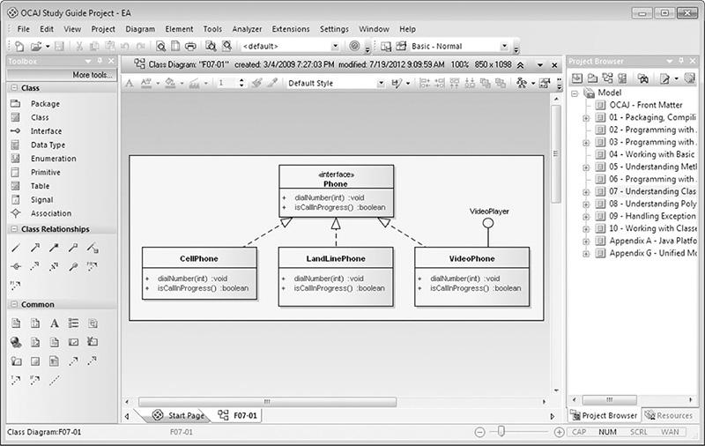

### EXAM READINESS CHECKLIST

At the end of the “Introduction,” you will find an “Exam Readiness Checklist.” This table has been constructed to enable you to cross-reference the official exam objectives with the objectives as they are presented and covered in this book. The checklist also helps you gauge your level of expertise on each objective at the outset of your studies so that you can check your progress and make sure you spend the time you need on more difficult or unfamiliar sections. References have been provided for the objective exactly as the vendor presents it, the section of the study guide that covers that objective, and a chapter and page reference.

### IN EVERY CHAPTER

We’ve created a set of chapter components that call your attention to important items, reinforce important points, and provide helpful exam-taking hints. Take a look at what you’ll find in every chapter:

 Every chapter begins with **Certification Objectives**—what you need to know to pass the section on the exam dealing with the chapter topic. The objective headings identify the objectives within the chapter, so you’ll always know an objective when you see it!

 **Exam Watch** notes call attention to information about, and potential pitfalls in, the exam. These helpful hints were written by authors who have taken the exams and received their certification. Who better to tell you what to worry about? They know what you’re about to go through!



***It is unlikely that you will see labeled statements on the exam. This coverage was simply intended for completeness of the transfer of control statement features*.**

 **Step-by-Step Exercises** are interspersed throughout the chapters. These are typically designed as hands-on exercises that enable you to get a feel for the real-world experience you’ll need to pass the exams. They help you master skills that are likely to be an area of focus on the exam. Don’t just read through the exercises—they are hands-on practice that you should be comfortable completing. Learning by doing is an effective way to increase your competency with a product.



 **On the Job** notes describe the issues that come up most often in real-world settings. They provide a valuable perspective on certification- and product-related topics. They point out common mistakes and address questions that have arisen from on-the-job discussions and experience.

 **Inside the Exam** sidebars highlight some of the most common and confusing problems that students encounter when taking a live exam. Designed to anticipate what the exam will emphasize, getting inside the exam will help ensure that you know what you need to know to pass the exam. You can get a leg up on how to respond to those difficult-to-understand questions by focusing extra attention on these sidebars.

 **Scenario & Solution** sections lay out potential problems and solutions in a quick-to-read format.

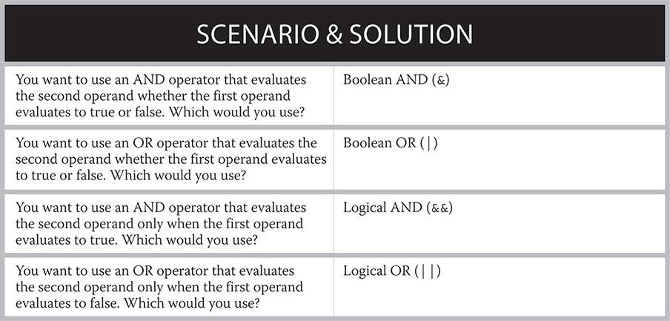

 The **Certification Summary** presents a succinct review of the chapter and a restatement of salient points regarding the exam.

✓

 The **Two-Minute**

**Drill** at the end of every chapter is a checklist of the main points of the chapter. Use it for last-minute review.

**Q&A**

 The **Self Test** offers questions similar to those found on the certification exams. The answers to these questions, as well as explanations of the answers, can be found at the end of each chapter. By taking the Self Test after completing each chapter, you’ll reinforce what you’ve learned from that chapter while becoming familiar with the structure of the exam questions.

### SOME POINTERS

Once you’ve finished reading this book, set aside some time to do a thorough review. You might want to return to the book several times and make use of all the methods it offers for reviewing the material:

 *Reread all the Two-Minute Drills*, or have someone quiz you. You also can use the drills as a quick cram before the exam. You may want to make some flash cards out of 3×5 index cards that contain Two-Minute Drill material.

 *Reread all the Exam Watch notes and Inside the Exam elements*. Remember that these notes are written by authors who have taken the exam and passed. They know what you should expect—and what you should be on the lookout for.

 *Review all the Scenario & Solution sections* for quick problem solving.

 *Retake the Self Tests*. Taking the tests right after you’ve read the chapter is a good idea because the questions help reinforce what you’ve just learned. However, it’s an even better idea to go back later and consider all the questions in the book in one sitting. Pretend that you’re taking the live exam. When you go through the questions the first time, you should mark your answers on a separate piece of paper. That way, you can run through the questions as many times as you need until you feel comfortable with the material.

 *Complete the exercises*. Did you do the exercises when you read through each chapter? If not, do them! These exercises are designed to cover exam topics, and there’s no better way to get to know this material than by practicing. Be sure you understand why you are performing each step in each exercise. If you are not clear on a particular topic, reread that section in the chapter.

**T**he OCA exam covers a significant amount of information detailing areas from Java fundamentals to object-oriented concepts. To complete a voluminous project like this book, covering all of the related objectives, the authors decided to take the divide-and-conquer approach by splitting up the chapters based on their individual expertise. Finegan focused on the chapters covering object-oriented basic concepts. Liguori focused on the core Java fundamentals chapters.

### OCA JAVA SE 8 PROGRAMMER STUDY GUIDE PROJECT TEAM ACKNOWLEDGMENTS

The McGraw-Hill Professional Support Team: Timothy Green, Amy Stonebraker, Jody McKenzie, Jim Kussow, LeeAnn Pickrell, Lisa Theobald, Lisa McCoy, and Rebecca Plunkett

Waterside Productions, Inc.: Carole Jelen McClendon

Technical Editor: Ryan Cuprak

Informal Reviewers: Shannon Reilly Finegan, Richard Tkatch (OCA 7 version), and Wayne Smith (SCJA version)

### PERSONAL ACKNOWLEDGEMENTS

Thank you to all of my family and friends. A project like this has a way of consuming more time than you ever expect. Their patience and encouragement has kept me motivated to accomplish this venture. I would like to give a special thanks to my wife, Shannon. She gave birth to our first child, Adalyn, during the second revision of this book. Right on schedule, during this third revision, our second child AJ joined our family. Shannon has always helped me balance the time between family and my professional endeavors. Without her support, this book would have never been completed.



I would also like to express my gratitude to my co-author, Robert Liguori. It has been an enriching experience collaborating with him on this project. Robert is a talented professional, and I sincerely thank him for keeping me on track. His enthusiasm and dedication to the Java community is truly remarkable and is evident in his work.

—Edward G. Finegan



I would like to thank my family, friends, and cousins for their friendship and support. Thanks again to my beautiful wife, Patti, and wonderful daughter, Ashleigh!

Also, thanks to my tech-savvy co-author Edward Finegan for working on this book with me; what a wonderful journey and endeavor this has been! Thanks also to our technical reviewer, Ryan Cuprak, and to all the folks at Waterside and McGraw-Hill Professional who made this book possible.

—Robert J. Liguori

## **INTRODUCTION**

**T**his *OCA Java SE 8 Programmer I Study Guide* has been designed to assist you in preparation of passing Oracle’s Java SE 8 Programmer I exam to achieve the OCA Java SE 8 Programmer certification. The information in this book is presented through textual content, coding examples, exercises, and more. To the best extent possible, all code examples have been validated on Apple OS X, Microsoft Windows, and Linux operating systems. Information is covered in detail for all exam objectives.

The following topics are covered in this book:

 The Java SE platform

 Java development and support tools

 Java fundamentals, including statements, variables, method primitives, and operators

 String and StringBuilder class methods and functionality

 Basic Java elements, including primitives, arrays, enumerations, and objects

 Classes and interfaces, including class relationships

 Object-oriented principles

 Exception handling

 Date and Time API

 Lambda expressions

Various appendices are included as well to assist you with your studies.

### SPECIFICS ABOUT THE OCA JAVA SE 8 PROGRAMMER CERTIFICATION EXAM

Specifics of the OCA Java SE 8 Programmer exam objectives are detailed on the Oracle Certification web site ([http://education.oracle.com](http://education.oracle.com/)). Specifics about the exam registration process are supplied by Pearson VUE when you enroll for the exam. However, we do detail in the following sections the most important information you will need to know to enroll for and take the exam. Visit the Oracle Certification web site for the most current information on exam objectives.

#### Referring to the Exam

The formal name for this exam is the Java SE 8 Programmer I (IZ0-808) exam. If you pass the exam, you will receive the Oracle Certified Associate, Java SE 8 Programmer certification.

Googling online, you will see that people and resources are calling out this IZ0-808 exam as the *OCA exam*, the *OCAJ exam*, the *OCAJP exam*, and the *OCAJP8*. This would correlate to the OCA certification, OCAJ certification, OCAJP certification, and OCAJP8 certification.

For simplicity, we have made the best effort to refer to the exam as the *OCA exam* and the certification as the *OCA certification*.

#### Dynamics of the Java SE 8 Programmer I (IZ0-808) Exam

This exam is geared toward matured Java programmers and developers who want to achieve foundational Java certification. The prerequisite-free exam consists of 77 questions. A passing percentage of 65 percent is necessary—in other words, you must answer at least 50 of the 77 questions correctly to pass. The designated time limit is 120 minutes (2 hours).

The current cost to take the exam is U.S. $245. If you are employed by a technical organization, check to see if your company has an educational assistance policy.

#### Scheduling the OCA Exam

The exam must be given at a proctored Pearson VUE testing location. You may schedule your appointment for the exam via one of three methods:

 Online

 By phone

 Through the test center

You will find all of the information you need for these options at the Pearson VUE web site ([www.pearsonvue.com/oracle/](http://www.pearsonvue.com/oracle/)). For a quick look, [Figure 2](https://learning.oreilly.com/library/view/oca-java-se/9781259587535/ch00_fm09_intro.html#fm09) shows the scheduling process on the site.

**FIGURE 2** Scheduling an exam

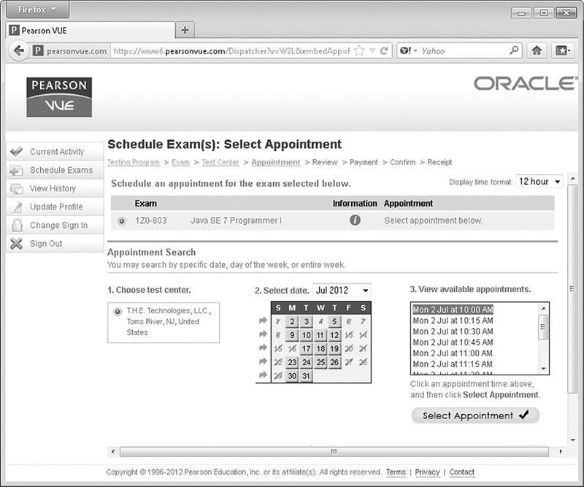

#### Pearson VUE Test Vouchers

Test Vouchers (prepaid exam certificates) may be available for purchase for the OCA exam. For more information about purchasing test vouchers, visit the voucher information page on the Pearson VUE web site at [www1.pearsonvue.com/vouchers/](http://www1.pearsonvue.com/vouchers/), or visit the Pearson VUE voucher store at [www1.pearsonvue.com/contact/voucherstore/](http://www1.pearsonvue.com/contact/voucherstore/).

#### Pearson VUE Test Center Locator

If you are interested in finding a testing facility near you, without registering, you can use Pearson VUE’s Test Center Locator at [www.vue.com/vtclocator/](http://www.vue.com/vtclocator/).

#### Preparing for the OCA Exam

Getting a good night’s rest before the exam and eating a healthy breakfast will contribute to good test marks, but you should already know that. Don’t cram for the exam the night before. If you find you need to cram, you should reschedule the exam since you won’t be ready for it.

You will need to bring a few things with you for the exam, *and* you’ll be leaving a few things behind. Let’s take a look at some do’s and don’ts.

#### Do’s

 *Do bring (at least) two forms of identification*. Valid identification includes a valid passport, current driver’s license, government-issued identification, credit cards, or check-cashing cards. Two items must include your signature, and at least one item must include your photograph. Make sure you don’t shorthand your signature when you sign in since it must match your identification.

 *Do show up early*. Plan to arrive 15 to 30 minutes before your exam’s scheduled start time. You may find that the center needs to set up several people for exams. Getting in early may get you set up early—or at the least it will ensure that you don’t start late.

 *Do use the restroom ahead of time*. The exam will take close to 2 hours to complete. Breaks are frowned upon and are most likely disallowed. In addition, you can’t pause the time you have allocated if you take a break.

 *Do print out directions to the test facility*. Or get the address and punch it into your GPS navigator or directions app if you have one.

#### Don’ts

 *Don’t bring your laptop, tablets, phone, or pager into the exam*. In addition, some facilities may ask that you do not enter the test area with your watch or wallet.

 *Don’t bring books, notes, or writing supplies*. You may be given an erasable noteboard to use. Do not use the noteboard until the exam has started.

 *Don’t bring large items*. Large storage may not be available for book bags and jackets. However, the testing facility may provide small securable lockers. Before storing your cell phone or other electronic device, turn it off.

 *Don’t bring drinks or snacks to the exam*. But feel free to enjoy refreshments while you are studying for the exam.

 *Don’t study in the test center*.

#### Taking the OCA Exam

Just prior to taking the exam, the proctor may take your photograph. Bring your best smile. You may be asked to sign in and wait while the proctor sets up your exam on a PC. In my case, the proctor adjusted the web cam in the room so it was facing me. There may be other people in the room taking other tests, so bring ear plugs if you are sensitive to the mouse clicks and general noises or people around you. The proctor should make sure that you get to the first question, and then he or she will leave room. Good luck!

After the exam, you may be presented with an optional computer-based survey, which will ask you about your technical background and other related information. A common misconception is that the questions are related to the exam questions you will be presented with; however, the survey is not related to the exam questions you will receive. The survey can take a few minutes to complete. The information gathered is important for those developing and refining future exams, so answer the questions honestly.

After you have completed the exam, your results will appear on the screen and will also be printed. Find the proctor (testing personnel) to retrieve your results from the printer and sign out. The point here is that *you should not leave* once you have completed the exam; stay and get your results.

#### Sharing Your Success

We would like to know how you did. You can send us an e-mail at results@ocajexam.com, or you can post your results on Java Ranch’s Wall of Fame.

#### Rescheduling the OCA Exam

If you need to reschedule (or cancel) your exam, do so outside of 24 hours of the start of the exam. Use Pearson VUE’s Test Taker Services page ([www.vue.com/programs/](http://www.vue.com/programs/)) to assist with the rescheduling or contact Pearson VUE directly. Rescheduling within 24 hours before the scheduled exam is subject to a same-day forfeit exam fee. Refunds are not granted if you don’t show up for the exam (that is, if you’re a no-show).

### ADDITIONAL OCA RESOURCES

You’ll find numerous resources to supplement this book and assist with your goal of OCA certification. These resources include Java software utilities, Java community forums, language specifications and related documentation, OCA-related books, online and purchasable mock exams, and software tools (such as IDE’s CASE tools, and so on). Although these peripheral tools and resources are highly beneficial and recommended, they are optional with regard to passing the OCA exam; this book attempts to cover all of the necessary material.

The following sections detail the previously mentioned resources.

#### Java Software

 Java Development Kits, [www.oracle.com/technetwork/java/archive-139210.html](http://www.oracle.com/technetwork/java/archive-139210.html)

 Java Enterprise Editions (out of scope of exam, provided here just FYI), [www.oracle.com/technetwork/java/javaee/overview/index.html](http://www.oracle.com/technetwork/java/javaee/overview/index.html)

#### Java Online Community Forums

 Java Ranch’s Big Moose Saloon Java technology forums, [www.coderanch.com/forums](http://www.coderanch.com/forums).

 Java Programming forums, <http://javaprogrammingforums.com/>

 </dream.in.code>, [www.dreamincode.net/forums/forum/32-java/](http://www.dreamincode.net/forums/forum/32-java/)

 IBM - Java Technology Forums, [www.ibm.com/developerworks/forums/dw_jforums.jspa](http://www.ibm.com/developerworks/forums/dw_jforums.jspa)

 Tek Tips Java Forum, [www.tek-tips.com/threadminder.cfm?pid=269](http://www.tek-tips.com/threadminder.cfm?pid=269)

 Code Guru - Java Programming, <http://forums.codeguru.com/forumdisplay.php?f=67>

 Go4Expert, [www.go4expert.com/forums/forumdisplay.php?f=21](http://www.go4expert.com/forums/forumdisplay.php?f=21)

 Java User Groups, <http://home.java.net/jugs/java-user-groups>

#### Java Tools and Technologies Specifications and Documentation

 The Java Tutorials, <http://docs.oracle.com/javase/tutorial/>

 Java Platform Standard Edition 8 Documentation, <http://docs.oracle.com/javase/8/docs/>

 Java Platform, Standard Edition 8 API Specification, <http://docs.oracle.com/javase/8/docs/api/>

 *The Java Language Specification: Java SE 8 Edition*, <http://docs.oracle.com/javase/specs/jls/se8/jls8.pdf>

#### Books Covering Material Found on the OCA Exam

Although the book you are holding sufficiently covers everything you need to know to pass the exam, supplemental reading can only help. Consider reviewing the following books to refine your skills:

 *Java 8 Pocket Guide*, by Robert and Patricia Liguori (O’Reilly Media, Inc., 2014)

 *NetBeans IDE Programmer Certified Expert Exam Guide (Exam-310-045)*, by Robert Liguori and Ryan Cuprak (McGraw-Hill Professional, 2010)

 *Java: The Complete Reference*, by Herbert Schildt (McGraw-Hill Professional, 2014)

#### OCA Mock Exams

In addition to the online mock exams associated with this book, various other free and commercial OCA mock exams exist. Various resources are listed here.

 Oracle certification practice exams, <http://education.oracle.com/pls/web_prod-plq-dad/db_pages.getpage?page_id=208>

 Enthuware mock exams, <http://enthuware.com/>

 Whizlabs SCJA Preparation Kit, <http://bit.ly/19h3fvg>

 ExamsExpert, <http://bit.ly/18Uw4hh>

 Transcender, <http://bit.ly/1NaCkyD>

#### Integrated Development Environments

An *integrated development environment (IDE)* is a development suite that enables developers to edit, compile, debug, connect to version control systems, collaborate, and do much more depending on the specific tool. Most modern IDEs have add-in capabilities for various software modules to enhance the IDE’s capabilities. There is no reason not to use an IDE. We (the authors) recommend that you use the NetBeans IDE for your test preparation because of its popularity, ease of use, and support from Oracle. However, any IDE from the following list would suffice:

 NetBeans IDE, [www.netbeans.org](http://www.netbeans.org/)

 Oracle JDeveloper IDE, <http://bit.ly/19h29jc>

 IntelliJ IDEA, [www.jetbrains.com](http://www.jetbrains.com/)

 Eclipse IDE, [www.eclipse.org](http://www.eclipse.org/)

 JCreator IDE, [www.jcreator.com](http://www.jcreator.com/)

 BlueJ, [www.bluej.org](http://www.bluej.org/)

#### Tools with UML Modeling Features

Several tools and IDEs have UML features. However, questions about UML are not included on the OCA. If you want to explore UML modeling, following are a few tools you may look into—but, again, this is not on the exam. We do believe, however, that software programmers and developers should learn UML early in their careers.

 NetBeans IDE, <http://netbeans.org/features/uml/>

 JDeveloper IDE, <http://bit.ly/1N4bpq8>

 Enterprise Architect CASE tool, [www.sparxsystems.com/products/ea/](http://www.sparxsystems.com/products/ea/)

 Visual Paradigm for UML (provides plug-ins for the popular IDEs), [www.visual-paradigm.com/product/vpuml/](http://www.visual-paradigm.com/product/vpuml/)

#### Miscellaneous Resources

Various other resources, such as the following, include games and Java news outlets that can assist you with getting high marks on the exam.

 Java Ranch Rules Round Up Game, [www.javaranch.com/game/game2.jsp](http://www.javaranch.com/game/game2.jsp)

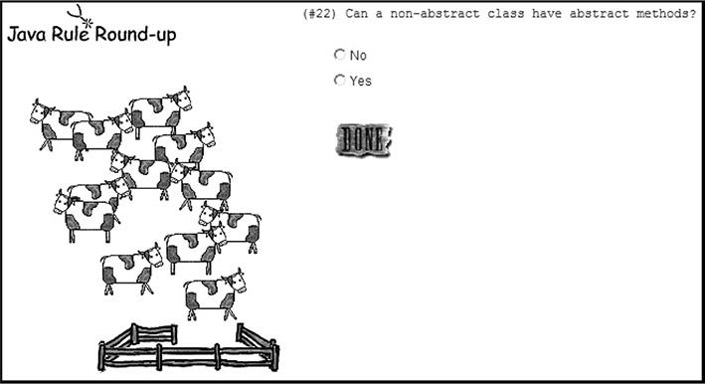

 DZone, [http://java.dzone.com](http://java.dzone.com/)

 The Server Side, [http://theserverside.com](http://theserverside.com/)

 OCA FAQs on Java Ranch, [www.coderanch.com/how-to/java/OcajpFaq](http://www.coderanch.com/how-to/java/OcajpFaq)

 Java Language Specifications, <http://docs.oracle.com/javase/specs/>

### ORACLE’S CERTIFICATION PROGRAM IN JAVA TECHNOLOGY

This section maps the exam’s objectives to specific coverage in the study guide.

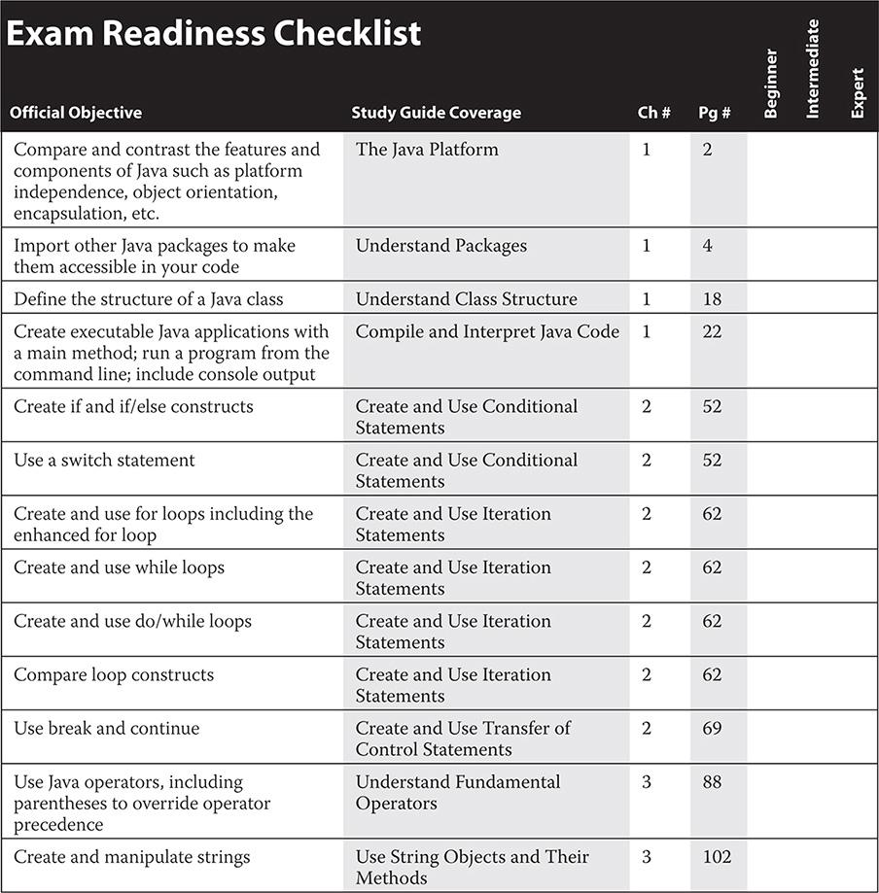

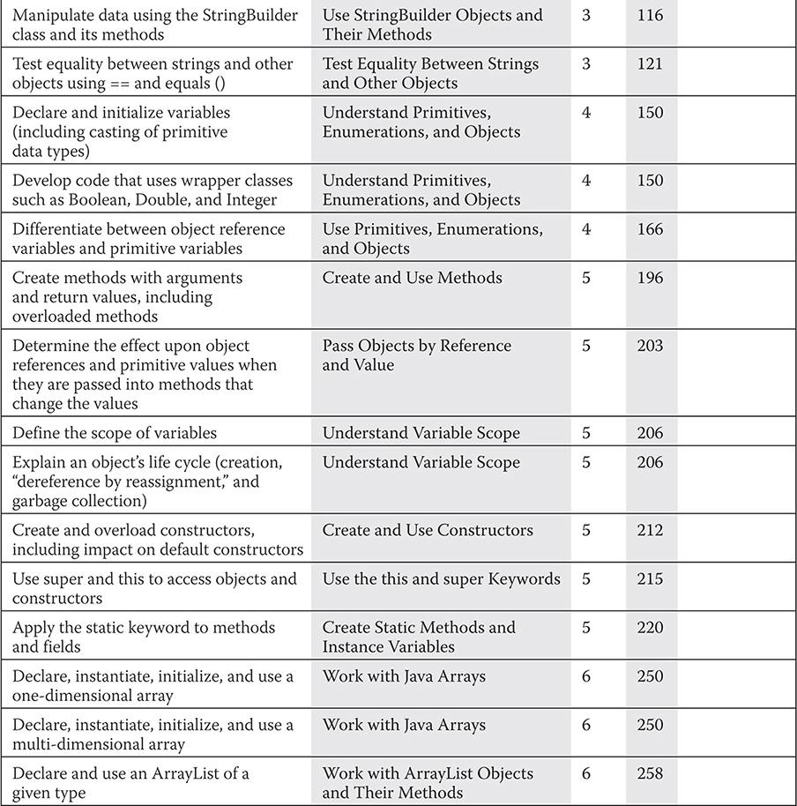

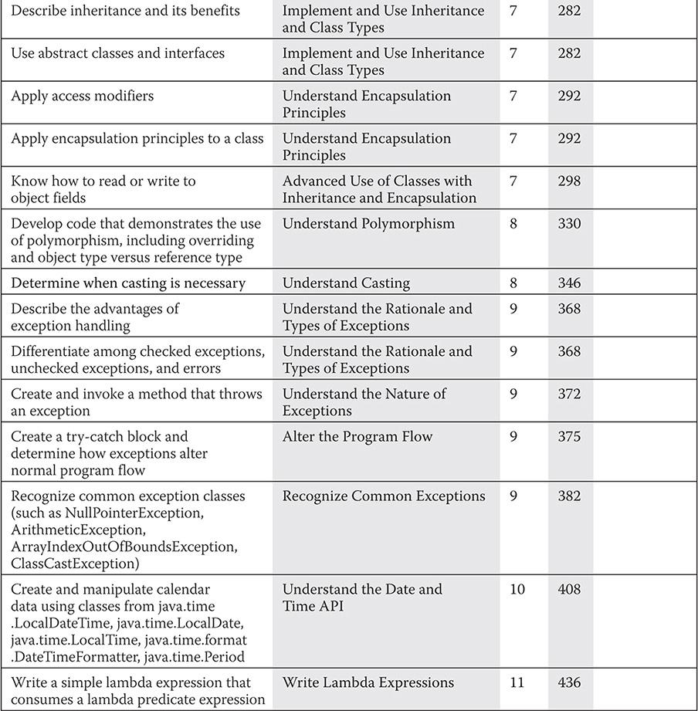



### 1

### PACKAGING, COMPILING, AND INTERPRETING JAVA CODE

**CERTIFICATION OBJECTIVES**

• [The Java Platform](https://learning.oreilly.com/library/view/oca-java-se/9781259587535/ch01.html#ch01lev1)

• [Understand Packages](https://learning.oreilly.com/library/view/oca-java-se/9781259587535/ch01.html#ch01lev5)

• [Understand Package-Derived Classes](https://learning.oreilly.com/library/view/oca-java-se/9781259587535/ch01.html#ch01lev8)

• [Understand Class Structure](https://learning.oreilly.com/library/view/oca-java-se/9781259587535/ch01.html#ch01lev15)

• [Compile and Interpret Java Code](https://learning.oreilly.com/library/view/oca-java-se/9781259587535/ch01.html#ch01lev19)

 [Two-Minute Drill](https://learning.oreilly.com/library/view/oca-java-se/9781259587535/ch01.html#ch01lev22)

**Q&A** [Self Test](https://learning.oreilly.com/library/view/oca-java-se/9781259587535/ch01.html#ch01lev24)

**S**ince you are holding this book, or reading an electronic version of it, you must have an affinity for Java. You must also have the desire to let everyone know through the Oracle Certified Associate, Java SE 8 Programmer (OCA), certification process that you are truly Java savvy. As such, you should either be—or have the desire to be—a Java programmer, and in the long term, a true Java developer. You may be or plan to be a project manager heading up a team of Java programmers and/or developers. In this case, you will need to acquire a basic understanding of the Java language and its technologies. In either case, this book is for you.

To start, you may be wondering about the core functional elements provided by the basic Java Standard Edition (SE) platform with regard to libraries and utilities, and how these elements are organized. This chapter answers these questions by discussing Java packages and classes, along with their packaging, structuring, compilation, and interpretation processes.

When you have finished this chapter, you will have a firm understanding of packaging Java classes, high-level details of common Java SE packages, and the fundamentals of Java’s compilation and interpretation tools.

**CERTIFICATION OBJECTIVE**

#### The Java Platform

*Exam Objective Compare and contrast the features and components of Java, such as platform independence, object orientation, encapsulation, and so on*

The Java language was first released in 1995 as a beta. At that time the Java team had a radical vision. They envisioned a language that was independent of the platform it was running on. They also wanted to create a language that was object oriented at its core and that used all the principles that this implied. Encapsulation, polymorphism, inheritance, and abstraction are all basic concepts upon which Java is built. This section will review the core philosophy that makes up the Java language.

##### Platform Independence

When the Java language is compiled, it is targeted for execution on the Java virtual machine, or JVM, instead of a specific hardware architecture. The compiled Java code is called *bytecode*. This is why it is possible to compile the Java language on a Windows PC and execute the output on a Linux server. The only requirement for the code to work on any computer is the presence of a compatible JVM.

The Java language extends past the PC and server, however. Many mobile phones have embraced the power of Java as their recommended language for apps. This allows the hardware manufacturer to change the hardware between models without breaking the compatibility of the software. Java is even present in embedded systems and appliances. On devices such as Blu-ray players and car infotainment systems, Java software is often present.

It is important that you understand that platform independence does not mean your server code will run on your Blu-ray player. Java has a few different JVM specs for devices with different capabilities. For example, embedded systems use a JVM with only a subset of features, and mobile phones typically use a JVM with mobile optimized user interface libraries. All of these JVMs share a common Java core, but platform independence is limited to compatible versions.

##### Java’s Object-Oriented Philosophy

Java was conceived as an object-oriented language, in contrast to the C language, which is procedural. An object-oriented language organizes related data and code together—a process called *encapsulation*. A properly encapsulated object uses data protection and exposes only some of its data and methods. The data and methods that are designed for internal use in the object are not exposed to other objects.

Object-oriented design also encourages *abstraction*, the ability to generalize algorithms. Abstraction facilitates code reuse and flexibility. These concepts are at the heart of the Java language. Inheritance and polymorphism are key concepts in creating reusable code. Both are covered in much more depth in [Chapters 7](https://learning.oreilly.com/library/view/oca-java-se/9781259587535/ch07.html#ch07) and [8](https://learning.oreilly.com/library/view/oca-java-se/9781259587535/ch08.html#ch08) of this book.

##### Robust and Secure

Security and robustness were major design goals when Java was created. C and C++ suffered from the misuse of pointers, memory management, and buffer overruns. Java was architected to overcome these issues and many more.

Java was designed not to have explicit pointers. In the C language family, pointers store a memory address to an object. This memory address can be directly altered. Java variables store references to objects but do not allow access to, or modification of, the memory address stored in the reference. This simplified development and removed a level of complexity that was often the source of application instability.

Memory management was addressed in Java with the JVM’s built-in garbage collector. When Java was introduced, many languages relied on explicit memory management. This meant that the developer was responsible for both allocating and deallocating the memory that was used for objects. This process could become tedious. If it was done incorrectly, the application could leak memory and/or crash. With Java, the JVM periodically runs the garbage collector, which looks for any objects that have gone out of scope or that are no longer referenced, and it automatically deallocates their memory. This frees the developer from this manual, error-prone task and increases robustness by ensuring that memory is properly managed.

Buffer overruns are a common exploit vector found in software that does not check for them. In a C program, when an array is created, the index used is never automatically checked to ensure it is in bounds. In fact, an out-of-bounds index may not even crash the program. The software will read or write to the memory address whether it is in bounds or out, and this can create unpredictable behavior. This can be used maliciously to alter the program in ways the developer never intended. Java automatically checks the bounds of arrays. If an index is out-of-bounds, an exception is thrown. This level of checking helps create both more robust and secure software.

**CERTIFICATION OBJECTIVE**

#### Understand Packages

*Exam Objective Import other Java packages to make them accessible in your code*

Packaging is a common approach used to organize related classes and interfaces. Most reusable code is packaged. Unpackaged classes are commonly found in books and online tutorials, as well as in software applications with a narrow focus. This section will show you how and when to package your Java classes and how to import external classes from your Java packages. The following topics will be covered:

 Package design

 Package and import statements

##### Package Design

Packages are considered containers for classes, but they actually define where classes will be located in the hierarchical directory structure. Packaging is encouraged by Java coding standards to decrease the likelihood of classes colliding in the same namespace. The package name plus the class names creates the *fully qualified class name*. Packaging your classes also promotes code reuse, maintainability, and the object-oriented principle of encapsulation and modularity.

When you design Java packages, such as the grouping of classes, consider the key areas shown in [Table 1-1](https://learning.oreilly.com/library/view/oca-java-se/9781259587535/ch01.html#ch01tab01).

**TABLE 1-1** Package Attribute Considerations

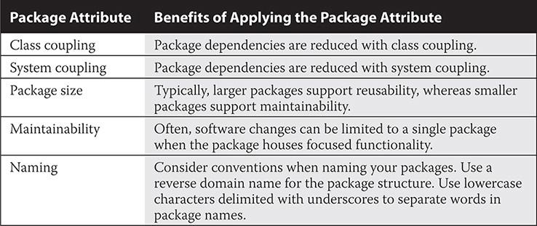

Let’s take a look at a real-world example. As program manager, suppose you need two sets of classes with unique functionality that will be used by the same end product. You task Developer A to build the first set and Developer B to build the second. You do not define the names of the classes, but you do define the purpose of the package and what it must contain. Developer A is to create several geometry-based classes, including a point class, a polygon class, and a plane class. Developer B is to build classes that will be included for simulation purposes, including objects such as hot air balloons, helicopters, and airplanes. You send them off to build their classes (without having them package their classes).

Come delivery time, they both give you a class named Plane.java—that is, one for the geometry plane class and one for the airplane class. Now you have a problem, because both of these source files (class files, too) cannot coexist in the same directory because they have the same name. The solution is packaging. If you had designated package names to the developers, this conflict never would have happened (as shown in [Figure 1-1](https://learning.oreilly.com/library/view/oca-java-se/9781259587535/ch01.html#ch01fig01)). The lesson learned is this: Always package your code, unless your coding project is trivial in nature.

**FIGURE 1-1** Separate packaging of classes with the same names

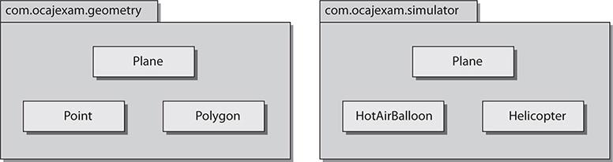

##### package and import Statements

You should now have a general idea of when and why to package your source files. Next, you need to know exactly how to do this. To place a source file into a package, you use the package statement at the beginning of that file. You may use zero or one package statements per source file. To import classes from other packages into your source file, you may use the import statement or you may precede each class name with its package name. The java.lang package that houses the core language classes is imported by default.

The following code listing shows usage of the package and import statements. You can return to this listing as we discuss the package and import statements in detail throughout the chapter.

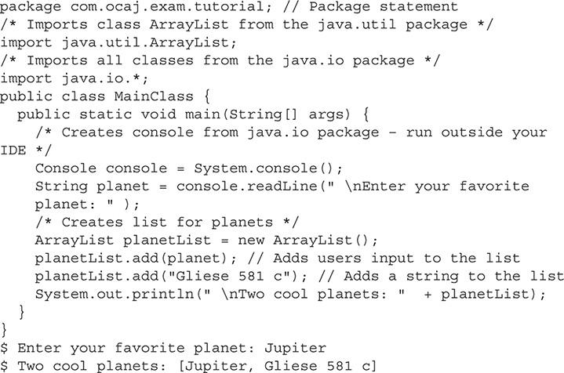

##### The package Statement

The package statement includes the package keyword, followed by the package path delimited with periods. [Table 1-2](https://learning.oreilly.com/library/view/oca-java-se/9781259587535/ch01.html#ch01tab02) shows valid examples of package statements. package statements have the following attributes:

**TABLE 1-2** Valid package Statements

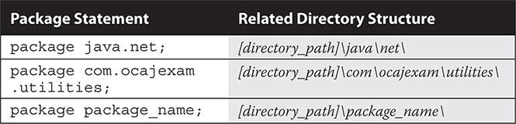

 They are optional.

 They are limited to one per source file.

 Standard coding convention for package statements reverses the domain name of the organization or group creating the package. For example, the owners of the domain name ocajexam.com may use the following package name for a utilities package: com.ocajexam.utilities.

 Package names equate to directory structures. The package name com.ocajexam.utils would equate to the directory com/ocajexam/utils. If a class includes a package statement that does not map to the relative directory structure, the class will not be usable.

 The package names beginning with java.* and javax.* are reserved.

 Package names should be lowercase. Individual words within the package name should be separated by underscores.

The Java SE API contains several packages. These packages are detailed in Oracle’s Online Javadoc documentation at <http://docs.oracle.com/javase/8/docs/api/>.

On the exam, you will see packages for the Java Abstract Window Toolkit API, the Java Swing API, the Java Basic Input/Output API, the Java Networking API, the Java Utilities API, and the core Java Language API. You will need to know the basic functionality that each package/API contains.

##### The import Statement

An import statement enables you to include source code from other classes into a source file at compile time. The import statement includes the import keyword followed by the package path delimited with periods and ending with a class name or an asterisk, as shown in [Table 1-3](https://learning.oreilly.com/library/view/oca-java-se/9781259587535/ch01.html#ch01tab03). These import statements occur after the optional package statement and before the class definition. Each import statement can relate to one package only.

**TABLE 1-3** Valid import Statements

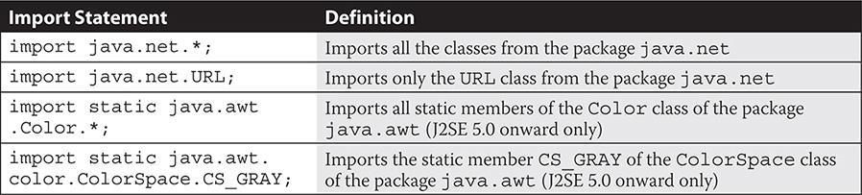



***For maintenance purposes, it is better that you import your classes explicitly. This will allow the programmer to determine quickly which external classes are used throughout the class. For example, rather than using* import java.util.\**, use* import java.util.Vector*. In this real-world example, the coder would quickly see (with the latter approach) that the class imports only one class and it is a collection type. In this case, it is a legacy type and the determination to update the class with a newer collection type could be done quickly*.**

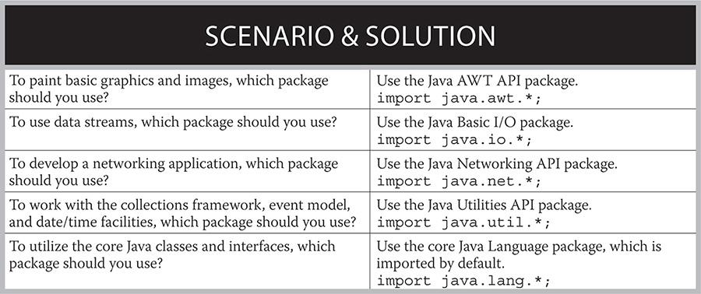

C and C++ programmers will see some look-and-feel similarities between Java’s import statement and C/C++’s #include statement, even though there is no direct mapping in functionality.

##### The static import Statement

Static import statements were introduced in Java SE 5.0. Simply put, static import statements allow you to import static members. The following example statements demonstrate this:

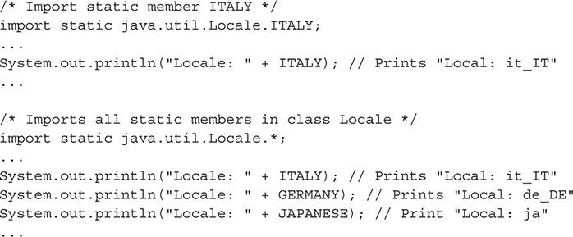

Without the static import statements shown in the example, the direct references to ITALY, GERMANY, and JAPANESE would be invalid and would cause compilation issues.

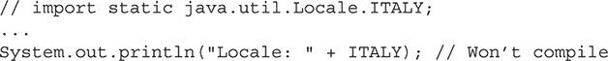

**EXERCISE 1-1**

**Replacing Implicit import Statements with Explicit import Statements**

Consider the following sample application:

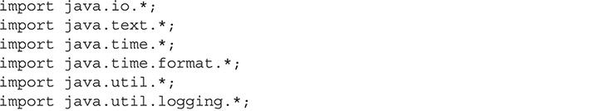

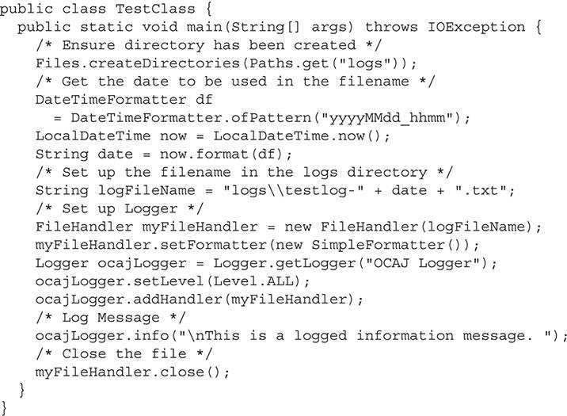

There can be implicit import statements that allow all necessary classes of a package to be imported:



There can be explicit import statements that allow only the designated class or interface of a package to be imported:



This exercise will have you using explicit import statements in lieu of the implicit import statements for all of the necessary classes of the sample application. If you are unfamiliar with compiling and interpreting Java programs, finish reading this chapter and then come back to this exercise. Otherwise, let’s begin.

**1.** Type the sample application into a new file and name it *TestClass.java*. Save the file.

**2.** Compile and run the application to ensure that you have created the file contents without error: javac TestClass.java to compile, java TestClass to run. Verify that the log message prints to the screen. Also verify that a file has been created in the logs subdirectory with the same message in it.

**3.** Comment out all of the import statements:

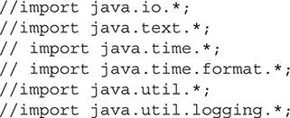

**4.** Compile the application: javac TestClass.java. You will be presented with several compiler errors related to the missing class imports. As an example, the following illustration demonstrates the errors that are displayed when only the java.io package has been commented out:

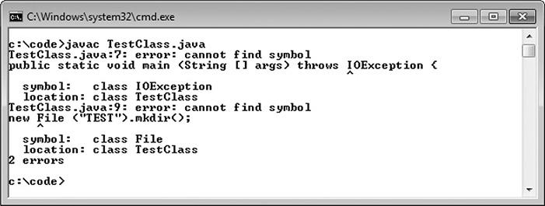

**5.** For each class that cannot be found, use the online Java Specification API to determine which package it belongs to and then update the source file with the necessary explicit import statement. Once completed, you will have replaced the four *implicit* import statements with nine *explicit* import statements.

**6.** Run the application again to ensure that the application works with the explicit import statements the same way it did with the implicit import statements.

#### Understand Package-Derived Classes

Oracle includes more than 200 packages in the Java SE 8 API. Each package has a specific focus. Fortunately, you need to be familiar with only a few of them for the OCA exam. These may include packages for Java utilities, basic input/output, networking, Abstract Window Toolkit (AWT), Swing, and data/time. The java data/time classes will be covered in more detail in [Chapter 10](https://learning.oreilly.com/library/view/oca-java-se/9781259587535/ch10.html#ch10).

The following sections address these APIs:

 Java Utilities API

 Java Basic Input/Output API

 Java Networking API

 Java Abstract Window Toolkit API

 Java Swing API

 JavaFX

##### Java Utilities API

The Java Utilities API is contained in the package java.util. This API provides functionality for a variety of utility classes. The API’s key classes and interfaces can be divided into several categories. Categories of classes that may be seen on the exam include the Java Collections Framework, date and time facilities, internationalization, and some miscellaneous utility classes.

Of these categories, the Java Collections Framework pulls the most weight because it is frequently used and provides the fundamental data structures necessary to build valuable Java applications. [Table 1-4](https://learning.oreilly.com/library/view/oca-java-se/9781259587535/ch01.html#ch01tab04) details the classes and interfaces of the Collections API that you may see referenced on the exam.

To assist collections in sorting where the ordering is not natural, the Collections API provides the Comparator interface. Similarly, the Comparable interface that resides in the java.lang package is used to sort objects by their natural ordering.

**TABLE 1-4** Various Classes of the Java Collections Framework

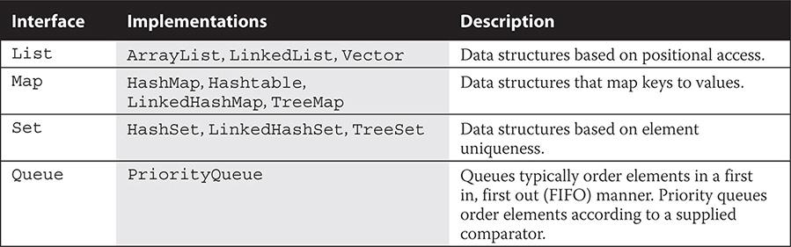

Various other classes and interfaces reside in the java.util package. Legacy date and time facilities are represented by the Date, Calendar, and TimeZone classes. Geographical regions are represented by the Locale class. The Currency class represents currencies per the ISO 4217 standard. A random-number generator is provided by the Random class. And StringTokenizer breaks strings into tokens. Several other classes exist within java.util, and these (and the collection interfaces and classes) are classes that you may find yourself commonly using on the job. These utilities classes are represented in [Figure 1-2](https://learning.oreilly.com/library/view/oca-java-se/9781259587535/ch01.html#ch01fig02).

**FIGURE 1-2** Various utility classes

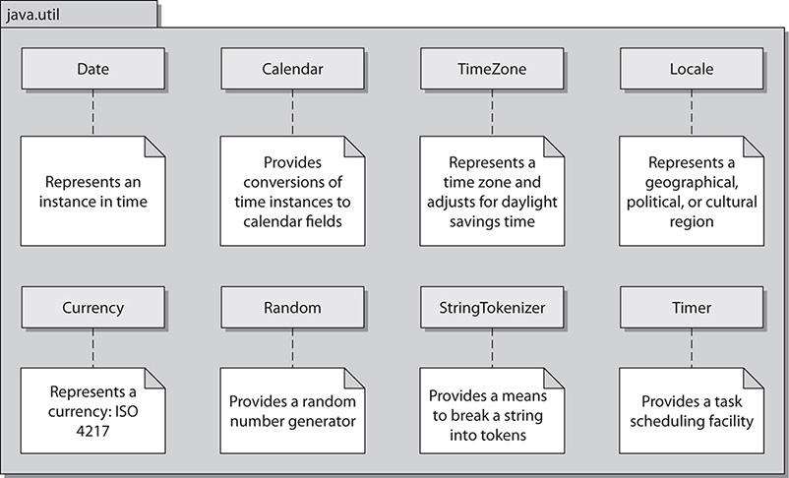



***Many packages have related classes and interfaces with unique functionality, so they are included in their own subpackages. For example, regular expressions are stored in a subpackage of the Java utilities (*java.util*) package. The subpackage is named* java.util.regex *and houses the* Matcher *and* Pattern *classes. Where needed, consider creating subpackages for your own projects*.**

##### Java Basic Input/Output API

The Java Basic Input/Output API is contained in the package java.io. This API provides functionality for general system input and output in relation to data streams, serialization, and the file system. Data-stream classes include byte-stream subclasses of the InputStream and OutputStream classes. Data-stream classes also include character-stream subclasses of the Reader and Writer classes. [Figure 1-3](https://learning.oreilly.com/library/view/oca-java-se/9781259587535/ch01.html#ch01fig03) depicts part of the class hierarchy for the Reader and Writer abstract classes.

**FIGURE 1-3** Reader and Writer class hierarchy

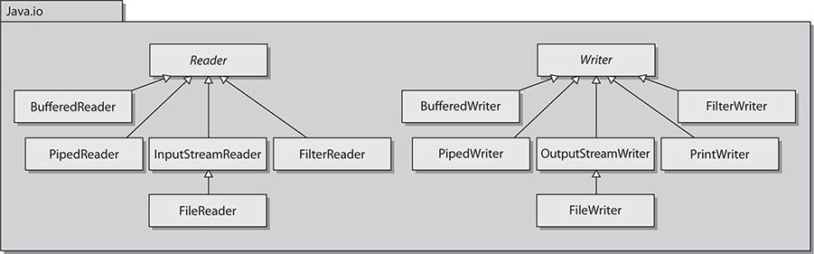

Other important java.io classes and interfaces include File, FileDescriptor, FilenameFilter, and RandomAccessFile. The File class provides a representation of file and directory pathnames. The FileDescriptor class provides a means to function as a handle for opening files and sockets. The FilenameFilter interface, as its name implies, defines the functionality to filter filenames. The RandomAccessFile class allows for the reading and writing of files to specified locations.

In JDK 7, the NIO.2 API was introduced in the package java.nio. This included the useful Paths interface, the Path class, and the Files class. The Files class has lines, list, walk, and find methods that work hand-in-hand with the Stream API. All of this is beyond the scope of the exam but is useful to know. The following code snippet provides a quick look at what you can do with the API and other new features of Java. You’ll see the lambda expression-related code in [Chapter 11](https://learning.oreilly.com/library/view/oca-java-se/9781259587535/ch11.html#ch11) (for example, p -> { statements; }).

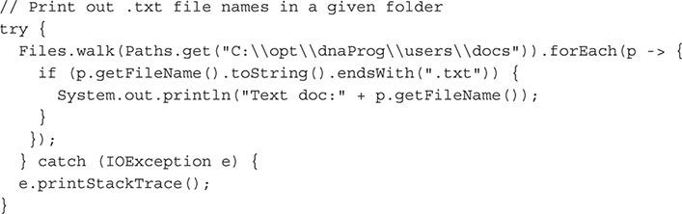

##### The Java Networking API

The Java Networking API is contained in the package java.net. This API provides functionality in support of creating network applications. The API’s key classes and interfaces are represented in [Figure 1-4](https://learning.oreilly.com/library/view/oca-java-se/9781259587535/ch01.html#ch01fig04). You will probably see few, if any, of these classes on the exam, but the figure will help you conceptualize what’s in the java.net package. The improved performance I/O API (java.nio) package, which provides for nonblocking networking and the socket factory support package (javax.net), is not included on the exam.

**FIGURE 1-4** Various classes of the Networking API

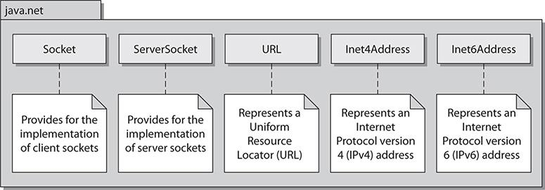

##### Java Abstract Window Toolkit API

The Java Abstract Window Toolkit API is contained in the package java.awt. This API provides functionality for creating heavyweight components with regard to creating user interfaces and painting associated graphics and images. The AWT API was Java’s original GUI API and has been superseded by the Swing API. Where Swing has been recommended over AWT, certain pieces of the AWT API still remain commonly used, such as the AWT Focus subsystem that was reworked in J2SE 1.4. The AWT Focus subsystem provides for navigation control between components. [Figure 1-5](https://learning.oreilly.com/library/view/oca-java-se/9781259587535/ch01.html#ch01fig05) depicts these major AWT elements.

**FIGURE 1-5** AWT major elements

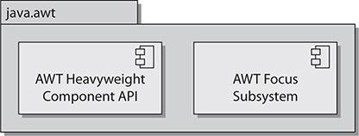

##### Java Swing API

The Java Swing API is contained in the package javax.swing. This API provides functionality for creating lightweight (pure-Java) containers and components. The Swing API, providing a more sophisticated set of GUI components, supersedes the AWT API. Many of the Swing classes are simply prefaced with the addition of “J” in contrast to the legacy AWT component equivalent. For example, Swing uses the class JButton to represent a button container, whereas AWT uses the class Button.

Swing also provides look-and-feel support, allowing for universal style changes of the GUI’s components. Other features include tooltips, accessibility functionality, an event model, and enhanced components such as tables, trees, text components, sliders, and progress bars. Some of the Swing API’s key classes are represented in [Figure 1-6](https://learning.oreilly.com/library/view/oca-java-se/9781259587535/ch01.html#ch01fig06).

**FIGURE 1-6** Various classes of the Swing API

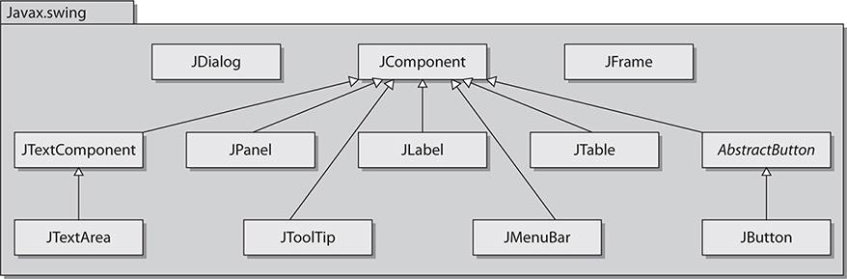

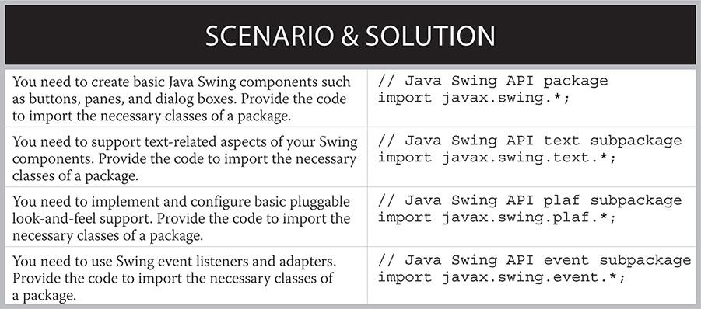

The Swing API makes excellent use of subpackages, with 18 of them in Java SE 8. As mentioned earlier, when common classes are separated into their own packages, code usability and maintainability are enhanced.

Swing takes advantage of the model-view-controller (MVC) architecture. The *model* represents the current state of each component. The *view* is the representation of the components on the screen. The *controller* is the functionality that ties the UI components to events. Although understanding the underlying architecture of Swing is important, it’s not necessary for the exam. For comprehensive information on the Swing API, look to the book *Swing: A Beginner’s Guide*, by Herbert Schildt (McGraw-Hill Professional).



***It’s good to be familiar with the package prefixes* java *and* javax*. The prefix* java *is commonly used for the core packages. The prefix* javax *is commonly used for packages that comprise Java standard extensions. Take special notice of the prefix usage in the AWT and Swing APIs:* java.awt *and* javax.swing*. Also note that JavaFX will be replacing Swing as the GUI toolkit for Java SE. Its prefix is* javafx.**

##### JavaFX API

JavaFX is Java’s latest technology for creating rich user interfaces. It is designed to provide lightweight, hardware-accelerated interfaces. JavaFX provides a similar set of features to the Swing library. JavaFX is intended to replace Swing in the same manner that Swing replaced AWT. The JavaFX libraries are part of the javafx package.

JavaFX best practices suggest that the MVC architecture be used when designing applications. FXML, an XML-based markup language, has been created for defining user interfaces. Many of the more than 60 UI controls can be styled by using Cascading Style Sheets (CSS). These features together represent a powerful new way to create user interfaces. JavaFX makes going from whiteboard design to implemented software faster than ever before. A great reference for JavaFX is *Introducing JavaFX 8 Programming*, by Herbert Schildt (Oracle Press).



***JavaFX is the latest technology for creating user interfaces. Oracle is actively promoting this technology as the go-to tool kit. However, the Swing libraries are not going away anytime soon. In Java 8, both JavaFX and Swing are fully supported and can be used interchangeably. The* SwingNode *class allows Swing elements to be embedded in JavaFX. The* JFXPanel *will allow the reverse so that JavaFX elements can be used in a Swing applications*.**

**CERTIFICATION OBJECTIVE**

#### Understand Class Structure

*Exam Objective Define the structure of a Java class*

You must understand the structure of a Java class to do well on the exam and to have a promising career with Java. It would help to have a fundamental knowledge of Java naming conventions as well as knowledge of the typical separators that are seen in Java source code (such as comment separators and brackets for enclosing entities). These topics are covered in the following sections:

 Naming Conventions

 Separators and Other Java Source Symbols

 Java Class Structure

##### Naming Conventions

Naming conventions are rules for the usage and application of characters in creation of identifiers, methods, class names, and so forth, throughout your code base. If some of your team members are not applying naming conventions to their code, you should encourage them to do so, for the good of the effort and for maintainability aspects for after the code is deployed.



***The popular article, “How to Write Unmaintainable Code,” by Roedy Green, is worth reading (***[***http://thc.org/root/phun/unmaintain.html***](http://thc.org/root/phun/unmaintain.html)***). It brings to light, in a comical way, the challenges that can occur with maintaining code when there is a blatant or intentional disregard to software development best practices. On the flip-side*,** *The Passionate Programmer: Creating a Remarkable Career in Software Development*, ***by Chad Fowler (Pragmatic Bookshelf, 2009), encourages the software developer to be the best that he or she can be*.**

You may encounter people who will come up with their own naming conventions. Although this is better than not applying any convention, an outsider trying to maintain that person’s code would need to learn the original convention and apply it as well for consistency. Fortunately, the Java community does subscribe to a shared thought on how naming conventions should be applied to the many different elements in Java. [Table 1-5](https://learning.oreilly.com/library/view/oca-java-se/9781259587535/ch01.html#ch01tab05) describes these conventions in a simple manner. When applying naming conventions, you should strive to use meaningful and unambiguous names. And remember that naming conventions exist for the primary goal of making Java programs more readable, and therefore maintainable. The practice of using CamelCase—using uppercase letters for the first characters in compound words—is part of the Java naming conventions.

**TABLE 1-5** Java Naming Conventions

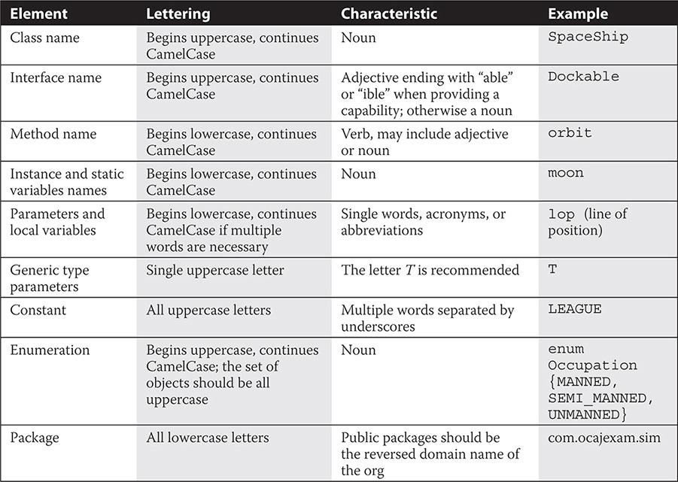

##### Separators and Other Java Source Symbols

The Java programming language makes use of several separators and symbols to aid in the structuring of the source code in a software program. [Table 1-6](https://learning.oreilly.com/library/view/oca-java-se/9781259587535/ch01.html#ch01tab06) details these separators and symbols.

**TABLE 1-6** Symbols and Separators

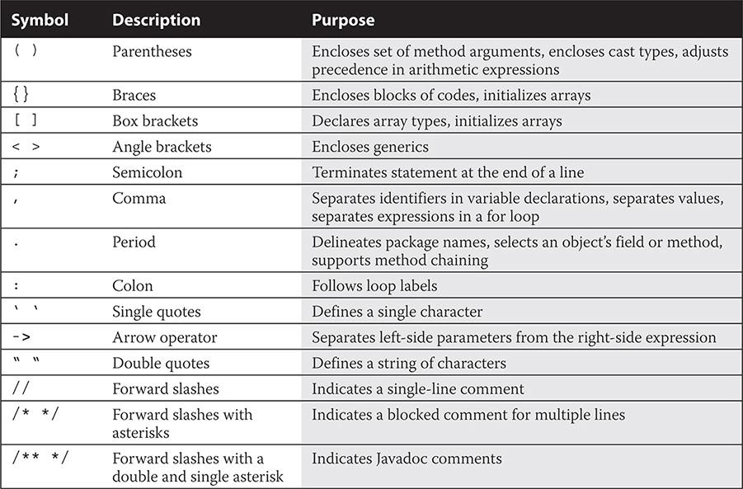

##### Java Class Structure

Every Java program has at least one class. A Java class has a signature, optional constructors, optional data members (fields), and optional methods, as outlined here:

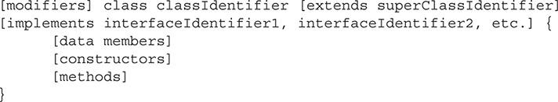

Each class may extend one and only one superclass. Each class may implement one or more interfaces. Interfaces are separated by commas.

The following SpaceShip class shows typical elements annotated with comments. The file containing this SpaceShip class must be called SpaceShip.java. Note that the class declaration extends the Ship class and implements the Dockable interface. The Dockable interface includes the dockShip method, which is overridden here. Ship class methods would be inherited by the SpaceShip class. [Chapters 4](https://learning.oreilly.com/library/view/oca-java-se/9781259587535/ch04.html#ch04)–[7](https://learning.oreilly.com/library/view/oca-java-se/9781259587535/ch07.html#ch07) go into more comprehensive details about creating and working with classes.

The following code shows the structure of a typical class:

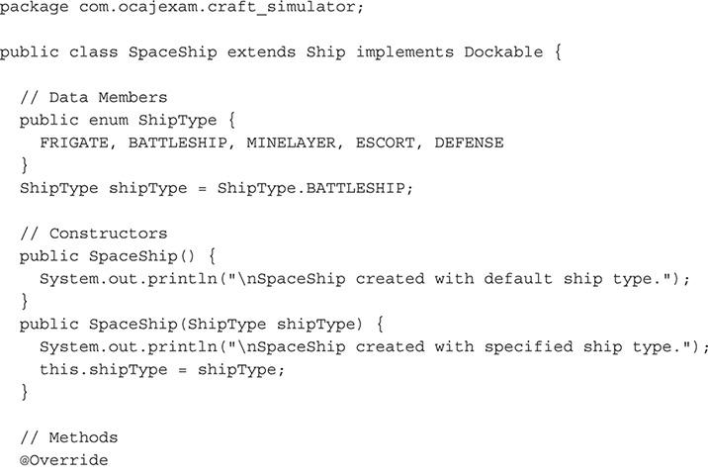

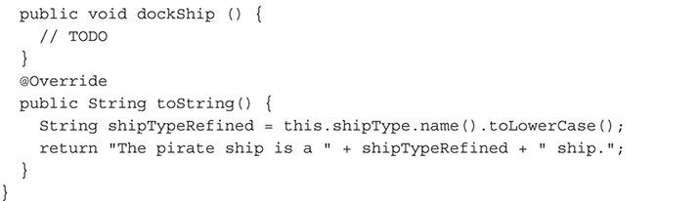

This SpaceShip class can be instantiated as demonstrated in the following code:

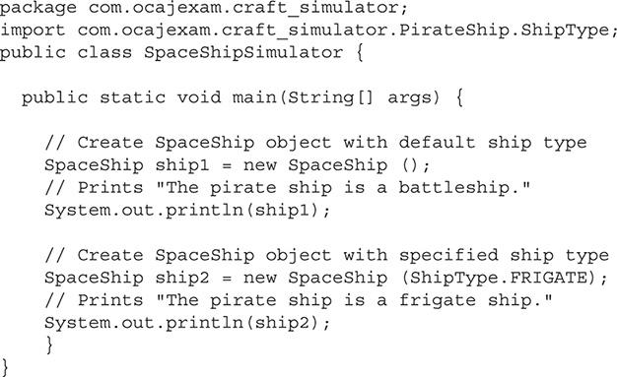



***The override annotation (*@Override*) indicates that a method declaration intends on overriding a method declaration in the class’s supertype*.**

**CERTIFICATION OBJECTIVE**

#### Compile and Interpret Java Code

*Exam Objective Create executable Java applications with a main method, run a program from the command line, including console output*

The Java Development Kit (JDK) includes several utilities for compiling, debugging, and running Java applications. This section details two utilities from the kit: the Java compiler and the Java interpreter. For more information on the JDK and its other utilities, see [Chapter 10](https://learning.oreilly.com/library/view/oca-java-se/9781259587535/ch10.html#ch10).

##### Java Compiler

Because we’ll need a sample application to use for our Java compiler and interpreter exercises, we’ll employ the simple GreetingsUniverse.java source file, shown in the following listing, throughout the section. This sample includes the main method used as the entry point of the executed code. When the program is started, this is the first method to be called by the JVM. The main method shown here contains one line of code. This line,



will print



to standard output. This output would typically be displayed on a Java application that was started from a console.

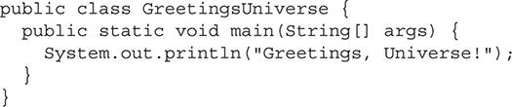

Let’s take a look at compiling and interpreting simple Java programs along with their most basic command-line options.

##### Compiling Your Source Code

The Java compiler is only one of several tools in the JDK. When you have time, inspect the other tools resident in the JDK’s bin folder, as shown in [Figure 1-7](https://learning.oreilly.com/library/view/oca-java-se/9781259587535/ch01.html#ch01fig07). For the scope of the OCA exam, you will need to know the details surrounding only the compiler and interpreter.

**FIGURE 1-7** Java Development Kit utilities

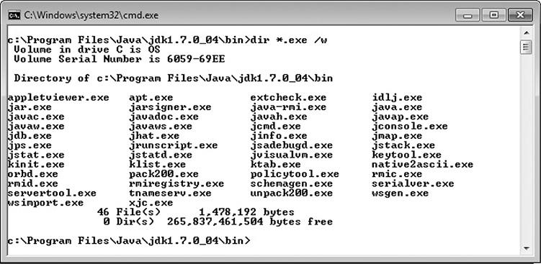

The Java compiler simply converts Java source files into bytecode. The Java compiler’s usage is as follows:



The most straightforward way to compile a Java class is to preface the Java source files with the compiler utility from the command line: javac.exe FileName.java. The .exe is the standard executable file extension on Windows machines and is optional. The .exe extension is not present on executables on UNIX-like systems.



This will result in a bytecode file being produced with the same preface, such as GreetingsUniverse.class. This bytecode file will be placed into the same folder as the source code, unless the code is packaged and/or it’s been told via a command-line option to be placed somewhere else.



***You will find that many projects use Apache Ant and/or Maven build environments. Understanding the fundamentals of the command-line tools is necessary for writing and maintaining the scripts associated with these build products*.**

##### Compiling Your Source Code with the -d Option

You may want to specify explicitly where you would like the compiled bytecode class files to go. You can accomplish this by using the -d option:



This command-line structure will place the class file into the classes directory, and since the source code was packaged (that is, the source file included a package statement), the bytecode will be placed into the relative subdirectories.



INSIDE THE EXAM

**Command-Line Tools**

Most projects use integrated development environments (IDEs) to compile and execute code. The clear benefit in using IDEs is that building and running code can be as easy as stepping through a couple of menu options or clicking a hot key. The disadvantage is that even though you may establish your settings through a configuration dialog and see the commands and subsequent arguments in one of the workspace windows, you are not getting direct experience in repeatedly creating the complete structure of the commands and associated arguments by hand. The exam is structured to validate that you have experience in scripting compiler and interpreter invocations. Do not take this prerequisite lightly. Take the exam only after you have mastered when and how to use the tools, switches, and associated arguments. At a later time, you can consider taking advantage of the “shortcut” features of popular IDEs such as those provided by NetBeans, Eclipse, IntelliJ IDEA, and JDeveloper.

##### Compiling Your Code with the -classpath Option

If you want to compile your application with user-defined classes and packages, you may need to tell the JVM where to look by specifying them in the classpath. This classpath inclusion is accomplished by telling the compiler where the desired classes and packages are with the -cp or -classpath command-line option. In the following compiler invocation, the compiler includes in its compilation any source files that are located under the 3rdPartyCode\classes directory, as well as any classes located in the present working directory (the period). The -d option (again) will place the compiled bytecode into the classes directory.



Note that you do not need to include the classpath option if the classpath is defined with the CLASSPATH environment variable, or if the desired files are in the present working directory.

On Windows systems, classpath directories are delimited with backward slashes and paths are delimited with semicolons:



On POSIX-based systems, classpath directories are delimited with forward slashes and paths are delimited with colons:



Again, the period represents the present (or current) working directory.



***Know your switches. The designers of the exam will try to throw you by presenting answers with mix-matching compiler and interpreter switches. You may even see some make-believe switches that do not exist anywhere. For additional preparation, query the commands’ complete set of switches by typing* java -help *or* javac -help*. Switches are also known as command-line parameters, command-line switches, options, and flags*.**

##### Java Interpreter

Interpreting the Java files is the basis for creating the Java application, as shown in [Figure 1-8](https://learning.oreilly.com/library/view/oca-java-se/9781259587535/ch01.html#ch01fig08). Let’s examine how to invoke the interpreter and its command-line options.



**FIGURE 1-8** Bytecode conversion

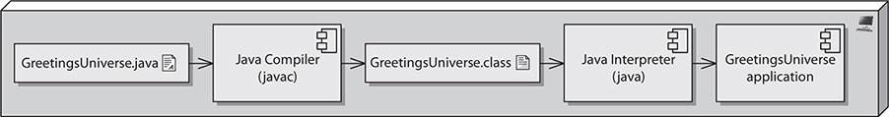

###### Interpreting Your Bytecode

The Java interpreter is invoked with the java[.exe] command. Use it to interpret bytecode and execute your program.

You can easily invoke the interpreter on a class that’s not packaged, as follows:



You can optionally start the program with the javaw command on Microsoft Windows to exclude the command window. This is a nice feature with GUI-based applications, because the console window is often not necessary.



Similarly, on POSIX-based systems, you can use the ampersand to run the application as a background process:



###### Interpreting Your Code with the -classpath Option

When interpreting your code, you may need to define where certain classes and packages are located. You can find your classes at runtime when you include the -cp or -classpath option with the interpreter. If the classes you want to include are packaged, then you can start your application by pointing the full path of the application to the base directory of classes, as in the following interpreter invocation:



The delimitation syntax is the same for the -cp and -classpath options, as defined earlier in the “Compiling Your Code with the -classpath Option” section.

###### Interpreting Your Bytecode with the -D Option

The -D command-line option allows for the setting of new property values. The usage is as follows:



The following single-file application comprising the PropertiesManager class prints out all of the system properties:

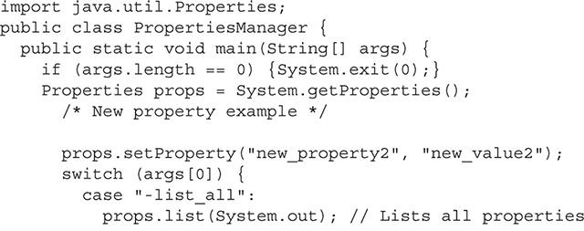

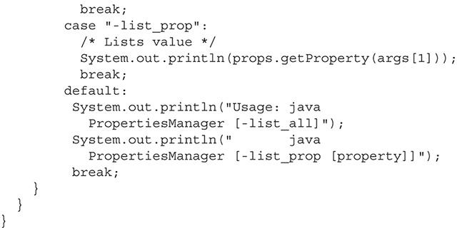

Let’s run this application while setting a new system property called new_property1 to the value of new_value1:



You’ll see in the standard output that the listing of the system properties includes the new property that we set and its value:

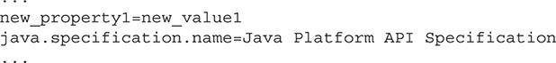

Optionally, you can set a value by instantiating the Properties class and then setting a property and its value with the setProperty method.

To help you conceptualize system properties a little better, [Table 1-7](https://learning.oreilly.com/library/view/oca-java-se/9781259587535/ch01.html#ch01tab07) details a subset of the standard system properties.

**TABLE 1-7** Subset of System Properties

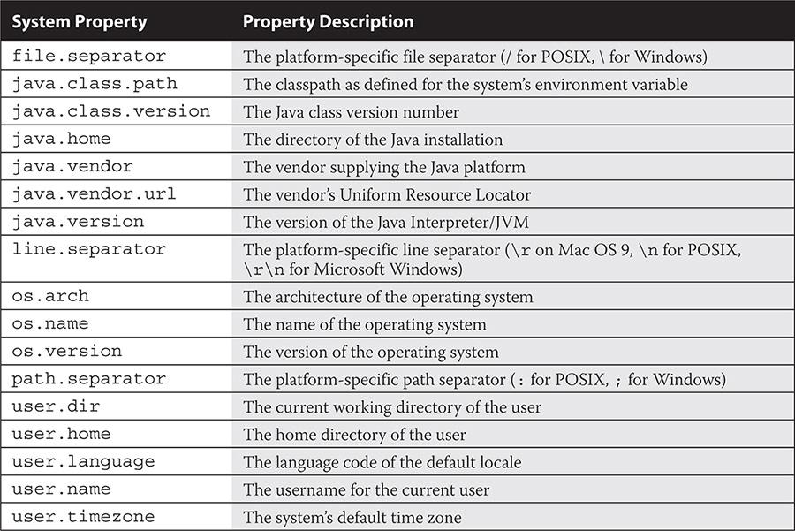

###### Retrieving the Version of the Interpreter with the -version Option

The -version command-line option is used with the Java interpreter to return the version of the JVM and exit. Don’t take the simplicity of the command for granted, as the designers of the exam may try to trick you by including additional arguments after the command. Take the time to toy with the command by adding arguments and putting the -version option in various places. Do not make any assumptions about how you think the application will respond. [Figure 1-9](https://learning.oreilly.com/library/view/oca-java-se/9781259587535/ch01.html#ch01fig09) demonstrates varying results based on where the -version option is used.

**FIGURE 1-9** The -version command-line option

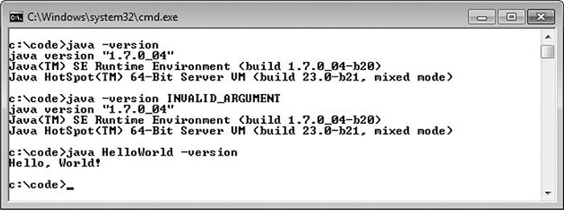



***Check out the other JDK utilities at your disposal. Java Flight Recorder and Java Mission Control in particular are valuable GUI-based tools that are used to monitor, profile, and collect runtime information*.**

**EXERCISE 1-2**

**Compiling and Interpreting Packaged Software**

When you compile and run packaged software from an IDE, the execution process can be as easy as clicking a run icon, as the IDE will maintain the classpath for you and will also let you know if anything is out of sorts. When you try to compile and interpret the code yourself from the command line, you will need to know exactly how to path your files. Consider our sample application that is placed in the com.ocajexam.tutorial package (that is, the com/ocajexam/tutorial directory).

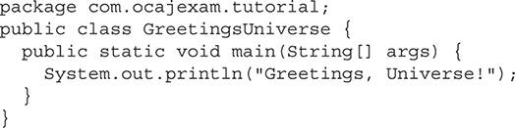

This exercise will have you compiling and running the application with new classes created in a separate package.

**1.** Compile the program:



**2.** Run the program to ensure it is error free:



**3.** Create three classes named Earth, Mars, and Venus and place them in the com.ocajexam.tutorial.planets package. Create constructors that will print the names of the planets to standard output. The details for the Earth class are given here as an example of what you will need to do:

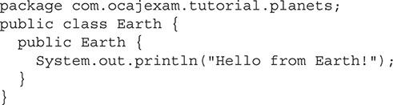

**4.** Instantiate each class from the main program by adding the necessary code to the GreetingsUniverse class.



**5.** Ensure that all of the source code is in the paths src/com/ocajexam/tutorial/and src/com/ocajexam/tutorial/planets/.

**6.** Determine the command-line arguments needed to compile the complete program. Compile the program, and debug where necessary.

**7.** Determine the command-line arguments needed to interpret the program. Run the program.

The standard output will read as follows:

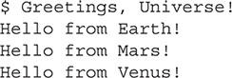

#### CERTIFICATION SUMMARY

This chapter discussed packaging, structuring, compiling, and interpreting Java code. The chapter started with a discussion on the importance of organizing your classes into packages as well as using the package and import statements to define and include different pieces of source code. Through the middle of the chapter, we discussed the key features of commonly used Java packages: java.awt, javax.swing, java.net, java.io, and java.util. We discussed the basic structure of a Java class. We then concluded the chapter by providing detailed information on how to compile and interpret Java source and class files and how to work with their command-line options. At this point, you should be able to (outside of an IDE) package, build, and run basic Java programs independently.

#### Images TWO-MINUTE DRILL

**Understand Packages**

 Packages are containers for classes.

 A package statement defines the directory path where files are stored.

 A package statement uses periods for delimitation.

 Package names should be lowercase and separated with underscores between words.

 Package names beginning with java.* and javax.* are reserved.

 There can be zero or one package statement per source file.

 An import statement is used to include source code from external classes.

 An import statement occurs after the optional package statement and before the class definition.

 An import statement can define a specific class name to import.

 An import statement can use an asterisk to include all classes within a given package.

**Understand Package-Derived Classes**

 The Java Abstract Window Toolkit API is included in the java.awt package and subpackages.

 The java.awt package includes GUI creation and painting graphics and images functionality.

 The Java Swing API is included in the javax.swing package and subpackages.

 The javax.swing package includes classes and interfaces that support lightweight GUI component functionality.

 The Java Basic Input/Output-related classes are contained in the java.io package.

 The java.io package includes classes and interfaces that support input/output functionality of the file system, data streams, and serialization.

 Java networking classes are included in the java.net package.

 The java.net package includes classes and interfaces that support basic networking functionality that is also extended by the javax.net package.

 Fundamental Java utilities are included in the java.util package.

 The java.util package and subpackages include classes and interfaces that support the Java Collections Framework, legacy collection classes, event model, date and time facilities, and internationalization functionality.

**Understand Class Structure**

 Naming conventions are used to make Java programs more readable and maintainable.

 Naming conventions are applied to several Java elements, including class names, interface names, method names, instance and static variable names, parameter and local variable names, generic type parameter names, constant names, enumeration names, and package names.

 The preferred order of presenting elements in a class is data members, followed by constructors, followed by methods. Note that the inclusion of each type of element is optional.

**Compile and Interpret Java Code**

 The Java compiler is invoked with the javac[.exe] command.

 The .exe extension is optional on Microsoft Windows machines and is not present on UNIX-like systems.

 The compiler’s -d command-line option defines where compiled class files should be placed.

 The compiler’s -d command-line option will include the package location if the class has been declared with a package statement.

 The compiler’s -classpath command-line option defines directory paths in search of classes.

 The Java interpreter is invoked with the java[.exe] command.

 The interpreter’s -classpath switch defines directory paths to use at runtime.

 The interpreter’s -D command-line option allows for the setting of system property values.

 The interpreter’s syntax for the -D command-line option is -Dproperty=value.

 The interpreter’s -version command-line option is used to return the version of the JVM and exit.

 The –h command-line option can be applied either to the compiler or the interpreter to print out the tool’s usage information.

#### SELF TEST

**Understanding Packages**

[**1.**](https://learning.oreilly.com/library/view/oca-java-se/9781259587535/ch01.html#ch01qa1a) Which two import statements will allow for the import of the HashMap class?

A. import java.util.HashMap;

B. import java.util.*;

C. import java.util.HashMap.*;

D. import java.util.hashMap;

[**2.**](https://learning.oreilly.com/library/view/oca-java-se/9781259587535/ch01.html#ch01qa2a) Which statement would designate that your file belongs in the package com.ocajexam.utilities?

A. pack com.ocajexam.utilities;

B. package com.ocajexam.utilities.*

C. package com.ocajexam.utilities.*;

D. package com.ocajexam.utilities;

[**3.**](https://learning.oreilly.com/library/view/oca-java-se/9781259587535/ch01.html#ch01qa3a) Which of the following is the only Java package that is imported by default?

A. java.awt

B. java.lang

C. java.util

D. java.io

**Understand Package-Derived Classes**

[**4.**](https://learning.oreilly.com/library/view/oca-java-se/9781259587535/ch01.html#ch01qa4a) The JCheckBox and JComboBox classes belong to which package?

A. java.awt

B. javax.awt

C. java.swing

D. javax.swing

[**5.**](https://learning.oreilly.com/library/view/oca-java-se/9781259587535/ch01.html#ch01qa5a) Which package contains the Java Collections Framework?

A. java.io

B. java.net

C. java.util

D. java.utils

[**6.**](https://learning.oreilly.com/library/view/oca-java-se/9781259587535/ch01.html#ch01qa6a) The Java Basic I/O API contains what types of classes and interfaces?

A. Internationalization

B. RMI, JDBC, and JNDI

C. Data streams, serialization, and file system

D. Collection API and data streams

[**7.**](https://learning.oreilly.com/library/view/oca-java-se/9781259587535/ch01.html#ch01qa7a) Which API provides a lightweight solution for GUI components?

A. AWT

B. Abstract Window Toolkit

C. Swing

D. AWT and Swing

[**8.**](https://learning.oreilly.com/library/view/oca-java-se/9781259587535/ch01.html#ch01qa8a) Consider the following illustration. What problem exists with the packaging? You may wish to reference [Appendix G](https://learning.oreilly.com/library/view/oca-java-se/9781259587535/ch18_app_g.html#ch18_app_g) of the Unified Modeling Language (UML) for assistance.

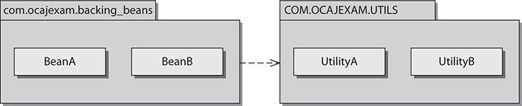

A. You can have only one class per package.

B. Packages cannot have associations between them.

C. Package com.ocajexam.backing_beans fails to meet the appropriate package naming conventions.

D. Package COM.OCAJEXAM.UTILS fails to meet the appropriate package naming conventions.

**Understand Class Structure**

[**9.**](https://learning.oreilly.com/library/view/oca-java-se/9781259587535/ch01.html#ch01qa9a) When apply naming conventions, which Java elements should start with an uppercase letter and continue on using the CamelCase convention?

A. Class names

B. Interface names

C. Constant names

D. Package names

E. All of the above

[**10.**](https://learning.oreilly.com/library/view/oca-java-se/9781259587535/ch01.html#ch01qa10a) When instantiating an object with generics, should you use angle brackets, box brackets, curly brackets, or double-quotation marks to enclose the generic type? Select the appropriate answer.

A. List<Integer> a = new ArrayList<Integer>();

B. List[Integer] a = new ArrayList[Integer]();

C. List{Integer} a = new ArrayList{Integer}();

D. List″Integer″ a = new ArrayList″Integer″();

[**11.**](https://learning.oreilly.com/library/view/oca-java-se/9781259587535/ch01.html#ch01qa11a) When you’re organizing the elements in a class, which order is preferred?

A. Data members, methods, constructors

B. Data members, constructors, methods

C. Constructors, methods, data members

D. Constructors, data members, methods

E. Methods, constructors, data members

**Compile and Interpret Java Code**

[**12.**](https://learning.oreilly.com/library/view/oca-java-se/9781259587535/ch01.html#ch01qa12a) Which usage represents a valid way of compiling a Java class?

A. java MainClass.class

B. javac MainClass

C. javac MainClass.source

D. javac MainClass.java

[**13.**](https://learning.oreilly.com/library/view/oca-java-se/9781259587535/ch01.html#ch01qa13a) Which two command-line invocations of the Java interpreter return the version of the interpreter?

A. java -version

B. java --version

C. java -version ProgramName

D. java ProgramName -version

[**14.**](https://learning.oreilly.com/library/view/oca-java-se/9781259587535/ch01.html#ch01qa14a) Which two command-line usages appropriately identify the classpath?

A. javac -cp /project/classes/ MainClass.java

B. javac -sp /project/classes/ MainClass.java

C. javac -classpath /project/classes/ MainClass.java

D. javac -classpaths /project/classes/ MainClass.java

[**15.**](https://learning.oreilly.com/library/view/oca-java-se/9781259587535/ch01.html#ch01qa15a) Which command-line usages appropriately set a system property value?

A. java -Dcom.ocajexam.propertyValue=003 MainClass

B. java -d com.ocajexam.propertyValue=003 MainClass

C. java -prop com.ocajexam.propertyValue=003 MainClass

D. java -D:com.ocajexam.propertyValue=003 MainClass

#### SELF TEST ANSWERS

**Understand Packages**

[**1.**](https://learning.oreilly.com/library/view/oca-java-se/9781259587535/ch01.html#ch01qa1) Which two import statements will allow for the import of the HashMap class?

A. import java.util.HashMap;

B. import java.util.*;

C. import java.util.HashMap.*;

D. import java.util.hashMap;

Answer:

 **A** and **B.** The HashMap class can be imported directly via import java.util.HashMap or with a wildcard via import java.util.*;.

 **C** and **D** are incorrect. **C** is incorrect because the answer is a static import statement that imports static members of the HashMap class, and not the class itself. **D** is incorrect because class names are case sensitive, so the class name hashMap does not equate to HashMap.

[**2.**](https://learning.oreilly.com/library/view/oca-java-se/9781259587535/ch01.html#ch01qa2) Which statement would designate that your file belongs in the package com.ocajexam.utilities?

A. pack com.ocajexam.utilities;

B. package com.ocajexam.utilities.*

C. package com.ocajexam.utilities.*;

D. package com.ocajexam.utilities;

Answer:

 **D.** The keyword package is appropriately used, followed by the package name delimited with periods and followed by a semicolon.

 **A, B,** and **C** are incorrect. **A** is incorrect because the word pack is not a valid keyword. **B** is incorrect because a package statement must end with a semicolon, and you cannot use asterisks in package statements. **C** is incorrect because you cannot use asterisks in package statements.

[**3.**](https://learning.oreilly.com/library/view/oca-java-se/9781259587535/ch01.html#ch01qa3) Which of the following is the only Java package that is imported by default?

A. java.awt

B. java.lang

C. java.util

D. java.io

Answer:

 **B.** The java.lang package is the only package that has all of its classes imported by default.

 **A, C,** and **D** are incorrect. The classes of packages java.awt, java.util, and java.io are not imported by default.

**Understand Package-Derived Classes**

[**4.**](https://learning.oreilly.com/library/view/oca-java-se/9781259587535/ch01.html#ch01qa4) The JCheckBox and JComboBox classes belong to which package?

A. java.awt

B. javax.awt

C. java.swing

D. javax.swing

Answer:

 **D.** Components belonging to the Swing API are generally prefaced with a uppercase *J*. Therefore, JCheckBox and JComboBox would be part of the Java Swing API and not the Java AWT API. The Java Swing API base package is javax.swing.

 **A, B,** and **C** are incorrect. **A** is incorrect because the package java.awt does not include the JCheckBox and JComboBox classes since they belong to the Java Swing API. Note that the package java.awt includes the CheckBox class, as opposed to the JCheckBox class. **B** and **C** are incorrect because the package names javax.awt and java.swing do not exist.

[**5.**](https://learning.oreilly.com/library/view/oca-java-se/9781259587535/ch01.html#ch01qa5) Which package contains the Java Collections Framework?

A. java.io

B. java.net

C. java.util

D. java.utils

Answer:

 **C.** The Java Collections Framework is part of the Java Utilities API in the java.util package.

 **A, B,** and **D** are incorrect. **A** is incorrect because the Java Basic I/O API’s base package is named java.io and does not contain the Java Collections Framework. **B** is incorrect because the Java Networking API’s base package is named java.net and also does not contain the Collections Framework. **D** is incorrect because there is no package named java.utils.

[**6.**](https://learning.oreilly.com/library/view/oca-java-se/9781259587535/ch01.html#ch01qa6) The Java Basic I/O API contains what types of classes and interfaces?

A. Internationalization

B. RMI, JDBC, and JNDI

C. Data streams, serialization, and file system

D. Collection API and data streams

Answer:

 **C.** The Java Basic I/O API contains classes and interfaces for data streams, serialization, and the file system.

 **A, B,** and **D** are incorrect. Internationalization (i18n), RMI, JDBC, JNDI, and the Collections framework are not included in the Basic I/O API.

[**7.**](https://learning.oreilly.com/library/view/oca-java-se/9781259587535/ch01.html#ch01qa7) Which API provides a lightweight solution for GUI components?

A. AWT

B. Abstract Window Toolkit

C. Swing

D. AWT and Swing

Answer:

 **C.** The Swing API provides a lightweight solution for GUI components, meaning that the Swing API’s classes render using pure Java code and not native platform widgets.

 **A, B,** and **D** are incorrect. AWT and the Abstract Window Toolkit are one and the same and provide a heavyweight solution for GUI components.

[**8.**](https://learning.oreilly.com/library/view/oca-java-se/9781259587535/ch01.html#ch01qa8) Consider the following illustration. What problem exists with the packaging? You may wish to reference [Appendix G](https://learning.oreilly.com/library/view/oca-java-se/9781259587535/ch18_app_g.html#ch18_app_g) of the Unified Modeling Language (UML) for assistance.

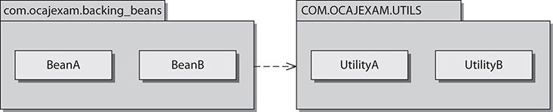

A. You can have only one class per package.

B. Packages cannot have associations between them.

C. Package com.ocajexam.backing_beans fails to meet the appropriate package naming conventions.

D. Package COM.OCAJEXAM.UTILS fails to meet the appropriate package naming conventions.

Answer:

 **D.** COM.OCAJEXAM.UTILS fails to meet the appropriate package naming conventions. Package names should be lowercase and should use an underscore between words. However, the words in ocajexam are joined in the URL; therefore, excluding the underscore here is acceptable. The package name should read com.ocajexam.utils.

 **A, B,** and **C** are incorrect. **A** is incorrect because being restricted to having one class in a package is ludicrous. There is no limit. **B** is incorrect because packages can and frequently do have associations with other packages. **C** is incorrect because com.ocajexam.backing_beans meets appropriate packaging naming conventions.

**Understand Class Structure**

[**9.**](https://learning.oreilly.com/library/view/oca-java-se/9781259587535/ch01.html#ch01qa9) When apply naming conventions, which Java elements should start with an uppercase letter and continue on using the CamelCase convention?

A. Class names

B. Interface names

C. Constant names

D. Package names

E. All of the above

Answer:

 **A** and **B.** Class names and interface names should start with an uppercase letter and continue on using the CamelCase convention.

 **C** and **D** are incorrect. **C** is incorrect because constant names should be all uppercase letters separated by underscores. **D** is incorrect because package names do not include uppercase letters, nor do they subscribe to the CamelCase convention.

[**10.**](https://learning.oreilly.com/library/view/oca-java-se/9781259587535/ch01.html#ch01qa10) When instantiating an object with generics, should you use angle brackets, box brackets, parentheses, or double-quotation marks to enclose the generic type? Select the appropriate answer.

A. List<Integer> a = new ArrayList<Integer>();

B. List[Integer] a = new ArrayList[Integer]();

C. List{Integer} a = new ArrayList{Integer}();

D. List″Integer″ a = new ArrayList“Integer”();

Answer:

 **A.** Generics use angle brackets.

 **B, C,** and **D** are incorrect. Box brackets (**B**), curly brackets (**C**), and double quotation marks (**D**) are not used to enclose the generic type.

[**11.**](https://learning.oreilly.com/library/view/oca-java-se/9781259587535/ch01.html#ch01qa11) When you’re organizing the elements in a class, which order is preferred?

A. Data members, methods, constructors

B. Data members, constructors, methods

C. Constructors, methods, data members

D. Constructors, data members, methods

E. Methods, constructors, data members

Answer:

 **B.** The preferred order in presenting elements in a class is to present the data members first, followed by constructors, followed by methods.

 **A, C, D,** and **E** are incorrect. Although ordering the elements in these manners will not cause any functional or compilation errors, none of these is the preferred order.

**Compile and Interpret Java Code**

[**12.**](https://learning.oreilly.com/library/view/oca-java-se/9781259587535/ch01.html#ch01qa12) Which usage represents a valid way of compiling a Java class?

A. java MainClass.class

B. javac MainClass

C. javac MainClass.source

D. javac MainClass.java

Answer:

 **D.** The compiler is invoked by the javac command. When compiling a Java class, you must include the filename, which houses the main classes, including the .java extension.

 **A, B,** and **C** are incorrect. **A** is incorrect because MainClass.class is bytecode that is already compiled. **B** is incorrect because MainClass is missing the .java extension. **C** is incorrect because MainClass.source is not a valid name for any type of Java file.

[**13.**](https://learning.oreilly.com/library/view/oca-java-se/9781259587535/ch01.html#ch01qa13) Which two command-line invocations of the Java interpreter return the version of the interpreter?

A. java -version

B. java --version

C. java -version ProgramName

D. java ProgramName -version

Answer:

 **A** and **C.** The -version flag should be used as the first argument. The application will return the appropriate strings to standard output with the version information and then immediately exit. The second argument is ignored.

 **B** and **D** are incorrect. **B** is incorrect because the version flag does not allow double dashes. You may see double dashes for flags in utilities, especially those following the GNU license. However, the double dashes do not apply to the version flag of the Java interpreter. **D** is incorrect because the version flag must be used as the first argument or its functionality will be ignored.

[**14.**](https://learning.oreilly.com/library/view/oca-java-se/9781259587535/ch01.html#ch01qa14) Which two command-line usages appropriately identify the classpath?

A. javac -cp /project/classes/ MainClass.java

B. javac -sp /project/classes/ MainClass.java

C. javac -classpath /project/classes/ MainClass.java

D. javac -classpaths /project/classes/ MainClass.java

Answer:

 **A** and **C.** The option flag that is used to specify the classpath is -cp or -classpath.

 **B** and **D** are incorrect. The option flags -sp (**B**) and -classpaths (**D**) are invalid.

[**15.**](https://learning.oreilly.com/library/view/oca-java-se/9781259587535/ch01.html#ch01qa15) Which command-line usages appropriately set a system property value?

A. java -Dcom.ocajexam.propertyValue=003 MainClass

B. java -d com.ocajexam.propertyValue=003 MainClass

C. java -prop com.ocajexam.propertyValue=003 MainClass

D. java -D:com.ocajexam.propertyValue=003 MainClass

Answer:

 **A.** The property setting is used with the interpreter, not the compiler. The property name must be sandwiched between the -D flag and the equal sign. The desired value should immediately follow the equal sign.

 **B, C,** and **D** are incorrect. The -d (**B**), -prop (**C**), and -D: (**D**) flags are invalid ways to designate a system property.



### 3

### PROGRAMMING WITH JAVA OPERATORS AND STRINGS

**CERTIFICATION OBJECTIVES**

• [Understand Fundamental Operators](https://learning.oreilly.com/library/view/oca-java-se/9781259587535/ch03.html#ch03lev1)

• [Use String Objects and Their Methods](https://learning.oreilly.com/library/view/oca-java-se/9781259587535/ch03.html#ch03lev7)

• [Use StringBuilder Objects and Their Methods](https://learning.oreilly.com/library/view/oca-java-se/9781259587535/ch03.html#ch03lev11)

• [Test Equality Between Strings and Other Objects](https://learning.oreilly.com/library/view/oca-java-se/9781259587535/ch03.html#ch03lev13)

 [Two-Minute Drill](https://learning.oreilly.com/library/view/oca-java-se/9781259587535/ch03.html#ch03lev15)

**Q&A** [Self Test](https://learning.oreilly.com/library/view/oca-java-se/9781259587535/ch03.html#ch03lev17)

**T**wo of the most fundamental elements of the Java programming language are Java *operators* and *strings*. This chapter discusses Java operators and how they manipulate their operands. You will need a full understanding of the different types and groupings of operators and their precedence to score well on the exam. This chapter provides you with all of the operator-related information you need to know.

Strings are commonly used in Java, so they will also be present throughout the exam. This chapter details the String and StringBuilder classes and their related functionality. Topics include the string concatenation operator and the toString method, as well as a discussion of valuable methods from the String and StringBuilder classes. We wrap up the chapter discussing the testing of equality between strings.

After completing this chapter, you will have all the knowledge necessary to score well on the operator- and string-related questions on the exam.

**CERTIFICATION OBJECTIVE**

#### Understand Fundamental Operators

*Exam Objective Use Java operators, including parentheses, to override operator precedence*

Java operators are used to return a result from an expression using one, two, or three operands. Operands are the values placed to the right or left side of the operators. Prefix- and postfix-increment and prefix- and postfix-decrement operators use one operand. The conditional ternary operator (?:) uses three operands. All other operators use two operands. Examples of operand use are shown in [Figure 3-1](https://learning.oreilly.com/library/view/oca-java-se/9781259587535/ch03.html#ch03fig01). Note that the result of evaluating operands is typically a primitive value.

**FIGURE 3-1** Operands

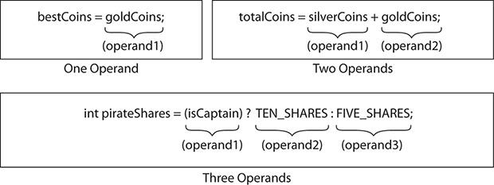

The following topics will be covered in these pages:

 Assignment operators

 Arithmetic operators

 Relational operators

 Logical operators

 Operator precedence

##### Assignment Operators

Assignment operators are used to assign values to variables.



The assignment operator is the equal sign (=). ([Chapter 2](https://learning.oreilly.com/library/view/oca-java-se/9781259587535/ch02.html#ch02) discusses assignment statements, and [Chapter 4](https://learning.oreilly.com/library/view/oca-java-se/9781259587535/ch04.html#ch04) discusses the assignment of literals into primitive data types and the creation of reference type variables.) At its simplest, the assignment operator moves valid literals into variables. Assignment operators cause compiler errors when the literals are not valid for the variable (that is, its associated type) to which they are assigned. The following are valid assignment statements using the assignment operator:

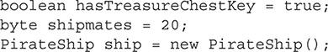

The following are invalid assignments and will cause compiler errors:

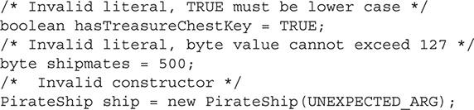

###### Compound Assignment Operators

A variety of compound assignment operators exist. The exam covers only the addition and subtraction compound assignment operators.



Consider these two assignment statements:

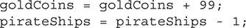

The following two statements (with the same meaning and results as the preceding examples) are written with compound assignment operators:

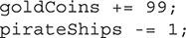



***Although the use of compound assignment operators cuts down on keystrokes, it is generally good practice to use the “longhand” approach since the code is clearly more readable*.**

**EXERCISE 3-1**

**Using Compound Assignment Operators**

This exercise will clear up any confusion you may have about compound assignment operators. The following application will be used for the exercise. (Don’t run it until after step 3.)

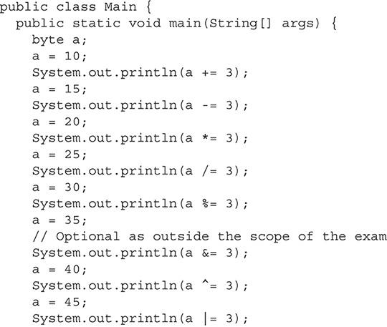

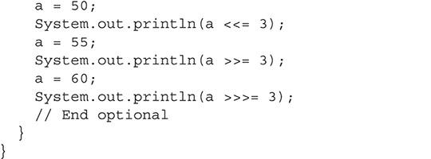

**1.** Grab a pencil and a piece of paper. Optionally, you can use [Table 3-1](https://learning.oreilly.com/library/view/oca-java-se/9781259587535/ch03.html#ch03tab01) as your worksheet.

**TABLE 3-1** Refactoring Compound Assignment Statements

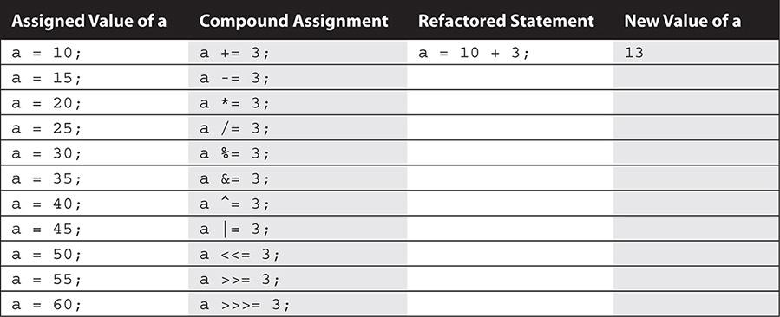

**2.** For each statement that has a compound assignment operator, rewrite the statement without the compound assignment operator and replace the variable with its associated value. For example, let’s take the assignment statement with the addition compound assignment operator:

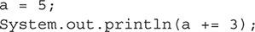

It would be rewritten as (a = a + 3)—specifically (a = 5 + 3);.

**3.** Evaluate the expressions without using a computer.

**4.** Compile and run the given application. Compare your results.

(Note that many of these operators do not appear on the exam. The point of the exercise is to get you properly acquainted with compound assignment operators through repetition.)



***It is common to represent assignments in pseudo-code with the colon and equal sign characters (for example,* A := 20*). Notice that* := *looks similar to* +=*,* -=*, and other Java assignment operators such as* *=*,* /=*, and* %=*. Be aware, however, that the pseudo-code assignment representation (*:=*) is not a Java assignment operator, and if you see it in any Java code, it will not compile*.**

##### Arithmetic Operators

The exam will include nine arithmetic operators. Five of these operators are used for basic operations (addition, subtraction, multiplication, division, and modulus). The other four operators are used for incrementing and decrementing a value. We’ll examine the five operators used for basic operations first.

###### Basic Arithmetic Operators

The five basic arithmetic operators are

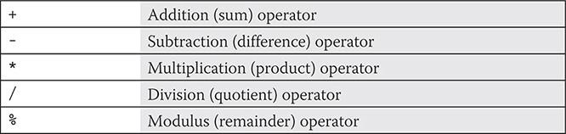

Adding, subtracting, multiplying, dividing, and producing remainders with operators is straightforward. The following examples demonstrate this:

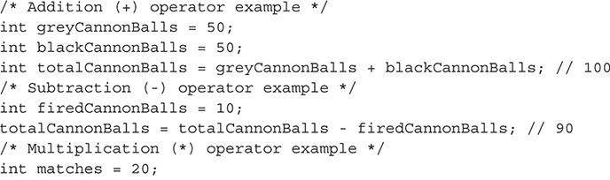

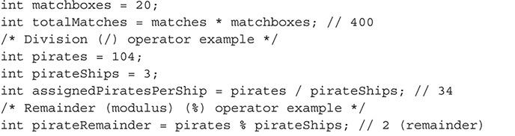

###### Prefix-Increment, Postfix-Increment, Prefix-Decrement, and Postfix-Decrement Operators

Four operators allow incrementing or decrementing of variables:

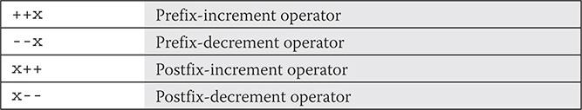

Prefix-increment and prefix-decrement operators provide a shorthand way of incrementing and decrementing the variable by 1. Rather than creating an expression as y=x+1, you could write y=++x. Similarly, you could replace the expression y=x-1 with y=--x. This works because the execution of the prefix operators occurs on the operand prior to the evaluation of the whole expression. Postfix-increment and postfix-decrement characters execute the postfix operators after the expression has been evaluated. Therefore, y = x++ would equate to y=x followed by x=x+1. And y = x-- would equate to y=x followed by x=x-1.

Note that y=++x is not exactly equivalent to y=x+1, because the value of x changes in the former but not in the latter. This is the same for y=--x and y=x-1.

The prefix-increment operator increments a value by 1 before an expression has been evaluated.



The postfix-increment operator increments a value by 1 after an expression has been evaluated.



The prefix-decrement operator decrements a value by 1 before an expression has been evaluated.

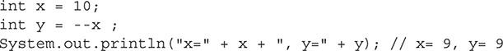

The postfix-decrement operator decrements a value by 1 after an expression has been evaluated.



##### Relational Operators

Relational operators return boolean values in relationship to the evaluation of their left and right operands. The six most common relational operators are on the exam. Four of them equate to the greater than and less than comparisons. Two are strictly related to equality, as we will discuss at the end of this section.

###### Basic Relational Operators

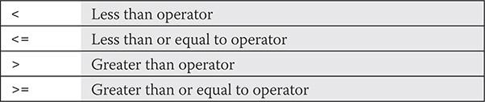

The less than, less than or equal to, greater than, and greater than or equal to operators are used to compare integers, floating points, and characters. When the expression used with the relational operators is true, the boolean value of true is returned; otherwise, false is returned. Here’s an example:

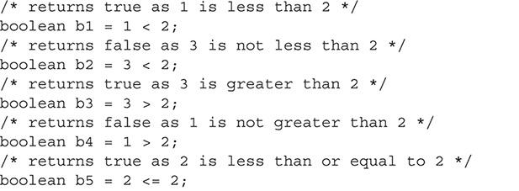

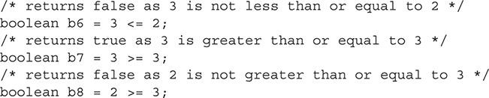

So far, we’ve examined only the relationship of int primitives. Let’s take a look at the various ways char primitives can be evaluated with relational operators, specifically the less than operator for these examples. Remember that characters (that is, char primitives) accept integers (within the valid 16-bit unsigned range), hexadecimal, octal, and character literals. Each literal in the following examples represents the letters “A” and “B.” The left operands are character “A” and the right operands are character “B.” Since each expression is essentially the same, they all evaluate to true.

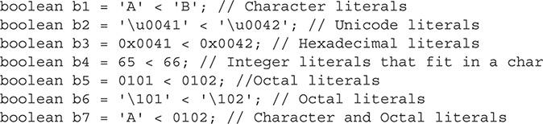

As mentioned, you can also test the relationship between floating points. The following are a few examples:

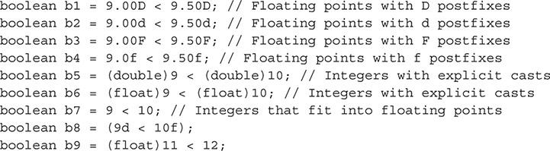

###### Equality Operators

Relational operators that directly compare the equality of primitives (numbers, characters, booleans) and object reference variables are considered equality operators.



Comparing primitives of the same type is straightforward. If the right and left operands of the equal to operator are equal, the boolean value of true is returned; otherwise, false is returned. If the right and left operands of the not equal to operator are not equal, the boolean value of true is returned; otherwise, false is returned. The following code examples compare all eight primitives to values of the same type:

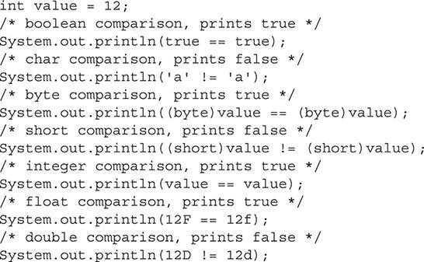



***You should actually use an epsilon when comparing floating-point numbers. See “Comparing Floating Point Numbers, 2012 Edition” for more information on comparing floating points for equality:*** [***http://randomascii.wordpress.com/2012/02/25/comparing-floating-point-numbers-2012-edition/***](http://randomascii.wordpress.com/2012/02/25/comparing-floating-point-numbers-2012-edition/)**.**

Reference values of objects can also be compared. Consider the following code:



The reference variables are a, b, and c. As shown, reference variables a and b are unique. Reference variable c refers to reference variable b, so for equality purposes, they are the same.

The following code shows the results of comparing these variables:

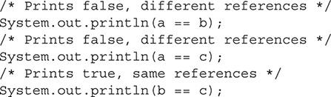

The following are similar statements, but they use the not equal to operator:



**Numeric Promotion of Binary Values** By this point, you may be wondering what the compiler does with the operands when they are of different primitive types. Numeric promotion rules are applied on binary values for the additive (+, -), multiplicative (*, /, %), comparison (<, <=, >, >=), equality (==, !=), bitwise (&, ^, |), and conditional (?:) operators. See [Table 3-2](https://learning.oreilly.com/library/view/oca-java-se/9781259587535/ch03.html#ch03tab02).

**TABLE 3-2** Numeric Promotion of Binary Values

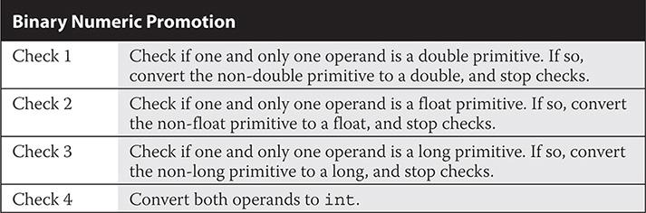

##### Logical Operators

Logical operators return boolean values. There are three logical operators on the exam: logical AND, logical OR, and logical negation.

###### Logical (Conditional) Operators

Logical (conditional) operators evaluate a pair of boolean operands. Understanding their short-circuit principle is necessary for the exam.



The logical AND operator evaluates the left and right operands. If both values of the operands have a value of true, then a value of true is returned. The logical AND is considered a short-circuit operator. If the left operand returns false, then there is no need to check the right operator since both would need to be true to return true; thus, it short-circuits. Therefore, whenever the left operand returns false, the expression terminates and returns a value of false.

The following code demonstrates the usage of the logical AND operator:

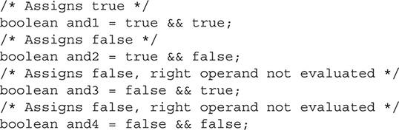

The logical OR operator evaluates the left and right operands. If either value of the operands has a value of true, a value of true is returned. The logical OR is considered a short-circuit operator. If the left operand returns true, there is no need to check the right operator, since either needs to be true to return true; thus, it short-circuits. Again, whenever the left operand returns true, the expression terminates and returns a value of true.

The following code demonstrates the usage of the logical OR operator:



###### Logical Negation Operator

The logical negation operator is also known as the inversion operator or boolean invert operator. This is a simple operator, but don’t take it lightly—you may see it quite often on the exam.



The logical negation operator returns the opposite of a boolean value.

The following code demonstrates the usage of the logical negation operator:

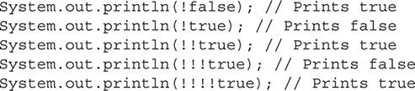

Expect to see the logical negation operator used in conjunction with any method or expression that returns a boolean value. The following list details some of these expressions that return boolean values:

 Expressions with relational operators return boolean values.

 Expressions with logical (conditional) operators return boolean values.

 The equals method of the Object class returns boolean values.

 The String methods startsWith and endsWith return boolean values.

The following are some examples of statements that include the logical negation operator:

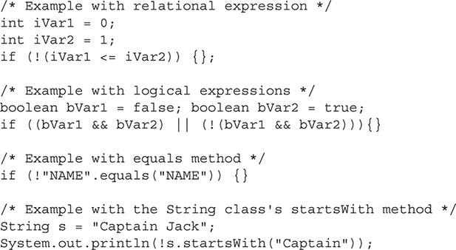

The logical inversion operator cannot be used on a non-boolean value. The following code will not compile:



Logical AND and logical OR are on the exam, but boolean AND and boolean OR, along with bitwise AND and bitwise OR, are not on the exam. You might, for example, want to use the nonlogical expressions associated with the right operand if a change occurs to a variable where the new result is used later in your code. The following Scenario & Solution details the specifics of this scenario.

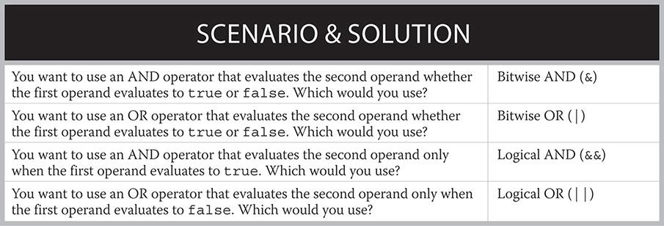

##### Understand Operator Precedence

*Operator precedence* is the order in which operators will be evaluated when several operators are included in an expression. Operator precedence can be overridden using parentheses. Know the basics surrounding operator precedence and you’ll do well on the exam in this area.

###### Operator Precedence

Operators with a higher precedence are evaluated before operators with a lower precedence. [Table 3-3](https://learning.oreilly.com/library/view/oca-java-se/9781259587535/ch03.html#ch03tab03) lists the Java operators from the highest precedence to the lowest precedence and their associations. The association (for example, left to right) defines which operand will be used (or evaluated) first.

**TABLE 3-3** Java Operators

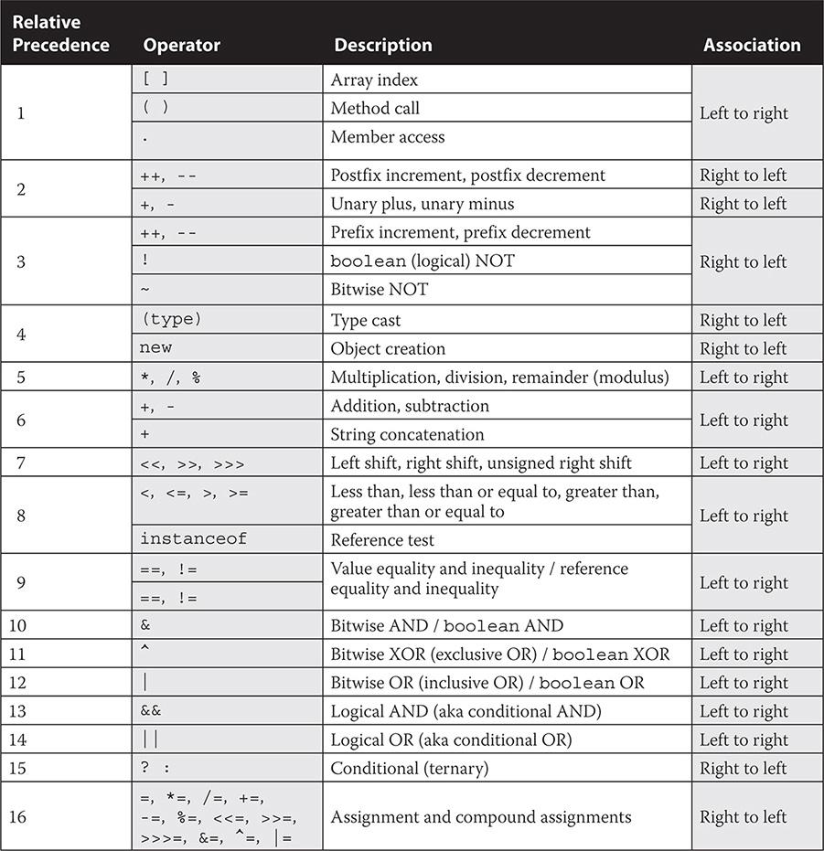

###### Overriding Operator Precedence

Use parentheses to override operator precedence. When multiple sets of parentheses are present, the innermost set is evaluated first. Let’s take a look at some basic code examples exercising operator precedence.

When operators have the same precedence, they are evaluated from left to right:

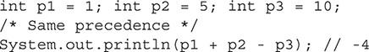

When operators do not have the same precedence, the operator with the higher precedence is evaluated first:

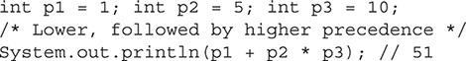

When an expression includes parentheses, operator precedence is overridden:



When an expression has multiple sets of parentheses, the operator associated with the innermost parentheses is evaluated first:

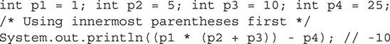

**CERTIFICATION OBJECTIVE**

#### Use String Objects and Their Methods

*Exam Objective Create and manipulate strings*

Strings are commonly used in the Java programming language. This section discusses what strings are and how to concatenate separate strings, and then it details the methods of the String class. When you have completed this section, which covers the following topics, you should fully understand what strings are and how to use them:

 Strings

 String concatenation operator

 Methods of the String class

##### Strings

String objects are used to represent 16-bit Unicode character strings. Consider the 16 bits 000001011001 followed by 000001101111. These bits in Unicode are represented as \u0059 and \u006F. The value \u0059 is mapped to the character “Y” and \u006F is mapped to the character “o”. An easy way of concatenating 16-bit Unicode character strings together in a reusable element is by declaring the data within a string:



See [Appendix C](https://learning.oreilly.com/library/view/oca-java-se/9781259587535/ch14_app_c.html#ch14_app_c) for more information on the Unicode standard.

Strings are *immutable* objects, meaning their values never change. For example, the following text, “Dead Men Tell No Tales”, can be created as a string:



In the following example, the value of the string does not change after a String method returns a modified value. Remember that strings are immutable. Here, we invoke the replace method on the string. Again, the new string is returned but will not change the value.



You can create strings in several ways. As with instantiating any object, you need to construct an object and assign it to a reference variable. As a reminder, a *reference variable* holds the value’s address. Let’s look at some of the things you can do with strings.

You can create a string without an assigned string object. Make sure you eventually give it a value, or you’ll get a compiler error.



You can use a couple of basic approaches to create a string object with an empty string representation:



You can create a string object without using a constructor:



You can create a string object while using a constructor:



You can create a reference variable that refers to a separate reference variable of a string object:



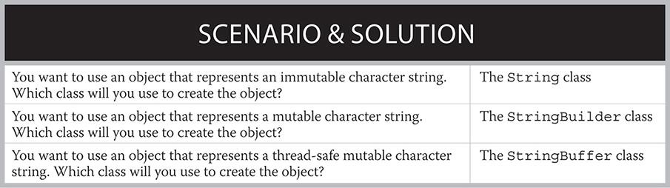

You can assign a new string object to an existing string reference variable:

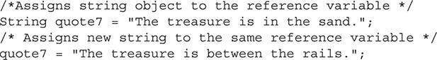

If you want to use a mutable character string, consider StringBuffer or StringBuilder as represented in the preceding Scenario & Solution.

##### The String Concatenation Operator

The string concatenation operator concatenates (joins) strings together. The operator is denoted with the + sign.



If you have been programming for at least six months, odds are you have glued two strings together at some time. Java’s string concatenation operator makes the act of joining two strings very easy. For example, “doub” + “loon” equates to “doubloon”. Let’s look at some more complete code:



Line 2 replaces the item variable with its contents, “doubloon”, and so the question string becomes



Notice that the question mark was appended as well.

Line 3 replaces the question variable with its contents and so the following string is returned:



It is that simple. But wait! What happens when primitives are added to the concatenation? The Java language specification reads, “The + operator is syntactically left-associative, no matter whether it is determined by type analysis to represent string concatenation or numeric addition.” We can examine this behavior in the following examples:

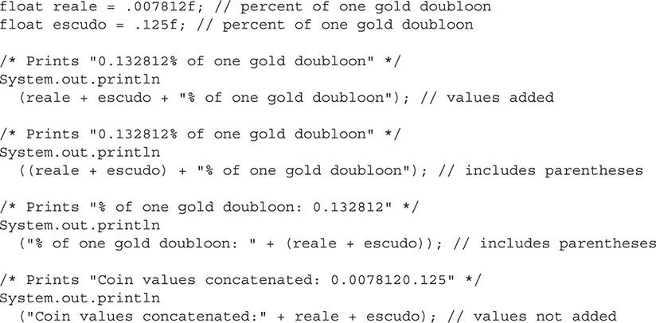

###### The toString Method

The Object class has a method that returns a string representation of objects. This method is appropriately named the toString method. All classes in Java extend the Object class by default; therefore, every class inherits this method. When you’re creating classes, it is common practice to override the toString method to return the data that best represents the state of the object. The toString method makes common use of the string concatenation operator.

Let’s take a look at the TreasureMap class with the toString method overridden.





Here, the toString method returns the contents of the class’s instance variables. Now let’s print out the representation of a TreasureMap object:

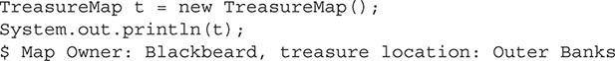

Concatenation results may be unexpected if you are including variables that are not initially strings. You should become very comfortable with working with the string concatenation operator, so let’s take another look at it.

Consider a string and two integers:

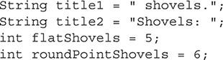

The compiler performs left-to-right association for the additive and string concatenation operators.

For the following two statements, the first two integers are added together. Next, the concatenation operator takes the toString representation of the result and concatenates it with the other string:

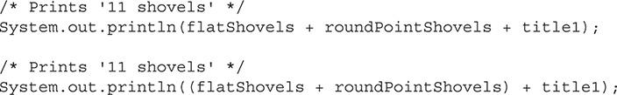

Next, moving from left to right, the compiler takes the title2 string and joins it with the string representation of the flatShovels integer variable. The result is a string. Now this result string is joined to the string representation of the roundPointShovels variable. Note that the toString method is used to return the string.



Parentheses take precedence, so you can join the sum of the integer values with the string if you code it as follows:



**EXERCISE 3-2**

**Uncovering Bugs that Your Compiler May Not Find**

Consider the strings in the following application:

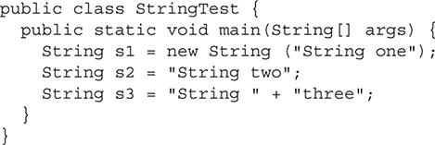

One of the strings is constructed in an inefficient manner. Do you know which one? Let’s find out using the FindBugs application from the University of Maryland.

**1.** Create a directory named “code” somewhere on your computer.

**2.** Create the StringTest.java source file.

**3.** Compile the StringTest.java source file: javac StringTest.java.

**4.** Download the FindBugs software from <http://findbugs.sourceforge.net/>.

**5.** Extract, install, and run the FindBugs application. Note that the Eclipse and NetBeans IDEs have plug-ins for the FindBugs tool as well as other software quality tools such as PMD and Checkstyle.

**6.** Create a new project in FindBugs by choosing File | New Project.

**7.** Add the project name (for instance, OCA String Test).

**8.** Click the Add button for the text area associated with the Class Archives And Directories To Analyze. Find and select the StringTest.class file in the code directory and click Choose.

**9.** Click the Add button for the text area associated with the Source Directories. Find and select the code directory (not the source file) and then click Choose.

**10.** The New Project dialog box will look similar to the following illustration, with the exception of your personal directory locations. Click Finish.



**11.** You will see that two bugs are returned. We are concerned with the first one. Drill down in the window that shows the bugs (Bugs | Performance | […]). The application will detail the warning and show you the source code with the line in error highlighted.

**12.** Fix the bug by not calling the constructor.

**13.** Rerun the test.

##### Methods of the String Class

Several methods of the String class are commonly used, such as the following: charAt, indexOf, length, concat, replace, startsWith, endsWith, substring, trim, toLowerCase, toUpperCase, and ensureIgnoreCase(). These methods are detailed in [Figure 3-2](https://learning.oreilly.com/library/view/oca-java-se/9781259587535/ch03.html#ch03fig02) and in the following sections.

**FIGURE 3-2** Commonly used methods of the String class



In the following sections, you’ll find a description of each method, followed by the method declarations and associated examples.

First, consider the following string:



The string has two leading blank spaces and one trailing blank space. This is important in relationship to the upcoming examples. The string is shown again in [Figure 3-3](https://learning.oreilly.com/library/view/oca-java-se/9781259587535/ch03.html#ch03fig03) with the index values shown in relationship to the individual characters.

**FIGURE 3-3** String object

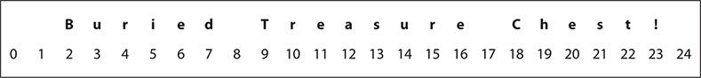

Let’s use each method to perform some action with the string pirateMessage.

###### The charAt Method

The String class’s charAt method returns a primitive char value from a specified int index value in relationship to the referenced string object.

There is one charAt method declaration:



Here are some examples:



###### The indexOf Method

The String class’s indexOf method returns primitive int values representing the index of a character or string in relationship to the referenced string object.

Four public indexOf method declarations exist:



Here are some examples:



###### The length Method

The String class’s length method returns a primitive int value representing the length of the referenced string object.

There is one length method declaration:



Here are some examples:





**The String class uses the length method (for example, string .length()). Arrays reference an instance variable in their state (for example, array .length). Therefore, the string methods use the set of parentheses to return their length and arrays do not. This is a gotcha that you will want to look for on the exam.**

###### The concat Method

The String class’s concat method concatenates the specified string to the end of the original string.

The sole concat method declaration is



Here’s an example:



###### The replace Method

The String class’s replace method returns strings, replacing all characters or strings in relationship to the referenced string object. The CharSequence interface allows for the use of either a String, StringBuffer, or StringBuilder object.

Two replace method declarations can be used:



Here are some examples:



###### The startsWith Method

The String class’s startsWith method returns a primitive boolean value representing the results of a test to see if the supplied prefix starts the referenced string object.

Two startsWith method declarations can be used:



Here are some examples:



###### The endsWith Method

The String class’s endsWith method returns a primitive boolean value representing the results of a test to see if the supplied suffix ends the referenced string object.

There is one endsWith method declaration:



Here are some examples:



###### The substring Method

The String class’s substring method returns new strings that are substrings of the referenced string object. The substring begins with the value in the begin argument and, if supplied, ends with the endIndex -1 argument. The String class’s substring method returns new strings that are substrings of the referenced string object.

Two substring method declarations exist:



Here are some examples:



###### The trim Method

The String class’s trim method returns the entire string minus leading and trailing whitespace characters in relationship to the referenced string object. The whitespace character corresponds to the Unicode character \u0020.



The sole trim method declaration is



Here is an example:



###### The toLowerCase Method

The String class’s toLowerCase method returns the entire string as lowercase characters.

Two toLowerCase method declarations can be used:



Here is an example:



###### The toUpperCase Method

The String class’s toUpperCase method returns the entire string as uppercase characters.

Two toUpperCase method declarations can be used:



Here is an example:



INSIDE THE EXAM

**Chaining**

Java allows for methods to be chained together. Consider the following message from the captain of a pirate ship:

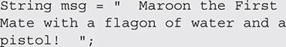

We want to change the message to read, “Maroon the Quartermaster with a flagon of water.”

Three changes need to be made to adjust the string as desired:

**1.** Trim the leading and trailing whitespace.

**2.** Replace the substring First Mate with Quartermaster.

**3.** Remove and a pistol!.

**4.** Add a period at the end of the sentence.

A variety of methods and utilities can be used to make these changes. We will use the trim, replace, and substring methods, in this order:

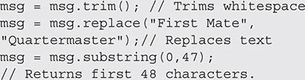

Rather than writing these assignments individually, we can have one assignment statement with all of the methods chained. For simplicity, we also add the period with the string concatenation operator:



Whether methods are invoked separately or chained together, the end result is the same:



Look for chaining on the exam.

###### The equalsIgnoreCase Method

The String class’s equalsIgnoreCase method returns a boolean value after comparing two strings while ignoring case consideration.

The equalsIgnoreCase method declaration is



Here are some examples:



**CERTIFICATION OBJECTIVE**

#### Use StringBuilder Objects and Their Methods

*Exam Objective Manipulate data using the StringBuilder class and its methods*

An object of the StringBuilder class represents a mutable character string, whereas an object of the StringBuffer class represents a thread-safe mutable character string. Remember that an object of the String class represents an immutable character string. In regard to the StringBuilder class and the exam, you need to familiarize yourself with the class’s most common methods and constructors.

##### Methods of the StringBuilder Class

Several methods of the StringBuilder class are commonly used: append, insert, delete, deleteCharAt, and reverse. These methods are included in [Figure 3-4](https://learning.oreilly.com/library/view/oca-java-se/9781259587535/ch03.html#ch03fig04) and discussed in the following sections.

**FIGURE 3-4** Commonly used methods of the StringBuilder class



Coming up, you’ll see a description of each method, followed by the method declarations and associated examples.

First, consider the following string:



The string is shown again in [Figure 3-5](https://learning.oreilly.com/library/view/oca-java-se/9781259587535/ch03.html#ch03fig05) with the index values shown in relationship to the individual characters. This message is used for many of the examples throughout this section.

**FIGURE 3-5** StringBuilder object



Let’s now look at some of the StringBuilder methods.

###### The append Method

The StringBuilder class’s append method appends the supplied data as a character string.

There are 13 append method declarations. These overloaded methods are shown here to provide coverage of the different Java types:



Here are some examples:



###### The insert Method

The StringBuilder class’s insert method inserts the string representation of the supplied data starting at the specified location.

There are 12 insert method declarations, though you need to be familiar with only the most basic declarations:



Here is an example:

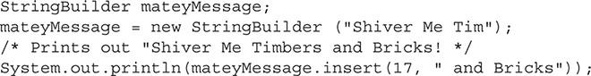

###### The delete Method

The StringBuilder class’s delete method removes characters in a substring of the StringBuilder object. The substring begins with the value in the start argument and ends with the end - 1 argument.

There is one delete method declaration:



Here is an example:



###### The deleteCharAt Method

The StringBuilder class’s deleteCharAt method removes the character from the specified index.

There is one deleteCharAt method declaration:



Here is an example:



###### The reverse Method

The StringBuilder class’s reverse method reverses the order of the character sequence.

There is one reverse method declaration:



Here is an example:



**EXERCISE 3-3**

**Using Constructors of the StringBuilder Class**

It’s a good idea to get familiar with the different constructors of the StringBuilder class. Review the Javadoc documentation to determine when you would use the different constructors and perform the following steps:

**1.** Create StringBuilder instances with the StringBuilder () constructor.

**2.** Create StringBuilder instances with the StringBuilder (CharSequence seq) constructor.

**3.** Create StringBuilder instances with the StringBuilder (int capacity) constructor.

**4.** Create StringBuilder instances with the StringBuilder (String str) constructor.

**CERTIFICATION OBJECTIVE**

#### Test Equality Between Strings and Other Objects

*Exam Objective Test equality between strings and other objects using* == *and equals ()*

One way to compare objects in Java is by performing a comparison by using the equals method. Note that the equals method in a class that will be used in a comparison must override the equals method of the Object class. The hashCode method also needs to be overridden, but this method is outside the scope of the test. For this objective, we’ll explore the equals method and the == operator a little further. The String class overrides the equals method, as is shown in the following code sample:



##### equals Method of the String Class

When comparing character strings among two separate strings, the equals method should be used:

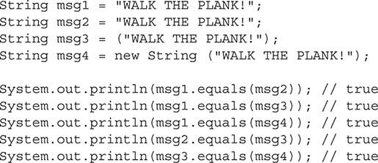

When comparing object references, the == operator should be used:



Do not attempt to compare character sequence values of strings with the == operator. Even though the result may appear to be correct, this is an inappropriate use of the operator, because the == operator is designed to check whether two object references refer to the same instance of an object, and not the character sequences of strings. Literal strings are pooled in the JVM and reused when possible. Here’s an example that does return true due to string reuse. This equality-testing approach should not be practiced:



If you do make this mistake, modern IDEs will typically flag the issue as a warning and give you the option to refactor the code to use the equals method, as shown here:



In addition, the IDE, such as NetBeans, may give you the option of refactoring in the equals method with null checks while using the ternary operator.



**EXERCISE 3-4**

**Working with the compareTo Method of the String Class**

Given the following code that prints “0”:

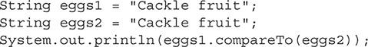

**1.** Modify the string(s) so that a value greater than 0 is printed, and explain why this happens.

**2.** Modify the string(s) so that a value less than 0 is printed, and explain why this happens.

#### CERTIFICATION SUMMARY

This chapter discussed everything you need to know about operators and strings for the exam.

Operators of type assignment, arithmetic, relational, and logical were all presented in detail. Assignment operators included the general assignment, assignment by addition, and assignment by subtraction operators. Arithmetic operators included the addition, subtraction, multiplication, division, and remainder (modulus) operators, as well as the prefix increment, prefix decrement, postfix increment, and postfix decrement operators. Relational operators included the less than, less than or equal to, greater than, greater than or equal to, equal to, and not equal to operators. Logical operators included the logical negation, logical AND, and logical OR operators.

We explored operator precedence and overriding operators. The concepts here were rather simple, and knowing the precedence of the common operators and the purposing of the parentheses in overriding precedence is all you’ll need to retain.

Strings were discussed in three main areas: creating strings, the string concatenation operator, and methods of the String class. The following methods of the String class were covered: charAt, indexOf, length, concat, replace, startsWith, endsWith, substring, trim, toLowerCase, toUpperCase, and equalsIgnoreCase. The StringBuilder class was discussed in comparison to the String class. The following methods of the StringBuilder class were covered: append, insert, delete, deleteCharAt, and reverse.

Testing object and String equality using the equals method was also discussed. The == operator was also discussed and we explained when to and when not to use it.

Knowing the fine details of these core areas related to operators and strings is necessary for the exam.

#### Images TWO-MINUTE DRILL

**Understand Fundamental Operators**

 The exam covers the following assignment and compound assignment operators: =, +=, and -=.

 The assignment operator (=) assigns values to variables.

 The additional compound assignment operator is used for shorthand. As such, a=a+b is written a+=b.

 The subtraction compound assignment operator is used for shorthand. As such, a=a-b is written a-=b.

 The exam covers the following arithmetic operators: +, -, *, /, %, ++, and --.

 The addition operator (+) is used to add two operands together.

 The subtraction operator (-) is used to subtract the right operand from the left operand.

 The multiplication operator (*) is used to multiply two operands together.

 The division operator (/) is used to divide the right operand into the left operand.

 The modulus operator (%) returns the remainder of a division.

 The prefix-increment (++) and prefix-decrement (--) operators are used to increment or decrement a value before it is used in an expression.

 The postfix-increment (++) and postfix-decrement (--) operators are used to increment or decrement a value after it is used in an expression.

 The exam covers the following relational operators: <, <=, >, >=, ==, and !=.

 The less than operator (<) returns true if the left operand is less than the right operand.

 The less than or equal to operator (<=) returns true if the left operand is less than or equal to the right operand.

 The greater than operator (>) returns true if the right operand is less than the left operand.

 The greater than or equal to operator (>=) returns true if the right operand is less than or equal to the left operand.

 The equal to equality operator (==) returns true if the left operand is equal to the right operand.

 The not equal to equality operator (!=) returns true if the left operand is not equal to the right operand.

 Equality operators can test numbers, characters, booleans, and reference variables.

 The exam covers the following logical operators: !, &&, and ||.

 The logical negation (inversion) operator (!) negates the value of the boolean operand.

 The logical AND (conditional AND) operator (&&) returns true if both operands are true.

 The logical AND operator is known as a short-circuit operator because it does not evaluate the right operand if the left operand is false.

 The logical OR (conditional OR) operator (||) returns true if either operand is true.

 The conditional OR operator is known as a short-circuit operator because it does not evaluate the right operand if the left operand is true.

**Understand Operator Precedence**

 Operators with a higher precedence are evaluated before operators with a lower precedence.

 Operator precedence is overridden by the use of parentheses.

 When multiple sets of parentheses are present relative to operator precedence, the innermost set is evaluated first.

 Operators in an expression that have the same precedence will be evaluated from left to right.

**Use String Objects and Their Methods**

 An object of the String class represents an immutable character string.

 *Mutable* means changeable. Java variables such as primitives are mutable by default and can be made immutable by using the final keyword.

 The CharSequence interface is implemented by the String class as well as the StringBuilder and StringBuffer classes. This interface can be used as an argument in the String class’s replace method.

 The string concatenation operator (+) joins two strings together and creates a new string.

 The string concatenation operator will join two operands together, as long as one or both of them are strings.

 The String class’s charAt method returns a primitive char value from a specified int index value in relationship to the referenced string.

 The String class’s indexOf method returns a primitive int value representing the index of a character or string in relationship to the referenced string.

 The String class’s length method returns a primitive int value representing the length of the referenced string.

 The String class’s concat method concatenates the specified string to the end of the original string.

 The String class’s replace method returns strings replacing all characters or strings in relationship to the referenced string.

 The String class’s startsWith method returns a primitive boolean value representing the results of a test to see if the supplied prefix starts the referenced string.

 The String class’s endsWith method returns a primitive boolean value representing the results of a test to see if the supplied suffix ends the referenced string.

 The String class’s substring method returns new strings that are substrings of the referenced string.

 The String class’s trim method returns the entire string minus leading and trailing whitespace characters in relationship to the referenced string.

 The String class’s toLowerCase method returns the entire string as lowercase characters.

 The String class’s toUpperCase method returns the entire string as uppercase characters.

 The String class’s equalsIgnoreCase method returns a boolean value after comparing two strings while ignoring case consideration.

**Use StringBuilder Objects and Their Methods**

 An object of the StringBuilder class represents a mutable character string.

 An object of the StringBuffer class represents a thread-safe mutable character string.

 The StringBuilder class makes use of the following methods that the String class has also declared: charAt, indexOf, length, replace, startsWith, endsWith, and substring.

 The StringBuilder class’s append method appends the supplied data as a character string.

 The StringBuilder class’s insert method inserts the string representation of the supplied data starting at the specified location.

 The StringBuilder class’s delete method removes characters in a substring of the StringBuilder object.

 The StringBuilder class’s deleteCharAt method removes the character from the specified index.

 The StringBuilder class’s reverse method reverses the order of the character sequence.

**Test Equality Between Strings and Other Objects**

 Use the equals method of the String class (overridden from the Object class) to test the equality of the character sequence values of string objects.

 Use the == operator to test to see if the object references (for example, the memory addresses) of strings are equal.

 Use the == operator to test the equality of primitives.

#### SELF TEST

**Understand Fundamental Operators**

[**1.**](https://learning.oreilly.com/library/view/oca-java-se/9781259587535/ch03.html#ch03qa1a) Given:



What will be printed to standard output?

A. True: i=0, j = 1

B. True: i=1, j = 1

C. False: i=0, j = 1

D. False: i=1, j = 1

[**2.**](https://learning.oreilly.com/library/view/oca-java-se/9781259587535/ch03.html#ch03qa2a) Which set of operators represents the complete set of valid Java assignment operators? (Note that shift operators include <<, >>, and >>>.)

A. %=, &=, *=, $=, :=, /=, ^=, |=, +=, <<=, =, -=, >>=, >>>=

B. %=, &=, *=, /=, ^=, |=, +=, <<=, <<<=, =, -=, >>=, >>>=

C. %=, &=, *=, /=, ^=, |=, +=, <<=, =, -=, >>=, >>>=

D. %=, &=, *=, $=, /=, ^=, |=, +=, <<=, <<<=, =, -=, >>=, >>>=

[**3.**](https://learning.oreilly.com/library/view/oca-java-se/9781259587535/ch03.html#ch03qa3a) Given the following Java code segment, what will be printed, considering the usage of the modulus operators?



A. 23

B. 3

C. 1

D. 0

[**4.**](https://learning.oreilly.com/library/view/oca-java-se/9781259587535/ch03.html#ch03qa4a) Given:



What will be printed, considering the usage of the logical boolean operators?

A. false, false, true

B. false, true, true

C. true, false, true

D. true, true, true

[**5.**](https://learning.oreilly.com/library/view/oca-java-se/9781259587535/ch03.html#ch03qa5a) Given:



What will be printed to standard output?

A. Value2: 300 Value2: 300 Value1: 300 Value1: 300

B. Value2: 299 Value2: 300 Value1: 299 Value1: 300

C. Value1: 299 Value1: 300 Value2: 299 Value2: 300

D. Value1: 300 Value1: 299 Value2: 300 Value2: 299

[**6.**](https://learning.oreilly.com/library/view/oca-java-se/9781259587535/ch03.html#ch03qa6a) Given the following code segment:



Which of the following is true? Hint: 17496 is not a prime number.

A. The code will not compile due to a syntactical error somewhere in the code.

B. The code will not compile since the expression (p % j == 0) should be written as ((p % j) == 0).

C. Divisors will be printed to standard output (for example, 2x8478, and so on), along with Prime number: false as the final output.

D. Divisors will be printed to standard output (for example, 2x8478, and so on), along with Prime number: 0 as the final output.

[**7.**](https://learning.oreilly.com/library/view/oca-java-se/9781259587535/ch03.html#ch03qa7a) Given:



Which expressions evaluate to true?

A. value1.equals(value2)

B. value1.equals(object1)

C. value1.equals(object3)

D. object1.equals(object2)

[**8.**](https://learning.oreilly.com/library/view/oca-java-se/9781259587535/ch03.html#ch03qa8a) Given:



What will be printed to standard output?

A. true, true

B. true, false

C. false, true

D. false, false

E. Compilation error

[**9.**](https://learning.oreilly.com/library/view/oca-java-se/9781259587535/ch03.html#ch03qa9a) In the following code segment, what is printed to standard output?



A. 9

B. 10

C. 11

D. A compiler error will occur.

E. A runtime error will occur.

[**10.**](https://learning.oreilly.com/library/view/oca-java-se/9781259587535/ch03.html#ch03qa10a) From highest precedence to lowest, which list of operators is ordered properly?

A. *, +, &&, =

B. *, &&, +, =

C. *, =, &&, +

D. +, *, &&, =

**Use String Objects and Their Methods**

[**11.**](https://learning.oreilly.com/library/view/oca-java-se/9781259587535/ch03.html#ch03qa11a) Given:



What will be printed to standard output?

A. 333 and 333

B. 63 and 63

C. 333 and 63

D. 63 and 333

[**12.**](https://learning.oreilly.com/library/view/oca-java-se/9781259587535/ch03.html#ch03qa12a) Consider the interface CharSequence that is a required argument in one of the replace method declarations:



This CharSequence interface is a super interface to which concrete classes?

A. String

B. StringBoxer

C. StringBuffer

D. StringBuilder

[**13.**](https://learning.oreilly.com/library/view/oca-java-se/9781259587535/ch03.html#ch03qa13a) Which statement is false about the toString method?

A. The toString method is a method of the Object class.

B. The toString method returns a string representation of the object.

C. The toString method must return the object’s state information in the form of a string.

D. The toString method is commonly overridden.

[**14.**](https://learning.oreilly.com/library/view/oca-java-se/9781259587535/ch03.html#ch03qa14a) Which indexOf method declaration is invalid?

A. indexOf(int ch)

B. indexOf(int ch, int fromIndex)

C. indexOf(String str, int fromIndex)

D. indexOf(CharSequence str, int fromIndex)

[**15.**](https://learning.oreilly.com/library/view/oca-java-se/9781259587535/ch03.html#ch03qa15a) Given:



What is printed to the standard output?

A. AAAAAAAAAA

B. LLLAAAAAAA

C. LLLLLLLLLA

D. LLLLLLLLLL

[**16.**](https://learning.oreilly.com/library/view/oca-java-se/9781259587535/ch03.html#ch03qa16a) Consider the following illustration. Which statements, also represented in the illustration, are true?

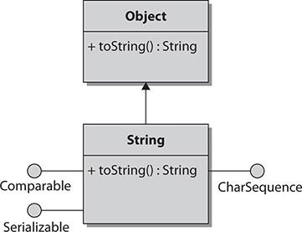

A. The String class implements the Object interface.

B. The String class implements the Comparable, Serializable, and CharSequence interfaces.

C. The toString method overrides the toString method of the Object class, allowing the string object to return its own string.

D. The toString method is publicly accessible.

**Use StringBuilder Objects and Their Methods**

[**17.**](https://learning.oreilly.com/library/view/oca-java-se/9781259587535/ch03.html#ch03qa17a) Which declaration of the StringBuilder class exists?

A. public StringBuilder reverse (String str) {…}

B. public StringBuilder reverse (int index, String str) {…}

C. public StringBuilder reverse () {…}

D. All of the above

**Test Equality Between Strings and Other Objects**

[**18.**](https://learning.oreilly.com/library/view/oca-java-se/9781259587535/ch03.html#ch03qa18a) Given:



Are the String and StringBuilder classes of comparable types? Select the correct statement.

A. The String and StringBuilder classes are comparable types.

B. The String and StringBuilder classes are incomparable types.

[**19.**](https://learning.oreilly.com/library/view/oca-java-se/9781259587535/ch03.html#ch03qa19a) Which append declaration does not exist in Java 8?

A. public StringBuilder append (short s) {…}

B. public StringBuilder append (int i) {…}

C. public StringBuilder append (long l) {…}

D. public StringBuilder append (float f) {…}

E. public StringBuilder append (double d) {…}

#### SELF TEST ANSWERS

**Understand Fundamental Operators**

[**1.**](https://learning.oreilly.com/library/view/oca-java-se/9781259587535/ch03.html#ch03qa1) Given:



What will be printed to standard output?

A. True: i=0, j = 1

B. True: i=1, j = 1

C. False: i=0, j = 1

D. False: i=1, j = 1

Answer:

 **D.** The value of j is prefix-incremented before the evaluation; however, the value of i is not. Therefore, the expression is evaluated with a boolean value of false as a result, since 0 does not equal 1 (that is, i=0 and j = 1). After the expression has been evaluated, but before the associated print statement is executed, the value of i is postfix-incremented (that is, (i=1)). Therefore, the correct answer is False: i=1, j = 1.

 **A, B,** and **C** are incorrect answers as justified by the correct answer’s explanation.

[**2.**](https://learning.oreilly.com/library/view/oca-java-se/9781259587535/ch03.html#ch03qa2) Which set of operators represents the complete set of valid Java assignment operators? (Note that shift operators include <<, >>, and >>>.)

A. %=, &=, *=, $=, :=, /=, ^=, |=, +=, <<=, =, -=, >>=, >>>=

B. %=, &=, *=, /=, ^=, |=, +=, <<=, <<<=, =, -=, >>=, >>>=

C. %=, &=, *=, /=, ^=, |=, +=, <<=, =, -=, >>=, >>>=

D. %=, &=, *=, $=, /=, ^=, |=, +=, <<=, <<<=, =, -=, >>=, >>>=

Answer:

 **C**. The complete set of valid Java assignment operators is represented.

 **A, B,** and **D** are incorrect answers. **A** is incorrect because $= and := are not valid Java assignment operators. **B** is incorrect because <<<= is not a valid Java assignment operator. **D** is incorrect because $= and <<<= are not valid Java assignment operators.

[**3.**](https://learning.oreilly.com/library/view/oca-java-se/9781259587535/ch03.html#ch03qa3) Given the following Java code segment, what will be printed, considering the usage of the modulus operators?



A. 23

B. 3

C. 1

D. 0

Answer:

 **D.** The remainder of 49/26 is 23. The remainder of 23/5 is 3. The remainder of 3/1 is 0. The answer is 0.

 **A, B,** and **C** are incorrect answers as justified by the correct answer’s explanation.

[**4.**](https://learning.oreilly.com/library/view/oca-java-se/9781259587535/ch03.html#ch03qa4) Given:



What will be printed, considering the usage of the logical boolean operators?

A. false, false, true

B. false, true, true

C. true, false, true

D. true, true, true

Answer:

 **A.** The first expression statement (!(true & !(false))) evaluates to false. Here, the right operand is negated to true by the (boolean invert) operator, the boolean AND operator equates the expression of the two operands to true, and the (boolean invert) operator equates the resultant value to false. The second expression statement (!(true | !(false))) evaluates to false. Here, the right operand is negated to true by the (boolean invert) operator, the boolean OR operator equates the expression of the two operands to true, and the (boolean invert) operator equates the resultant value to false. The third expression statement (!(true ^ !(false))) evaluates to true. Here, the right operand is negated to true by the (boolean invert) operator, the boolean XOR operator equates the expression of the two operands to false, and the (boolean invert) operator equates the resultant value to true.

 **B, C,** and **D** are incorrect answers as justified by the correct answer’s explanation.

[**5.**](https://learning.oreilly.com/library/view/oca-java-se/9781259587535/ch03.html#ch03qa5) Given:

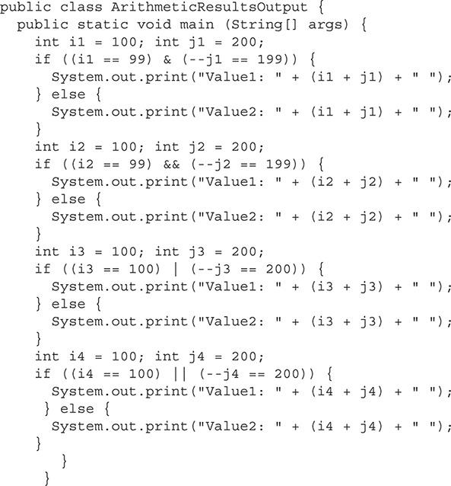

What will be printed to standard output?

A. Value2: 300 Value2: 300 Value1: 300 Value1: 300

B. Value2: 299 Value2: 300 Value1: 299 Value1: 300

C. Value1: 299 Value1: 300 Value2: 299 Value2: 300

D. Value1: 300 Value1: 299 Value2: 300 Value2: 299

Answer:

 **B.** Value2: 299 Value2: 300 Value1: 299 Value1: 300 will be printed to the standard output. Note that && and || are short-circuit operators. When the first operand of a conditional AND (&&) expression evaluates to false, the second operand is not evaluated. When the first operand of a conditional OR (||) expression evaluates to true, the second operand is not evaluated. Thus, for the second and fourth if statements, the second operand isn’t evaluated. Therefore, the prefix increment operators are never executed and do not affect the values of the j[*x*] variables.

 **A, C,** and **D** are incorrect answers as justified by the correct answer’s explanation.

[**6.**](https://learning.oreilly.com/library/view/oca-java-se/9781259587535/ch03.html#ch03qa6) Given the following code segment:



Which of the following is true? Hint: 17496 is not a prime number.

A. The code will not compile due to a syntactical error somewhere in the code.

B. The code will not compile since the expression (p % j == 0) should be written as ((p % j) == 0).

C. Divisors will be printed to standard output (for example, 2x8478, and so on), along with Prime number: false as the final output.

D. Divisors will be printed to standard output (for example, 2x8478, and so on), along with Prime number: 0 as the final output.

Answer:

 **C.** Divisors will be printed to standard output followed by Prime number: false. For those who are curious, the complete list of divisors printed are 2x8748, 3x5832, 4x4374, 6x2916, 8x2187, 9x1944, 12x1458, 18x972, 24x729, 27x648, 36x486, 54x324, 72x243, 81x216, and 108x162.

 **A, B,** and **D** are incorrect. **A** is incorrect because there are no syntactical errors in the code. **B** is incorrect because a set of parentheses around p % j is not required. Answer **D** is incorrect because the code does not print out the character 0; it prints out the boolean literal value false.

[**7.**](https://learning.oreilly.com/library/view/oca-java-se/9781259587535/ch03.html#ch03qa7) Given:



Which expressions evaluate to true?

A. value1.equals(value2)

B. value1.equals(object1)

C. value1.equals(object3)

D. object1.equals(object2)

Answer:

 **A** and **C. A** is correct because the class Integer implements the Comparable interface, allowing use of the equals method. **C** is correct because the Integer object was used to create the Object reference.

 **B** and **D** are incorrect because the code cannot equate two objects with different references.

[**8.**](https://learning.oreilly.com/library/view/oca-java-se/9781259587535/ch03.html#ch03qa8) Given:



What will be printed to standard output?

A. true, true

B. true, false

C. false, true

D. false, false

E. Compilation error

Answer:

 **E.** Concatenation of a boolean and a string is not allowed in the first print statement. Therefore, the first line will not compile. Changing the statement by adding parentheses around the boolean evaluations would allow the line to compile:



Once the line was compilable, the correct answer would have been A, considering operating precedence with the boolean AND (&) operator having a higher precedence over the boolean OR (|) operator.

 **A, B, C,** and **D** are incorrect. **A** is incorrect because the code will not compile. **B**, **C**, and **D** are incorrect because if the code were refined to be compilable, the answer would have been A.

[**9.**](https://learning.oreilly.com/library/view/oca-java-se/9781259587535/ch03.html#ch03qa9) In the following code segment, what is printed to standard output?



A. 9

B. 10

C. 11

D. A compiler error will occur.

E. A runtime error will occur.

Answer:

 **B.** This variable score is not incremented until the operation is completed since it is a postfix-increment operator, so 10 is printed.

 **A, C, D,** and **E** are incorrect. **A** would be correct if this were a prefix-decrement operator. **C** would be correct if this were a prefix-increment operator. **D** and **E** are incorrect because the code contains no errors.

[**10.**](https://learning.oreilly.com/library/view/oca-java-se/9781259587535/ch03.html#ch03qa10) From highest precedence to lowest, which list of operators is ordered properly?

A. *, +, &&, =

B. *, &&, +, =

C. *, =, &&, +

D. +, *, &&, =

Answer:

 **A.** In order of precedence, the following is correct: multiplication (*), addition (+), conditional AND (&&), assignment (=).

 **B, C,** and **D** are incorrect because they are improperly ordered.

**Use String Objects and Their Methods**

[**11.**](https://learning.oreilly.com/library/view/oca-java-se/9781259587535/ch03.html#ch03qa11) Given:

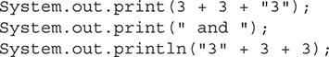

What will be printed to standard output?

A. 333 and 333

B. 63 and 63

C. 333 and 63

D. 63 and 333

Answer:

 **D.** The + operators have left-to-right association. The first two operands of the first statement are numeric, so the addition (+) operator is used. Therefore, 3 + 3 = 6. Since 6 + “3” uses a string as an operand, the string concatenation (+) operator is used. Therefore, concatenating the strings 6 and 3 renders the string 63. The last statement is handled a little differently. The first operand is a String; therefore, the string concatenation operator is used with the other operands. Thus, concatenating strings “3” + “3” + “3” renders the string 333. The correct answer is 63 and 333.

 **A, B,** and **C** are incorrect. Note that changing (“3” + 3 + 3) to (“3” + (3 + 3)) would have rendered 36.

[**12.**](https://learning.oreilly.com/library/view/oca-java-se/9781259587535/ch03.html#ch03qa12) Consider the interface CharSequence that is a required argument in one of the replace method declarations:



This CharSequence interface is a super interface to which concrete classes?

A. String

B. StringBoxer

C. StringBuffer

D. StringBuilder

Answer:

 **A, C,** and **D.** The concrete classes String, StringBuffer, and StringBuilder all implement the interface CharSequence. These classes can all be used in a polymorphic manner in regard to CharSequence being an expected argument in one of the String class’s replace methods.

 **B** is incorrect. There is no such thing as a StringBoxer class.

[**13.**](https://learning.oreilly.com/library/view/oca-java-se/9781259587535/ch03.html#ch03qa13) Which statement is false about the toString method?

A. The toString method is a method of the Object class.

B. The toString method returns a string representation of the object.

C. The toString method must return the object’s state information in the form of a string.

D. The toString method is commonly overridden.

Answer:

 **C.** While the toString method is commonly used to return the object’s state information, any information that can be gathered may be returned in the string.

 **A, B,** and **D** are incorrect answers because they all represent true statements. **A** is incorrect because the toString method is a method of the Object class. **B** is incorrect because the toString method returns a string representation of the object. **D** is incorrect because the toString method is also commonly overridden.

[**14.**](https://learning.oreilly.com/library/view/oca-java-se/9781259587535/ch03.html#ch03qa14) Which indexOf method declaration is invalid?

A. indexOf(int ch)

B. indexOf(int ch, int fromIndex)

C. indexOf(String str, int fromIndex)

D. indexOf(CharSequence str, int fromIndex)

Answer:

 **D.** The method declaration including indexOf(CharSequence str, int fromIndex) is invalid. CharSequence is not used as an argument in any indexOf method. Note that String, StringBuffer, and StringBuilder all declare their own indexOf methods.

 **A, B,** and **C** are incorrect because they are all valid method declarations.

[**15.**](https://learning.oreilly.com/library/view/oca-java-se/9781259587535/ch03.html#ch03qa15) Given:



What is printed to the standard output?

A. AAAAAAAAAA

B. LLLAAAAAAA

C. LLLLLLLLLA

D. LLLLLLLLLL

Answer:

 **C.** The replace method of the String class replaces all instances of the specified string. The first three instances of AAA are replaced by LLL, making LLLLLLLLLA correct.

 **A, B,** and **D** are incorrect answers as justified by the correct answer’s explanation.

[**16.**](https://learning.oreilly.com/library/view/oca-java-se/9781259587535/ch03.html#ch03qa16) Consider the following illustration. Which statements, also represented in the illustration, are true?



A. The String class implements the Object interface.

B. The String class implements the Comparable, Serializable, and CharSequence interfaces.

C. The toString method overrides the toString method of the Object class, allowing the string object to return its own string.

D. The toString method is publicly accessible.

Answer:

 **B, C,** and **D.** These answers all represent true statements. **B** is correct because the String class implements the Comparable, Serializable, and CharSequence interfaces. **C** is correct because the toString method overrides the toString method of the Object class, allowing the string object to return its own string. **D** is correct because the toString method is also publicly accessible.

 **A** is incorrect. The Object class is a concrete class. Therefore, the String class does not implement an Object interface since there is no such thing as an Object interface. The String class actually extends an Object concrete class.

**Use StringBuilder Objects and Their Methods**

[**17.**](https://learning.oreilly.com/library/view/oca-java-se/9781259587535/ch03.html#ch03qa17) Which declaration of the StringBuilder class exists?

A. public StringBuilder reverse (String str) {…}

B. public StringBuilder reverse (int index, String str) {…}

C. public StringBuilder reverse () {…}

D. All of the above

Answer:

 **C.** The reverse method of the StringBuilder class does not have any arguments.

 **A, B,** and **D** are incorrect answers as justified by the correct answer’s explanation.

**Test Equality Between Strings and Other Objects**

[**18.**](https://learning.oreilly.com/library/view/oca-java-se/9781259587535/ch03.html#ch03qa18) Given:



Are the String and StringBuilder classes of comparable types? Select the correct statement.

A. The String and StringBuilder classes are comparable types.

B. The String and StringBuilder classes are incomparable types.

Answer:

 **B.** The String and StringBuilder classes are incomparable types.

 **A** is incorrect because the String and StringBuilder classes are incomparable types.

[**19.**](https://learning.oreilly.com/library/view/oca-java-se/9781259587535/ch03.html#ch03qa19) Which append declaration does not exist in Java 8?

A. public StringBuilder append (short s) {…}

B. public StringBuilder append (int i) {…}

C. public StringBuilder append (long l) {…}

D. public StringBuilder append (float f) {…}

E. public StringBuilder append (double d) {…}

Answer:

 **A.** The append declaration that includes a short is not included in the StringBuilder class. This is because the short value is automatically casted to an integer when passed for integer literal. Therefore, the following declaration will also handle a short argument: public StringBuilder append (int i) {…}.

 **B, C, D,** and **E** are incorrect. **B** is incorrect because the append declaration that includes an int is included in the StringBuilder class. **C** is incorrect because the append declaration that includes a long is included in the StringBuilder class.

**D** is incorrect because the append declaration that includes a float is included in the StringBuilder class. **E** is incorrect because the append declaration that includes a double is included in the StringBuilder class.



### 4

### WORKING WITH BASIC CLASSES AND VARIABLES

**CERTIFICATION OBJECTIVES**

• [Understand Primitives, Enumerations, and Objects](https://learning.oreilly.com/library/view/oca-java-se/9781259587535/ch04.html#ch04lev1)

• [Use Primitives, Enumerations, and Objects](https://learning.oreilly.com/library/view/oca-java-se/9781259587535/ch04.html#ch04lev8)

 [Two-Minute Drill](https://learning.oreilly.com/library/view/oca-java-se/9781259587535/ch04.html#ch04lev11)

**Q&A** [Self Test](https://learning.oreilly.com/library/view/oca-java-se/9781259587535/ch04.html#ch04lev13)

**T**his chapter will cover the basics of primitive variables and objects. OCA questions will require that the test taker understand the difference between primitives and objects and how each is used. The next few chapters will build on this foundation. The following topics will be covered in this chapter:

 Primitives

 Objects

 Arrays

 Enumerations

 Java’s strongly typed nature

 Naming conventions

**CERTIFICATION OBJECTIVE**

#### Understand Primitives, Enumerations, and Objects

*Exam Objective Declare and initialize variables (including casting of primitive data types)*

*Exam Objective Develop code that uses wrapper classes such as Boolean, Double, and Integer*

*Exam Objective Differentiate between object reference variables and primitive variables*.

An application is made up of *variables* that store data and code that manipulates the data. Java uses *primitive* variables to store its most basic data. These primitives are then used in more advanced data types called *objects*. This is what makes Java an object-oriented language: it allows the developer to organize related code and data together in discrete objects.

This is a very important and fundamental concept that you must understand to know how the Java language truly works.

##### Primitive Variables

Java primitives are a special subset of Java data types. They are the foundation of storing data in a program. It is important that you understand what a primitive is and what it is not for the OCA exam. The Java language has eight primitives. The important thing to remember about each primitive is what kind of value you would store in it. The size in memory and minimum/maximum value sizes are good to know, but you will not be required to memorize them for the exam.

###### What Is a Primitive?

A primitive is the most basic form of data in a Java program, hence its name. When a primitive is declared, it reserves a certain number of bits in memory. The size of the memory allocation is dependent on the type of primitive. Each primitive data type has a set size that it will always occupy in memory.

The eight primitive data types are

 boolean (boolean)

 char (character)

 byte (byte)

 short (short integer)

 int (integer)

 long (long integer)

 float (floating point)

 double (double precision floating point)

Remember that something represented in code as an Integer (which refers to an object) is different from an int (which refers to a primitive containing an integer value).

While working with a primitive variable, you may only set it or read it. Calculations performed with primitives are much faster than calculations performed with similar objects.

###### Declaring and Initializing Primitives

Like all variables in Java, primitives need to be declared before they can be used. When a variable is declared, its type and name are set. The following code shows a primitive int being declared:



The gallons variable is now declared as an int. This variable can store only an integer and cannot be broken down into any smaller elements. Now that the variable is declared, it can only be set or read—that is all. No methods can be called using this variable because it is a primitive.

This will be discussed in more depth later in the chapter when objects are explored. Primitives that are declared as instance variables get assigned a default value of 0 or false if they are a boolean. When primitives are used in the body of a method, they must be assigned a value before being used. If they are not assigned a value, a compile time error will be generated.

This code uses the new integer:



###### boolean Primitive

A boolean primitive is used to store a value of true or false. They store a 1-bit value and will default to false as an instance variable. Although they represent only 1 bit of information, their exact size is not defined in the Java standard and may occupy more space on different platforms. Valid literals include true and false.

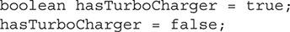

###### char Primitive

The char primitive is used to store a single 16-bit Unicode character and requires 16 bits of memory. The range of a char corresponds to the minimum and maximum as defined by the Unicode specification ‘\u0000’ (or 0) and ‘\uffff’ (or 65,535 inclusive), respectively. When a char is set with a character in code, single quotes should be used—’Y’, for example. A char has a default value of ‘\u0000’, or 0, when used as an instance variable. This primitive is always unsigned.

The following code segments demonstrate the uses of char. Valid literals include individual characters, special characters, Unicode characters, and hexadecimal and octal representations:

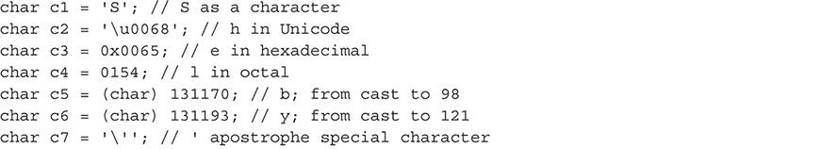



See [Table E-1](https://learning.oreilly.com/library/view/oca-java-se/9781259587535/ch16_app_e.html#ch16tab01) in [Appendix E](https://learning.oreilly.com/library/view/oca-java-se/9781259587535/ch16_app_e.html#ch16_app_e) of the Unicode standard for representation of printable and nonprintable ASCII characters as Unicode values.

###### byte Primitive

A byte is a Java primitive that is normally used to store small, signed numbers up to 1 byte in size. As an instance variable, it has a default value of 0. A byte occupies 8 bits of memory and can store an 8-bit signed two’s complement non–floating-point number. It has a maximum value of 127 and a minimum value of −128, inclusive. When a literal integer is stored in a byte primitive, it is implicitly cast to 1 byte. The following code segments demonstrate the uses of byte:



###### short Primitive

A short is a Java primitive used for small numbers. It is most commonly used when the developer wants to save memory space over an int. As an instance variable, it has a default value of 0. A short occupies 16 bits of memory and can store a 16-bit signed two’s complement non–floating-point number. It has a maximum value of 32,767 and a minimum value of −32,768, inclusive. The following code segments demonstrate the uses of short:



###### int Primitive

An int is the most commonly used Java primitive. An int is used to store most whole numbers. As an instance variable, it has a default value of 0. An int occupies 32 bits of memory and can store a 32-bit signed two’s complement non–floating-point number. It has a maximum value of 2,147,483,647 and a minimum value of −2,147,483,648, inclusive. Java 8 has added helper methods to the Integer class that enable the developer to treat the int as if it were unsigned. However, when dealing with the int primitive directly, the Java virtual machine (JVM) will always assume it to be a signed value. The following code segments demonstrate the uses of int:

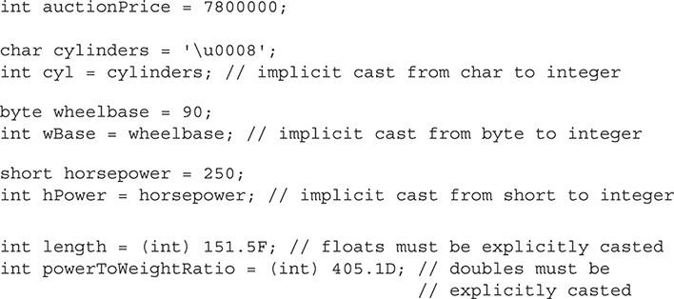

###### long Primitive

A long is a Java primitive used for whole numbers that are larger than an int can store. As an instance variable, it has a default value of 0L. The l or L appended to this number indicates that it is a long and not an int. A long occupies 64 bits of memory and can store a 64-bit signed two’s complement non–floating-point number. It has a maximum value of 9,223,372,036,854,775,807 and a minimum value of −9,223,372,036,854,775,808, inclusive. Java 8 has added helper methods to the Long class that enable the developer to treat the long as if it were unsigned. However, when dealing with the long primitive directly, the JVM will always assume it to be a signed value. The following code segments demonstrate the uses of long:

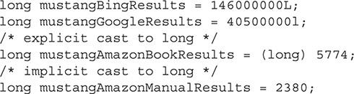

###### float Primitive

A float primitive is used to store decimal values. It has a default value of 0.0f when used as an instance variable. This value is equal to 0, but the f or F appended to the end indicates that this value is a float, not a double. A float requires 32 bits of memory and may contain a 32-bit value with a maximum of 3.4e+38 and a minimum positive nonzero value of 1.4e−45, inclusive. (These values are rounded for simplicity. The exact size of a float is a formula that can be found in section 4.2.3 of *The Java Language Specification: Java SE 8 Edition*, by James Gosling, Bill Joy, Guy Steele, Gilad Bracha, and Alex Buckley [Oracle, 2014], but this is beyond the scope of this book and the OCA exam.) The following code segments demonstrate the uses of float (notice the use of f or F to denote that the number is a float):

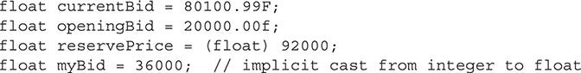

###### double Primitive

A double primitive is used to store large decimal values. The double primitive is the default primitive that most developers use to store floating-point numbers. It has a default value of 0.0 as an instance variable. A double occupies 64 bits of memory and may contain a 64-bit value with a maximum of 1.8e+308 and a minimum positive nonzero value of 5e–324, inclusive. (These values are rounded for simplicity. The exact size of a double is a formula that can be found in section 4.2.3 of *The Java Language Specification*, but this is beyond the scope of this book and the OCA exam.) The following code segments demonstrate the uses of double:

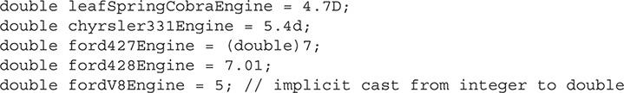

###### Why So Many Primitives?

There are eight Java primitives. The astute reader will likely be wondering why Java has so many, and why most seem to store the same data. This is a very good observation. The primitives byte, short, int, and long all store whole numbers. These primitives are listed in size order from smallest to largest. If a number such as 32 were to be stored, all four primitives would work without issue, since 32 is small enough to fit into a byte, which is the smallest type. The only negative to using a larger type such as a short, int, or long would be the space that it occupies in memory.

The primitives for storing floating-point numbers are float and double. A small number such as 5.3 can be stored in either, with the only difference being the memory that the primitive consumes. However, as a floating-point number grows, it can lose precision. A double has double the precision of a float.

The char and boolean primitives are each unique. A boolean is the only primitive that can store a true or false value. And a char is the only primitive that stores an unsigned whole number.

###### Floating-Point Math

As a developer, you must be careful when using floating-point numbers. A floating-point number will lose precision as the number becomes larger. The following code is a simple example of two floats being added and printed to standard output:

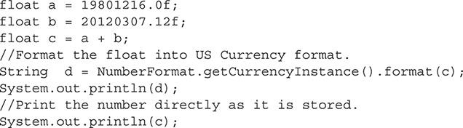

It is easy to expect the output of this code segment to be $39,921,523.12 after the NumberFormat class formats the number as U.S. currency. However, this is not the correct output. The code will instead output the following:

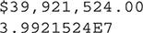

The output is off by 0.88. This is an example of the float primitive losing the precision of a number. Although the output is not correct, it is expected based on how floats work. If the code segment is changed to use the double primitive, the correct output will be displayed. The following code segments use double, which increases the precision of the numbers:

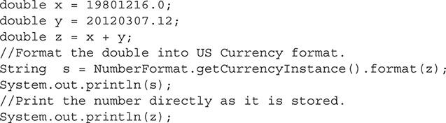

This code segment will output the following:



This is the correct output. Notice that the raw double, 3.9921523120000005E7, is much more precise then the raw float, 3.9921524E7. However, it is important for you to understand that the double does not solve all problems like this. In this case, the precision needed was more than the float was able to provide, but it was within the bounds of a double. If the required precision grew or the number got larger, a double would have the same problem. This example illustrates why currency should never be stored as a double or float. The proper way to store currency, or any other floating-point number that needs guaranteed precision, is to use the Java class BigDecimal. BigDecimal can store any number, with the only limit being the memory your application is able to use. BigDecimal is not as fast to work with as primitives are, but it provides accuracy that primitives cannot provide. For more information on how BigDecimal works, see the Java Platform, Standard Edition 8 API Specification.

The following Scenario & Solution details each of the primitives that will appear on the OCA exam. It is important that you understand this content.

###### Primitives vs. Their Wrapper Class

You know that primitives are the basic building blocks in Java and are one of the few things that are not objects. Java has a built-in wrapper class for each primitive that can convert a primitive to an object. The wrapper classes are Integer, Double, Boolean, Character, Short, Byte, Long, and Float. Notice that each of these classes starts with a *capital* letter, whereas a primitive begins with a *lowercase* letter. If you see a data type Float, it is referring to the object, while the data type float refers to the primitive. As of J2SE 5.0, a primitive will automatically be converted in either direction between its wrapper class and associated primitive. This feature is called *autoboxing* and *unboxing*.

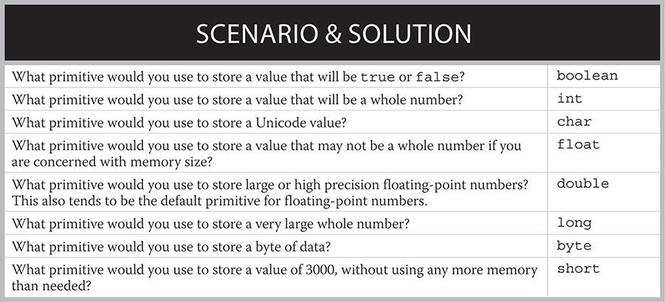

The following is an example of an Integer object being initialized:

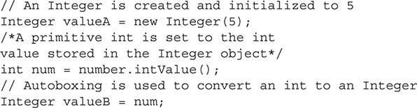

Primitives and their equivalent objects can, in most cases, be used interchangeably. However, this is a bad coding practice. When performing math operations, using primitives will result in much faster calculations. Primitives also consume a smaller memory footprint.



***You’ll most commonly see primitive wrapper classes when you’re working with the Java collections classes where an object is required*.**

###### Reviewing All Primitives

[Table 4-1](https://learning.oreilly.com/library/view/oca-java-se/9781259587535/ch04.html#ch04tab01) details all eight Java primitives. For the OCA exam, it is most important that you remember what data type you would use for the data you are storing. The size and range are nice to know but are not required for the exam.

**TABLE 4-1** Java Primitive Data Types

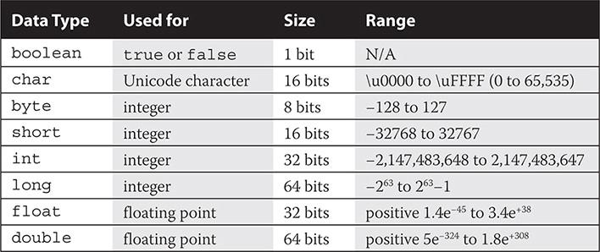



***When you’re reading Java code that other developers have created, you will mostly see the primitives* int*,* double*, and* boolean*. These three primitives cover most standard cases and are the default choice of most developers. Developers tend to worry only about optimizing the size of primitives when they are used repeatedly in arrays or in data structures that remain persistent for a long period of time*.**

##### Objects

Java is an object-oriented language, and your understanding of what objects are and how they work is fundamental and very important. Almost everything you work with in Java is an object. Primitives are one of the few exceptions to this rule. You will learn what is stored in objects and how objects help keep code organized.

###### Understanding Objects

Objects are a more advanced data type than primitives. They internally use primitives and other objects to store their data and contain related code. The data is used to maintain the state of the object, while the code is organized into methods that perform actions on this data. A well-designed class should be clearly defined and easily reused in different applications. This is the fundamental philosophy of an object-oriented language.

###### Objects vs. Classes and the New Operator

The distinction between objects and classes is important for you to understand. When a developer writes code, he or she is creating or modifying a class. A class is the file containing the code that the developer writes. It is a tangible item. A class is like a blueprint to tell the JVM how to create an object at runtime. The new operator tells the JVM to use the blueprint to create a new instance of this class, the result of which is an object. Many objects can be built from one class. The following is an example of a class that is employed to create an object used to represent a car:

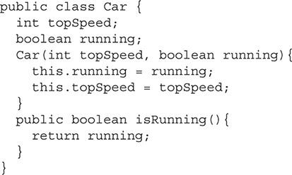

The preceding class can be used to represent a Car object. The class can store a boolean value that represents whether the car is running and an int value that represents the top speed. From this class, the JVM can create one or many instances of the Car class. Each instance will become its own Car object.

In the following code segment, two Car objects are created:



Both fastCar and slowCar are instances of the Car class. To initialize an object, the new operator must be used. The new operator tells the JVM that it needs to create a Car object with the arguments given to the constructor. The new operator will always return a new and independent instance of the class.

###### Initializing Objects

Earlier in the chapter, you learned how each primitive has a finite predetermined size. Unlike a primitive, an object’s size is not clearly defined. An object’s size depends on the size of all the primitives and objects that it stores. Because objects store other objects, their size must also be considered. When an object is initialized, the JVM makes a reference in memory to the location of the object. Objects also have the ability to change in size as the objects they store grow or shrink. An object is declared in the same manner as a primitive, but it cannot be used until it has been initialized, with the new operator or set equal to an existing object.

In the following example, we use the Car class again:

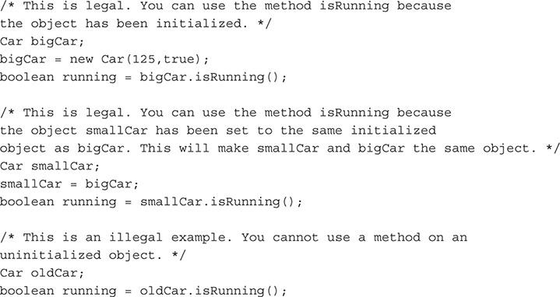

Notice that, unlike a primitive, an object must be initialized with the new operator. Before initialization, an object is set to null by default. If a null object is used, it will throw a null pointer exception.

###### When to Use Objects

Primitives are used to store simple values. Integers or floating-point numbers within the bounds of a primitive data type are easy to store. Unfortunately, not all applications deal with values that fit neatly in the bounds of a primitive. For example, if an integer value is very large and has the potential to become even larger, the primitive int or long may not be appropriate. Instead, the developer may have to use one of the classes from the built-in Java packages for handling large numbers. These classes are BigInteger and BigDecimal. BigInteger is able to store a whole number and is limited in size only by the memory that the application can use. BigDecimal is similar to BigInteger except that it can store a floating-point number.

Objects can and should be created to store data that is similar. Remember that it is good object-oriented design to group together like code and data in a distinct class. Objects should be used to store complex related data.

###### Null Objects

Before an object is assigned or initialized, it is given the null value. A NullPointerException is a runtime exception that is thrown when an object is used that is null. This is a very common runtime error and can cause an application to terminate. It can be very frustrating and time consuming to track down. The best way to prevent this is to be careful, initialize your objects, and use a condition statement to check objects that may have been set to null elsewhere in code.

Here is an example of how to check whether an object is null:

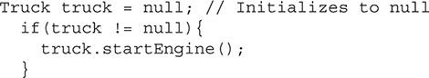

Here, a Truck object is declared and called truck. The variable truck is then checked to determine whether it is null. If it is not null, it proceeds inside of the if statement and executes the startEngine method. In this case, truck is never initialized, so it would not pass the condition of the if statement. The flow of execution would skip the body of the if statement, and the startEngine method would never be called. This prevents a NullPointerException from being thrown.

It is a good habit to check to see if unknown variables are null before they are used. Even if your application is in an error state, checking the variable will allow a better log message to be recorded before the application exits.

**EXERCISE 4-1**

**Compile and Run an Object**

This exercise will get you more familiar with objects. You will use the Car class and then add more functionality to it.

**1.** Copy the Car class into a text file and save it as Car.java.

**2.** Create a new text file and name it Main.java. This will be your main class. Copy the following code into this file:

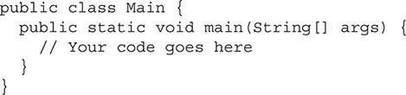

**3.** Use the following code to create a Car object:



**4.** Use the following code to display to the user whether or not the car is running:



**5.** Go back to the Car class and add a method to get the car’s top speed.

**6.** Add a line to your Main.java file that will display the car’s top speed.

##### Arrays

An array is a series of variables of the same type that can be accessed by an index. Arrays are useful when all the variables in a set of data will be used in a similar way. Arrays can be made from primitive data types or objects. Even if an array is made of primitive data types, the new operator must be used.

The following is an example of an array made up of the int data type:



In this example, we declare a variable named testScore to be an integer array. This is done by adding box brackets to the end of the data type: int[] is the result. The [] after the data type means it will be an array. The box brackets should follow the data type, but it is valid for them to follow the variable name instead. Standard Java coding conventions suggest they should be used only with the data type. Regardless of whether the new array is of primitives or objects, it must be initialized with new and then with the data type. The number in brackets indicates the size of the array. In this example, the array has three items. Each item is of type int. Individual elements in the array can be accessed or modified; they can also be placed in another int. The index for an array is zero based. This means that the first element has an index of zero.

The example that follows demonstrates how an array can be used:

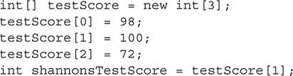

Arrays are useful in loops. It is very common to access an array in a loop with a variable as the index. This variable would be incremented each time through the loop until the end of the array. The developer must take caution not to use an index that is out of bounds. An out-of-bounds index will cause the JVM to throw an exception at runtime. Once the size of an array is set, it cannot be changed. This makes arrays less useful for situations in which the data set may grow. [Figure 4-1](https://learning.oreilly.com/library/view/oca-java-se/9781259587535/ch04.html#ch04fig01) shows a basic array declaration.

**FIGURE 4-1** Array declaration

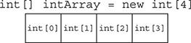

Arrays can also be multidimensional. A multidimensional array has more than one index. Arrays and their uses will be discussed in more detail in [Chapter 6](https://learning.oreilly.com/library/view/oca-java-se/9781259587535/ch06.html#ch06).

##### Enumerations

Enumerations are a special data type in Java that allows for a variable to be set to predefined constants. The variable must equal one of the values that have been predefined for it. An enumeration is useful when there is a limited set of options that a variable can equal and it is restricted to these known values. For example, a deck of playing cards will always have four suits: clubs, diamonds, hearts, and spades. If a developer wanted to represent a card, an enumeration could be used to represent the suit:



This is an example of an enumeration that would be used to store the suit of a playing card. It is defined with the keyword enum. The enum keyword is used in the same manner as the class keyword. It can be defined in its own Java file or embedded in a class.

The next example demonstrates the use of an enumeration. The variable card is declared as a Suit. Suit was defined earlier as an enumeration. The cardSuit variable can now be used to store one of the four predefined suit values.

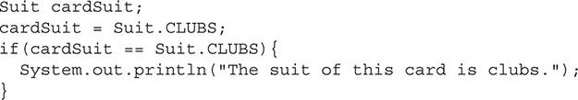

###### Benefits of Using Enumerations

An object can be created to work in the same manner as an enumeration. In fact, enumerations were not even included in the Java language until version 5.0. However, enumerations make code more readable and provide less room for programmer error.

##### Java Is Strongly Typed

Java is a *strongly typed* programming language. Java requires that a developer declare the data type of each variable used. Once a variable is declared as one type, all data stored in it must be compatible with that type. Think back to the primitive data types we reviewed earlier in the chapter. For example, once a variable is declared as an int, only int data can be stored within it. Data can be converted, by casting, from one type to another, as discussed in the following sections.

###### Understanding Strongly Typed Variables

Strongly typed variables help to create more reliable code. In most cases, the Java compiler will not allow the developer to store mismatched data types. Only variables with the same data type are compatible with each other. For example, a float cannot be stored in any other data type other than a float. The same is true for all primitives and objects. The JVM will perform some automatic conversions for the developer. It is important that you understand that the types are not compatible and that the code will work only because of the conversion that is happening.

An example of a conversion would be going from an int to a float. The JVM will allow for an int to be placed into a float because it can convert an int to a float without losing precision. However, the converse is not true. A float cannot be converted to an int without the loss of precision.

###### Casting Variables to Different Types

Java does allow a variable to be cast to a different type. Casting tells the compiler that a variable of one type is intended to be used as a different type. To cast a variable, place the new data type in parentheses in front of the data or variable. Data can be cast only to types with which it is compatible. If data is illegally cast, the program will throw an exception at runtime.

An object can be cast to any parent or child object if the object was initialized as that child object. (This is an advanced concept of object-oriented languages and will be discussed in more detail in later chapters.) Primitives can also be cast to other primitives or compatible objects. For example, a float can be cast to an int. In this scenario, the cast would truncate the float to a whole number. Following are some examples of casting variables and data:

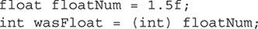

The variable wasFloat would be equal to 1 since the .5 would be truncated to make the data compatible.



***Developers should use casting variables lightly. There are times when variables must be cast, and some advanced programming techniques even rely on it. However, casting variables adds unneeded complexity to the code. Cast data only when you have a good reason to do so*.**

##### Naming Conventions

Using the correct naming conventions while creating a Java application is a critical step in creating easily readable and maintainable code. Java does not have many restrictions on how classes and objects can be named. However, nearly every experienced Java developer uses a single naming convention suggested by Oracle. For all the conventions, see Oracle’s *Code Conventions for the Java Programming Language* specification. This section will cover the common conventions that will be seen on the OCA exam.

When you are creating a class, the class name should be a noun. The first letter should be capitalized along with each internal word after the first. Names should be short, yet descriptive. Shown next are some examples of good class names that follow the naming convention:

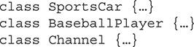

Variables should also have short but meaningful names. However, it is okay to use one-letter names for temporary variables. A variable’s name should give an outside observer some insight as to what the variable is used for. The name should start with a lowercase letter, but each sequential internal word should be capitalized. Shown next is a sample of some variable names that follow the convention:

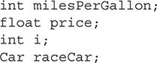



***The OCA exam will ask questions about which variable is a primitive data type and which is an object. If you don’t have a firm understanding of each, you may find the answers confusing. Remember that the OCA exam will always follow proper Java naming conventions and start object data types with a capital letter and begin primitive data types with a lowercase letter. For example, a* float *is a primitive data type and a* Float *is an object*.**

**CERTIFICATION OBJECTIVE**

#### Use Primitives, Enumerations, and Objects

*Exam Objective Differentiate between object reference variables and primitive variables*

This section will build on the fundamental concepts that were discussed in the previous sections. The OCA exam will not require that you write code from scratch. However, the exam creators have decided to present scenarios in which the candidate will need to determine the best-suited code from a list of segments. The exam will also present segments of code and ask varying questions about its elements. This section specifically covers literals and practical examples of primitives, enumerations, and objects.

##### Literals

A *literal* is a term used for a hard-coded value used within code. A literal is any value that is not a variable. The following example demonstrates the use of literals:

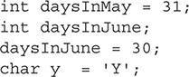

As used here, 31, 30, and "Y" are examples of literals. Valid literal value formats for all primitives except the boolean type include character, decimal, hexadecimal, octal, and Unicode. Literals values for booleans must be true or false.



***Starting in Java 7, it is possible to insert underscores in numeric literals. This allows the developer to create more readable code. The underscores are ignored at runtime and are used solely to make the code easier to read. The underscores can be placed in both whole and floating-point numbers. They cannot be placed before the first number, or after the last number, or adjacent to a decimal point. They also cannot be placed prior to the* f *and* l *suffixes for a* float *or* long*. The following are some examples of underscores in use:***

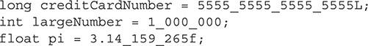

##### Examples of Primitives, Enumerations, and Objects

This section will provide a few examples of all the topics covered in this chapter so far. Each example will be accompanied by an explanation. These examples will mimic the types of scenarios likely found on the OCA exam.

###### Primitives in Action

Primitives are the most basic data types in Java. As stated, they can only be set or read. The following sample program uses each primitive that will be on the OCA exam. This program calculates a baseball pitcher’s earned run average (ERA).

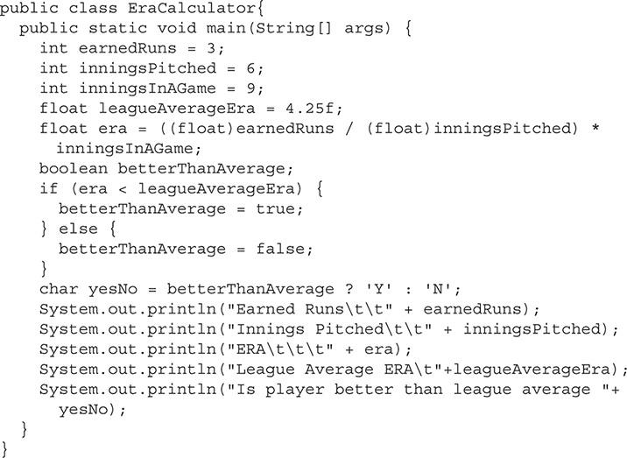

Notice that on the line where the variable ERA is calculated, the two int variables, earnedRuns and inningsPitched, are cast to a float. The cast to a float is needed so the division will be performed on variables of type float instead of their original type of int. The variables earnedRuns, inningsPitched, inningsInAGame, and leagueAverageEra are all set by literals. The preceding program shows how primitives are used. When the code is executed, it will produce the following output:

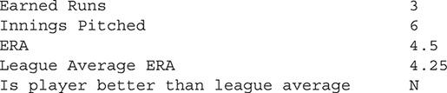

###### Primitives and Their Wrapper Class

The code segment that follows shows four variables being declared. Of the four, two are primitives and two are objects. The objects are instances of primitive wrapper classes. On the exam, pay close attention to how the variables are declared. There will likely be a segment where the question will ask how many of the variables are primitives.

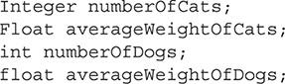

In the preceding example, int and float are primitives and Integer and Float are objects. Note that the capital F in Float signifies an object.

###### Enumerations

Enumerations are used for variables that can have the value of only a few predefined constants. The following example demonstrates a small class. This class has an enumeration defined that contains three different shoe types. The createRunningShoes() method is used to set the shoe variable to the enumerated type of a running shoe:

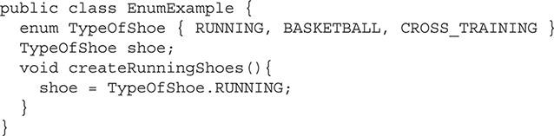

###### Objects

The OCA exam does not require that you develop your own objects, but it is important that you understand the content of an object and be able to recognize it in code. It is also important that you understand how to use methods that an object contains. In the following example, a class is defined. This class is the Thermostat class. As its name suggests, it would be used to represent a thermostat for a heater or furnace. This is a very basic class, because it has only two methods and one instance variable. A more useful class would have many more of both.

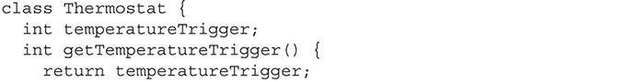

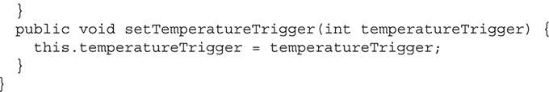

The preceding Thermostat class stores the temperature that will trigger the system to turn on in the variable named temperatureTrigger. The two methods are used to get the value and set the value. These are called *getters* and *setters* and will be discussed in [Chapter 7](https://learning.oreilly.com/library/view/oca-java-se/9781259587535/ch07.html#ch07).

The following code segments will use the Thermostat class to create an object:



This code segment declares a new variable as a Thermostat object. The object is then initialized with the new keyword. The next line uses the setTemperatureTrigger method to modify the state of the object. The final line uses the getTemperatureTrigger method to read this value and display it to the user. For the OCA exam, it is important that you be familiar with this syntax and understand how the methods are used.

**EXERCISE 4-2**

**Creating Getters and Setters**

Creating a dozen getter and setter methods by hand could take you a while to complete. Fortunately, most modern IDEs have an automated way of creating getter and setter methods. Using this automated feature produces the methods with just a few mouse clicks. Follow along with this exercise to get a feel for how this works in the Eclipse IDE.

**1.** Create a few instance variables.

**2.** If you are using Eclipse, do the following:

**a.** Highlight the desired instance variable you want to produce getters and setters for, and then right-click the mouse.

**b.** A pop-up menu will be displayed. Select Source followed by Generate Getters and Setters….

**c.** Another dialog box will be displayed with additional options that are not needed for this example. Finally, click the OK button to generate the methods.

**3.** If you are using NetBeans, do the following:

**a.** In the NetBeans text editor, highlight the instance variable and right-click.

**b.** From the drop-down box, select Refactor | Encapsulate Fields….

**c.** A pop-up box will display the highlighted instance variable already selected. You can then click the Refactor button to add the getter and setter with the default settings.

See [Chapter 7](https://learning.oreilly.com/library/view/oca-java-se/9781259587535/ch07.html#ch07) for more information on getter and setter methods.

#### CERTIFICATION SUMMARY

In this chapter, some of the most fundamental concepts of Java were discussed in relationship to basic classes and variables. Even though the OCA exam includes only two objectives covering these concepts, many advanced concepts and objectives are built upon the content of this chapter. Your understanding of this chapter will result in a better understanding of the next few chapters.

Java primitives were examined first. Primitives are the basic building blocks of a Java program. The eight primitive variable data types that will appear on the OCA are int, double, boolean, char, byte, short, long, and float. It is important that you remember these primitives and what type of data they are designed to store.

Objects were then discussed. Objects are a very important concept for you to understand for the OCA exam. Objects are an advanced Java data type that can be custom created or found in the many Java packages that are included with the Java Virtual Machine. Objects are the pieces that interact to make up an application. Java is an object-oriented language, which means that nearly every aspect of the program is represented as objects, and the interaction between the objects is what gives an application its functionality.

Arrays were then discussed. Arrays are good for keeping like data together. They use a zero-based index to access the individual elements of the array. Arrays can be of objects or primitives and must be initialized.

Enumerations were the last group of data types discussed. Enumerations are special objects that are used to denote a value among a defined set of values. Although regular objects can be used to achieve the same results, enumerations provide a way to limit the data set without implementing a lot of custom code.

Next, the details of what makes Java a strongly typed language were examined. In general, the Java language allows for variables to change data type only by explicitly casting them to a new data type. If a variable is cast to a data type that it is not compatible with, an exception will be generated.

The final Java concept covered was Java naming conventions. Even though there are very few limitations on how variables and classes can be named, it is good coding practice to follow the conventions used by nearly every Java developer. Not following these conventions is a quick way to test the patience of your fellow developers.

The chapter concluded with a group of examples and explanations. These examples are important for you to understand. The OCA will not ask you to write large sections of code, but you must be able to understand code segments and determine what the output will be or if errors are present in the code.

#### Images TWO-MINUTE DRILL

**Understand Primitives, Enumerations, and Objects**

 Primitives are the fundamental data type in Java.

 int is a primitive data type that is used to store integer values. It is the default value for whole numbers.

 double is a primitive data type for large floating-point values. It is the default value for floating-point numbers.

 boolean is a primitive data type that is used to store true or false values.

 char is a primitive data type that is used to store a single Unicode character.

 byte is a primitive used to store small numbers that are 1 byte (8 bits) or smaller.

 short is a primitive used to store whole numbers up to 16 bits.

 long is a primitive used to store large whole numbers up to 64 bits.

 float is a primitive data type used to store floating-point values.

 Primitive data types all start with a lowercase letter, while classes start with a capital letter.

 Each primitive data type has a corresponding wrapper class: Integer, Double, Boolean, Character, Byte, Short, Long, and Float. Notice the capital letters.

 Objects are more advanced data types. They may be defined by a developer or found in a built-in Java package.

**Use Primitives, Enumerations, and Objects**

 Objects must be initialized by using the new keyword.

 Arrays allow you to store multiple variables together that can be accessed by an index.

 Enumerations allow a developer to create a predefined set of constants. A variable can then be set only to one of the predefined values.

 Java is a strongly typed language. Variables must be declared as a type, and any value that is stored must be compatible with this type.

 It is possible to cast a variable to a different data type. If incompatible types are cast, an exception will be thrown.

 A literal is a value that is hard-coded in code as the value itself.

 Java naming conventions dictate that a class should be named with the first letter capitalized, along with each sequential word in the name.

 Java naming conventions dictate that a variable should be named with the first letter lowercased and with each sequential word in the name beginning with a capital letter.

#### SELF TEST

**Understand Primitives, Enumerations, and Objects**

[**1.**](https://learning.oreilly.com/library/view/oca-java-se/9781259587535/ch04.html#ch04qa1a) You need to create an application that is used to calculate the attendance at a baseball game. What data type would be most appropriate for storing the attendance?

A. boolean

B. char

C. float

D. int

[**2.**](https://learning.oreilly.com/library/view/oca-java-se/9781259587535/ch04.html#ch04qa2a) What is the best data type to use if you are required to perform many addition, subtraction, and multiplication calculations on a whole number?

A. double

B. Double

C. int

D. Integer

[**3.**](https://learning.oreilly.com/library/view/oca-java-se/9781259587535/ch04.html#ch04qa3a) You are writing a class that will store the status of an on/off switch. Which data type is most appropriate for storing this value?

A. boolean

B. char

C. short

D. int

[**4.**](https://learning.oreilly.com/library/view/oca-java-se/9781259587535/ch04.html#ch04qa4a) You have decided on the data type for a variable that will store the information about the on/off switch. Now you must determine a name for it. Which of the following names follows the Java naming conventions?

A. LIGHTSWITCHENABLED

B. LightSwitchEnabled

C. lightSwitchEnabled

D. x

[**5.**](https://learning.oreilly.com/library/view/oca-java-se/9781259587535/ch04.html#ch04qa5a) What is the best data type to use when storing a status code that may have one of the following values: success, failed, success with errors, or undetermined?

A. Object

B. Class

C. boolean

D. enum

E. int

[**6.**](https://learning.oreilly.com/library/view/oca-java-se/9781259587535/ch04.html#ch04qa6a) A system has three sensors attached to it. You need a way to represent this system in your program. What would be the best data type to use to model this system and sensors?

A. Object

B. boolean

C. enum

D. int

[**7.**](https://learning.oreilly.com/library/view/oca-java-se/9781259587535/ch04.html#ch04qa7a) The new keyword is used to initialize which of the following data types? (Choose all that apply.)

A. Object

B. boolean

C. Boolean

D. Float

E. float

F. float[]

[**8.**](https://learning.oreilly.com/library/view/oca-java-se/9781259587535/ch04.html#ch04qa8a) In the following line of code, what does the (int) represent?



A. Rounding the sensorReading variable to the nearest int.

B. Casting the sensorReading variable to the int data type.

C. Nothing; it is there as a comment.

[**9.**](https://learning.oreilly.com/library/view/oca-java-se/9781259587535/ch04.html#ch04qa9a) Given the following line of code, which of the next lines of code listed are incorrect? (Choose all that apply.)



A. c = new char();

B. c = ‘Y’;

C. c = ‘\u0056’;

D. c = “Yes”;

[**10.**](https://learning.oreilly.com/library/view/oca-java-se/9781259587535/ch04.html#ch04qa10a) When dealing with currency, what data type should be used?

A. float

B. double

C. BigDecimal

D. BigNumber

[**11.**](https://learning.oreilly.com/library/view/oca-java-se/9781259587535/ch04.html#ch04qa11a) Complete the sentence. The Integer class _______________.

A. is the same as an int primitive

B. is the primitive wrapper class for all whole numbers

C. is the primitive wrapper class for just int primitives

D. None of these statements is valid.

[**12.**](https://learning.oreilly.com/library/view/oca-java-se/9781259587535/ch04.html#ch04qa12a) Which of the statements are correct? (Choose all that apply.)

A. 3.0 is a valid literal for an int.

B. 3.0 is a valid literal for a float.

C. 3 is a valid literal for an int.

D. 3 is a valid literal for a float.

E. 3f is a valid literal for an int.

F. 3f is a valid literal for a float.

[**13.**](https://learning.oreilly.com/library/view/oca-java-se/9781259587535/ch04.html#ch04qa13a) What literal values are acceptable to use with the boolean primitive?

A. true and false

B. true, false, and null

C. true, false, TRUE, and FALSE

D. TRUE and FALSE

**Use Primitives, Enumerations, and Objects**

[**14.**](https://learning.oreilly.com/library/view/oca-java-se/9781259587535/ch04.html#ch04qa14a) Which of the following variables are being set with the use of a literal? (Choose all that apply.)

A. int tvChannel = 4;

B. char c = ‘5’;

C. char d = ‘\u0123’;

D. char e = c;

E. int oldChannel = tvChannel;

[**15.**](https://learning.oreilly.com/library/view/oca-java-se/9781259587535/ch04.html#ch04qa15a) Given the following line of code, what next lines are valid? (Choose all that apply.)



A. Sports sport = FOOTBALL;

B. Sports sport = Sports.FOOTBALL;

C. Sports sport = Sports.HOCKEY;

D. Sports sport = ‘TRACK’

[**16.**](https://learning.oreilly.com/library/view/oca-java-se/9781259587535/ch04.html#ch04qa16a) What is wrong with the following method?

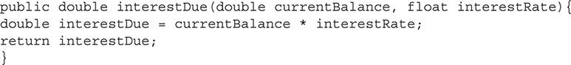

A. It should use all float primitives.

B. It should use all Float objects.

C. It should use all double primitives.

D. It should use all Double objects.

E. It should use BigDecimal objects.

F. Nothing is wrong with this method.

G. It does not compile because you cannot do math operations with primitives that are not the same type.

[**17.**](https://learning.oreilly.com/library/view/oca-java-se/9781259587535/ch04.html#ch04qa17a) What is the correct way to create an array with five int data types? (Choose all that apply.)

A. int intArray = new int[5];

B. int intArray = new int(5);

C. int[] intArray = new int[5];

D. int intArray[] = new int[5];

[**18.**](https://learning.oreilly.com/library/view/oca-java-se/9781259587535/ch04.html#ch04qa18a) What is the correct way to initialize a variable declared with the data type of Book as a new Book object?

A. Book b;

B. Book b = new Book();

C. Book b = new Book[];

D. Book b = Book();

[**19.**](https://learning.oreilly.com/library/view/oca-java-se/9781259587535/ch04.html#ch04qa19a) What is the difference between an int and an Integer?

A. Nothing. They are both fully interchangeable.

B. An int is an object and Integer is a primitive. An int is fastest when performing calculations.

C. An int is a primitive and Integer is an object. An int is fastest when performing calculations.

D. This is a trick question. There is no such thing as an Integer.

E. This is a trick question. An Integer can be defined to be anything a developer wants it to be.

[**20.**](https://learning.oreilly.com/library/view/oca-java-se/9781259587535/ch04.html#ch04qa20a) What is the result of using a method of an uninitialized object?

A. Null is returned.

B. The object is automatically initialized and an appropriate value is returned.

C. A NullPointerException is thrown from the Java virtual machine.

[**21.**](https://learning.oreilly.com/library/view/oca-java-se/9781259587535/ch04.html#ch04qa21a) What is wrong with the following code segment? (Choose all that apply.)

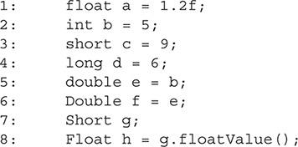

A. Nothing is wrong.

B. There is an error on line 1.

C. There is an error on line 2.

D. There is an error on line 3.

E. There is an error on line 4.

F. There is an error on line 5.

G. There is an error on line 6.

H. There is an error on line 7.

I. There is an error on line 8.

[**22.**](https://learning.oreilly.com/library/view/oca-java-se/9781259587535/ch04.html#ch04qa22a) What is the value of variable x in the following code segment?

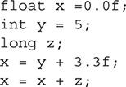

A. 0

B. 0.0f

C. 5.0f

D. 8.3f

E. 8.3

F. This code will not compile.

[**23.**](https://learning.oreilly.com/library/view/oca-java-se/9781259587535/ch04.html#ch04qa23a) Which integer declaration uses a valid octal literal?

A. int value1 = 0000;

B. int value2 = ‘\u0777 ‘;

C. int value3 = ‘\01111 ‘;

D. int value4 = ‘\x0123 ‘;

[**24.**](https://learning.oreilly.com/library/view/oca-java-se/9781259587535/ch04.html#ch04qa24a) Given:

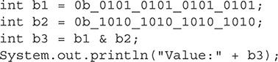

What will be the result?

A. Value: 0 will be printed.

B. Value: 65535 will be printed.

C. 0b_1111_1111_1111_1111 will be printed.

D. A compiler error will occur.

[**25.**](https://learning.oreilly.com/library/view/oca-java-se/9781259587535/ch04.html#ch04qa25a) Which code example makes use of arrays without producing a compiler or runtime error?

A. public class Actor {

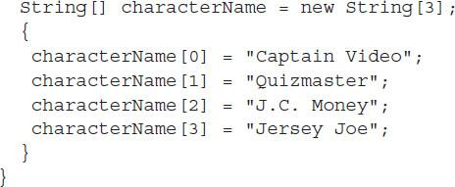

B. public class Actor {

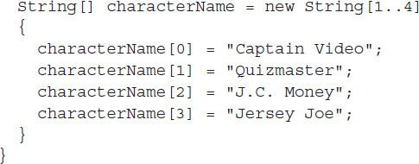

C. public class Actor {



D. public class Actor {



#### SELF TEST ANSWERS

**Understand Primitives, Enumerations, and Objects**

[**1.**](https://learning.oreilly.com/library/view/oca-java-se/9781259587535/ch04.html#ch04qa1) You need to create an application that is used to calculate the attendance at a baseball game. What data type would be most appropriate for storing the attendance?

A. boolean

B. char

C. float

D. int

Answer:

 **D**. The attendance of a baseball game is going to be a whole number within the range of an int.

 **A**, **B**, and **C** are incorrect. **A** is incorrect because boolean variables are used to store literals with values of true or false. **B** is incorrect because the char data type is used to store a single Unicode character. **C** is incorrect because float is used to store floating-point numbers.

[**2.**](https://learning.oreilly.com/library/view/oca-java-se/9781259587535/ch04.html#ch04qa2) What is the best data type to use if you are required to perform many addition, subtraction, and multiplication calculations on a whole number?

A. double

B. Double

C. int

D. Integer

Answer:

 **C**. An int is used to store whole numbers and is a primitive. Primitive variables perform calculations faster than their associated wrapper class.

 **A**, **B**, and **D** are incorrect. **A** is incorrect because a double is used for floating-point numbers. **B** is incorrect because Double is a primitive wrapper class used for floating-point numbers. **D** is incorrect because the Integer data type is the wrapper class for an int. You can tell that it is not a primitive because the first letter is capitalized like all class names. Performing calculations with an Integer would be much slower than doing so with the primitive int.

[**3.**](https://learning.oreilly.com/library/view/oca-java-se/9781259587535/ch04.html#ch04qa3) You are writing a class that will store the status of an on/off switch. Which data type is most appropriate for storing this value?

A. boolean

B. char

C. short

D. int

Answer:

 **A**. A boolean primitive is used to store true or false, which can be applied to a switch.

 **B**, **C**, and **D** are incorrect. They are all primitives used for different types of data.

[**4.**](https://learning.oreilly.com/library/view/oca-java-se/9781259587535/ch04.html#ch04qa4) You have decided on the data type for a variable that will store the information about the on/off switch. Now you must determine a name for it. Which of the following names follows the Java naming conventions?

A. LIGHTSWITCHENABLED

B. LightSwitchEnabled

C. lightSwitchEnabled

D. x

Answer:

 **C**. A variable should begin with a lowercase letter, with each sequential word capitalized. The name should also be descriptive of what the variable is used for.

 **A**, **B**, and **D** are incorrect. **A** is incorrect because all capitals is not a correct naming convention for a variable. **B** is incorrect because it starts with a capital letter. **D** is incorrect because it is not descriptive.

[**5.**](https://learning.oreilly.com/library/view/oca-java-se/9781259587535/ch04.html#ch04qa5) What is the best data type to use when storing a status code that may have one of the following values: success, failed, success with errors, or undetermined?

A. Object

B. Class

C. boolean

D. enum

E. int

Answer:

 **D**. An enum, or enumeration, is used to store data that has the possibility to be one of a few predefined data types.

 **A**, **B**, **C**, and **E** are incorrect. **A** is incorrect because objects are used to store complex data structures. **B** is incorrect because classes are used to create objects. **C** and **E** are incorrect because both are primitives and not suitable for this specific application.

[**6.**](https://learning.oreilly.com/library/view/oca-java-se/9781259587535/ch04.html#ch04qa6) A system has three sensors attached to it. You need a way to represent this system in your program. What would be the best data type to use to model this system and sensors?

A. Object

B. boolean

C. enum

D. int

Answer:

 **A**. An Object data type is one that the developer can define to represent the system and its state in the application’s code.

 **B**, **C**, and **D** are incorrect. None of them is a primitive type, and none can be defined to hold complex data structures.

[**7.**](https://learning.oreilly.com/library/view/oca-java-se/9781259587535/ch04.html#ch04qa7) The new keyword is used to initialize which of the following data types? (Choose all that apply.)

A. Object

B. boolean

C. Boolean

D. Float

E. float

F. float[]

Answer:

 **A**, **C**, **D**, and **F** are correct. New is used to initialize any variable that is not a primitive.

 **B** and **E** are incorrect. Both boolean and float are primitive data types.

[**8.**](https://learning.oreilly.com/library/view/oca-java-se/9781259587535/ch04.html#ch04qa8) In the following line of code, what does the (int) represent?



A. Rounding the sensorReading variable to the nearest int.

B. Casting the sensorReading variable to the int data type.

C. Nothing; it is there as a comment.

Answer:

 **B**. It is casting the variable sensorReading to an int.

 **A** and **C** are incorrect. **A** is incorrect because casting to an int will not round the value but instead result in loss of precision. **C** is incorrect because this is not used as a comment.

[**9.**](https://learning.oreilly.com/library/view/oca-java-se/9781259587535/ch04.html#ch04qa9) Given the following line of code, which of the next lines of code listed are incorrect? (Choose all that apply.)



A. c = new char();

B. c = ‘Y’;

C. c = ‘\u0056’;

D. c = “Yes”;

Answer:

 **A** and **D**. **A** is a correct answer because the new keyword cannot be used with the primitive char. **D** is a correct answer because char cannot store a string.

 **B** and **C** are incorrect. Both are valid lines of code.

[**10.**](https://learning.oreilly.com/library/view/oca-java-se/9781259587535/ch04.html#ch04qa10) When dealing with currency, what data type should be used?

A. float

B. double

C. BigDecimal

D. BigNumber

Answer:

 **C**. The BigDecimal class can handle large floating-point numbers without loss of precision.

 **A**, **B**, and **D** are incorrect. **A** and **B** are incorrect because their precision is limited by their size and would require the use of floating-point math. **D** is incorrect because the BigNumber class is limited to whole numbers.

[**11.**](https://learning.oreilly.com/library/view/oca-java-se/9781259587535/ch04.html#ch04qa11) Complete the sentence. The Integer class _______________.

A. is the same as an int primitive

B. is the primitive wrapper class for all whole numbers

C. is the primitive wrapper class for just int primitives

D. None of these statements is valid.

Answer:

 **C**. The Integer class is used as a wrapper class only for int primitives.

 **A**, **B**, and **D** are incorrect. **A** is incorrect because an int and Integer classes are not the same. Integer is an object, and int is a primitive. However, they may appear to be the same since autoboxing and auto unboxing allow them to be used interchangeably. **B** is incorrect because the Integer class is the primitive wrapper class for the int primitive.

[**12.**](https://learning.oreilly.com/library/view/oca-java-se/9781259587535/ch04.html#ch04qa12) Which of the statements are correct? (Choose all that apply.)

A. 3.0 is a valid literal for an int.

B. 3.0 is a valid literal for a float.

C. 3 is a valid literal for an int.

D. 3 is a valid literal for a float.

E. 3f is a valid literal for an int.

F. 3f is a valid literal for a float.

Answer:

 **C**, **D**, and **F**. **C** is correct because an int is used to store an integer number. **D** is correct because the compiler will automatically convert 3 to a floating-point number. **F** is also correct because when an f is appended to a number, it implies that that number is a floating-point number, even if it does not have a decimal.

 **A**, **B**, and **E** are incorrect. **A** is incorrect because an int cannot store a decimal number. **B** is incorrect because 3.0f would be a valid literal for a float, but 3.0 would not (the compiler treats 3.0 as a double). **E** is incorrect because an int cannot have f appended to it.

[**13.**](https://learning.oreilly.com/library/view/oca-java-se/9781259587535/ch04.html#ch04qa13) What literal values are acceptable to use with the boolean primitive?

A. true and false

B. true, false, and null

C. true, false, TRUE, and FALSE

D. TRUE and FALSE

Answer:

 **A**. Valid literal values for the boolean primitive are true and false.

 **B**, **C**, and **D** are incorrect. TRUE, FALSE, and null are all invalid literals for the boolean primitive. The null value is a valid literal for the Boolean wrapper class.

**Use Primitives, Enumerations, and Objects**

[**14.**](https://learning.oreilly.com/library/view/oca-java-se/9781259587535/ch04.html#ch04qa14) Which of the following variables are being set with the use of a literal? (Choose all that apply.)

A. int tvChannel = 4;

B. char c = ‘5’;

C. char d = ‘\u0123’;

D. char e = c;

E. int oldChannel = tvChannel;

Answer:

 **A, B,** and **C**. A literal is a value that is not a variable. **A** has the literal 4. **B** has the literal ‘5’. **C** has the literal ‘\u0123’.

 **D** and **E** are incorrect. **D** is incorrect because the variable c is used to set this char. **E** is incorrect because tvChannel is a variable.

[**15.**](https://learning.oreilly.com/library/view/oca-java-se/9781259587535/ch04.html#ch04qa15) Given the following line of code, what next lines are valid? (Choose all that apply.)



A. Sports sport = FOOTBALL;

B. Sports sport = Sports.FOOTBALL;

C. Sports sport = Sports.HOCKEY;

D. Sports sport = ‘TRACK’

Answer:

 **B**. This is the only line that uses a sport that is in the enumeration and that uses the correct syntax.

 **A**, **C**, and **D** are incorrect. **A** is incorrect because it uses incorrect syntax. **C** is incorrect because HOCKEY is not defined as a sport type. **D** is incorrect because the syntax is incorrect.

[**16.**](https://learning.oreilly.com/library/view/oca-java-se/9781259587535/ch04.html#ch04qa16) What is wrong with the following method?



A. It should use all float primitives.

B. It should use all Float objects.

C. It should use all double primitives.

D. It should use all Double objects.

E. It should use BigDecimal objects.

F. Nothing is wrong with this method.

G. It does not compile because you cannot do math operations with primitives that are not the same type.

Answer:

 **E**. Primitives should not be used when working with currency on any value that cannot lose precision. Instead, objects such as BigDecimal should be used.

 **A**, **B**, **C**, **D**, **F**, and **G** are incorrect. **A**, **B**, **C**, and **D** are incorrect because they can all lose precision and cause unexpected rounding errors. **F** is incorrect because the method will produce rounding errors in some cases. **G** is incorrect because this code will compile.

[**17.**](https://learning.oreilly.com/library/view/oca-java-se/9781259587535/ch04.html#ch04qa17) What is the correct way to create an array with five int data types? (Choose all that apply.)

A. int intArray = new int[5];

B. int intArray = new int(5);

C. int[] intArray = new int[5];

D. int intArray[] = new int[5];

Answer:

 **C** and **D**. **C** is the preferred way to declare an array. **D** is correct, but it does not follow standard conventions.

 **A** and **B** are incorrect ways to declare an array.

[**18.**](https://learning.oreilly.com/library/view/oca-java-se/9781259587535/ch04.html#ch04qa18) What is the correct way to initialize a variable declared with the data type of Book as a new Book object?

A. Book b;

B. Book b = new Book();

C. Book b = new Book[];

D. Book b = Book();

Answer:

 **B**. The correct way to declare an object is to use new and then the object name followed by parentheses. The parentheses are used to pass arguments to the constructor if needed.

 **A**, **C**, and **D** are incorrect. **A** is incorrect because it does not initialize a new Book object. **C** is incorrect because the incorrect square brackets are used instead of parentheses. **D** is incorrect because the new keyword is missing.

[**19.**](https://learning.oreilly.com/library/view/oca-java-se/9781259587535/ch04.html#ch04qa19) What is the difference between an int and an Integer?

A. Nothing. They are both fully interchangeable.

B. An int is an object and Integer is a primitive. An int is fastest when performing calculations.

C. An int is a primitive and Integer is an object. An int is fastest when performing calculations.

D. This is a trick question. There is no such thing as an Integer.

E. This is a trick question. An Integer can be defined to be anything a developer wants it to be.

Answer:

 **C**. An int is a primitive, and primitives are faster when performing calculations. An Integer is an object. The capital letter *I* should help you distinguish objects from primitives.

 **A**, **B**, **D**, and **E** are incorrect. **A** is incorrect because an int and Integer are distinctly different. Auto boxing and unboxing will automatically preform conversions between the two, but this does not make them them same. **B** is incorrect because an int is the primitive and Integer is an object. **D** and **E** are incorrect because this is not a trick question.

[**20.**](https://learning.oreilly.com/library/view/oca-java-se/9781259587535/ch04.html#ch04qa20) What is the result of using a method of an uninitialized object?

A. Null is returned.

B. The object is automatically initialized and an appropriate value is returned.

C. A NullPointerException is thrown from the Java virtual machine.

Answer:

 **C**. A NullPointerException is thrown from the Java virtual machine.

 **A** and **B** are incorrect. **A** is incorrect because a method cannot be called on an uninitialized object. However, an uninitialized object has a value of null and can be checked before a method is called. **B** is incorrect because an object cannot be automatically initialized, because it may need special parameters for its constructor or other custom initialization.

[**21.**](https://learning.oreilly.com/library/view/oca-java-se/9781259587535/ch04.html#ch04qa21) What is wrong with the following code segment? (Choose all that apply.)





A. Nothing is wrong.

B. There is an error on line 1.

C. There is an error on line 2.

D. There is an error on line 3.

E. There is an error on line 4.

F. There is an error on line 5.

G. There is an error on line 6.

H. There is an error on line 7.

I. There is an error on line 8.

Answer:

 **I**. In line 8, the object g is never initialized. Therefore, when a method is called, it causes a compile time error.

 **A**, **B**, **C**, **D**, **E**, **F**, **G**, and **H** are incorrect. These are all valid lines of code.

[**22.**](https://learning.oreilly.com/library/view/oca-java-se/9781259587535/ch04.html#ch04qa22) What is the value of variable x in the following code segment?



A. 0

B. 0.0f

C. 5.0f

D. 8.3f

E. 8.3

F. This code will not compile.

Answer:

 **F**. The primitive z is never assigned a value. Therefore, this code will not compile.

 **A**, **B**, **C**, **D**, and **E** are incorrect. **D** would be correct if z were initialized to 0.

[**23.**](https://learning.oreilly.com/library/view/oca-java-se/9781259587535/ch04.html#ch04qa23) Which integer declaration uses a valid octal literal?

A. int value1 = 0000;

B. int value2 = ‘\u0777 ‘;

C. int value3 = ‘\01111 ‘;

D. int value4 = ‘\x0123 ‘;

Answer:

 **A**. Octal literals must start with a 0.

 **B**, **C**, and **D** are incorrect. **B** is incorrect because octal literals do not start with \u. **C** is incorrect because octal literals do not start with \0. **D** is incorrect because octal literals do not start with \x.

[**24.**](https://learning.oreilly.com/library/view/oca-java-se/9781259587535/ch04.html#ch04qa24) Given:

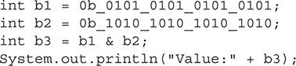

What will be the result?

A. Value: 0 will be printed.

B. Value: 65535 will be printed.

C. 0b_1111_1111_1111_1111 will be printed.

D. A compiler error will occur.

Answer:

 **D**. A compilation error will occur because an underscore cannot be used after the b in the literal. The other underscores are allowed.

 **A**, **B**, and **C** are incorrect. **A** is incorrect because a compiler error occurs. If the underscores after the b’s were removed in the literal, this would have been the correct answer. **B** is incorrect because a compiler error occurs. If the underscores after the b’s were removed in the literal, this still would have been an incorrect answer. Note that with the underscores removed, 65535 would have resulted if the exclusive OR (|) was used in place of the &. **C** is incorrect because an integer value representation would be expected as output if the binary literals were used appropriately.

[**25.**](https://learning.oreilly.com/library/view/oca-java-se/9781259587535/ch04.html#ch04qa25) Which code example makes use of arrays without producing a compiler or runtime error?

A. public class Actor {



B. public class Actor {



C. public class Actor {



D. public class Actor {



Answer:

 **D**. The array declaration and element assignments are used appropriately and compile without error.

 **A**, **B**, and **C** are incorrect. **A** compiles with an ArrayIndexOutOfBoundsException exception thrown at runtime. This is because the array index characterName[3] is out of bounds. **B** fails to compile because only an integer is expected in the box brackets. **C** fails to compile because the box brackets that are needed to create the array are mis



### 5

### UNDERSTANDING METHODS AND VARIABLE SCOPE

**CERTIFICATION OBJECTIVES**

• [Create and Use Methods](https://learning.oreilly.com/library/view/oca-java-se/9781259587535/ch05.html#ch05lev1)

• [Pass Objects by Reference and Value](https://learning.oreilly.com/library/view/oca-java-se/9781259587535/ch05.html#ch05lev5)

• [Understand Variable Scope](https://learning.oreilly.com/library/view/oca-java-se/9781259587535/ch05.html#ch05lev8)

• [Create and Use Constructors](https://learning.oreilly.com/library/view/oca-java-se/9781259587535/ch05.html#ch05lev13)

• [Use the this and super Keywords](https://learning.oreilly.com/library/view/oca-java-se/9781259587535/ch05.html#ch05lev17)

• [Create Static Methods and Instance Variables](https://learning.oreilly.com/library/view/oca-java-se/9781259587535/ch05.html#ch05lev20)

 [Two-Minute Drill](https://learning.oreilly.com/library/view/oca-java-se/9781259587535/ch05.html#ch05lev24)

**Q&A** [Self Test](https://learning.oreilly.com/library/view/oca-java-se/9781259587535/ch05.html#ch05lev26)

**T**his chapter will look at some of the details of methods and variable scoping. You are likely familiar with methods; this chapter will review the nuances of method and constructor creation. The effect of a static variable and method will be reviewed and demonstrated with code samples. The this and super keywords and their effects on the flow of execution will also be covered.

**CERTIFICATION OBJECTIVE**

#### Create and Use Methods

*Exam Objective Create methods with arguments and return values, including overloaded methods*

This section will explore the construction and use of methods. Methods operate on data encapsulated within an object. They make up the backbone of your application. The way objects interact with methods defines the functionality of the software. Some of the OCA exam questions require that you understand how methods work. They present code segments that use many different methods. You must understand the flow of the code as well as determine whether it is valid. This section will demonstrate how to create and use methods:

 Using method syntax

 Making and calling a method

 Overloading a method

##### Using Method Syntax

All methods must be defined inside of a class. Methods are made up of five parts: the access modifier, the return type, the method identifier, the parameter list, and the body. Some of these parts can be empty. The following example shows the parts of a method and then a few valid examples:





Notice that although the first example does not include any parameters, it is valid. A method that has no parameter list means that it does not need any outside input to perform its action. The last example has no access modifier. In this case, the method is using the default access modifier; this method is also valid.

###### Access Modifier

The Java language allows for methods to be given access modifiers that indicate to the compiler and Java virtual machine (JVM) what other objects can access this code. Java has four access modifiers. They are, in order of most restrictiveness, private, default (*package-private*), protected, and public.

The private, protected, and public access modifiers are all indicated by placing them at the start of the method declaration. If no access modifier is declared, the method will use the default modifier. Here is an example of all four being used:

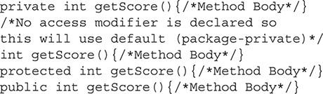

Access modifiers, and what they do, will be discussed in more detail in [Chapter 7](https://learning.oreilly.com/library/view/oca-java-se/9781259587535/ch07.html#ch07). For now, it is important that you understand that every method has an access modifier, even if it is the default modifier. For the rest of this chapter, all of the methods will use the least restrictive public access modifier for simplicity.

###### Return Type

Methods can return data to the code that has called them. A method can return either one variable or none at all. The returned variable may be an object or a primitive. Every method must declare a return type or use the void keyword to indicate that nothing will be returned to the caller from this method. Once a method declares that it will return a value, a return statement must be included in the method body to pass the data back to the calling code. A return statement must include the keyword return followed by a variable or a literal of the declared return type. Once the return statement is executed, the method is finished. No code will execute after the return statement.

The following example shows a few methods; notice the return type in the method declaration:

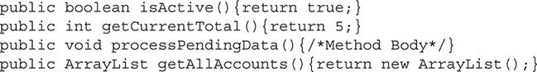

In this example, we see a boolean, an int, and an ArrayList all being returned by the different methods. The void indicates that the method does not return any data. In this simple example, the literal true, an int 5, and a new ArrayList are returned.

###### Method Identifier

The method identifier, sometimes called method name, is the text that is used to reference the method later in code. The identifier should be descriptive as to what the method does. [Chapter 7](https://learning.oreilly.com/library/view/oca-java-se/9781259587535/ch07.html#ch07) provides details about standard Java naming conventions.

The next example demonstrates a method with the identifier sampleMethod:



###### Parameter List

A method’s parameter list follows the method identifier. It is enclosed in parentheses and is a comma-delimited list. A method may have no parameters, in which case the parentheses are empty. Methods can contain up to 255 parameters, though it is best not to use this upward limit, since passing more than a handful of parameters is often a sign of bad design.

Parameters can be objects, enumeration types, or primitives. When creating the parameter list, the type is placed in front of the variable name. This is continued for each parameter, separated by commas. Following are a few examples of method declarations with various sized parameter lists:

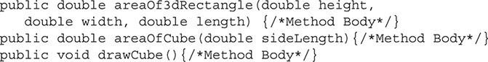

The first example has three parameters: (double height, double width, double length). The next example has only one parameter, (double sideLength), and the final example has no parameters.

###### Method Body

The method body is the main part of the method and contains all the code that makes up the functionality of the method. It may contain as few as one line of code or several hundred lines. If the method declares a return type, it must have a return statement that returns a literal or variable to match that type. If the return type is void, no return statement is required; however, the method can be used without a variable or literal to exit the method.

Following are two examples of a simple method with a complete body:

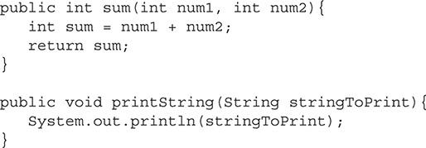

The first example demonstrates using the return statement to return a value. The second example does not return any data, which is indicated by the void keyword.



***When you are creating methods, keep them focused and concise. If your method includes more than a few hundred lines of code, you may want to consider refactoring it into more than one method*.**

##### Making and Calling a Method

A class comprises variables and methods. The instance variables make up the state of the object, and the methods are responsible for all actions. When a class is created, the author must decide what its purpose is and implement that functionality as methods. Keep in mind the syntax rules discussed earlier in this chapter while we look at some scenarios.

The class for this example will be used to perform some simple math calculations. The first method that we’ll create will determine the lower value of two int primitives. The public access modifier will be included since we do not want any restrictions on where this method can be used. This method should return to the caller the int that is smaller. Therefore, this method must have a return type of int. The method will be called findLowerValue. This method will accept two parameters; both are int primitives and will be called number1 and number2. The method body will use conditional statements to determine what variable has a lower value. Here is this method:

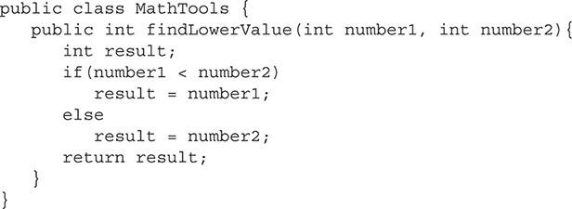

The parameters in this example are compared, and then the int with the lower value is stored in the result variable. This variable is then returned.

Methods are contained in objects. A method must be called from an instance of the object it is part of. The findLowerValue method in the preceding code is part of the MathTools class. To use this method, you must create an instance of MathTools. The syntax for calling a method is object name followed by a dot (.), and then the method identifier with its parameter list. The following code segment calls the findLowerValue method:

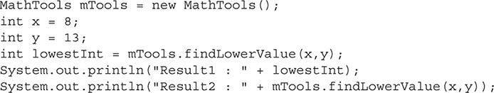

First, this example must create a MathTools object and call it mTools. Two int primitives are then created. Next, the findLowerValue method is called. The x and y variables are passed to this method. Notice that the variable names in the parameter list do not have to match names in the method definition; however, they must be a compatible type. The findLowerValue method returns the parameter that has the least value. This is stored in the lowest Int variable. Then the results are printed to standard output. The results are printed twice to highlight the fact that a method call with a return value can also be used in place of a variable of the same type. The output is as follows:

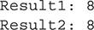

If a method has no parameters, the parameter list is left empty. Methods that do not return any data, return type void, cannot be used to set a variable as we did in the preceding example. However, the data from methods that do return a variable does not have to be used. In that case, the caller would be interested only in the action that the method performs.



***The NetBeans IDE provides refactoring support allowing for automated actions such as safely renaming methods, moving methods to superclasses or subclasses, introducing a new method from an existing block of code (where the existing block of code is replaced with a call to the method), and generating accessor (getters) and mutator (setters) methods. For more information on using the refactoring features of the* NetBeans IDE, see NetBeans IDE Programmer Certified Expert Exam Guide (Exam 310-045), *by Robert Liguori and Ryan Cuprak (McGraw-Hill Professional, 2010)*.**

##### Overloading a Method

When several methods share the same identifier, but have different parameter lists, the methods are said to be overloaded. The parameter list may comprise more or fewer parameters than the other methods, or different types. This is a useful feature when a method may, for example, have five parameters; three of them are nearly always defaulted to a certain value, however. In this case, a method can be provided with all five parameters, plus another for convenience that has just two, which sets the other three to their defaults. Additionally, overloaded methods are not required to have the same return type.

Overloading methods can also be useful when a method can produce a similar result using different data types as its parameters. In the previous example of the findLowerValue method, two int primitives were compared to find the one with the lower values. This method can be overloaded to work the same with double primitives. Here is an example of this method overloaded:

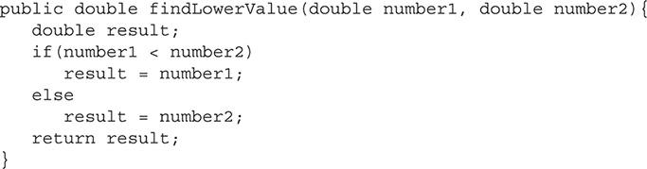

This method can be added to the MathTools class. The findLowerValue is now overloaded to work with both int and double primitives. The compiler determines what method is called by matching the parameter lists. If two double primitives are used, it executes the code in the second method; two int primitives would still use the original method.

The next example is a class called LogManager that can be used to perform some basic log management. It has two methods for printing log information to standard output. Here is this class:



***Pay close attention to overloaded methods on the exam. It is easy to mistake which method is being used*.**

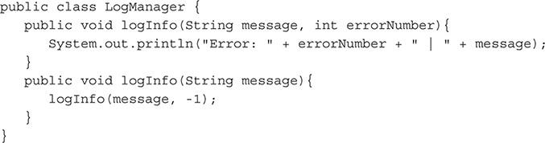

The first method in this class has two parameters: the first is a String and is the message to be printed, and the second is a corresponding error number. This method will then print a line to standard output. The second method has only a String as a parameter. The logInfo method is overloaded since there is more than one method with the same identifier. The second logInfo method will be used when a specific error number for the message is not included. In these cases, the error number will default to -1. Instead of implementing most of the same code as the first method, the second method will simply call the first method and pass in its default value.

The following code segment uses this case:

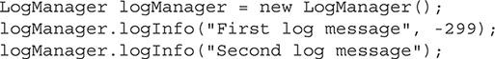

Here’s the output:

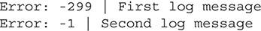



***A good design habit is to ensure that any overloaded methods behave in a similar manner. Your code will be confusing if two methods with the same identifier but different parameters have vastly different results*.**

**CERTIFICATION OBJECTIVE**

#### Pass Objects by Reference and Value

*Exam Objective Determine the effect upon object references and primitive values when they are passed into methods that change the values*

This section will explore the way that Java passes data between methods. A variable will be passed by value if it’s a primitive and by reference if it’s an object. The differences between these two concepts are subtle but can have a big effect on application design. The following is covered:

 Passing primitives by value to methods

 Passing objects by reference to methods

##### Passing Primitives by Value to Methods

When a primitive is used as an argument, a copy of the value is made and provided to the method. If the method sets the value of the parameter to a different value, it has no effect on the variable that was passed to the method. The following is an example of a method that adds 2 to the int primitive that is passed to it:

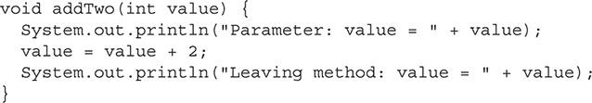

Because primitives are passed by value, a copy of the variable value is passed to the method. Even though the method modifies the parameter (since it is just a copy of the original argument used to invoke the method), the original argument remains unchanged from the perspective of the calling code. The following is a code segment that could be used to call this method:

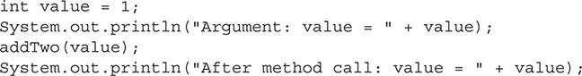

If this code segment were executed, it would produce the following results. Read the output that follows and walk through the code.

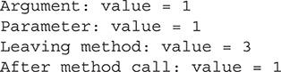

##### Passing Objects by Reference to Methods

A *reference* is basically an internal index that represents the object. Objects are passed by reference to a method. This means that instead of making a copy of the object and passing it, a reference to the original object is passed to the method.



***This section can start a very technical conversation, which is beyond the scope of this book. The OCA is not going to drill into the details of how an object is passed internally. In short, for the OCA exam, it is important that you understand that any object is passed by reference*.**

The following example is similar to the example that demonstrated how primitives were passed by value. Instead of passing an int this time, it will pass a custom Number object. The following is the Number class:

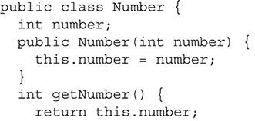

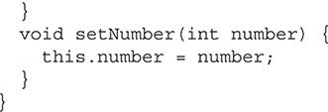

Here is the method that will be called; this time, it will add 3 to the value passed to it:

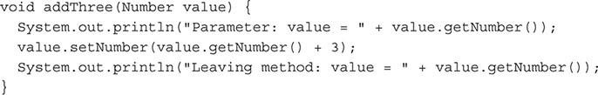

Finally, here’s the code segment used to call this method:

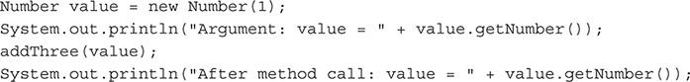

This example is almost identical to the earlier one. The only difference is that now an object is passed by reference and the method adds 3 instead of 2. If this code segment were executed, the following would be the output. Notice that, this time, when the method returns to the calling code, the object has been modified.

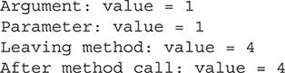



***The OCA exam will include questions asking about the difference between passing variables by reference and value. The question will not directly ask you to identify the difference. It will present some code and ask for the output. In the group of answers to select from, you’ll see an answer that will be correct if you assume the arguments are passed by value, and another answer that will be correct if the arguments are passed by reference. It is easy to get this type of question incorrect if you don’t fully understand the concept of passing variables by reference and value*.**

**CERTIFICATION OBJECTIVE**

#### Understand Variable Scope

*Exam Objective Define the scope of variables*

*Exam Objective Explain an object’s lifecycle (creation, “dereference by reassignment,” and garbage collection)*

This section will explore the way variables are organized in your code. As you can imagine, any nontrivial application will have countless variables. If variables could be accessed anywhere in the code, it would be difficult to find unique names that still conveyed a meaning. This scenario would also promote bad coding practices, and a programmer may try to access a variable that is in a completely different part of the program. To solve these problems, Java has variable scope. *Scope* refers to the section of code that has access to a declared variable. The scope may be as small as a few lines, or it may include the entire class.

In this section, we will cover the following topics:

 Local variables

 Method parameters

 Instance variables

##### Local Variables

Local variables are declared inside of methods. As the name implies, these variables are used locally in code. They are commonly declared at the start of a method and in loops, but they can be declared anywhere in code. A local variable may be a temporary variable that is used just once, or it can be used throughout a method.

The block of code in which a variable is declared determines the scope of the local variable. A block of code is determined by braces: { }. For example, if the variable is declared at the start of a method after the left brace ({), it would remain in scope until the method is closed with the right brace (}). Once a variable goes out of scope, it can no longer be used and its value is lost. The JVM may reallocate the memory that it occupies at any time.

A block of code can be created anywhere. A block can also be nested inside another block. A variable is in scope for the code block in which it is declared and for all code blocks that exist inside it. The most common blocks are if statements and for or while loops.

The following example demonstrates the use of local variables in code blocks:

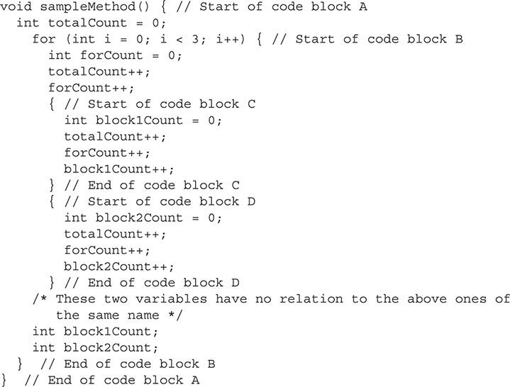

Code block A is the method. Any variable that is declared in this block is in scope for the entire method. The variable totalCount is declared in block A; therefore, it can be accessed from anywhere else in the example method.

Code block B starts with the for loop. The variable i is declared in this block; even though it is not between the brackets, because it was declared in the for statement, it is considered to be in code block B. The variable forCount is also declared in block B. Because both of these variables are declared in block B, they are in scope only for block B and any blocks contained within B. They are out of scope for block A, and a compiler error would be generated if they were accessed from this block.

Contained inside block B is code block C. This block is started arbitrarily. In Java, it is valid to start a block of code at any time, although this is not often done in practice. The variable block1Count is declared in this block. It is in scope only for block C. However, any code inside block C also has access to the variables that have been declared in blocks A and B.

Block C is closed, and block D is created in block B. Block D contains the variable block2Count. This variable is in scope only for block D. Like block C, block D can also access variables that have been declared in blocks A and B. Understand that the variables in block C are not in scope for block D, and variables in D are not in scope for C.

In block B, the line after the closure of block D, two new variables are declared: block1Count and block2Count. These variables happen to have the same names as the variables that were declared in blocks C and D. Because the variables in blocks C and D are now out of scope, these two new variables have no relationship with the scope variables. Giving variables the same names as others that are out of scope is valid in Java; however, it is not good coding practice because it can make the code difficult to maintain.

[Figure 5-1](https://learning.oreilly.com/library/view/oca-java-se/9781259587535/ch05.html#ch05fig01) represents another way to visualize this code example. Each code block represents scope. This figure shows each variable as it is declared in the code example. A variable is in scope from where it is declared until the end of its block; nested code blocks are included. These blocks correspond to the braces in the code example.

**FIGURE 5-1** Code blocks visualized

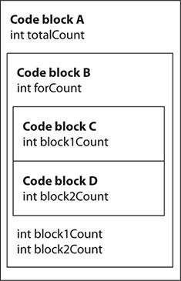



***The exam will ask scope-related questions, for which you will need to conceptualize the scope of various variables clearly. To help with scope conceptualization when working on a problem, you may want to draw out the code in blocks, as in*** [***Figure 5-1***](https://learning.oreilly.com/library/view/oca-java-se/9781259587535/ch05.html#ch05fig01)***. All the variables in the examples are considered local variables. Understanding variable scope is important. It is likely that at least a few questions on the test will center on a variable’s scope*.**

A local variable is used when data needs to be accessed in only a certain part, or locally, in your code. For example, a variable used as a counter should be a local variable. Often times, a variable that you want to return will start as a local variable.



***When developing Java source code, variables should be declared with the most limited scope possible. This coding practice helps reduce programming mistakes and improves code readability*.**

##### Method Parameters

Method parameters are the variables that are passed to the method from the calling segment of code. They are passed as arguments to the method. Method parameters may be primitives or objects. A method can have as many parameters as the developer defines, up to 255. These variables are in scope for the entire method block. Method parameters are defined in the declaration for the method.

The following example contains two method parameters:



In this example, milesTraveled and hoursTraveled are both method parameters. They are declared in the method’s declaration. In this example, they are declared as floats. When this method is called, two floats must pass to the method as arguments. These two variables may be accessed anywhere in this method.

##### Instance Variables

Instance variables are declared in the class. They are called *instance variables* because they are created and remain in memory for as long as the instance of the class exists. Instance variables store the state of the object. They are not within the scope of any one particular method; instead, they are in scope for the entire class. They exist and retain their value from the time a class is initialized until that class is either reinitialized or no longer referenced.

The following example demonstrates two instance variables:

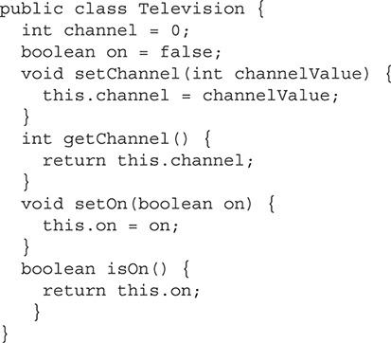

In this example, channel is declared as an int, and on is declared as a boolean. These are both instance variables. Remember that instance variables must be declared in the class, not in a method. The four methods in this class each access one of the instance variables. The setChannel method is used to set the instance variable channel to the value of the int that was passed to it as an argument. The getChannel and isOn methods return the values that are stored in the two instance variables, respectively. Notice that the setOn method has a parameter that has the same name as an instance variable. This is valid code. In a method that has these conditions, if the variable is referenced, it will be the method argument. To reference the instance variable, use the this keyword, which will be discussed in detail later in this chapter.

The following code segment demonstrates the Television class in use:

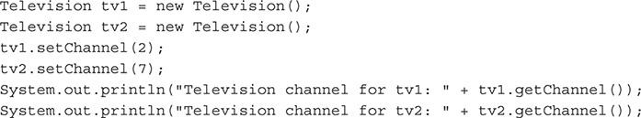

The first two lines of this example create two unique instances of the Television class. When the instance of the class is created, each object gets an instance variable that will store a channel. The next two lines use the setChannel method to set the channel to 2 and 7, respectively.

[Figure 5-2](https://learning.oreilly.com/library/view/oca-java-se/9781259587535/ch05.html#ch05fig02) represents the two objects that have been created and the value of both of their instance variables. The last two lines of code use the getChannel method to retrieve the value stored in the channel instance variable.

**FIGURE 5-2** Two instances of the tv class

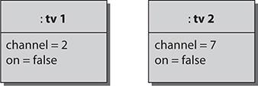

If the code was executed, the following would be the output. Remember that each tv object has a unique set of instance variables.

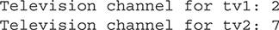

The following Scenario & Solution covers types of variable scope and a likely use for each.

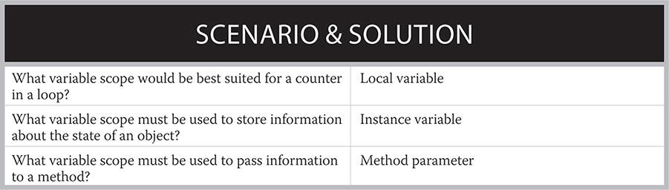

##### An Object’s Lifecycle

Objects are created and destroyed many times during the course of an application. This cycle is known as an object’s *lifecycle*. Objects start out by being declared, when the data type and variable name are assigned. At this point, the code is telling the compiler that a variable of a certain name and type can be referenced in other places.

An object must then be *instantiated* and *initialized*. Instantiation of an object occurs when the new operator is used. At this point, the JVM allocates space for the object. Then the object is initialized with the object’s *constructor*. The constructor sets all of the object’s initial values and prepares the object to be used.

The object next enters the main part of its life. It is ready to have its methods called, which will perform actions and will store the data it was intended to store. As long as other active objects retain a reference to the object, it remains in this state. This is where the object will spend most of its time.

An object continues to exist until no other object holds a reference to it. An object can be deallocated when all its variables go out of scope, are set to reference a different object, are set to null, or any combination of these conditions. Once there are no other active references to the object, it is eligible to be removed from memory by the Java garbage collector. At this point, the object can no longer be called. The garbage collector will eventually reclaim the memory used for the discarded object, making it available for other uses.

**CERTIFICATION OBJECTIVE**

#### Create and Use Constructors

*Exam Objective Create and overload constructors, including impact on default constructors*

A *constructor* is a special type of method in Java that, as its name implies, is used to construct an object. Every class in Java has a constructor. A class may have one or more user-defined constructors, or it may use the compiler-added default constructor. This section will look at how to create and use constructors:

 Making a constructor

 Overloading a constructor

 Using the default constructor

##### Making a Constructor

The constructor is a special method that is used to initialize an object. The constructor is called after the new operator. The next example shows the constructor for the Integer object being called, with one parameter:



Every class is required to have at least one constructor, which may be user defined or the implicated default constructor that is added by the Java compiler. By defining a constructor, the developer is able to initialize the object any way he or she sees fit. This may mean initializing the instance variables to predetermined defaults and/or setting up resources such as a database connection.

A constructor always shares the name of the class, including the capitalized first letter. It is possible for a constructor to use any of the four access modifiers. However, only more common public access modifiers will be included on the OCA exam. Other modifiers tend to be used only in more advanced design patterns, and these patterns are not a part of the exam. Unlike a method, a constructor does not declare any return value, including void.

Here is an example of a constructor being defined in a class:

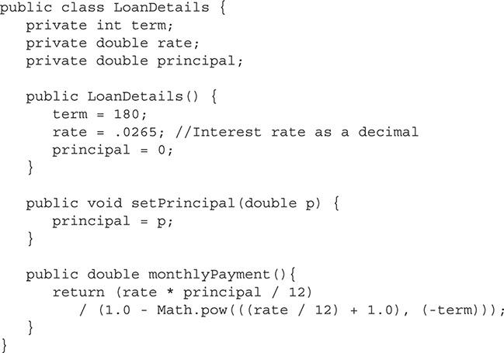



***Remember that constructors have no return type declared, not even the* void *keyword*.**

This class is used to calculate details about a basic loan. The constructor is called LoanDetails. It does not accept any parameters. Notice that it has no return type declared. When a LoanDetails object is created, the constructor sets the term, rate, and principal instance values to their default settings. This class assumes that the user will later set the principal amount based on the loan in question—that is why the setter, setPrincipal, for the principal instance variable is included with this class. This class includes another method for calculating the monthly payment of a loan. (You do not need to understand the details of this calculation, but it is accurate and based on industry-standard formulas.)

The following code segment demonstrates the use of this class:

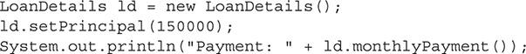

This segment will produce the following output:



##### Overloading a Constructor

Just as methods can be overloaded, so can constructors. To overload a constructor, the programmer must declare another constructor with the same name but a different parameter list. This is useful when a class wants to provide a simple constructor for most cases and a more advanced one for when it is needed. Continuing with the preceding example, the LoanDetails constructor can be overloaded to provide parameters for setting the term, rate, and principal. The next example shows the constructor that can be added to the LoanDetails class:

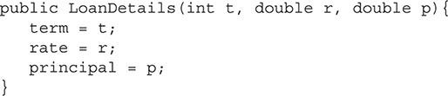

This new constructor has three parameters, (int t, double r, double p), and allows the entire object to be set up and initialized directly from the constructor.

The next code segment demonstrates both constructors in use:

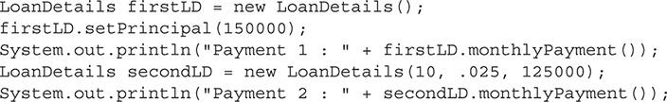

This code is valid since the constructor is overloaded. The new constructor allows for the object to be initialized with the parameters passed to it. It is possible to overload the constructor as many times as needed, as long as each constructor has a unique set of parameters. The parameters are considered unique if the data types do not match any of the other constructors’ data types.

The output is as follows:

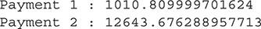

##### Using the Default Constructor

Every class must have a constructor. If no constructor is defined by the developer, the Java compiler adds one at compile time. This is called the *default constructor*. This constructor has no parameters. When called, it simply calls the superclass’s constructor. This constructor is always named the same as the class. The default constructor is accessed in code the same way a user-defined constructor is called if it has no parameters. In fact, the calling code does not know whether the constructor is user defined or the default.



***If one user-defined constructor is defined, the compiler will not add a default one. This means methods are not guaranteed to have a constructor that takes no parameters*.**

**CERTIFICATION OBJECTIVE**

#### Use the this and super Keywords

*Exam Objective Use super and this to access objects and constructors*

The this and super keywords are used to access Java elements explicitly in relation to the current class. This section will look at how each works and when they should be used.

##### The this Keyword

The this keyword is used to refer explicitly to the current object. It is most commonly used when accessing instance variables. If a method or local variable has the same name as an instance variable, this can be used to refer explicitly to the instance variable. Following is an example of a class with one method that uses this to set the instance variable from the method parameter:

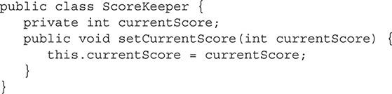

In this example the class contains an instance variable, currentScore. The setter for this variable has a parameter by the same name. To access the instance variable, this is used. If this were not used, any reference to currentScore in the setter would refer to the parameter.

The this keyword can also be used to call constructors from inside of the method. The next example rewrites the LoanDetails class using the this keyword:

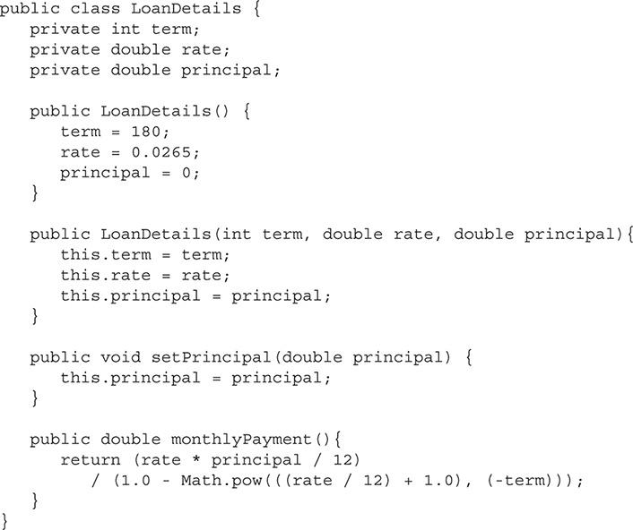

In this example, the parameter names of the constructor and setter have been changed to make the code more readable. However, they are now named the same as the instance variable. In both, this is used to access the instance variable. If this were not used, the parameter would be accessed instead.



***It is always good practice to use the* this *keyword to access instance variables. It provides clarity when reading the code and lets the reader know immediately that an instance variable is being accessed*.**

The this keyword can also be used to refer to methods and constructors in the same object. Oftentimes, when a class has an overloaded constructor, the constructor that accepts the most parameters will do all of the initialized work and the other constructors will call it with sensible defaults. We can further rewrite the LoanDetails class to demonstrate this. The next code segment shows the constructor that does not accept any parameters rewritten:

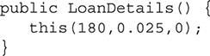

This new constructor uses this to call the other constructor and passes it three parameters. It is valid to use this only in the first line of the constructor. A compiler error will be generated if this is used after that. This new constructor has the same effect as the original version of this method. However, this version is a better design. In some cases, the constructors may include many lines of code. It is easier to maintain one constructor and have the others call it than to maintain many different constructors.

The this keyword can also be used in front of methods in the same manner it is used with instance variables. However, this is not often used. An example is the following line of code, which would have to be in the LoanDetails class to be valid:



##### The super Keyword

The super keyword is used to refer to an object’s superclass. It can be used to access methods that have been overridden in the current class or the constructor of a superclass. When the default constructor is used, it automatically calls its parent class’s constructor by using super. A user-defined constructor can call its parent’s constructor by using super on the first line. A compiler error will be generated if it is used past the first line. If a user-defined method does not use super, the compiler will automatically make a call with super to the parent class’s constructor with no parameters. If this constructor does not exist in the parent class, a compile time error will be generated.

The following two classes show the super keyword in use:

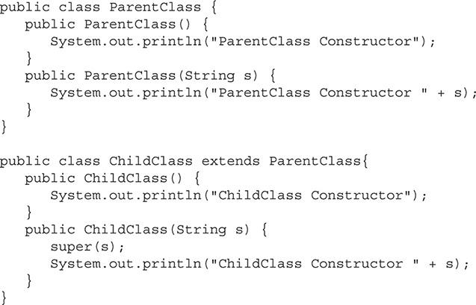

Both classes have two constructors. One accepts no parameters and the other accepts a string.

The ChildClass extends the ParentClass. The following code segment shows these classes in use:



The first line in this code segment calls the first constructor in the ChildClass class. Since there is no reference to super, the compiler automatically calls the constructor with no parameters of the parent class. The second line of code calls the ChildClass class’s constructor that accepts a string as a parameter. This constructor then uses super to call its parent class’s constructor that also accepts a string. Here is the output of this code segment:



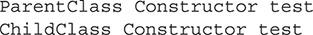

Trace through the code and ensure that you understand the flow of execution. The concepts presented here may be confusing at first, but are important to grasp, because they will be seen in some form on the OCA exam.

The super keyword works with methods in a way similar to how it works with constructors. When a method has been overridden, super can be used to gain access to the method from the parent class. Following is an example of this. This method would be added to the ParentClass:

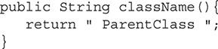

This method would be added to the ChildClass:

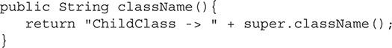

Notice how this method is called super .*methodIdentifer*. That will call the method that is overridden from the parent class. Here is a code segment to demonstrate this:



This segment creates a new object and then prints the results of the className method to standard output. The result of this code is as follows:

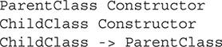

The same text from the constructor is displayed as before. The className method appends its current name to that of its parent class by using super. Finally, it is printed to standard output.



***The* this *and* super *keywords can be used only on the first line of the constructor. Otherwise, a compile-time error will be generated*.**

**CERTIFICATION OBJECTIVE**

#### Create Static Methods and Instance Variables

*Exam Objective Apply the static keyword to methods and fields*

A static method and field are also known as *class methods* and *class variables*. Both use the static keyword to indicate that they belong to the class and not an instance of the class. This section will look at how the static keyword is used to create class methods, class variables, and a common form for creating constants in Java.

##### Static Methods

The static keyword can be used to indicate that a method is a static, or class, method instead of a standard method. A static method belongs to the class and not to an object or the instances of the class. Because these methods do not belong to the instance of an object, they cannot access any instance variables or standard methods. Static methods are also unable to use the this and super keywords. However, they can access other static methods or static variables. A static method is accessed by using the class name in place of the object’s instance name. Here is an example of a class with a static method:

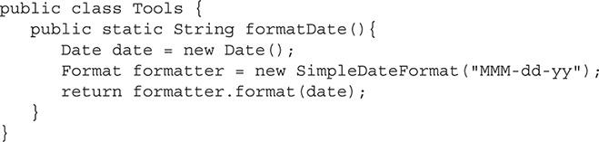

The Tools class has one method called formatDate. The static keyword is used to indicate that this is a static method. As shown in this example, the static keyword must be placed after the access modifier.

The next code segment is an example of this static method being used.



This single line of code prints the output of the method to standard output. Notice how the class name is used to call the method instead of an object. This is able to happen because the method is static and therefore belongs to the class, not to an object. Here is the output for this line of code:



Static methods are most commonly used as utility methods. For example, if you look though the Java API you will find that many of the methods in the Math class are static. This is because these methods are intended to perform a single task and have no reason to maintain the state of their own object. For example, the sin method in the Math class is used to find the trigonometric sine of an angle. It has no need for instance variables and is used more as a utility, or helper, method.



***Next time you start a project, take a look at the* main *method. Notice that it is a static method*.**

##### Static Variables

The static keyword can also be used to create class variables. A class variable is similar to an instance variable, but instead of belonging to the instance of the object, it belongs to the class. The key difference between the two is that every instance of an object has access to the same class variable, but each instance has access to its own set of unique instance variables.

This example will demonstrate a class that is used to assign tracking numbers to packages. Each package must have a unique number. This class is called ShippingPackage and is shown next:

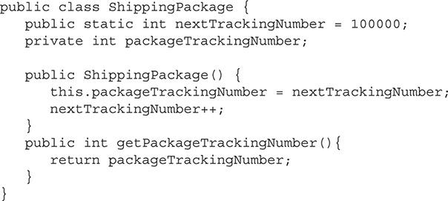

This class has a static class variable that is called nextTrackingNumber. It is used to store the next available number for a package. This variable is set to 100000 initially, representing the first valid tracking number. The class also has an instance variable that is used to store the assigned tracking number. When the constructor is called, it sets the instance variable, packageTrackingNumber, to the next available number stored in nextTrackingNumber. It then increments this variable. Since the nextTrackingNumber is static, every instance of the ShippingPackage class will access the same variable and data that it contains.

The next code segment will use the ShippingPackage class:

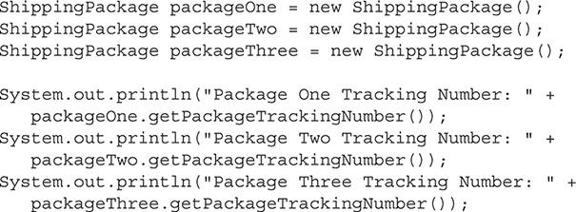

This code segment creates three instances of the ShippingPackage class. It then prints to standard output the tracking number that was assigned to each from the ShippingPackage constructor.

The output of the code is as follows:

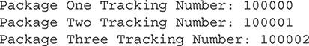

In this output, notice how each tracking number is incremented by 1. This happens because the static variable, nextTrackingNumber, is a class variable and therefore common between all instances of the object.

Class variables with less restrictive access modifiers can be accessed in code similar to how class methods are accessed. The method identifier can be used. In the preceding example, the nextTrackingNumber variable is public. The following line of code can be used to get the variable and print it to standard output:



Notice how the class name is used to access this public variable. The following will be output from this example:



##### Constants

Static variables can also be used to create constants in code. A *constant* is simply a variable that has a set value at compile time that can never be changed. A Java constant is made by adding the final keyword to a class variable. The final keyword simply indicates that this variable can never have its value changed. Here is an example of a Java constant:



This constant is for the value of PI. This can be accessed anywhere in your code by using its class name. This constant is already defined in the Java API, but to a much higher precision.

#### CERTIFICATION SUMMARY

Most of the objectives in this chapter cover a smaller section of the Java language. However, they are equally important to understand if you want to become a great developer.

This chapter began by discussing methods. Method syntax was reviewed, and each part of a method declaration was examined. You must understand methods or you will find it difficult to understand deeper topics. Overloading methods is another critical topic covered in the first section. It is important that you remember that methods that are overloaded, which means they have the same identifier, must each have a unique parameter list.

The difference between passing objects to methods and passing primitives was also examined in this chapter. When a primitive is passed as an argument, a copy is made and the original will remain unchanged. However, when an object is passed as an argument, a reference of the object is passed to the method, and any changes made to the object in the method will be present in the original calling object.

Mastering the scope of variables is important as you design and read large Java applications. The next section covered these topics. First, local variables were discussed. These are the variables that should be used when the data needs to be stored for only a short amount of time and accessed from only one place in a class. The scope of these variables is the block of code in which they are declared.

Method parameters are the variables passed to the method. These variables will be used only when the method needs outside input from the calling code. They are declared in the method’s signature and have a scope of the entire method.

Finally, instance variables were discussed. These variables are declared inside of a class, but outside of a method. These variables are accessible throughout the entire class. They provide the state of an object and retain their value through the lifecycle of the object. Different methods may access them to read or modify the instance variables’ data.

Class constructors are a lot like normal methods, except that they are used only with the new operator to initialize an object. Unlike methods, constructors do not have any return type, including void. Every class must have a constructor. It may be user defined, or a default constructor will be added if none has been defined. Like methods, constructors can also be overloaded.

The this and super keywords are used to reference objects that are in relation to the current object. The this keyword will reference the current object, and the super keyword will reference the parent, or superclass, of the current object. The this keyword can be used on the first line of a constructor to call other constructors from the same class. The super keyword can similarly be used on the first line of a constructor, but it will call the parent class constructor.

Finally, this chapter reviewed the use of the static keyword. Java allows for variables and methods to be declared static, and the method or object belongs to the class, and not an object instance. Static methods, or class methods, can access only other static methods and variables. Static variables, or class variables, are shared between all instances of an object. Java constants are defined by creating a static variable and marking it final by using the final keyword.

This chapter covered different material that may not always seem to be tightly related. However, your understanding all of these concepts will help you create rich applications that use sophisticated design patters. An OCA test taker is expected to understand these concepts. They will not all make up a huge part of this test, but a good understanding will help push your score higher.

#### Images TWO-MINUTE DRILL

**Create and Use Methods**

 Methods may return one variable or none at all.

 A method return type can be a primitive or an object.

 A method must declare the data type of any variable it returns.

 If a method does not return any data, it must use void as its return type.

 The syntax for a method is <Access Modifier> <Return Type> <Method Identifier > (<Parameter List>) {<Body>}.

 Methods can be overloaded by creating another method with the same identifier but a different parameter list.

 Methods can be overloaded as much as needed.

**Pass Objects by Reference and Value**

 Primitives are passed by value.

 When passing a primitive by value, the value is copied into the method.

 Objects are passed by reference.

 When passing an object by reference, a reference to the object is copied into the method. Changes to the object will be present in all references to that object.

**Understand Variable Scope**

 A variable’s scope defines what parts of the code have access to that variable.

 An instance variable is declared in the class, not inside a method. It is in scope for the entire method and remains in memory for as long as the instance of the class it was declared in remains in memory.

 Method parameters are declared in the method declaration; they are in scope for the entire method.

 Local variables may be declared anywhere in code. They remain in scope as long as the execution of code does not leave the block in which they were declared.

**Create and Use Constructors**

 Constructors are used to initialize an object.

 If you do not define a constructor, the complier will add a default one for you.

 A constructor can be overloaded with a unique parameter list as many times as needed.

**Use the this and super Keywords**

 The this keyword is a reference to the current object.

 It is good practice to append this in front of instance variables.

 this() can be used to access other constructors in the current class.

 this() can be used only on the first line of a constructor.

 The super keyword is a reference to the parent object of the current object.

 super can be used to access the overridden methods of a parent.

 super() can be used to call the constructor of the parent class.

 super() can be used only on the first line of a constructor.

**Create Static Methods and Instance Variables**

 The static keyword can be used to create static methods and variables.

 A static method is also known as a class method.

 A static variable is also known as a class variable.

 Static methods belong to the class, not an object instance.

 Static variables belong to the class, not an object instance.

 Static methods can access only other static methods and variables.

 Every object of a class has access to the same variable if it is static.

 The static keyword with the final keyword can be use to create Java constants.

#### SELF TEST

**Create and Use Methods**

[**1.**](https://learning.oreilly.com/library/view/oca-java-se/9781259587535/ch05.html#ch05qa1a) A method needs to be created that accepts an array of floats as an argument and does not return any variables. The method should be called setPoints. Which of the following method declarations is correct?

A. setPoints(float[] points) {…}

B. void setPoints(float points) {…}

C. void setPoints(float[] points) {…}

D. float setPoints(float[] points) {…}

[**2.**](https://learning.oreilly.com/library/view/oca-java-se/9781259587535/ch05.html#ch05qa2a) When the void keyword is used, which of the following statements are true? (Choose all that apply.)

A. A return statement with a value following it must be used.

B. A return statement with a value following it can optionally be used.

C. A return statement with a value following it should never be used.

D. A return statement by itself must be used.

E. A return statement by itself can optionally be used.

F. A return statement by itself should never be used.

G. A return statement must be omitted.

H. A return statement can optionally be omitted.

I. A return statement should never be omitted.

[**3.**](https://learning.oreilly.com/library/view/oca-java-se/9781259587535/ch05.html#ch05qa3a) Given the SampleClass, what is the output of this code segment?

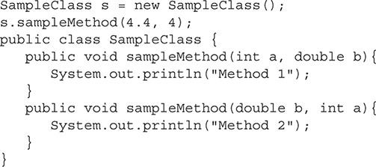

A. Method 1

B. Method 2

C. Method 1

Method 2

D. Method 2

Method 1

E. Compiler error

[**4.**](https://learning.oreilly.com/library/view/oca-java-se/9781259587535/ch05.html#ch05qa4a) Which of the following methods returns a float and accepts an int as a parameter?

A. public void method1(int var1, float var2) {/*Method Body*/}

B. public int method2(float var1) {/*Method Body*/}

C. public float method3(int var1) {/*Method Body*/}

D. public float, int method4() {/*Method Body*/}

[**5.**](https://learning.oreilly.com/library/view/oca-java-se/9781259587535/ch05.html#ch05qa5a) You want to create a method that takes in three character parameters and returns a string. Which declaration is valid?

A. public void doMethod (char a, char b, char c) {String s = null; return s;}

B. public String doMethod (Char a, Char b, Char c) {String s = null; return s;}

C. public String doMethod (char a, char b, char c) {String s = null; return s;}

D. public string doMethod (char a, char b, char c) {String s = null; return s;}

**Pass Objects by Reference and Value**

[**6.**](https://learning.oreilly.com/library/view/oca-java-se/9781259587535/ch05.html#ch05qa6a) Given the class FloatNumber and method addHalf, what is the output if the following code segment is executed?

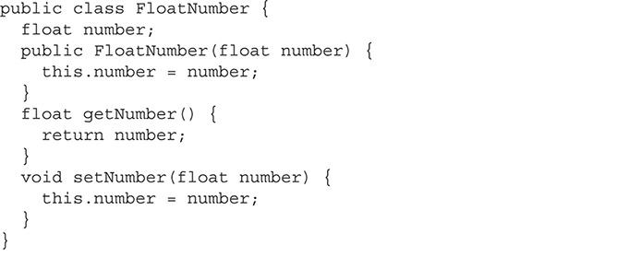

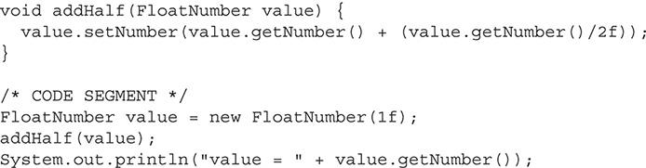

A. value = 1

B. value = 1.5

C. value = 2

D. value = 0

[**7.**](https://learning.oreilly.com/library/view/oca-java-se/9781259587535/ch05.html#ch05qa7a) Objects are passed by ________________.

A. value

B. sum

C. reference

D. pointer

[**8.**](https://learning.oreilly.com/library/view/oca-java-se/9781259587535/ch05.html#ch05qa8a) Primitives are passed by ________________.

A. value

B. sum

C. reference

D. pointer

[**9.**](https://learning.oreilly.com/library/view/oca-java-se/9781259587535/ch05.html#ch05qa9a) What is the value of the variable number when the following code segment is finished?

Code segment:

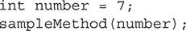

Supporting method:

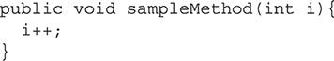

A. 0

B. 1

C. 7

D. 8

E. A compiler error occurs.

F. A runtime error occurs.

**Understand Variable Scope**

[**10.**](https://learning.oreilly.com/library/view/oca-java-se/9781259587535/ch05.html#ch05qa10a) You need to create a class to store information about books contained in a library. What variable scope is best suited for the variable that will store the title of a book?

A. Local variable

B. Static variable

C. Global variable

D. Method parameter

E. Instance variable

[**11.**](https://learning.oreilly.com/library/view/oca-java-se/9781259587535/ch05.html#ch05qa11a) Given the SampleClass, when the following code segment is executed, what is the value of the instance variable size?



A. 0

B. 1

C. 5

D. Compiler error

E. Runtime error

[**12.**](https://learning.oreilly.com/library/view/oca-java-se/9781259587535/ch05.html#ch05qa12a) What type of variable would be used to store the state of an object?

A. Local variable

B. Method parameter

C. Instance variable

D. Object variable

**Create and Use Constructors**

[**13.**](https://learning.oreilly.com/library/view/oca-java-se/9781259587535/ch05.html#ch05qa13a) Given the SampleClass, what is the output of this code segment?



A. Using default values

B. Setting size

C. Setting priority

D. Compiler error

[**14.**](https://learning.oreilly.com/library/view/oca-java-se/9781259587535/ch05.html#ch05qa14a) What constructor is equivalent to the one listed here?



A. 

B. 

C. 

D. 

E. None of the above

[**15.**](https://learning.oreilly.com/library/view/oca-java-se/9781259587535/ch05.html#ch05qa15a) If a constructor does not include an access modifier, which modifier will it use by default?

A. A constructor that does not include an access modifier will always be declared as public.

B. A constructor that does not include an access modifier will make use of the same access modifier that is used for its class.

C. A compilation error will occur if a constructor does not include an access modifier.

D. A constructor that does not include an access modifier will have package-private access.

**Use the this and super Keywords**

[**16.**](https://learning.oreilly.com/library/view/oca-java-se/9781259587535/ch05.html#ch05qa16a) Given the SampleClass, what is the output of this code segment?



A. Using default values

B. Setting size

C. Using default values Setting size

D. Setting size Using default values

E. Compiler error

[**17.**](https://learning.oreilly.com/library/view/oca-java-se/9781259587535/ch05.html#ch05qa17a) What is the effect of the following line of code?



A. The method that is overridden by the current method is called.

B. The parent class’s constructor is called.

C. The current class’s constructor is called.

D. The child class’s constructor is called.

E. The current method is recursively called.

**Create Static Methods and Instance Variables**

[**18.**](https://learning.oreilly.com/library/view/oca-java-se/9781259587535/ch05.html#ch05qa18a) Given the SampleClass, what is the output of this code segment?



A. sampleMethodOne

B. sampleMethodTwo

C. sampleMethodOne

sampleMethodTwo

D. sampleMethodTwo

sampleMethodOne

E. Compiler error

[**19.**](https://learning.oreilly.com/library/view/oca-java-se/9781259587535/ch05.html#ch05qa19a) Given the SampleClass, what is the value of currentCount for the instance of object x after the code segment had be executed?



A. 0

B. 1

C. 2

D. 3

E. Compiler error

F. Runtime error

[**20.**](https://learning.oreilly.com/library/view/oca-java-se/9781259587535/ch05.html#ch05qa20a) Static methods have access to which of the following? (Choose all that apply.)

A. Static variables

B. Instance variables

C. Standard methods

D. Static methods

E. None of the above

#### SELF TEST ANSWERS

**Create and Use Methods**

[**1.**](https://learning.oreilly.com/library/view/oca-java-se/9781259587535/ch05.html#ch05qa1) A method needs to be created that accepts an array of floats as an argument and does not return any variables. The method should be called setPoints. Which of the following method declarations is correct?

A. setPoints(float[] points) {…}

B. void setPoints(float points) {…}

C. void setPoints(float[] points) {…}

D. float setPoints(float[] points) {…}

Answer:

 **C**. void must be used for methods that do not return any data.

 **A**, **B**, and **D** are incorrect. **A** is incorrect because it is missing the return type. If the method is not going to return a variable, it still must use void. **B** is incorrect because it does not have an array of floats as a parameter. **D** is incorrect because it uses the incorrect return type.

[**2.**](https://learning.oreilly.com/library/view/oca-java-se/9781259587535/ch05.html#ch05qa2) When the void keyword is used, which of the following statements are true? (Choose all that apply.)

A. A return statement with a value following it must be used.

B. A return statement with a value following it can optionally be used.

C. A return statement with a value following it should never be used.

D. A return statement by itself must be used.

E. A return statement by itself can optionally be used.

F. A return statement by itself can never be used.

G. A return statement must be omitted.

H. A return statement can optionally be omitted.

I. A return statement should never be omitted.

Answer:

 **C**, **E**, and **H**. When void is used, it indicates that there is no returned data from the method. **C** is correct because it is not valid to return any data. **E** is correct because it is valid to optionally use a return by itself. **H** is correct because the return statement can also be optionally omitted.

 **A**, **B**, **D**, **F**, **G**, and **I** are incorrect. **A** and **B** are incorrect since the void keyword means you cannot return a value. **D**, **F**, **G**, and **I** are incorrect because the return statement is optional when void is used.

[**3.**](https://learning.oreilly.com/library/view/oca-java-se/9781259587535/ch05.html#ch05qa3) Given the SampleClass, what is the output of this code segment?



A. Method 1

B. Method 2

C. Method 1

Method 2

D. Method 2

Method 1

E. Compiler error

Answer:

 **B**. This is an example of a class with an overloaded method. Since it passes double and int primitives as parameters, it will call the second method, which matches these data types.

 **A**, **C**, **D**, and **E** are incorrect. **A** is incorrect because Method 1 is printed from a method with the signature of sampleMethod(int a, double b). The correct signature is sampleMethod(double b, int a). It is important to notice the order of the parameters. **C** and **D** are incorrect because overloading a method does not result in two methods being called. **E** is incorrect because there is no compiler error.

[**4.**](https://learning.oreilly.com/library/view/oca-java-se/9781259587535/ch05.html#ch05qa4) Which of the following methods returns a float and accepts an int as a parameter?

A. public void method1(int var1, float var2) {/*Method Body*/}

B. public int method2(float var1) {/*Method Body*/}

C. public float method3(int var1) {/*Method Body*/}

D. public float, int method4() {/*Method Body*/}

Answer:

 **C**. The parts of a method are <Access Modifier> <Return Type> <Method Identifier> (<Parameter List>){<Body>}, and answer **C**, public float method3(int var1) {/*Method Body*/}, includes these parts.

 **A**, **B**, and **D** are incorrect. **A** is incorrect because it has no return type. **B** is incorrect because it returns an int and uses a float as a parameter. **D** is incorrect because it is invalid Java code and will cause a compiler error.

[**5.**](https://learning.oreilly.com/library/view/oca-java-se/9781259587535/ch05.html#ch05qa5) You want to create a method that takes in three character parameters and returns a string. Which declaration is valid?

A. public void doMethod (char a, char b, char c) {String s = null; return s;}

B. public String doMethod (Char a, Char b, Char c) {String s = null; return s;}

C. public String doMethod (char a, char b, char c) {String s = null; return s;}

D. public string doMethod (char a, char b, char c) {String s = null; return s;}

Answer:

 **C**. This is a perfectly formed method declaration.

 **A**, **B**, and **D** are incorrect. **A** is incorrect because the declaration states that no value (void) is to be returned, but a string is. **B** is incorrect because the wrapper class for character is Character and not Char. **D** is incorrect because the return type of String does not start with a capital letter as it should. That is, “public string doMethod” should read “public String doMethod”.

**Pass Objects by Reference and Value**

[**6.**](https://learning.oreilly.com/library/view/oca-java-se/9781259587535/ch05.html#ch05qa6) Given the class FloatNumber and method addHalf, what is the output if the following code segment is executed?



A. value = 1

B. value = 1.5

C. value = 2

D. value = 0

Answer:

 **B**. The FloatNumber object is passed by reference. Therefore, when the method changes its value, this change is still present when the code returns to the original calling code segment.

 **A**, **C**, and **D** are incorrect. **A** is incorrect because the FloatNumber is passed by reference. If it were a primitive float this would be the correct answer. **C** and **D** are incorrect, regardless if the variable is passed by reference or value.

[**7.**](https://learning.oreilly.com/library/view/oca-java-se/9781259587535/ch05.html#ch05qa7) Objects are passed by ________________.

A. value

B. sum

C. reference

D. pointer

Answer:

 **C**. Objects are always passed by reference.

 **A**, **B**, and **D** are incorrect. **A** is incorrect because primitives are passed only by value. **B** is incorrect because “sum” is not a real term. **D** is incorrect because Java does not use the term “pointer.”

[**8.**](https://learning.oreilly.com/library/view/oca-java-se/9781259587535/ch05.html#ch05qa8) Primitives are passed by ________________.

A. value

B. sum

C. reference

D. pointer

Answer:

 **A**. Primitives are always passed by value.

 **B**, **C**, and **D** are incorrect. **B** is incorrect because “sum” is not a real term. **C** is incorrect because objects are passed only by reference. **D** is incorrect because Java does not use the term “pointer.”

[**9.**](https://learning.oreilly.com/library/view/oca-java-se/9781259587535/ch05.html#ch05qa9) What is the value of the variable number when the following code segment is finished?

Code segment:

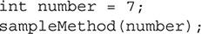

Supporting method:



A. 0

B. 1

C. 7

D. 8

E. A compiler error occurs.

F. A runtime error occurs.

Answer:

 **C**. Because primitives are passed by value, a copy of the data is sent to the method. Any changes the method makes on the data does not affect the original variable since a copy was made.

 **A**, **B**, **D**, **E**, and **F** are incorrect. **A**, **B**, and **D** are all incorrect values. **E** and **F** are incorrect because this will not produce any errors.

**Understand Variable Scope**

[**10.**](https://learning.oreilly.com/library/view/oca-java-se/9781259587535/ch05.html#ch05qa10) You need to create a class to store information about books contained in a library. What variable scope is best suited for the variable that will store the title of a book?

A. Local variable

B. Static variable

C. Global variable

D. Method parameter

E. Instance variable

Answer:

 **E**. In a class that stores information about books, you would want to store the title of the book in a variable that will remain in scope for the life of the object.

 **A**, **B**, **C**, and **D** are incorrect. **A** is incorrect because a local variable is best suited for data that will be used for only a short amount of time. **B** is incorrect because a static or class variable is best suited for data that all instances of the class would need to access. **C** is incorrect since global variables are discouraged in Java and would not make much sense in this situation. **D** is incorrect since it can only be used with methods.

[**11.**](https://learning.oreilly.com/library/view/oca-java-se/9781259587535/ch05.html#ch05qa11) Given the SampleClass, when the following code segment is executed, what is the value of the instance variable size?



A. 0

B. 1

C. 5

D. Compiler error

E. Runtime error

Answer:

 **A**. The instance variable is hidden with the parameter since they both have the same name. The instance variable is 0 because that is the default value assigned to instance variables.

 **B**, **C**, **D**, and **E** are incorrect. **B** is incorrect because the instance variable is set to 0, and not 1, by default. **C** is incorrect because to set size to 5, this.size = size; would have to be used. **D** and **E** are incorrect because this code is valid.

[**12.**](https://learning.oreilly.com/library/view/oca-java-se/9781259587535/ch05.html#ch05qa12) What type of variable would be used to store the state of an object?

A. Local variable

B. Method parameter

C. Instance variable

D. Object variable

Answer:

 **C**. Instance variables retain their value for the life of the object.

 **A**, **B**, and **D** are incorrect. **A** is incorrect because a local variable is used for temporary items and stays in scope only until the block of code it is declared in is exited. **B** is incorrect because method parameters are the variables passed to a method as arguments. They are in scope only for that method. **D** is incorrect because the object variable does not exist.

**Create and Use Constructors**

[**13.**](https://learning.oreilly.com/library/view/oca-java-se/9781259587535/ch05.html#ch05qa13) Given the SampleClass, what is the output of this code segment?



A. Using default values

B. Setting size

C. Setting priority

D. Compiler error

Answer:

 **D**. This would generate a compiler error because you cannot overload a constructor or method and have the same data types for the parameters.

 **A**, **B**, and **C** are incorrect. **A** is incorrect; however, if this were valid code, it would be the correct answer. **B** and **C** are incorrect; even if these were valid, they do not represent the flow of execution of the code segment.

[**14.**](https://learning.oreilly.com/library/view/oca-java-se/9781259587535/ch05.html#ch05qa14) What constructor is equivalent to the one listed here?



A. 

B. 

C. 

D. 

E. None of the above

Answer:

 **B**. If super is not called on the first line of a constructor, the compiler will automatically add it for you.

 **A**, **C**, **D**, and **E** are incorrect. **A** is incorrect because this() calls a constructor of the current class. **C** and **D** are not valid uses of super or this. **E** is incorrect because answer **B** is correct.

[**15.**](https://learning.oreilly.com/library/view/oca-java-se/9781259587535/ch05.html#ch05qa15) If a constructor does not include an access modifier, which modifier will it use by default?

A. A constructor that does not include an access modifier will always be declared as public.

B. A constructor that does not include an access modifier will make use of the same access modifier that is used for its class.

C. A compilation error will occur if a constructor does not include an access modifier.

D. A constructor that does not include an access modifier will have package-private access.

Answer:

 **D**. A constructor will behave the same way a method behaves. If no access modifier is provided, it will default to package-private. A constructor with package-private access can only be called from other classes in the same package.

 **A**, **B**, and **C** are incorrect. **A** is incorrect because constructors that do not include an access modifier are not always declared as public; they are declared the same as their class. **B** is incorrect because a constructor works like a standard method and will be package-private if no modifiers are present. **C** is incorrect because a compilation error will not occur if a constructor does not have an access modifier.

**Use the this and super Keywords**

[**16.**](https://learning.oreilly.com/library/view/oca-java-se/9781259587535/ch05.html#ch05qa16) Given the SampleClass, what is the output of this code segment?



A. Using default values

B. Setting size

C. Using default values Setting size

D. Setting size Using default values

E. Compiler error

Answer:

 **D**. The first constructor is called. It uses this(1); to call the second constructor. The second constructor prints out its statement and then returns to the first constructor, where it prints out its statement.

 **A**, **B**, **C**, and **E** are incorrect. **A**, **B**, and **C** are incorrect because they do not represent the correct execution of the code segment. **E** is incorrect because this is valid code.

[**17.**](https://learning.oreilly.com/library/view/oca-java-se/9781259587535/ch05.html#ch05qa17) What is the effect of the following line of code?



A. The method that is overridden by the current method is called.

B. The parent class’s constructor is called.

C. The current class’s constructor is called.

D. The child class’s constructor is called.

E. The current method is recursively called.

Answer:

 **B**. The super keyword in this case is used to call the parent class’s constructor. This must be done from the first line of a constructor in the current class.

 **A**, **C**, **D**, and **E** are incorrect. **A** is incorrect because to refer to an overridden method, super and the method identifier must be used. **C** is incorrect because this() would be used to call a correct class’s constructor. **D** is incorrect since it is impossible to refer to a child class’s methods. **E** is incorrect because super has nothing to do with recursion.

**Create Static Methods and Instance Variables**

[**18.**](https://learning.oreilly.com/library/view/oca-java-se/9781259587535/ch05.html#ch05qa18) Given the SampleClass, what is the output of this code segment?

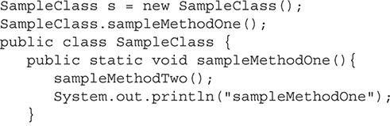

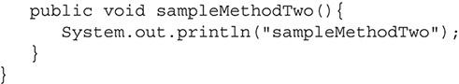

A. sampleMethodOne

B. sampleMethodTwo

C. sampleMethodOne

sampleMethodTwo

D. sampleMethodTwo

sampleMethodOne

E. Compiler error

Answer:

 **E**. The method sampleMethodOne is a static method. This method is not able to call other standard methods; therefore, this will generate a compiler error when it is called.

 **A**, **B**, **C**, and **D** are incorrect. **A**, **B**, and **C** are incorrect because the code has a compiler error. **D** is incorrect because of the compiler error; however, it would be correct if sampleMethodOne was not static and this was valid code.

[**19.**](https://learning.oreilly.com/library/view/oca-java-se/9781259587535/ch05.html#ch05qa19) Given the SampleClass, what is the value of currentCount for the instance of object x after the code segment had been executed?





A. 0

B. 1

C. 2

D. 3

E. Compiler error

F. Runtime error

Answer:

 **D**. The variable currentCount is a static variable; therefore, every instance of this class has access to the same variable. The code segment creates two new instances of this class. The constructor increments this variable each time. Finally, the increaseCount method is called, which also increments the variable.

 **A**, **B**, **C**, **E**, and **F** are incorrect. **A**, **B**, and **C** are incorrect because currentCount is a static variable and the same value is incremented each time an object is created in the increaseCount method. **E** and **F** are incorrect because this is valid code.

[**20.**](https://learning.oreilly.com/library/view/oca-java-se/9781259587535/ch05.html#ch05qa20) Static methods have access to which of the following? (Choose all that apply.)

A. Static variables

B. Instance variables

C. Standard methods

D. Static methods

E. None of the above

Answer:

 **A** and **D**. Static methods can access only static variables and other static methods.

 **B**, **C**, and **E** are incorrect. **B** and **C** are incorrect because static methods cannot access data that is associated with an instance of a class. **E** is incorrect because **A** and **D** are correct answers.



### 6

### PROGRAMMING WITH ARRAYS

**CERTIFICATION OBJECTIVES**

• [Work with Java Arrays](https://learning.oreilly.com/library/view/oca-java-se/9781259587535/ch06.html#ch06lev1)

• [Work with ArrayList Objects and Their Methods](https://learning.oreilly.com/library/view/oca-java-se/9781259587535/ch06.html#ch06lev4)

 [Two-Minute Drill](https://learning.oreilly.com/library/view/oca-java-se/9781259587535/ch06.html#ch06lev7)

**Q&A** [Self Test](https://learning.oreilly.com/library/view/oca-java-se/9781259587535/ch06.html#ch06lev9)

**A**cornerstone of software development is working with data structures to store and retrieve data. Arrays are one of the most fundamental data structures; in fact, they can be found in nearly every programming language, and Java is no exception. Java inherited arrays from the C language, along with many of its other syntax rules. In addition to standard arrays, Java has an ArrayList class that is included in its software development kit. This is a modern approach to standard arrays and follows the principles of object-oriented programming. This chapter will discuss both types of arrays and prepare you for the questions you will encounter on the OCA exam.

**CERTIFICATION OBJECTIVE**

#### Work with Java Arrays

*Exam Objective Declare, instantiate, initialize, and use a one-dimensional array*

*Exam Objective Declare, instantiate, initialize, and use multi-dimensional array*

Java arrays are built into the language to handle multiple pieces of data that are of the same type. They allow the developer to use one variable with one or more indexes to access multiple independent pieces of data. Arrays can be used to store both primitives and objects.

Questions regarding arrays are included throughout the OCA exam. Questions will range from where to use an array, to what type of array to use, how to initialize an array, and how to work with arrays in code. The details of arrays are an important concept for you to understand to achieve success on the OCA exam. This section will review one-dimensional and multi-dimensional arrays.

##### One-Dimensional Arrays

A Java array is an object that acts as a container by storing a fixed number of the same type values. The values are accessed by using an index. A one-dimensional array uses only a single index. The following is an example of an array of int primitives:

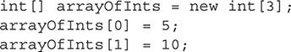

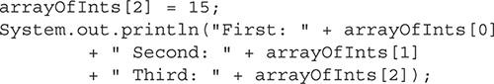

[Figure 6-1](https://learning.oreilly.com/library/view/oca-java-se/9781259587535/ch06.html#ch06fig01) is a visual representation of this code segment.

**FIGURE 6-1** int[ ] arrayOfInts

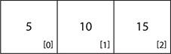

This code would produce the following output:



This is a basic example of a one-dimensional array in action. Let’s take a closer look at what happens here before we dig into the details of arrays.

First, the variable arrayOfInts is declared. It is declared with the type int[]. The square brackets indicate that this is an array of int primitives. Next, it is initialized with the new operator. The new operator must be used because all arrays are considered objects. It is initialized with its type, which is int, with the square brackets to indicate an array and finally a number inside the brackets. The number is used to assign a size to the array. In this case, it is an array containing three int primitives. The next three lines set a value for each index in the array. Notice that the first index has a value of 0. All arrays are zero based and have a first number index of 0. Finally, the values are accessed and sent to standard output.

###### Declaring One-Dimensional Arrays

One-dimensional arrays are declared either by using square brackets after the type or by using the square brackets after the variable name. Both are valid. When the array is being declared, a number is never placed inside the brackets. An array is declared the same way for both objects and primitives. Here’s an example:

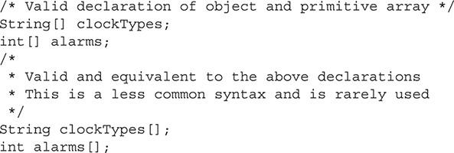

###### Initializing One-Dimensional Arrays

Once an array is declared, it must be initialized. An array can be initialized similarly to how an object is initialized. The new operator is used followed by the type, with square brackets containing the length, or size, of the array. This initialization can be done on the same line as the declaration or on its own line. The following code segment demonstrates this:

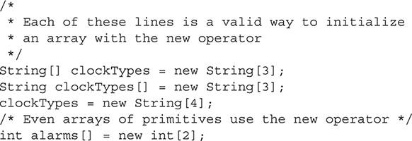

Once an array is assigned a size, it cannot be changed without initializing it again. If the declared array contains primitives, then every primitive inside the array is set to 0. An array of objects has each element initially set to null.

It is also possible to initialize an array with all of its values immediately after being declared. This is done by placing the values to be stored in the array in curly brackets. The curly brackets must follow the declaration on the same line. The values in the brackets are separated with commas. This will initialize the array and assign a value to each element in the array. The following code demonstrates this:



This example shows the alarms array, containing int primitives, being initialized with two int values. This array now has a length of two and is populated with 730 at index 0 and 900 at index 1. The next line is an array of String objects. This array is initialized with the three strings: “Wrist Watch”, “Desk Clock”, and “Wall Clock”. The array has a length of three. The final example is an object called Clock. This object has a constructor that forms a new object and requires the time to initialize the clock by using an argument. The objects are created inline, and both are stored in the array.

When an array is initialized with curly brackets, it must do so within the same statement as the declaration. Unlike the new operator, an array cannot be initialized with curly brackets on a different line of code.



***This section has demonstrated how arrays can be declared with square brackets after the variable type or the variable name. In practice, most developers place the square brackets after the variable type because the square brackets describe the type*.**

###### Using One-Dimensional Arrays

One-dimensional arrays are very straightforward to use. Once declared and initialized, each element from the array can be accessed by using its corresponding index. Every object or primitive has an index number associated with it. It is important for you to remember that an array with a length of three has the indexes 0, 1, and 2. The first index is always 0.

The next example prints out the string that is stored in the array at index 1:



The output would be as follows:



This array is made up of String objects. When the array is used with an index number, it behaves just as a String object variable would. For example, the equalsIgnoreCase() method from the String class can be used like so:

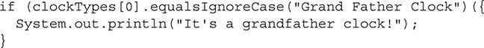

It is also possible to get the length of an array. Arrays are objects in Java. You can access the public length field to obtain the length of the array. In the next example, notice that length is not a method with open and close parentheses; it is a public field that can be accessed to get the length of the array:



The example would produce the following output:



Java has built-in methods for copying the data from one array to another. These methods copy the data and create two independent arrays upon completion. The arraycopy() method is a static method that is part of the System class. The method signature for arraycopy() is shown next:



This method has five parameters. The src parameter is the source array, the array from which you intend to copy data. The srcPos parameter is the starting position in the array and is where copying starts. The dest parameter is the array into which data will be copied. The parameter destPos is the starting position of where data will be placed in the array. Finally, the length parameter is the number of elements from the array to be copied. When using this method, you must ensure that you do not go outside the bounds of either array. The destination array must also be declared as the same type and initialized.

The following code listing demonstrates part of an array being copied into another array:

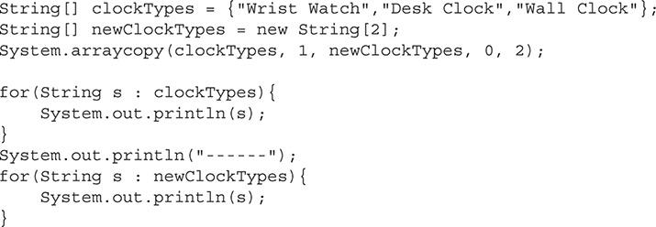

In this example, the last two elements from clockTypes are copied into newClockTypes. Then both are printed to standard output. The two arrays are independent. If values in one are modified, it will not affect the other array. The following is the output of this code segment:

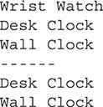



***The* Arrays *class of the Java utilities package provides sorting, searching, and comparing features for arrays. Static methods of the* Arrays *class include* asList*,* binarySearch*,* copyOf*,* copyOfRange*,* equals*,* fill*,* sort*, and many other useful methods*.**

##### Multi-Dimensional Arrays

Multi-dimensional arrays have more than one index. A multi-dimensional array with two dimensions, or indexes, is an array of arrays. An array can have three, four, or more dimensions. The Java language specification does not place a limit on the number of dimensions that an array can have. However, the Java virtual machine (JVM) specification does set a practical limit of 256 dimensions.

Here is a complete example of a two-dimensional array. We will go over all of the rules of the arrays in the next few sections.

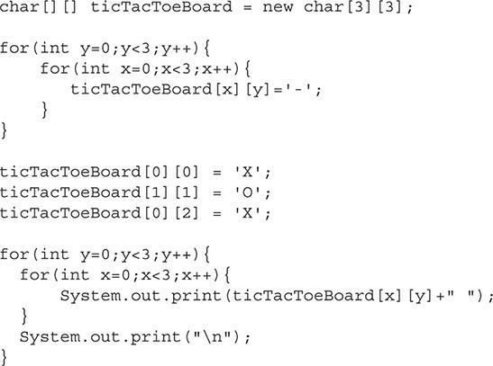

This example uses a two-dimensional array to represent a tic-tac-toe board. The array is first declared as char primitives and then initialized to have the size of 3-by-3. The first loop sets each value to a ‘-’ character. Next, the board spaces at 0,0 and 0,2 are set to ‘X’, and 1,1 is set to ‘O’. Finally the board is printed to standard output, resulting in the following output:

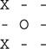

###### Declaring Multi-Dimensional Arrays

A multi-dimensional array is declared similarly to a one-dimensional array, with additional square brackets for each dimension. Where a one-dimensional array has one square bracket following the type or variable name, a two-dimensional array has two brackets, a three-dimensional array would have three, and so on. Following are some examples of multi-dimensional arrays being declared:

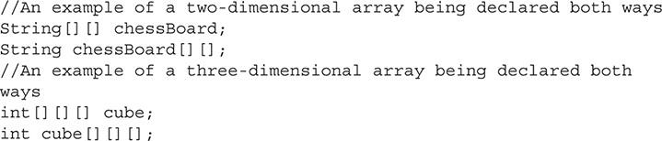

###### Initializing Multi-Dimensional Arrays

Multi-dimensional arrays can be initialized similarly to one-dimensional arrays. They are either initialized with the new operator or they use curly brackets with the values to be stored in the array:

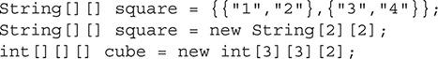

In this example, the curly bracket groups are separated by commas. The values inside the curly brackets represent an array. You can think of multi-dimensional arrays as an array of arrays. This is because the first level is an array that contains an array at each element.

The arrays that are contained do not all have to be the same length. The next code segment demonstrates an array with different sized subarrays. [Figure 6-2](https://learning.oreilly.com/library/view/oca-java-se/9781259587535/ch06.html#ch06fig02) shows a visual representation of this array.

**FIGURE 6-2** int[ ][ ] oddSizeArray

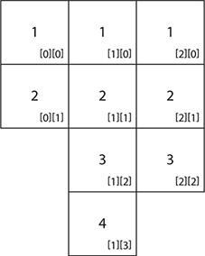



When you use the new operator to initialize an array, the size of each dimension does not have to be defined. Because a multi-dimensional array is just an array of arrays, it is okay to define the length of only the first dimension. You can then either assign a preexisting array to that element or use the new operator again:

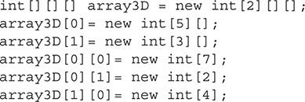

In this example, array3D initializes only the size of the first dimension when it is declared. Then on separate lines, both elements from the first dimension are initialized with another array. And, finally, some elements from the second dimension are initialized with their arrays.

###### Using Multi-Dimensional Arrays

Multi-dimensional arrays are used similarly to one-dimensional arrays, except that additional dimensions need to be accounted for. When an element is accessed, an index must be provided in square brackets for each dimension:

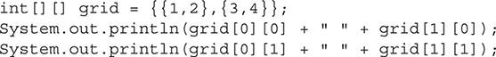

It is also possible to assign one of the subarrays to another one-dimensional array. The following example continues with the last example to demonstrate this concept:



INSIDE THE EXAM

**Searching for Clues on the Exam**

When you’re taking the OCA exam, pay close attention to questions containing multi-dimensional arrays. As this section has shown, these arrays can be used in many different ways. Think through the question and try to determine whether the array is valid. If you’re in doubt, skip the question. While working on other questions, notice how the exam writers use arrays in these questions.

**CERTIFICATION OBJECTIVE**

#### Work with ArrayList Objects and Their Methods

*Exam Objective Declare and use an ArrayList of a given type*

The Java ArrayList class is an object-orientated representation of the standard array discussed previously in this chapter. The ArrayList class is part of the java.util package.

##### Using the ArrayList Class

The ArrayList class can be used to create an object that can store other objects, including enumeration types (enums). An index is used to access the objects inside the ArrayList. The ArrayList provides additional flexibility over a standard array. It can be dynamically resized and allows for objects to be inserted in the middle of the ArrayList while automatically moving other elements to make room. Next is an example of an ArrayList in action:

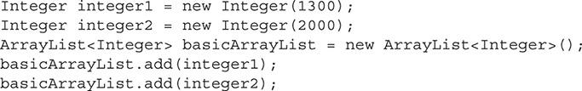

In this example, two Integer objects are created: integer1 and integer2. They will be later stored in an ArrayList. You should remember that ArrayList objects cannot store primitives like basic arrays can. If a primitive is needed, it must be placed into a primitive wrapper object first. If a primitive is added to an ArrayList, autoboxing will occur to place it in its wrapper class automatically. Next, the ArrayList object basicArrayList is created. Notice the <Integer> within chevrons—this is a Java generic type indicator. This indicates that the ArrayList will be storing Integer objects. The compiler will enforce the type declared in the generic. Only objects of that type, or subclasses of it, can be stored in the ArrayList. The default constructor is used to create an ArrayList. Finally, both objects are added. The default constructor creates an ArrayList with ten internal elements. The size of the ArrayList is still based on the number of objects in it, and an exception will be thrown if the index is not valid. If the internal size is surpassed, the ArrayList is automatically expanded.

The following line of code demonstrates how to access the elements in the ArrayList. ArrayList indexes are zero based.



This would result in the following output:



To get the length of an ArrayList, the size() method is used. The size() method returns an int that represents the number of elements currently being stored.



This example would produce the following output:



When the default constructor is used to create an ArrayList, it is given an initial capacity of ten. The capacity is different from the size. As you saw in the preceding example, the basicArrayList object used the default constructor and therefore had a capacity of ten. However, the size() method returns only the number of elements that it is storing. The ArrayList will manage the capacity automatically. When the capacity is exceeded, the ArrayList will expand automatically. However, this does incur some overhead. When developing software, if you have a rough idea of the needed capacity, you can set this with the ArrayList constructor. This reduces the overhead of the ArrayList expanding multiple times. Here is the method signature of this constructor:



The capacity of the ArrayList can be changed later with the ensureCapacity() method. This method increases the size of the ArrayList to the argument passed to the method. Here is the ensureCapacity() method signature:



As mentioned, it is possible to add an element into an ArrayList at a given index. If the index is in the middle of the ArrayList, the current element at that index and everything after it are shifted down by one. Continuing the basicArrayList example, the following code will place an element in the middle of the ArrayList:

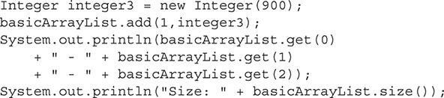

A third Integer is created and the add() method is used, which accepts both the index to place the element and the element as arguments. When this code is executed, the following would be displayed:

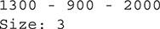

Notice that the new Integer, 900, is placed at index one. The size has also been increased by one. The method signature for this add method is shown here:



Objects can be just as easily removed from the ArrayList. When an object is removed, all of the elements after the removed element shift their indexes down by one. The size will also be decreased by one. An element can be removed by referencing its index number or by passing the object to the ArrayList. Here are the two method signatures to remove an object:

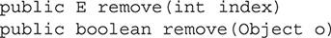

This section covers only the most important methods of the ArrayList class. The bulk of the ArrayList exam questions will focus on these methods. However, it is still a good idea for you to review the Java API for the ArrayList class to get a feel for all of the functionality that this class provides.



***The* ArrayList *class belongs to a group of classes called the collection classes. These classes all implement the* Collection *interface. As the name implies, the collection classes are used to store data. These classes are some of the most used in the Java language. Every developer should be familiar with most of the classes in this group. This group of classes contains stacks, sets, lists, queues, and arrays. Although* ArrayList *is the only such class on the OCA exam, it is still worthwhile for you to review the Java API for more information on these classes*.**

##### ArrayList vs. Standard Arrays

This chapter has discussed two different valid ways to store data in your software. Which one is the best to use? As with any tool, your best bet is to use the one that fits the job. In most general cases, the ArrayList is likely to be easier to work with. It allows for growing and shrinking data sets, allows elements to be added or removed at any valid index, and offers many more methods that make working with ArrayList easy.

However, if you are concerned about overhead, using the basic array may be better. If the size of the data is known, then the automatic expanding and shrinking feature of ArrayList would not come into play. If primitives are being used, a standard array will be more efficient since they will not be required to be converted to their object wrapper classes.

The following table shows the pros and cons of using ArrayList:



The following table shows pros and cons of using standard one-dimensional and multi-dimensional arrays:



**EXERCISE 6-1**

**Implement an ArrayList and Standard Array**

This exercise will help you get more familiar with both the ArrayList class and standard arrays.

**1.** Create a Java project in the IDE of your choice.

**2.** Find the daily high temperature for the last seven days.

**3.** Create a standard one-dimensional array and enter each day’s temperature into the array. It should contain seven elements when you are done.

**4.** Create an ArrayList and enter the same seven temperatures into it.

**5.** Use both the standard array and the ArrayList and find the average temperature over that time.

**6.** Print each value to standard output.

**7.** Ensure that you have calculated the same value from each array type.

#### CERTIFICATION SUMMARY

This chapter examined how to use standard Java arrays and ArrayLists. For the OCA exam, you need to know how to use each array type, how each works, and the semantic details of what is and is not valid. The exam will test you on all three areas in the same question.

Standard Java arrays and their syntax were inherited into the Java language from C. They are a very primitive way of storing multiple values of the same type. They incur low overhead, but changes must be managed manually. Once a size is declared, the array cannot grow. These arrays are able to store both primitive values and objects. It is also easy to create an array with many dimensions.

The ArrayList is a Java class that attempts to provide the same functionality as a standard array, but in an object-orientated manner. The ArrayList can store only objects, but primitives can be used when placed into their wrapper class first. The ArrayList will automatically adjust its size if its capacity is exceeded. It is also possible to add or remove elements from any location in the ArrayList. When objects are added or removed, the ArrayList will adjust the remaining objects.

The OCA exam will focus equally on using both array types, as well as the proper syntax for both. It is not enough to know how to use a standard array or ArrayList. You must also know the details of what is and is not valid.

#### Images TWO-MINUTE DRILL

**Work with Java Arrays**

 Standard Java arrays are built into the Java language.

 Standard Java arrays can store both objects and primitives.

 Standard Java arrays can have one or many dimensions.

 Standard Java arrays are objects and must be initialized after they are declared.

 Standard Java arrays can be declared with square brackets after the type or variable name. Example: int[] myArray or int myArray[].

 Standard Java arrays can be initialized with the new operator and their size in square brackets after the type. Example: int[] myArray = **new int[4]**.

 Standard Java arrays can be initialized by placing the values that will populate the array in curly brackets. Example: int[] myArray = **{1,2,3,4}**.

 Standard Java arrays can be multi-dimensional; each set of square brackets represents a dimension.

 A three-dimensional array would be declared as int[][][] threeDArray.

 Multi-dimensional arrays can declared with the new operator by placing the size of each dimension in square brackets. Example: int[][][] threeDArray = **new int[3][2][2]**.

 Multi-dimensional arrays can be initialized by placing the values that will populate the array in curly brackets. Each dimension is represented by a nested set of curly brackets. Example: int[][][] threeDArray = **{{{1,2},{3,4}},{{5,6},{7,8}},{{9,10},{11,12}}}**.

 Multi-dimensional arrays do not have to have the same size subarrays. Example: int[][] oddSizes = {{1,2,3,4},{3},{6,7}}.

 Multi-dimensional arrays do not have to declare the size of every dimension when initialized. Example: int[][][] array5 = new int[3][][].

**Work with ArrayList Objects and Their Methods**

 The ArrayList class is an object-orientated representation of a standard Java array.

 The ArrayList class is part of the java.util package.

 An ArrayList object will automatically resize if its capacity is exceeded.

 An ArrayList object can have its internal capacity adjusted manually to improve efficiency.

 An ArrayList object can have elements added at any index in the array and will automatically move the other elements.

 An ArrayList object can have any element in it removed and will automatically move the other elements.

 In most cases, the ArrayList is the preferred method of storing data in an array.

#### SELF TEST

**Work with Java Arrays**

[**1.**](https://learning.oreilly.com/library/view/oca-java-se/9781259587535/ch06.html#ch06qa1a) What lines will compile without errors? (Choose all that apply.)

A. Object obj = new Object();

B. Object[] obj = new Object();

C. Object obj[] = new Object();

D. Object[] obj = new Object[];

E. Object[] obj = new Object[3]();

F. Object[] obj = new Object[7];

G. Object obj[] = new Object[];

H. Object obj[] = new Object[3]();

I. Object obj[] = new Object[7];

J. Object[8] obj = new Object[];

K. Object[3] obj = new Object[3]();

L. Object[7] obj = new Object[7];

M. Object obj[] = new {new Object(), new Object()};

N. Object obj[] = {new Object(), new Object()};

O. Object obj[] = {new Object[1], new Object[2]};

[**2.**](https://learning.oreilly.com/library/view/oca-java-se/9781259587535/ch06.html#ch06qa2a) What is the output of the following code segment?



A. One Two Three

B. Three Two One

C. A compile time error will be generated.

D. A runtime exception will be thrown.

[**3.**](https://learning.oreilly.com/library/view/oca-java-se/9781259587535/ch06.html#ch06qa3a) What is the output of the following code segment?



A. One Two Three

B. Three Two One

C. A compile time error will be generated.

D. A runtime exception will be thrown.

[**4.**](https://learning.oreilly.com/library/view/oca-java-se/9781259587535/ch06.html#ch06qa4a) What is the output of the following code segment?



A. Length: 4

B. Length: 5

C. Length: 100

D. A compile time error will be generated.

E. A runtime exception will be thrown.

[**5.**](https://learning.oreilly.com/library/view/oca-java-se/9781259587535/ch06.html#ch06qa5a) What is the output of the following code segment?



A. 100 1 30 50

B. 100 1

C. 100 30

D. 100 1 30

E. 600 1

F. 600 30

G. 600 1 30

H. A compile time error will be generated.

I. A runtime exception will be thrown.

[**6.**](https://learning.oreilly.com/library/view/oca-java-se/9781259587535/ch06.html#ch06qa6a) What line *will* produce a compiler error?

A. double[][] numbers;

B. double[][][] numbers;

C. double[][] numbers = {{1,2,3},{7,8,9},{4,5,6}};

D. double[][] numbers = {{1,2,3},{7,8},{4,5,6,9}};

E. double[][][] numbers = new double[7][][];

F. double[][][] numbers = new double[][][];

G. double[][][] numbers = new double[7][3][2];

[**7.**](https://learning.oreilly.com/library/view/oca-java-se/9781259587535/ch06.html#ch06qa7a) What is the value of the variable sum at the end of this code segment?



A. 0

B. 5

C. 10

D. 15

E. 20

F. 25

G. 30

H. 35

I. 40

J. 45

K. 50

L. It will generate a compiler error.

[**8.**](https://learning.oreilly.com/library/view/oca-java-se/9781259587535/ch06.html#ch06qa8a) The following code segment is valid. True or false?



A. True

B. False

[**9.**](https://learning.oreilly.com/library/view/oca-java-se/9781259587535/ch06.html#ch06qa9a) Given:



What is the value of the variable var?

A. 3

B. 5

C. 7

D. 6

E. 8

F. A compiler error will occur.

G. A runtime error will occur.

[**10.**](https://learning.oreilly.com/library/view/oca-java-se/9781259587535/ch06.html#ch06qa10a) What is missing from the following multi-dimensional array declaration?



A. Curly brackets

B. Parentheses

C. The new keyword

D. Nothing is missing.

**Work with ArrayList Objects and Their Methods**

[**11.**](https://learning.oreilly.com/library/view/oca-java-se/9781259587535/ch06.html#ch06qa11a) What can be stored in an ArrayList? (Choose all that apply.)

A. Primitives

B. Objects

C. Standard arrays

D. Enums

[**12.**](https://learning.oreilly.com/library/view/oca-java-se/9781259587535/ch06.html#ch06qa12a) What is the value of the size variable at the completion of this code segment?



A. 0

B. 1

C. 2

D. 10

E. 15

F. A compile time error will be generated.

G. A runtime exception will be thrown.

[**13.**](https://learning.oreilly.com/library/view/oca-java-se/9781259587535/ch06.html#ch06qa13a) For standard situations, what is typically the best type of array to use?

A. ArrayList

B. One-dimensional array

C. Multi-dimensional array

[**14.**](https://learning.oreilly.com/library/view/oca-java-se/9781259587535/ch06.html#ch06qa14a) What is the output of the following code segment?



A. One Two Three

B. One Three Two

C. Three One Two

D. One Three

E. Three Two

F. A compile time error will be generated.

G. A runtime exception will be thrown.

[**15.**](https://learning.oreilly.com/library/view/oca-java-se/9781259587535/ch06.html#ch06qa15a) The ArrayList class is part of what Java package?

A. java.lang

B. java.util

C. javax.tools

D. javax.swing

[**16.**](https://learning.oreilly.com/library/view/oca-java-se/9781259587535/ch06.html#ch06qa16a) What array type has the most overhead?

A. One-dimensional array

B. Multi-dimensional array

C. ArrayList

[**17.**](https://learning.oreilly.com/library/view/oca-java-se/9781259587535/ch06.html#ch06qa17a) What best describes the result of the following code segment? The ArrayList sampleArrayList has already been declared and initialized.

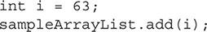

A. The int is successfully placed into the ArrayList.

B. The int is converted to an Integer via autoboxing and then placed into the ArrayList.

C. null is placed into the ArrayList.

D. A compile time error will be generated.

E. A runtime exception will be thrown.

[**18.**](https://learning.oreilly.com/library/view/oca-java-se/9781259587535/ch06.html#ch06qa18a) Which of the following are interfaces to ArrayList? (Choose all that apply.)

A. List

B. Map

C. Queue

D. Set

E. RandomAccess

#### SELF TEST ANSWERS

**Work with Java Arrays**

[**1.**](https://learning.oreilly.com/library/view/oca-java-se/9781259587535/ch06.html#ch06qa1) What lines will compile without errors? (Choose all that apply.)

A. Object obj = new Object();

B. Object[] obj = new Object();

C. Object obj[] = new Object();

D. Object[] obj = new Object[];

E. Object[] obj = new Object[3]();

F. Object[] obj = new Object[7];

G. Object obj[] = new Object[];

H. Object obj[] = new Object[3]();

I. Object obj[] = new Object[7];

J. Object[8] obj = new Object[];

K. Object[3] obj = new Object[3]();

L. Object[7] obj = new Object[7];

M. Object obj[] = new {new Object(), new Object()};

N. Object obj[] = {new Object(), new Object()};

O. Object obj[] = {new Object[1], new Object[2]};

Answer:

 **A**, **F**,**I**,**N**, and **O**. Are all correct ways to declare and initialize an array.

 **B**, **C**, **D**, **E**, **G**, **H**, **J**, **K**, **L**, and **M** are incorrect. **B** and **C** are incorrect because they have () instead of [] after the type. **D** and **G** are incorrect because they do not assign a size to the array. **E** and **H** are incorrect because the () after the [] is not the correct syntax. **J** and **L** are incorrect because the size is not assigned when it is declared. **K** is incorrect because the size is in the declaration and the extra () after the [] is not the correct syntax. **M** is incorrect because the first new operator is being used with the {} initialization method.

[**2.**](https://learning.oreilly.com/library/view/oca-java-se/9781259587535/ch06.html#ch06qa2) What is the output of the following code segment?



A. One Two Three

B. Three Two One

C. A compile time error will be generated.

D. A runtime exception will be thrown.

Answer:

 **D**. Array indexes start at 0. The numbers[3] variable will throw a runtime ArrayIndexOutOfBoundsException.

 **A**, **B**, and **C** are incorrect. If the indexes were each one number lower, **B** would be the correct answer.

[**3.**](https://learning.oreilly.com/library/view/oca-java-se/9781259587535/ch06.html#ch06qa3) What is the output of the following code segment?

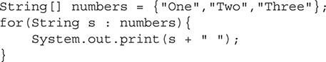

A. One Two Three

B. Three Two One

C. A compile time error will be generated.

D. A runtime exception will be thrown.

Answer:

 **A**. The enhanced for loop will print out each string in order.

 **B**, **C**, and **D** are incorrect. **B** is incorrect because it is in the wrong order. **C** and **D** are incorrect because this code is valid.

[**4.**](https://learning.oreilly.com/library/view/oca-java-se/9781259587535/ch06.html#ch06qa4) What is the output of the following code segment?



A. Length: 4

B. Length: 5

C. Length: 100

D. A compile time error will be generated.

E. A runtime exception will be thrown.

Answer:

 **B**. The length of an array equals the number of elements in the array.

 **A**, **C**, **D**, and **E** are incorrect. **A** is incorrect because length is not zero based, which the value 4 would imply. **C** is incorrect because the length returns the size of the array, not the last value. **D** and **E** are incorrect because no error or exceptions will be generated.

[**5.**](https://learning.oreilly.com/library/view/oca-java-se/9781259587535/ch06.html#ch06qa5) What is the output of the following code segment?



A. 100 1 30 50

B. 100 1

C. 100 30

D. 100 1 30

E. 600 1

F. 600 30

G. 600 1 30

H. A compile time error will be generated.

I. A runtime exception will be thrown.

Answer:

 **C**. 100 is added to the array first, and then the 30 is copied into the array with the arraycopy() method.

 **A**, **B**, **D**, **E**, **F**, **G**, **H**, and **I** are incorrect. Each of these sets of numbers is not what will be output from this code segment.

[**6.**](https://learning.oreilly.com/library/view/oca-java-se/9781259587535/ch06.html#ch06qa6) What line *will* produce a compiler error?

A. double[][] numbers;

B. double[][][] numbers;

C. double[][] numbers = {{1,2,3},{7,8,9},{4,5,6}};

D. double[][] numbers = {{1,2,3},{7,8},{4,5,6,9}};

E. double[][][] numbers = new double[7][][];

F. double[][][] numbers = new double[][][];

G. double[][][] numbers = new double[7][3][2];

Answer:

 **F**. When the new operator is used, at least one array dimension in a multi-dimensional array must be given a size.

 **A**, **B**, **C**, **D**, **E**, and **G** are incorrect. These are all valid ways to work with arrays.

[**7.**](https://learning.oreilly.com/library/view/oca-java-se/9781259587535/ch06.html#ch06qa7) What is the value of the variable sum at the end of this code segment?

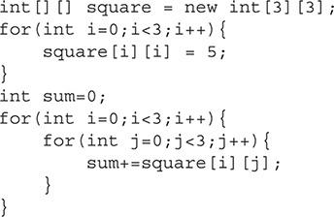

A. 0

B. 5

C. 10

D. 15

E. 20

F. 25

G. 30

H. 35

I. 40

J. 45

K. 50

L. It will generate a compiler error.

Answer:

 **D**. All primitive array elements start with a value of 0. Then the first for loop sets square[0][0], square[1][1], and square[2][2] to 5. All the array elements are summed in the second for loop, resulting in the sum variable having the value of 15 at the end.

 **A**, **B**, **C**, **E**, **F**, **G**, **H**, **I**, **J**, and **K** are incorrect. These values are all incorrect results for the sum variable. **L** is incorrect because this is valid code that does not produce an error.

[**8.**](https://learning.oreilly.com/library/view/oca-java-se/9781259587535/ch06.html#ch06qa8) The following code segment is valid. True or false?



A. True

B. False

Answer:

 **A**. The code sample is valid, so the answer is true.

 **B** is incorrect because the sample is valid.

[**9.**](https://learning.oreilly.com/library/view/oca-java-se/9781259587535/ch06.html#ch06qa9) Given:

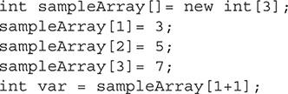

What is the value of the variable var?

A. 3

B. 5

C. 7

D. 6

E. 8

F. A compiler error will occur.

G. A runtime error will occur.

Answer:

 **G**. This will cause a runtime error. This code will throw a java.lang.ArrayIndexOutOfBoundsException. Arrays have an index that starts at 0. In this code segment, the valid indexes would be 0, 1, and 2.

 **A**, **B**, **C**, **D**, **E**, and **F** are incorrect. **A**, **B**, **C**, **D**, and **E** are incorrect because this code cannot be run without an error. However, if sampleArray[3] was changed to sampleArray[0], **B** would be correct. **F** is incorrect since the code will compile without any issues; however, some IDEs may flag this as a possible problem.

[**10.**](https://learning.oreilly.com/library/view/oca-java-se/9781259587535/ch06.html#ch06qa10) What is missing from the following multi-dimensional array declaration?



A. Curly brackets

B. Parentheses

C. The new keyword

D. Nothing is missing.

Answer:

 **C**. The new keyword is needed to establish memory allocation.

 **A**, **B**, and **D** are incorrect. **A** is incorrect because for the declaration specified, curly brackets are not needed. **B** is incorrect because for the declaration specified, parentheses are not needed. **D** is incorrect because the new keyword is missing.

**Work with ArrayList Objects and Their Methods**

[**11.**](https://learning.oreilly.com/library/view/oca-java-se/9781259587535/ch06.html#ch06qa11) What can be stored in an ArrayList? (Choose all that apply.)

A. Primitives

B. Objects

C. Standard arrays

D. Enums

Answer:

 **B**, **C**, and **D**. Objects, standard arrays, and enums can be stored in an ArrayList.

 **A** is incorrect. Primitives cannot be stored in an ArrayList unless they are placed in their primitive wrapper class.

[**12.**](https://learning.oreilly.com/library/view/oca-java-se/9781259587535/ch06.html#ch06qa12) What is the value of the size variable at the completion of this code segment?



A. 0

B. 1

C. 2

D. 10

E. 15

F. A compile time error will be generated.

G. A runtime exception will be thrown.

Answer:

 **C**. The size of an ArrayList is based on the number of objects in it, not its capacity.

 **A**, **B**, **D**, **E**, **F**, and **G** are incorrect because the size of an ArrayList is based on the number of objects in it, not its capacity.

[**13.**](https://learning.oreilly.com/library/view/oca-java-se/9781259587535/ch06.html#ch06qa13) For standard situations, what is typically the best type of array to use?

A. ArrayList

B. One-dimensional array

C. Multi-dimensional array

Answer:

 **A**. An ArrayList is a modern implementation of an array. It provides more flexibility than standard arrays, and its methods and automatic managing of internal resources will help reduce programming errors.

 **B** and **C** are incorrect. Both of these standard Java arrays are less flexible than an ArrayList.

[**14.**](https://learning.oreilly.com/library/view/oca-java-se/9781259587535/ch06.html#ch06qa14) What is the output of the following code segment?



A. One Two Three

B. One Three Two

C. Three One Two

D. One Three

E. Three Two

F. A compile time error will be generated.

G. A runtime exception will be thrown.

Answer:

 **B**. The Three string is inserted at index 1. Since arrays have indexes starting at 0, an index of 1 places Three in the middle of the other two elements.

 **A**, **C**, **D**, **E**, **F**, and **G** are incorrect. **A, C, D,** and **E** are not the correct output for the given code segment. **F** and **G** are incorrect because this is a valid code segment.

[**15.**](https://learning.oreilly.com/library/view/oca-java-se/9781259587535/ch06.html#ch06qa15) The ArrayList class is part of what Java package?

A. java.lang

B. java.util

C. javax.tools

D. javax.swing

Answer:

 **B**. The java.util package contains the collection classes and many other common Java classes.

 **A**, **C**, and **D** are incorrect. **A** is incorrect because java.lang contains many of the fundamental classes that make up Java. **C** is incorrect because javax.tools contains Java tools that can be invoked from programs. **D** is incorrect because javax.swing contains classes that are used to create graphical interfaces.

[**16.**](https://learning.oreilly.com/library/view/oca-java-se/9781259587535/ch06.html#ch06qa16) What array type has the most overhead?

A. One-dimensional array

B. Multi-dimensional array

C. ArrayList

Answer:

 **C**. ArrayList objects have more overhead involved than standard arrays. However, their flexibility often more than makes up for this.

 **A** and **B** are incorrect. These are examples of traditional Java arrays. They both have less overhead than an ArrayList and therefore are incorrect answers for this question.

[**17.**](https://learning.oreilly.com/library/view/oca-java-se/9781259587535/ch06.html#ch06qa17) What best describes the result of the following code segment? The ArrayList sampleArrayList has already been declared and initialized.



A. The int is successfully placed into the ArrayList.

B. The int is converted to an Integer via autoboxing and then placed into the ArrayList.

C. null is placed into the ArrayList.

D. A compile time error will be generated.

E. A runtime exception will be thrown.

Answer:

 **B**. Primitives cannot be stored in an ArrayList. However, if they are placed into their primitive wrapper class, they can be stored. Java will automatically make that conversion via its autoboxing feature if a primitive is placed into an ArrayList.

 **A**, **C**, **D**, and **E** are incorrect. **A** is incorrect because an int cannot be directly placed into an ArrayList. **C** is incorrect because null is not placed into the ArrayList. **D** and **E** are incorrect because this is valid code.

[**18.**](https://learning.oreilly.com/library/view/oca-java-se/9781259587535/ch06.html#ch06qa18) Which of the following are interfaces to ArrayList? (Choose all that apply.)

A. List

B. Map

C. Queue

D. Set

E. RandomAccess

Answer:

 **A** and **E**. List and RandomAccess are interfaces to ArrayList.

 **B**, **C**, and **D** are incorrect. **B** is incorrect because Map is not an interface to ArrayList. **C** is incorrect because Queue is not an interface to ArrayList. **D** is incorrect because Set is not an inter



### 7

### UNDERSTANDING CLASS INHERITANCE

**CERTIFICATION OBJECTIVES**

• [Implement and Use Inheritance and Class Types](https://learning.oreilly.com/library/view/oca-java-se/9781259587535/ch07.html#ch07lev1)

• [Understand Encapsulation Principles](https://learning.oreilly.com/library/view/oca-java-se/9781259587535/ch07.html#ch07lev7)

• [Advanced Use of Classes with Inheritance and Encapsulation](https://learning.oreilly.com/library/view/oca-java-se/9781259587535/ch07.html#ch07lev11)

 [Two-Minute Drill](https://learning.oreilly.com/library/view/oca-java-se/9781259587535/ch07.html#ch07lev16)

**Q&A** [Self Test](https://learning.oreilly.com/library/view/oca-java-se/9781259587535/ch07.html#ch07lev17)

**I**nheritance is a core feature of object-orientated programming languages. It allows for better architected software through code reuse, encapsulation, and data protection. It is critical that you understand this fundamental concept for the OCA exam. As a professional developer, you will be required to use inheritance daily in your own code and while interacting with existing code and frameworks. This chapter will cover the important theory of inheritance and demonstrate it with practical examples.

**CERTIFICATION OBJECTIVE**

#### Implement and Use Inheritance and Class Types

*Exam Objective Describe inheritance and its benefits*

*Exam Objective Use abstract classes and interfaces*

Inheritance is a fundamental concept of the Java language that allows specific classes to inherit the methods and instance variables of more general classes. This enables you to create code that is maintainable and emphasizes code reuse. You will need to have a thorough understanding of these topics for the exam.

This section also examines the differences between concrete classes and abstract classes. *Concrete* classes are basic normal classes, whereas *abstract* classes are tied to inheritance. The OCA exam will surely include a few questions for which you will need to understand what type of class is being used.

Finally, interfaces will be discussed. In short, an *interface* allows the developer to specify an external public interface to a class. Any class that implements or uses this interface must abide by the specifications outlined in the interface.

This section is about inheritance and the details of how inheritance works. This concept will not only be a major part of the OCA exam, but is also a very important concept to understand as a developer. The following topics will be covered in this chapter:

 Inheritance

 Overriding methods

 Abstract classes

 Interfaces

 Advanced concepts of inheritance

##### Inheritance

Inheritance allows a developer to create general classes that can be used as the foundation for multiple specific classes. For example, a program may be required to have classes that represent animals. The animals that must be represented are dogs, cats, and horses. All of these animal classes share some common elements. In this simple example, each animal would have a weight, age, and color instance variable. Each animal class would also have methods that allow it to do such things as eat, rest, and move. These methods could be called eat(), rest(), and move(int direction).

This can be implemented without inheritance by creating a class for each animal type and then defining each of the methods. This implementation approach will work, but it has a few drawbacks. Since each type of animal eats, rests, and moves very similarly, there will be a lot of duplicated code between each class. Duplicated code makes a program hard to maintain. If a bug is found in one class, the developer must remember to find it in every other class that has a copy of that code. The same problem exists for adding features to the duplicated code. It becomes very easy for code that *should* perform the same to slowly start performing differently as the code goes through the development and maintenance process. Another disadvantage of this approach is that polymorphism cannot be used. *Polymorphism* is a technique that allows a specific object, such as a dog object, to be referred to in code as its more general parent animal. (Polymorphism will be covered in detail in [Chapter 8](https://learning.oreilly.com/library/view/oca-java-se/9781259587535/ch08.html#ch08).) Because this approach does not use inheritance, polymorphism is not possible. The following is an example of each animal class implemented in this approach. The details of the class are represented as comments to explain what functionality would be present if implemented.

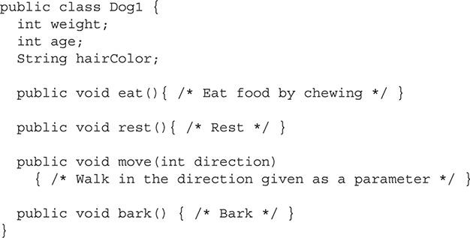

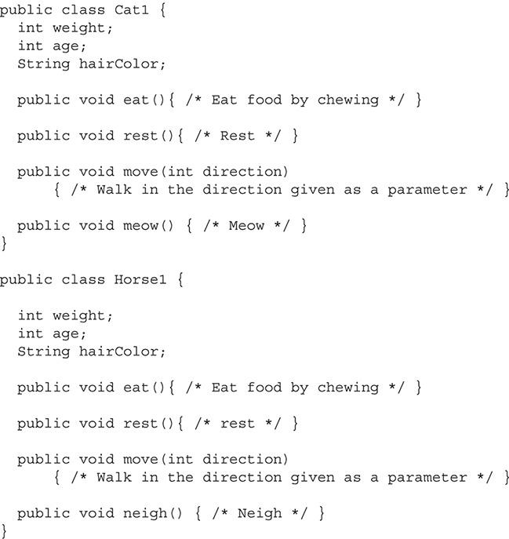

The first implementation of these animals is to create a unique class for each one. Each of the preceding classes has no relationship to the other. It is easy to see that the classes are all very similar and code is duplicated among them. In fact, all the methods are the same except the bark(), meow(), and neigh() methods. Although there is no explicit relationship defined in the code, it is easy to infer that all three classes are related.

The same example can be better implemented by using inheritance. In the next simple example, three of the four methods that need to be implemented are common to each different animal. A dog, cat, and horse all eat, rest, and move in similar fashion. This common functionality can be placed in a general Animal class that defines all the general methods and instance variables that make up an animal. When the developer creates more specific types of animals such as dogs, cats, or horses, he or she can use the Animal class as a base, or *superclass*. The more specific classes will inherit all of the nonprivate methods and instance variables from the base Animal class. A class is inherited when it is extended. It is important to remember that a class can extend only one class. It is invalid to inherit multiple classes in one class. However, a class can inherit a class that then inherits another class, and so on. The extends keyword is used in the class signature line. The following is an example of the same animals being implemented using inheritance:

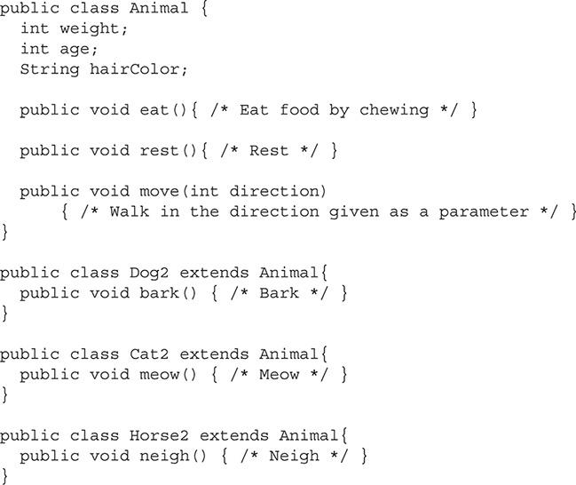



***Saying that class X* extends *class Y is the same as saying that class X* inherits *class Y*.**

This example creates Dog2, Cat2, and Horse2 classes that are functionally the same as the first example. Each one of these classes extends, or inherits, the Animal class. The Animal class is used as their base, or superclass. The specific classes inherit all of the methods and instance variables from the Animal class and are then permitted to add specific methods and variables that the particular class may need. In this example, each class added a method to make the noise of the animal. You may add as many instance variables or methods as needed to the class or use only those provided from the superclass.

When a class extends another class, any nonprivate methods that are contained in the superclass are accessible from the subclass. Later in this chapter, in the section “Understand Encapsulation Principles,” you’ll learn more about the four Java access modifiers; for now, assume that all of the examples use public methods. They can be invoked in the same manner as the methods implemented in the subclass. The following example demonstrates how the Dog2 class can be used:

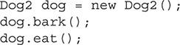

In this example, a Dog2 object named dog is created. Then the bark() and eat() methods are called. Notice that both methods can be called in the same manner, even though only the bark() method is implemented in the Dog2 class. This is because any Dog2 object inherits all of the nonprivate methods in the Animal class.

##### Overriding Methods

Inheriting, or extending, a class is a very good approach for factoring out common functionality between classes. Specific classes extending more general classes allow code to be reused in a project. As stated previously, this helps keep the project more maintainable and less prone to bugs as the development cycle progresses.

The problem with this approach, however, is that the subclass that inherits the methods of the superclass is sometimes slightly different. For example, if a Fish class extends the Animal class, the move() method would not work since it is implemented by code that walks—and a fish needs to swim. A class that extends another class may override any inherited method. This is done by defining another method called move() with the same arguments and return type. When the move() method is invoked, the one that is implemented in the Fish class will be used. A class may override all, none, or just some of the methods it inherits from a parent class. The following is an example of the Fish class extending the Animal class and then overriding the move() method:

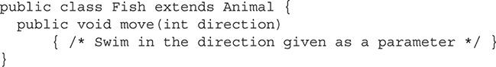

Notice that the move() method signature is the same as in the Animal class. However, the move() method in the Fish class is overriding the move() method in the Animal class. When a Fish object is created and the move() method is called, the code that is located in the Fish class will be executed. To override a method, the method signatures, which is all of the parameters and return type, must be identical.

When a subclass overrides a method, it has the option of calling the method that is being overridden. This can be achieved by using the super keyword. The super keyword works just like the this keyword, but instead of referring to the current class, super refers to the superclass. When super is used, it must pass the correct arguments to the parent method. The following is an example of super being used in the Horse3 class. Because horses normally rest standing, the Horse2 class from earlier can be further modified to put the horse in a standing position before it performs the rest() method.

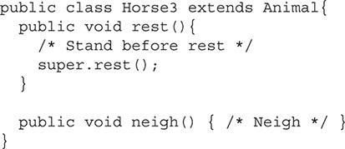

When a Horse3 object has its rest() method called, it will execute the code inside the rest() method of the Horse3 class. This is because the rest() method overrides the rest() method in the Animal class. The Horse3’s rest() method makes the horse stand and then uses super to call the rest() method in the Animal class.

##### Abstract Classes

So far, all the examples presented use concrete classes. A *concrete class* is a regular class that can be instantiated. Java has another class type called an *abstract class*, which is different from a concrete class because it cannot be instantiated and must be extended. An abstract class may contain *abstract methods*, or methods that are not implemented. They have a valid method signature but must be overridden and implemented in the concrete class that extends the abstract class. However, an abstract class can extend another abstract class without implementing its methods. Abstract classes can have instance variables that may be used by concrete classes that extend the abstract class. The following is an example of an abstract class:

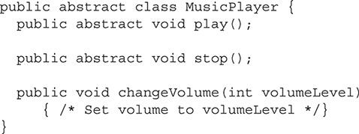

This example is an abstract class for a music player. This is intended to be the base class for different music-playing devices such as MP3 players or CD players. Notice how the class is defined: the keyword abstract is used to indicate that this is an abstract class. This class provides some functionality with the changeVolume() method. It also contains two abstract methods. An abstract method can exist only in an abstract class. The abstract keyword is used to mark a method as such. Every abstract method must be implemented in the concrete subclass that extends it.

An abstract class can extend other abstract classes. Abstract classes are not required to implement the methods of an abstract superclass. However, all of these methods must be implemented by the first concrete subclass. The purpose of an abstract method is to define the required functionality that any subclass must have. In this case, any music player must be able to play and stop. The functionality cannot be implemented in the MusicPlayer class because it is different from player to player. The following example shows two classes extending the MusicPlayer class:

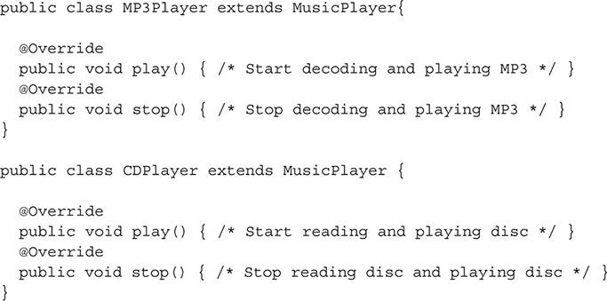

The MP3Player and CDPlayer classes are both types of music players. By extending the MusicPlayer class, they are required to implement the play() and stop() methods by overriding the abstract classes in the base class.



***The* @Override *and* @Implements *annotations provide a way for the Java compiler to check that the annotated method is truly doing what the developer intends.* @Override *should be used when a method is overriding, and therefore hiding, a method in a superclass. The* @Implements *annotation is used when a method from an interface is implemented*.**

##### Interfaces

Interfaces are used in the Java language to define a required set of functionalities for the classes that implement the interface. Unlike extending base classes, a class is free to implement as many interfaces as needed. An interface can be thought of as an abstract class with all abstract methods.

When a concrete class implements an interface, it is required to implement all of the methods defined in the interface. An abstract class is not required to implement the interface methods, but the concrete class that extends it is still responsible to provide the functionality that the interface defines. Interfaces are used to create a standard public interface for similar items. This enables code to be more modular.

The interface keyword is used to create an interface in the next example:

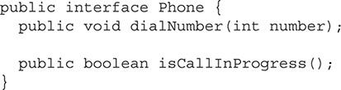

This example is a very basic interface for a phone.

The next example demonstrates this interface being implemented by a cell phone class and a landline phone. The keyword implements is used to implement an interface.

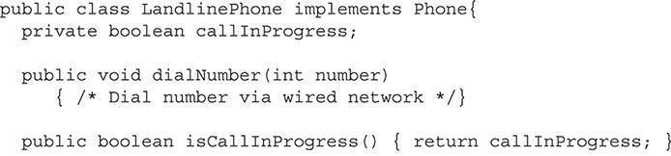

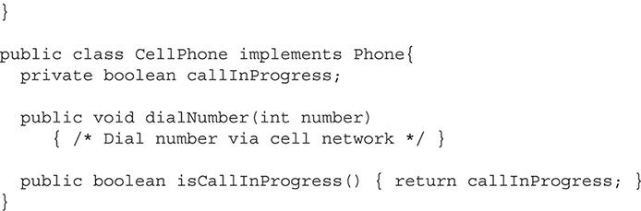

When an interface is implemented, all of its methods must then be implemented in that class. It is possible to implement multiple interfaces. When more than one interface is being used, they are separated in a comma-delimited list. When multiple interfaces are used, all of the methods defined in each one must be implemented. Any unimplemented methods will cause the compiler to generate errors. The following is an example of a class implementing two interfaces:

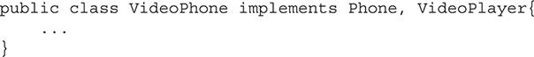

The big advantage of using interfaces is that any class that uses the same interface will have the same public methods, as shown in [Figure 7-1](https://learning.oreilly.com/library/view/oca-java-se/9781259587535/ch07.html#ch07fig01). This means that the CellPhone class shown earlier could be used instead of LandlinePhone. Changing between these classes should not require any code change other than the type declared. This gets close to the idea of polymorphism and will be covered in detail in [Chapter 8](https://learning.oreilly.com/library/view/oca-java-se/9781259587535/ch08.html#ch08).

**FIGURE 7-1** Implementation of the Phone interface

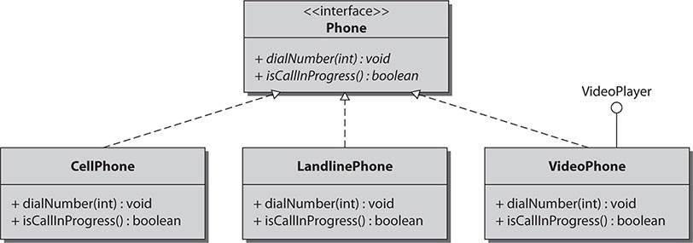

##### Advanced Concepts of Inheritance

The last few sections discussed the basic cases of inheritance—one concrete class extending another concrete class, abstract class, or implementing interfaces. However, it is possible and common to have many levels of inheritance. In fact, every class in the Java language inherits from the base class Object. This includes the classes built by developers.

The use of Object as a base class is implied and does not have to be explicitly extended with the extends keyword. This means that in the preceding examples where a class was inherited, there were really two levels of inheritance. Looking back at the animal example, the Dog2 class extended the Animal class, and the Animal class extended the Object class. This means that the Dog2 class gained all of the functionality of both classes. If a class overrides the methods of another, the new method is then passed down the inheritance chain. The inheritance chain can continue as long as it is applicable to the application, meaning class A can extend class B, which extends C, which extends D, and so forth. The classes can be a mixture of abstract and concrete. The classes are also able to implement any interfaces required.

Interfaces may also extend other interfaces. When an interface extends another interface, it gains all of the defined methods of the extended interface. Unlike a class, an interface may extend multiple interfaces. This is achieved by using the extends keyword, followed by a comma-delimited list of interfaces.

The diagram in [Figure 7-2](https://learning.oreilly.com/library/view/oca-java-se/9781259587535/ch07.html#ch07fig02) represents a possible inheritance tree. At the bottom of this tree is the concrete class SportsCar. This class extends the abstract class Car. The Car class extends the PassengerVehicle class, which extends the base Object class. The PassengerVehicle class also implements the Drivable interface.

**FIGURE 7-2** An example of an inheritance tree

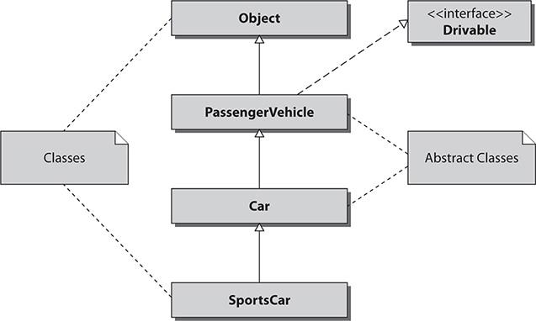

In an example like this, the SportsCar class has access to all the visible methods and instance variables in both the PassengerVehicle class and the Car class. The SportsCar class must also implement any methods that were abstract and unimplemented, including those required by the Drivable interface.

**CERTIFICATION OBJECTIVE**

#### Understand Encapsulation Principles

*Exam Objective Apply access modifiers*

*Exam Objective Apply encapsulation principles to a class*

*Encapsulation* is the concept of storing data together with methods that operate on that data. Objects are used as the container for the data and code. This section discusses the principles of encapsulation and how it should be applied by a developer.

Encapsulation allows for data and method hiding. This concept is called *information hiding*. Information hiding makes it possible to expose a public interface while hiding the implementation details. Finally, this section will explore the JavaBean conventions for creating getter and setter methods. These are the methods used to read and modify properties of a Java object.

This section will expose the reader to some good basic design principles that should be used with the Java language. The OCA exam will require an understanding of these principles. These conventions will be used on the exam even when the question is not directly related to them. Learning these concepts thoroughly will help you in understanding many exam questions.

##### Good Design with Encapsulation

The fundamental theory of an object-oriented language is that software is designed by creating discrete objects that interact to make up the functionality of the application. Encapsulation is the concept of storing similar data and methods together in discrete classes. In many non–object-oriented languages, there is no association between where the data is and where the code is. This can increase the complexity of maintaining the code, because often the variables that the code is using are spread apart over the code base. Bugs in the code can be hard to find and resolve due to different remote procedures using the same variables.

Encapsulation tries to solve these problems. It lets you create code that is easier to read and maintain by allowing you to group related variables and methods together in classes. Object-oriented software is very modular, and encapsulation is used for creating these modules.

A well-encapsulated class has a single clear purpose. This class should contain only the methods and variables that are needed to fulfill its purpose. For example, if a class was intended to represent a television, it should contain variables such as currentChannel, volume, and isPoweredOn. A Television class would also have methods such as setChannel(int channel) or setVolume(int volume). These variables and methods are all related. They are specific to the properties and actions needed to create a Television class. The Television class would not contain methods such as playBluray(); this should be contained in a separate Bluray class.

Encapsulation is about creating well-defined classes that have a clear purpose. These classes contain all the data and methods needed to perform their intended functions.

Encapsulation is defined slightly differently depending on the source. Sometimes the definition indicates that encapsulation is solely about storing related data and methods together in a class. Other places define encapsulation as also including information hiding of the implementation details. We will be using the first, more pure definition of encapsulation.

##### Access Modifiers

Access modifiers are keywords that define what can access methods and instance variables. The three access modifiers are private, protected, and public. These all change the default level of access. The default access level does not use a keyword and is assigned to a method or instance variable when neither private, protected, nor public is used, and the area is left blank. Access modifiers are an important concept in object-oriented languages. They allow the implementation details to be hidden in a class. The developer can choose specifically what parts of a class are accessible to other objects.

The OCA exam will focus on the different effects that each modifier has. The topics listed next will be covered in the following subsections:

 The access modifiers

 Information hiding

 Exposing object functionality

###### The Access Modifiers

As mentioned, Java uses three access modifiers: private, protected, and public. There is also the default access level, which is known as *package-private*. Each access level has different restrictions that allow or deny classes access to methods or instance variables. Access modifiers are also used when defining a class. This is beyond the scope of the OCA, so you can just assume all classes are public. The Java compiler will produce errors if a restricted method or instance variable is accessed by code that is unauthorized.

The private access modifier is the most restrictive and most commonly used access modifier. Any method or instance variable that is marked as private can be accessed only by other methods in the same class. Subclasses cannot access instance variables or methods that are private. The following is an example of the private keyword in use:



The default access level is the second most restrictive. It is often referred to as *package-private*. This access level allows access to its methods and instance variables from code that is in the same package. The default access level does not have a keyword to indicate it is in use. A method or instance variable is set to default when an access modifier is omitted. The following is an example of this access level in use:

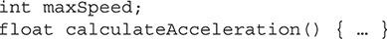

The protected access modifier is the third most restrictive. It is the same as the default access level but adds the ability of subclasses outside of the package to access its methods or instance variables. This means the methods that can access this data must either be in the same package (same as default) or be in a subclass of the class that contains the protected data. Remember that a subclass is a class that extends another class. The following is an example of the use of the protected access modifier:

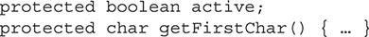

The final access modifier is public. This is the least restrictive and second most common access modifier. The public access modifier provides no restriction to what can access its methods and instance variables. Any method can access a public method or instance variable regardless of which package it is contained in or which superclass it extends. An item marked as public is accessible to the world. The following is an example of using the public access modifier:

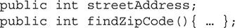

###### Information Hiding

Information hiding is the concept of hiding the implementation details of a class. Information hiding is achieved by using restrictive access modifiers. By hiding data, the developer can control how the data is accessed.

Instance variables are used to store the state of an object. If outside objects were able to access an object’s entire set of instance variables, the risk of introducing bugs would be increased. A developer may create a new class that incorrectly tries to use the internal features of another class. Even if this approach works at first, it requires that the class’s internal data structure not change. This concept also applies to methods. Not all methods need to be accessible by external classes. Often, a class will be composed of more methods used internally to perform tasks rather than methods designed for external objects.

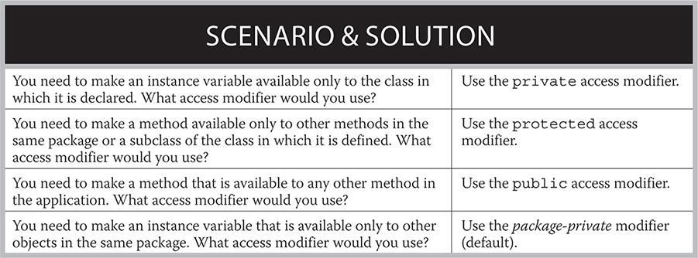

A benefit of hiding data can be seen in this scenario: A class contains an instance variable that must be between a certain range. An outside object may set this variable and disregard the proper range. To prevent this, the variable can be marked private and a public method can be used to set it. This method would contain code that would change its value only if the new value were valid.



***When you’re working on a project, a general rule is that every method and instance variable should use the most restrictive access modifier possible. This promotes good encapsulated design by protecting data and helps reduce the areas in which bugs can be inadvertently introduced*.**

###### Exposing Object Functionality

Once all of your internal implementation details are hidden, the class must have a set of public methods that expose its functionality to other objects. In most classes, all of the instance variables will use the private access modifier. The public methods should be the only required methods that other classes need to use this class. Any method used internally and not required by external classes should not be public.

Methods that are public can be compared to controls on the inside of a car. Only a few exist, but they allow the car to be driven. However, inside the car are many wires and mechanical controls that should not be altered and do not need to be altered to drive the car. These controls are like public methods, while the inside components are like private methods and instance variables.

Earlier in this chapter, interfaces were discussed. If a class implements an interface, it is required to implement each method in the interface as a public method. They are called “interfaces” because they represent the interface that other classes must use to work with this class. The public methods of any class can be thought of as an interface for the class. External objects have no knowledge of the underlying details of the class. They can see and use only the public interface that an object presents to them.

##### Setters and Getters

*Setters* and *getters* are the final concept of information hiding and encapsulation. As was discussed previously, it is good design to make all instance variables private. This means external classes have no way to access these variables. Sometimes an external object may need to read one of these variables to determine its state, or it may have to set the value. To achieve this, a public method is created for the variable, both to get and set the value. These are called *getters* and *setters*. They can be as simple as one line that only sets or returns a value.

The following example is a class that has one instance variable and a setter and getter:

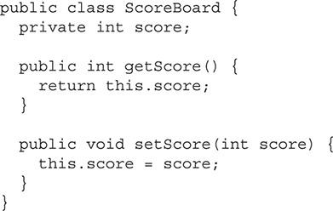

Notice in this example a private instance variable named score. The two methods that are present are a getter and setter for the variable score. In this case, the class is giving read and write access to the variable via the methods. In some cases, a class may give only one or the other. The getter and setter in this example are simple and only set or return the value. However, if the class had to perform an action every time the score variable was changed, it could be done from the setter. For example, each time the score is changed, the class must record it to a log. This can be done in the setter. This is the benefit of keeping instance variables private. It gives control to the class as to how its instance variables are accessed.

Getters and setters are the standard way of creating access to a class’s instance variables. When developers are working with a class, they expect to find getters and setters. They also expect the JavaBeans naming convention to be followed. When creating a getter, the name should start with a lowercase get, followed by the variable name with no spaces and the first letter capitalized. The one exception to this is when a boolean value is returned. In this case, instead of using get, is is used with the same rules being applied to the variable name. When creating a setter, a similar convention should be followed. A setter should start with the word set, followed by the variable name with the first letter capitalized.

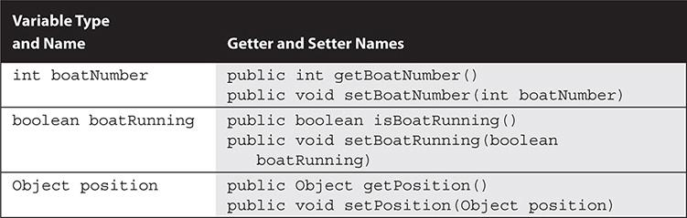

**CERTIFICATION OBJECTIVE**

#### Advanced Use of Classes with Inheritance and Encapsulation

*Exam Objective 2.3* *Know how to read or write to object fields*

This section will conclude the chapter by revisiting all of the concepts that have been discussed and demonstrating them with code examples. Each example will be followed by a detailed explanation of what is being highlighted and how it works. Pay close attention to the examples. They should help reinforce all of the concepts already covered.

##### Java Access Modifiers Example

The following example is a class implemented with its implementation details hidden. It uses public methods to expose an interface, as well as getters and setters to allow access to its instance variables.

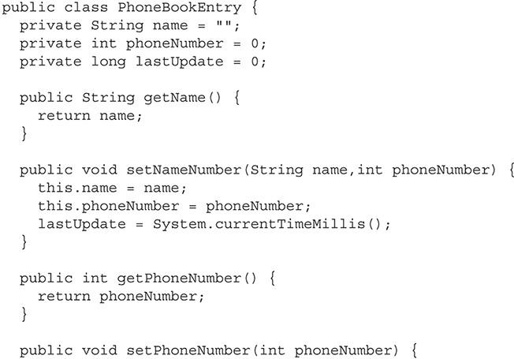

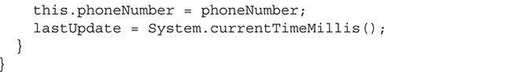

This example is a well-encapsulated class. It is a class that represents a basic phone book entry. It can store a name and a phone number. It also uses an instance variable to track the last time it was updated. All of the instance variables use the private access modifier. This means external classes are unable to read or modify them. It then uses getters and setters to modify the instance variables. In this example, there is no setter to set the name instance variable. To set the name instance variable, the object must also set the phoneNumber variable. This ensures that there is never a name without a phone number. If the instance variables were public, this class could not prevent another class from setting a name without a number.

This example also uses its setters to update the lastUpdate variable. This variable is used to track the last time this class had its information updated. By using the getters and setters, the class can guarantee that any time an external object updates a field via a setter, the lastUpdate variable will also be updated. The details of how lastUpdate becomes updated are invisible to external objects.

##### Inheritance with Concrete Classes Examples

A concrete class is the standard Java class. All of its methods are implemented and it can be instantiated. The following example uses a Bicycle class. The base class represents a basic bicycle. Another class represents a ten-speed bicycle. It is called TenSpeedBicycle and extends the Bicycle class. The TenSpeedBicycle class is able to inherit some of its functionality while overriding the parts of the base class that need to behave differently. The TenSpeedBicycle class has the ability to change its gear ratio in addition to what the Bicycle class can do.

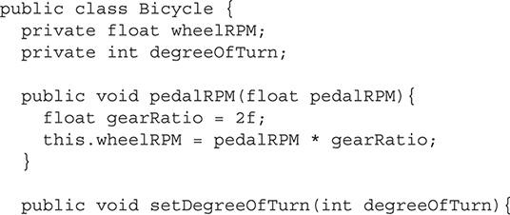

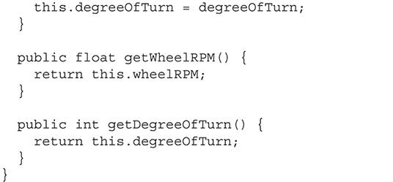

The Bicycle class is a concrete class and, therefore, can be instantiated. It represents a basic bicycle. It has two instance variables: wheelRPM, which is used to store the RPM of the wheels, and degreeOfTurn, which is used to store the degree the handlebars are turned. Each variable has a getter, and degreeOfTurn has a setter. The wheelRPM variable is set with the method pedalRPM(float pedalRPM). This accepts an argument that contains the RPM of the pedals and then multiplies that by a set gear ratio to find and set the wheelRPM variable.

The next example is the TenSpeedBicycle class. It extends the Bicycle class:

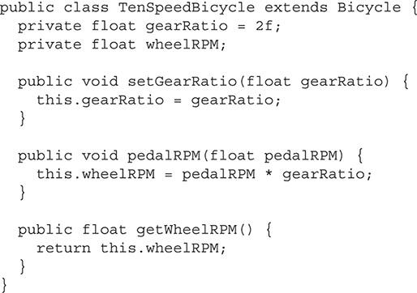

The TenSpeedBicycle class represents a bicycle that has ten different possible gear ratios. The regular Bicycle class cannot be used, because it has a fixed gear ratio. The TenSpeedBicycle class adds a method and instance variable so a gear ratio can be set. It also overrides the wheelRPM variable. This must be done because the Bicycle class has no setter to set that variable directly. The TenSpeedBicycle class also overrides the pedalRPM(float pedalRPM) method. In the Bicycle class version of this method, the gear ratio was fixed. In the newer version, it uses the gear ratio that can be set. To retrieve the wheelRPM variable, the getter must also be overridden. This is because the original version of this method can return only the instance variable that is in its same class.

The next segment of code demonstrates both classes in use.

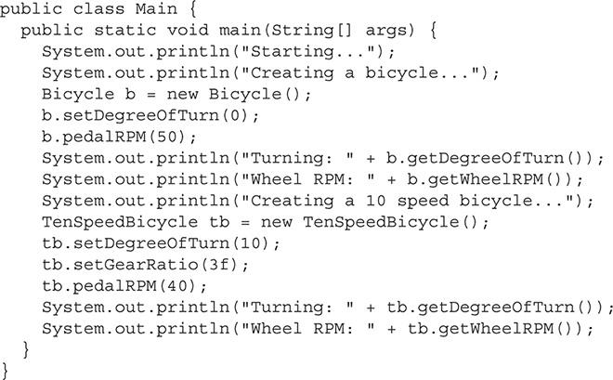

This code prints information to standard output for each step it takes. First, it creates a Bicycle object. It then sets the degree of turn to 0 and the pedal RPM to 50. The code then prints out the degree of turn, which will be 0, and the wheel RPM, which will be 100, since the gear ratio is 2 (2 × 50). Next, a TenSpeedBicycle object is created. This object has its degree of turn set to 10, its gear ratio set to 3, and its pedal RPM set to 40. Finally, this object prints out its degree of turn, which is 10, and its wheel RPM, which is 120 (3 × 40). Notice that the TenSpeedBicycle object’s getDegreeOfTurn() and setDegreeOfTurn() were inherited from the base class Bicycle.

This is the output of the program after it was compiled and run:

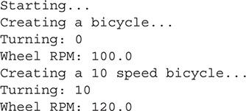

This example shows most of the basic concepts of inheritance, as you can see in [Figure 7-3](https://learning.oreilly.com/library/view/oca-java-se/9781259587535/ch07.html#ch07fig03).

**FIGURE 7-3** Basic inheritance

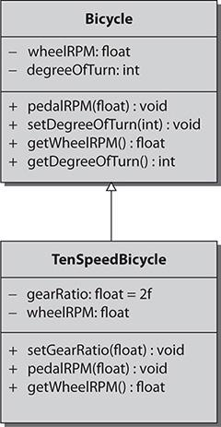



***As preparation for the OCA exam, you should review this code example until you fully understand how the preceding output was generated*.**

##### Inheritance with Abstract Classes Examples

This example will demonstrate an abstract class, a Java class that cannot be instantiated. Another concrete class must extend it. An abstract class may contain both concrete methods that have implementations and abstract methods that must be implemented by the subclass.

This example creates a plant simulator. It has a Plant abstract class that is extended by a MapleTree class and Tulip class. The Plant class is a good abstract class, because a plant is an abstract, or general, thing. Plants all share some characteristics that can be placed in this class. Each specific class can then contain the implementation details. The following code segment is the abstract Plant class:

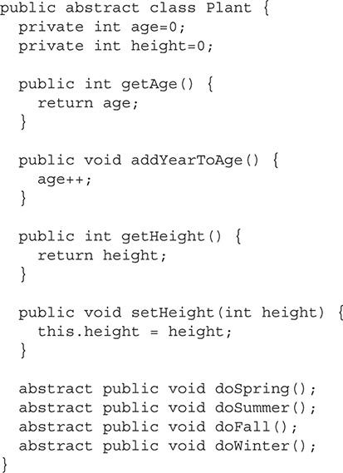

This abstract class offers a very simplistic view of what represents a plant. It contains two instance variables that every type of plant would use: age and height. There is both a getter and setter for height and a getter for age. The age instance variable has a method that is used to increment it each year.

The Plant class has four abstract methods. Each of these methods represents the actions that a plant must take during the specified season. These actions are specific to the type of plant and, therefore, cannot be generalized. Having them declared in the abstract Plant class guarantees that any class that extends the Plant class must implement them.

The next class is the MapleTree class:



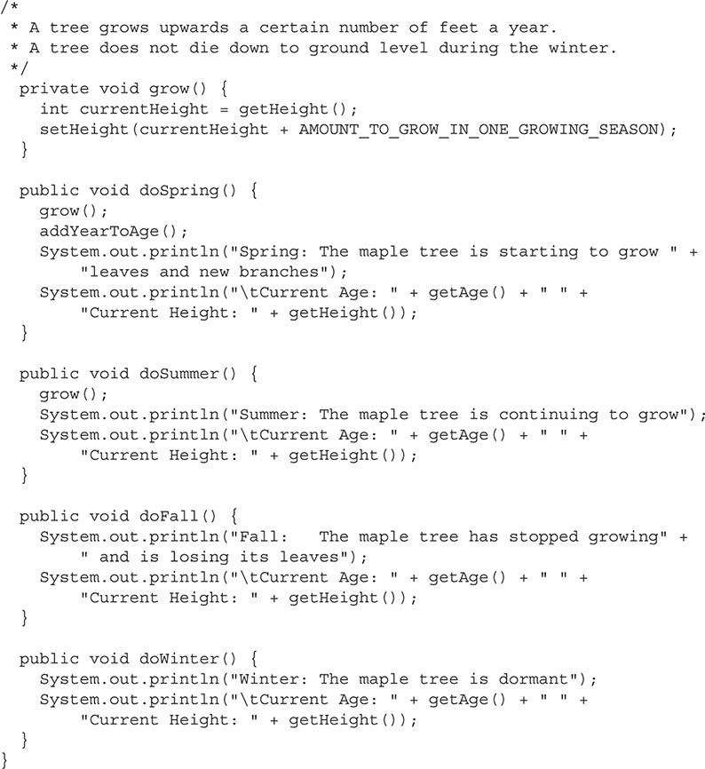

The MapleTree class extends the Plant class and is used as a simple representation of a maple tree. Because the Plant class is abstract, the MapleTree class must implement all of its abstract methods. The MapleTree class contains one variable named AMOUNT_TO_GROW_IN_ONE_GROWING_SEASON. This variable is marked as private static final int. This is how Java declares a constant. These details are beyond the scope of the OCA exam. Just consider this a constant that is a primitive int and is private. This variable is used to set the amount of growth that a maple tree completes during a growing season.

The MapleTree class contains a method to grow, called grow(). This method is used to add the new height to the current height. The next four methods are all methods that are required to be implemented. These abstract methods are declared in the Plant class, with each one representing a different season. When they are invoked, they perform any required action that is needed for that season and then print two lines to standard output. The first line of text states what season it is and what the maple tree is doing. The next line displays the values of the age and height variables.

The next class is the Tulip class:

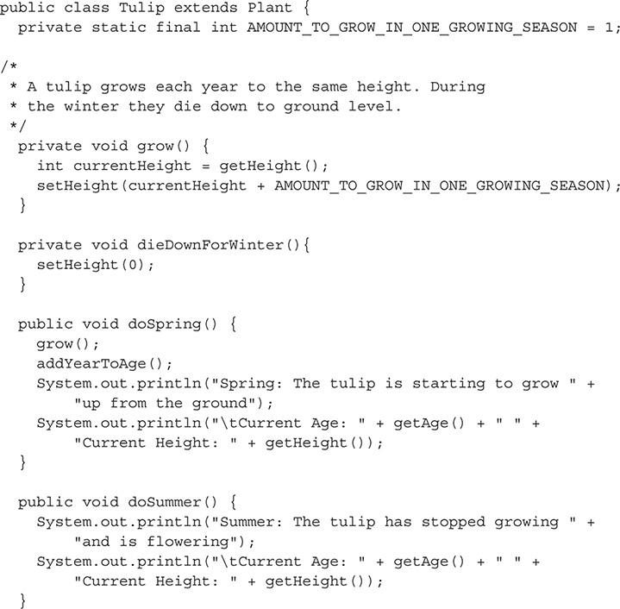

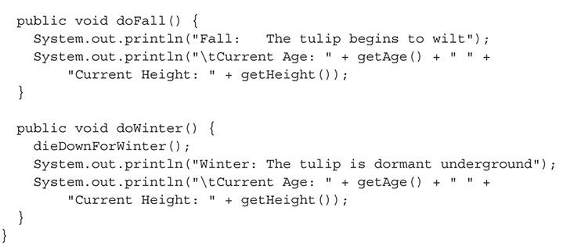

The Tulip class is intended to represent a tulip. It extends the Plant class and, therefore, must also implement all its abstract methods. Like the MapleTree class, the Tulip class also has a constant that is used to store the amount of growth per growing season.

The Tulip class has two private methods: a grow() method that is like the one present in the MapleTree class, and a dieDownForWinter() method that is used to reset the height to 0 when the tulip loses all of its leaves during the winter.

The last four methods in the class are the abstract methods from the Plant class. Each season method performs the needed actions first, such as grow, die down, or age. It then prints to standard output a message about what it is doing and what season it is. The second line of text contains the values of the age and height variables.

The final code segment is the main() method that uses both the Tulip and MapleTree classes:

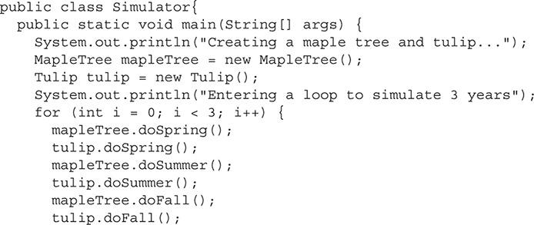

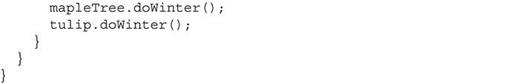

First, an object of each type is created. Then a for loop invokes the methods for all four seasons for each object. This loop represents a simple simulation program. Each time through the loop represents one year. Both objects age and grow from year to year.

When the preceding code is executed, it will produce the output shown next:

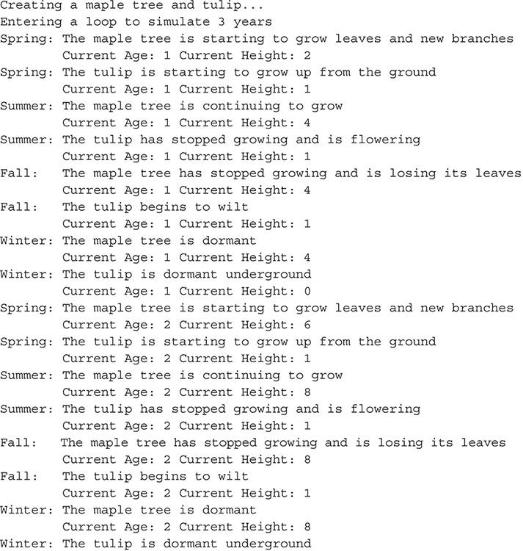

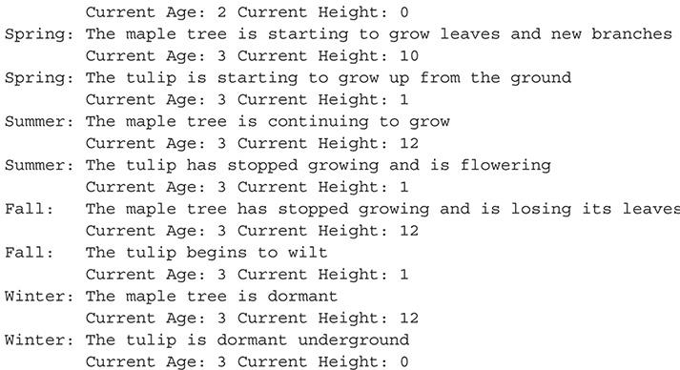

Notice how the maple tree continues to grow each year. The tulip, however, must regrow each year. Both the Tulip and the MapleTree objects have access to the getAge() and getHeight() methods that were implemented in the abstract Plant class. Review the code and the output thoroughly. Your understanding of the examples in this section will better prepare you for the OCA exam.

**EXERCISE 7-1**

**Add Functionality to the Plant Simulator**

This exercise will use the previous plant simulator and add new functionality to it.

**1.** Copy the plant simulator into the text editor or IDE of your choice.

**2.** Compile and run the example to ensure that the code has been copied correctly.

**3.** Add a new class called Rose that will represent a rose. Use the Plant base class and implement all of the required methods.

**4.** Add your new class into the simulator and run the application.

##### Interface Example

This final example involves interfaces. An *interface* is a public set of methods that must be implemented by the class that uses the interface. By using an interface, a class is declaring that it implements the functionality defined by the interface. New for Java 8 is the ability to define default methods and static methods in an interface. Default methods are fully implemented methods that will be used if the method is not defined in the class that is using the interface. Static methods are methods that belong to the interface and are useful for helper and utility methods.

This example includes two interfaces. One is called Printer and provides a public interface that printers should implement. Any class that implements Printer can be said to have the ability to print. The other interface in this example is Fax. It provides the public interface for a faxing capability. Finally, this example has a class that implements both interfaces. This class represents an all-in-one printer/fax machine. The class is called PrinterFaxCombo.

In this simple example, the printer can do two things: it can print a file with the printFile(File f) method, and it can check the ink levels with the getInkLevel() method. Notice that the getInkLevel() method has a default implementation defined.

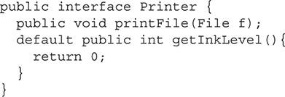

The next interface is for a fax machine. This simple fax machine can send a file with the sendFax(File f,int number) method or return a fax as an Object with the getReceivedFaxes() method.

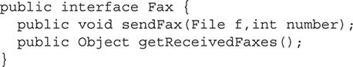

The following is the PrinterFaxCombo class. This class implements both interfaces.

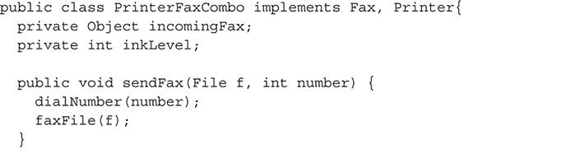

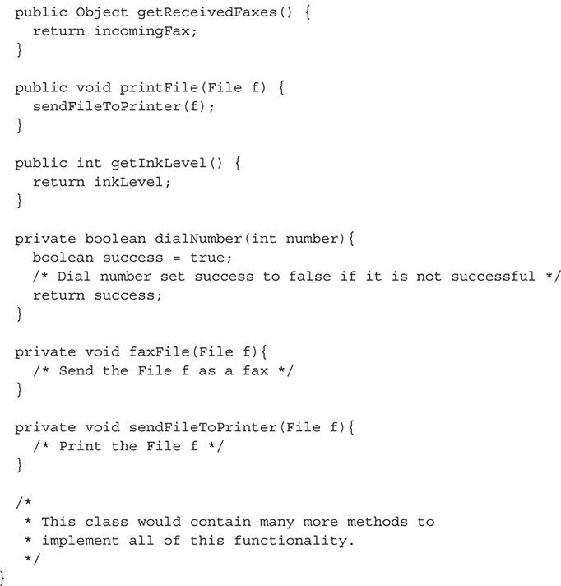

The PrinterFaxCombo class is a simplistic version of a printer that can also fax. The class is not fully implemented, but the comments in the empty methods should explain the purpose of each method. The important point of this example is that this class implements both the Printer and Fax interfaces. By implementing the interfaces, the PrinterFaxCombo class is obligated to implement each method they contain that does not have a default implementation. Implementing interfaces allows an external object to know that this class provides the functionality of a printer and fax machine. Every class that implements the Printer interface provides printing functionality and has the same public interface. This creates modular code and allows easy swapping in and out of different classes based on the needs of the application. Interfaces also allow for polymorphism, which will be discussed in detail in [Chapter 8](https://learning.oreilly.com/library/view/oca-java-se/9781259587535/ch08.html#ch08).

#### CERTIFICATION SUMMARY

This chapter has been about class inheritance and encapsulation. *Inheritance* is an important concept in Java. It is the term used to describe one class gaining the methods and instance variables of a parent class. This allows a developer to find commonality between classes and create a general parent class that each specific class can extend, or inherit, to then gain common functionality. This promotes code reuse.

Concrete classes and abstract classes are both able to be extended to create subclasses. The class that is extended is then considered the superclass, or base class. A class may extend only one class. Concrete classes are the standard class type with each method implemented. A class that extends a concrete class gains all of its visible methods. Abstract classes must be extended and cannot be instantiated in code. They contain a mixture of implemented and abstract, or unimplemented, methods. When an abstract class is extended, all of its abstract methods must be implemented by the concrete subclass.

Interfaces are a set of primarily unimplemented methods. When a class implements an interface, that class must then implement each method that is in the interface with the exception of methods that already contain a default implantation. Interfaces are used to define a predetermined set of exposed methods. Classes may implement as many interfaces as they need as long as all methods are then implemented in that class.

Next, Java access modifiers were discussed. The public, private, protected, and default access modifiers are used to prefix a method or instance variable. The public access modifier allows any code to access the method or instance variable that it prefixes. The private access modifier allows code only within its own class to access the method or instance variable. The default, or package-private, modifier restricts access only to classes in the same package. The protected modifier allows any class in the same package, or in a subclass, to have access.

Another major concept covered in this chapter was encapsulation. Encapsulation is the design concept of storing related code and variables together. It can also lead to the practice of information hiding, which allows access to a class only through a public interface while hiding the rest of the implementation details. A public interface is created by the methods that have the public access modifier. Implementation details should be hidden by using the private, protected, or default access modifier. Getters and setters are normally used to access the hidden data. A getter is a simple method that returns an instance variable, and a setter is a method that sets an instance variable to the value passed to it as an argument.

This chapter concluded with code examples. These examples are important for you to understand because the OCA exam will have questions based on a given code segment.

#### Images TWO-MINUTE DRILL

**Implement and Use Inheritance and Class Type**

 Inheritance is used to place common code in a base class.

 Inheritance makes code more modular and easier to maintain.

 The extends keyword is used for a class to extend or inherit another class, or for an interface to extend or inherit another interface.

 When a class inherits another class, it gains access to all of its public and protected methods and instance variables. If the two classes are in the same package, it also gains access to any methods or instance variables that have the default, or package-private, access.

 The class that is being inherited is called the base class or superclass.

 The class that gains the functionality is called the subclass.

 A method in a superclass can be overridden by the subclass having a method with an identical signature.

 The super keyword can be used to access the overridden method.

 A class can extend only one other class.

 A concrete class can be instantiated; all of its methods must have been implemented.

 An abstract class cannot be instantiated. It must be extended and may or may not contain abstract methods.

 When a concrete class extends an abstract class, all of the abstract methods must be implemented.

 An interface is used to define a public interface that a class must have.

 The keyword implements is used to implement an interface.

 A class may implement multiple interfaces by using a comma-delimited list.

 A class that implements an interface must implement all of the methods contained in the interface that do not have a default implementation defined.

**Understand Encapsulation Principles**

 Access modifiers can be used to restrict access to methods and instance variables.

 The public access modifier allows any class to access the public method or instance variable.

 The protected access modifier allows classes that are in the same package or are a subclass to have access to the method or instance variable.

 The default, or package-private, access allows classes that are in the same package to access the method or instance variable.

 The private access modifier allows only methods in the same class to access the private method or instance variable.

 Information hiding is the concept of using restrictive access modifiers to hide the implementation details of a class.

 Both getters and setters should follow the JavaBeans naming convention. They should start with get, set, or is, followed by the variable name, starting with a capital letter.

**Advanced Use of Classes with Inheritance and Encapsulation**

 When creating methods or instance variables, the most restrictive access modifier possible should be used.

 A getter is used to access private instance variables.

 A setter is used to set private instance variables.

#### SELF TEST

**Implement and Use Inheritance and Class Type**

[**1.**](https://learning.oreilly.com/library/view/oca-java-se/9781259587535/ch07.html#ch07qa1a) What contains methods and instance variables and can be instantiated?

A. Concrete class

B. Abstract class

C. Java class

D. Interface

[**2.**](https://learning.oreilly.com/library/view/oca-java-se/9781259587535/ch07.html#ch07qa2a) What is used to define a public interface?

A. Concrete class

B. Abstract class

C. Java class

D. Interface

[**3.**](https://learning.oreilly.com/library/view/oca-java-se/9781259587535/ch07.html#ch07qa3a) What can contain unimplemented methods and instance variables and cannot be instantiated?

A. Concrete class

B. Abstract class

C. Java class

[**4.**](https://learning.oreilly.com/library/view/oca-java-se/9781259587535/ch07.html#ch07qa4a) Inheritance provides which of the following? (Choose all that apply.)

A. Allows faster execution times since methods can inherit processor time from superclasses

B. Allows developers to place general code in a class that more specialized classes can gain through inheritance

C. Promotes code reuse

D. Is an automated process to transfer old code to the latest Java version

[**5.**](https://learning.oreilly.com/library/view/oca-java-se/9781259587535/ch07.html#ch07qa5a) A class being inherited is referred to by what name? (Choose all that apply.)

A. Subclass

B. Superclass

C. Base class

D. Super duper class

[**6.**](https://learning.oreilly.com/library/view/oca-java-se/9781259587535/ch07.html#ch07qa6a) Must an abstract class implement all of the abstract methods inherited from another abstract class?

A. Yes.

B. No, but it must implement at least one method.

C. No; it does not have to implement any methods.

D. No, but it must implement any methods that are defined in its immediate superclass.

[**7.**](https://learning.oreilly.com/library/view/oca-java-se/9781259587535/ch07.html#ch07qa7a) Which keyword can be used to access overridden methods?

A. super

B. transient

C. top

D. upper

[**8.**](https://learning.oreilly.com/library/view/oca-java-se/9781259587535/ch07.html#ch07qa8a) If class A extends class B, what terms can be used to describe class A? (Choose all that apply.)

A. Subclass

B. Superclass

C. Base class

D. Parent class

E. Child class

**Understand Encapsulation Principles**

Refer to this class for the following two questions.

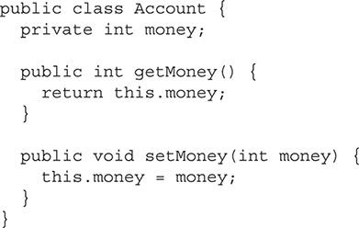

[**9.**](https://learning.oreilly.com/library/view/oca-java-se/9781259587535/ch07.html#ch07qa9a) In the code segment, what is the method getMoney() considered?

A. Get method

B. Access method

C. Getter method

D. Instance variable method

[**10.**](https://learning.oreilly.com/library/view/oca-java-se/9781259587535/ch07.html#ch07qa10a) In the code segment, what is the method setMoney(int money) considered?

A. Set method

B. Access method

C. Setter method

D. Instance variable method

[**11.**](https://learning.oreilly.com/library/view/oca-java-se/9781259587535/ch07.html#ch07qa11a) Which of the following defines information hiding?

A. Information hiding is about hiding as much detail about your class as possible so others can’t steal it.

B. Information hiding is about hiding implementation details and protecting variables from being used the wrong way.

C. Information hiding is used to obscure the interworking of your class so external classes must use the public interface.

[**12.**](https://learning.oreilly.com/library/view/oca-java-se/9781259587535/ch07.html#ch07qa12a) What access modifier is used to make the instance variable or method available only to the class in which it is defined?

A. public

B. private

C. protected

D. package-private (default)

[**13.**](https://learning.oreilly.com/library/view/oca-java-se/9781259587535/ch07.html#ch07qa13a) What access modifier is used for methods that were defined in an interface?

A. public

B. private

C. protected

D. package-private (default)

[**14.**](https://learning.oreilly.com/library/view/oca-java-se/9781259587535/ch07.html#ch07qa14a) Unless there is a particular reason not to use it, what access modifier, if any, should be used on all instance variables?

A. public

B. private

C. protected

D. package-private (default)

[**15.**](https://learning.oreilly.com/library/view/oca-java-se/9781259587535/ch07.html#ch07qa15a) The private and protected access modifiers can be used with which entities? (Choose all that apply.)

A. Classes

B. Interfaces

C. Constructors

D. Methods

E. Data members

**Advanced Use of Classes with Inheritance and Encapsulation**

[**16.**](https://learning.oreilly.com/library/view/oca-java-se/9781259587535/ch07.html#ch07qa16a) What is the proper signature for class X if it inherits class Z?

A. public class X inherits Z{ … }

B. public class X extends Z{ … }

C. public class X implements Z{ … }

[**17.**](https://learning.oreilly.com/library/view/oca-java-se/9781259587535/ch07.html#ch07qa17a) How many classes can a class extend directly?

A. Zero

B. One

C. Two

D. As many as it needs

[**18.**](https://learning.oreilly.com/library/view/oca-java-se/9781259587535/ch07.html#ch07qa18a) How many interfaces can a class implement directly?

A. Zero

B. One

C. Two

D. As many as it needs

[**19.**](https://learning.oreilly.com/library/view/oca-java-se/9781259587535/ch07.html#ch07qa19a) Consider the following UML illustration for assistance with this question:

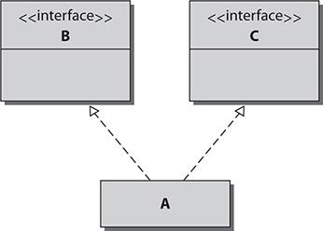

What is the proper signature for class A if it implements interfaces B and C?

A. public class A implements B, implements C{ … }

B. public class A implements B, C{ … }

C. public class A interface B, interface C{ … }

D. public class A interface B, C{ … }

E. public class A extends B, C{ … }

[**20.**](https://learning.oreilly.com/library/view/oca-java-se/9781259587535/ch07.html#ch07qa20a) Consider the following UML illustration for assistance with this question:

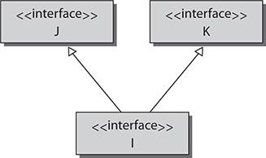

What is the proper signature for interface I to inherit interfaces J and K?

A. public interface I extends J, K{ … }

B. public interface I implements J, K{ … }

C. public interface I implements J, implements K{ … }

D. public interface I interface J, K{ … }

#### SELF TEST ANSWERS

**Implement and Use Inheritance and Class Type**

[**1.**](https://learning.oreilly.com/library/view/oca-java-se/9781259587535/ch07.html#ch07qa1) What contains methods and instance variables and can be instantiated?

A. Concrete class

B. Abstract class

C. Java class

D. Interface

Answer:

 **A**. A concrete class is the standard Java class that is used to create objects.

 **B**, **C**, and **D** are incorrect. **B** is incorrect because an abstract class cannot be instantiated. **C** is incorrect because a Java class is a made-up term. **D** is incorrect because an interface cannot be instantiated.

[**2.**](https://learning.oreilly.com/library/view/oca-java-se/9781259587535/ch07.html#ch07qa2) What is used to define a public interface?

A. Concrete class

B. Abstract class

C. Java class

D. Interface

Answer:

 **D**. An interface is used to define a public list of methods that must be implemented by the class. This represents a public interface.

 **A**, **B**, and **C** are incorrect. **A** is incorrect because a concrete class is used to build objects. **B** is incorrect because abstract classes are used to define abstract methods for other classes to override. **C** is incorrect because a Java class is a made-up term.

[**3.**](https://learning.oreilly.com/library/view/oca-java-se/9781259587535/ch07.html#ch07qa3) What can contain unimplemented methods and instance variables and cannot be instantiated?

A. Concrete class

B. Abstract class

C. Java class

Answer:

 **B**. An abstract class must always be extended; it cannot be instantiated to create an object. It can contain implemented and unimplemented methods.

 **A** and **C** are incorrect. **A** is incorrect because a concrete class is not able to have any unimplemented methods. **C** is incorrect because a Java class is a made-up term.

[**4.**](https://learning.oreilly.com/library/view/oca-java-se/9781259587535/ch07.html#ch07qa4) Inheritance provides which of the following? (Choose all that apply.)

A. Allows faster execution times since methods can inherit processor time from superclasses

B. Allows developers to place general code in a class that more specialized classes can gain through inheritance

C. Promotes code reuse

D. Is an automated process to transfer old code to the latest Java version

Answer:

 **B** and **C**. Both statements are true about inheritance.

 **A** and **D** are incorrect. **A** is incorrect because inheritance has no effect on processor scheduling. **D** is incorrect because inheritance has no relationship to the Java version.

[**5.**](https://learning.oreilly.com/library/view/oca-java-se/9781259587535/ch07.html#ch07qa5) A class being inherited is referred to by what name? (Choose all that apply.)

A. Subclass

B. Superclass

C. Base class

D. Super duper class

Answer:

 **B** and **C**. The class that is inherited is the superclass or base class in reference to the class that extends it.

 **A** and **D** are incorrect. **A** is incorrect because the subclass is the class that inherits from another. **D** is incorrect because this is a made-up term.

[**6.**](https://learning.oreilly.com/library/view/oca-java-se/9781259587535/ch07.html#ch07qa6) Must an abstract class implement all of the abstract methods inherited from another abstract class?

A. Yes.

B. No, but it must implement at least one method.

C. No; it does not have to implement any methods.

D. No, but it must implement any methods that are defined in its immediate superclass.

Answer:

 **C**. An abstract class does not have to implement all of the abstract methods inherited from another abstract class because it is also abstract.

 **A**, **B**, and **D** are incorrect. A concrete class must implement all of the methods.

[**7.**](https://learning.oreilly.com/library/view/oca-java-se/9781259587535/ch07.html#ch07qa7) Which keyword can be used to access overridden methods?

A. super

B. transient

C. top

D. upper

Answer:

 **A**. The super keyword can be used to access overridden methods.

 **B**, **C**, and **D** are incorrect. **B** is incorrect because the transient keyword is used when serializing objects. **C** is incorrect because there is no top keyword. **D** is incorrect because there is no upper keyword.

[**8.**](https://learning.oreilly.com/library/view/oca-java-se/9781259587535/ch07.html#ch07qa8) If class A extends class B, what terms can be used to describe class A? (Choose all that apply.)

A. Subclass

B. Superclass

C. Base class

D. Parent class

E. Child class

Answer:

 **A** and **E**. A class that gains the functionality of other classes is called either a subclass or child class.

 **B**, **C**, and **D** are incorrect. Superclass, base class, and parent class are all terms to describe the class that is being inherited.

**Understand Encapsulation Principles**

Refer to this class for the following two questions.

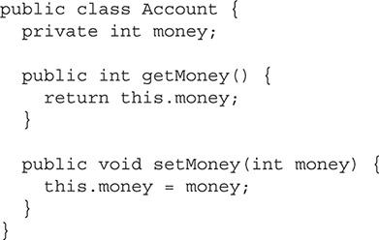

[**9.**](https://learning.oreilly.com/library/view/oca-java-se/9781259587535/ch07.html#ch07qa9) In the code segment, what is the method getMoney() considered?

A. Get method

B. Access method

C. Getter method

D. Instance variable method

Answer:

 **C**. This is a getter. Getters are used to retrieve a private instance variable. The name of a getter method is always get followed by the variable name with a capital letter. If the variable is a boolean, the get is replaced with is.

 **A**, **B**, and **D** are incorrect. None of these answers is a typical Java term.

[**10.**](https://learning.oreilly.com/library/view/oca-java-se/9781259587535/ch07.html#ch07qa10) In the code segment, what is the method setMoney(int money) considered?

A. Set method

B. Access method

C. Setter method

D. Instance variable method

Answer:

 **C**. This is a setter. Setters are used to set a private instance variable. The name of a setter method is always set, followed by the variable name with a capital letter. They take one argument and use this to set the variable.

 **A**, **B**, and **D** are incorrect. None of these answers is a typical Java term.

[**11.**](https://learning.oreilly.com/library/view/oca-java-se/9781259587535/ch07.html#ch07qa11) Which of the following defines information hiding?

A. Information hiding is about hiding as much detail about your class as possible so others can’t steal it.

B. Information hiding is about hiding implementation details and protecting variables from being used the wrong way.

C. Information hiding is used to obscure the interworking of your class so external classes must use the public interface.

Answer:

 **B**. Good class design hides as many methods and instance variables as possible. This is done by using the private access modifier. This is so external objects do not try to interact with the object in ways the developer has not intended. Hiding information makes code easier to maintain and more modular.

 **A** and **C** are incorrect. **A** is incorrect because information hiding has nothing to do with protecting your code from others. **C** is incorrect because access modifiers should be used to force external classes to use the proper public interface.

[**12.**](https://learning.oreilly.com/library/view/oca-java-se/9781259587535/ch07.html#ch07qa12) What access modifier is used to make the instance variable or method available only to the class in which it is defined?

A. public

B. private

C. protected

D. package-private (default)

Answer:

 **B**. The private access modifier is used to allow only the methods in the class to access the method or instance variable.

 **A**, **C**, and **D** are incorrect. **A** is incorrect because public would make the instance variable available to every class. **C** is incorrect because protected would make the instance variable available to any subclass or class in the same package. **D** is incorrect because package-private, or the default access level, would make the instance variable available to any other class in the same package.

[**13.**](https://learning.oreilly.com/library/view/oca-java-se/9781259587535/ch07.html#ch07qa13) What access modifier is used for methods that were defined in an interface?

A. public

B. private

C. protected

D. package-private (default)

Answer:

 **A**. The public access modifier is used when implementing methods from an interface. Furthermore, the Java Language Specification states that it is permitted, but discouraged as a matter of style, to redundantly specify the public and/or abstract modifier for a method declared in an interface.

 **B**, **C**, and **D** are incorrect. All three of these are incorrect because they limit the accessibility of the method and therefore would not be appropriate for an interface.

[**14.**](https://learning.oreilly.com/library/view/oca-java-se/9781259587535/ch07.html#ch07qa14) Unless there is a particular reason not to use it, what access modifier, if any, should be used on all instance variables?

A. public

B. private

C. protected

D. package-private (default)

Answer:

 **B**. Instance variables should have the most restrictive modifier compatible with their intended use. The private modifier is the most restrictive and therefore the correct answer.

 **A**, **C**, and **D** are incorrect. All of these access modifiers, including the default access level, are less restrictive than private.

[**15.**](https://learning.oreilly.com/library/view/oca-java-se/9781259587535/ch07.html#ch07qa15) The private and protected access modifiers can be used with which entities? (Choose all that apply.)

A. Classes

B. Interfaces

C. Constructors

D. Methods

E. Data members

Answer:

 **C**, **D**, and **E**. The private and protected access modifiers can be used with constructors, methods, data members, and inner classes.

 **A** and **B** are incorrect. The private and protected access modifiers cannot be used with classes and interfaces.

**Advanced Use of Classes with Inheritance and Encapsulation**

[**16.**](https://learning.oreilly.com/library/view/oca-java-se/9781259587535/ch07.html#ch07qa16) What is the proper signature for class X if it inherits class Z?

A. public class X inherits Z{ … }

B. public class X extends Z{ … }

C. public class X implements Z{ … }

Answer:

 **B**. The extends keyword is used to inherit a class.

 **A** and **C** are incorrect. **A** is incorrect because inherits is not a valid Java keyword. **C** is incorrect because the implements keyword is used for interfaces, not classes.

[**17.**](https://learning.oreilly.com/library/view/oca-java-se/9781259587535/ch07.html#ch07qa17) How many classes can a class extend directly?

A. Zero

B. One

C. Two

D. As many as it needs

Answer:

 **B**. A class can extend only one other class. However, it is possible to have one class extend a class that extends another class, and so on.

 **A**, **C**, and **D** are incorrect.

[**18.**](https://learning.oreilly.com/library/view/oca-java-se/9781259587535/ch07.html#ch07qa18) How many interfaces can a class implement directly?

A. Zero

B. One

C. Two

D. As many as it needs

Answer:

 **D**. A class can implement as many interfaces as it needs.

 **A**, **B**, and **C** are incorrect.

[**19.**](https://learning.oreilly.com/library/view/oca-java-se/9781259587535/ch07.html#ch07qa19) Consider the following UML illustration for assistance with this question:

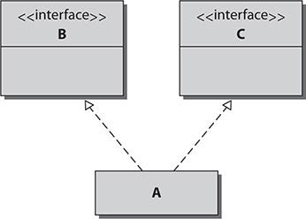

What is the proper signature for class A if it implements interfaces B and C?

A. public class A implements B, implements C{ … }

B. public class A implements B, C{ … }

C. public class A interface B, interface C{ … }

D. public class A interface B, C{ … }

E. public class A extends B, C{ … }

Answer:

 **B**. A class uses the keyword implements to implement an interface. To implement multiple interfaces, the interface names should appear in a comma-delimited list after the keyword implements.

 **A**, **C**, **D**, and **E** are incorrect. **A** is incorrect because the implements keyword should not be included more than once. **C** is incorrect because the implements keyword should be used instead of interface, and it should be used only once. **D** is incorrect because implements should be used instead of interface. **E** is incorrect because extends is used for classes, not interfaces; implements should be used instead.

[**20.**](https://learning.oreilly.com/library/view/oca-java-se/9781259587535/ch07.html#ch07qa20) Consider the following UML illustration for assistance with this question:

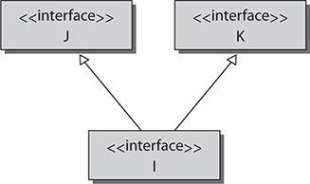

What is the proper signature for interface I to inherit interfaces J and K?

A. public interface I extends J, K{ … }

B. public interface I implements J, K{ … }

C. public interface I implements J, implements K{ … }

D. public interface I interface J, K{ … }

Answer:

 **A**. An interface can also inherit other interfaces. Unlike classes, interfaces can inherit or extend as many other interfaces as needed. An interface uses the keyword extends, followed by a comma-delimited list of all the other interfaces it wants to extend.

 **B**, **C**, and **D** are incorrect. **B** is incorrect because only classes implement interfaces. An interface extends other interfaces. **C** is incorrect because extends should be used, and only once. **D** is incorrect because the interface keyword is not used correctly.



### 8

### UNDERSTANDING POLYMORPHISM AND CASTS

**CERTIFICATION OBJECTIVES**

• [Understand Polymorphism](https://learning.oreilly.com/library/view/oca-java-se/9781259587535/ch08.html#ch08lev1)

• [Understand Casting](https://learning.oreilly.com/library/view/oca-java-se/9781259587535/ch08.html#ch08lev4)

 [Two-Minute Drill](https://learning.oreilly.com/library/view/oca-java-se/9781259587535/ch08.html#ch08lev6)

**Q&A** [Self Test](https://learning.oreilly.com/library/view/oca-java-se/9781259587535/ch08.html#ch08lev7)

**T**he OCA exam will expect you to have a firm understanding of what polymorphism is and when it should be used. The exam will present scenarios using polymorphism in correct and incorrect ways.

Casting will also be covered on the OCA exam. On the surface, casting looks similar to polymorphism; however, it is very different. The OCA exam is likely to ask questions that require you to have a solid understanding of when and how casting can be used.

At the conclusion of this chapter you should understand how to manipulate the type of an object using either polymorphism or casting. You should also know when each is needed or not needed. These are core concepts that will be asked directly on the OCA exam.

**CERTIFICATION OBJECTIVE**

#### Understand Polymorphism

*Exam Objective Develop code that demonstrates the use of polymorphism, including overriding and object type versus reference type*

Polymorphism is a fundamental aspect of object-oriented programming languages, including Java. Polymorphism allows the developer to write generic code that is flexible and that allows for easier code reuse, another fundamental object-oriented principle.

##### Concepts of Polymorphism

The word *polymorphism* comes from the Greeks and roughly means “many forms.” In Java, polymorphism means that one object can take the form or place of an object of a different type. Polymorphism can exist when one class inherits another. It can also exist when a class implements an interface. This section will describe how polymorphism can apply in both cases. Finally, this section will demonstrate what polymorphism looks like in Java code.

The following topics will be discussed:

 Polymorphism via class inheritance

 Polymorphism via implementing interfaces

 Polymorphism in code

###### Polymorphism via Class Inheritance

A more specific object can polymorphically take the place of a more general object. You’ll recall that you can extend one object to create a more specific object that inherits the original object’s functionality in addition to the new functionality. For example, suppose a method requires a Human object. When the Child and Adult classes extend the Human class, they would each inherit all of the functionality of Human, plus all the more specific functionality of their specific classes. The Child and Adult objects are guaranteed to inherit all of the methods of the Human object. Therefore, both the Child and Adult objects would satisfy any operation that required a Human object. To continue the example further, suppose the Shannon and Colleen classes each extend the Adult class. Each of the objects created from the Shannon and Colleen classes would inherit the functionality of the more general Adult and Human classes and could therefore be used anywhere a Human or Adult object is required.

Polymorphism utilizes the *is-a* relationship. In [Figure 8-1](https://learning.oreilly.com/library/view/oca-java-se/9781259587535/ch08.html#ch08fig01), the Child object *is-a* Human object, and the Adult object *is-a* Human object. Both Child and Adult are specific types of a Human object. Furthermore, the Shannon object *is-an* Adult object and *is-a* Human object. This is also true for the Colleen object. The Shannon object is not only a more specific type of Adult object, but it’s also a more specific type of Human object. Any subclass object is a more specific type of its parent object. The *is-a* relationship is created when an object inherits, or extends, another. Any object that extends another object can be said to have an *is-a* relationship to the object that it extends. Any object that has an *is-a* relationship with another can polymorphically be used as that object.

**FIGURE 8-1** Polymorphic objects

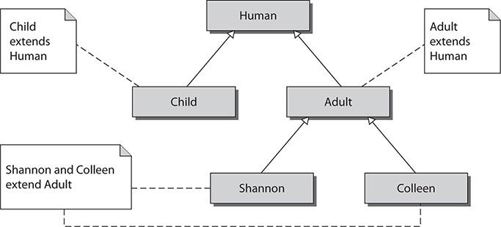

When an object is polymorphically acting as another object, the more specific object is restricted to using only the public interface of the more general object. In the preceding example, when the Adult object is used as a Human object, only the methods that are available in the Human class can be used. This is because the Java code that is using the Adult object as a Human object has no knowledge that this Human object is really an Adult object. This is the benefit of polymorphism. The Java code does not always have to be aware of the specifics of an object. If a general object meets the needs of a method, Java does not care whether the object is general or specific. The only requirement is that the object has an *is-a* relationship with the object that the method requires.

This relationship is unidirectional, so the more specific object can take the place of a general object, but not vice versa. For example, if an Adult object were needed, a more general Human object would not be able to provide all of the functionality of an Adult object.



***Abstract classes and concrete classes behave the same way with polymorphism. Because an abstract class cannot be instantiated, the only way to assign an object to an abstract data type is by using polymorphism. Pay close attention to how abstract classes are initialized*.**

###### Polymorphism via Implementing Interfaces

The application of polymorphism is not limited to class inheritance. Polymorphism can also be applied to the objects of classes that implement interfaces. When a class implements an interface, it is then required to implement all of the methods that the interface contains. By doing this, the class is guaranteed to have the functionality that the interface defines. This allows the objects created from these classes to be treated as instances of the interface.

An interface called Display, for example, can be used for classes that have the ability to display text on a screen. This interface contains two methods: One method is used to display text, and the second is used to get the text that is currently being displayed. Any class that implements this interface is declaring to other objects that it has the functionality of a Display. By implementing this interface, the class is then required to implement every method that the interface contains. Since the object was created from a class that implements the Display interface, it is guaranteed to have the functionality of a display. The object has an *is-a* relationship with Display. This object can now masquerade as an object of the Display type. An object can polymorphically act as any interface that its class or any superclass implements.



***Polymorphism and interfaces are very powerful tools. They are used extensively on large projects. As a professional developer, you’ll find it helpful to study design patterns to look for common reusable software designs that make use of the concepts in this chapter. A good developer not only understands all of the basic concepts, but also knows how best to use them*.**

###### Polymorphism in Code

When one specific object can be used as another general object polymorphically, the specific object can be used in place of the more general one without being cast. For example (see [Figure 8-2](https://learning.oreilly.com/library/view/oca-java-se/9781259587535/ch08.html#ch08fig02)), if class TypeC extends TypeB, and TypeB extends TypeA, any time an object type of TypeA or TypeB is needed, TypeC can be used. The following code segment shows an example of this:

**FIGURE 8-2** TypeA, TypeB, and TypeC

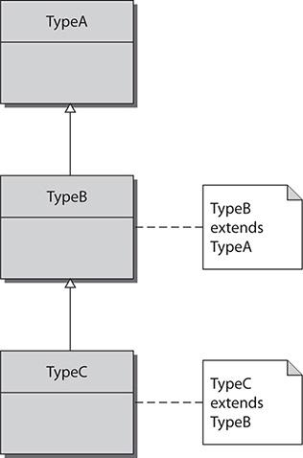

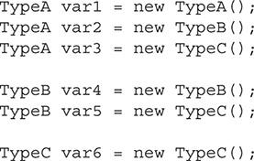

In this example, any subclass can be used interchangeably with its superclass. The variable var3 is declared as a TypeA object but is initialized with a new TypeC object. Even though var3 is really a TypeC object, it will be treated as a TypeA object anywhere var3 is referenced. This is okay because the TypeC object has inherited all of the functionality of the TypeA and TypeB objects. However, since var3 was declared as TypeA, it can now be treated only as an object of this type. If TypeC objects have additional methods that are not part of the TypeA class, these methods would be unavailable.

More commonly, polymorphism will be used for method arguments. This allows a method to be written more abstractly and therefore more flexible. For instance, a method may be required to accept a type of animal object as its argument and use it to determine whether the animal is hungry. In this scenario, there is no benefit in creating a method that would accept a Penguin object and another that accepts a PolarBear object. Instead, it would be a better design to create one single method that accepts an Animal class. The state of hunger is general to the Animal class. The Animal class is a superclass for both the Penguin class and PolarBear class.

These basic examples are provided to help you understand the concepts of polymorphism. Keep in mind that they are described at a very high level here. This chapter will later offer more examples that show polymorphism in greater depth.

###### Programming to an Interface

“Programming to an interface” is the concept that code should interact based on a defined set of functionality instead of an explicitly defined object type. In other words, it is better for the public interfaces of objects to use data types that are defined as interfaces as opposed to a particular class when possible. When an object is implementing an interface, it is declaring that it has a certain set of functionalities. Many different classes can implement the same interface and provide its functionality. When a method uses an interface as its argument type, it allows any object, regardless of its type, to be used as long as it implements the interface. This allows the code to be more abstract and flexible and also promotes code reuse. Programming to an interface is also known as “design by contract.”



***This chapter goes deeper into polymorphism than is required for the OCA exam, but the information provided here should help you better understand the test questions. Most of the questions on the test will either be theory questions regarding the definition of polymorphism or simple scenarios that will require the OCA candidate to choose a code segment that is correct*.**

##### Practical Examples of Polymorphism

The first section in this chapter approached polymorphism from a theoretical viewpoint; this section will look at coding examples. These examples are important for you to understand, and if you review them carefully, they should give you a clear understanding of the concepts presented in the earlier section.

The first example will demonstrate how polymorphism can be applied when a class extends another. There is no difference between the use of concrete and abstract classes. The next example demonstrates the use of polymorphism when interfaces are used. These examples will help reinforce the concepts covered in this chapter. The OCA exam will require that you know how to use polymorphism. Understanding these examples will better prepare you for the polymorphism questions on the test.

###### Examples of Polymorphism via Class Inheritance

The following example is intended to demonstrate the use of polymorphism with class inheritance. This example has three classes. Two classes are used to represent phones. The Phone class is intended to be a simple representation of a standard phone. This class has a method to dial a number and return to the state of whether the phone is ringing or not. The second class represents a smart phone and is appropriately named SmartPhone. The SmartPhone class extends the Phone class. This class adds the functionality of being able to send and receive e-mails. The final class is named Tester and is used as a driver to test both phone classes and demonstrate polymorphism in action. The phone classes are simple representations, and most of their functionality is not implemented. Instead, it is noted as comments regarding its intended purposes. The following is the Phone class:

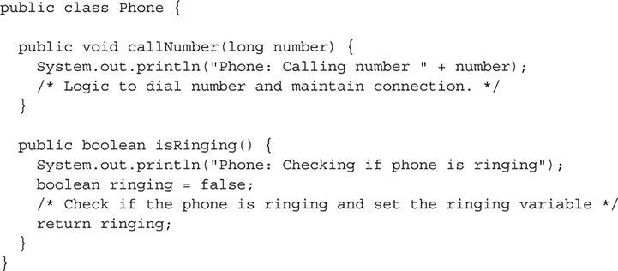

The Phone class is a simple class used for a normal phone with basic features. The class has a callNumber() method that is used to call the number that is passed as an argument. The isRinging() method is used to determine whether the phone is currently ringing. This class prints to standard output its class name and what action it is performing as it enters each method. The Phone class is the base class for the SmartPhone class. The SmartPhone class is listed next:

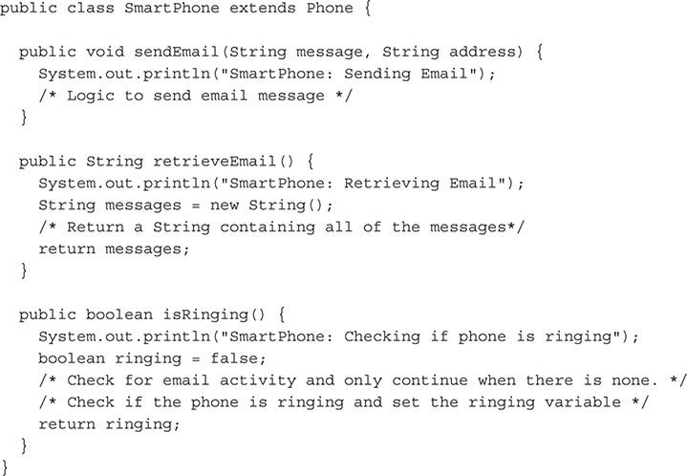

The SmartPhone class represents a smart phone. This class extends the Phone class and therefore inherits its functionality. The SmartPhone class has a sendEmail() method that is used to send an e-mail message. It has a retrieveEmail() method that will return a String for any messages that have not yet been retrieved. This class also has an isRinging() method that overrides the isRinging() method from the superclass Phone. Similar to the Phone class, the SmartPhone class prints to standard output the class name and function that it will perform each time it enters a method.

The final class is named Tester. The class has the main() method for the demonstration program. This class exercises all of the methods in the Phone and SmartPhone classes.

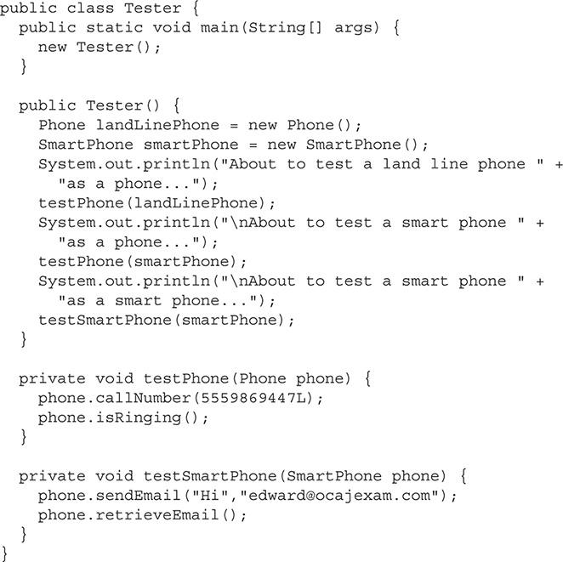

The main() method kicks off the program by creating a Tester object and therefore calling Tester() the constructor. The constructor is used to call each test method. In between each method call, it prints a line to standard output that indicates what the program is doing. The testPhone() method is used to test each method of the Phone class. It accepts a Phone object as an argument. The final method is the testSmartPhone() method. This method tests each method of the SmartPhone class.

The Tester() constructor starts by creating two local variables. The first is called landLinePhone and is a Phone object. The second is called smartPhone and is a SmartPhone object. The constructor then displays a message and calls the testPhone() method with the landLinePhone variable as an argument.

Next, the constructor displays another message and again calls the testPhone() method. The smartPhone variable is used as the argument. The testPhone() method requires a Phone object as its argument, but the example has used a SmartPhone object instead. This is polymorphism. A smart phone is a more specific type of phone. A smart phone can do everything a landline phone can and more. This is represented in the SmartPhone class by it extending Phone. Notice that the testPhone() method is expecting a Phone object as an argument. It is perfectly acceptable if it gets a more specific type of phone. However, any additional method of the more specific class cannot be utilized. Since this method is designed for a Phone object as an argument, it can use only methods declared in the Phone class.

Finally, the constructor displays another status message and calls the testSmartPhone() method. This method exercises the methods declared in the SmartPhone object. Since polymorphism is unidirectional, the testSmartPhone() method cannot be called with a Phone object as its argument. The following output would be generated by this program:

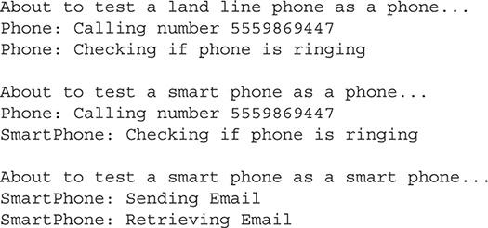

When the landLinePhone variable is used with the testPhone() method, the output is simply generated from the Phone class since it is a Phone object. When the smartPhone variable is used with the testPhone() method, the flow of execution is more complex. Because the SmartPhone class extends the Phone class, the SmartPhone class inherits both the callNumber() and isRinging() methods. However, the SmartPhone class overrides the isRinging() method with its own. When the callNumber() method is invoked on a SmartPhone object, the method in the Phone class is used since it is not overridden. However, when the isRinging() method is called, the method in the SmartPhone class is used. This follows the basic rule of inheritance and overriding methods.

###### Examples of Polymorphism via Implementing Interfaces

This example will focus on an object’s ability to behave polymorphically as an interface that its class implements. This allows objects that may be radically different, but share some common functionality, to be treated similarly. The common functionality is defined in an interface that each class must implement.

This example is composed of three classes and one interface. There is a Tester class to test the program. The other two classes are objects representing a goat and his home (that is, his shelter). Both in this program and conceptually, the objects are very different. A goat is a living animal and a goat shelter is an inanimate item. However, they both share a common ability. Both the Goat class and the GoatShelter class can describe themselves. This functionality has been reflected in the fact that they both implement the Describable interface. Classes that implement this interface are then required to implement the getDescription() method. Here is the Describable interface:

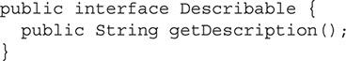

This interface has only one method. The getDescription() method is used to return a description about the object. Any class that implements this interface is stating it has a method that can be used to get its description. The Goat class is shown next.

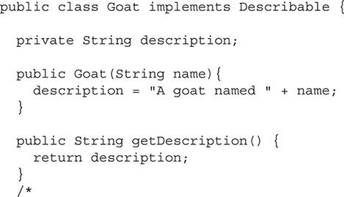

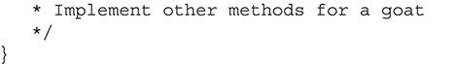

The Goat class is a simple class that can be used to represent a goat. This class implements the Describable interface and therefore is required to implement the getDescription() method. The constructor of the Goat class has one parameter that it uses to place the name of the goat in the description string. The next class in this example is the GoatShelter class. It is listed next:

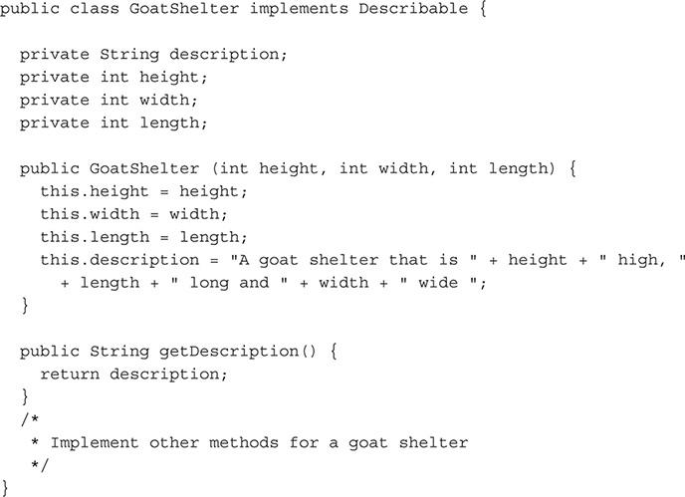

The GoatShelter class is designed generally to model a box. Its constructor requires that the dimensions of the box be used as arguments. The constructor also creates the description text that is returned in the getDescription() method. Similar to the Goat class, the GoatShelter class also implements the Describable interface. The final class is the Tester class. This class is used to demonstrate the concept of polymorphism with interfaces.

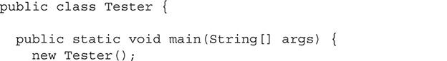

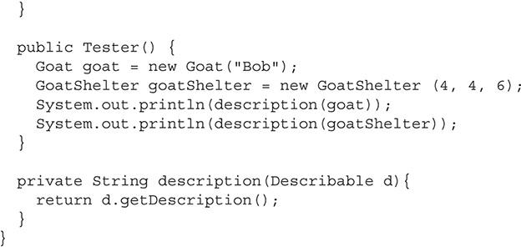

The Tester class contains the main() method that starts the execution of the program. This calls the Tester() constructor, where a Goat object and GoatShelter object are both created. The description() method is then used to print to standard output the description of each object. The description() method requires a Describable object. It is impossible to have a true Describable object since it is an interface. However, classes that implement this interface are declaring that they have the functionality of Describable. These objects can then polymorphically act as if they were of type Describable. The following is the output of this program:



**INSIDE THE EXAM**

**Unidirectional Polymorphism**

The OCA exam may try to present the test taker with a polymorphism question in which the more general object behaves as the more specific one. Remember that polymorphism works in only one direction. Only specific objects can behave as more general ones.

**EXERCISE 8-1**

**Add Functionality to the Describable Example**

This exercise will use the preceding example. The goal of the exercise is to compile and run the example and add a class that implements the Describable interface.

**1.** Copy the example into the text editor or IDE of your choice.

**2.** Compile and run the example to ensure the code has been copied correctly.

**3.** Add a new class that implements the Describable interface.

**4.** Compile and run the application.

###### Examples of Programming to an Interface

This example will demonstrate the concept of programming to an interface. This concept allows a developer to define the functionality that is required instead of defining an actual object type. This creates more flexible code that adheres to the object-oriented design principle of creating reusable code.

Suppose a developer creates a class that is used for creating log files. This class is responsible for creating and managing the log file on the file system, and then appending the log messages to it. This class is called Logger. The Logger class has a method called appendToLog() that accepts one object as an argument and then appends a message about it in the log.

The developer could overload this method with every possible data type that the program uses. Although this would work, it would be very inefficient. Suppose the program-to-an-interface concept is used instead, and the developer creates an interface that defines the required method for a logable class. This interface is called Logable. The appendToLog() method then uses the Logable interface as its argument. Any class that requires logging could implement this interface and then be used polymorphically with the appendToLog() method.

The following is the Logable interface:

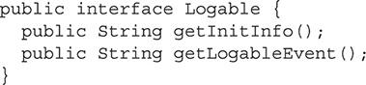

The Logable interface is a basic interface that defines the methods required to work with the appendToLog() method in the Logger class. The appendToLog() method is not concerned with the details of an object other than what pertains to logging. By using this interface, the developer has defined a functionality requirement as opposed to a strict object data type. This is what is meant by the phrase “programming to an interface.”

The Logger class is displayed next:

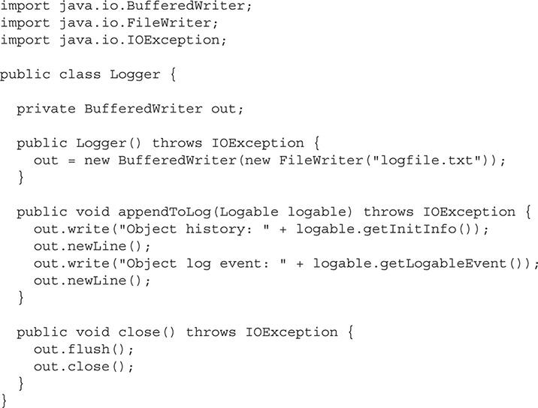

The Logger class creates a BufferedWriter, which is a means to write to a file. (This is beyond the scope of this chapter and therefore will not be discussed.) The appendToLog() method is used to write to the log file. This class uses the Logable interface to remain flexible. This method will work with any other class that implements this interface and will follow the program-to-an-interface concept.

The next class is the NetworkConnection class. This class implements the Logable interface.

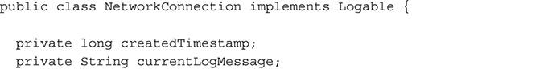

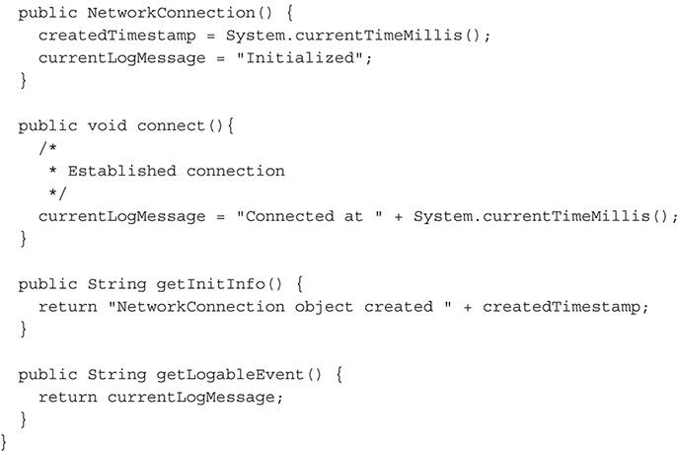

This class implements the Logable interface and all of the methods required for it. When this class is polymorphically behaving as the Logable data type, the code being used does not care about the implementation details of the class. As long as the class implements the Logable interface, it is free to choose how the methods are implemented.

The SystemStatus class is the other class that uses the Logable interface.

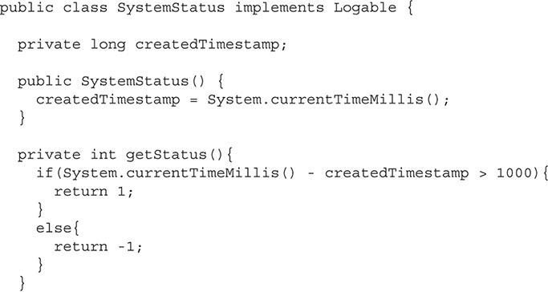

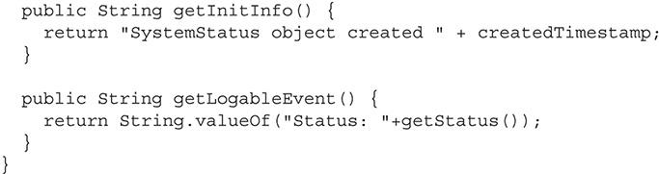

The SystemStatus class’s only similarity to the NetworkConnection class is that they both implement the Logable interface. This class chooses to implement the required getInitInfo() and getLogableEvent() methods in a different manner than the NetworkConnection class.

The final class is the Tester class. This is a simple class that demonstrates all of the preceding classes and interface in action.

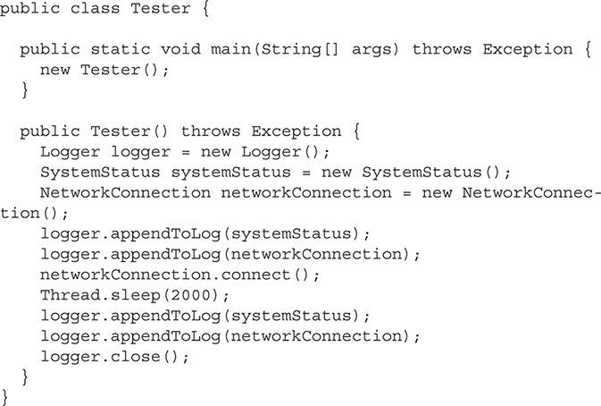

The Tester class does all of its work in its constructor. The class creates a new Logger object called logger. It then creates a SystemStatus object named systemStatus and a NetworkConnection object named networkConnection. It then uses the appendToLog() method from the Logger object. This method uses the Logable object as a parameter. Because both the SystemStatus and NetworkConnection classes implement this interface, their objects can be used polymorphically with this method. The following text is written to the log file:

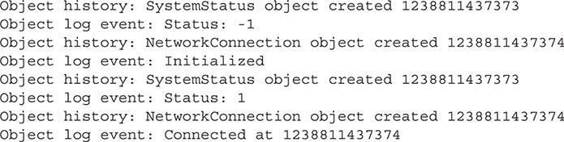

**CERTIFICATION OBJECTIVE**

#### Understand Casting

*Exam Objective Determine when casting is necessary*

So far, this chapter has discussed how to use a more specific object in place of a general one. Polymorphism allows for any subclass to fill in for its superclass. You saw that no special conversion is needed to do this. We are now going to look at the opposite situation. How can you take an object that is general and make it more specific? *Casting* will allow you to convert an object back to its original runtime type or any of its superclasses.

##### When Casting Is Needed

Polymorphism allows an object to be used as a more general object without the need to add new syntax. However, casting must be used when an object is to be used as a more detailed type or when converting a primitive to a type that will cause data to be lost. Polymorphism can occur without interaction because there is no possibility of incompatible data. When there is the chance of incompatible data types, the Java compiler requires the developer to declare formally their intention to use a variable as a different type.

Casting must occur when the primitive double is used as a float or a HashMap object is used as a LinkedHashMap object. This section will look at each case and explain when it is possible to convert the object or primitive and why you might need to do so.

The Java syntax to cast an object or primitive is relatively simple. To cast an object or primitive, place the type before it in parentheses. In the next example, detailedScore is declared as a double. It is then assigned to a float. For this code to be valid and compile, detailedScore must be cast to a float. The cast is performed by placing (float) in front of the double, detailedScore. This tells the compiler to treat detailedScore as a float and allow it to be assigned the variable score, which is declared as a float.



###### Casting Primitives

Primitives need to be explicitly cast when the conversion will potentially result in the loss of precision. If there is no potential for precision loss, the compiler will automatically cast the primitive. Precision is lost when a larger primitive is cast to a smaller primitive. Precision can also be lost when a primitive with a floating-point decimal is cast to a whole number primitive type. For example, an int is a 32-bit signed two’s complement integer and has a minimum value of −2,147,483,648 and a maximum value of 2,147,483,647 (inclusive). A byte is an 8-bit signed two’s complement integer with a minimum value of −128 and a maximum value of 127 (inclusive). If an int that was storing the value 1236 were cast to a byte, there would be a loss of precision, because a byte cannot store a value as large as 1236.

So, if a byte cannot store a large int, but the compiler will allow you to cast the int into a byte, what happens at runtime? At runtime, the Java virtual machine (JVM) will truncate the bits from the int. In the cast of an int with the value of 1236, the JVM would truncate it to a byte with the value of −44. The following code will output Byte: -44:

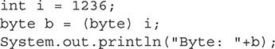

To understand where the value −44 comes from, you need to look at the binary representation of the numbers. In the following example, the number *1236* is displayed as a 32-bit binary number. The number *−44* is displayed as an 8-bit binary number. Remember that the most significant bit is used as a signed byte.



**TABLE 8-1** Primitive Casting

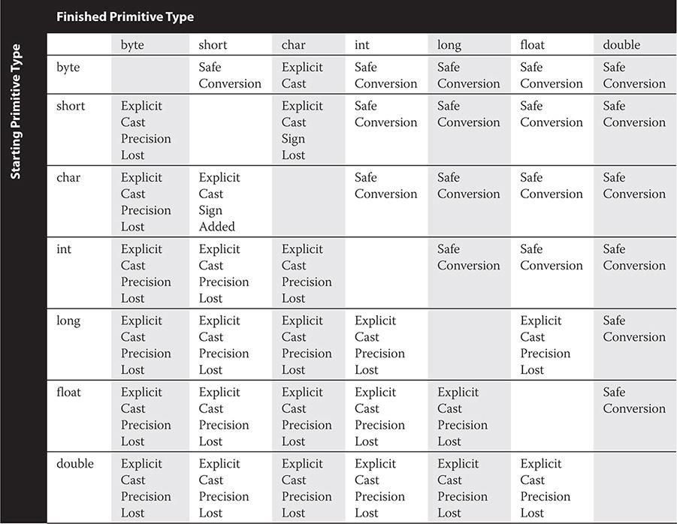

It is easy to see that the 24 most significant bits are being truncated from the int. The negative signed value is due to the most significant bit of the byte being a 1.

A cast is also required to convert a floating-point decimal number such as a float or double to a primitive whole number. The decimal value of the number is truncated. For example, the value of 5.7 would be truncated to 5. Rounding the number is not a consideration. Once the decimal value is removed, bits are truncated from the most significant bit onward until it is the proper new size.

###### Casting Between Primitives and Objects

Since the introduction of Java 5.0, it is possible to cast primitives to and from their object wrapper classes. Not only has Java made it easy to make these basic conversions, but it will also automatically do the casting with autoboxing and auto unboxing. Autoboxing and unboxing allow a primitive to be used interchangeably as its object wrapper class. The proper conversion is done automatically. The following code segment will demonstrate different ways of making an Integer object from an int:

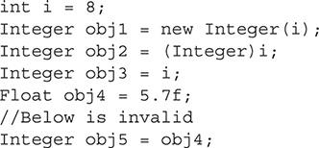

In this code segment, a primitive int named i is created and set to 8. This variable is then used to create three Integer objects. The object obj1 is created using the method that was required prior to Java 5.0. It uses the Integer class’s constructor to instantiate a new object. This line of code demonstrates the basic way to instantiate an object and does not demonstrate any casting. Next, the obj2 variable is set by casting a primitive int to an Integer object. Although this syntax is valid, it is rarely used. The obj3 object is set by using only the primitive i. No cast is used in this case. However, the autoboxing feature of Java performs the cast for you. Most developers will use the autoboxing and unboxing method to move between primitives and their wrapper class. A Float object is also created. Autoboxing is used to convert the 5.7f value to a Float object. Finally, an invalid example is shown. Unlike a primitive where a float will be automatically truncated to fit into an int, a Float object will not automatically truncate to fit into an Integer object. This line of code would produce compiler warnings and throw a runtime exception. It is important to remember that you do not have to cast explicitly when writing the code, because a cast will be done for you automatically.

**INSIDE THE EXAM**

**Hidden Casting**

Be on the lookout for hidden casting. The Java compiler does not require you to cast explicitly between a primitive and its corresponding wrapper classes. However, a cast is still happening automatically as a convenience.

###### Casting Objects

An object can polymorphically become any object that is its superclass. Once an object is assigned a more general type, it can no longer access its more specific features. An object has to be cast back into its original runtime type to use these methods. It is important to ensure that the object to be cast was instantiated as that object or an object that inherited it. A runtime exception will be thrown if an object is incorrectly cast. Following are three example classes:

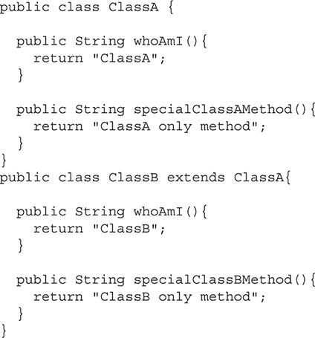

ClassA in the example is a basic class with two methods: one method returns a string with its class name, and the other represents a unique method that only ClassA contains. ClassB extends ClassA. It overrides the whoAmI method with its own functionality. It also contains a method that is unique to itself, specialClassBMethod.

The following code segment creates a ClassB object named obj1. It then creates a ClassA object, obj2. This object is initialized with a new ClassB object. This is valid because a ClassB object can polymorphically act as a ClassA object since ClassB extends ClassA. Finally a second ClassA object is created and initialized with a new ClassA object.

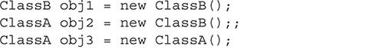

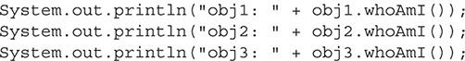

The following is the output when the preceding code is executed:

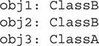

The obj2 object is assigned the type of ClassA but is initialized with a ClassB object. This object retains all of the functionality of a ClassB object. This can be seen when the string from obj2.whoAmI() method is printed. However, since this object is assigned the type ClassA, it can be treated only as a ClassA object. For example, the following line of code would not compile:



Even though obj2 was created as a ClassB object, it was assigned the ClassA type and therefore can be treated only as a ClassA object. To be able to access the functionality that ClassB provides, the object would have to be cast to the ClassB type. The next example demonstrates obj2 being cast into a ClassB object:



It is also possible to cast the object inline. This shorthand syntax would be as follows:



It is important that you understand that obj3 cannot be cast to a ClassB object. You can cast to an object type successfully only if the object was instantiated as it or as one of its subclasses. If it were cast to ClassB, a runtime exception would be thrown.



***When you’re taking the OCA exam, remember that you have to cast objects only when you are going down the inheritance chain—that is, superclass to subclass. It is also important that you understand that the object at one point must have been the object that is being cast to, or a subclass of it*.**



***When casting an object, you should always check whether the object can be cast without generating an exception. To check whether an object is the proper type, use the Java instanceof operator. This operator can be used in an if statement to determine whether object A is an instance of object B*.**

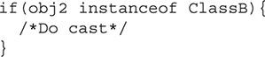

#### CERTIFICATION SUMMARY

Polymorphism is a fundamental concept of any object-oriented programming language. This chapter has discussed the fundamental concepts of polymorphism and then demonstrated these concepts through examples.

The first part of this chapter defined polymorphism. Polymorphism is a tool that can be used to create more reliable code and produce it faster. Polymorphism allows you to treat a specific object as if it were a more general object. In other words, a class’s object can masquerade as any object that the class uses to derive itself. The benefit is that applications can be written more abstractly. A common form of polymorphism is between classes that extend other classes. A class’s object can be treated as any object that it extends, and this includes both concrete and abstract classes. Polymorphism also allows an object to be treated as any interface that it implements.

Polymorphism is most commonly used for method arguments. Often, a method will require only a general object. A more specific object can be used, however, since it will provide all of the functionality of the general object. You can think of the *is-a* relationship to help you understand polymorphism. For example, a specific object such as Blue *is-a* Color. So Blue is a specific object and extends the Color object.

This chapter then covered the benefits of programming to an interface. Programming to an interface allows the developer to specify the capabilities or behaviors that are expected, instead of strictly defining an expected object type. This allows the code to be more abstract and flexible. This is an example of polymorphism in use. Programming to an interface requires that an object polymorphically act as the interface it implements.

The chapter then used coding examples to clarify polymorphism and programming to an interface. These examples highlighted the important concepts discussed in theory in this chapter.

Finally, casting was examined. Casting is often used with polymorphism to return an object back to its original level of detail. It is important that you learn how to use casting correctly. Improper use can lead to unstable and difficult-to-maintain code that often crashes.

#### Images TWO-MINUTE DRILL

**Understand Polymorphism**

 Polymorphism is a fundamental concept of object-oriented languages, including Java.

 Polymorphism stimulates code reuse.

 Polymorphism allows one object to act as either one of its superclasses or as an interface that it implements.

 In an *is-a* relationship, the subclass object (the more specific object) “is-a” superclass object (the more general object).

 Polymorphism is unidirectional. More specific objects can act polymorphically only as more general objects.

 By implementing an interface, an object is declaring it has the functionality defined in the interface. This allows that object to act polymorphically as the interface.

 Programming to an interface is the concept in which the developer defines the required functionality instead of defining strict object data types. This allows other developers to interact with the code using any object they choose as long as it implements the required interfaces.

 An object can be used interchangeably with any of its superclasses without the need to be cast.

 An object can be used interchangeably with any interface that it implements without the need to be cast.

 When a more specific object is polymorphically used as a general object, the more specific functionality is not available.

 Polymorphism is commonly used for method arguments.

**Understand Casting**

 Casting is needed to convert an object back to a more detailed object in its inheritance chain.

 If you cast an object to an invalid type, a runtime exception will be thrown.

 To cast an object, you place the class name in front of it in parentheses.

 You must cast a primitive to another primitive type if there is the possibility that precision will be lost.

 Casting is not needed when going from a primitive to its wrapper class. Java’s autoboxing/unboxing feature will do this automatically.

 Objects need to be cast when they move down the inheritance chain—that is, from a superclass to a subclass. Polymorphism allows objects to become more general.

#### SELF TEST

**Understand Polymorphism**

[**1.**](https://learning.oreilly.com/library/view/oca-java-se/9781259587535/ch08.html#ch08qa1a) Which statement is true about the term *polymorphism*?

A. It is a Latin word that roughly means “changeable.”

B. It is a Greek word that roughly means “many forms.”

C. It is an Old English word that roughly means “insectlike.”

D. It is a new technical term that means “Java object.”

[**2.**](https://learning.oreilly.com/library/view/oca-java-se/9781259587535/ch08.html#ch08qa2a) What type of object can polymorphically behave as another?

A. An object can act as any subclass of the class it was created from.

B. An object can act as any superclass of the class it was created from.

C. An object can act as any other abstract class.

[**3.**](https://learning.oreilly.com/library/view/oca-java-se/9781259587535/ch08.html#ch08qa3a) Polymorphism helps to facilitate which of the following? (Choose all that apply.)

A. Highly optimized code

B. Code reuse

C. Code obfuscation

D. Code that is generic and flexible

[**4.**](https://learning.oreilly.com/library/view/oca-java-se/9781259587535/ch08.html#ch08qa4a) What is a correct *is-a* relationship?

A. A specific object *is-a* more generic one.

B. A generic object *is-a* more specific one.

C. A null reference *is-an* object.

[**5.**](https://learning.oreilly.com/library/view/oca-java-se/9781259587535/ch08.html#ch08qa5a) Which of the following statements explains why an object can polymorphically behave as an interface?

A. By implementing the interface, the object is required to have all of the functionality that the interface represents.

B. By implementing the interface, the object inherits all the required methods it defines.

C. An object can behave as an interface because interfaces do not have a strict expected behavior and therefore any object can act as an interface.

[**6.**](https://learning.oreilly.com/library/view/oca-java-se/9781259587535/ch08.html#ch08qa6a) What does it mean if a developer is programming to an interface?

A. The developer is implementing an interface for the class he or she is working on.

B. The developer was given a set of interfaces he or she must implement.

C. The developer is defining the functionality instead of strict object types as much as possible.

The following code example will be referenced in questions 7 through 12. Afterward, see [Figure 8-3](https://learning.oreilly.com/library/view/oca-java-se/9781259587535/ch08.html#ch08fig03).

**FIGURE 8-3** UML for questions 7–12



The Drivable interface:



The Tractor class:

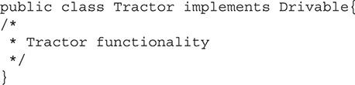

The Vehicle class:



The Car class:



The Truck class:

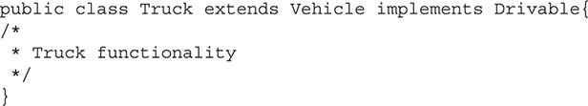

[**7.**](https://learning.oreilly.com/library/view/oca-java-se/9781259587535/ch08.html#ch08qa7a) Given the preceding classes and interface, would the following code segment produce errors when compiled?



A. No errors would be produced.

B. This code would result in compile errors.

[**8.**](https://learning.oreilly.com/library/view/oca-java-se/9781259587535/ch08.html#ch08qa8a) Given the preceding classes and interface, would the following code segment produce errors when compiled?



A. No errors would be produced.

B. This code would result in compile errors.

[**9.**](https://learning.oreilly.com/library/view/oca-java-se/9781259587535/ch08.html#ch08qa9a) Given the preceding classes and interface, would the following code segment produce errors when compiled?



A. No errors would be produced.

B. This code would result in compile errors.

[**10.**](https://learning.oreilly.com/library/view/oca-java-se/9781259587535/ch08.html#ch08qa10a) Given the preceding classes and interface, would the following code segment produce errors when compiled?



A. No errors would be produced.

B. This code would result in compile errors.

[**11.**](https://learning.oreilly.com/library/view/oca-java-se/9781259587535/ch08.html#ch08qa11a) Given the preceding classes and interface, would the following code segment produce errors when compiled?

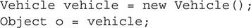

A. No errors would be produced.

B. This code would result in compile errors.

[**12.**](https://learning.oreilly.com/library/view/oca-java-se/9781259587535/ch08.html#ch08qa12a) Given the preceding classes and interface, would the following code segment produce errors when compiled?

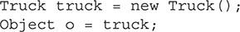

A. No errors would be produced.

B. This code would result in compile errors.

**Understand Casting**

[**13.**](https://learning.oreilly.com/library/view/oca-java-se/9781259587535/ch08.html#ch08qa13a) In what cases is casting needed? (Choose all that apply.)

A. Going from a superclass to subclass

B. Going from a subclass to superclass

C. Using an int as a double

D. Using a float as a long

[**14.**](https://learning.oreilly.com/library/view/oca-java-se/9781259587535/ch08.html#ch08qa14a) Why must the a variable be cast?

A. So future developers understand the intended use of the variable

B. To tell the compiler that the data conversion is safe to make

C. Because it was used polymorphically before

[**15.**](https://learning.oreilly.com/library/view/oca-java-se/9781259587535/ch08.html#ch08qa15a) What would cause an exception to be thrown from a cast?

A. If precision is lost due to the cast

B. If the object is cast to a superclass of its current type

C. If the object was never instantiated as the object that it is being cast to or one of its subclasses

D. If the object being cast is null

#### SELF TEST ANSWERS

**Understand Polymorphism**

[**1.**](https://learning.oreilly.com/library/view/oca-java-se/9781259587535/ch08.html#ch08qa1) Which statement is true about the term *polymorphism*?

A. It is a Latin word that roughly means “changeable.”

B. It is a Greek word that roughly means “many forms.”

C. It is an Old English word that roughly means “insectlike.”

D. It is a new technical term that means “Java object.”

Answer:

 **B**. The word *polymorphism* comes from the Greeks and means “many forms.”

 **A**, **C**, and **D** are incorrect.

[**2.**](https://learning.oreilly.com/library/view/oca-java-se/9781259587535/ch08.html#ch08qa2) What type of object can polymorphically behave as another?

A. An object can act as any subclass of the class it was created from.

B. An object can act as any superclass of the class it was created from.

C. An object can act as any other abstract class.

Answer:

 **B**. An object inherits all of the functionality of its superclasses and can therefore polymorphically behave as they do.

 **A** and **C** are incorrect. **A** is incorrect because an object cannot behave as its subclass since this class is more specific and contains functionality that is not present in the superclass. **C** is incorrect because there needs to be an *is-a* relationship between the classes. This answer does not mention what the relationship is.

[**3.**](https://learning.oreilly.com/library/view/oca-java-se/9781259587535/ch08.html#ch08qa3) Polymorphism helps to facilitate which of the following? (Choose all that apply.)

A. Highly optimized code

B. Code reuse

C. Code obfuscation

D. Code that is generic and flexible

Answer:

 **B** and **D**. Polymorphism aids in creating reusable code, because it allows the code to be written more abstractly, thus **B** is correct. Similar to **B**, polymorphism allows the code to be generic by using generic data types that any more specific object can fulfill. Thus, **D** is also correct.

 **A** and **C** are incorrect. **A** is incorrect because polymorphism has no effect on the level of optimization of the code. **C** is incorrect because obfuscated code (code that is intentionally difficult to read) is not related to polymorphism.

[**4.**](https://learning.oreilly.com/library/view/oca-java-se/9781259587535/ch08.html#ch08qa4) What is a correct *is-a* relationship?

A. A specific object *is-a* more generic one.

B. A generic object *is-a* more specific one.

C. A null reference *is-an* object.

Answer:

 **A**. A more specific object can be considered to be a more generic one. This is the fundamental principle of polymorphism.

 **B** and **C** are incorrect. **B** is incorrect because generic objects do not have all of the functionality of more specific ones and therefore do not possess an *is-a* relationship with the specific objects. **C** is incorrect because a null reference has no effect on its relationship with other objects.

[**5.**](https://learning.oreilly.com/library/view/oca-java-se/9781259587535/ch08.html#ch08qa5) Which of the following statements explains why an object can polymorphically behave as an interface?

A. By implementing the interface, the object is required to have all of the functionality that the interface represents.

B. By implementing the interface, the object inherits all the required methods it defines.

C. An object can behave as an interface because interfaces do not have a strict expected behavior and therefore any object can act as an interface.

Answer:

 **A**. When a class implements an interface, it is then required to implement all the methods the interface contains. This gives the class the functionality defined in the interface and therefore allows this class to behave as the interface.

 **B** and **C** are incorrect. **B** is incorrect because nothing is inherited when an interface is implemented. **C** is incorrect because each interface has a strict behavior expected of it. This is represented by the methods that must be implemented.

[**6.**](https://learning.oreilly.com/library/view/oca-java-se/9781259587535/ch08.html#ch08qa6) What does it mean if a developer is programming to an interface?

A. The developer is implementing an interface for the class he or she is working on.

B. The developer was given a set of interfaces he or she must implement.

C. The developer is defining the functionality instead of strict object types as much as possible.

Answer:

 **C**. Programming to an interface means that a developer is defining functionality instead of object data types. Any object can then implement the required interface and be used. If an interface were not used, only objects of the specific defined data type would be usable.

 **A** and **B** are incorrect. **A** is incorrect because programming to an interface is a larger concept than just implementing one interface in one class. **B** is incorrect because in this situation the developer is just implementing a group of interfaces that have been predetermined.

The following code example will be referenced in questions 7 through 12.

**FIGURE 8-3** UML for questions 7–12

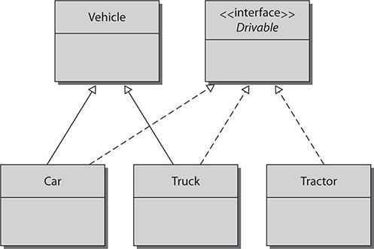

The Drivable interface:



The Tractor class:



The Vehicle class:



The Car class:



The Truck class:



[**7.**](https://learning.oreilly.com/library/view/oca-java-se/9781259587535/ch08.html#ch08qa7) Given the preceding classes and interface, would the following code segment produce errors when compiled?



A. No errors would be produced.

B. This code would result in compile errors.

Answer:

 **A**. No errors would be produced because the Car class extends the Vehicle class and therefore can be used as a Vehicle object.

 **B** is incorrect.

[**8.**](https://learning.oreilly.com/library/view/oca-java-se/9781259587535/ch08.html#ch08qa8) Given the preceding classes and interface, would the following code segment produce errors when compiled?



A. No errors would be produced.

B. This code would result in compile errors.

Answer:

 **A**. No errors would be produced because the Truck class implements the Drivable interface and therefore can be used as a Drivable object.

 **B** is incorrect.

[**9.**](https://learning.oreilly.com/library/view/oca-java-se/9781259587535/ch08.html#ch08qa9) Given the preceding classes and interface, would the following code segment produce errors when compiled?



A. No errors would be produced.

B. This code would result in compile errors.

Answer:

 **B**. This code would result in compile errors because the Vehicle class is not a superclass for the Tractor class.

 **A** is incorrect.

[**10.**](https://learning.oreilly.com/library/view/oca-java-se/9781259587535/ch08.html#ch08qa10) Given the preceding classes and interface, would the following code segment produce errors when compiled?



A. No errors would be produced.

B. This code would result in compile errors.

Answer:

 **B**. This code would result in compile errors because the Drivable interface cannot be instantiated since it is an interface.

 **A** is incorrect.

[**11.**](https://learning.oreilly.com/library/view/oca-java-se/9781259587535/ch08.html#ch08qa11) Given the preceding classes and interface, would the following code segment produce errors when compiled?



A. No errors would be produced.

B. This code would result in compile errors.

Answer:

 **A**. No errors would be produced because the Vehicle class is concrete, and the Object class is the superclass for every Java object.

 **B** is incorrect.

[**12.**](https://learning.oreilly.com/library/view/oca-java-se/9781259587535/ch08.html#ch08qa12) Given the preceding classes and interface, would the following code segment produce errors when compiled?



A. No errors would be produced.

B. This code would result in compile errors.

Answer:

 **A**. No errors would be produced because the Object class is the superclass for all Java objects.

 **B** is incorrect.

**Understand Casting**

[**13.**](https://learning.oreilly.com/library/view/oca-java-se/9781259587535/ch08.html#ch08qa13) In what cases is casting needed? (Choose all that apply.)

A. Going from a superclass to subclass

B. Going from a subclass to superclass

C. Using an int as a double

D. Using a float as a long

Answer:

 **A** and **D**. **A** is correct because a cast is always needed to go down the inheritance chain. **D** is correct because a long is not a floating-point number; precision will be lost and therefore it requires a cast.

 **B** and **C** are incorrect. **B** is incorrect because polymorphism occurs when going from a subclass to a superclass. **C** is incorrect because no precision is lost when using an int as a double, so no cast is needed.

[**14.**](https://learning.oreilly.com/library/view/oca-java-se/9781259587535/ch08.html#ch08qa14) Why must the a variable be cast?

A. So future developers understand the intended use of the variable

B. To tell the compiler that the data conversion is safe to make

C. Because it was used polymorphically before

Answer:

 **B**. If there is a possibility of incompatible data, a cast must be used.

 **A** and **C** are incorrect. **A** is incorrect, even though it is helpful for developers—that is not its sole purpose. **C** is incorrect because polymorphism does not change when a variable needs to be cast.

[**15.**](https://learning.oreilly.com/library/view/oca-java-se/9781259587535/ch08.html#ch08qa15) What would cause an exception to be thrown from a cast?

A. If precision is lost due to the cast

B. If the object is cast to a superclass of its current type

C. If the object was never instantiated as the object that it is being cast to or one of its subclasses

D. If the object being cast is null

Answer:

 **C**. If the object was not instantiated with the level of detail it is being cast to, it will cause a runtime exception.

 **A**, **B**, and **D** are incorrect. **A** is incorrect because if precision is lost between primitive types, there is no exception. **B** is an example of polymorphism. A cast can be done but is not needed. **D** is incorrect because a null reference can be cast. This will not cause an exception. However, if the cast is to an invalid type, the compiler will produce an



### 9

### HANDLING EXCEPTIONS

**CERTIFICATION OBJECTIVES**

• [Understand the Rationale and Types of Exceptions](https://learning.oreilly.com/library/view/oca-java-se/9781259587535/ch09.html#ch09lev1)

• [Understand the Nature of Exceptions](https://learning.oreilly.com/library/view/oca-java-se/9781259587535/ch09.html#ch09lev7)

• [Alter the Program Flow](https://learning.oreilly.com/library/view/oca-java-se/9781259587535/ch09.html#ch09lev11)

• [Recognize Common Exceptions](https://learning.oreilly.com/library/view/oca-java-se/9781259587535/ch09.html#ch09lev17)

 [Two-Minute Drill](https://learning.oreilly.com/library/view/oca-java-se/9781259587535/ch09.html#ch09lev21)

**Q&A** [Self Test](https://learning.oreilly.com/library/view/oca-java-se/9781259587535/ch09.html#ch09lev22)

**“T**hrow and catch.” Once that phrase makes sense to you, you’ll know that you understand exception handling in Java. Throughout this chapter, we will explore the primary focus of exception handling in Java by throwing exceptions and handling them where appropriate. We’ll discuss the different types of exceptions, when and how to handle them, as well as how to recognize common checked exceptions, unchecked exceptions, and errors. By the end of the chapter, you should know enough about exception handling in Java to score well on the exceptions-related questions when you sit the exam. Good luck!

**CERTIFICATION OBJECTIVE**

#### Understand the Rationale and Types of Exceptions

*Exam Objective* *Describe the advantages of exception handling*

*Exam Objective* *Differentiate among checked exceptions, unchecked exceptions, and errors*

The Java Language Specification provides the following definition for a software exception: “When a program violates the semantic constraints of the Java programming language, the Java virtual machine signals this error to the program as an exception.”

Exceptions are used in Java to handle events that affect the normal flow of the application’s execution. These events can result from coding errors or issues with the resources in place. For portability and robustness, Java aims to manage exceptions in a predictable way, by throwing and catching exceptions that have been or will be grouped in logical, sensible ways. We’ll explore the exception hierarchy in Java and the different types of exceptions.

The following topics will be covered:

 Advantages of exceptions

 Exception hierarchy in Java

 Checked exceptions

 Unchecked exceptions

 Errors

##### Advantages of Exceptions

Java exceptions provide three main advantages to writing and maintaining code. The first advantage is the separation of error-handling code from the main code of a program. The use of try-catch blocks allows a block of code to be executed without having to explicitly check each possible statement for errors. Instead, the statements can be grouped together, and any error will generate an exception that can be caught in a different section of code. This makes code much easier to read and maintain.

Exceptions provide a means to propagate errors up the call stack—the second advantage. Oftentimes, the code that may be best suited for handling the error condition is a method higher up in the call stack. Java allows exceptions to be thrown up the chain. Exceptions allow this to occur in a consistent and organized manor.

Another advantage of Java exception handling is the ability to group like exceptions together. Since exceptions are Java objects, the grouping is done via class hierarchy. For example, the IOException is one of the most common exceptions a developer will encounter. More specific exceptions will extend it. The FileNotFoundException is a subclass of IOException. When handling exceptions, a developer can catch the more generic IOException or target specific exceptions such as the FileNotFoundException.

##### Exception Hierarchy in Java

An exception in Java is defined by an instance of the class Throwable. Exception classes include the class Throwable and all of its subclasses. [Figure 9-1](https://learning.oreilly.com/library/view/oca-java-se/9781259587535/ch09.html#ch09fig01) depicts the Exception class’s hierarchy.

**FIGURE 9-1** Exception handling class hierarchy

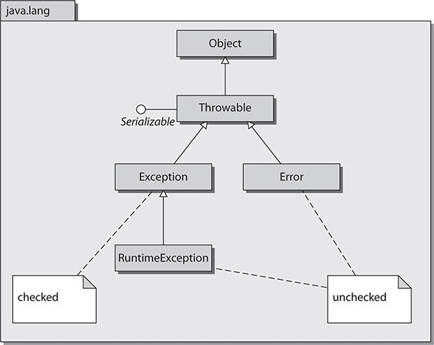

In the hierarchy, the two direct subclasses to Throwable are Exception and Error. Another important subclass is RuntimeException, which is a direct subclass to the Exception class. Runtime exceptions and errors are not checked. All of the other exceptions are checked. Let’s take a look at each category.

##### Checked Exceptions

Checked exceptions are checked by the compiler at compile time. Checked exceptions must be caught by a catch block or the thread will terminate, and so will the application if it is the only thread. The application will not terminate if you have started nondaemon threads. A handler can actually be registered to catch the exception in a multithreaded application. The following code demonstrates an application throwing an uncaught exception, but continuing to run because of the existence of other threads:

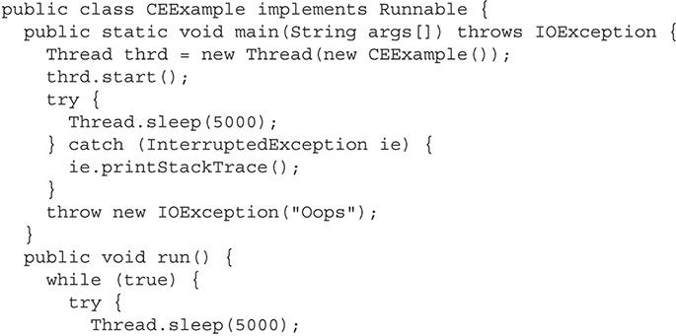

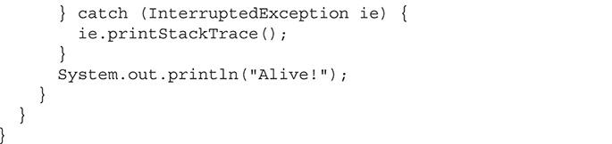

##### Unchecked Exceptions

Unchecked exceptions are checked at runtime, rather than at compile time. Unchecked exceptions are all subclasses to the RuntimeException class, including RuntimeException itself. Unchecked exceptions and Errors do not need to be caught. More specifically, you should code your application with the assumption that unchecked exceptions would not be encountered; this is why you do not need to waste your efforts trying to catch and manage them, as these exceptions should rarely occur. Most runtime exceptions occur due to programming mistakes.



***Oracle provides excellent online coverage of exceptions through the Java Tutorial, “Lesson: Exceptions.” The section “Unchecked Exceptions - The Controversy” is of particular interest and is worth review*.**

##### (Unchecked) Errors

Errors are unchecked exceptions that represent extreme conditions and will typically cause your application to fail. Most errors are unrecoverable external errors. Errors shouldn’t be handled, but they can be.

**EXERCISE 9-1**

**Determining When to Use Assertions in Place of Exceptions**

This chapter does not cover assertions because assertions are not covered on the exam. But you should know when to use them. Do a little research and determine when assertions should be used in place of traditional exception handling.

**CERTIFICATION OBJECTIVE**

#### **Understand the Nature of Exceptions**

*Exam Objective* *Create and invoke a method that throws an exception*

Creating, throwing, and propagating exceptions is easier than it seems. In this section, we’ll take a quick look at throwing exceptions; in the next section, we’ll look further into catching them.

The following topics will be covered:

 Defining exceptions

 Throwing exceptions

 Propagating exceptions

##### Defining Exceptions

Exceptions in Java should have a no argument constructor and a constructor with a single String argument, as shown in the upcoming code sample. These guidelines are provided by convention and should be followed. To reinforce this point and provide a reference to the convention, *Murach’s Java Programming, 4th Edition*, by Joel Murach (Mike Murach & Associates, 2011) states the following: “By convention, all exception classes should have a default constructor that doesn’t accept any arguments and another constructor that accepts a string argument.” The following example demonstrates a custom exception called RecordException:

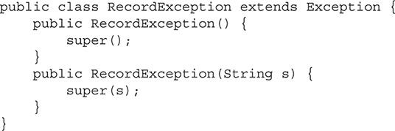

This example demonstrates the creation of a checked exception as it is directly inherited from the Exception class. This Exception class could easily be made an unchecked exception by inheriting from the RuntimeException class.

All Exception subclass names should end with Exception—for example, SQLException and NumberFormatException. All Error subclass names should end with Error—for example, VirtualMachineError and OutOfMemoryError.

##### Throwing Exceptions

Methods use the throw statement to throw exceptions in Java. Only objects of the type or subtype of class Throwable can be thrown. Here is a valid throw statement:



An error will occur if the application attempts to throw an object that is not an instance of Throwable:



This statement will invoke a compilation error and will also result in the following error message if executed:

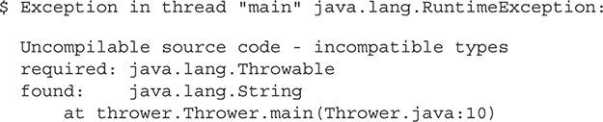



***Remember that any checked exception, unchecked exception, or error may be thrown*.**

##### Propagating Exceptions

Exceptions can be propagated all the way up to the main method. If the main method does not handle the exception, it will be thrown to the Java virtual machine (JVM) and the application may be terminated. When an application throws an exception, the method that contains the exception must catch the exception or send it to the calling method, or else the application will end. To send an exception to the calling method, you must include the throws keyword in the method declaration along with the exception name to be thrown. This is demonstrated in the following code:

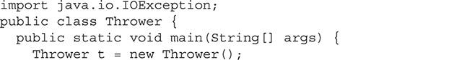

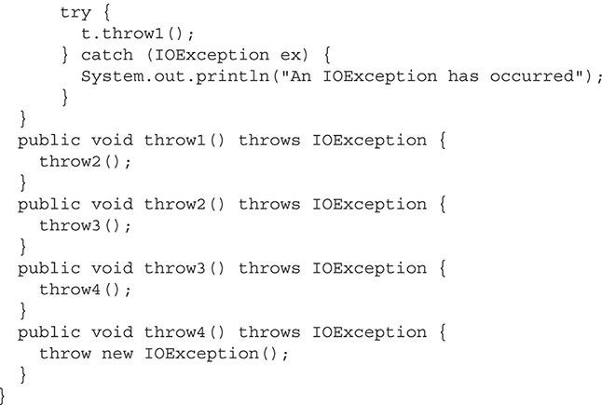



***A best practice is to use a logging API in conjunction with the items being caught in your catch statements. Take a look at your current projects. If the projects are littered with print statements (directed to standard output), especially in the* catch *clauses, consider doing some refactoring to leverage off of the logging APIs*.**

**EXERCISE 9-2**

**Creating a Custom Exception Class**

In this exercise, you will create a custom checked Exception class.

**1.** Determine a name and purpose for your checked Exception class.

**2.** Create a new class that inherits from the Exception class.

**3.** Create a no-argument constructor that calls super().

**4.** Create a constructor with a single string argument that calls super(s).

**5.** Develop code that will throw the exception.

**6.** Develop code that will catch the exception.

**CERTIFICATION OBJECTIVE**

#### Alter the Program Flow

*Exam Objective* *Create a try-catch block and determine how exceptions alter normal program flow*

When code that is in scope of a try clause throws an exception, the exception will be evaluated by the associated catch clauses. Various statements work in conjunction with the try clause. We’ll take a look at each one.

The following topics will be covered in these pages:

 The try-catch statement

 The try-finally statement

 The try-catch-finally statement

 The try-with-resources statement

 The multi-catch clause

##### The try-catch Statement

The try-catch statement contains code to “catch” thrown exceptions from within the try block, either explicitly or propagated up through method calls. In a try clause, the code within its block is attempting (trying) to complete without encountering any exceptions. If an exception is thrown, all statements after the exception in the try block will not be executed. This is demonstrated in the following code:

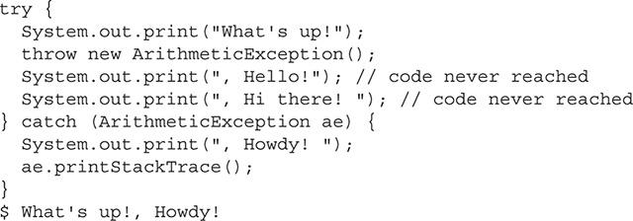

Always begin with the subclasses when ordering the catch clauses to catch exceptions. This necessary design (coding implementation) is illustrated in the next example:

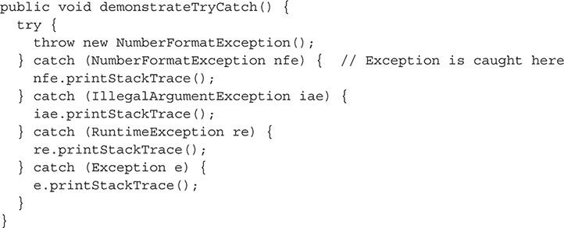

NumberFormatException is on the bottom of the hierarchy and is a subclass to IllegalArgumentException. IllegalArgumentException is a subclass to RuntimeException, and RuntimeException is a subclass to Exception. Therefore, the order of the catch clauses is relative to this order: NumberFormatException, IllegalArgumentException, RuntimeException, and Exception.



***In the real world, it is not a best practice to catch* RuntimeException *or the* Exception *classes themselves. That is, you should catch their subclasses as appropriate to your code*.**

You have several options when you’re printing data relative to an exception being caught, such as using the getMessage, toString, and printStackTrace methods. The getMessage method returns a detailed message about the exception. The toString method returns detailed messages about the exception and a class name. The printStackTrace method prints a detailed message, the class name, and a stack trace. These methods are demonstrated in the following code:

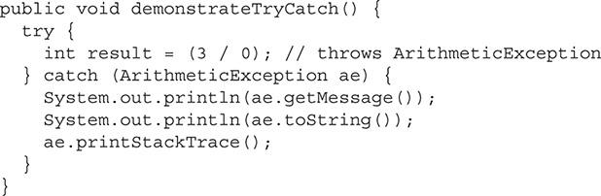

They result in this output:

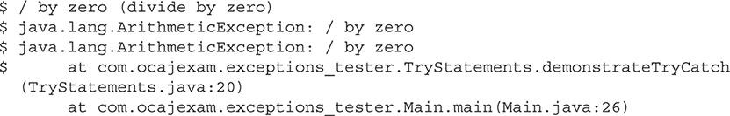

The catch clause should never be empty. This is considered *silencing* an exception and is not a good practice. A catch clause should either log a message, print the stack trace, or provide some sort of notification to the consumer (developer, user, and so on) of the application that an error has occurred. Here’s an example:

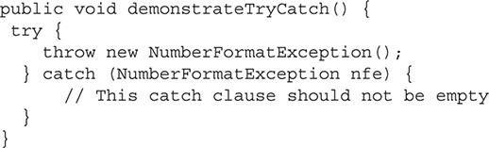

When exceptions are being caught, if the Exception class is not found, the system will look for the superclass of the exception being thrown. In the following example, IllegalArgumentException is the superclass of NumberFormatException, so it will catch the exception being thrown:

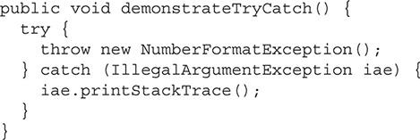

In the preceding examples, you’ll notice a common naming convention for the exception parameters. It is customary to use the first letter of each word in the Exception class for the parameter name. For example, for ClassCastException, the parameter name would be cce.

##### The try-finally Statement

In the try-finally statement, the finally clause is always executed after the try clause has completed, unless, of course, the application is terminated prior to the try clause finishing up.

The following example demonstrates the try-finally statement:

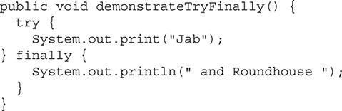

The resultant output of running the demonstrateTryFinally method is as follows:



The following example demonstrates a try-finally statement in which the try clause exits prematurely with a call to System.exit:

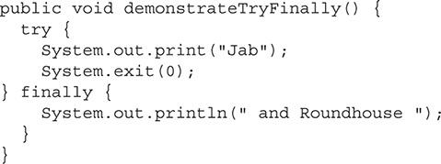

The resultant output of running the demonstrateTryFinally method in this scenario is as follows:



Note that if an unchecked exception is thrown in a try block, the finally method will be invoked, as shown next. Because the unchecked exception is not caught, the application terminates, but only *after* the finally statement completes.

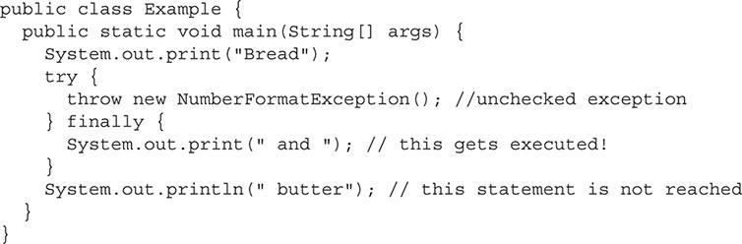

Because of the termination of the application after completion of the finally statement, but before the end of the program, we do not get our butter:



##### The try-catch-finally Statement

The try-catch-finally statement is exactly what it appears to be—a try-catch statement with a finally clause attached. The finally clause will execute after the try-catch portion of the statement, unless the application is terminated prior to the entry point of the finally clause.

##### The try-with-resources Statement

The try-with-resources statement provides the capability of declaring resources that must be closed when they are no longer needed. These resources must implement the AutoCloseable interface. Prior to Java SE 7, these resources were typically closed in the finally clause. With version 7, the resources are automatically closed at the end of the try-with-resources statement—that is, if an exception is thrown or if the code block reaches its end, the resource is closed.

The Javadoc documentation for AutoCloseable (<http://docs.oracle.com/javase/8/docs/api/java/lang/AutoCloseable.html>) calls out all of the classes that can be used with the try-with-resources statement. The following classes here implement AutoCloseable; they give you the big picture of the wide and possible usages of resources for the try-with-resources statement:

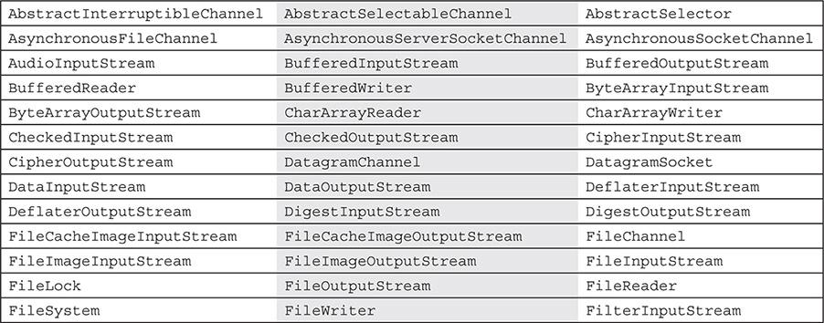

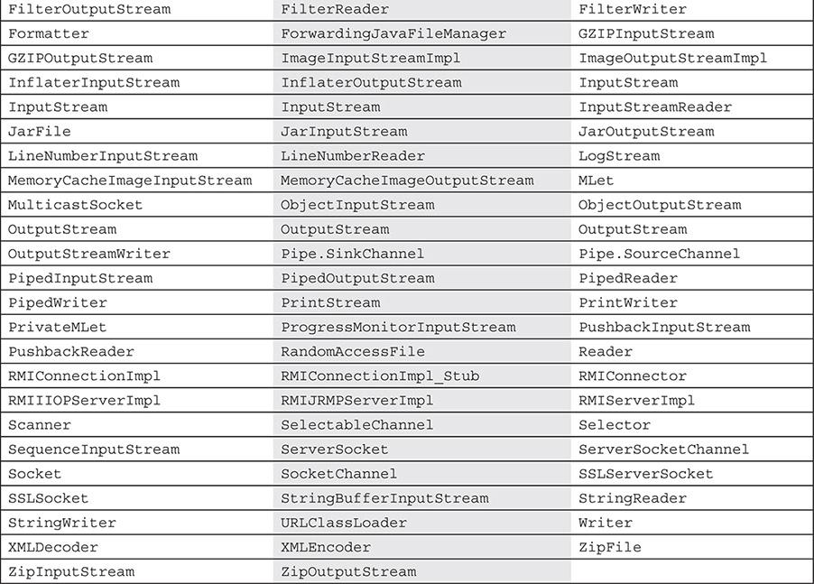

Now let’s compare some code. Here is the legacy try-catch-finally code performing the close method explicitly in the finally statement:

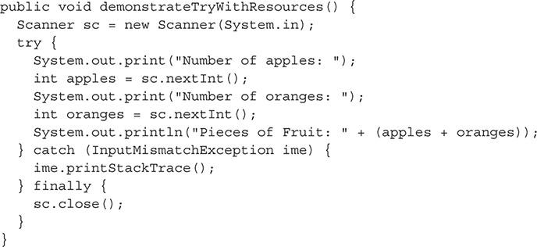

Now let’s refactor this code into a try-with-resources statement, where the close method will be called implicitly. Notice two changes: the first is the Scanner declaration as an argument in the try clause, and the second is the removal of the finally clause.

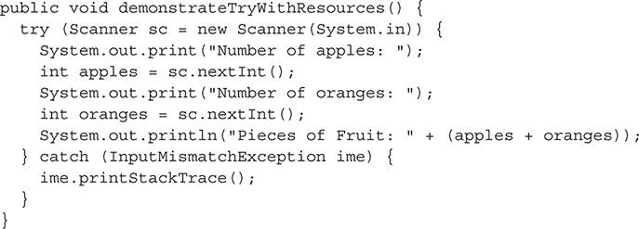

##### The multi-catch Clause

The multi-catch clause allows for multiple exception arguments in one catch clause. Examine the following code segment:

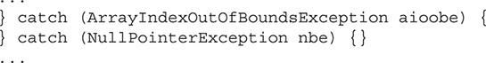

These two catch clauses can be refactored into one multi-catch clause using the appropriate syntax:



An example of multi-catch is shown in the following demonstrateMultiCatch method:

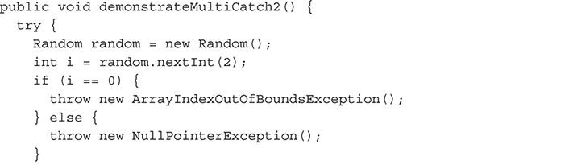

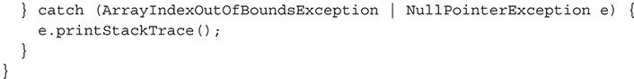



***The left margin of the NetBeans source editor will provide hints that encourage the automated refactoring of multiple related* catch *statements to a* multi-catch *statement. You can search for “Seven NetBeans Hints for Modernizing Java Code” on the Web to find more information*.**

**EXERCISE 9-3**

**Using NetBeans Code Templates for Exception Handling Elements**

The NetBeans integrated development environment (IDE) includes a nice feature called *code templates*. Code templates are abbreviated strings that expand into fuller strings or blocks of code. There are currently six related code templates for exception handling. This exercise has you using them all:

**1.** Make use of the ca code template.

**2.** Make use of the fy code template.

**3.** Make use of the th code template.

**4.** Make use of the tw code template.

**5.** Make use of the twn code template.

**6.** Make use of the trycatch code template.

**CERTIFICATION OBJECTIVE**

#### Recognize Common Exceptions

*Exam Objective* *Recognize common Exception classes (such as NullPointerException, ArithmeticException, ArrayIndexOutOfBoundsException, ClassCastException)*

This objective is pretty much a review, because we’ve already discussed the differences between exception types. To help you grasp the specifics of the most common exceptions, let’s take a look at the class hierarchies in some diagrams and produce some unchecked exceptions.

##### Common Checked Exceptions

Common checked exceptions include the following:

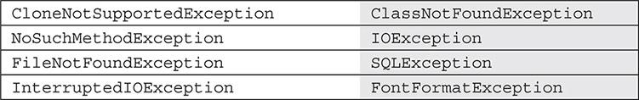

These exceptions are shown in [Figure 9-2](https://learning.oreilly.com/library/view/oca-java-se/9781259587535/ch09.html#ch09fig02) and are detailed in the following sections.

**FIGURE 9-2** Common checked exceptions

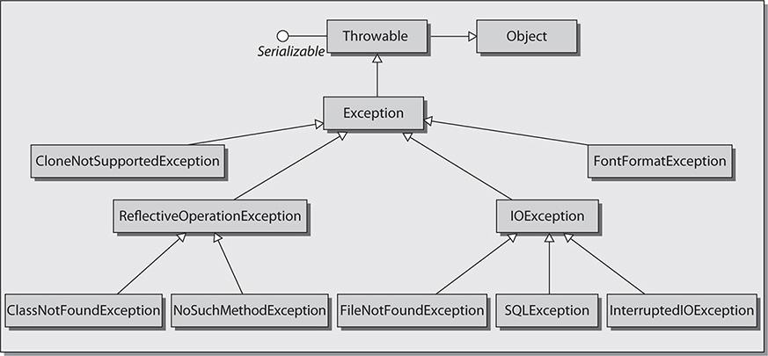

###### CloneNotSupportedException

The CloneNotSupportedException is thrown when the clone method is called by an object that cannot be cloned. Deep copy cannot be generated. Deep copying (for example, deep cloning) is when a cloned object makes an exact duplicate of an object’s state. (To learn more about deep copies [and shallow copies] read “Deep Copy and Shallow Copy” from JusForTechies [[www.jusfortechies.com/java/core-java/deepcopy_and_shallowcopy.php](http://www.jusfortechies.com/java/core-java/deepcopy_and_shallowcopy.php)].)

###### ClassNotFoundException

The ClassNotFoundException is thrown when a class cannot be loaded because of a failure to locate its definition.

###### NoSuchMethodException

The NoSuchMethodException is thrown when a called method is unable to be located. For example, a NoSuchMethodException would occur if you tried to use reflection and attempted to invoke a method that did not exist.

###### FileNotFoundException

The FileNotFoundException is thrown with an attempt to open a file that cannot be found.

###### IOException

The IOException is thrown when a failed input/output operation occurs.

###### SQLException

The SQLException is thrown when a database or SQL statement error occurs.

###### InterruptedIOException

The InterruptedIOException is thrown when a thread is interrupted. This class has a bytesTransferred field that provides information on how many bytes were transferred successfully before the interruption occurred.

##### Common Unchecked Exceptions

Common unchecked exceptions include the following:

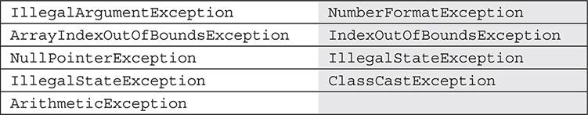

These exceptions are visualized in [Figure 9-3](https://learning.oreilly.com/library/view/oca-java-se/9781259587535/ch09.html#ch09fig03) and are detailed in the following sections with examples.

**FIGURE 9-3** Common unchecked exceptions

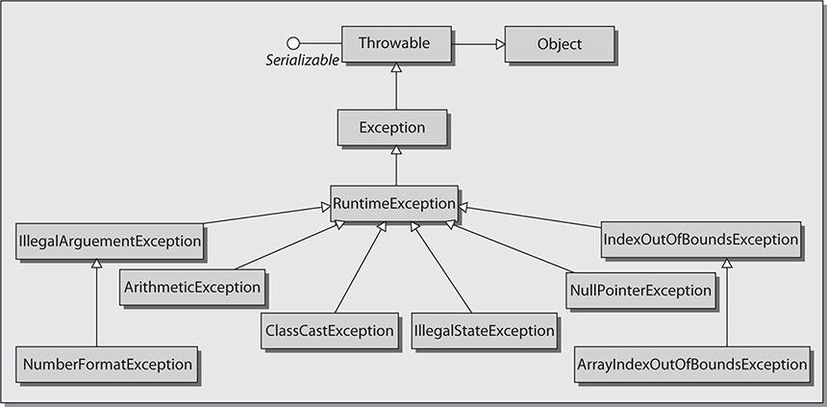

###### The IllegalArgumentException Class

The IllegalArgumentException of the java.nio.file package is thrown when a method has been passed an illegal or inappropriate argument.

Here’s an example:

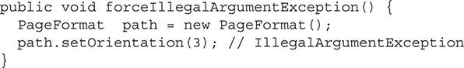

###### The NumberFormatException Class

The NumberFormatException is thrown when the application has attempted to convert a string to one of the numeric types with the wrong format.

Here’s an example:

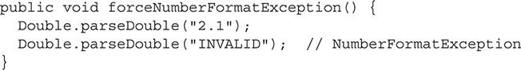

###### The ArrayIndexOutOfBoundsException Class

The ArrayIndexOutOfBoundsException is thrown when an array has been accessed with an illegal index that is either less than, equal to, or greater than the size of the array.

Here’s an example:

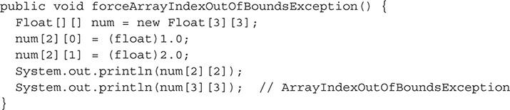

###### The IndexOutOfBoundsException Class

The IndexOutOfBoundsException is thrown when an index is out of range.

Here’s an example:

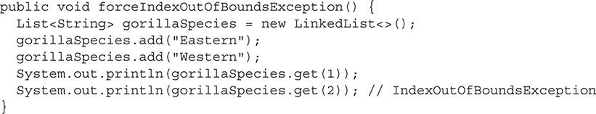

###### The NullPointerException Class

The NullPointerException is thrown when an application is required to use an object but finds null instead.

Here’s an example:

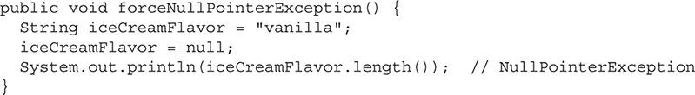

**The IllegalStateException Class**

The IllegalStateException is thrown when a method has been invoked at an illegal or inappropriate time due to being in an inappropriate state.

Here’s an example:

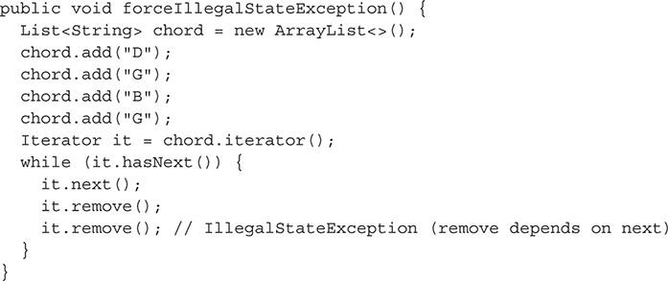

###### The ClassCastException Class

The ClassCastException is thrown when the code attempts to cast an object to a subclass of which it is not an instance.

Here’s an example:

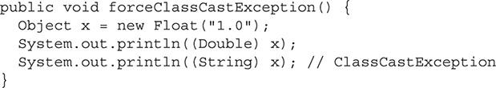

###### The ArithmeticException Class

The ArithmeticException is thrown when an exceptional arithmetic condition has occurred.

Here’s an example:

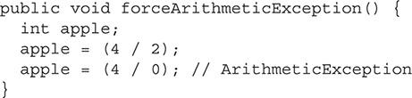

##### Common Errors

Common (unchecked) errors include the following: AssertionError, ExceptionInInitializeError, VirtualMachineError, OutOfMemoryError, and NoClassDefFoundError. These errors, as well as many others, of the error classes in JDK 8 are visualized in [Figure 9-4](https://learning.oreilly.com/library/view/oca-java-se/9781259587535/ch09.html#ch09fig04). The five common errors are detailed in the following sections.

**FIGURE 9-4** Common errors

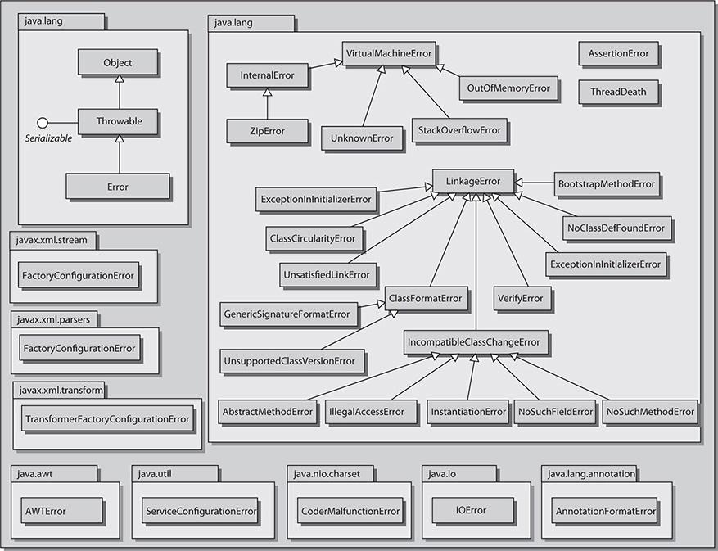

###### The AssertionError Class

The AssertionError is thrown upon a failed assertion.

###### The ExceptionInInitializeError Class

The ExceptionInInitializeError is thrown when an unexpected exception occurs in a static initializer.

###### The VirtualMachineError Class

The VirtualMachineError is thrown when a JVM error occurs.

###### The OutOfMemoryError Class

The OutOfMemoryError is thrown when garbage collection is performed but is unable to free up any space.

###### The NoClassDefFoundError Class

The NoClassDefFoundError is thrown when the JVM cannot find a class definition that was found at compile time.

**EXERCISE 9-4**

**Creating an Error Condition**

Errors are not typically encountered, but when they are, your application is probably doomed. To demonstrate creating an error, the following code causes an OutOfMemoryError (“Exception in thread ‘main’ java.lang.OutOfMemoryError: Java heap space”):

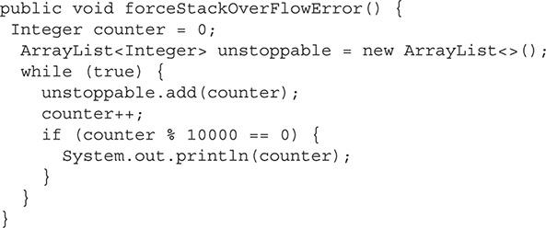

It’s now your turn.

**1.** Select an error you’d like to force from [Figure 9-4](https://learning.oreilly.com/library/view/oca-java-se/9781259587535/ch09.html#ch09fig04).

**2.** Study the error in the Javadoc documentation. You can find documentation for the subclasses of the Error class here: <http://docs.oracle.com/javase/8/docs/api/>.

**3.** Develop and execute a simple application.

**4.** Do whatever it takes to impress your selected Error on the application.

**5.** Share what you did with the JavaRanch at this thread, “Various examples of having errors thrown relative to the Error class,” at [www.coderanch.com/t/583633/java-SCJA/certification/Various-examples-having-errors-thrown#2656332](http://www.coderanch.com/t/583633/java-SCJA/certification/Various-examples-having-errors-thrown#2656332).

#### CERTIFICATION SUMMARY

This chapter discussed the exception handling hierarchy in Java. We went over the different types/categories of exceptions in Java. We discussed the various try block statements and how to throw, catch, and handle exceptions. Finally, we discussed the various types of common exceptions and errors that you’ll see when working with the Java programming language.

When you sit the OCA exam, you will see several questions on exception handling, most of them dealing with presented code samples. Your knowledge of working with exceptions must be strong or you will feel defeated even before you finish the exam. If after reading this chapter, you still think your knowledge is weak on exceptions, read it through again, making sure you complete all the exercises. Also, for this chapter as well as the others, you should always feel comfortable with going straight into the Java Language Specification for clarity or information: <http://docs.oracle.com/javase/specs/jls/se8/jls8.pdf>.

Finally, mastering exception handling won’t be important just for the exam; you’ll be using it a lot in your own code for your projects at work, at school, and anywhere else.

#### Images TWO-MINUTE DRILL

**Understand the Rationale and Types of Exceptions**

 All exceptions and errors inherit from the Throwable class.

 Types include checked exceptions, unchecked exceptions, and errors.

 Checked exceptions are checked by the compiler at compile time.

 Checked exceptions are all subclasses to the Exception class; however, RuntimeException and its subclasses are not part of the Exception class.

 Unchecked exceptions are checked at runtime, not compile time.

 Unchecked exceptions are all subclasses to the RuntimeException class, including RuntimeException itself.

 Unchecked exceptions and errors do not need to be caught.

 Errors represent extreme conditions and will typically cause your application to fail.

**Understand the Nature of Exceptions**

 Code cannot be placed between the try and catch blocks, try and finally blocks, or catch and finally blocks—that is, extra code cannot be immediately placed before or after the curly braces that separate the blocks in these statements.

 The common naming convention for catch clause arguments is the representation of a string containing the first letter of each word of the exception being passed.

 Exceptions are thrown with the throw keyword.

 The throws keyword is used in definitions of methods that throw an exception.

 Methods of the Throwable class provide support for gathering information about a thrown exception. The methods getMessage, toString, and printStackTrace are commonly used.

 Thrown exceptions move up the call stack until they are caught. If they are not caught and reach the main method, the application will end.

**Alter the Program Flow**

 The try block must contain code that can throw an exception.

 The try block must have one catch or finally block.

 The try-with-resources statement declares resources that can be automatically closed. The objects must implement AutoCloseable.

 The catch block must be ordered by subtypes first.

 The multi-catch feature allows for multiple exception types to be caught in one catch block.

 The try-catch statement is a valid statement that does not include a finally clause.

 The finally block of the try-catch-finally and try-finally statements are always invoked, unless the JVM terminates first.

 The finally block is typically used for releasing resources.

**Recognize Common Exceptions**

 Common checked exceptions include CloneNotSupportedException, ClassNotFoundException, NoSuchMethodException, IOException, FileNotFoundException, SQLException, InterruptedIOException, and FontFormatException.

 Common unchecked exceptions include IllegalArgumentException, NumberFormatException, ArrayIndexOutOfBoundsException, IndexOutOfBoundsException, NullPointerException, IllegalStateException, IllegalStateException, ClassCastException, and ArithmeticException.

 Common (unchecked) errors include AssertionError, ExceptionInInitializeError, VirtualMachineError, OutOfMemoryError, and NoClassDefFoundError.

#### SELF TEST

**Understand the Rationale and Types of Exceptions**

[**1.**](https://learning.oreilly.com/library/view/oca-java-se/9781259587535/ch09.html#ch09qa1a) Which class has the fewest subclasses: Exception, RuntimeException, or Error? Select the correct statement.

A. The Exception class has fewer subclasses than the RuntimeException and Error classes.

B. The RuntimeException class has fewer subclasses than the Exception and Error classes.

C. The Error class has fewer subclasses than the Exception and RuntimeException classes.

[**2.**](https://learning.oreilly.com/library/view/oca-java-se/9781259587535/ch09.html#ch09qa2a) Of the following types of exceptions, which will an IDE help you in catching, if it is not handled in your code?

A. Checked exceptions.

B. Unchecked exceptions.

[**3.**](https://learning.oreilly.com/library/view/oca-java-se/9781259587535/ch09.html#ch09qa3a) Which statement about the Throwable class is not correct?

A. The Throwable class extends the Object class.

B. The Throwable class implements the Serializable interface.

C. Direct subclasses to the Throwable class include the RuntimeException and Error classes.

D. The Throwable class is in the java.lang package.

[**4.**](https://learning.oreilly.com/library/view/oca-java-se/9781259587535/ch09.html#ch09qa4a) Exceptions fall into three categories. Which is not an exceptions category?

A. Check Exceptions

B. Unchecked Exceptions

C. Assertions

D. Errors

[**5.**](https://learning.oreilly.com/library/view/oca-java-se/9781259587535/ch09.html#ch09qa5a) Which classes are subclasses of the IOException class? (Choose three.)

A. FileNotFoundException

B. SQLException

C. ClassNotFoundException

D. InterruptedIOException

[**6.**](https://learning.oreilly.com/library/view/oca-java-se/9781259587535/ch09.html#ch09qa6a) Which of the following code fragments will throw a NumberFormatException?

A. Integer.parseInt("INVALID");

B. int e = (2 / 0);

C. Object x = new Float(“1.0”); Double d = (Double) x;

D. String s = null; int i = s.length();

**Understand the Nature of Exceptions**

[**7.**](https://learning.oreilly.com/library/view/oca-java-se/9781259587535/ch09.html#ch09qa7a) Which of the following classes can be thrown? (Choose all that apply.)

A. throw new Error();

B. throw new RuntimeException();

C. throw new Exception();

D. throw new Assertion();

E. throw new Throwable();

[**8.**](https://learning.oreilly.com/library/view/oca-java-se/9781259587535/ch09.html#ch09qa8a) Given:

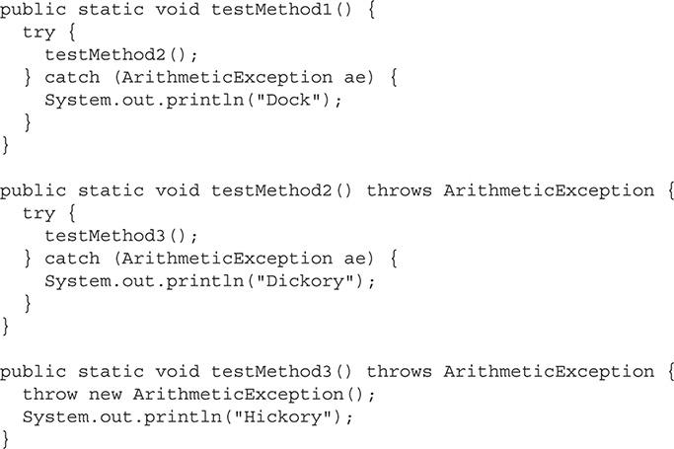

What will be printed when the testMethod1 is invoked (after allowing the code to run with compilation warnings)?

A. “Hickory Dickory Dock” is printed.

B. “Dickory” is printed.

C. “Dock” is printed.

[**9.**](https://learning.oreilly.com/library/view/oca-java-se/9781259587535/ch09.html#ch09qa9a) Given:

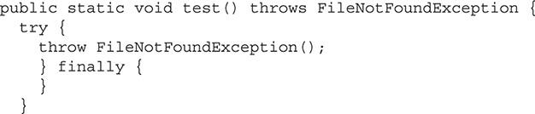

Determine why it will not compile. Which statement is correct?

A. The code will not compile without a catch clause.

B. The code needs the new keyword after the throw keyword.

C. The finally clause should be the final clause.

D. There is no class called FileNotFoundException.

[**10.**](https://learning.oreilly.com/library/view/oca-java-se/9781259587535/ch09.html#ch09qa10a) Can a method throw more than one exception?

A. Yes, a method can throw more than one exception.

B. No, a method cannot throw more than one exception.

[**11.**](https://learning.oreilly.com/library/view/oca-java-se/9781259587535/ch09.html#ch09qa11a) Following the common convention of naming the parameter in the catch clause, what would the parameter be for the exception EnumConstantNotPresentException?

A. e

B. ex

C. ee

D. ecnpe

**Alter the Program Flow**

[**12.**](https://learning.oreilly.com/library/view/oca-java-se/9781259587535/ch09.html#ch09qa12a) What new features came with Java 7 to enhance exception handling capabilities? (Choose all that apply.)

A. The multi-catch feature

B. The boomerang feature

C. The try-with-resources feature

D. The try-with-riches feature

[**13.**](https://learning.oreilly.com/library/view/oca-java-se/9781259587535/ch09.html#ch09qa13a) Given:

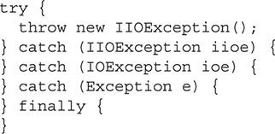

This code will not compile. Why?

A. Although it’s a best practice that Exception classes have a no argument constructor, this isn’t always followed, as in the case of the IIOException class that does not have a no argument constructor.

B. The exceptions listed in the catch blocks should be in the reverse order. The catch blocks should be ordered like so: Exception, followed by IOException, followed by IIOException.

C. The finally block must include statements.

D. The throws keyword should be used in place of the throw keyword.

**Recognize Common Exceptions**

[**14.**](https://learning.oreilly.com/library/view/oca-java-se/9781259587535/ch09.html#ch09qa14a) What do the InternalError, OutOfMemoryError, StackOverflowError, and UnknownError classes have in common? (Choose all that apply.)

A. They are all subclasses to the VirtualMachineError class.

B. They all have a no argument constructor.

C. They all have a constructor that accepts a single String argument.

D. They are all subclasses to the RuntimeException class.

E. All of the above

[**15.**](https://learning.oreilly.com/library/view/oca-java-se/9781259587535/ch09.html#ch09qa15a) The bytesTransferred field of which checked exception provides information on how many bytes were transferred successfully before a disruption occurred?

A. IOException

B. InterruptedIOException

C. IntrospectionException

D. TimeoutException

[**16.**](https://learning.oreilly.com/library/view/oca-java-se/9781259587535/ch09.html#ch09qa16a) Given:

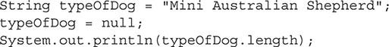

Which of the following is true?

A. A NullPointerException will be thrown.

B. An IllegalStateException will be thrown.

C. An IllegalArgumentException will be thrown.

D. A compilation error will occur.

[**17.**](https://learning.oreilly.com/library/view/oca-java-se/9781259587535/ch09.html#ch09qa17a) Which of the following is not a valid Java exception?

A. IOException

B. InterruptedIOException

C. CPUProcessException

D. CloneNotSupportedException

E. ClassNotFoundException

#### SELF TEST ANSWERS

**Understand the Rationale and Types of Exceptions**

[**1.**](https://learning.oreilly.com/library/view/oca-java-se/9781259587535/ch09.html#ch09qa1) Which class has the fewest subclasses: Exception, RuntimeException, or Error? Select the correct statement.

A. The Exception class has fewer subclasses than the RuntimeException and Error classes.

B. The RuntimeException class has fewer subclasses than the Exception and Error classes.

C. The Error class has fewer subclasses than the Exception and RuntimeException classes.

Answer:

 **C**. The Error class has fewer subclasses than the Exception and RuntimeException classes.

 **A** and **B** are incorrect. **A** is incorrect because the Exception class has the most subclasses compared to the RuntimeException class and the Error class. Remember that RuntimeException is a subclass of the Exception class. **B** is incorrect because the RuntimeException class has more subclasses than the Error classes.

[**2.**](https://learning.oreilly.com/library/view/oca-java-se/9781259587535/ch09.html#ch09qa2) Of the following types of exceptions, which will an IDE help you in catching, if it is not handled in your code?

A. Checked exceptions.

B. Unchecked exceptions.

Answer:

 **A**. An IDE will provide hints to help you catch checked exceptions that are not handled in your code.

 **B** is incorrect. An IDE will not provide hints to catch unchecked exceptions that are not handled in your code, as unchecked exceptions are not required to be caught.

[**3.**](https://learning.oreilly.com/library/view/oca-java-se/9781259587535/ch09.html#ch09qa3) Which statement about the Throwable class is not correct?

A. The Throwable class extends the Object class.

B. The Throwable class implements the Serializable interface.

C. Direct subclasses to the Throwable class include the RuntimeException and Error classes.

D. The Throwable class is in the java.lang package.

Answer:

 **C**. Direct subclasses to the Throwable class include the Exception and Error classes. The RuntimeException class is a subclass, but not a *direct* subclass.

 **A**, **B**, and **D** are incorrect. **A** is incorrect because the statement is correct; the Throwable class does extend the Object class. **B** is incorrect because the statement is correct; the Throwable class does implement the Serializable interface. **D** is incorrect because the statement is correct; the Throwable class is in the java.lang package.

[**4.**](https://learning.oreilly.com/library/view/oca-java-se/9781259587535/ch09.html#ch09qa4) Exceptions fall into three categories. Which is not an exceptions category?

A. Check Exceptions

B. Unchecked Exceptions

C. Assertions

D. Errors

Answer:

 **C**. Assertions is not an exception category.

 **A**, **B** and **D** are incorrect. Check Exceptions, Unchecked Exceptions, and Errors are all exception categories in Java.

[**5.**](https://learning.oreilly.com/library/view/oca-java-se/9781259587535/ch09.html#ch09qa5) Which classes are subclasses of the IOException class? (Choose three.)

A. FileNotFoundException

B. SQLException

C. ClassNotFoundException

D. InterruptedIOException

Answer:

 **A**, **B**, and **D**. FileNotFoundException, SQLException, and InterruptedIOException are all subclasses of IOException.

 **C** is incorrect. ClassNotFoundException is not a subclass of IOException; it is a subclass of ReflectiveOperationException.

[**6.**](https://learning.oreilly.com/library/view/oca-java-se/9781259587535/ch09.html#ch09qa6) Which of the following code fragments will throw a NumberFormatException?

A. Integer.parseInt(“INVALID”);

B. int e = (2 / 0);

C. Object x = new Float(“1.0”); Double d = (Double) x;

D. String s = null; int i = s.length();

Answer:

 **A**. Evaluation of the statement causes a NumberFormatException to be thrown.

 **B**, **C**, and **D** are incorrect. **B** is incorrect because evaluation of the statement causes an ArithmeticException to be thrown. **C** is incorrect because evaluation of the statement causes a ClassCastException to be thrown. **D** is incorrect because evaluation of the statement causes a null pointer exception.

**Understand the Nature of Exceptions**

[**7.**](https://learning.oreilly.com/library/view/oca-java-se/9781259587535/ch09.html#ch09qa7) Which of the following classes can be thrown? (Choose all that apply.)

A. throw new Error();

B. throw new RuntimeException();

C. throw new Exception();

D. throw new Assertion();

E. throw new Throwable();

Answer:

 **A**, **B**, **C**, and **E**. The Error, RuntimeException, Exception, and Throwable classes can all be thrown.

 **D** is incorrect. There is no Assertion class in Java. There is, however, an AssertionError class in Java that may be thrown.

[**8.**](https://learning.oreilly.com/library/view/oca-java-se/9781259587535/ch09.html#ch09qa8) Given:

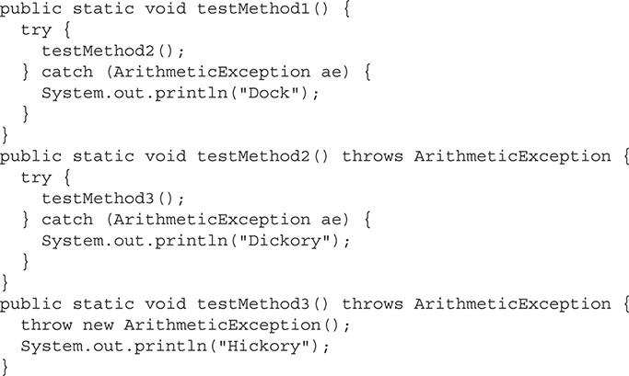

What will be printed when the testMethod1 is invoked (after allowing the code to run with compilation warnings)?

A. “Hickory Dickory Dock” is printed.

B. “Dickory” is printed.

C. “Dock” is printed.

Answer:

 **B**. “Dickory” is printed.

 **A** and **C** are incorrect. **A** is incorrect because the “Hickory” statement is never reached and an exception is not thrown to the testMethod2 invocation. **C** is incorrect because an exception is not thrown to the testMethod2 invocation, which would have been necessary to print out “Dock”.

[**9.**](https://learning.oreilly.com/library/view/oca-java-se/9781259587535/ch09.html#ch09qa9) Given:

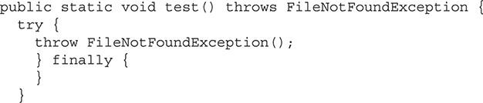

Determine why it will not compile. Which statement is correct?

A. The code will not compile without a catch clause.

B. The code needs the new keyword after the throw keyword.

C. The finally clause should be the final clause.

D. There is no class called FileNotFoundException.

Answer:

 **B**. The code needs the new keyword after the throw keyword in this example.

 **A**, **C**, and **D** are incorrect. **A** is incorrect because a catch clause is not needed if a finally clause is provided. **C** is incorrect because using finally instead of final is correct. **D** is incorrect because there is an Exception class called FileNotFoundException.

[**10.**](https://learning.oreilly.com/library/view/oca-java-se/9781259587535/ch09.html#ch09qa10) Can a method throw more than one exception?

A. Yes, a method can throw more than one exception.

B. No, a method cannot throw more than one exception.

Answer:

 **A**. There are no restrictions on how many different types of exceptions a method can throw.

 **B** is incorrect because methods can throw one or more exceptions.

[**11.**](https://learning.oreilly.com/library/view/oca-java-se/9781259587535/ch09.html#ch09qa11) Following the common convention of naming the parameter in the catch clause, what would the parameter be for the exception EnumConstantNotPresentException?

A. e

B. ex

C. ee

D. ecnpe

Answer:

 **D**. ecnpe would be the parameter name for EnumConstantNotPresentException in the catch clause, with each letter representing one of the words in the exception.

 **A**, **B**, and **C** are incorrect. **A** is incorrect because e does not follow the convention for the parameter name for EnumConstantNotPresentException in the catch clause. **B** is incorrect because ex does not follow the convention for the parameter name for EnumConstantNotPresentException in the catch clause. **C** is incorrect because ee does not follow the convention for the parameter name for EnumConstantNotPresentException in the catch clause.

**Alter the Program Flow**

[**12.**](https://learning.oreilly.com/library/view/oca-java-se/9781259587535/ch09.html#ch09qa12) What new features came with Java 7 to enhance exception handling capabilities? (Choose all that apply.)

A. The multi-catch feature

B. The boomerang feature

C. The try-with-resources feature

D. The try-with-riches feature

Answer:

 **A** and **C**. Java 7 introduced the multi-catch and try-with-resources features.

 **B** and **D** are incorrect. **B** is incorrect because there is no boomerang feature. **D** is incorrect because there is no try-with-riches feature.

[**13.**](https://learning.oreilly.com/library/view/oca-java-se/9781259587535/ch09.html#ch09qa13) Given:

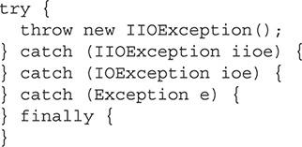

This code will not compile. Why?

A. Although it’s a best practice that Exception classes have a no argument constructor, this isn’t always followed, as in the case of the IIOException class that does not have a no argument constructor.

B. The exceptions listed in the catch blocks should be in the reverse order. The catch blocks should be ordered like so: Exception, followed by IOException, followed by IIOException.

C. The finally block must include statements.

D. The throws keyword should be used in place of the throw keyword.

Answer:

 **A**. Although it’s a best practice that Exception classes have a no argument constructor, this isn’t always followed. In this case, the IIOException class does not have a no argument constructor and will fail compilation.

 **B**, **C**, and **D** are incorrect. **B** is incorrect because the catch blocks are ordered appropriately, with the subclasses listed first in the appropriate hierarchical manner. **C** is incorrect because the finally block does not have to include any statements—that is, it can remain empty. **D** is incorrect because the throw keyword is used appropriately.

**Recognize Common Exceptions**

[**14.**](https://learning.oreilly.com/library/view/oca-java-se/9781259587535/ch09.html#ch09qa14) What do the InternalError, OutOfMemoryError, StackOverflowError, and UnknownError classes have in common? (Choose all that apply.)

A. They are all subclasses to the VirtualMachineError class.

B. They all have a no argument constructor.

C. They all have a constructor that accepts a single String argument.

D. They are all subclasses to the RuntimeException class.

E. All of the above

Answer:

 **A**, **B**, and **C**. **A** is correct because InternalError, OutOfMemoryError, StackOverflowError, and UnknownError are all subclasses to the VirtualMachineError class. **B** is correct because InternalError, OutOfMemoryError, StackOverflowError, and UnknownError all have a no argument constructor. **C** is correct because InternalError, OutOfMemoryError, StackOverflowError, and UnknownError all have a constructor that accepts a single String argument.

 **D** and **E** are incorrect. **D** is incorrect because InternalError, OutOfMemoryError, StackOverflowError, and UnknownError are not subclasses to the RuntimeException class. **E** is incorrect because all of the answers are not correct.

[**15.**](https://learning.oreilly.com/library/view/oca-java-se/9781259587535/ch09.html#ch09qa15) The bytesTransferred field of which checked exception provides information on how many bytes were transferred successfully before a disruption occurred?

A. IOException

B. InterruptedIOException

C. IntrospectionException

D. TimeoutException

Answer:

 **B**. The InterruptedIOException class includes a bytesTransferred field that provides information on how many bytes were transferred successfully before the interruption occurred.

 **A**, **C**, and **D** are incorrect. **A** is incorrect because IOException does not have a bytesTransferred field. **C** is incorrect because IntrospectionException does not have a bytesTransferred field. **D** is incorrect because the TimeoutException does not have a bytesTransferred field.

[**16.**](https://learning.oreilly.com/library/view/oca-java-se/9781259587535/ch09.html#ch09qa16) Given:

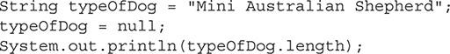

Which of the following is true?

A. A NullPointerException will be thrown.

B. An IllegalStateException will be thrown.

C. An IllegalArgumentException will be thrown.

D. A compilation error will occur.

Answer:

 **D**. A compilation error will occur. To make use of the length method of the String class, parentheses must be used. The statement should have read, System.out.println(typeOfDog.length()); and not System.out.println(typeOfDog.length);.

 **A**, **B**, and **C** are incorrect. **A** is incorrect because a NullPointerException will not be thrown. Note that the statement wouldn’t have been incorrect if the length method were used properly. **B** is incorrect because an IllegalStateException will not be thrown. **C** is incorrect because an IllegalArgumentException will not be thrown.

[**17.**](https://learning.oreilly.com/library/view/oca-java-se/9781259587535/ch09.html#ch09qa17) Which of the following is not a valid Java exception?

A. IOException

B. InterruptedIOException

C. CPUProcessException

D. CloneNotSupportedException

E. ClassNotFoundException

Answer:

 **C**. CPUProcessException is not a valid Java exception

 **A**, **B**, **D**, and **E** are incorrect. They are all valid J



### 10

### PROGRAMMING WITH THE DATE AND TIME API

**CERTIFICATION OBJECTIVES**

• [Work with the Date and Time API](https://learning.oreilly.com/library/view/oca-java-se/9781259587535/ch10.html#ch10lev1)

 [Two-Minute Drill](https://learning.oreilly.com/library/view/oca-java-se/9781259587535/ch10.html#ch10lev6)

**Q&A** [Self Test](https://learning.oreilly.com/library/view/oca-java-se/9781259587535/ch10.html#ch10lev7)

**O**racle’s exam topics include working with selected classes from the Java SE API. In this chapter and the next, we cover the objectives related to the new features of Java SE 8. The new Date and Time API is covered in this chapter, and new lambda expressions are covered in [Chapter 11](https://learning.oreilly.com/library/view/oca-java-se/9781259587535/ch11.html#ch11).

Because most applications rely heavily on calendar data, most people need to be familiar with this API. Whether calendar data is being presented on a web page, persisted in a database, or present in logging records or filenames, calendar data is everywhere when it comes to software applications. The rich, robust, and fluent Java SE 8 Date and Time API makes it easy for coders to work with calendar data.

Objectives related to APIs originating in Java versions previous to Java 8 are covered in prior chapters. This additional external coverage includes the following:

 Creating and manipulating strings (see [Chapter 3](https://learning.oreilly.com/library/view/oca-java-se/9781259587535/ch03.html#ch03))

 Manipulating data using the StringBuilder class and its methods (see [Chapter 3](https://learning.oreilly.com/library/view/oca-java-se/9781259587535/ch03.html#ch03))

 Declaring and using an ArrayList of a given type (see [Chapter 6](https://learning.oreilly.com/library/view/oca-java-se/9781259587535/ch06.html#ch06))

**CERTIFICATION OBJECTIVE**

#### Understand the Date and Time API

*Exam Objective Create and manipulate calendar data using classes from java.time.LocalDateTime, java.time.LocalDate, java.time.LocalTime, java.time.format.DateTimeFormatter, java.time.Period*

Date, time, and calendar calculations are supported by the Date and Time API (Java Special Request [JSR] 310), which is provided by the ThreeTen Project ([www.threeten.org](http://www.threeten.org/)) as its reference implementation (RI). JSR 310 is available in Java 8. The Date and Time API includes five calendar-related packages: java.time, java.time.chrono, java.time.format, java.time.temporal, and java.time.zone. For the OCA 8 exam, you will need to be acquainted with only a few classes in the java.time package—LocalTime, LocalDate, LocalDateTime, DateTimeFormatter, and Period—all of which are covered in this chapter.

The International Organization for Standardization date and time data exchange mode (ISO 8601) is used by the Date and Time API. ISO 8601 is properly named, “Data elements and interchange formats – Information interchange – Representation of dates and times.” The Gregorian calendar sets the basis for ISO 8601 and for the Date and Time API.

This chapter explores the Date and Time API through calendar data creation, calendar data manipulation, period support, and calendar data formatting support. Each area of coverage is provided in its own section.

##### Calendar Data Creation

Prior to Java 8, calendar data creation was supported with the Date, Calendar, and GregorianCalendar classes. Moving forward, we are leaving these classes in the past and aim to create our calendar data with a new set of classes. For the exam, you will need to master three calendar data creation classes: LocalDate, LocalTime, and LocalDateTime.

Before stepping through each one of these classes, let’s take a look at the main classes in the API used in association with calendar data creation. These classes are shown in [Table 10-1](https://learning.oreilly.com/library/view/oca-java-se/9781259587535/ch10.html#ch10tab01).

**TABLE 10-1** Calendar Creation–Related Classes

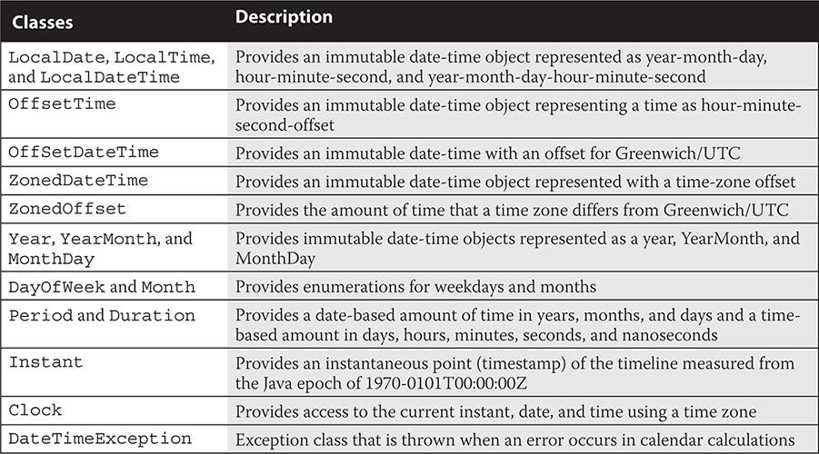

Many say Java reads like a book, and so do we. The Date and Time API makes use of the fluent API design to influence the implementation of its API. A fluent API, also known as a fluent interface, makes code more readable and maintainable. The usability goals of fluent APIs are achieved using *method chaining*, which allows objects to be wired together. Here’s an example:



The method prefixes in [Table 10-2](https://learning.oreilly.com/library/view/oca-java-se/9781259587535/ch10.html#ch10tab02) are seen throughout the API when creating, manipulating, and formatting calendar data and when working with the Period class.

**TABLE 10-2** Date and Time API Method Prefixes

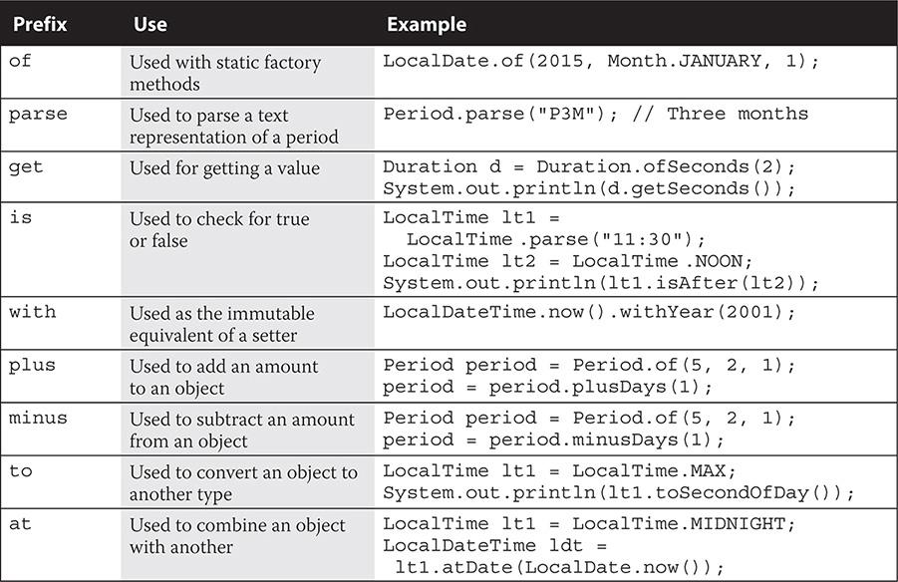

When creating dates, the of, parse, and now methods are commonly used for the LocalTime, LocalDate, and LocalDateTime classes.

###### LocalTime Class

The LocalTime class includes several method declarations in support of creating a time (without a date or time zone).

Here are some of the LocalTime class’s method declarations:

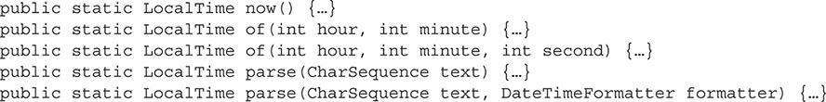

Here are some examples:

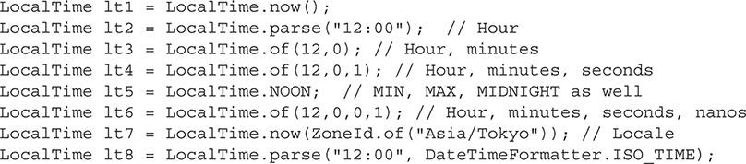

###### LocalDate Class

The LocalDate class includes several method declarations in support of creating a time without a time or time zone.

Here are some of the LocalDate class’s method declarations:

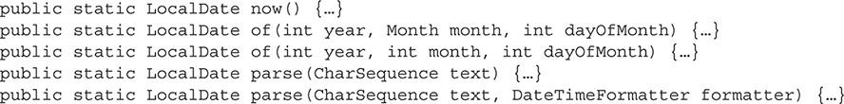

Here are some examples:

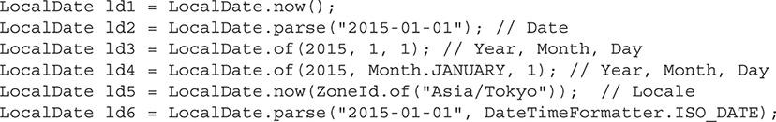

###### LocalDateTime Class

The LocalDateTime class includes several method declarations in support of creating a date-time without a time zone.

Here are some of the LocalDateTime class’s method declarations:

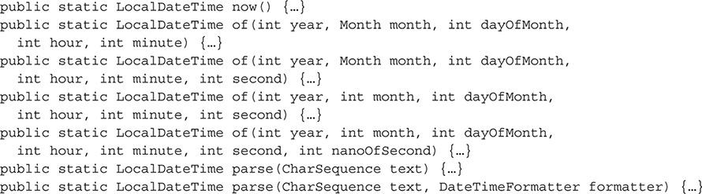

Here are some examples:

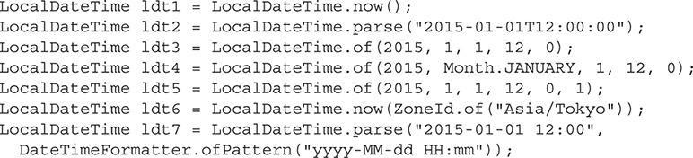

###### Legacy Date/Time Support

Legacy calendar classes are supported by new methods to allow integration with JSR 310. These changes include updates to java.util.Calendar, java.util.DateFormat, java.util.GregorianCalendar, java.util.TimeZone, and java.util.Date. The following code demonstrates the integration of the older classes (such as Calendar and Date) with the new classes of JSR 310 (such as Instant and LocalDateTime). This interoperability is not on the exam, but it is helpful to know.

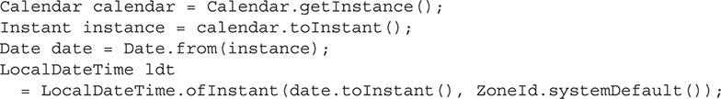



***Four regional calendars are packaged with Java SE 8: Hijrah, Japanese imperial, Minguo, and Thai Buddhist. The API is flexible enough to allow for the creation of additional calendars. For new calendars, the* Era, Chronology*, and* ChronoLocalDate *interfaces need to be implemented*.**

##### Calendar Data Manipulation

Questions on manipulating calendar data will perhaps be the easiest part of your exam. This section is concerned with adding or subtracting units of time to instances of LocalTime, LocalDate, and LocalDateTime. You should know 16 plus/minus methods that all apply to LocalDateTime, eight methods that apply to LocalDate, and eight methods that apply to LocalTime. Let’s look at all of them starting with LocalDateTime.

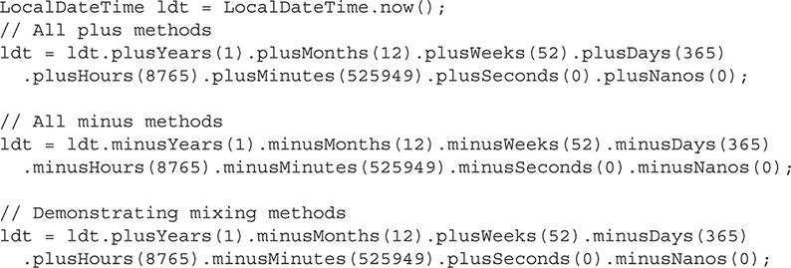

Working with the LocalDate class, you can add and subtract units of years, months, weeks, and days. In this context, you cannot add or subtract units of hours, minutes, seconds, or nanos.

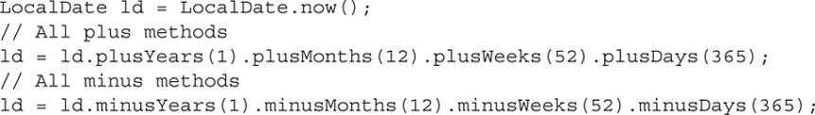

Working with the LocalTime class, you can add and subtract units of hours, minutes, seconds, or nanos. In this context, you cannot add or subtract units of years, months, weeks, or days.

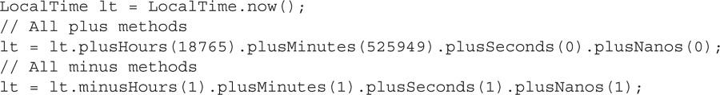

Look for the exam to try and trip you up in using methods where they do not belong. In the following code segment, plusYears is not a method of the LocalTime class and plusHours is not a method of the LocalDate class. The compiler will let you know accordingly—but you won’t have a compiler at the exam.

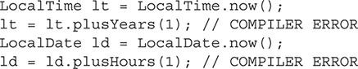



***Interoperability between the calendar types within the* java.time *and* java.sql *packages exists in the Java API.*** [***Table 10-3***](https://learning.oreilly.com/library/view/oca-java-se/9781259587535/ch10.html#ch10tab03) ***provides the relationships between the JSR 310 types and the SQL types, as well as the XML Schema (XSD) types. Note that there were no changes made to the JDBC API. Instead, you have to use the* setObject/getObject *to use this new API with JDBC*.**

**TABLE 10-3** JSR 310, SQL, and XSD Type Mapping in the Java SE API

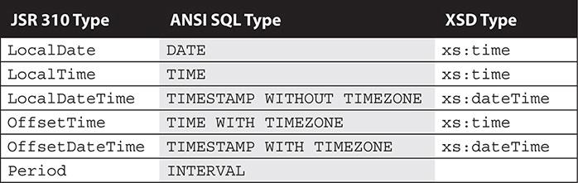

##### Calendar Periods

A calendar Period in Java is a date-based amount made up of years, months, and days. A calendar Duration is a time-based amount made up of days, hours, minutes, seconds, and nanoseconds. The Period class is on the exam, but the Duration class is not. Both classes implement the ChronoPeriod interface. Several methods of the Period class are commonly used, such as the following: of[interval], parse, get[interval], with[interval], plus[interval], minus[interval], is[*state*], and between methods. These methods and more are detailed in the following section with descriptions, declarations, and examples.

###### The of[interval] Method

The Period class of*[interval]* method returns a Period from an integer value representing years, months, weeks, or days.

There are five of[*interval*] method declarations:

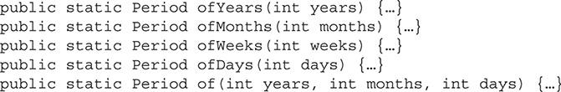

Here are some examples:

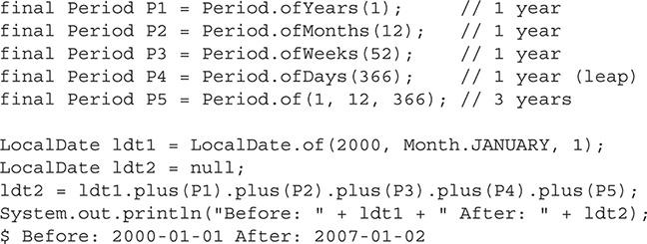

###### The parse Method

The Period class static parse method returns a Period from a string PnYnMnD, where P is for period, Y is for years, M is for months, and D is for days. A Period is also returned from a string PnW, where P is for period and W is for weeks.

There is one parse method declaration:



Here is an example:

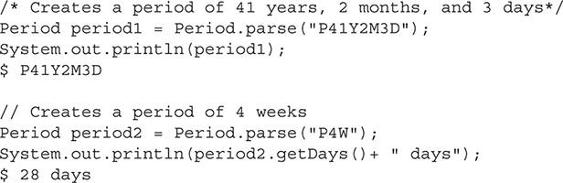

###### The get[interval] Method

The Period class get[*interval*] method returns a value relative to the type described in the method name.

There are six get[*interval*] method declarations:

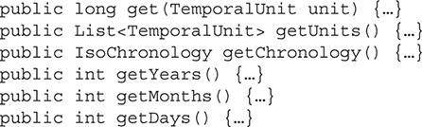

Here are some examples:

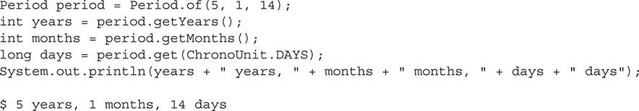

###### The with[interval] Methods

The Period class with[*interval*] method returns a copy of the Period object from a specified int that identifies either the years, months, or days value to change.

There are three with[*interval*] method declarations:

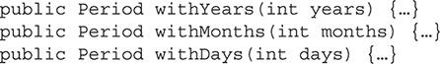

Here are some examples:

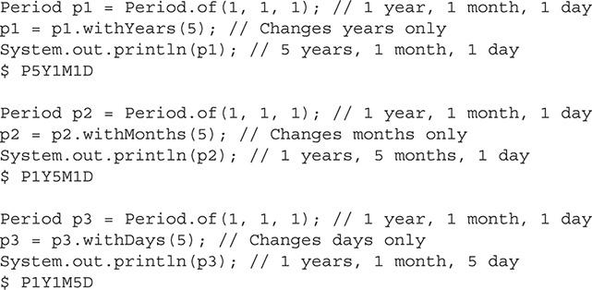

###### The plus[interval] Method

The Period class plus[*interval*] method returns a copy of the Period object from a specified long index value or TemporalAmount with the desired amount added.

There are four plus[interval] method declarations:

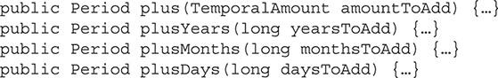

Here are some examples:

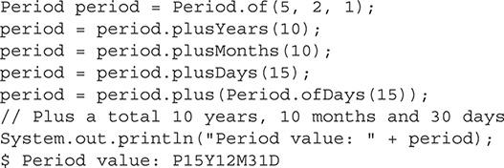

###### The minus[interval] Method

The Period class minus[interval] method returns a copy of the Period object from a specified long index value or TemporalAmount with the desired amount added.

There are four minus[interval] method declarations:

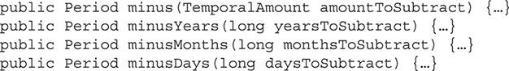

Here are some examples:

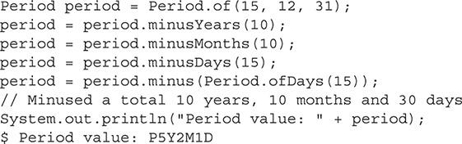

###### The is[state] Method

The Period class is[*state*] method returns a boolean from a string PnYnMnD, where P is for period, Y is for years, M is for months, and D is for days.

There are two is[*state*] method declarations:



Here is an example:

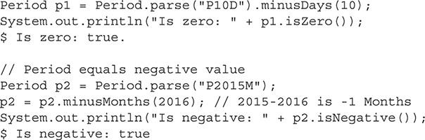

###### The between Method

The Period class between method returns a Period from two LocalDate arguments.

There is one between method declaration:



Here is an example:

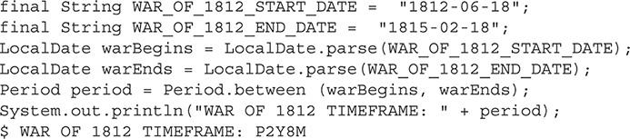

**EXERCISE 10-1**

**Using the normalized Method of the Period Class**

In this exercise, you will examine the normalized method of the Period class. This method is not on the exam, but this exercise will help get you more familiar with the Period class. The normalized method adjusts the months in tandem with the years so there is never less than zero or more than eleven months, as you see demonstrated here:

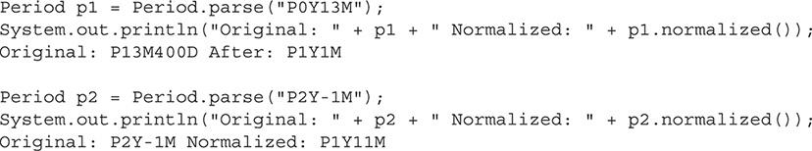

Both of the Period and Duration classes implement the TemporalAmount interface.

**1.** Use an IDE (such as NetBeans) to view the contents of the src.zip file that is distributed in JDK 1.8 at C:\Program Files\Java\jdk1.8.0_40\src.zip.

**2.** Open the package node for java.util and double-click the Period.java class.

**3.** Examine the Javadoc header and body of the normalized method to get a better idea of exactly how the method operates.

**4.** Now answer these questions:

**a.** As the Period class

has a normalized method, does the Duration class have one as well?

**b.** If the Duration class does have a normalized method, what does it normalize?

**c.** If the Duration class does not have a normalized method, why not?

**5.** Visit the Javadoc for the Duration class to verify your hypothesis.

##### Calendar Data Formatting

Calendar data formatting is supported by the DateTimeFormatter class. The API supplies predefined formatters, localized formatting with support of the FormatStyle enumeration type (enum), and specialized formatting (which is your own customization). The following sections examine all three.

###### Predefined Formatters

Several predefined formatters are included in the DateTimeFormatter class. The constant static variables that associate each formatter can be used directly with the class name, or the static import can be used to remove the class name from inline use, as shown here. This means that DateTimeFormatter.ISO_WEEK_DATE and ISO_WEEK_DATE (with import static java.time.format.DateTimeFormatter.*;) are essentially the same.

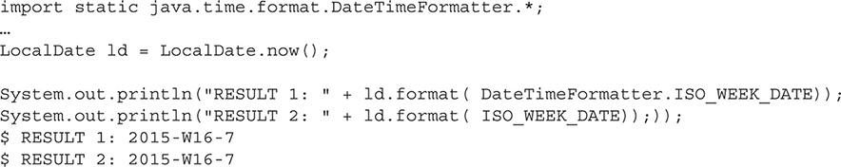

Several predefined formatters will work for different classes, such as the OffsetDateTime and the ZonedDateTime classes.

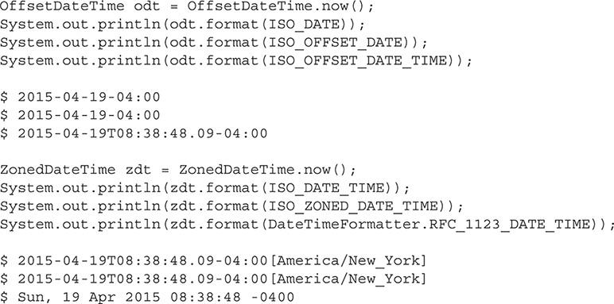

###### Localized Formatters

Localized DateTimeFormatter class formatters with static methods ofLocalizedTime, ofLocalizedDate, and ofLocalizedDateTime use the FormatStyle enum values FormatStyle.SHORT, FormatStyle.MEDIUM, FormatStyle.LONG, and FormatStyle.FULL to support localized formats. FormatStyle.LONG and FormatStyle.FULL are not on the exam.

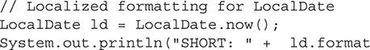



***For the scope of the exam, you should be familiar with the formatters that are most commonly used with the* LocalDateTime *class and what the formatted results look like*.**

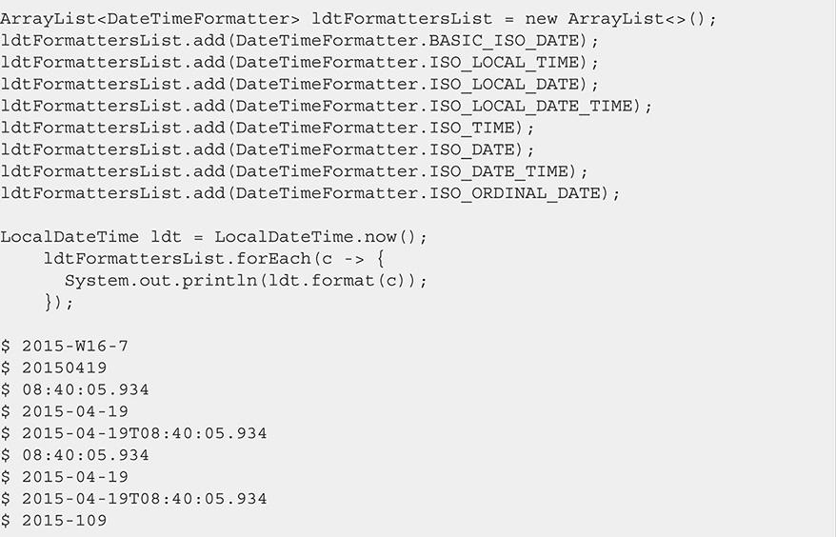

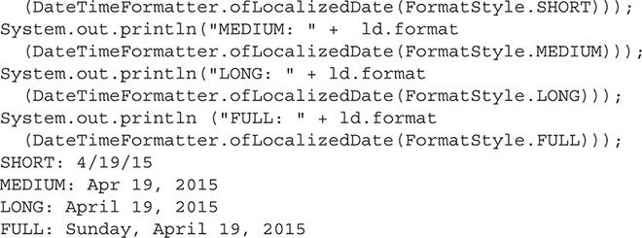

In addition to getting the formatted value from passing the localized formatter into the format method of the calendar classes, the formatters have a format method that accepts the calendar instance to achieve the same formatted string results.

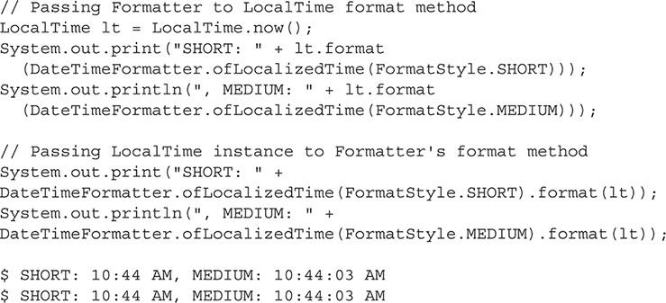

The three localized methods can be used only with the appropriate calendar classes; otherwise, an UnsupportedTemporalTypeException will be thrown. Also, using FormatStyle.LONG and FormatStyle.FULL where they are not accepted will result in java.time.DateTimeException exceptions being thrown.

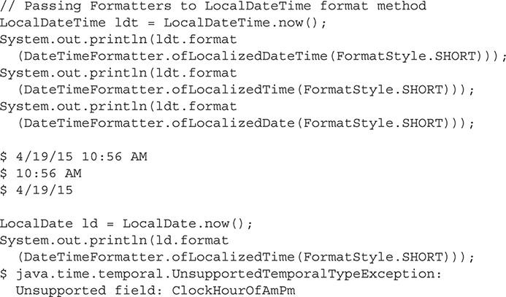

###### Specialized Formatters

Specialized formatters allow the use of letter and symbol sequences to produce custom desired format output.

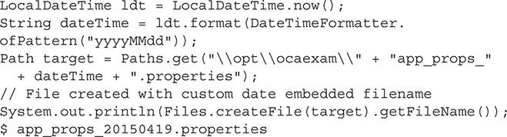

The syntax for the formatting can be found in the DateTimeFormatter documentation within the Java 8 Javadoc (<https://docs.oracle.com/javase/8/docs/api/java/time/format/DateTimeFormatter.html>). However, for the exam, the following code example demonstrates the extent of what you will need to know, being m, mm, h, hh, d, dd, M, MM, MMM, MMMM, MMMMM, y, yy, yyy, and yyyy.

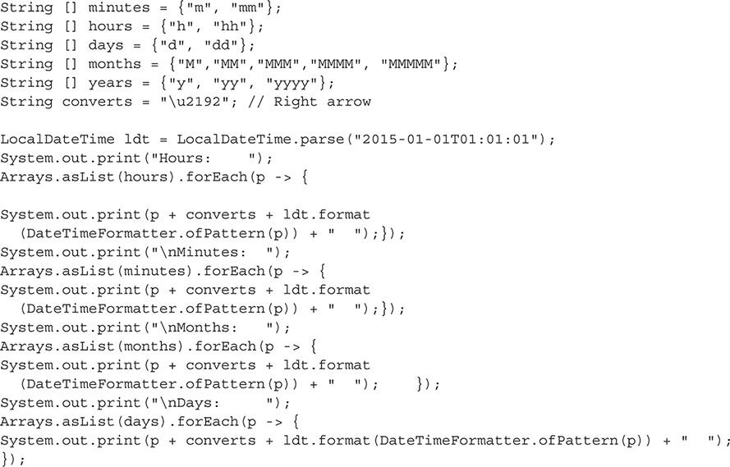

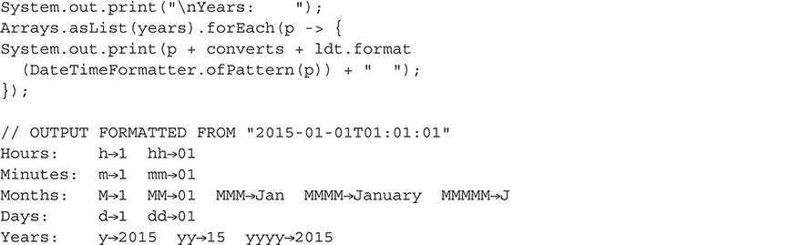

#### CERTIFICATION SUMMARY

This chapter covered what you need to know about the Date and Time API. We discussed calendar data creation with the LocalDate, LocalTime, and LocalDateTime classes. We also covered calendar data manipulation with the plus/minus methods, and we explored working with the Period class and its methods as a way to use a time-based amount composed of days, hours, minutes, seconds, and nanoseconds. Finally, we looked at calendar data formatting with the DateTimeFormatter class, utilizing localized formatters and specialized formatters.

Once you are comfortable coding with these classes and their support methods, you will surely do well when presented with questions about the Date and Time API on the exam.

#### Images TWO-MINUTE DRILL

**Understand the Date and Time API**

 The Date and Time API belongs to JSR 310 and is packaged in java.time, java.time.chrono, java.time.format, java.time.temporal, and java.time.zone.

 JSR 310 is based on ISO 8601, “Data elements and interchange formats – Information interchange – Representation of dates and times.”

 Calendar data is created by use of the LocalTime, LocalDate, and LocalDateTime classes.

 Calendar data is supported by a fluent API and prefaced methods of, parse, get, is, with, plus, minus, to, and at.

 The Period class provides various methods to support periods: date-based amounts of time made up of years, months, and days. These include of[interval], parse, get[interval], is[interval], with[interval], plus[interval], minus[interval], and between methods.

 The Period class static parse method returns a Period from a string PnYnMnD, where P is for period, Y is for years, M is for months, and D is for days.

 The Period class static parse method returns a Period from a string PnW, where P is for period and W is for weeks.

 The DateTimeFormatter class supports formatting with predefined formatters, localized formatters, and specialized formatters.

 Predefined formatters are used with the calendar classes (such as LocalDateTime and ZonedDateTime) to achieve commonly used formatting.

 Localized formatters use the static methods ofLocalizedTime, ofLocalizedDate, and ofLocalizedDateTime, along with the FormatStyle enumerations to support localized formats.

 Specialized formatters use the characters m, mm, h, hh, d, dd, M, MM, MMM, MMMM, MMMMM, y, yy, yyy, and yyyy to achieve custom formatting of dates and times.

#### SELF TEST

**Understand the Date and Time API**

[**1.**](https://learning.oreilly.com/library/view/oca-java-se/9781259587535/ch10.html#ch10qa1a) Given the following code, what will be the result?

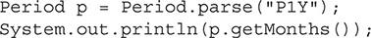

A. 12 is printed to standard output.

B. 1 is printed to standard output.

C. 0 is printed to standard output.

D. This code will not compile.

[**2.**](https://learning.oreilly.com/library/view/oca-java-se/9781259587535/ch10.html#ch10qa2a) Given the following code, at what line is an UnsupportedTemporalTypeException exception thrown at runtime?

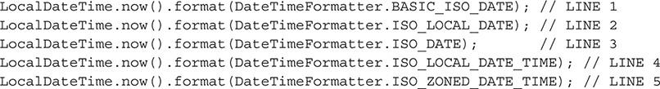

A. Line 1

B. Lines 2 and 3

C. Lines 4 and 5

D. Line 5

[**3.**](https://learning.oreilly.com/library/view/oca-java-se/9781259587535/ch10.html#ch10qa3a) Given the following code, what will be the result?

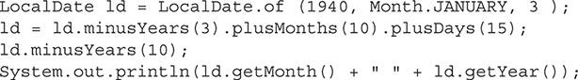

A. NOVEMBER 1937 is printed to standard output.

B. NOVEMBER 1927 is printed to standard output.

C. JANUARY 1940 is printed to standard output.

D. JANUARY 18 1940 is printed to standard output.

[**4.**](https://learning.oreilly.com/library/view/oca-java-se/9781259587535/ch10.html#ch10qa4a) Given the following code, what change can be made so the code will not throw a runtime exception?

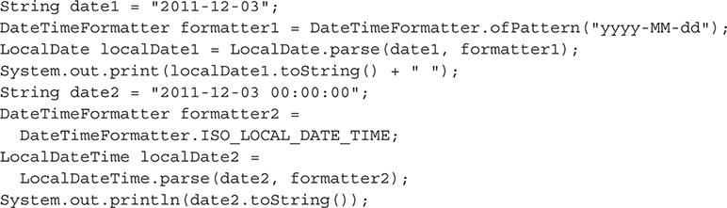

A. Change LocalDate.parse(date1, formatter1) to LocalDate.parse(formatter1, date1) and change LocalDate.parse(date2, formatter2) to LocalDate.parse(formatter2, date2)

B. Change DateTimeFormatter.ofPattern(“yyyy-MM-dd”); to DateTimeFormatter.ofPattern(“YYYY-MM-DD”);

C. Change String date2 = “2011-12-03 00:00:00”; to String date2 = “2011-12-03T00:00:00”;

D. No changes are needed.

[**5.**](https://learning.oreilly.com/library/view/oca-java-se/9781259587535/ch10.html#ch10qa5a) Given the following code, which line of code could replace line 1 with the end result of 2002-02-02T01:01:00 being printed to standard output?

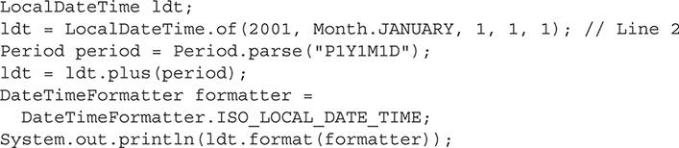

A. ldt = LocalDateTime.parse(“2001-01-00T01:01:01”);

B. ldt = LocalDateTime.parse(“2001-01-01T01:01:00”);

C. ldt = LocalDateTime.parse(“01-01-2001 01:01:01”);

D. ldt = LocalDateTime.parse(“01-01-2001T01:01:00”);

[**6.**](https://learning.oreilly.com/library/view/oca-java-se/9781259587535/ch10.html#ch10qa6a) Given the following code, which statement is correct?

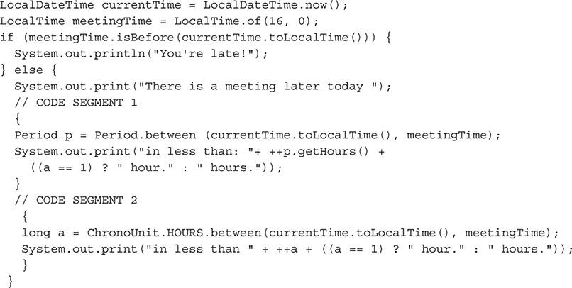

A. Code segments 1 and 2 will achieve the same result.

B. Segment 1 will not compile.

C. Segment 2 will not compile.

D. Neither segment 1 nor segment 2 will compile.

#### SELF TEST ANSWERS

**Understand the Date and Time API**

[**1.**](https://learning.oreilly.com/library/view/oca-java-se/9781259587535/ch10.html#ch10qa1) Given the following code, what will be the result?

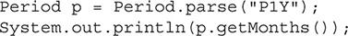

A. 12 is printed to standard output.

B. 1 is printed to standard output.

C. 0 is printed to standard output.

D. This code will not compile.

Answer:

 **C**. 0 is printed to standard output.

 **A, B,** and **D** are incorrect. **A** is incorrect because 12 is not printed to standard output. **B** is incorrect because 1 is not printed to standard output. **D** is incorrect because the code compiles just fine.

[**2.**](https://learning.oreilly.com/library/view/oca-java-se/9781259587535/ch10.html#ch10qa2) Given the following code, at what line is an UnsupportedTemporalTypeException exception thrown at runtime?

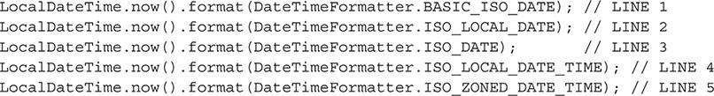

A. Line 1

B. Lines 2 and 3

C. Lines 4 and 5

D. Line 5

Answer:

 **D.** The exception java.time.temporal.UnsupportedTemporalTypeException is thrown at runtime because of an unsupported field: OffsetSeconds relative to line 5.

 **A, B,** and **C** are incorrect. **A** is incorrect because no exception is thrown at line 1. **B** is incorrect because no exception is thrown at lines 2 and 3. **C** is incorrect because no exception is thrown at lines 4 and 5.

[**3.**](https://learning.oreilly.com/library/view/oca-java-se/9781259587535/ch10.html#ch10qa3) Given the following code, what will be the result?

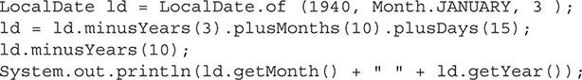

A. NOVEMBER 1937 is printed to standard output.

B. NOVEMBER 1927 is printed to standard output.

C. JANUARY 1940 is printed to standard output.

D. JANUARY 18 1940 is printed to standard output.

Answer:

 **A.** NOVEMBER 1937 is printed to standard output.

 **B, C,** and **D** are incorrect. **B** is incorrect because NOVEMBER 1927 is not printed to standard output. **C** is incorrect because JANUARY 1940 is not printed to standard output. **D** is incorrect because JANUARY 18 1940 is not printed to standard output.

[**4.**](https://learning.oreilly.com/library/view/oca-java-se/9781259587535/ch10.html#ch10qa4) Given the following code, what change can be made so the code will not throw a runtime exception?

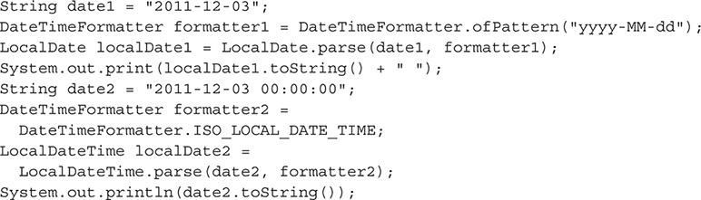

A. Change LocalDate.parse(date1, formatter1) to LocalDate.parse(formatter1, date1) and change LocalDate.parse(date2, formatter2) to LocalDate.parse(formatter2, date2)

B. Change DateTimeFormatter.ofPattern(“yyyy-MM-dd”); to DateTimeFormatter.ofPattern(“YYYY-MM-DD”);

C. Change String date2 = “2011-12-03 00:00:00”; to String date2 = “2011-12-03T00:00:00”;

D. No changes are needed.

Answer:

 **C.** Changing String date2 = “2011-12-03 00:00:00”; to String date2 = “2011-12-03T00:00:00”; will avoid a DateTimeParseException from being thrown a runtime at the related LocalDateTime.parse() method. That is, the letter T is needed in the string after the date and before the time.

 **A, B,** and **D** are incorrect. **A** is incorrect because the code was fine as it was. **B** is incorrect because the code was fine as it was. **D** is incorrect because a change is needed so a DateTimeParseException is not thrown.

[**5.**](https://learning.oreilly.com/library/view/oca-java-se/9781259587535/ch10.html#ch10qa5) Given the following code, which line of code could replace line 1 with the end result of 2002-02-02T01:01:00 being printed to standard output?

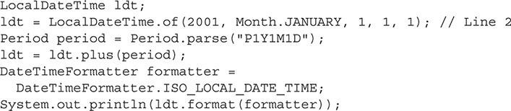

A. ldt = LocalDateTime.parse(“2001-01-00T01:01:01”);

B. ldt = LocalDateTime.parse(“2001-01-01T01:01:00”);

C. ldt = LocalDateTime.parse(“01-01-2001 01:01:01”);

D. ldt = LocalDateTime.parse(“01-01-2001T01:01:00”);

Answer:

 **B.** ldt = LocalDateTime.parse(“2001-01-01T01:01:00”); will result in the same result to standard output as line 2.

 **A, C,** and **D** are incorrect. **A** is incorrect because ldt = LocalDateTime.parse(“2001-01-00T01:01:01”); will not produce the desired result, throwing a DateTimeParseException. **C** is incorrect because ldt = LocalDateTime.parse(“01-01-2001 01:01:01”); will not produce the desired result, throwing a DateTimeParseException. **D** is incorrect because ldt = LocalDateTime.parse(“01-01-2001 01:01:00”); will throw a DateTimeParseException.

[**6.**](https://learning.oreilly.com/library/view/oca-java-se/9781259587535/ch10.html#ch10qa6) Given the following code, which statement is correct?

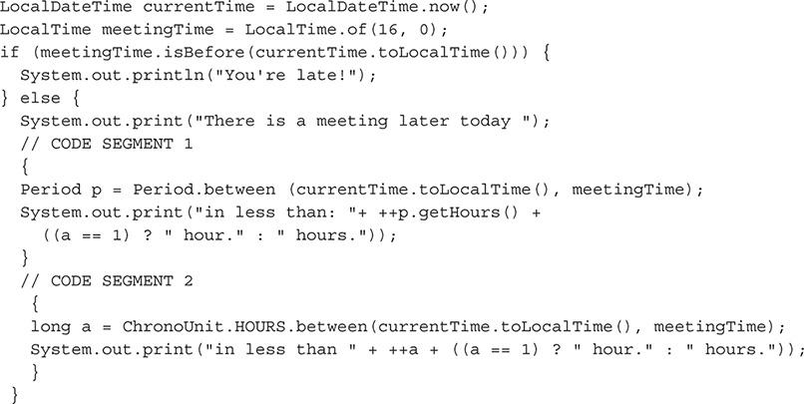

A. Code segments 1 and 2 will achieve the same result.

B. Segment 1 will not compile.

C. Segment 2 will not compile.

D. Neither segment 1 nor segment 2 will compile.

Answer:

 **B.** Segment 1 will not compile because the between method of the Period class requires LocalDate arguments only.

 **A, C,** and **D** are incorrect. **A** is incorrect because segment 1 will not compile and segment 2 will compile, so the results of segments 1 and 2 are not the same. **C** is incorrect because segment 2 will compile fine. **D** is incorrect because, although segment 1 will not compile, segment 2 will compile.



### A

### CLASS RELATIONSHIPS

**O**bject relationships are often described in terms of *composition* and *association*. The SCJA exam (predecessor to the OCA exam) included questions that required that you understand the relationship between objects and distinguish between a composition relationship and an association relationship. The OCA exam does not include specific objectives for this skill set, but it is implied that you understand class compositions and associations. As such, we provide this coverage as a bonus to aid in your exam preparation.

#### Understand Class Compositions and Associations

Composition and association are two general descriptions for object relationships. Composition and association encompass four specific types of relationship descriptors: direct association, composition association, aggregation association, and temporary association. These descriptors are covered in this appendix. By studying the four specific relationship types, you will have a greater understanding of the difference between composition and association. Multiplicities are also discussed. Every object relationship has a multiplicity.

The following topics will be covered in this appendix:

 Class compositions and associations

 Class relationships

 Multiplicities

 Association navigation

##### Class Compositions and Associations

*Composition* and *association* are the general terms used to describe a class relationship. An association or composition relationship is formed between two objects when one contains a reference to the other. The reference is often stored as an instance variable. The reference may be in one direction or bidirectional.

An association relationship is a relationship of two objects, where neither one directly depends on the other for its logical meaning. For example, suppose object A has an association relationship with object B. If this relationship was lost, both objects would still retain the same meaning they had before the relationship. These are considered weak relationships. Objects in an association relationship have no dependence on each other for the management of their lifecycle. In other words, the existence of one object is not tied to the existence of the other object in the relationship. Another example would be a CarFactory object and a CarFrame object. The CarFactory object and CarFrame object have an association relationship. If this relationship no longer existed, each object could continue to make sense logically and would retain its original meaning on its own.

A composition relationship is stronger than an association relationship. Composition means that one object is composed of another. An object may be composed of one or multiple objects. If, for example, object A is composed of object B, object A depends on object B. This statement does not imply that object A is composed of only object B, however; in fact, object A may also be composed of other objects. If the relationship were lost between object A and object B, the logical meaning of both objects would be lost or significantly altered. In this example, object B—the inner object that object A is composed of—would depend on object A to manage its lifecycle. The existence of object B is directly tied to the existence of object A, so when object A no longer exists, object B would also no longer exist. Object B would also become nonexistent if the relationship between the two objects were lost. Examples of objects that have a composition relationship tend to be more abstract than those with association relationships. Consider a Car object and CarStatus object, for example. The Car object is composed of the CarStatus object, and both objects depend on this relationship to define their meanings. The CarStatus object also depends on the Car object to maintain its lifecycle. When the Car object no longer exists, the CarStatus object would also no longer exist.

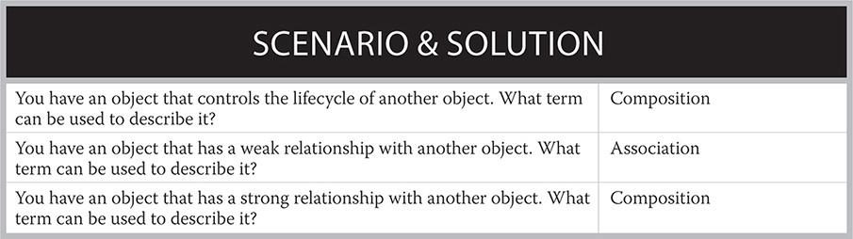

In many cases, determining the type of relationship between two objects is not as clear as the preceding examples. Some interpretation is needed to determine the relationship. A composition relationship will always be responsible for an object’s lifecycle. Composition relationships also represent a stronger relationship compared to an association. Objects belonging to an association relationship make more sense by themselves than objects in a composition relationship.

##### Class Relationships

This section will break down the four specific class relationships that are possible. Each represents a different way objects can have relationships. Association and composition relationships are not mutually exclusive. In fact, composition association is one of the detailed relationship types, and it is sometimes referred to as simply composition. The other three detailed relationship types, direct association, aggregation association, and temporary association, are often referred to as simply association.

The following topics will be covered in the next few sections:

 Direct association

 Composition association

 Aggregation association

 Temporary association

###### Direct Association

Direct association describes a “has a” relationship. This is a basic association that represents navigability. Direct association is a weak relationship and therefore can be generalized to an association. There is no lifecycle responsibility, and each object in the relationship can conceptually be independent. This tends to be the default association when nothing else can accurately describe the relationship.

If a truck was modeled as an object to create a Truck object, it may have a Trailer object that it has a direct association with. The Truck object and Trailer object are weakly associated, because each could be used without the other and still maintain its intended purpose. A Truck object does not need to have a Trailer object, and a Trailer object is not required for the construction of the Truck object. This direct association relationship is depicted in the Unified Modeling Language (UML) diagram in [Figure A-1](https://learning.oreilly.com/library/view/oca-java-se/9781259587535/ch12_appa.html#ch12fig01).

**FIGURE A-1** Direct association



###### Composition Association

Composition associations are used to describe an object’s relationship where one object is composed of one or more objects. A composition association is a strong relationship and will be generalized as a composition. The internal object makes conceptual sense only while stored in the containing object. This relationship represents ownership. In a composition association, object A is “composed of” object B. For example, a Tire object would be composed of a RubberStrips object. The Tire object requires a RubberStrips object; the RubberStrips object is not very useful by itself.

The containing object also has the responsibility of managing the lifecycle of the internal object. It is possible for this object to pass the lifecycle management to another object. Lifecycle management means that the object composed of the second object, or the containing object, must maintain a reference to the inner object; otherwise, the Java virtual machine will destroy it. If the containing object is destroyed, any objects that compose it will also be destroyed. This composition association relationship is depicted in the UML diagram in [Figure A-2](https://learning.oreilly.com/library/view/oca-java-se/9781259587535/ch12_appa.html#ch12fig02).

**FIGURE A-2** Composition association



###### Aggregation Association

An aggregation association is a relationship that represents one object being part of another object. An aggregation association represents a “part of” the whole relationship. In this relationship, even though one object is a part of the other, each object can maintain its own meaning independently if the relationship is lost. Neither object depends on the other for its existence. The aggregation relationship does not require the object to perform lifecycle management for the object that it references. Aggregation association is a weak relationship. It can be generalized as an association.

A Motorcycle object would have an aggregation association with a Windshield object. The Motorcycle object and Windshield object are weakly associated, because each could be used without the other and still maintain its intended purpose. The Windshield object has a “part of” relationship with the Motorcycle object. This aggregation association relationship is depicted in the UML diagram in [Figure A-3](https://learning.oreilly.com/library/view/oca-java-se/9781259587535/ch12_appa.html#ch12fig03).

**FIGURE A-3** Aggregation association



###### Temporary Association

Temporary association is also known as a dependency. Typically, a temporary association will be an object used as a local variable, return value, or method parameter. It is considered a dependency because object A depends on object B as either an argument, a return value, or at some point, a local variable. A temporary association is the weakest form of association. This relationship will not persist for the entire lifecycle of the object.

For example, a Car object may have a method called startEngine that has a Key object as a parameter. The Key object as a parameter would represent a temporary association. This temporary association relationship is depicted in the UML diagram in [Figure A-4](https://learning.oreilly.com/library/view/oca-java-se/9781259587535/ch12_appa.html#ch12fig04).

**FIGURE A-4** Temporary association

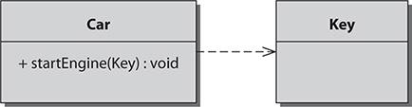

##### Multiplicities

Every relationship has a multiplicity. *Multiplicity* refers to the number of objects that are part of a relationship. The three general classifications of multiplicity you should know are one-to-one, one-to-many, and many-to-many.

The following topics will be covered in the next few sections:

 One-to-one multiplicity

 One-to-many multiplicity

 Many-to-many multiplicity



***Developers often just use the terms “composition” or “association.” When they say “composition,” they are referring to composition association and a strong relationship. The term “association” is often used to refer to any of the other three weaker relationships: aggregation, direct, and temporary association*.**

[Table A-1](https://learning.oreilly.com/library/view/oca-java-se/9781259587535/ch12_appa.html#ch12tab01) shows how each of the four specific relationship types relates to composition and association.

**TABLE A-1** Object Relationship Characteristics

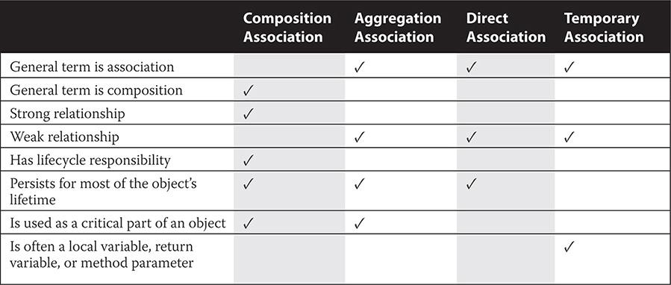

###### One-to-One Multiplicity

A one-to-one association is a basic relationship where one object contains a reference to another object. All four relationship types may have a one-to-one multiplicity. An example of a one-to-one relationship would be the Motorcycle object that has a relationship with a single Engine object.

###### One-to-Many Multiplicity

One-to-many relationships are created when one object contains a reference to a group of like objects. The multiple object references are normally stored in an array or a collection. All four relationship types may be one-to-many. The Car object can contain four Tire objects. This would be an aggregation association since the Car and Tire objects have a “part of” association with each other. The Tire objects can be stored in an array or collection. As the name implies, a one-to-many relationship may have many more than four objects. A many-to-one relationship is also possible.

###### Many-to-Many Multiplicity

Many-to-many relationships are possible only for aggregation associations, direct associations, and temporary associations. Composition association is a strong relationship that implies a lifecycle responsibility for the object that composes it. If many objects have a relationship with an object, it is impossible for any individual object to control the lifecycle of the other object in the relationship. If the car example were broadened to a traffic simulator application, it would include many other Car objects. Each of these Car objects contains references to many other TrafficLight objects. This represents a direct association, since a single Car object does not maintain the lifecycle of the TrafficLight objects. Each car object has a TrafficLight object. The relationship between a Car object and the TrafficLight object is weak. The TrafficLight objects are all shared between all of the Car objects. A many-to-many association does not have to include an equal number of objects on each side of the relationship.



***Relationships (for example, aggregation and composition) and multiplicities can be easily depicted with UML. Drawing out class relationships can help you convey design concepts to your fellow employees. UML diagrams are covered in*** [***Appendix G***](https://learning.oreilly.com/library/view/oca-java-se/9781259587535/ch18_app_g.html#ch18_app_g)**.**

##### Association Navigation

*Association navigation* is a term used to describe the direction in which a relationship can be traveled. An object that is contained within another object is said to be navigable if the containing object has methods for accessing the inner object. Most relationships are navigable in one direction, but if both objects contain references to the other, it is possible to have a bidirectional navigable relationship. Oftentimes, the methods for accessing inner objects are called *getters* and *setters*. A getter is a simple method that just returns an instance variable. A setter is a method that accepts an argument and uses it to set an instance variable.

#### Class Compositions and Associations in Practice

This section reviews practical examples of association and composition relationships. The following examples and explanations should help provide a solid understanding of these concepts.

These topics are covered in the following sections:

 Examples of class association relationships

 Examples of class composition relationships

 Examples of association navigation

##### Examples of Class Association Relationships

This section examines associations. The following three examples demonstrate possible multiplicities of an aggregation association. An explanation follows to highlight the important points from the example.

The following topics are covered:

 One-to-one class association

 One-to-many class association

 Many-to-many class association

###### One-to-One Class Association

The following example shows a Truck object and Trailer object. This is an example of a one-to-one direct association.

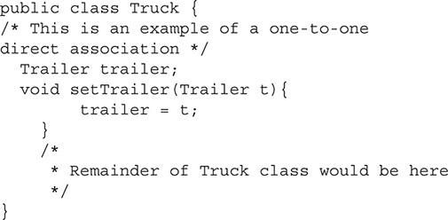

In this example of a one-to-one association, the Truck object contains a reference to the Trailer object. This is a one-to-one association because the variable trailer is a single variable. It is not part of an array or collection. This example is a direct association, because the Truck object is not responsible for the lifecycle of the trailer variable. Another indication that it is a direct association is that, logically, the Truck object “has a” Trailer object.

In this example, and in most real-world situations, it is not always easy or even possible to determine if one object controls the lifecycle of another. Oftentimes, you must make the best determination based on the information that is available. In this example, the trailer variable is being set by the method setTrailer. Since this method is used to set the variable, it can be assumed that other objects contain a reference to the trailer object and, therefore, no sole object is responsible for the lifecycle of the other object. Finally, since this was determined to be a direct association, the relationship can be generalized to an association relationship.

###### One-to-Many Class Association

The next example demonstrates an aggregation association. This example shows a relationship that is one-to-many. Here, Wheel objects are “part of” a Car object.

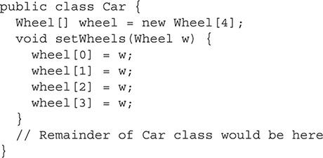

This example has an array of four Wheel objects. Since there is one Car object that contains four Wheel objects, this relationship is one-to-many. With a one-to-many relationship, the multiple objects will normally be stored in an array or collection such as a Vector. This example is an aggregation association, because the Wheel object is “part of” the Car object. Because this is a weak relationship and there are no lifecycle responsibilities, this can be generalized as an association.

###### Many-to-Many Class Association

The many-to-many relationship is more complex than the one-to-one and one-to-many relationships. In this example, the relationship is between a group of Car objects and a group of TrafficLight objects. The following is the code segment for the two objects:

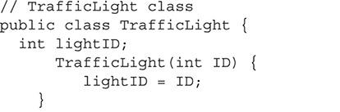

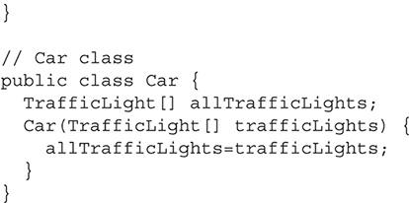

This next segment is the code that creates both objects. This segment is important because it shows how the relationships are formed between the objects.

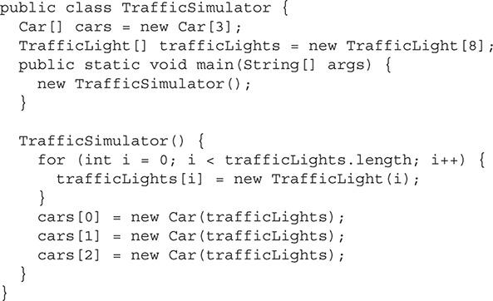

This segment contains a main method. The sole job of main is to create a new TrafficSimulator object. The TrafficSimulator object contains an array of Car objects and an array of TrafficLight objects. First, the TrafficLight objects are created. Each TrafficLight object stores a unique ID. Next, the Car objects are created. Each Car object contains an array of all the TrafficLight objects. This example is many-to-many, because each Car object contains the same group of multiple TrafficLight objects. This relationship can be classified as a direct association because the Car objects have an array of TrafficLight objects.

##### Examples of Class Composition Relationships

This section is similar to the last section except that composition associations are demonstrated here. Composition associations have only two possible multiplicities. This section shows an example of each followed by an explanation.

###### One-to-One Class Composition

This example demonstrates a one-to-one composition relationship. This is a composition association because that is the only type of association that can create a composition relationship.

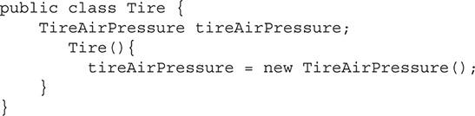

In this example, the Tire object and the TireAirPressure object have a one-to-one relationship. The Tire object is “composed of” the TireAirPressure object. This represents a composition association. The relationship between the two objects is strong. The Tire object has lifecycle management responsibilities to the TireAirPressure object. If the Tire object was destroyed, the TireAirPressure object would also be destroyed.

###### One-to-Many Class Composition

This final example demonstrates a composition relationship with a one-to-many multiplicity. The following code segment is of a SensorStatus class:

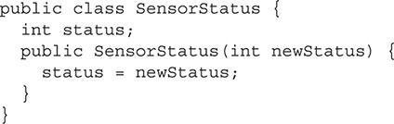

The next segment demonstrates a CarComputer object that is “composed of” an array of five SensorStatus objects:

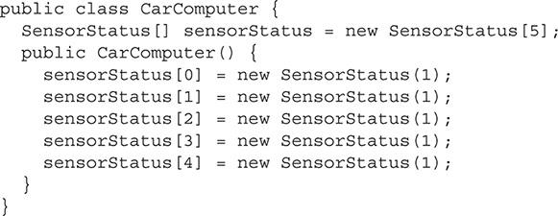

Because there is one CarComputer object and five SensorStatus objects, this represents a one-to-many relationship. The relationship is composition association. Again, notice how the relationship is strong and that the SensorStatus array depends on the CarComputer object to manage its lifecycle.

###### Examples of Association Navigation

*Association navigation* is the ability to navigate a relationship. The following example demonstrates a PinStripe object that is “composed of” a Color object:

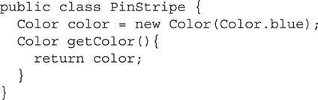

In this example, any object that had access to the PinStripe object could use its getColor method, which is considered a getter, to navigate to the Color object. In this example, the navigation is only in a single direction.

#### APPENDIX SUMMARY

This appendix discussed the different relationships that are possible among objects. Association and composition are the general description of relationships and are important for you to be familiar with.

*Association* is used to describe an object-to-object reference. This type of reference means that object A has a reference to object B and can access object B’s public methods and member variables. Object B may or may not have a reference back to object A. A relationship of association means that both objects are independent and neither one relies on the other to maintain its existence. Direct association, aggregation association, and temporary association are all more detailed forms of association.

Composition relationships are a stronger form of association relationships. A composition relationship is a type of association in which an object that is composed of another object is also responsible for the lifecycle management of that object. A composition relationship may have one-to-one or one-to-many multiplicities. Composition association is an example of composition.

Next, this appendix covered each of the four possible relationships in detail. Direct association, aggregation association, and temporary association are three of the four relationship types. Each of these belongs in the general category of association. They imply no responsibility of lifecycle management. Composition association belongs to the category of general composition. Composition association has a lifecycle responsibility.

There may be three different multiplicities of relationships. In a one-to-one relationship, one object contains a reference to another object of a particular type. In a one-to-many relationship, an object contains an array of object references, or a collection such as an ArrayList or Vector. The final relationship is many-to-many. In this relationship, many objects contain a reference to the same collection or array of objects. The many-to-many relationship is unique for association and cannot exist for a composition relationship.

This appendix concluded with examples of each multiplicity for association and composition relationships. These examples are important for you to understand. In [Appendix G](https://learning.oreilly.com/library/view/oca-java-se/9781259587535/ch18_app_g.html#ch18_app_g) of this book, these relationships will be revisited when UML modeling is discussed.



### B

### JAVA SE 8 PACKAGES

Because Java is a programming language, the OCA exam focuses on many of the packages and classes within the core Java SE distributions. Light Java EE coverage was included in the precursor SCJA exam but has been removed in the subsequent OCA versions of the exam. The tables provided in this appendix detail the full set of Java SE 8 packages.

You don’t need to learn the low-level details of Java packages to perform well on the OCA exam. To a large extent, just knowing what the packages are designed for and what type of functionality they contain will help you achieve a high score.

Java SE 8 provides packages in the following areas:

 **Core packages** Language, utility, and base packages

 **Integration packages** Java Database Connectivity (JDBC), Java Naming and Directory Interface (JNDI), Remote Method Invocation (RMI)/RMI-Internet Inter-Orb Protocol (IIOP), and scripting packages

 **User interface packages** JavaFX, Swing API, Abstract Window Toolkit (AWT) API, sound, image I/O, printing packages, accessibility

 **Security packages** Security and cryptography packages

 **XML-based packages** XML-based packages, web services

 **Temporal packages** Calendar, Date, and Time packages

The documentation for the OMG packages that are part of the Java SE 8 distribution are not listed in this appendix but can be viewed in the Java SE 8 API documentation: <http://docs.oracle.com/javase/8/docs/api/>.

#### Core Packages

The following tables detail the core Java packages (that is, language, utility, and base packages). The definitions provided in these tables, as well as the other tables throughout this appendix, are primarily those definitions used in the Java SE 8 API documentation.

**TABLE B-1** Language Packages

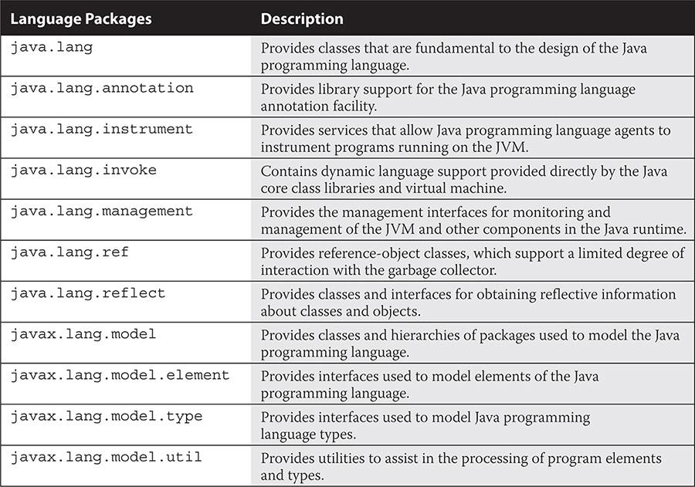

**TABLE B-2** Utility Packages

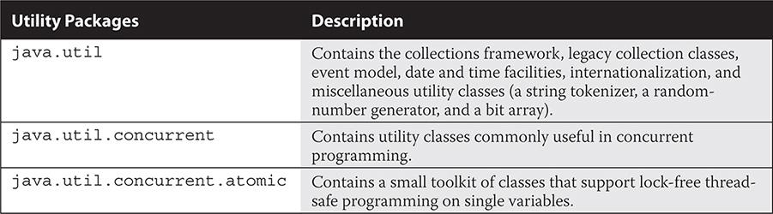

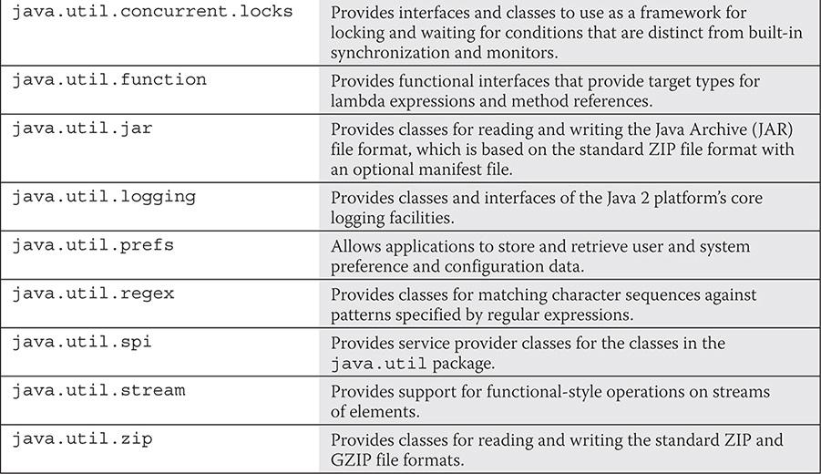

**TABLE B-3** Base Packages

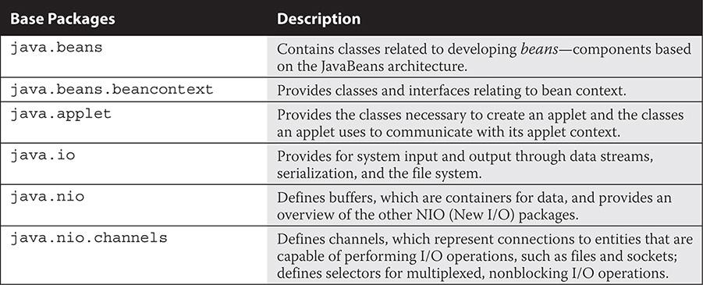

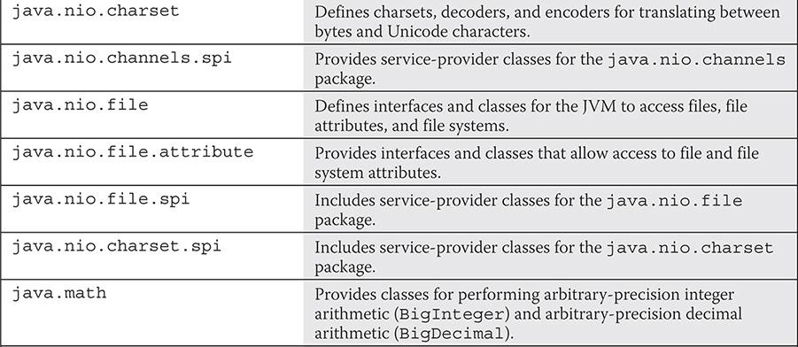

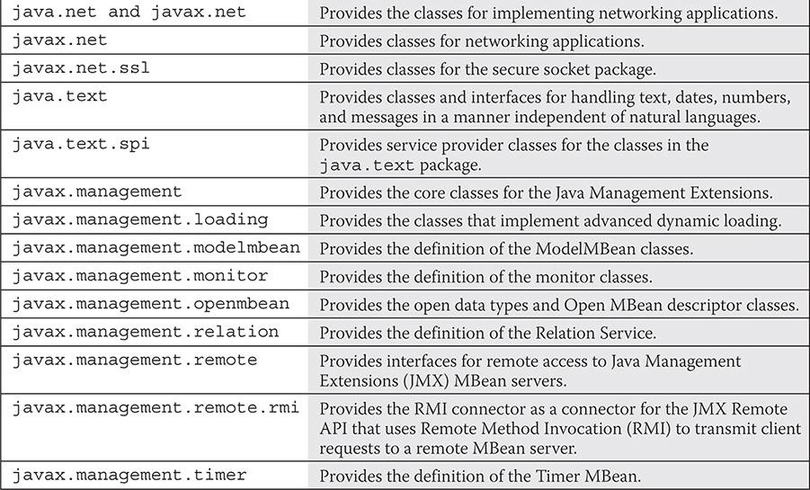

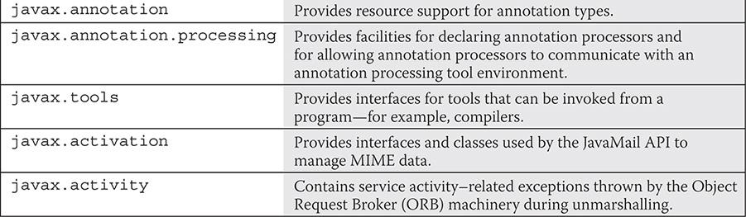

#### Integration Packages

The following tables detail the integration Java packages (JDBC, JNDI, RMI/RMI-IIOP, scripting, and transactions packages).

**TABLE B-4** Java Database Connectivity (JDBC) Packages

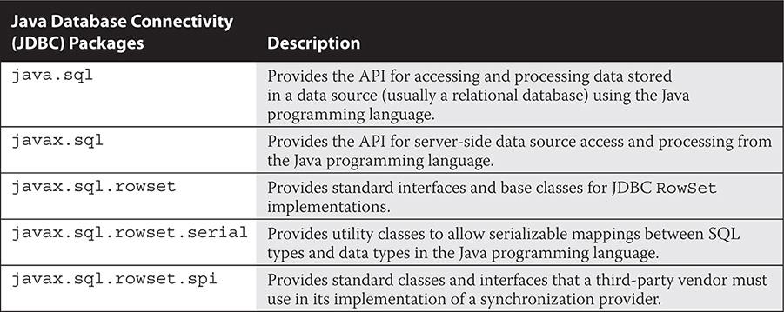

**TABLE B-5** Java Naming and Directory Interface (JNDI) Packages

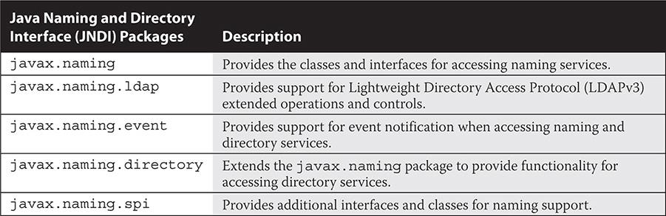

**TABLE B-6** Remote Method Invocation (RMI) Packages

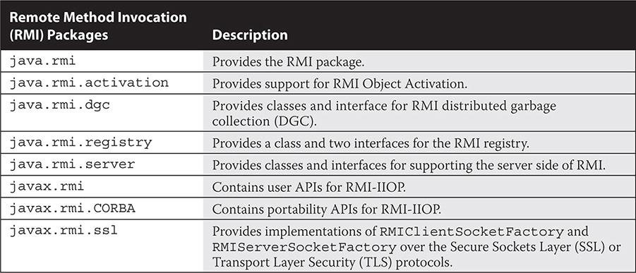

**TABLE B-7** Scripting Packages

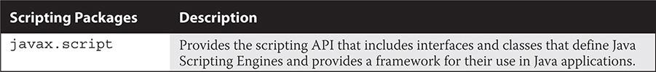

**TABLE B-8** Transactions Packages

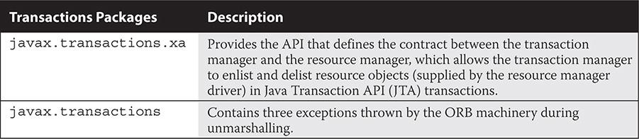

#### User Interface Packages

The following tables detail the user-interface Java packages (JavaFX API, Swing API, Abstract Window Toolkit [AWT] API, image I/O, sound, printing, and accessibility packages).

**TABLE B-9** JavaFX API Packages

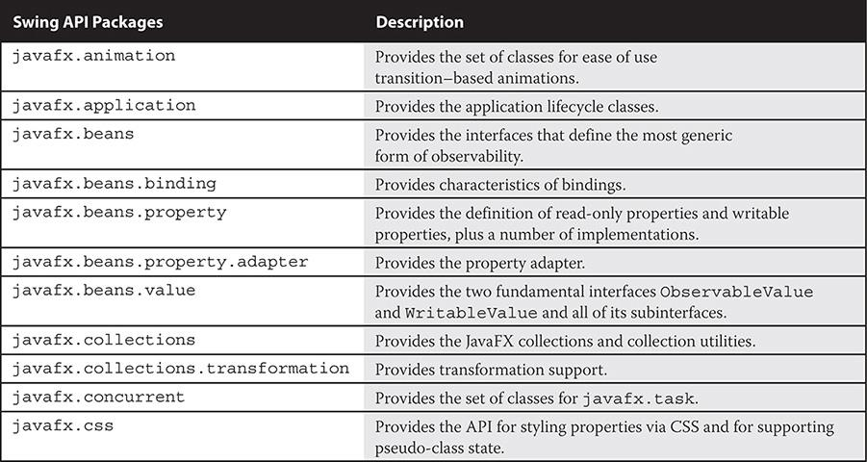

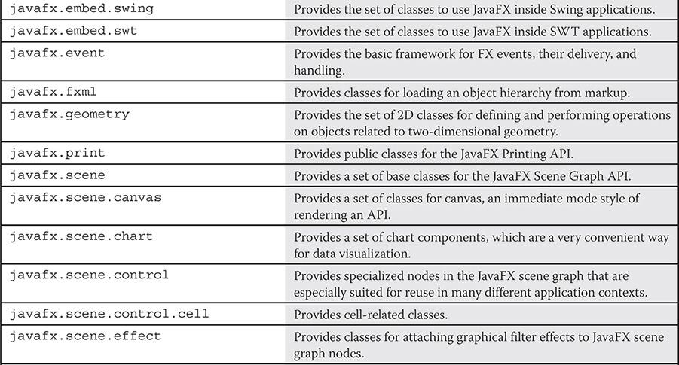

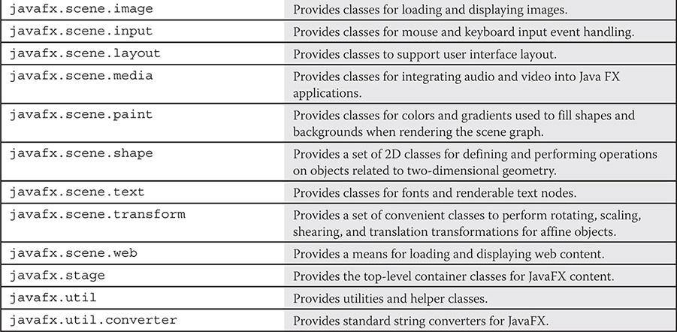

**TABLE B-10** Swing API Packages

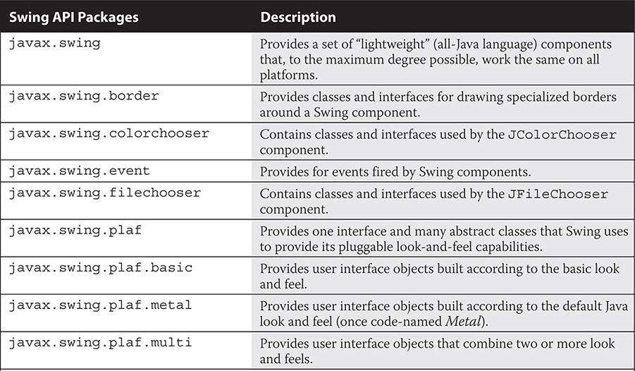

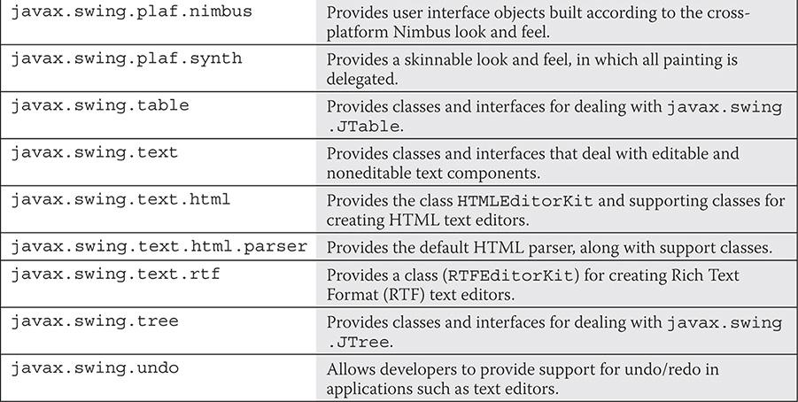

**TABLE B-11** AWT API Packages

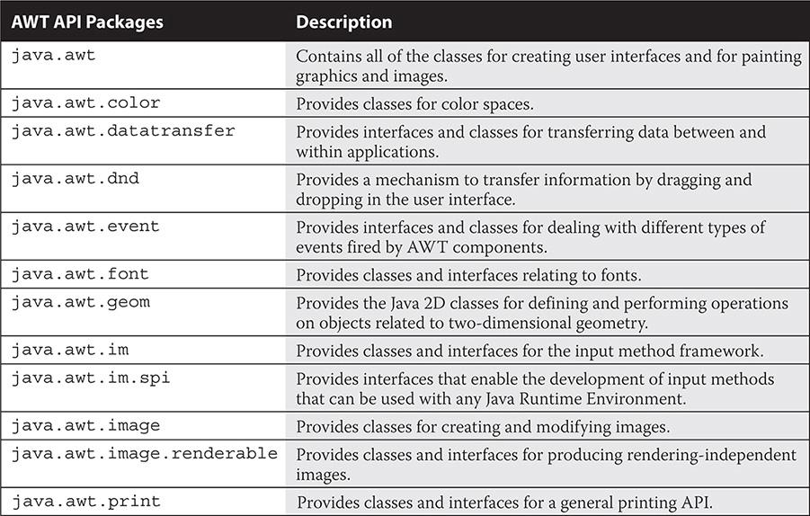

**TABLE B-12** Java Image I/O Packages

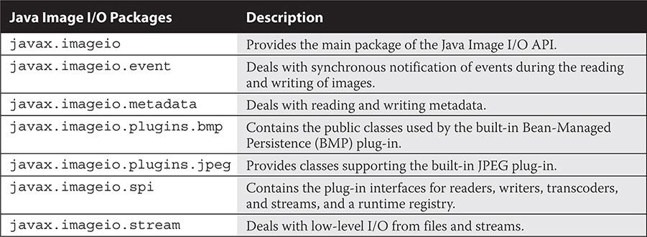

**TABLE B-13** Sound API Packages

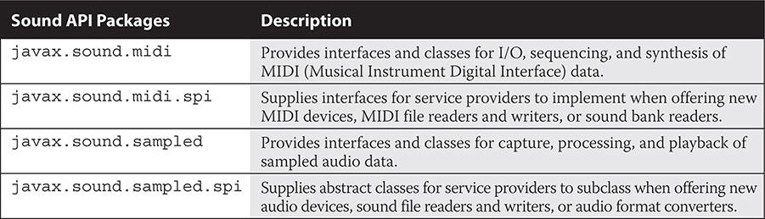

**TABLE B-14** Java Print Service API Packages

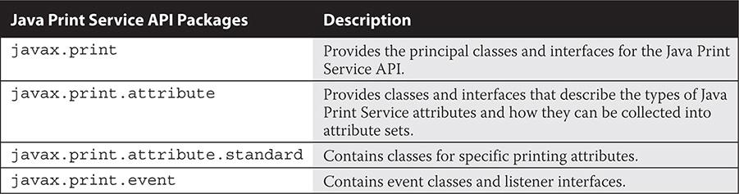

**TABLE B-15** Accessibility Package

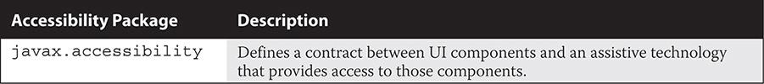

#### Security Packages

The following tables detail the security-related Java packages (such as cryptography packages).

**TABLE B-16** Security Packages

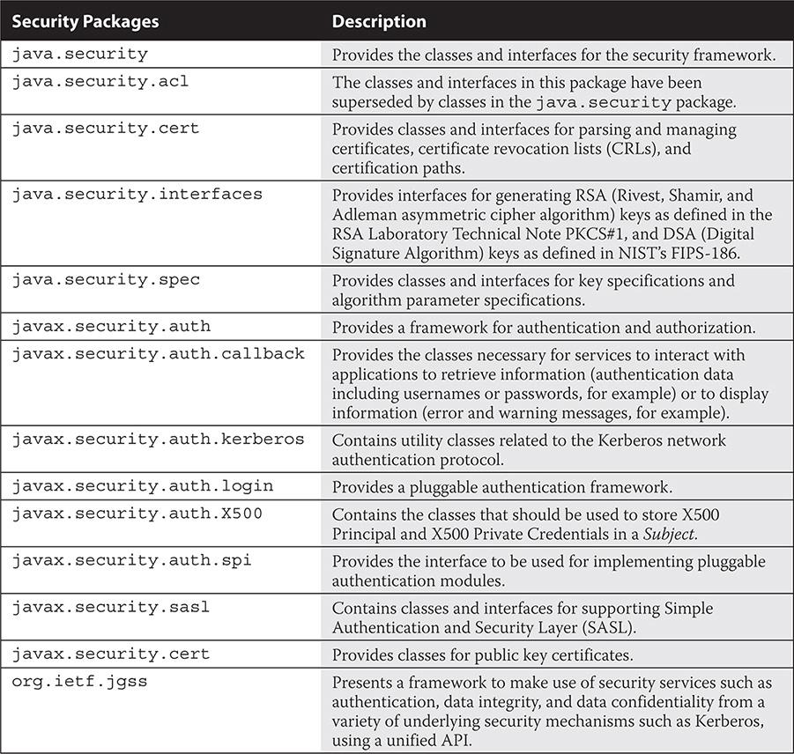

**TABLE B-17** Cryptography Packages

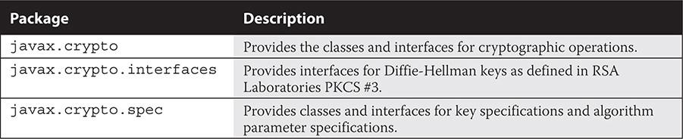

#### XML-based Packages

The following table details the XML-related Java packages.

**TABLE B-18** XML-based Packages

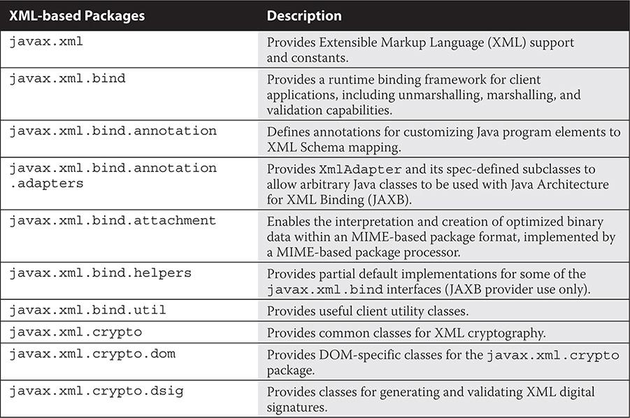

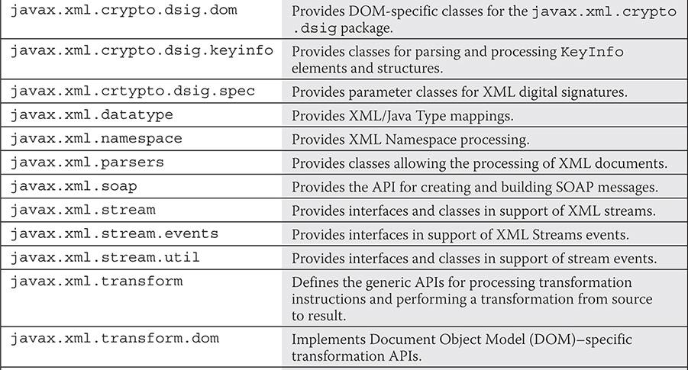

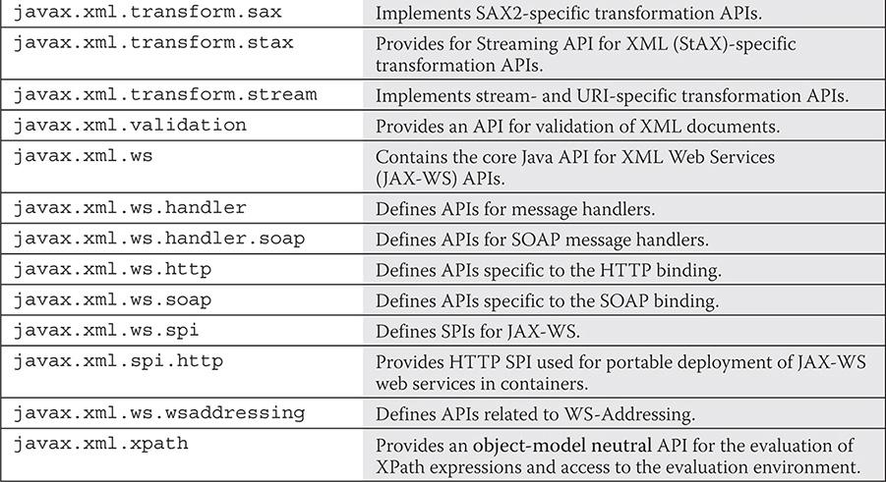

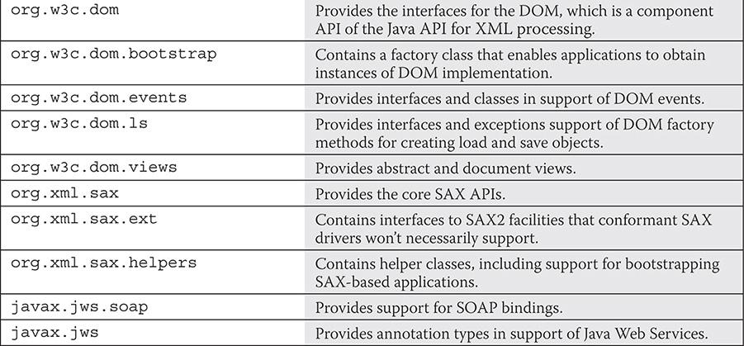

#### Temporal Packages

The following table details the time-related Java packages relative to Java 8’s new Date and Time API.

**TABLE B-19** Temporal-based Packages

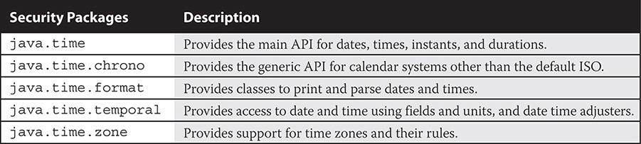



### C

### JAVA KEYWORDS

The following table represents all of the valid Java keywords.

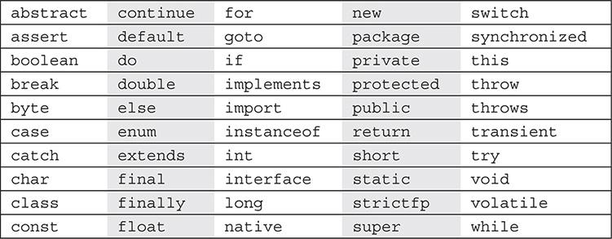

Please note the following:

 Java keywords cannot be used as identifiers.

 The enum keyword was added in J2SE 5.0 (Tiger).

 The assert keyword was added in J2SE 1.4 (Merlin).

 Reserved literals named true, false, and null are not keywords.

Keywords const and goto are reserved Java keywords but are not functionally used. Note that since they are commonly used C language keywords, providing them as keywords allows the IDEs and compilers to provide better error messages when these keywords are encountered in a Java program.



### D

### BRACKET CONVENTIONS

#### Java Bracket Conventions

The Java programming language, like many programming languages, makes strong use of brackets. The OCA exam requires that you be familiar with the different types of brackets. The following table contains each type of bracket that appears throughout this book and in the exam. This table details the bracket names as they are used in the Java Language Specification (JLS) as well as common alternative names.

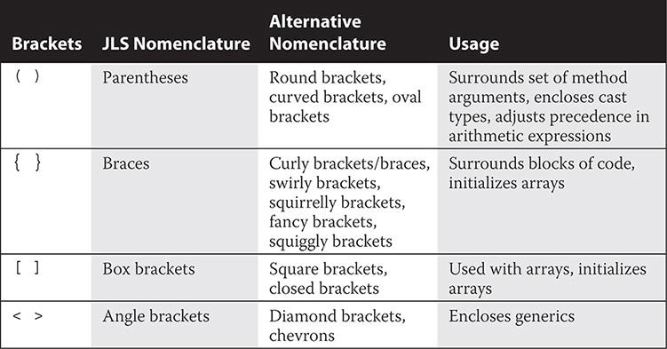

#### Miscellaneous Bracket Conventions

Guillemet characters, as represented in the next table, are used in Universal Modeling Language (UML). UML was covered in the SCJA exam but does not appear in the OCA exam. This information is provided here because you may find yourself using UML at some point in your career.

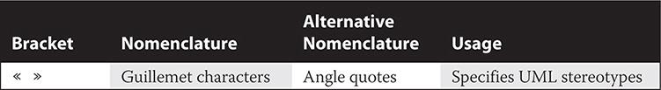



### E

### UNICODE STANDARD

The Unicode Standard is a character coding system designed to form a universal character set. This standard is maintained by the Unicode Consortium standards organization. The characters in this set are technically known as Unicode scalar values (in other words, hex numbers). Commonly known as Unicode characters, the characters are primarily organized into symbol and punctuation characters, as well as script characters (for example, spoken language characters).

Literal values in Java can be written using Unicode, as shown in the following examples:



Code charts for Unicode are maintained by the consortium for easy reference. You can access the “Code Charts for Symbols and Punctuation” from <http://unicode.org/charts/#symbols>. You’ll find “The Unicode Character Code Charts by Script” at <http://unicode.org/charts/index.html>.

Current Oracle release documentation states that Java SE 8 supports the Unicode Standard 6.2.0. Unicode 6.2.0 added support for more characters, scripts, and blocks. Java SE 7 introduced support for Unicode version 6.0.0. The Java SE 6 and J2SE 5.0 API’s character information is based on the Unicode standard, version 4.0. The J2SE 1.4 API’s character information is based on the Unicode standard, version 3.0. This Unicode compliancy information is found in the documentation of the Character class.

Many Unicode standard groupings of characters exist, such as language characters, currency symbols, Braille patterns, arrows, and mathematical operators. The most commonly used characters are the ASCII punctuation characters.

### **ASCII PUNCTUATION CHARACTERS**

The first 128 characters are the same as those in the American Standard Code for Information Exchange (ASCII) character set. The Unicode Consortium references them as ASCII punctuation characters. [Table E-1](https://learning.oreilly.com/library/view/oca-java-se/9781259587535/ch16_app_e.html#ch16tab01) represents these characters. The values \u0000 to \u001F and 0007F represent nonprintable ASCII characters. The values \u0020 to \u007E represent printable ASCII characters. The character \u0020 represents a blank space. As an example, the space could also be referenced by its decimal equivalent value (that is, 32), its octal equivalent value (040), its HTML equivalent value (&#32;), or directly by its printable character, as in char c = ' ';.

**Table E-1** Printable and Nonprintable ASCII Characters

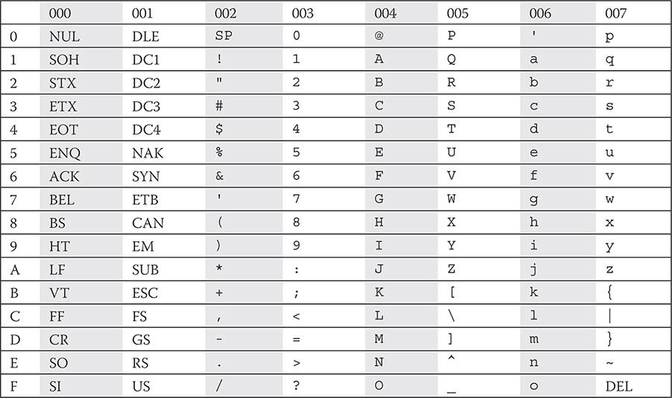

The Java tutorials provide more information about the Unicode industry standard in their online trail: [http://docs.oracle.com/javase/tutorial/i18n/text/uni](http://docs.oracle.com/javase/tutorial/i18n/text/unicode.html)



### F

### PSEUDO-CODE ALGORITHMS

Pseudo-code algorithms were covered on previous version of the exam. The coverage has been removed for the updated OCA exam. Therefore, we have included this content as a supplement. The pseudo-code algorithms are important for you to be familiar with in the real world and will help if you are reviewing old test materials.

**Note *Because you do not need to know about pseudo-code algorithms for the OCA exam, your review of this appendix is optional*.**

#### Implementing Statement-Related Algorithms from Pseudo-code

Pseudo-code is a structured means to allow algorithm designers to express computer programming algorithms in a human-readable format. Pseudo-code is informally written and is compact and high-level in nature. Even though pseudo-code does not need to be tied to any specific software language, the designer will typically script the pseudo-code algorithms based on the structural conventions of the target software language.

You may be thinking, “Hey, pseudo-code sounds great! Where do I get started writing high-quality algorithms in pseudo-code?” Well, don’t get too excited. No standards exist for writing pseudo-code, since its main purpose is to help designers build algorithms in their own language. With so many different languages having varying structural differences and paradigms, creating a pseudo-code standard that applies to them all would be impossible. Essentially, writing pseudo-code allows for the quick and focused production of algorithms based on logic, not language syntax.

The following topics presented in the next sections will discuss working with basic pseudo-code and converting pseudo-code algorithms into Java code with an emphasis on statements:

 Pseudo-code algorithms

 Pseudo-code algorithms and Java

##### Pseudo-code Algorithms

The previous exam presented pseudo-code algorithms to the test candidate. In turn, the candidate had to decide which Java code segment correctly implemented the algorithms. This was tricky, since the pseudo-code algorithms did not need to represent Java syntax in any way, but the Java code segments had to be structurally and syntactically accurate to be correct.

Let’s take a look at a pseudo-code algorithm:

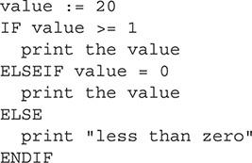

While surfing the Internet, you’ll come to the conclusion that there is no universally accepted convention for pseudo-code. For demonstration purposes, [Table F-1](https://learning.oreilly.com/library/view/oca-java-se/9781259587535/ch17_app_f.html#ch17tab01) gives you a general idea of how a typical representation of pseudo-code can be translated to Java.

**TABLE F-1** Pseudo-code Conventions

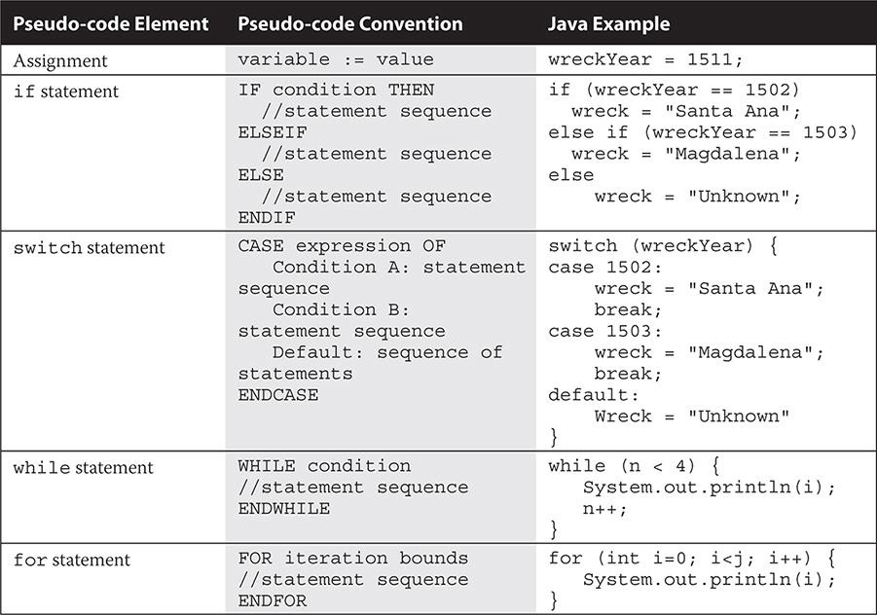

##### Pseudo-code Algorithms and Java

Pseudo-code can be a fragment of a complete source file, and it is okay that some primitive declarations may be missing. However, conditional and iteration statements are always represented completely.

Let’s take a look at some examples. Here’s a pseudo-code algorithm:

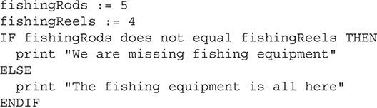

Here’s a Java implementation:

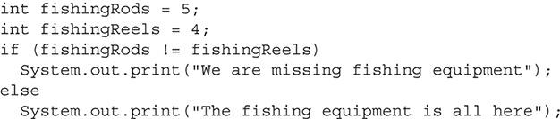

Note that this appendix leveraged off of the “PSEUDOCODE STANDARD” page of the Cal Poly State University web site; the authors did a pretty good job proposing a standard: <http://users.csc.calpoly.edu/~jdalbey/SWE/pdl_std.html>.



### G

### UNIFIED MODELING LANGUAGE

The Unified Modeling Language (UML) specification defines a modeling language for the specification, presentation, construction, and documentation of object-oriented system elements. UML is covered here to offer you a quick understanding to complement the UML diagrams that appear in this book.

The UML standard is the culmination of the works from James Rumbaugh’s object-modeling technique, Grady Booch’s “Booch method,” and Ivar Jacobson’s object-oriented software engineering method. The collaborative effort of this trio has earned them the name “The Three Amigos.” The origins of their efforts leading to the UML standard are detailed in [Table G-1](https://learning.oreilly.com/library/view/oca-java-se/9781259587535/ch18_app_g.html#ch18tab01).

The modern UML specification, maintained by the Object Management Group (OMG), has gone through several revisions, as represented in [Table G-2](https://learning.oreilly.com/library/view/oca-java-se/9781259587535/ch18_app_g.html#ch18tab02). The latest formal specification (UML 2.4.1) comprises four parts. The first two parts are the “OMG UML Infrastructure Specification version 2.4.1” and the “OMG UML Superstructure Specification version 2.4.1.” The Infrastructure specification has a tighter focus concerning class-based structures and houses all of the basic information you should know. The Superstructure specification details user-level constructs and cross-references the Infrastructure specification so that the two parts may be integrated into one volume in the future. The remaining parts are the “Object Constraint Language (OCL)” for defining model element rules and the “UML Diagram Interchange” used for defining the exchange of UML 2 diagram layouts. The current versions of the specifications are obtainable from the OMG at [www.omg.org/spec/UML/Current](http://www.omg.org/spec/UML/Current). In short, this appendix will teach you how to recognize the main diagram elements and relationships used by UML.

**TABLE G-1** Object Methodologies Preceding UML

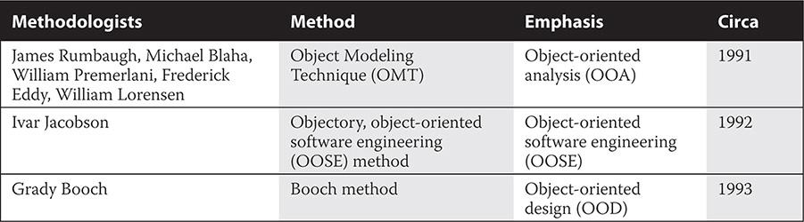

**TABLE G-2** Evolving UML Specifications

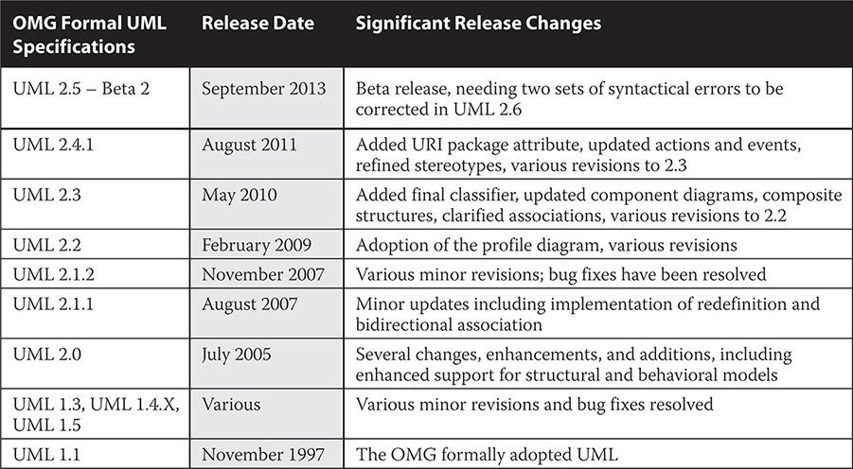

The complete set of 14 UML diagrams from the UML 2.4 standard is shown in [Table G-3](https://learning.oreilly.com/library/view/oca-java-se/9781259587535/ch18_app_g.html#ch18tab03).

Two closely related UML focal areas are covered in this appendix. One focal area relates to the recognitions of simple class structure artifacts and basic OO principles. The other relates to depicting UML features related to class relationships.

**TABLE G-3** Types of UML Diagrams

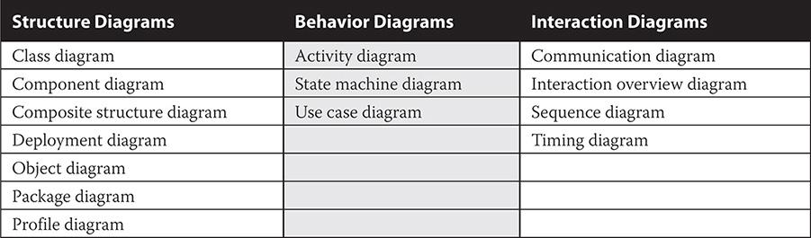

**FIGURE G-1** UML package icons



To start with your first UML element—in this case, let’s call it an icon—we’ll take a look at the basic Java SE package icons represented in [Figure G-1](https://learning.oreilly.com/library/view/oca-java-se/9781259587535/ch18_app_g.html#ch18fig01). The package icons are typically represented by a folder with the package name located in the top-left compartment (also known as the tab). The package name may also be optionally placed into the larger compartment (as shown in [Figure G-1](https://learning.oreilly.com/library/view/oca-java-se/9781259587535/ch18_app_g.html#ch18fig01)), as is commonly done when no other UML elements are enclosed in the package icon. Note that the package icon is not on the test, but we include it in many of the diagrams to show packages that enclose depicted classes.

This is a good time to look at the core UML information that you should be familiar with. This appendix is filled with details on the representation of these UML elements. After you have read the appendix, you will be able to recognize all of the core UML elements, as well as relationships between elements.

#### Recognizing Representations of Significant UML Elements

Getting acquainted with the different UML elements can actually be quite fun, and the sense of accomplishment you’ll have when mastering the art of reading and writing class relationship diagrams with UML is equally rewarding.

Our initial coverage is geared toward the class diagrams themselves. Attributes and operations compartments and visibility modifiers are also covered. Once you work though this section, you will know how to recognize the basic class elements of UML. These topics will be covered in the following subsections:

 Classes, abstract classes, and interface diagrams

 Attributes and operations

 Visibility modifiers

**FIGURE G-2** Class diagram

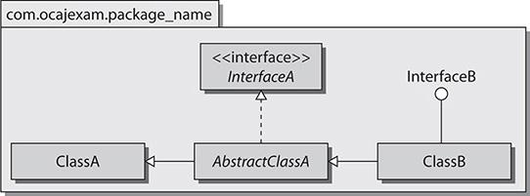

##### Classes, Abstract Classes, and Interface Diagrams

One of the simplest ways to represent classes and interfaces in UML is to show the class diagrams with only their name compartments. This holds true as well with representing interface implementations and class inheritances. [Figure G-2](https://learning.oreilly.com/library/view/oca-java-se/9781259587535/ch18_app_g.html#ch18fig02) depicts two interfaces, two classes, one abstract class, and their generalization and realization relationships. Abstract classes, concrete classes, and interfaces are all represented in a rectangle with their names in boldface type. Abstract classes are italicized. Interfaces are prefaced by the word “interface” between guillemot characters (like this: <<interface>>). An interface can be optionally depicted with its name beside the lollipop element (as with InterfaceB in the figure).

The generalization and realization relationships between the classes in [Figure G-2](https://learning.oreilly.com/library/view/oca-java-se/9781259587535/ch18_app_g.html#ch18fig02) are further explained in the following sections.

###### Generalization

*Generalization* is expressed as an *is-a* relationship, where a class allows its more general attributes and operations to be inherited. In [Figure G-2](https://learning.oreilly.com/library/view/oca-java-se/9781259587535/ch18_app_g.html#ch18fig02), ClassB inherits from *AbstractClassA* and also from ClassA. *AbstractClassA* inherits from ClassA. We can also say ClassB *is-an AbstractClassA*, ClassB *is-a* ClassA, and *AbstractClassA is-a* ClassA. We could also say that ClassA and *AbstractClassA* are superclasses to ClassB, and, appropriately, ClassB would be their subclass. The generalization class relationship is depicted in the figure with a solid line and a closed white arrowhead.

###### Realization

*Realization* is the general principle of implementing an interface. *AbstractClassA* implements the InterfaceA interface. ClassB implements the InterfaceB interface. The realization class relationship is depicted with a dotted line and a closed white arrowhead or the lollipop element.

###### Code Engineering from UML Diagrams

UML provides many benefits; it is not limited to explaining existing code. When a system architect or system designer models the classes for a particular application, someone will need to develop code to those models. Many UML modeling tools can automatically generate the code structure for these models. However, most coders will use UML as a guide and choose to begin their coding from scratch.

##### Attributes and Operations

*Attributes*, also known as *member variables*, define the state of a class. *Operations*, sometimes called *member functions*, detail the methods of a class. Let’s take a look at adding attributes and operations to a class UML diagram. The following is a code listing for an arbitrary PrimeNumber class. We will depict this class with UML.

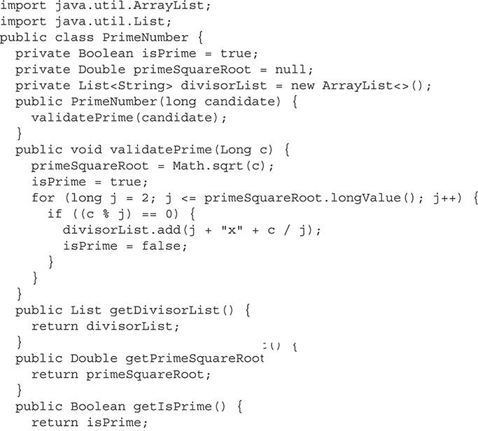

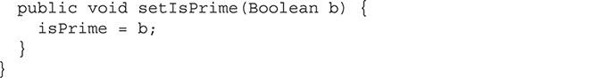

Before we actually look at the associated UML diagram(s), let’s examine the scope and required format for the information within the attributes and operations compartments.

###### Attributes Compartment

The attributes compartment houses the classes’ attributes, or member variables. The attributes compartment is optionally present under the name compartment of the class diagram. The UML usage for each variable of the attributes compartment is detailed. For the sake of general knowledge, it’s good to be familiar with the following condensed attributes format:



Here, visibility defines the optionally displayed visibility modifier. The name would be the variable’s name, and the type would be the type of the variable.

###### Operations Compartment

The operations compartment houses the classes’ operations, or member functions or methods. The operations compartment is optionally present under the attributes compartment of the class diagram. If the attributes compartment is excluded, then the operations compartment may reside under the name compartment of the class diagram. The UML usage for each method of the operations compartment is detailed. Again, it’s good to be familiar with following condensed operations format:



Here, visibility defines the optionally displayed visibility modifier. The name would be the method’s name, the optionally displayed parameter-list is just as it says, and this is the same for the return-type.

###### Displaying the Attributes and Operations Compartments

The display of level-of-detail information with regard to most UML elements is optional. This is true for the member variables and methods in the attributes and operations compartments as well. [Figure G-3](https://learning.oreilly.com/library/view/oca-java-se/9781259587535/ch18_app_g.html#ch18fig03) shows a more complete usage as defined in the compartment sections.

**FIGURE G-3** Detailed attributes and operations compartments

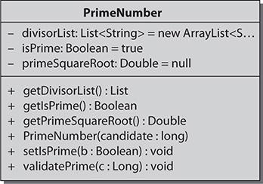

In [Figure G-4](https://learning.oreilly.com/library/view/oca-java-se/9781259587535/ch18_app_g.html#ch18fig04), a more condensed representation of attributes and operations usages is shown.

Both of the following representations are valid; by taking the time to understand this completely, you can avoid confusion when working with UML.

For attributes: <variable_name> [: <type>]

For operations: <method_name> [<parameter-list>]

##### Visibility Modifiers

As you are aware, there are four access modifiers: *public*, *private*, *protected*, and *package-private*. These modifiers are depicted with symbols in UML and are used as shorthand in the attributes and operations compartments of a class diagram. These symbols are known as *visibility modifiers* or *visibility indicators*. The visibility indicator for the *public* access modifier is the plus sign (+). The visibility indicator for the *private* access modifier is the minus sign (–), the visibility indicator for the *protected* access modifier is the pound sign (#), and the visibility indicator for the *package-private* modifier is the tilde (~) modifier. All four visibility modifiers are depicted in [Figure G-5](https://learning.oreilly.com/library/view/oca-java-se/9781259587535/ch18_app_g.html#ch18fig05) within the attributes and operations compartments. Visibility indicators are also optional and need not be displayed.

**FIGURE G-4** Abbreviated attributes and operations compartments

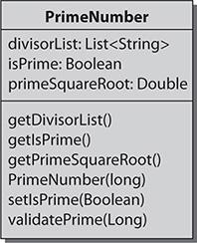

**FIGURE G-5** Visibility modifiers

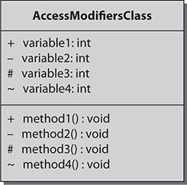

Several UML modeling tools are freely and commercially available in the marketplace. Being familiar with these tools will make you more productive in the workplace, will assist in collaboration, and will ultimately give you a more professional edge.

#### Recognizing Representations of UML Associations

The preceding section solidified your knowledge of basic class diagrams and their main components. This section focuses on the relationships between classes in regard to their associations and compositions. Multiplicity indicators and role names are detailed as well to assist you in specifying the relationships between classes. When you have completed this section, you will know how to recognize connectors used between classes and how to interpret any specified multiplicity indicators and role names. The following topics will be covered:

 Graphic paths

 Relationship specifiers

##### Graphic Paths

The structure diagram graphic paths, also defined as class relationships, include notations for aggregation, association, composition, and dependency, as depicted in [Figure G-6](https://learning.oreilly.com/library/view/oca-java-se/9781259587535/ch18_app_g.html#ch18fig06). Generalization and realization graphic paths were covered in the preceding section.

**FIGURE G-6** Graphic path notations

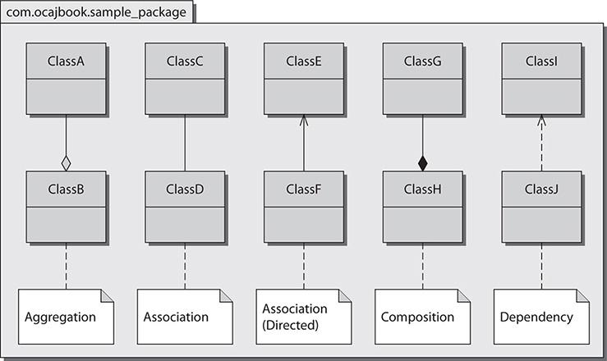

###### Aggregation Association

Aggregation association depicts one class as the owner of one or more classes. Aggregation is depicted with a solid line and an unfilled diamond. The diamond is on the side of the classifier. In [Figure G-6](https://learning.oreilly.com/library/view/oca-java-se/9781259587535/ch18_app_g.html#ch18fig06), you could say that a ClassA object is part of a ClassB object.

###### Association

An association that is not marked by navigability arrows is implied to be navigable in both directions; therefore, each association end is owned by the opposite classifier. Association is depicted with a solid line. In [Figure G-6](https://learning.oreilly.com/library/view/oca-java-se/9781259587535/ch18_app_g.html#ch18fig06), you could say there is an association between ClassC and ClassD objects.

###### Directed Association

An association has (directed) navigation when it is marked with a navigability arrow, also described as a stick arrow. This directed association’s arrow denotes navigation in the direction of that end, the classifier has ownership of the marked association end, and the unmarked association’s end is owned by the association. In addition to the navigability arrow, directed association is depicted with a solid line. In [Figure G-6](https://learning.oreilly.com/library/view/oca-java-se/9781259587535/ch18_app_g.html#ch18fig06), you could say that a ClassE object has a ClassF object.

###### Composition

Composition association depicts a class being composed of one or more classes. The component parts/classes live only as long as the composite class. Composition is depicted with a solid line and a filled diamond. The diamond is on the side of the classifier. In [Figure G-6](https://learning.oreilly.com/library/view/oca-java-se/9781259587535/ch18_app_g.html#ch18fig06), you could say that a ClassH object is composed of one or more ClassG objects.

###### Dependency

Dependency association depicts one class having a temporary association with another class. Dependency associations occur when a class needs another class to exist or when an object is used as a return value, local variable, or method argument. Dependency is depicted with a dotted line and a stick arrow. In [Figure G-6](https://learning.oreilly.com/library/view/oca-java-se/9781259587535/ch18_app_g.html#ch18fig06), you could say that a ClassJ object depends on a ClassI object.

**Note *As you probably noticed upon reading through the explanations of the relationships, class relationships can be written out using catchphrases between the objects. Common relationship catchphrases include “has-a,” “is-a,” “is composed of,” “is part of,” and “uses-a.”***

###### Notes

Notes are represented in UML as a rectangle with a folded upper-right corner. Comments are placed into the notes element, and a dotted line is drawn from the notes element to the artifact being commented on.

##### Relationship Specifiers

Sometimes depicting class relationships with the basic UML elements such as class diagrams and connectors is not enough to convey the true relationship between classes. A reader may clearly see that a relationship exists but may want to know more with regard to the constraints and high-level interaction. Multiplicity indicators and role names are specifiers used to define and clarify these relationships further.

###### Multiplicity Indicators

Multiplicity indicators are numerical representations used to depict the number of objects that may or must be used in an association. [Table G-4](https://learning.oreilly.com/library/view/oca-java-se/9781259587535/ch18_app_g.html#ch18tab04) defines the meanings of the different multiplicity indicators. If an association end does not show a multiplicity indicator, then the value is assumed to be 1. Multiplicity indicators can take the form of a single value or can be represented as a bounded relationship (<lowerbound>..<upperbound>).

Multiplicity indicators in use are represented in [Figure G-7](https://learning.oreilly.com/library/view/oca-java-se/9781259587535/ch18_app_g.html#ch18fig07). Here you see the following: ResearchStation objects must be aware of 20 or more ResearchBuoy objects. ResearchBuoy objects must be aware of at least one ResearchStation. Each ResearchBuoy must be composed of zero or more GpsDevice objects.

**TABLE G-4** Multiplicity Indicators and Their Meanings

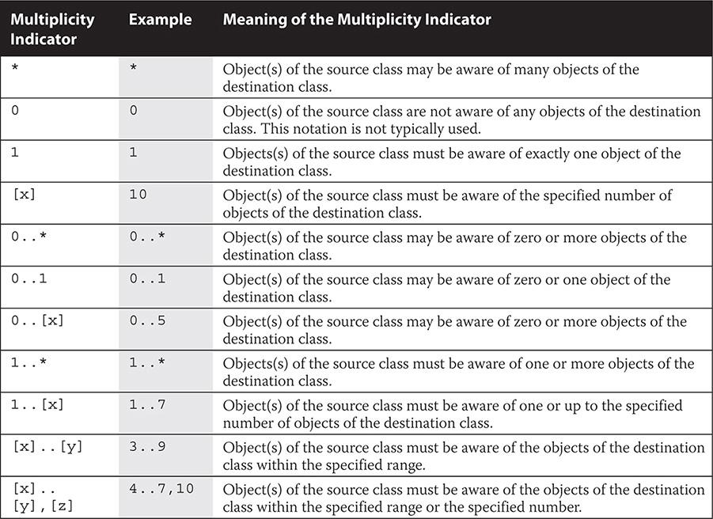

**FIGURE G-7** Multiplicity indicators

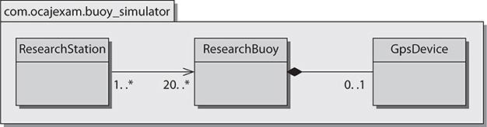

###### Association Role Names

Role names are commonly used to clarify the usage of the associated objects and their multiplicities. In [Figure G-8](https://learning.oreilly.com/library/view/oca-java-se/9781259587535/ch18_app_g.html#ch18fig08), we see that the ResearchStation object interrogates the ResearchBuoy object. Without this descriptive role name, the relationship may have been unclear. We can also deduce that the ResearchStation object is aware of 20 ResearchBuoy objects, and each ResearchBuoy object is associated with one or more ResearchStation objects.

**FIGURE G-8** Association role name

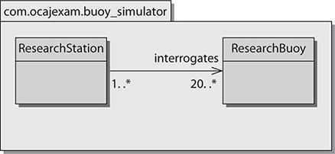

* [Search in book...](https://learning.oreilly.com/library/view/oca-java-se/9781259587535/ch19_app_h.html#)
* [Toggle Font Controls](https://learning.oreilly.com/library/view/oca-java-se/9781259587535/ch19_app_h.html#)

[PREV](https://learning.oreilly.com/library/view/oca-java-se/9781259587535/ch18_app_g.html)

[Previous Chapter](https://learning.oreilly.com/library/view/oca-java-se/9781259587535/ch18_app_g.html)

[NEXT](https://learning.oreilly.com/library/view/oca-java-se/9781259587535/ch20_app_i.html)

[Next Chapter](https://learning.oreilly.com/library/view/oca-java-se/9781259587535/ch20_app_i.html)

[](https://learning.oreilly.com/library/view/oca-java-se/9781259587535/ch20_app_i.html)

### H

### FUNCTIONAL INTERFACES

JDK 1.8 includes specific-purpose and general-purpose functional interfaces (FIs). An easy way to locate FIs is to search through the source code for the @FunctionalInterface annotation. Java SE 8 source code is included in the src.zip and javafx-src.zip files that are distributed with the JDK.

The following list was produced from “grepping” on the extracted JavaFX source code in the javafx-src directory. The FIs in this listing could be considered JavaFX Specific Purpose FIs (SPFIs). Note that you can run grep on POSIX-based machines or Windows machines with CYGWIN installed.

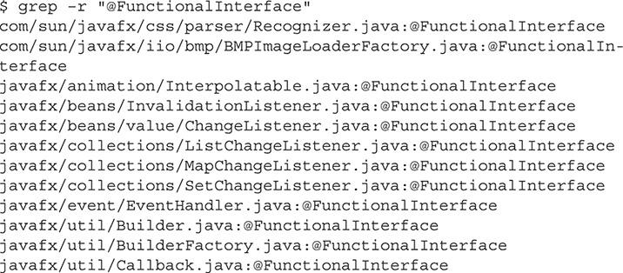

#### Specific-Purpose FIs

Specific-purpose FIs are designed to support the packages in which they are included, as you have seen with the JavaFX SPFIs. You can examine the source code for specific-purpose FIs in newer Java distributions (as they are released) to see what additional interfaces become available to use.

Various specific-purpose FIs are listed in [Table H-1](https://learning.oreilly.com/library/view/oca-java-se/9781259587535/ch19_app_h.html#ch19tab01). Default methods and static methods are optional in FIs. However, of the FIs listed in [Table H-1](https://learning.oreilly.com/library/view/oca-java-se/9781259587535/ch19_app_h.html#ch19tab01), only the Comparator interface had a need for default and static methods.

**TABLE H-1** Specific-Purpose Functional Interfaces

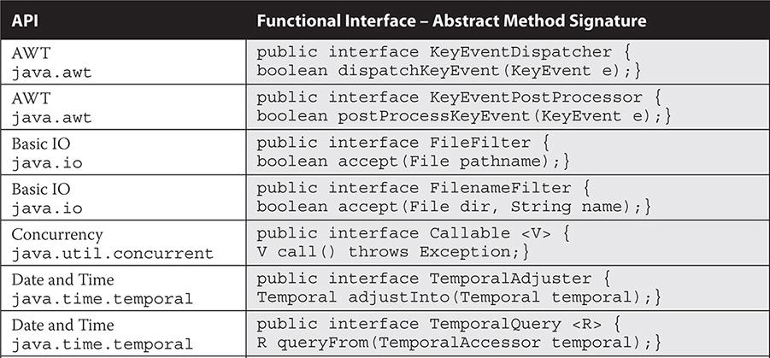

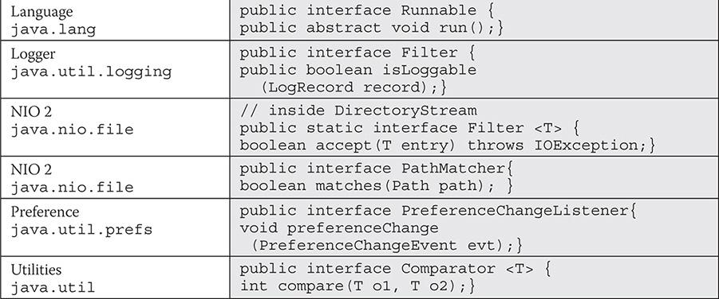

#### General-Purpose FIs

General-purpose FIs are designed to support the primary features of the JDK. These FIs reside in java.util.function. All of the general-purpose FIs available in JDK 1.8-40 are provided in [Table H-2](https://learning.oreilly.com/library/view/oca-java-se/9781259587535/ch19_app_h.html#ch19tab02), along with their single abstract method signatures.

**TABLE H-2** General-Purpose Functional Interfaces

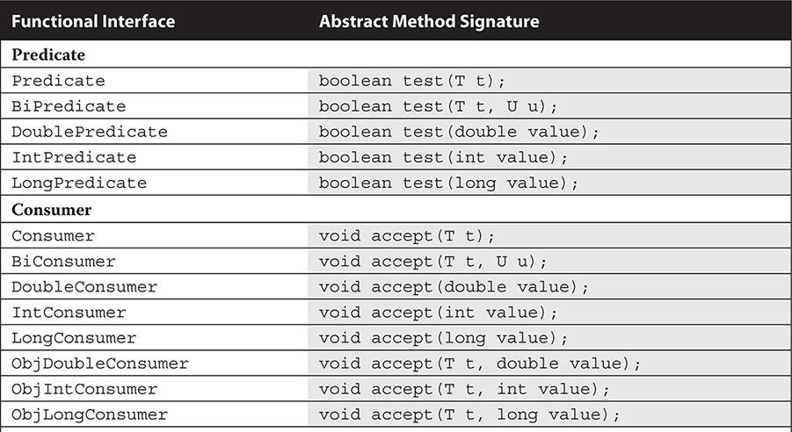

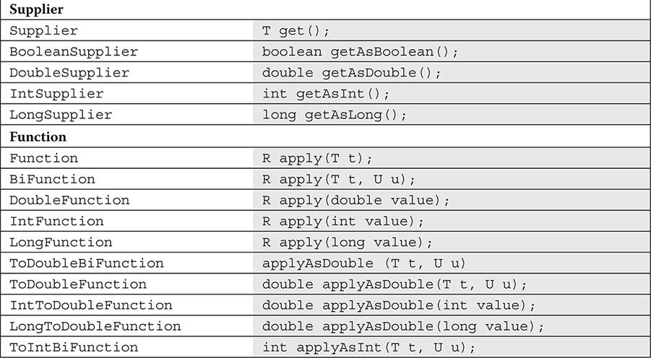

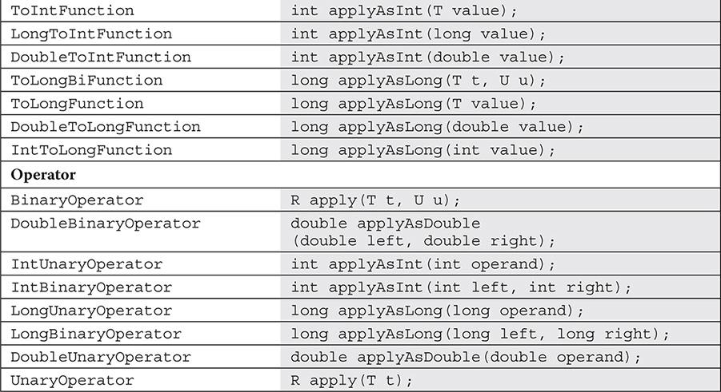



### I

### ABOUT THE DOWNLOAD

This e-book comes with the following download from the McGraw-Hill Professional Media Center:

• Oracle Press Practice Exam software that simulates the 1Z0-808 exam

• An Enterprise Architect project file

• Code samples from the book

The Practice Exam software is easy to install on any Mac or Windows computer and must be installed to access the Practice Exam feature. The EAP file and the code samples are included as part of the download.

#### System Requirements

The software requires Microsoft Windows XP; Windows Server 2003; Windows Server 2008; Windows Vista Home Premium, Business, Ultimate, or Enterprise (including 64-bit editions) with Service Pack 2; or Windows 7 or Mac OS X 10.6 and 10.7 with 512MB of RAM (1GB recommended).

#### McGraw-Hill Professional Media Center Download

To access the available download, visit McGraw-Hill Professional’s Media Center by clicking the link below and entering this e-book’s 13-digit ISBN and your e-mail address. You will then receive an e-mail message with a download link for the additional content.

<http://mhprofessional.com/mediacenter/>

This e-book’s ISBN is 9781259587535.

Once you’ve received the e-mail message from McGraw-Hill Professional’s Media Center, click the link included to download a zip file. Extract all of the files from the zip file and save them to your computer. If you do not receive the e-mail, be sure to check your spam folder.

#### Oracle Press Practice Exam Software

See the following section for information on how to install and run the software using either a Mac or a Windows computer.

##### Installing the Practice Exam Software

Review the system requirements before proceeding with the installation.

Follow the instructions for Windows or Mac OS.

###### Windows

**Step 1** Open the InstallerforPC.zip file. You will need to unzip the file and extract or copy and paste the contents to your hard drive.

**Step 2** Locate the Installer.exe file and double click the file. After a few moments, the installer will open.

**Step 3** Follow the onscreen instructions to install the application.

###### Mac OS

**Step 1** Open the InstallerforMac.zip file. You will need to unzip the file and extract or copy and paste the contents to your hard drive.

**Step 2** After a few moments, the contents of the .zip file will be displayed.

**Step 3** Double-click Installer to begin installation.

**Step 4** Follow the onscreen instructions to install the application.

**NOTE:** If you get an error while installing the software, ensure that your antivirus or Internet security programs are disabled and try installing the software again. You can enable the antivirus or Internet security program again after installation is complete.

##### *Running the Practice Exam Software*

Follow the instructions after you have completed the software installation.

###### Windows

After installing, you can start the application using either of the two following methods:

• Double-click the Oracle Press OCA Java SE 8 Exams icon on your desktop.

• From the Start menu, click Programs or All Programs. Click Oracle Press OCA Java SE 8 Exams to start the application.

###### Mac OS

Open Oracle Press OCA Java SE 8 Exams folder inside your Mac’s Application folder and double-click the Oracle Press OCA Java SE 8 Exams icon to run the application.

##### *Practice Exam Software Features*

The Practice Exam Software provides a simulation of the actual exam. The software also features a custom mode that you can use to generate quizzes by exam objective domain. Quiz mode is the default mode. To launch an exam simulation, select one of the OCA exam buttons at the top of the screen, or select the Exam Mode check box at the bottom of the screen and select the OCA exam in the custom window.

The number of questions, types of questions, and the time allowed on the exam simulation are intended to be a representation of the live exam. The custom exam mode includes hints and references, and in-depth answer explanations are provided through the Feedback feature.

When you launch the software, a digital clock display will appear in the upper-right corner of the question window. The clock will continue to count unless you choose to end the exam by selecting Grade The Exam.

##### *Removing Installation*

The Practice Exam Software is installed on your hard drive. For best results for removal of programs using a Windows PC, use the Control Panel | Uninstall A Program option and then choose Oracle Press OCA Java SE 8 Exams to uninstall.

For best results for removal of programs using a Mac, go to the Oracle Press OCA Java SE 8 Exams folder inside your Applications folder and drag the Oracle Press OCA Java SE 8 Exams icon to the trash.

##### *Help*

A help file is provided through the Help button on the main page in the top-right corner. A readme file is also included in the Bonus Content folder, which provides more information about the additional content available with the book.

#### Enterprise Architect Project File

Enterprise Architect (EA) is a CASE tool that supports UML modeling and reverse source code engineering. EA was used to create the draft UML diagrams for this book. Because knowing UML is a requirement for the exam, the authors have included the project file for these diagrams in the download to assist you in your learning.

To open the project file, you must have a version of EA. You can download a 30-day trial version of the application from the Sparx Systems web site at <http://www.sparxsystems.com/products/ea/trial.html>. Once it is installed, you will be able to view and modify each of the UML diagrams. You will find the diagrams to be organized in the EA project as they are presented in each chapter. See [Appendix G](https://learning.oreilly.com/library/view/oca-java-se/9781259587535/ch18_app_g.html#ch18_app_g) for detailed information on UML.

#### Code Samples

Selected samples of code from the book are included in the download. To access the sample code, open the NetBeans Sample Code folder.

#### Technical Support

Technical support information is provided in the following sections by feature.

##### *Windows 8 Troubleshooting*

The following known errors on Windows 8 have been reported. See the following for information on troubleshooting these known issues.

If you get an error while installing the software, such as “The application could not be installed because the installer file is damaged. Try obtaining the new installer from the application author,” you may need to disable your antivirus or Internet security programs and try installing the software again. You can enable the antivirus or Internet security program again after installation is complete.

For more information on how to disable antivirus programs in Windows, visit the web site of the software provider of your antivirus program. For example, if you use Norton or MacAfee products, visit the Norton or MacAfee web site and search for “how to disable antivirus in Windows 8.” Antivirus programs are different from firewall technology, so be sure to disable the antivirus program, and be sure to re-enable the program after you have installed the Practice Exam software.

Although Windows doesn’t include default antivirus software, it can often detect antivirus software installed by you or the manufacturer of your computer, and it typically displays the status of any such software in the Action Center, located in the Control Panel under System and Security (select Review Your Computer’s Status). The Windows help feature can also provide more information on how to detect your antivirus software. If the antivirus software is on, check the Help feature that came with that software for information on how to disable it.

Windows will not detect all antivirus software. If your antivirus software isn’t displayed in the Action Center, you can try typing the name of the software or the publisher in the Start menu search field.

##### *McGraw-Hill Education Content Support*

For questions regarding the content of the practice exam software, e-mail techsolutions@mhedu.com or visit [http://mhp.softwareassist.com](http://mhp.softwareassist.com/).

For questions regarding e-book content, e-mail customer.service@mheducation.com. For customers outside the United States, e-mail international_cs@mheducation.com.

* [Search in book...](https://learning.oreilly.com/library/view/oca-java-se/9781259587535/ch21_glossary.html#)
* [Toggle Font Controls](https://learning.oreilly.com/library/view/oca-java-se/9781259587535/ch21_glossary.html#)

[PREV](https://learning.oreilly.com/library/view/oca-java-se/9781259587535/ch20_app_i.html)

[Previous Chapter](https://learning.oreilly.com/library/view/oca-java-se/9781259587535/ch20_app_i.html)

[NEXT](https://learning.oreilly.com/library/view/oca-java-se/9781259587535/ch22_index.html)

[Next Chapter](https://learning.oreilly.com/library/view/oca-java-se/9781259587535/ch22_index.html)

[](https://learning.oreilly.com/library/view/oca-java-se/9781259587535/ch22_index.html)

### GLOSSARY

**absolute path** The full path to a directory or file from the root directory. For example, C:\NetBeansProject\SampleProject is an absolute path. The paths ..\ SampleProject or Projects\SampleProject are relative paths.

**abstract** A modifier that indicates that either a class or a method has some behavior that must be implemented by its subclasses.

**access modifiers** Modifiers that define the access privileges of interfaces, classes, methods, constructors, and data members. Access modifiers include *package-private*, private, protected, and public.

**accessor method** A method used to return the value of a private field. See also *getter*.

**annotation** Metadata that provides additional data about the program but is not directly part of the resulting application. Annotations are always prepended by @.

**application server** A (Java EE) server that hosts various applications and their environments.

**arithmetic operator** Java programming language operator that performs addition (+), subtraction (-), multiplication (*), division (/), or remainder production (%) operations.

**array** A fixed-length group of the same type variables or references that are accessed with an index.

**ArrayList** A resizable array implementation of the List interface; an object-oriented representation of an array.

**assertions** Boolean expressions that are used to validate whether code functions as expected while debugging.

**assignment statement** A statement that allows for the definition or redefinition of a variable by assigning it a value. It is represented by the equal operator (=) in Java code.

**attributes** The state of a class’s instance and static variables (fields).

**autoboxing** A convenience feature in Java that allows a primitive to be used as its wrapper object class without any special conversion by the developer.

**AutoCloseable** A Java interface that represents a resource that must be closed when it is no longer needed. Objects that inherit from AutoCloseable may be used with the try-with-resources statement.

**AWT** The *Abstract Window Toolkit* is the original package for developing cross-platform user interfaces.

**base class** See *superclass*.

**bean** A reusable software component that conforms to design and naming conventions.

**bitwise operator** A Java programming language operator that may be used to compare two operands of numeric type or two operands of type boolean. Bitwise operators include bitwise AND (&), bitwise exclusive OR (^), and bitwise inclusive OR (|).

**block** Code placed between matching braces—for example, { int x; }.

**boolean** A Java keyword (boolean) that is used to define a primitive variable as having a Boolean type with a value of either true or false. The corresponding wrapper class is Boolean.

**byte** A Java keyword (byte) used to define a primitive variable as an integer with 1 byte of storage. The corresponding wrapper class is Byte.

**bytecode** The name of a compiled Java binary.

**casting** Converting one type to another, such as converting/casting a primitive long to a primitive int.

**char** A Java keyword (char) used to define a variable as a specific Unicode character with 2 bytes of storage. The corresponding wrapper class is Character.

**Checkstyle** A development tool that assists programmers in writing Java code that adheres to coding standards. See <http://checkstyle.sourceforge.net/> for information.

**child class** See *subclass*.

**class** A Java type that defines the implementation of an object. Classes include instance variables, class variables, and methods. Classes also specify the superclass and interfaces in which they inherit and implement. All classes inherit from the Object class.

**class method** The name of a method that is not static and belongs to a specific class.

**class variable** See *static variable*.

**classpath** A variable that includes an argument set telling the Java virtual machine where to look for user-defined classes/packages.

**comment** Text within a source file that provides explanations of associated code. In Java, comments are delimited with // (single line), /*…*/ (multiple line), or /**…*/ (multiple line) Javadoc comments.

**composition association** A whole–part relationship between classes whereby the whole is responsible for the lifetime of its parts. Composition is also known as *containment* and is a strong relationship.

**compound assignment operator** An operator with an abbreviated syntax that is used in place of the assignment of an arithmetic or bitwise operator. The compound assignment operator evaluates the two operands first, and then assigns the results to the first operand.

**concatenation operator** An operator (+) that is used to concatenate (join) two strings.

**concrete class** A class that has all of its methods implemented. Concrete classes can be instantiated.

**conditional statement** A decision-making control flow used to execute statements and blocks of statements conditionally. Examples are if, if else, if else if, and switch.

**constructor** A method that initializes a new object.

**DateTimeFormatter** A class in the Date and Time API. The DateTimeFormatter class is a formatter for printing and parsing date-time objects.

**declaration** A statement that establishes an identifier with associated attributes. A class declaration lists its instance variables and methods. Declarations within methods define the type of local variables.

**default constructor** The empty constructor that is automatically used by the compiler if no other constructors are defined.

**dereference** A term used to describe when an object loses a reference. This may result from a variable being reassigned or going out of scope.

**double** A Java keyword (double) that is used to define a primitive variable as a floating-point number with 8 bytes of storage. The corresponding wrapper class is Double.

**Duration** A class in the Date and Time API. The Duration class provides a simple measure of time along the timeline in nanoseconds.

**encapsulation** The principle of defining (designing) a class that exposes a concise public interface while hiding its implementation details from other classes.

**enumeration type** A type with a fixed set of constants as fields.

**Error** A subclass of the class Throwable. The Error class indicates issues that an application should not try to catch.

**Exception** A subclass of the class Throwable. The Exception class indicates issues that an application may want to catch.

**executable JAR** A JAR file containing a manfest.mf in META-INF directory with the Main-Class attribute set to a class with a public static void main(String args[]) method.

**expression statement** A statement that changes part of the application’s state. Expression statements include method calls, assignments, object creation, pre/post-increments, and pre/post-decrements. An expression statement can be evaluated to a single value.

**FI** Acronym for functional interface—an interface that has one abstract method and zero or more default methods.

**FindBugs** A program that uses static analysis to look for bugs in Java code; see findbugs.sourceforge.net for more information.

**float** A Java keyword (float) that is used to define a primitive variable as a floating-point number with 4 bytes of storage. The corresponding wrapper class is Float.

**functional interface** Also known as a single abstract method (SAM). An interface that has just one abstract method, and thus represents a single function contract.

**garbage collection** The name of the Java process that consumes objects that are no longer in scope and frees their memory.

**generic** Generics are the term for a generic class or interface that can be passed as a parameter. This allows methods and objects to work with objects of different types while maintaining compile-time data type checks.

**getter** A simple public method used to return a private instance variable.

**Git** An open-source distributed version control system.

**heap** An area in memory where objects are stored.

**IDE** Acronym for *integrated development environment*. A development suite that allows developers to edit, compile, debug, connect to version control systems, collaborate, and do much more depending on the specific tool. Most modern IDEs have add-in capabilities for various software modules to enhance capabilities. Popular IDEs include the NetBeans IDE, JDeveloper, Eclipse, and IntelliJ IDEA.

**import statement** A statement used in the beginning of a class that allows for external packages to be made available within the class.

**inheritance** The ability of one Java class to extend another and gain its functionality.

**instance variable** A variable that is declared in the class instead of in a particular method. This variable’s lifecycle lasts for the duration of the object’s existence. This variable is in scope for all methods.

**Instant** A class in the Date and Time API. The Instant represents a numerical timestamp.

**int** A Java keyword (int) that is used to define a primitive variable as an integer with 4 bytes of storage. The corresponding wrapper class is Integer.

**interface** A definition of public methods that must be implemented by a class.

**iteration statement** A control flow through which a statement or block of statements is iterated, based on a maintained state of a variable or expression. The for loop, the enhanced for loop, and the while and do-while statements are used for iterating.

**J2EE** Acronym for *Java 2 Platform, Enterprise Edition*. The legacy term for Java EE. See *Java EE*.

**J2ME** Acronym for *Java 2 Platform, Micro Edition*. The legacy term for Java ME. See *Java ME*.

**J2SE** Acronym for *Java 2 Platform, Standard Edition*. The legacy term for Java SE. See *Java SE*.

**JAR** Acronym for *Java Archive*. A JAR file is used to store a collection of Java class files. It is represented by one file with the .jar extension in the file system. It may be executable. The JAR file is based on the ZIP file format. A JAR file is created with the jar utility and can contain a manifest file referencing the main class.

**Java EE** Acronym for *Java Platform, Enterprise Edition*. A software development platform that includes a collection of enterprise API specifications for Enterprise JavaBeans, servlets, and JavaServer Pages. Java EE compliance is reached when an application server (full compliance) or web container (partial compliance) implements the necessary Java EE specifications.

**Java ME** Acronym for *Java Platform, Micro Edition*. A software development platform that includes a collection of APIs designed for embedded devices.

**Java SE** Acronym for *Java Platform, Standard Edition*. A software development platform that includes a collection of APIs designed for client application development.

**JavaBean** A reusable Java component based on a platform-independent reusable component model in which a standardized means is used to access and modify the object state of the bean.

**Javadoc** A tool that produces HTML documentation from extracted comments of Java source code. The comment symbols and annotations in the comments must comply with the Javadoc specification.

**JavaFX** A rich client platform that provides a lightweight, hardware-accelerated Java UI platform.

**jConsole** A monitoring and management tool that is a part of the JDK. It enables the local or remote monitoring of an application to track CPU and memory usage. It connects and uses information provided via the Java Management Extension (JMX).

**JDK** Acronym for *Java Development Kit*. A bundled set of development utilities for compiling, debugging, and interpreting Java applications. The Java Runtime Environment (JRE) is included in the JDK.

**JRE** Acronym for *Java Runtime Environment*, an environment used to run Java applications. It contains basic client and server JVMs, core classes, and supporting files.

**JVM** Acronym for *Java virtual machine*, the platform-independent environment where the Java interpreter executes.

**keyword** A word in the Java programming language that cannot be used as an identifier (in other words, a variable or method name). Java SE 8 maintains 50 keywords, each designed to be used for a specific purpose.

**lambda expression** A lambda expression, also known as a closure, provides a means to implement an instance of a one-use anonymous class that has a single method. In other words, a lambda expression provides a means to represent anonymous methods.

**library** A set of compiled classes that add functionality to a Java application.

**literal** A value represented as an integer, floating-point, or character value that can be stored in a variable. For example, 1115 is an integer literal, 12.5 is a floating-point literal, and A is a character literal.

**local variable** A variable that is in scope only for a single method, constructor, or block.

**LocalDate** A class in the Date and Time API. The LocalDate class stores a date and time like so: 2015-03-15.

**LocalDateTime** A class in the Date and Time API. The LocalDateTime class stores a date and time like so: 2015-03-15T12:00.

**LocalTime** A class in the Date and Time API. The LocalTime class stores a date and time like so: 12:00.

**logical operator** Java programming language operators that perform logical operations, such as the Boolean NOT (!), conditional AND (&&), and conditional OR (||).

**long** A Java keyword (long) used to define a primitive variable as an integer with a storage of 8 bytes. The corresponding wrapper class is Long.

**method** A procedure that contains the code for performing operations in a class.

**method argument** A variable that is passed to a method. A method may have multiple arguments or none.

**method parameter** A variable that is in scope for the entire method. It is declared in the method signature and is initialized from the method arguments.

**modulus** The remainder production operator (%).

**multi-catch** A clause that allows for multiple exception arguments in one catch clause.

**mutator method** A method used to set the value of a private field. See *setter*.

**null** A Java keyword (null) representing a reserved constant that points to nothing. Specifically, a null type has a null (void) reference represented by the literal null.

**object** An instance of a class created at runtime from a class file.

**object-oriented** The design principle that uses objects and their interactions to design applications. Each object can represent an abstract concept. Related code and data are stored together in these objects. This is in contrast to procedural programming in a language such as C.

**operator** A Java element that performs operations on up to three operands and returns a result.

**operator precedence** The order in which operators will be evaluated when more than one operator is included in an expression.

**overloading** The process of implementing more than one method with the same return type and name, while using various numbers and/or types of parameters to distinguish between them.

**overriding** The process of overriding a superclass’s method by using the same method signature.

**package** A Java keyword (package) that begins a statement at the beginning of a class. This statement indicates the package name with which it is associated. The fully qualified name for a class includes this package name.

**package-private modifier** The default modifier that allows package-only access to the associated class, interface, constructor, method, or data member.

**parent class** See *superclass*.

**pass-by-reference** The action of passing an argument to a method in which the Java virtual machine gives the method a reference to the same object that was passed to it. This is how objects are passed.

**pass-by-value** The action of passing an argument to a method in which the Java virtual machine copies the value for the method. This is how primitives are passed.

**Period** A class in the Date and Time API. The Period class expresses an amount of time in units meaningful to humans, such as in years or hours.

**polymorphism** A concept that allows data of one type to be handled and referred to by a type that is more general. Generalities can be created by using inheritance and extending classes, or by implementing interfaces.

**POSIX** Acronym for *Portable Operating System Interface*. It is a group of standards defined by IEEE (Institute of Electrical and Electronics Engineers) that cover APIs and command-line utilities.

**postfix increment/decrement operator** These operators provide a shorthand way of incrementing and decrementing the value of a variable by 1 after the expression has been evaluated.

**predicate** A functional interface that determines whether the input object matches given criteria.

**prefix increment/decrement operators** Operators that provide a shorthand way of incrementing and decrementing the value of a variable by 1 before the expression has been evaluated.

**primitive** A fundamental data type that is not an object. The Java primitives are byte, short, int, long, float, double, Boolean, and char.

**primitive cast** A technique in Java of changing the primitive data type of a variable to another primitive type.

**private access modifier** A Java keyword that allows class-only access to the associated constructor, method, or data member.

**profile** A term used in Java ME to describe more specific features that a Java virtual machine target implements.

**protected access modifier** A Java keyword that allows package-external subclass access and package-only access to the associated constructor, method, or data member.

**pseudo-code** A structured means to allow algorithm designers to express computer programming algorithms in a human-readable format.

**public access modifier** A Java keyword that allows unrestricted access to the associated class, interface, constructor, method, or data member.

**relational operator** A Java programming language operator that performs relational operations such as less than (<), less than or equal to (<=), greater than (>), greater than or equal to (>=), value equality (==), and value inequality (=!).

**relative path** A path that is not anchored to the root of a drive. Its resolution depends upon the current path. For example, ../usr/bin is a relative path. If the current path was /home/user/Documents, this path would resolve to /home/usr/bin.

**RuntimeException** A subclass of the class Exception. The RuntimeException class is the superclass of those exceptions that can be thrown during normal runtime of the Java virtual machine.

**SAM** Acronym for *Single Abstract Method*. See *functional interface*.

**scope** The block of code in which a variable is in existence and may be used.

**setter** A simple public method that accepts one argument and is used to set the value of an instance variable.

**short** A Java keyword (short) that is used to define a primitive variable as an integer with a storage of 2 bytes. The corresponding wrapper class is Short.

**statement** A command that performs an activity when executed by the Java interpreter. Common Java statement types include expression, conditional, iteration, and transfer-of-control statements.

**static variable** A variable that is declared in the class, such as an instance variable. This variable, however, is common to all objects of the same type. Only one instance of this variable exists for all objects of a particular type. Each instance of the class shares the same variable.

**stream** A mechanism used for conveying elements from a data source through a computational pipeline.

**String class** A class representing an immutable character string.

**StringBuilder** The StringBuilder class represents a mutable sequence of characters.

**subclass** A class that is derived from another class through inheritance. Also called a *child class*.

**super** A Java keyword (super) used to invoke overridden methods.

**superclass** A class used to derive other classes through inheritance. Also called a *parent class* or *base class*.

**SVN** Apache Subversion, an open source version control system.

**Swing API** A rich GUI application programming interface complete with an event model that is used for creating and managing user interfaces.

**this** A Java keyword that is used to assist in referring to any member of the current object. The this keyword must be used from within an instance method or constructor.

**transfer-of-control statement** A statement used to change the controlled flow in an application. Transfer-of-control statements include break, continue, and return statements.

**try-catch** A statement that contains code to “catch” thrown exceptions from within the try block, either explicitly or propagated up through method calls.

**try-catch-finally** A try-catch statement that includes a finally clause.

**try-finally** A statement that contains a finally clause that is always executed after successful execution of the try block.

**try-with-resources** A statement that declares resources that can be automatically closed. The objects/resources that are declared must implement AutoCloseable.

**unboxing** A convenience feature in Java that allows a primitive wrapper object to be used as its native primitive without any special conversion by the developer.

**Unicode character** A 16-bit set of characters that make up the Unicode standard.

**Unicode Standard** A character coding system designed to form a universal character set. The Unicode Standard is maintained by the Unicode Consortium standards organization.

**variable** A term for a symbolic reference to data in Java code.

**void** The keyword used to indicate that no data will be returned from a method.

**XML** Acronym for *Extensible Markup Language*. A general-purpose specification used for creating markup languages. This specification allows for the creation of custom tags in structured text files. Web-based solutions make common use of XML files as configuration, deployment descriptor, and tag library files.

## INDEX

*Please note that index links point to page beginnings from the print edition. Locations are approximate in e-readers, and you may need to page down one or more times after clicking a link to get to the indexed material*.

**SYMBOLS**

" " (double quotes), [20](https://learning.oreilly.com/library/view/oca-java-se/9781259587535/ch01.html#page_20)

! (logical negation operator), [98](https://learning.oreilly.com/library/view/oca-java-se/9781259587535/ch03.html#page_98), [101](https://learning.oreilly.com/library/view/oca-java-se/9781259587535/ch03.html#page_101)

!! (logical OR) operator, [97](https://learning.oreilly.com/library/view/oca-java-se/9781259587535/ch03.html#page_97)

!= (not equal to operator), [95](https://learning.oreilly.com/library/view/oca-java-se/9781259587535/ch03.html#page_95), [101](https://learning.oreilly.com/library/view/oca-java-se/9781259587535/ch03.html#page_101)

% (modulus)

defined, [542](https://learning.oreilly.com/library/view/oca-java-se/9781259587535/ch21_glossary.html#page_542)

using, [92](https://learning.oreilly.com/library/view/oca-java-se/9781259587535/ch03.html#page_92)–93, [101](https://learning.oreilly.com/library/view/oca-java-se/9781259587535/ch03.html#page_101)

& (Bitwise/boolean AND) operator, [101](https://learning.oreilly.com/library/view/oca-java-se/9781259587535/ch03.html#page_101)

&& (logical AND) operator, [97](https://learning.oreilly.com/library/view/oca-java-se/9781259587535/ch03.html#page_97), [101](https://learning.oreilly.com/library/view/oca-java-se/9781259587535/ch03.html#page_101)

' ' (single quotes), [20](https://learning.oreilly.com/library/view/oca-java-se/9781259587535/ch01.html#page_20)

( ) (parentheses)

about, [20](https://learning.oreilly.com/library/view/oca-java-se/9781259587535/ch01.html#page_20)

Java bracket conventions for, [498](https://learning.oreilly.com/library/view/oca-java-se/9781259587535/ch15_app_d.html#page_498)

precedence and overriding operators in, [101](https://learning.oreilly.com/library/view/oca-java-se/9781259587535/ch03.html#page_101), [102](https://learning.oreilly.com/library/view/oca-java-se/9781259587535/ch03.html#page_102)

using to return lengths in strings, [111](https://learning.oreilly.com/library/view/oca-java-se/9781259587535/ch03.html#page_111)

/ (division), [92](https://learning.oreilly.com/library/view/oca-java-se/9781259587535/ch03.html#page_92)–93, [101](https://learning.oreilly.com/library/view/oca-java-se/9781259587535/ch03.html#page_101)

/* */ (comments), [20](https://learning.oreilly.com/library/view/oca-java-se/9781259587535/ch01.html#page_20)

/** */ (comments), [20](https://learning.oreilly.com/library/view/oca-java-se/9781259587535/ch01.html#page_20)

* (multiplication), [92](https://learning.oreilly.com/library/view/oca-java-se/9781259587535/ch03.html#page_92)–93, [101](https://learning.oreilly.com/library/view/oca-java-se/9781259587535/ch03.html#page_101)

+ (plus)

concatenation, [536](https://learning.oreilly.com/library/view/oca-java-se/9781259587535/ch21_glossary.html#page_536)

precedence of, [101](https://learning.oreilly.com/library/view/oca-java-se/9781259587535/ch03.html#page_101)

string concatenation in if-then statements, [56](https://learning.oreilly.com/library/view/oca-java-se/9781259587535/ch02.html#page_56)

as string concatenation operator, [101](https://learning.oreilly.com/library/view/oca-java-se/9781259587535/ch03.html#page_101), [104](https://learning.oreilly.com/library/view/oca-java-se/9781259587535/ch03.html#page_104)–107

using, [92](https://learning.oreilly.com/library/view/oca-java-se/9781259587535/ch03.html#page_92)–93

+= (assignment by addition operator), [89](https://learning.oreilly.com/library/view/oca-java-se/9781259587535/ch03.html#page_89)

++x (prefix-increment operator), [93](https://learning.oreilly.com/library/view/oca-java-se/9781259587535/ch03.html#page_93)

– (minus)

Bitwise not, [101](https://learning.oreilly.com/library/view/oca-java-se/9781259587535/ch03.html#page_101)

operator precedence for, [101](https://learning.oreilly.com/library/view/oca-java-se/9781259587535/ch03.html#page_101)

subtraction using, [92](https://learning.oreilly.com/library/view/oca-java-se/9781259587535/ch03.html#page_92)–93

-= (assignment by subtraction operator), [89](https://learning.oreilly.com/library/view/oca-java-se/9781259587535/ch03.html#page_89)

-> (arrow operator), [20](https://learning.oreilly.com/library/view/oca-java-se/9781259587535/ch01.html#page_20)

--x (prefix-decrement operator), [93](https://learning.oreilly.com/library/view/oca-java-se/9781259587535/ch03.html#page_93)

. (period), [20](https://learning.oreilly.com/library/view/oca-java-se/9781259587535/ch01.html#page_20), [101](https://learning.oreilly.com/library/view/oca-java-se/9781259587535/ch03.html#page_101)

// (forward slashes), [20](https://learning.oreilly.com/library/view/oca-java-se/9781259587535/ch01.html#page_20)

: (colon), [20](https://learning.oreilly.com/library/view/oca-java-se/9781259587535/ch01.html#page_20), [58](https://learning.oreilly.com/library/view/oca-java-se/9781259587535/ch02.html#page_58)

; (semicolon), [20](https://learning.oreilly.com/library/view/oca-java-se/9781259587535/ch01.html#page_20), [50](https://learning.oreilly.com/library/view/oca-java-se/9781259587535/ch02.html#page_50)

< (less than operator), [94](https://learning.oreilly.com/library/view/oca-java-se/9781259587535/ch03.html#page_94), [101](https://learning.oreilly.com/library/view/oca-java-se/9781259587535/ch03.html#page_101)

<< (left shift operator), [101](https://learning.oreilly.com/library/view/oca-java-se/9781259587535/ch03.html#page_101)

< > (angle brackets), [20](https://learning.oreilly.com/library/view/oca-java-se/9781259587535/ch01.html#page_20), [498](https://learning.oreilly.com/library/view/oca-java-se/9781259587535/ch15_app_d.html#page_498)

<< >> (Guillemet characters), [498](https://learning.oreilly.com/library/view/oca-java-se/9781259587535/ch15_app_d.html#page_498)

<= (less than or equal to operator), [94](https://learning.oreilly.com/library/view/oca-java-se/9781259587535/ch03.html#page_94), [101](https://learning.oreilly.com/library/view/oca-java-se/9781259587535/ch03.html#page_101)

= (assignment operator), [89](https://learning.oreilly.com/library/view/oca-java-se/9781259587535/ch03.html#page_89)

== (equal to operator), [95](https://learning.oreilly.com/library/view/oca-java-se/9781259587535/ch03.html#page_95), [101](https://learning.oreilly.com/library/view/oca-java-se/9781259587535/ch03.html#page_101), [122](https://learning.oreilly.com/library/view/oca-java-se/9781259587535/ch03.html#page_122)

> (greater than operator), [94](https://learning.oreilly.com/library/view/oca-java-se/9781259587535/ch03.html#page_94), [101](https://learning.oreilly.com/library/view/oca-java-se/9781259587535/ch03.html#page_101)

>> (right shift operator), [101](https://learning.oreilly.com/library/view/oca-java-se/9781259587535/ch03.html#page_101)

>>> (unsigned right shift operator), [101](https://learning.oreilly.com/library/view/oca-java-se/9781259587535/ch03.html#page_101)

>= (greater than or equal to operator), [94](https://learning.oreilly.com/library/view/oca-java-se/9781259587535/ch03.html#page_94), [101](https://learning.oreilly.com/library/view/oca-java-se/9781259587535/ch03.html#page_101)

? (question mark), [58](https://learning.oreilly.com/library/view/oca-java-se/9781259587535/ch02.html#page_58)

?: (conditional ternary), [101](https://learning.oreilly.com/library/view/oca-java-se/9781259587535/ch03.html#page_101)

@Implements annotation, [289](https://learning.oreilly.com/library/view/oca-java-se/9781259587535/ch07.html#page_289)

@Override annotation, [22](https://learning.oreilly.com/library/view/oca-java-se/9781259587535/ch01.html#page_22), [289](https://learning.oreilly.com/library/view/oca-java-se/9781259587535/ch07.html#page_289)

[ ] (box brackets), [20](https://learning.oreilly.com/library/view/oca-java-se/9781259587535/ch01.html#page_20), [101](https://learning.oreilly.com/library/view/oca-java-se/9781259587535/ch03.html#page_101), [251](https://learning.oreilly.com/library/view/oca-java-se/9781259587535/ch06.html#page_251), [253](https://learning.oreilly.com/library/view/oca-java-se/9781259587535/ch06.html#page_253), [498](https://learning.oreilly.com/library/view/oca-java-se/9781259587535/ch15_app_d.html#page_498)

^ (caret), [101](https://learning.oreilly.com/library/view/oca-java-se/9781259587535/ch03.html#page_101)

| (pipe), [101](https://learning.oreilly.com/library/view/oca-java-se/9781259587535/ch03.html#page_101)

|| (double pipe), [101](https://learning.oreilly.com/library/view/oca-java-se/9781259587535/ch03.html#page_101)

{ } (braces)

about, [20](https://learning.oreilly.com/library/view/oca-java-se/9781259587535/ch01.html#page_20)

bracket conventions using, [498](https://learning.oreilly.com/library/view/oca-java-se/9781259587535/ch15_app_d.html#page_498)

enclosing multiple statements in, [52](https://learning.oreilly.com/library/view/oca-java-se/9781259587535/ch02.html#page_52)–53

identifying code blocks within, [206](https://learning.oreilly.com/library/view/oca-java-se/9781259587535/ch05.html#page_206)–207

methods for formatting braces, [66](https://learning.oreilly.com/library/view/oca-java-se/9781259587535/ch02.html#page_66)–67

x-- (postfix-decrement operator), [93](https://learning.oreilly.com/library/view/oca-java-se/9781259587535/ch03.html#page_93), [101](https://learning.oreilly.com/library/view/oca-java-se/9781259587535/ch03.html#page_101)

**A**

about this book

downloadable code samples, [531](https://learning.oreilly.com/library/view/oca-java-se/9781259587535/ch20_app_i.html#page_531)

McGraw-Hill Education content support, [532](https://learning.oreilly.com/library/view/oca-java-se/9781259587535/ch20_app_i.html#page_532)

absolute path, [533](https://learning.oreilly.com/library/view/oca-java-se/9781259587535/ch21_glossary.html#page_533)

abstract, [533](https://learning.oreilly.com/library/view/oca-java-se/9781259587535/ch21_glossary.html#page_533)

abstract classes

about, [287](https://learning.oreilly.com/library/view/oca-java-se/9781259587535/ch07.html#page_287)–289, [311](https://learning.oreilly.com/library/view/oca-java-se/9781259587535/ch07.html#page_311)

defined, [282](https://learning.oreilly.com/library/view/oca-java-se/9781259587535/ch07.html#page_282), [312](https://learning.oreilly.com/library/view/oca-java-se/9781259587535/ch07.html#page_312)

exam tips for, [332](https://learning.oreilly.com/library/view/oca-java-se/9781259587535/ch08.html#page_332)

interfaces as, [289](https://learning.oreilly.com/library/view/oca-java-se/9781259587535/ch07.html#page_289)

polymorphism and, [332](https://learning.oreilly.com/library/view/oca-java-se/9781259587535/ch08.html#page_332)

representing with UML, [511](https://learning.oreilly.com/library/view/oca-java-se/9781259587535/ch18_app_g.html#page_511)–512

abstract methods, [287](https://learning.oreilly.com/library/view/oca-java-se/9781259587535/ch07.html#page_287)

abstraction in object-oriented design, [3](https://learning.oreilly.com/library/view/oca-java-se/9781259587535/ch01.html#page_3)

access modifiers, [293](https://learning.oreilly.com/library/view/oca-java-se/9781259587535/ch07.html#page_293)–296

certification summary for, [311](https://learning.oreilly.com/library/view/oca-java-se/9781259587535/ch07.html#page_311)

defined, [533](https://learning.oreilly.com/library/view/oca-java-se/9781259587535/ch21_glossary.html#page_533)

depicting in UML, [514](https://learning.oreilly.com/library/view/oca-java-se/9781259587535/ch18_app_g.html#page_514)–515

implementing classes with, [298](https://learning.oreilly.com/library/view/oca-java-se/9781259587535/ch07.html#page_298)–299

information hiding with, [292](https://learning.oreilly.com/library/view/oca-java-se/9781259587535/ch07.html#page_292), [295](https://learning.oreilly.com/library/view/oca-java-se/9781259587535/ch07.html#page_295)–296

rule for using, [296](https://learning.oreilly.com/library/view/oca-java-se/9781259587535/ch07.html#page_296)

scenarios & solutions for, [295](https://learning.oreilly.com/library/view/oca-java-se/9781259587535/ch07.html#page_295)

two-minute drill for, [313](https://learning.oreilly.com/library/view/oca-java-se/9781259587535/ch07.html#page_313)

using for methods, [197](https://learning.oreilly.com/library/view/oca-java-se/9781259587535/ch05.html#page_197)

accessibility packages, [490](https://learning.oreilly.com/library/view/oca-java-se/9781259587535/ch13_app_b.html#page_490)

accessor method, [533](https://learning.oreilly.com/library/view/oca-java-se/9781259587535/ch21_glossary.html#page_533). *See also* getters

aggregation associations

defined, [469](https://learning.oreilly.com/library/view/oca-java-se/9781259587535/ch12_appa.html#page_469)–470, [477](https://learning.oreilly.com/library/view/oca-java-se/9781259587535/ch12_appa.html#page_477)

depicting, [516](https://learning.oreilly.com/library/view/oca-java-se/9781259587535/ch18_app_g.html#page_516)

Allman style brace formatting, [66](https://learning.oreilly.com/library/view/oca-java-se/9781259587535/ch02.html#page_66)

American Standard Code for Information Exchange (ASCII) punctuation characters, [501](https://learning.oreilly.com/library/view/oca-java-se/9781259587535/ch16_app_e.html#page_501)

AND operator, [100](https://learning.oreilly.com/library/view/oca-java-se/9781259587535/ch03.html#page_100)

annotations

@Implements, [289](https://learning.oreilly.com/library/view/oca-java-se/9781259587535/ch07.html#page_289)

@Override, [22](https://learning.oreilly.com/library/view/oca-java-se/9781259587535/ch01.html#page_22), [289](https://learning.oreilly.com/library/view/oca-java-se/9781259587535/ch07.html#page_289)

defined, [533](https://learning.oreilly.com/library/view/oca-java-se/9781259587535/ch21_glossary.html#page_533)

anonymous inner classes

refactoring, [453](https://learning.oreilly.com/library/view/oca-java-se/9781259587535/ch11.html#page_453)–454

using for Comparator interface, [443](https://learning.oreilly.com/library/view/oca-java-se/9781259587535/ch11.html#page_443)

append method, [118](https://learning.oreilly.com/library/view/oca-java-se/9781259587535/ch03.html#page_118)

application server, [534](https://learning.oreilly.com/library/view/oca-java-se/9781259587535/ch21_glossary.html#page_534)

arithmetic operators, [92](https://learning.oreilly.com/library/view/oca-java-se/9781259587535/ch03.html#page_92)–93, [534](https://learning.oreilly.com/library/view/oca-java-se/9781259587535/ch21_glossary.html#page_534)

ArithmeticException class unchecked exception, [387](https://learning.oreilly.com/library/view/oca-java-se/9781259587535/ch09.html#page_387)

arraycopy() method parameters, [253](https://learning.oreilly.com/library/view/oca-java-se/9781259587535/ch06.html#page_253)–254

ArrayIndexOutOfBoundsException class unchecked exception, [386](https://learning.oreilly.com/library/view/oca-java-se/9781259587535/ch09.html#page_386)

ArrayList class

certification summary for, [262](https://learning.oreilly.com/library/view/oca-java-se/9781259587535/ch06.html#page_262)

defined, [534](https://learning.oreilly.com/library/view/oca-java-se/9781259587535/ch21_glossary.html#page_534)

exam objective for, [258](https://learning.oreilly.com/library/view/oca-java-se/9781259587535/ch06.html#page_258)

implementing arrays with, [262](https://learning.oreilly.com/library/view/oca-java-se/9781259587535/ch06.html#page_262)

iterating through, [65](https://learning.oreilly.com/library/view/oca-java-se/9781259587535/ch02.html#page_65)

modifying to remove elements in lambda expressions, [453](https://learning.oreilly.com/library/view/oca-java-se/9781259587535/ch11.html#page_453)

self test and answers for, [268](https://learning.oreilly.com/library/view/oca-java-se/9781259587535/ch06.html#page_268)–270, [276](https://learning.oreilly.com/library/view/oca-java-se/9781259587535/ch06.html#page_276)–280

standard arrays vs., [261](https://learning.oreilly.com/library/view/oca-java-se/9781259587535/ch06.html#page_261)

two-minute drill for, [264](https://learning.oreilly.com/library/view/oca-java-se/9781259587535/ch06.html#page_264)

using, [258](https://learning.oreilly.com/library/view/oca-java-se/9781259587535/ch06.html#page_258)–261

arrays, [250](https://learning.oreilly.com/library/view/oca-java-se/9781259587535/ch06.html#page_250)–280. *See also* ArrayList class

about, [163](https://learning.oreilly.com/library/view/oca-java-se/9781259587535/ch04.html#page_163), [250](https://learning.oreilly.com/library/view/oca-java-se/9781259587535/ch06.html#page_250)

ArrayList class vs., [261](https://learning.oreilly.com/library/view/oca-java-se/9781259587535/ch06.html#page_261)

certification summary, [171](https://learning.oreilly.com/library/view/oca-java-se/9781259587535/ch04.html#page_171), [262](https://learning.oreilly.com/library/view/oca-java-se/9781259587535/ch06.html#page_262)

defined, [534](https://learning.oreilly.com/library/view/oca-java-se/9781259587535/ch21_glossary.html#page_534)

exam objectives for, [250](https://learning.oreilly.com/library/view/oca-java-se/9781259587535/ch06.html#page_250)

illustrated, [163](https://learning.oreilly.com/library/view/oca-java-se/9781259587535/ch04.html#page_163)

implementing, [262](https://learning.oreilly.com/library/view/oca-java-se/9781259587535/ch06.html#page_262)

initializing, [252](https://learning.oreilly.com/library/view/oca-java-se/9781259587535/ch06.html#page_252)–253

multi-dimensional, [255](https://learning.oreilly.com/library/view/oca-java-se/9781259587535/ch06.html#page_255)–257

one-dimensional, [250](https://learning.oreilly.com/library/view/oca-java-se/9781259587535/ch06.html#page_250)–254

parentheses not used to return lengths, [111](https://learning.oreilly.com/library/view/oca-java-se/9781259587535/ch03.html#page_111)

self test and answers for, [265](https://learning.oreilly.com/library/view/oca-java-se/9781259587535/ch06.html#page_265)–268, [271](https://learning.oreilly.com/library/view/oca-java-se/9781259587535/ch06.html#page_271)–276

two-minute drill for, [263](https://learning.oreilly.com/library/view/oca-java-se/9781259587535/ch06.html#page_263)

Arrays class, [254](https://learning.oreilly.com/library/view/oca-java-se/9781259587535/ch06.html#page_254)

ASCII (American Standard Code for Information Exchange) punctuation characters, [501](https://learning.oreilly.com/library/view/oca-java-se/9781259587535/ch16_app_e.html#page_501)

assert statements, [48](https://learning.oreilly.com/library/view/oca-java-se/9781259587535/ch02.html#page_48)

AssertionError class unchecked error, [388](https://learning.oreilly.com/library/view/oca-java-se/9781259587535/ch09.html#page_388)

assertions

defined, [534](https://learning.oreilly.com/library/view/oca-java-se/9781259587535/ch21_glossary.html#page_534)

handling exceptions with, [371](https://learning.oreilly.com/library/view/oca-java-se/9781259587535/ch09.html#page_371), [393](https://learning.oreilly.com/library/view/oca-java-se/9781259587535/ch09.html#page_393), [399](https://learning.oreilly.com/library/view/oca-java-se/9781259587535/ch09.html#page_399), [400](https://learning.oreilly.com/library/view/oca-java-se/9781259587535/ch09.html#page_400)

assignment expression statements. *See* assignment statements

assignment operators

about, [89](https://learning.oreilly.com/library/view/oca-java-se/9781259587535/ch03.html#page_89)–92

compound, [90](https://learning.oreilly.com/library/view/oca-java-se/9781259587535/ch03.html#page_90)–92, [101](https://learning.oreilly.com/library/view/oca-java-se/9781259587535/ch03.html#page_101)

pseudo-code, [92](https://learning.oreilly.com/library/view/oca-java-se/9781259587535/ch03.html#page_92)

assignment statements

about, [50](https://learning.oreilly.com/library/view/oca-java-se/9781259587535/ch02.html#page_50)–51

avoiding compile errors with boolean values in, [55](https://learning.oreilly.com/library/view/oca-java-se/9781259587535/ch02.html#page_55)

certification summary for, [74](https://learning.oreilly.com/library/view/oca-java-se/9781259587535/ch02.html#page_74)

chaining methods in, [115](https://learning.oreilly.com/library/view/oca-java-se/9781259587535/ch03.html#page_115)

combining declarations and expressions in, [51](https://learning.oreilly.com/library/view/oca-java-se/9781259587535/ch02.html#page_51)

defined, [49](https://learning.oreilly.com/library/view/oca-java-se/9781259587535/ch02.html#page_49), [534](https://learning.oreilly.com/library/view/oca-java-se/9781259587535/ch21_glossary.html#page_534)

self test and answers for, [77](https://learning.oreilly.com/library/view/oca-java-se/9781259587535/ch02.html#page_77), [81](https://learning.oreilly.com/library/view/oca-java-se/9781259587535/ch02.html#page_81)–82

two-minute drill, [75](https://learning.oreilly.com/library/view/oca-java-se/9781259587535/ch02.html#page_75)

association navigation, [472](https://learning.oreilly.com/library/view/oca-java-se/9781259587535/ch12_appa.html#page_472), [477](https://learning.oreilly.com/library/view/oca-java-se/9781259587535/ch12_appa.html#page_477)

association relationships

aggregation associations, [469](https://learning.oreilly.com/library/view/oca-java-se/9781259587535/ch12_appa.html#page_469)–470, [477](https://learning.oreilly.com/library/view/oca-java-se/9781259587535/ch12_appa.html#page_477), [516](https://learning.oreilly.com/library/view/oca-java-se/9781259587535/ch18_app_g.html#page_516)

association role names, [519](https://learning.oreilly.com/library/view/oca-java-se/9781259587535/ch18_app_g.html#page_519)

composition associations, [469](https://learning.oreilly.com/library/view/oca-java-se/9781259587535/ch12_appa.html#page_469), [478](https://learning.oreilly.com/library/view/oca-java-se/9781259587535/ch12_appa.html#page_478)

defined, [466](https://learning.oreilly.com/library/view/oca-java-se/9781259587535/ch12_appa.html#page_466)–468, [477](https://learning.oreilly.com/library/view/oca-java-se/9781259587535/ch12_appa.html#page_477)

direct association, [468](https://learning.oreilly.com/library/view/oca-java-se/9781259587535/ch12_appa.html#page_468), [516](https://learning.oreilly.com/library/view/oca-java-se/9781259587535/ch18_app_g.html#page_516)

examples of class, [473](https://learning.oreilly.com/library/view/oca-java-se/9781259587535/ch12_appa.html#page_473)–475

navigation in, [516](https://learning.oreilly.com/library/view/oca-java-se/9781259587535/ch18_app_g.html#page_516)

one-to-one, [473](https://learning.oreilly.com/library/view/oca-java-se/9781259587535/ch12_appa.html#page_473)–474

temporary associations, [470](https://learning.oreilly.com/library/view/oca-java-se/9781259587535/ch12_appa.html#page_470), [477](https://learning.oreilly.com/library/view/oca-java-se/9781259587535/ch12_appa.html#page_477)

when to use, [467](https://learning.oreilly.com/library/view/oca-java-se/9781259587535/ch12_appa.html#page_467)

attributes

attributes compartment, [513](https://learning.oreilly.com/library/view/oca-java-se/9781259587535/ch18_app_g.html#page_513)–514

defined, [534](https://learning.oreilly.com/library/view/oca-java-se/9781259587535/ch21_glossary.html#page_534)

package, [5](https://learning.oreilly.com/library/view/oca-java-se/9781259587535/ch01.html#page_5)

package statement, [7](https://learning.oreilly.com/library/view/oca-java-se/9781259587535/ch01.html#page_7)

UML, [512](https://learning.oreilly.com/library/view/oca-java-se/9781259587535/ch18_app_g.html#page_512)–513

autoboxing

defined, [534](https://learning.oreilly.com/library/view/oca-java-se/9781259587535/ch21_glossary.html#page_534)

primitive wrapper classes, [158](https://learning.oreilly.com/library/view/oca-java-se/9781259587535/ch04.html#page_158)

AutoCloseable, [534](https://learning.oreilly.com/library/view/oca-java-se/9781259587535/ch21_glossary.html#page_534)

AWT, [15](https://learning.oreilly.com/library/view/oca-java-se/9781259587535/ch01.html#page_15)–16, [489](https://learning.oreilly.com/library/view/oca-java-se/9781259587535/ch13_app_b.html#page_489), [534](https://learning.oreilly.com/library/view/oca-java-se/9781259587535/ch21_glossary.html#page_534)

**B**

base classes, [291](https://learning.oreilly.com/library/view/oca-java-se/9781259587535/ch07.html#page_291). *See also* superclasses

base packages, [482](https://learning.oreilly.com/library/view/oca-java-se/9781259587535/ch13_app_b.html#page_482)–484

bean, [534](https://learning.oreilly.com/library/view/oca-java-se/9781259587535/ch21_glossary.html#page_534)

between method, [418](https://learning.oreilly.com/library/view/oca-java-se/9781259587535/ch10.html#page_418)

binary numeric promotion, [97](https://learning.oreilly.com/library/view/oca-java-se/9781259587535/ch03.html#page_97)

bitwise operators, [101](https://learning.oreilly.com/library/view/oca-java-se/9781259587535/ch03.html#page_101), [535](https://learning.oreilly.com/library/view/oca-java-se/9781259587535/ch21_glossary.html#page_535)

blocks. *See also* try blocks

conceptualizing variable scope in, [209](https://learning.oreilly.com/library/view/oca-java-se/9781259587535/ch05.html#page_209)

creating, [206](https://learning.oreilly.com/library/view/oca-java-se/9781259587535/ch05.html#page_206)–207

defined, [535](https://learning.oreilly.com/library/view/oca-java-se/9781259587535/ch21_glossary.html#page_535)

illustrated, [208](https://learning.oreilly.com/library/view/oca-java-se/9781259587535/ch05.html#page_208)

scope, [206](https://learning.oreilly.com/library/view/oca-java-se/9781259587535/ch05.html#page_206), [544](https://learning.oreilly.com/library/view/oca-java-se/9781259587535/ch21_glossary.html#page_544)

statements within, [53](https://learning.oreilly.com/library/view/oca-java-se/9781259587535/ch02.html#page_53)

using local variables in, [206](https://learning.oreilly.com/library/view/oca-java-se/9781259587535/ch05.html#page_206)–209

boolean keyword, [535](https://learning.oreilly.com/library/view/oca-java-se/9781259587535/ch21_glossary.html#page_535)

boolean primitives, [152](https://learning.oreilly.com/library/view/oca-java-se/9781259587535/ch04.html#page_152), [158](https://learning.oreilly.com/library/view/oca-java-se/9781259587535/ch04.html#page_158), [159](https://learning.oreilly.com/library/view/oca-java-se/9781259587535/ch04.html#page_159)

boolean values in if statements, [55](https://learning.oreilly.com/library/view/oca-java-se/9781259587535/ch02.html#page_55)

Boolean wrapper class objects, [56](https://learning.oreilly.com/library/view/oca-java-se/9781259587535/ch02.html#page_56)

bracket conventions, [498](https://learning.oreilly.com/library/view/oca-java-se/9781259587535/ch15_app_d.html#page_498)

break statements

about, [48](https://learning.oreilly.com/library/view/oca-java-se/9781259587535/ch02.html#page_48), [61](https://learning.oreilly.com/library/view/oca-java-se/9781259587535/ch02.html#page_61), [69](https://learning.oreilly.com/library/view/oca-java-se/9781259587535/ch02.html#page_69)–70

using labeled statements with, [72](https://learning.oreilly.com/library/view/oca-java-se/9781259587535/ch02.html#page_72)–73

byte keyword, [535](https://learning.oreilly.com/library/view/oca-java-se/9781259587535/ch21_glossary.html#page_535)

byte primitives, [153](https://learning.oreilly.com/library/view/oca-java-se/9781259587535/ch04.html#page_153), [158](https://learning.oreilly.com/library/view/oca-java-se/9781259587535/ch04.html#page_158), [348](https://learning.oreilly.com/library/view/oca-java-se/9781259587535/ch08.html#page_348)

bytecode

converting source code to, [23](https://learning.oreilly.com/library/view/oca-java-se/9781259587535/ch01.html#page_23)–24

defined, [2](https://learning.oreilly.com/library/view/oca-java-se/9781259587535/ch01.html#page_2), [535](https://learning.oreilly.com/library/view/oca-java-se/9781259587535/ch21_glossary.html#page_535)

interpreting, [26](https://learning.oreilly.com/library/view/oca-java-se/9781259587535/ch01.html#page_26)–27

**C**

calendars. *See also* Date and Time API; Period class

calendar periods, [414](https://learning.oreilly.com/library/view/oca-java-se/9781259587535/ch10.html#page_414)–419

classes related to creating, [409](https://learning.oreilly.com/library/view/oca-java-se/9781259587535/ch10.html#page_409)

data formatting for, [419](https://learning.oreilly.com/library/view/oca-java-se/9781259587535/ch10.html#page_419)–424

exam objective for, [408](https://learning.oreilly.com/library/view/oca-java-se/9781259587535/ch10.html#page_408)

implementing new interfaces for, [413](https://learning.oreilly.com/library/view/oca-java-se/9781259587535/ch10.html#page_413)

interoperability between, [414](https://learning.oreilly.com/library/view/oca-java-se/9781259587535/ch10.html#page_414)

manipulating data for, [413](https://learning.oreilly.com/library/view/oca-java-se/9781259587535/ch10.html#page_413)–414

regional, [413](https://learning.oreilly.com/library/view/oca-java-se/9781259587535/ch10.html#page_413)

call stack, [369](https://learning.oreilly.com/library/view/oca-java-se/9781259587535/ch09.html#page_369)

case statements, [48](https://learning.oreilly.com/library/view/oca-java-se/9781259587535/ch02.html#page_48), [61](https://learning.oreilly.com/library/view/oca-java-se/9781259587535/ch02.html#page_61)

casting, [346](https://learning.oreilly.com/library/view/oca-java-se/9781259587535/ch08.html#page_346)–352

about, [346](https://learning.oreilly.com/library/view/oca-java-se/9781259587535/ch08.html#page_346)

certification summary, [352](https://learning.oreilly.com/library/view/oca-java-se/9781259587535/ch08.html#page_352)

defined, [535](https://learning.oreilly.com/library/view/oca-java-se/9781259587535/ch21_glossary.html#page_535)

exam objective for, [346](https://learning.oreilly.com/library/view/oca-java-se/9781259587535/ch08.html#page_346)

exam tips for, [330](https://learning.oreilly.com/library/view/oca-java-se/9781259587535/ch08.html#page_330)

hidden, [349](https://learning.oreilly.com/library/view/oca-java-se/9781259587535/ch08.html#page_349)

objects, [350](https://learning.oreilly.com/library/view/oca-java-se/9781259587535/ch08.html#page_350)–352

primitives, [347](https://learning.oreilly.com/library/view/oca-java-se/9781259587535/ch08.html#page_347)–348

self test and answers for, [358](https://learning.oreilly.com/library/view/oca-java-se/9781259587535/ch08.html#page_358), [365](https://learning.oreilly.com/library/view/oca-java-se/9781259587535/ch08.html#page_365)–366

two-minute drill for, [353](https://learning.oreilly.com/library/view/oca-java-se/9781259587535/ch08.html#page_353)–354

when to use, [346](https://learning.oreilly.com/library/view/oca-java-se/9781259587535/ch08.html#page_346)–347

catch statements. *See also* try blocks

catching RuntimeExceptions or Exception subclasses, [376](https://learning.oreilly.com/library/view/oca-java-se/9781259587535/ch09.html#page_376)

multi-catch clause, [381](https://learning.oreilly.com/library/view/oca-java-se/9781259587535/ch09.html#page_381)–382, [392](https://learning.oreilly.com/library/view/oca-java-se/9781259587535/ch09.html#page_392)

using logging API in conjunction with, [374](https://learning.oreilly.com/library/view/oca-java-se/9781259587535/ch09.html#page_374)

chaining methods, [115](https://learning.oreilly.com/library/view/oca-java-se/9781259587535/ch03.html#page_115)

char keyword, [535](https://learning.oreilly.com/library/view/oca-java-se/9781259587535/ch21_glossary.html#page_535)

char primitives, [152](https://learning.oreilly.com/library/view/oca-java-se/9781259587535/ch04.html#page_152)–153, [158](https://learning.oreilly.com/library/view/oca-java-se/9781259587535/ch04.html#page_158), [348](https://learning.oreilly.com/library/view/oca-java-se/9781259587535/ch08.html#page_348)

character strings, mutable, [104](https://learning.oreilly.com/library/view/oca-java-se/9781259587535/ch03.html#page_104), [116](https://learning.oreilly.com/library/view/oca-java-se/9781259587535/ch03.html#page_116)

characters

ASCII punctuation, [501](https://learning.oreilly.com/library/view/oca-java-se/9781259587535/ch16_app_e.html#page_501)

Guillemet, [498](https://learning.oreilly.com/library/view/oca-java-se/9781259587535/ch15_app_d.html#page_498)

charAt method, [109](https://learning.oreilly.com/library/view/oca-java-se/9781259587535/ch03.html#page_109)–110

checked exceptions

ClassNotFoundException class, [384](https://learning.oreilly.com/library/view/oca-java-se/9781259587535/ch09.html#page_384)

CloneNotSupportedException, [383](https://learning.oreilly.com/library/view/oca-java-se/9781259587535/ch09.html#page_383)

FileNotFoundException class, [384](https://learning.oreilly.com/library/view/oca-java-se/9781259587535/ch09.html#page_384)

illustrated, [383](https://learning.oreilly.com/library/view/oca-java-se/9781259587535/ch09.html#page_383)

InterruptedIOException class, [384](https://learning.oreilly.com/library/view/oca-java-se/9781259587535/ch09.html#page_384)

IOException class, [384](https://learning.oreilly.com/library/view/oca-java-se/9781259587535/ch09.html#page_384)

listing of common, [383](https://learning.oreilly.com/library/view/oca-java-se/9781259587535/ch09.html#page_383)

NoSuchMethodException class, [384](https://learning.oreilly.com/library/view/oca-java-se/9781259587535/ch09.html#page_384)

overview of, [369](https://learning.oreilly.com/library/view/oca-java-se/9781259587535/ch09.html#page_369)–371, [373](https://learning.oreilly.com/library/view/oca-java-se/9781259587535/ch09.html#page_373), [383](https://learning.oreilly.com/library/view/oca-java-se/9781259587535/ch09.html#page_383)–384

self test and answers for, [393](https://learning.oreilly.com/library/view/oca-java-se/9781259587535/ch09.html#page_393)–394, [398](https://learning.oreilly.com/library/view/oca-java-se/9781259587535/ch09.html#page_398)–400

SQLException class, [384](https://learning.oreilly.com/library/view/oca-java-se/9781259587535/ch09.html#page_384)

Checkstyle, [535](https://learning.oreilly.com/library/view/oca-java-se/9781259587535/ch21_glossary.html#page_535)

child class. *See* subclasses

class methods, [535](https://learning.oreilly.com/library/view/oca-java-se/9781259587535/ch21_glossary.html#page_535)

class relationships, [515](https://learning.oreilly.com/library/view/oca-java-se/9781259587535/ch18_app_g.html#page_515)–517

class variables, [221](https://learning.oreilly.com/library/view/oca-java-se/9781259587535/ch05.html#page_221)–222, [223](https://learning.oreilly.com/library/view/oca-java-se/9781259587535/ch05.html#page_223), [226](https://learning.oreilly.com/library/view/oca-java-se/9781259587535/ch05.html#page_226)

ClassCastException class unchecked exception, [387](https://learning.oreilly.com/library/view/oca-java-se/9781259587535/ch09.html#page_387)

classes. *See also* inheritance; packages; *and specific classes*

accessing instance variables with getters and setters, [297](https://learning.oreilly.com/library/view/oca-java-se/9781259587535/ch07.html#page_297)

association relationships for, [473](https://learning.oreilly.com/library/view/oca-java-se/9781259587535/ch12_appa.html#page_473)–475

composition relationships for, [475](https://learning.oreilly.com/library/view/oca-java-se/9781259587535/ch12_appa.html#page_475)–477

concrete and abstract, [287](https://learning.oreilly.com/library/view/oca-java-se/9781259587535/ch07.html#page_287)–289, [311](https://learning.oreilly.com/library/view/oca-java-se/9781259587535/ch07.html#page_311)

creating calendar data, [424](https://learning.oreilly.com/library/view/oca-java-se/9781259587535/ch10.html#page_424)

custom exception, [374](https://learning.oreilly.com/library/view/oca-java-se/9781259587535/ch09.html#page_374)

default constructor for, [215](https://learning.oreilly.com/library/view/oca-java-se/9781259587535/ch05.html#page_215)

defined, [535](https://learning.oreilly.com/library/view/oca-java-se/9781259587535/ch21_glossary.html#page_535)

defining methods inside, [196](https://learning.oreilly.com/library/view/oca-java-se/9781259587535/ch05.html#page_196)

designing with encapsulation, [292](https://learning.oreilly.com/library/view/oca-java-se/9781259587535/ch07.html#page_292)–293

embedding Swing elements in JavaFX, [18](https://learning.oreilly.com/library/view/oca-java-se/9781259587535/ch01.html#page_18)

exam objective for, [18](https://learning.oreilly.com/library/view/oca-java-se/9781259587535/ch01.html#page_18)

extending or inheriting, [285](https://learning.oreilly.com/library/view/oca-java-se/9781259587535/ch07.html#page_285)

helper classes with Predicate FI expressions, [452](https://learning.oreilly.com/library/view/oca-java-se/9781259587535/ch11.html#page_452)

hierarchy of Java exception, [369](https://learning.oreilly.com/library/view/oca-java-se/9781259587535/ch09.html#page_369), [370](https://learning.oreilly.com/library/view/oca-java-se/9781259587535/ch09.html#page_370)

implementing Comparator interface from, [441](https://learning.oreilly.com/library/view/oca-java-se/9781259587535/ch11.html#page_441)–443

implementing interfaces, [311](https://learning.oreilly.com/library/view/oca-java-se/9781259587535/ch07.html#page_311)

implementing using access modifiers, [298](https://learning.oreilly.com/library/view/oca-java-se/9781259587535/ch07.html#page_298)–299

importing explicitly, [8](https://learning.oreilly.com/library/view/oca-java-se/9781259587535/ch01.html#page_8)

inheritance and encapsulation for instance variables, [313](https://learning.oreilly.com/library/view/oca-java-se/9781259587535/ch07.html#page_313)

Java Collections Framework, [12](https://learning.oreilly.com/library/view/oca-java-se/9781259587535/ch01.html#page_12)

Java Swing API, [17](https://learning.oreilly.com/library/view/oca-java-se/9781259587535/ch01.html#page_17)

LocalDate, [411](https://learning.oreilly.com/library/view/oca-java-se/9781259587535/ch10.html#page_411)

LocalDateTime, [412](https://learning.oreilly.com/library/view/oca-java-se/9781259587535/ch10.html#page_412)

LocalTime, [411](https://learning.oreilly.com/library/view/oca-java-se/9781259587535/ch10.html#page_411)

naming conventions for, [18](https://learning.oreilly.com/library/view/oca-java-se/9781259587535/ch01.html#page_18)–20, [165](https://learning.oreilly.com/library/view/oca-java-se/9781259587535/ch04.html#page_165)–166

Object, [291](https://learning.oreilly.com/library/view/oca-java-se/9781259587535/ch07.html#page_291)

objects vs., [159](https://learning.oreilly.com/library/view/oca-java-se/9781259587535/ch04.html#page_159)–160

package design and grouping of, [5](https://learning.oreilly.com/library/view/oca-java-se/9781259587535/ch01.html#page_5)

polymorphism and class inheritance, [331](https://learning.oreilly.com/library/view/oca-java-se/9781259587535/ch08.html#page_331)–332, [335](https://learning.oreilly.com/library/view/oca-java-se/9781259587535/ch08.html#page_335)–339, [352](https://learning.oreilly.com/library/view/oca-java-se/9781259587535/ch08.html#page_352)

providing legacy date/time support, [412](https://learning.oreilly.com/library/view/oca-java-se/9781259587535/ch10.html#page_412)–413

Reader and Writer class hierarchy, [14](https://learning.oreilly.com/library/view/oca-java-se/9781259587535/ch01.html#page_14), [15](https://learning.oreilly.com/library/view/oca-java-se/9781259587535/ch01.html#page_15)

recognizing common Exception, [382](https://learning.oreilly.com/library/view/oca-java-se/9781259587535/ch09.html#page_382)–387, [392](https://learning.oreilly.com/library/view/oca-java-se/9781259587535/ch09.html#page_392), [396](https://learning.oreilly.com/library/view/oca-java-se/9781259587535/ch09.html#page_396)–397, [404](https://learning.oreilly.com/library/view/oca-java-se/9781259587535/ch09.html#page_404)–406

representing with UML, [511](https://learning.oreilly.com/library/view/oca-java-se/9781259587535/ch18_app_g.html#page_511)–512

StringBuilder, [116](https://learning.oreilly.com/library/view/oca-java-se/9781259587535/ch03.html#page_116)–120

structure of, [21](https://learning.oreilly.com/library/view/oca-java-se/9781259587535/ch01.html#page_21)–22, [33](https://learning.oreilly.com/library/view/oca-java-se/9781259587535/ch01.html#page_33), [36](https://learning.oreilly.com/library/view/oca-java-se/9781259587535/ch01.html#page_36)–37, [42](https://learning.oreilly.com/library/view/oca-java-se/9781259587535/ch01.html#page_42)–43

symbols and separators in source code, [20](https://learning.oreilly.com/library/view/oca-java-se/9781259587535/ch01.html#page_20)

two-minute drill for, [33](https://learning.oreilly.com/library/view/oca-java-se/9781259587535/ch01.html#page_33)

using anonymous inner class for Comparator interface, [443](https://learning.oreilly.com/library/view/oca-java-se/9781259587535/ch11.html#page_443)

using interfaces to implement methods, [308](https://learning.oreilly.com/library/view/oca-java-se/9781259587535/ch07.html#page_308)–310, [311](https://learning.oreilly.com/library/view/oca-java-se/9781259587535/ch07.html#page_311)

ClassNotFoundException checked exception, [384](https://learning.oreilly.com/library/view/oca-java-se/9781259587535/ch09.html#page_384)

classpath

defined, [536](https://learning.oreilly.com/library/view/oca-java-se/9781259587535/ch21_glossary.html#page_536)

IDE maintenance of, [30](https://learning.oreilly.com/library/view/oca-java-se/9781259587535/ch01.html#page_30)

-classpath option, [25](https://learning.oreilly.com/library/view/oca-java-se/9781259587535/ch01.html#page_25)–26, [27](https://learning.oreilly.com/library/view/oca-java-se/9781259587535/ch01.html#page_27)

CloneNotSupportedException checked exception, [383](https://learning.oreilly.com/library/view/oca-java-se/9781259587535/ch09.html#page_383)

code blocks. *See* blocks

code templates for exception handling, [382](https://learning.oreilly.com/library/view/oca-java-se/9781259587535/ch09.html#page_382)

command-line tools

-classpath option, [25](https://learning.oreilly.com/library/view/oca-java-se/9781259587535/ch01.html#page_25)–26, [27](https://learning.oreilly.com/library/view/oca-java-se/9781259587535/ch01.html#page_27)

-d option, [24](https://learning.oreilly.com/library/view/oca-java-se/9781259587535/ch01.html#page_24), [27](https://learning.oreilly.com/library/view/oca-java-se/9781259587535/ch01.html#page_27)–28

exam objective for, [22](https://learning.oreilly.com/library/view/oca-java-se/9781259587535/ch01.html#page_22)

necessity for using, [24](https://learning.oreilly.com/library/view/oca-java-se/9781259587535/ch01.html#page_24), [25](https://learning.oreilly.com/library/view/oca-java-se/9781259587535/ch01.html#page_25)

-version option, [28](https://learning.oreilly.com/library/view/oca-java-se/9781259587535/ch01.html#page_28), [29](https://learning.oreilly.com/library/view/oca-java-se/9781259587535/ch01.html#page_29)

comments, [20](https://learning.oreilly.com/library/view/oca-java-se/9781259587535/ch01.html#page_20), [536](https://learning.oreilly.com/library/view/oca-java-se/9781259587535/ch21_glossary.html#page_536)

Comparator FI

implementing from class, [441](https://learning.oreilly.com/library/view/oca-java-se/9781259587535/ch11.html#page_441)–443

lambda expressions with, [443](https://learning.oreilly.com/library/view/oca-java-se/9781259587535/ch11.html#page_443)–447

used with anonymous inner class, [443](https://learning.oreilly.com/library/view/oca-java-se/9781259587535/ch11.html#page_443)

compareTo method, [123](https://learning.oreilly.com/library/view/oca-java-se/9781259587535/ch03.html#page_123)

comparing floating-point numbers, [96](https://learning.oreilly.com/library/view/oca-java-se/9781259587535/ch03.html#page_96)

compiler

about Java, [23](https://learning.oreilly.com/library/view/oca-java-se/9781259587535/ch01.html#page_23)

checking annotated methods in, [289](https://learning.oreilly.com/library/view/oca-java-se/9781259587535/ch07.html#page_289)

exposing corner cases with, [64](https://learning.oreilly.com/library/view/oca-java-se/9781259587535/ch02.html#page_64)

uncovering bugs not found by, [107](https://learning.oreilly.com/library/view/oca-java-se/9781259587535/ch03.html#page_107)–108

compiling and interpreting Java code, [22](https://learning.oreilly.com/library/view/oca-java-se/9781259587535/ch01.html#page_22)–31

-classpath option for compiling code, [25](https://learning.oreilly.com/library/view/oca-java-se/9781259587535/ch01.html#page_25)–26

compiling and running objects, [162](https://learning.oreilly.com/library/view/oca-java-se/9781259587535/ch04.html#page_162)

compiling source code, [23](https://learning.oreilly.com/library/view/oca-java-se/9781259587535/ch01.html#page_23)–24

errors caused by assignment operators, [89](https://learning.oreilly.com/library/view/oca-java-se/9781259587535/ch03.html#page_89)

exam objective for, [22](https://learning.oreilly.com/library/view/oca-java-se/9781259587535/ch01.html#page_22)

executing packaged software, [30](https://learning.oreilly.com/library/view/oca-java-se/9781259587535/ch01.html#page_30)–31

exposing corner cases with compilers, [64](https://learning.oreilly.com/library/view/oca-java-se/9781259587535/ch02.html#page_64)

interpreting bytecode, [26](https://learning.oreilly.com/library/view/oca-java-se/9781259587535/ch01.html#page_26)–27

platform independence and, [2](https://learning.oreilly.com/library/view/oca-java-se/9781259587535/ch01.html#page_2)–3

self test and answers for, [37](https://learning.oreilly.com/library/view/oca-java-se/9781259587535/ch01.html#page_37)–38, [44](https://learning.oreilly.com/library/view/oca-java-se/9781259587535/ch01.html#page_44)–45

two-minute drill for, [33](https://learning.oreilly.com/library/view/oca-java-se/9781259587535/ch01.html#page_33)–34

composition associations

defined, [469](https://learning.oreilly.com/library/view/oca-java-se/9781259587535/ch12_appa.html#page_469), [478](https://learning.oreilly.com/library/view/oca-java-se/9781259587535/ch12_appa.html#page_478), [536](https://learning.oreilly.com/library/view/oca-java-se/9781259587535/ch21_glossary.html#page_536)

UML depictions of, [517](https://learning.oreilly.com/library/view/oca-java-se/9781259587535/ch18_app_g.html#page_517)

composition relationships

defined, [466](https://learning.oreilly.com/library/view/oca-java-se/9781259587535/ch12_appa.html#page_466), [467](https://learning.oreilly.com/library/view/oca-java-se/9781259587535/ch12_appa.html#page_467)–468, [477](https://learning.oreilly.com/library/view/oca-java-se/9781259587535/ch12_appa.html#page_477)

examples of class, [475](https://learning.oreilly.com/library/view/oca-java-se/9781259587535/ch12_appa.html#page_475)–477

when to use, [467](https://learning.oreilly.com/library/view/oca-java-se/9781259587535/ch12_appa.html#page_467)

compound assignment operators

defined, [536](https://learning.oreilly.com/library/view/oca-java-se/9781259587535/ch21_glossary.html#page_536)

precedence of, [101](https://learning.oreilly.com/library/view/oca-java-se/9781259587535/ch03.html#page_101)

using, [90](https://learning.oreilly.com/library/view/oca-java-se/9781259587535/ch03.html#page_90)–92

concat method, [111](https://learning.oreilly.com/library/view/oca-java-se/9781259587535/ch03.html#page_111)

concatenation operators, [56](https://learning.oreilly.com/library/view/oca-java-se/9781259587535/ch02.html#page_56), [101](https://learning.oreilly.com/library/view/oca-java-se/9781259587535/ch03.html#page_101), [104](https://learning.oreilly.com/library/view/oca-java-se/9781259587535/ch03.html#page_104)–107, [536](https://learning.oreilly.com/library/view/oca-java-se/9781259587535/ch21_glossary.html#page_536)

concrete classes

about, [287](https://learning.oreilly.com/library/view/oca-java-se/9781259587535/ch07.html#page_287), [299](https://learning.oreilly.com/library/view/oca-java-se/9781259587535/ch07.html#page_299), [311](https://learning.oreilly.com/library/view/oca-java-se/9781259587535/ch07.html#page_311)

defined, [282](https://learning.oreilly.com/library/view/oca-java-se/9781259587535/ch07.html#page_282), [312](https://learning.oreilly.com/library/view/oca-java-se/9781259587535/ch07.html#page_312), [536](https://learning.oreilly.com/library/view/oca-java-se/9781259587535/ch21_glossary.html#page_536)

inheritance example using, [299](https://learning.oreilly.com/library/view/oca-java-se/9781259587535/ch07.html#page_299)–302, [311](https://learning.oreilly.com/library/view/oca-java-se/9781259587535/ch07.html#page_311)

polymorphism and, [332](https://learning.oreilly.com/library/view/oca-java-se/9781259587535/ch08.html#page_332)

self test and answers for, [314](https://learning.oreilly.com/library/view/oca-java-se/9781259587535/ch07.html#page_314), [319](https://learning.oreilly.com/library/view/oca-java-se/9781259587535/ch07.html#page_319)

conditional statements

abrupt terminations using if statements, [58](https://learning.oreilly.com/library/view/oca-java-se/9781259587535/ch02.html#page_58)

Boolean wrapper class objects in, [56](https://learning.oreilly.com/library/view/oca-java-se/9781259587535/ch02.html#page_56)

certification summary for, [74](https://learning.oreilly.com/library/view/oca-java-se/9781259587535/ch02.html#page_74)

defined, [49](https://learning.oreilly.com/library/view/oca-java-se/9781259587535/ch02.html#page_49), [536](https://learning.oreilly.com/library/view/oca-java-se/9781259587535/ch21_glossary.html#page_536)

exam objectives for, [52](https://learning.oreilly.com/library/view/oca-java-se/9781259587535/ch02.html#page_52)

if, [52](https://learning.oreilly.com/library/view/oca-java-se/9781259587535/ch02.html#page_52)–54

if-then, [52](https://learning.oreilly.com/library/view/oca-java-se/9781259587535/ch02.html#page_52), [53](https://learning.oreilly.com/library/view/oca-java-se/9781259587535/ch02.html#page_53), [54](https://learning.oreilly.com/library/view/oca-java-se/9781259587535/ch02.html#page_54), [56](https://learning.oreilly.com/library/view/oca-java-se/9781259587535/ch02.html#page_56)

if-then-else, [52](https://learning.oreilly.com/library/view/oca-java-se/9781259587535/ch02.html#page_52), [53](https://learning.oreilly.com/library/view/oca-java-se/9781259587535/ch02.html#page_53), [57](https://learning.oreilly.com/library/view/oca-java-se/9781259587535/ch02.html#page_57)–58, [59](https://learning.oreilly.com/library/view/oca-java-se/9781259587535/ch02.html#page_59)

selecting keywords for, [68](https://learning.oreilly.com/library/view/oca-java-se/9781259587535/ch02.html#page_68), [69](https://learning.oreilly.com/library/view/oca-java-se/9781259587535/ch02.html#page_69)

self test and answers for, [77](https://learning.oreilly.com/library/view/oca-java-se/9781259587535/ch02.html#page_77)–79, [82](https://learning.oreilly.com/library/view/oca-java-se/9781259587535/ch02.html#page_82)–84

switch statements, [49](https://learning.oreilly.com/library/view/oca-java-se/9781259587535/ch02.html#page_49), [52](https://learning.oreilly.com/library/view/oca-java-se/9781259587535/ch02.html#page_52), [59](https://learning.oreilly.com/library/view/oca-java-se/9781259587535/ch02.html#page_59)–61

two-minute drill, [75](https://learning.oreilly.com/library/view/oca-java-se/9781259587535/ch02.html#page_75)

types of, [52](https://learning.oreilly.com/library/view/oca-java-se/9781259587535/ch02.html#page_52)

constants, [223](https://learning.oreilly.com/library/view/oca-java-se/9781259587535/ch05.html#page_223)

constructors, [212](https://learning.oreilly.com/library/view/oca-java-se/9781259587535/ch05.html#page_212)–215

class, [215](https://learning.oreilly.com/library/view/oca-java-se/9781259587535/ch05.html#page_215), [224](https://learning.oreilly.com/library/view/oca-java-se/9781259587535/ch05.html#page_224)

creating string objects with/without, [103](https://learning.oreilly.com/library/view/oca-java-se/9781259587535/ch03.html#page_103)

default, [215](https://learning.oreilly.com/library/view/oca-java-se/9781259587535/ch05.html#page_215)

defined, [212](https://learning.oreilly.com/library/view/oca-java-se/9781259587535/ch05.html#page_212), [536](https://learning.oreilly.com/library/view/oca-java-se/9781259587535/ch21_glossary.html#page_536)

exam objective for, [212](https://learning.oreilly.com/library/view/oca-java-se/9781259587535/ch05.html#page_212)

exception class, [372](https://learning.oreilly.com/library/view/oca-java-se/9781259587535/ch09.html#page_372)

initializing objects with, [211](https://learning.oreilly.com/library/view/oca-java-se/9781259587535/ch05.html#page_211)

making, [212](https://learning.oreilly.com/library/view/oca-java-se/9781259587535/ch05.html#page_212)–214

no return type declared for, [213](https://learning.oreilly.com/library/view/oca-java-se/9781259587535/ch05.html#page_213)

overloading, [214](https://learning.oreilly.com/library/view/oca-java-se/9781259587535/ch05.html#page_214)–215

self test and answers for, [231](https://learning.oreilly.com/library/view/oca-java-se/9781259587535/ch05.html#page_231)–232, [242](https://learning.oreilly.com/library/view/oca-java-se/9781259587535/ch05.html#page_242)–244

StringBuilder class, [120](https://learning.oreilly.com/library/view/oca-java-se/9781259587535/ch03.html#page_120)

super keyword for accessing, [217](https://learning.oreilly.com/library/view/oca-java-se/9781259587535/ch05.html#page_217)–219

this keyword for accessing, [215](https://learning.oreilly.com/library/view/oca-java-se/9781259587535/ch05.html#page_215)–217

two-minute drill for, [226](https://learning.oreilly.com/library/view/oca-java-se/9781259587535/ch05.html#page_226)

continue statements

about, [48](https://learning.oreilly.com/library/view/oca-java-se/9781259587535/ch02.html#page_48), [70](https://learning.oreilly.com/library/view/oca-java-se/9781259587535/ch02.html#page_70)–71

using labeled statements with, [72](https://learning.oreilly.com/library/view/oca-java-se/9781259587535/ch02.html#page_72)–73

controller in MVC architecture, [17](https://learning.oreilly.com/library/view/oca-java-se/9781259587535/ch01.html#page_17)

core packages, [480](https://learning.oreilly.com/library/view/oca-java-se/9781259587535/ch13_app_b.html#page_480)–484

base packages, [482](https://learning.oreilly.com/library/view/oca-java-se/9781259587535/ch13_app_b.html#page_482)–484

defined, [480](https://learning.oreilly.com/library/view/oca-java-se/9781259587535/ch13_app_b.html#page_480)

language packages, [481](https://learning.oreilly.com/library/view/oca-java-se/9781259587535/ch13_app_b.html#page_481)

utility packages, [481](https://learning.oreilly.com/library/view/oca-java-se/9781259587535/ch13_app_b.html#page_481)–482

-cp option, [27](https://learning.oreilly.com/library/view/oca-java-se/9781259587535/ch01.html#page_27)

cryptography packages, [492](https://learning.oreilly.com/library/view/oca-java-se/9781259587535/ch13_app_b.html#page_492)

custom exception classes, [374](https://learning.oreilly.com/library/view/oca-java-se/9781259587535/ch09.html#page_374)

**D**

-d option

compiling code with, [24](https://learning.oreilly.com/library/view/oca-java-se/9781259587535/ch01.html#page_24)

interpreting code with, [27](https://learning.oreilly.com/library/view/oca-java-se/9781259587535/ch01.html#page_27)–28

data

accessing hidden, [311](https://learning.oreilly.com/library/view/oca-java-se/9781259587535/ch07.html#page_311)

encapsulating Java code and, [3](https://learning.oreilly.com/library/view/oca-java-se/9781259587535/ch01.html#page_3)

formatting calendar, [419](https://learning.oreilly.com/library/view/oca-java-se/9781259587535/ch10.html#page_419)–424

manipulating calendar, [413](https://learning.oreilly.com/library/view/oca-java-se/9781259587535/ch10.html#page_413)–414

storing in objects, [161](https://learning.oreilly.com/library/view/oca-java-se/9781259587535/ch04.html#page_161)

unable to instantiate for abstract class data types, [332](https://learning.oreilly.com/library/view/oca-java-se/9781259587535/ch08.html#page_332)

data streams, [14](https://learning.oreilly.com/library/view/oca-java-se/9781259587535/ch01.html#page_14)

Date and Time API, [407](https://learning.oreilly.com/library/view/oca-java-se/9781259587535/ch10.html#page_407)–433

calendar periods, [414](https://learning.oreilly.com/library/view/oca-java-se/9781259587535/ch10.html#page_414)–419

classes related to calendar creation, [409](https://learning.oreilly.com/library/view/oca-java-se/9781259587535/ch10.html#page_409)

data formatting, [419](https://learning.oreilly.com/library/view/oca-java-se/9781259587535/ch10.html#page_419)–424

exam objective for, [408](https://learning.oreilly.com/library/view/oca-java-se/9781259587535/ch10.html#page_408)

legacy date/time support, [412](https://learning.oreilly.com/library/view/oca-java-se/9781259587535/ch10.html#page_412)–413

LocalDate class, [411](https://learning.oreilly.com/library/view/oca-java-se/9781259587535/ch10.html#page_411)

LocalDateTime class, [412](https://learning.oreilly.com/library/view/oca-java-se/9781259587535/ch10.html#page_412)

LocalTime class, [411](https://learning.oreilly.com/library/view/oca-java-se/9781259587535/ch10.html#page_411)

manipulating calendar data, [413](https://learning.oreilly.com/library/view/oca-java-se/9781259587535/ch10.html#page_413)–414

method prefixes for, [410](https://learning.oreilly.com/library/view/oca-java-se/9781259587535/ch10.html#page_410)

self test and answers for, [426](https://learning.oreilly.com/library/view/oca-java-se/9781259587535/ch10.html#page_426)–433

time-related Java packages and, [494](https://learning.oreilly.com/library/view/oca-java-se/9781259587535/ch13_app_b.html#page_494)

two-minute drill for, [425](https://learning.oreilly.com/library/view/oca-java-se/9781259587535/ch10.html#page_425)

understanding, [408](https://learning.oreilly.com/library/view/oca-java-se/9781259587535/ch10.html#page_408)–409

DateTimeFormatter class

defined, [536](https://learning.oreilly.com/library/view/oca-java-se/9781259587535/ch21_glossary.html#page_536)

localized formatters, [420](https://learning.oreilly.com/library/view/oca-java-se/9781259587535/ch10.html#page_420)–422, [425](https://learning.oreilly.com/library/view/oca-java-se/9781259587535/ch10.html#page_425)

predefined formatters for, [419](https://learning.oreilly.com/library/view/oca-java-se/9781259587535/ch10.html#page_419)–420, [425](https://learning.oreilly.com/library/view/oca-java-se/9781259587535/ch10.html#page_425)

specialized formatters, [423](https://learning.oreilly.com/library/view/oca-java-se/9781259587535/ch10.html#page_423)–424, [425](https://learning.oreilly.com/library/view/oca-java-se/9781259587535/ch10.html#page_425)

declarations

combining expressions with, [51](https://learning.oreilly.com/library/view/oca-java-se/9781259587535/ch02.html#page_51)

defined, [536](https://learning.oreilly.com/library/view/oca-java-se/9781259587535/ch21_glossary.html#page_536)

insert method, [119](https://learning.oreilly.com/library/view/oca-java-se/9781259587535/ch03.html#page_119)

multi-dimensional arrays, [255](https://learning.oreilly.com/library/view/oca-java-se/9781259587535/ch06.html#page_255)–256

one-dimensional arrays, [251](https://learning.oreilly.com/library/view/oca-java-se/9781259587535/ch06.html#page_251)

default access modifiers, [313](https://learning.oreilly.com/library/view/oca-java-se/9781259587535/ch07.html#page_313)

default constructors, [215](https://learning.oreilly.com/library/view/oca-java-se/9781259587535/ch05.html#page_215), [537](https://learning.oreilly.com/library/view/oca-java-se/9781259587535/ch21_glossary.html#page_537)

default modifier, [294](https://learning.oreilly.com/library/view/oca-java-se/9781259587535/ch07.html#page_294), [295](https://learning.oreilly.com/library/view/oca-java-se/9781259587535/ch07.html#page_295), [311](https://learning.oreilly.com/library/view/oca-java-se/9781259587535/ch07.html#page_311)

defining exceptions, [372](https://learning.oreilly.com/library/view/oca-java-se/9781259587535/ch09.html#page_372)–373

delete method, [119](https://learning.oreilly.com/library/view/oca-java-se/9781259587535/ch03.html#page_119)

deleteCharAt method, [119](https://learning.oreilly.com/library/view/oca-java-se/9781259587535/ch03.html#page_119)–120

dependencies between objects, [470](https://learning.oreilly.com/library/view/oca-java-se/9781259587535/ch12_appa.html#page_470), [517](https://learning.oreilly.com/library/view/oca-java-se/9781259587535/ch18_app_g.html#page_517)

dereference, [537](https://learning.oreilly.com/library/view/oca-java-se/9781259587535/ch21_glossary.html#page_537)

direct association relationships, [468](https://learning.oreilly.com/library/view/oca-java-se/9781259587535/ch12_appa.html#page_468), [477](https://learning.oreilly.com/library/view/oca-java-se/9781259587535/ch12_appa.html#page_477)

directed association, [516](https://learning.oreilly.com/library/view/oca-java-se/9781259587535/ch18_app_g.html#page_516)–517

do-while statements, [48](https://learning.oreilly.com/library/view/oca-java-se/9781259587535/ch02.html#page_48), [63](https://learning.oreilly.com/library/view/oca-java-se/9781259587535/ch02.html#page_63), [67](https://learning.oreilly.com/library/view/oca-java-se/9781259587535/ch02.html#page_67)

double keyword, [537](https://learning.oreilly.com/library/view/oca-java-se/9781259587535/ch21_glossary.html#page_537)

double primitives, [155](https://learning.oreilly.com/library/view/oca-java-se/9781259587535/ch04.html#page_155), [158](https://learning.oreilly.com/library/view/oca-java-se/9781259587535/ch04.html#page_158), [159](https://learning.oreilly.com/library/view/oca-java-se/9781259587535/ch04.html#page_159), [348](https://learning.oreilly.com/library/view/oca-java-se/9781259587535/ch08.html#page_348)

Duration class, [537](https://learning.oreilly.com/library/view/oca-java-se/9781259587535/ch21_glossary.html#page_537)

**E**

Eclipse IDE, [170](https://learning.oreilly.com/library/view/oca-java-se/9781259587535/ch04.html#page_170)–171

empty statements, [38](https://learning.oreilly.com/library/view/oca-java-se/9781259587535/ch01.html#page_38)

encapsulation, [292](https://learning.oreilly.com/library/view/oca-java-se/9781259587535/ch07.html#page_292)–297

certification summary, [311](https://learning.oreilly.com/library/view/oca-java-se/9781259587535/ch07.html#page_311)

class design using, [292](https://learning.oreilly.com/library/view/oca-java-se/9781259587535/ch07.html#page_292)–293

defined, [3](https://learning.oreilly.com/library/view/oca-java-se/9781259587535/ch01.html#page_3), [537](https://learning.oreilly.com/library/view/oca-java-se/9781259587535/ch21_glossary.html#page_537)

exam objectives for, [292](https://learning.oreilly.com/library/view/oca-java-se/9781259587535/ch07.html#page_292)

getter and setters, [296](https://learning.oreilly.com/library/view/oca-java-se/9781259587535/ch07.html#page_296)–297

information hiding with, [292](https://learning.oreilly.com/library/view/oca-java-se/9781259587535/ch07.html#page_292), [295](https://learning.oreilly.com/library/view/oca-java-se/9781259587535/ch07.html#page_295)–296

Java’s object-oriented design and, [3](https://learning.oreilly.com/library/view/oca-java-se/9781259587535/ch01.html#page_3)

self test and answers for, [315](https://learning.oreilly.com/library/view/oca-java-se/9781259587535/ch07.html#page_315)–318, [322](https://learning.oreilly.com/library/view/oca-java-se/9781259587535/ch07.html#page_322)–327

two-minute drill for, [313](https://learning.oreilly.com/library/view/oca-java-se/9781259587535/ch07.html#page_313)

endsWith method, [113](https://learning.oreilly.com/library/view/oca-java-se/9781259587535/ch03.html#page_113)

enhanced for loops, [63](https://learning.oreilly.com/library/view/oca-java-se/9781259587535/ch02.html#page_63), [64](https://learning.oreilly.com/library/view/oca-java-se/9781259587535/ch02.html#page_64)–65

Enterprise Architect (EA) project file, [531](https://learning.oreilly.com/library/view/oca-java-se/9781259587535/ch20_app_i.html#page_531)

enumeration type, [537](https://learning.oreilly.com/library/view/oca-java-se/9781259587535/ch21_glossary.html#page_537)

enumerations

about, [163](https://learning.oreilly.com/library/view/oca-java-se/9781259587535/ch04.html#page_163)–164

benefits of, [164](https://learning.oreilly.com/library/view/oca-java-se/9781259587535/ch04.html#page_164)

certification summary, [171](https://learning.oreilly.com/library/view/oca-java-se/9781259587535/ch04.html#page_171)

exam objective for, [150](https://learning.oreilly.com/library/view/oca-java-se/9781259587535/ch04.html#page_150)

examples of, [169](https://learning.oreilly.com/library/view/oca-java-se/9781259587535/ch04.html#page_169), [172](https://learning.oreilly.com/library/view/oca-java-se/9781259587535/ch04.html#page_172)

self test and answers for, [175](https://learning.oreilly.com/library/view/oca-java-se/9781259587535/ch04.html#page_175)–194

two-minute drill for, [173](https://learning.oreilly.com/library/view/oca-java-se/9781259587535/ch04.html#page_173)–174

equality operators, [95](https://learning.oreilly.com/library/view/oca-java-se/9781259587535/ch03.html#page_95)–97

equals method, [122](https://learning.oreilly.com/library/view/oca-java-se/9781259587535/ch03.html#page_122)

equalsIgnoreCase method, [115](https://learning.oreilly.com/library/view/oca-java-se/9781259587535/ch03.html#page_115)–116

Error subclass, [537](https://learning.oreilly.com/library/view/oca-java-se/9781259587535/ch21_glossary.html#page_537)

errors. *See also* checked exceptions; unchecked errors

avoiding assignment statement compile, [55](https://learning.oreilly.com/library/view/oca-java-se/9781259587535/ch02.html#page_55)

avoiding this and super keyword compile-time, [219](https://learning.oreilly.com/library/view/oca-java-se/9781259587535/ch05.html#page_219)

caused by assignment operators, [89](https://learning.oreilly.com/library/view/oca-java-se/9781259587535/ch03.html#page_89)

certification summary for, [390](https://learning.oreilly.com/library/view/oca-java-se/9781259587535/ch09.html#page_390)

comparing third-party JDK error messages, [64](https://learning.oreilly.com/library/view/oca-java-se/9781259587535/ch02.html#page_64)

creating, [389](https://learning.oreilly.com/library/view/oca-java-se/9781259587535/ch09.html#page_389)–390

handling with exceptions, [369](https://learning.oreilly.com/library/view/oca-java-se/9781259587535/ch09.html#page_369)

if statement termination and overflow, [58](https://learning.oreilly.com/library/view/oca-java-se/9781259587535/ch02.html#page_58)

illustrated, [388](https://learning.oreilly.com/library/view/oca-java-se/9781259587535/ch09.html#page_388)

intentionally introducing your own, [64](https://learning.oreilly.com/library/view/oca-java-se/9781259587535/ch02.html#page_64)

messages for third-party JDK, [64](https://learning.oreilly.com/library/view/oca-java-se/9781259587535/ch02.html#page_64)

recognizing, [382](https://learning.oreilly.com/library/view/oca-java-se/9781259587535/ch09.html#page_382)–387, [392](https://learning.oreilly.com/library/view/oca-java-se/9781259587535/ch09.html#page_392), [396](https://learning.oreilly.com/library/view/oca-java-se/9781259587535/ch09.html#page_396)–397, [404](https://learning.oreilly.com/library/view/oca-java-se/9781259587535/ch09.html#page_404)–406

Exam mode (Practice Exam software), [530](https://learning.oreilly.com/library/view/oca-java-se/9781259587535/ch20_app_i.html#page_530)

exam tips

abstract classes, [332](https://learning.oreilly.com/library/view/oca-java-se/9781259587535/ch08.html#page_332)

basic inheritance concepts, [302](https://learning.oreilly.com/library/view/oca-java-se/9781259587535/ch07.html#page_302)

casting, [330](https://learning.oreilly.com/library/view/oca-java-se/9781259587535/ch08.html#page_330)

class compositions and associations, [466](https://learning.oreilly.com/library/view/oca-java-se/9781259587535/ch12_appa.html#page_466)

focus on packages and classes, [480](https://learning.oreilly.com/library/view/oca-java-se/9781259587535/ch13_app_b.html#page_480)

formatters, [421](https://learning.oreilly.com/library/view/oca-java-se/9781259587535/ch10.html#page_421)

getting better exam results, [64](https://learning.oreilly.com/library/view/oca-java-se/9781259587535/ch02.html#page_64)

inheritance, [302](https://learning.oreilly.com/library/view/oca-java-se/9781259587535/ch07.html#page_302)

multi-dimensional arrays, [257](https://learning.oreilly.com/library/view/oca-java-se/9781259587535/ch06.html#page_257)

for objects, [150](https://learning.oreilly.com/library/view/oca-java-se/9781259587535/ch04.html#page_150), [166](https://learning.oreilly.com/library/view/oca-java-se/9781259587535/ch04.html#page_166), [169](https://learning.oreilly.com/library/view/oca-java-se/9781259587535/ch04.html#page_169), [171](https://learning.oreilly.com/library/view/oca-java-se/9781259587535/ch04.html#page_171)

overloading methods, [223](https://learning.oreilly.com/library/view/oca-java-se/9781259587535/ch05.html#page_223)

passing objects by reference to methods, [204](https://learning.oreilly.com/library/view/oca-java-se/9781259587535/ch05.html#page_204)–205

passing variables by reference and values, [205](https://learning.oreilly.com/library/view/oca-java-se/9781259587535/ch05.html#page_205)

polymorphism, [330](https://learning.oreilly.com/library/view/oca-java-se/9781259587535/ch08.html#page_330), [335](https://learning.oreilly.com/library/view/oca-java-se/9781259587535/ch08.html#page_335)

pseudo-code algorithms, [504](https://learning.oreilly.com/library/view/oca-java-se/9781259587535/ch17_app_f.html#page_504)

questions containing multi-dimensional arrays, [257](https://learning.oreilly.com/library/view/oca-java-se/9781259587535/ch06.html#page_257)

switches, [26](https://learning.oreilly.com/library/view/oca-java-se/9781259587535/ch01.html#page_26)

variables, [166](https://learning.oreilly.com/library/view/oca-java-se/9781259587535/ch04.html#page_166)

writing/understanding code, [166](https://learning.oreilly.com/library/view/oca-java-se/9781259587535/ch04.html#page_166)–167, [172](https://learning.oreilly.com/library/view/oca-java-se/9781259587535/ch04.html#page_172)

Exception subclass, [537](https://learning.oreilly.com/library/view/oca-java-se/9781259587535/ch21_glossary.html#page_537)

ExceptionInInitializeError class unchecked errors, [388](https://learning.oreilly.com/library/view/oca-java-se/9781259587535/ch09.html#page_388)

exceptions, [367](https://learning.oreilly.com/library/view/oca-java-se/9781259587535/ch09.html#page_367)–406

about, [368](https://learning.oreilly.com/library/view/oca-java-se/9781259587535/ch09.html#page_368)

advantages of, [369](https://learning.oreilly.com/library/view/oca-java-se/9781259587535/ch09.html#page_369)

altering program flow, [375](https://learning.oreilly.com/library/view/oca-java-se/9781259587535/ch09.html#page_375)–382, [392](https://learning.oreilly.com/library/view/oca-java-se/9781259587535/ch09.html#page_392), [395](https://learning.oreilly.com/library/view/oca-java-se/9781259587535/ch09.html#page_395)–396, [403](https://learning.oreilly.com/library/view/oca-java-se/9781259587535/ch09.html#page_403)–404

assertions for handling, [371](https://learning.oreilly.com/library/view/oca-java-se/9781259587535/ch09.html#page_371)

casting objects without generating, [352](https://learning.oreilly.com/library/view/oca-java-se/9781259587535/ch08.html#page_352)

catching RuntimeExceptions or Exception subclass, [376](https://learning.oreilly.com/library/view/oca-java-se/9781259587535/ch09.html#page_376)

certification summary for, [390](https://learning.oreilly.com/library/view/oca-java-se/9781259587535/ch09.html#page_390)

checked, [369](https://learning.oreilly.com/library/view/oca-java-se/9781259587535/ch09.html#page_369)–371, [373](https://learning.oreilly.com/library/view/oca-java-se/9781259587535/ch09.html#page_373), [383](https://learning.oreilly.com/library/view/oca-java-se/9781259587535/ch09.html#page_383)–384

common errors, [387](https://learning.oreilly.com/library/view/oca-java-se/9781259587535/ch09.html#page_387)–389

creating custom classes for, [374](https://learning.oreilly.com/library/view/oca-java-se/9781259587535/ch09.html#page_374)

defining, [372](https://learning.oreilly.com/library/view/oca-java-se/9781259587535/ch09.html#page_372)–373

exam objectives for, [368](https://learning.oreilly.com/library/view/oca-java-se/9781259587535/ch09.html#page_368), [372](https://learning.oreilly.com/library/view/oca-java-se/9781259587535/ch09.html#page_372)

Java hierarchy of, [369](https://learning.oreilly.com/library/view/oca-java-se/9781259587535/ch09.html#page_369), [370](https://learning.oreilly.com/library/view/oca-java-se/9781259587535/ch09.html#page_370)

multi-catch clause, [381](https://learning.oreilly.com/library/view/oca-java-se/9781259587535/ch09.html#page_381)–382, [392](https://learning.oreilly.com/library/view/oca-java-se/9781259587535/ch09.html#page_392)

NetBeans IDE code templates for, [382](https://learning.oreilly.com/library/view/oca-java-se/9781259587535/ch09.html#page_382)

propagating, [373](https://learning.oreilly.com/library/view/oca-java-se/9781259587535/ch09.html#page_373)–374

rationale and types of, [391](https://learning.oreilly.com/library/view/oca-java-se/9781259587535/ch09.html#page_391), [393](https://learning.oreilly.com/library/view/oca-java-se/9781259587535/ch09.html#page_393)–394, [398](https://learning.oreilly.com/library/view/oca-java-se/9781259587535/ch09.html#page_398)–400

recognizing common, [382](https://learning.oreilly.com/library/view/oca-java-se/9781259587535/ch09.html#page_382)–387, [392](https://learning.oreilly.com/library/view/oca-java-se/9781259587535/ch09.html#page_392), [396](https://learning.oreilly.com/library/view/oca-java-se/9781259587535/ch09.html#page_396)–397, [404](https://learning.oreilly.com/library/view/oca-java-se/9781259587535/ch09.html#page_404)–406

self test and answers for, [393](https://learning.oreilly.com/library/view/oca-java-se/9781259587535/ch09.html#page_393)–406

throwing, [373](https://learning.oreilly.com/library/view/oca-java-se/9781259587535/ch09.html#page_373), [391](https://learning.oreilly.com/library/view/oca-java-se/9781259587535/ch09.html#page_391), [394](https://learning.oreilly.com/library/view/oca-java-se/9781259587535/ch09.html#page_394)–395, [400](https://learning.oreilly.com/library/view/oca-java-se/9781259587535/ch09.html#page_400)–403

try-catch-finally statement, [49](https://learning.oreilly.com/library/view/oca-java-se/9781259587535/ch02.html#page_49), [379](https://learning.oreilly.com/library/view/oca-java-se/9781259587535/ch09.html#page_379), [392](https://learning.oreilly.com/library/view/oca-java-se/9781259587535/ch09.html#page_392)

try-catch statements, [375](https://learning.oreilly.com/library/view/oca-java-se/9781259587535/ch09.html#page_375)–377, [392](https://learning.oreilly.com/library/view/oca-java-se/9781259587535/ch09.html#page_392)

try-finally statement, [377](https://learning.oreilly.com/library/view/oca-java-se/9781259587535/ch09.html#page_377)–379, [392](https://learning.oreilly.com/library/view/oca-java-se/9781259587535/ch09.html#page_392)

try-with resources statement, [379](https://learning.oreilly.com/library/view/oca-java-se/9781259587535/ch09.html#page_379)–381

two-minute drill for, [391](https://learning.oreilly.com/library/view/oca-java-se/9781259587535/ch09.html#page_391)–392

unchecked, [371](https://learning.oreilly.com/library/view/oca-java-se/9781259587535/ch09.html#page_371), [373](https://learning.oreilly.com/library/view/oca-java-se/9781259587535/ch09.html#page_373), [385](https://learning.oreilly.com/library/view/oca-java-se/9781259587535/ch09.html#page_385)–387

executable JAR, [537](https://learning.oreilly.com/library/view/oca-java-se/9781259587535/ch21_glossary.html#page_537)

explicit import statements, [9](https://learning.oreilly.com/library/view/oca-java-se/9781259587535/ch01.html#page_9)–11

expression statements

certification summary for, [74](https://learning.oreilly.com/library/view/oca-java-se/9781259587535/ch02.html#page_74)

combining with declarations, [51](https://learning.oreilly.com/library/view/oca-java-se/9781259587535/ch02.html#page_51)

defined, [48](https://learning.oreilly.com/library/view/oca-java-se/9781259587535/ch02.html#page_48), [49](https://learning.oreilly.com/library/view/oca-java-se/9781259587535/ch02.html#page_49), [537](https://learning.oreilly.com/library/view/oca-java-se/9781259587535/ch21_glossary.html#page_537)

evaluating with while statements, [66](https://learning.oreilly.com/library/view/oca-java-se/9781259587535/ch02.html#page_66)

examples of, [50](https://learning.oreilly.com/library/view/oca-java-se/9781259587535/ch02.html#page_50)

expressions, storing in subpackages, [13](https://learning.oreilly.com/library/view/oca-java-se/9781259587535/ch01.html#page_13)

extending classes. *See* inheritance

extends keyword, [312](https://learning.oreilly.com/library/view/oca-java-se/9781259587535/ch07.html#page_312)

Extensible Markup Language-based (XML) packages, [480](https://learning.oreilly.com/library/view/oca-java-se/9781259587535/ch13_app_b.html#page_480), [492](https://learning.oreilly.com/library/view/oca-java-se/9781259587535/ch13_app_b.html#page_492)–494, [546](https://learning.oreilly.com/library/view/oca-java-se/9781259587535/ch21_glossary.html#page_546)

**F**

FileNotFoundException checked exception, [384](https://learning.oreilly.com/library/view/oca-java-se/9781259587535/ch09.html#page_384)

filters method with Predicate FI, [452](https://learning.oreilly.com/library/view/oca-java-se/9781259587535/ch11.html#page_452)

FindBugs application, [107](https://learning.oreilly.com/library/view/oca-java-se/9781259587535/ch03.html#page_107)–108, [538](https://learning.oreilly.com/library/view/oca-java-se/9781259587535/ch21_glossary.html#page_538)

FIs. *See* functional interfaces

float keyword, [538](https://learning.oreilly.com/library/view/oca-java-se/9781259587535/ch21_glossary.html#page_538)

Float object, [166](https://learning.oreilly.com/library/view/oca-java-se/9781259587535/ch04.html#page_166)

float primitives, [154](https://learning.oreilly.com/library/view/oca-java-se/9781259587535/ch04.html#page_154)–155, [158](https://learning.oreilly.com/library/view/oca-java-se/9781259587535/ch04.html#page_158), [166](https://learning.oreilly.com/library/view/oca-java-se/9781259587535/ch04.html#page_166), [348](https://learning.oreilly.com/library/view/oca-java-se/9781259587535/ch08.html#page_348)

floating-point math, [156](https://learning.oreilly.com/library/view/oca-java-se/9781259587535/ch04.html#page_156)–157, [348](https://learning.oreilly.com/library/view/oca-java-se/9781259587535/ch08.html#page_348)

for loops, [48](https://learning.oreilly.com/library/view/oca-java-se/9781259587535/ch02.html#page_48), [62](https://learning.oreilly.com/library/view/oca-java-se/9781259587535/ch02.html#page_62)–65

foreach method with Predicate FI, [452](https://learning.oreilly.com/library/view/oca-java-se/9781259587535/ch11.html#page_452)

formatters. *See also* DateTimeFormatter class

exam tips for, [421](https://learning.oreilly.com/library/view/oca-java-se/9781259587535/ch10.html#page_421)

localized, [420](https://learning.oreilly.com/library/view/oca-java-se/9781259587535/ch10.html#page_420)–422, [425](https://learning.oreilly.com/library/view/oca-java-se/9781259587535/ch10.html#page_425)

predefined, [419](https://learning.oreilly.com/library/view/oca-java-se/9781259587535/ch10.html#page_419)–420, [425](https://learning.oreilly.com/library/view/oca-java-se/9781259587535/ch10.html#page_425)

specialized date and time, [423](https://learning.oreilly.com/library/view/oca-java-se/9781259587535/ch10.html#page_423)–424, [425](https://learning.oreilly.com/library/view/oca-java-se/9781259587535/ch10.html#page_425)

used with LocalDateTime class, [421](https://learning.oreilly.com/library/view/oca-java-se/9781259587535/ch10.html#page_421)

formatting

braces in code, [66](https://learning.oreilly.com/library/view/oca-java-se/9781259587535/ch02.html#page_66)–67

calendar data, [419](https://learning.oreilly.com/library/view/oca-java-se/9781259587535/ch10.html#page_419)–424

fully qualified class name, [5](https://learning.oreilly.com/library/view/oca-java-se/9781259587535/ch01.html#page_5)

functional interfaces (FIs), [522](https://learning.oreilly.com/library/view/oca-java-se/9781259587535/ch19_app_h.html#page_522)–525

about, [438](https://learning.oreilly.com/library/view/oca-java-se/9781259587535/ch11.html#page_438)–439

annotating, [439](https://learning.oreilly.com/library/view/oca-java-se/9781259587535/ch11.html#page_439)

Comparator, [443](https://learning.oreilly.com/library/view/oca-java-se/9781259587535/ch11.html#page_443)–447

defined, [537](https://learning.oreilly.com/library/view/oca-java-se/9781259587535/ch21_glossary.html#page_537), [538](https://learning.oreilly.com/library/view/oca-java-se/9781259587535/ch21_glossary.html#page_538)

general-purpose, [523](https://learning.oreilly.com/library/view/oca-java-se/9781259587535/ch19_app_h.html#page_523)–525

JavaFX specific-purpose FIs, [522](https://learning.oreilly.com/library/view/oca-java-se/9781259587535/ch19_app_h.html#page_522)–523

Predicate, [436](https://learning.oreilly.com/library/view/oca-java-se/9781259587535/ch11.html#page_436), [447](https://learning.oreilly.com/library/view/oca-java-se/9781259587535/ch11.html#page_447)–453

searching source code for, [522](https://learning.oreilly.com/library/view/oca-java-se/9781259587535/ch19_app_h.html#page_522)

**G**

garbage collection

defined, [538](https://learning.oreilly.com/library/view/oca-java-se/9781259587535/ch21_glossary.html#page_538)

for memory management, [3](https://learning.oreilly.com/library/view/oca-java-se/9781259587535/ch01.html#page_3)–4

object lifecycle and, [212](https://learning.oreilly.com/library/view/oca-java-se/9781259587535/ch05.html#page_212)

generalization relationships, [511](https://learning.oreilly.com/library/view/oca-java-se/9781259587535/ch18_app_g.html#page_511)

generic, [538](https://learning.oreilly.com/library/view/oca-java-se/9781259587535/ch21_glossary.html#page_538)

get[interval] method, [416](https://learning.oreilly.com/library/view/oca-java-se/9781259587535/ch10.html#page_416)

getters

accessing hidden data with, [311](https://learning.oreilly.com/library/view/oca-java-se/9781259587535/ch07.html#page_311)

creating access to instance variables with, [297](https://learning.oreilly.com/library/view/oca-java-se/9781259587535/ch07.html#page_297)

defined, [538](https://learning.oreilly.com/library/view/oca-java-se/9781259587535/ch21_glossary.html#page_538)

in Eclipse IDE, [170](https://learning.oreilly.com/library/view/oca-java-se/9781259587535/ch04.html#page_170)–171

encapsulation using, [296](https://learning.oreilly.com/library/view/oca-java-se/9781259587535/ch07.html#page_296)–297

for instance variables, [313](https://learning.oreilly.com/library/view/oca-java-se/9781259587535/ch07.html#page_313)

in NetBeans IDE, [201](https://learning.oreilly.com/library/view/oca-java-se/9781259587535/ch05.html#page_201)

Git, [538](https://learning.oreilly.com/library/view/oca-java-se/9781259587535/ch21_glossary.html#page_538)

glossary, [533](https://learning.oreilly.com/library/view/oca-java-se/9781259587535/ch21_glossary.html#page_533)–546

graphic paths in UML, [515](https://learning.oreilly.com/library/view/oca-java-se/9781259587535/ch18_app_g.html#page_515)–517

**H**

handling exceptions. *See* exceptions

*has a* relationships, [468](https://learning.oreilly.com/library/view/oca-java-se/9781259587535/ch12_appa.html#page_468)

heap, [538](https://learning.oreilly.com/library/view/oca-java-se/9781259587535/ch21_glossary.html#page_538)

helper classes with Predicate FI expressions, [452](https://learning.oreilly.com/library/view/oca-java-se/9781259587535/ch11.html#page_452)

hidden casting, [349](https://learning.oreilly.com/library/view/oca-java-se/9781259587535/ch08.html#page_349)

**I**

IDEs (integrated development environments). *See also* NetBeans IDE

command-line tools vs., [25](https://learning.oreilly.com/library/view/oca-java-se/9781259587535/ch01.html#page_25)

customizable formatting of, [66](https://learning.oreilly.com/library/view/oca-java-se/9781259587535/ch02.html#page_66)

defined, [538](https://learning.oreilly.com/library/view/oca-java-se/9781259587535/ch21_glossary.html#page_538)

Eclipse, [170](https://learning.oreilly.com/library/view/oca-java-se/9781259587535/ch04.html#page_170)–171

if statements

about, [52](https://learning.oreilly.com/library/view/oca-java-se/9781259587535/ch02.html#page_52)–54

covered on exam, [55](https://learning.oreilly.com/library/view/oca-java-se/9781259587535/ch02.html#page_55)

termination caused by overflow error, [58](https://learning.oreilly.com/library/view/oca-java-se/9781259587535/ch02.html#page_58)

using Boolean wrapper class objects in, [56](https://learning.oreilly.com/library/view/oca-java-se/9781259587535/ch02.html#page_56)

if-then-else statements, [48](https://learning.oreilly.com/library/view/oca-java-se/9781259587535/ch02.html#page_48), [52](https://learning.oreilly.com/library/view/oca-java-se/9781259587535/ch02.html#page_52), [53](https://learning.oreilly.com/library/view/oca-java-se/9781259587535/ch02.html#page_53), [57](https://learning.oreilly.com/library/view/oca-java-se/9781259587535/ch02.html#page_57)–58, [59](https://learning.oreilly.com/library/view/oca-java-se/9781259587535/ch02.html#page_59)

if-then statements, [48](https://learning.oreilly.com/library/view/oca-java-se/9781259587535/ch02.html#page_48), [52](https://learning.oreilly.com/library/view/oca-java-se/9781259587535/ch02.html#page_52), [53](https://learning.oreilly.com/library/view/oca-java-se/9781259587535/ch02.html#page_53), [54](https://learning.oreilly.com/library/view/oca-java-se/9781259587535/ch02.html#page_54), [56](https://learning.oreilly.com/library/view/oca-java-se/9781259587535/ch02.html#page_56)

IllegalArgumentException class unchecked exception, [385](https://learning.oreilly.com/library/view/oca-java-se/9781259587535/ch09.html#page_385)

IllegalStateException class unchecked exception, [386](https://learning.oreilly.com/library/view/oca-java-se/9781259587535/ch09.html#page_386)–387

immutability of strings, [103](https://learning.oreilly.com/library/view/oca-java-se/9781259587535/ch03.html#page_103)

implements annotation (@Implements), [289](https://learning.oreilly.com/library/view/oca-java-se/9781259587535/ch07.html#page_289)

implements keyword, [312](https://learning.oreilly.com/library/view/oca-java-se/9781259587535/ch07.html#page_312)

implicit import statements, [9](https://learning.oreilly.com/library/view/oca-java-se/9781259587535/ch01.html#page_9)–11

import statements

compiling source code from other classes with, [7](https://learning.oreilly.com/library/view/oca-java-se/9781259587535/ch01.html#page_7)–8

defined, [538](https://learning.oreilly.com/library/view/oca-java-se/9781259587535/ch21_glossary.html#page_538)

replacing implicit with explicit, [9](https://learning.oreilly.com/library/view/oca-java-se/9781259587535/ch01.html#page_9)–11

static, [9](https://learning.oreilly.com/library/view/oca-java-se/9781259587535/ch01.html#page_9)

valid, [8](https://learning.oreilly.com/library/view/oca-java-se/9781259587535/ch01.html#page_8)

indexOf method, [110](https://learning.oreilly.com/library/view/oca-java-se/9781259587535/ch03.html#page_110)

IndexOutOfBoundsException class unchecked exception, [386](https://learning.oreilly.com/library/view/oca-java-se/9781259587535/ch09.html#page_386)

information hiding

example of, [298](https://learning.oreilly.com/library/view/oca-java-se/9781259587535/ch07.html#page_298)–299

implementing access modifiers with, [292](https://learning.oreilly.com/library/view/oca-java-se/9781259587535/ch07.html#page_292), [295](https://learning.oreilly.com/library/view/oca-java-se/9781259587535/ch07.html#page_295)–296

inheritance, [282](https://learning.oreilly.com/library/view/oca-java-se/9781259587535/ch07.html#page_282)–327. *See also* encapsulation; polymorphism

about, [282](https://learning.oreilly.com/library/view/oca-java-se/9781259587535/ch07.html#page_282)

about concrete and abstract classes, [287](https://learning.oreilly.com/library/view/oca-java-se/9781259587535/ch07.html#page_287)–289, [311](https://learning.oreilly.com/library/view/oca-java-se/9781259587535/ch07.html#page_311)

abstract classes example of, [302](https://learning.oreilly.com/library/view/oca-java-se/9781259587535/ch07.html#page_302)–308

coding examples with and without, [283](https://learning.oreilly.com/library/view/oca-java-se/9781259587535/ch07.html#page_283)–286

creating interfaces, [289](https://learning.oreilly.com/library/view/oca-java-se/9781259587535/ch07.html#page_289)–290

defined, [538](https://learning.oreilly.com/library/view/oca-java-se/9781259587535/ch21_glossary.html#page_538)

exam objectives for, [282](https://learning.oreilly.com/library/view/oca-java-se/9781259587535/ch07.html#page_282)

exam tips for, [302](https://learning.oreilly.com/library/view/oca-java-se/9781259587535/ch07.html#page_302)

example using concrete classes, [299](https://learning.oreilly.com/library/view/oca-java-se/9781259587535/ch07.html#page_299)–302, [311](https://learning.oreilly.com/library/view/oca-java-se/9781259587535/ch07.html#page_311)

extending to other interfaces, [291](https://learning.oreilly.com/library/view/oca-java-se/9781259587535/ch07.html#page_291)

illustrated, [291](https://learning.oreilly.com/library/view/oca-java-se/9781259587535/ch07.html#page_291), [302](https://learning.oreilly.com/library/view/oca-java-se/9781259587535/ch07.html#page_302)

overriding methods with super keyword, [286](https://learning.oreilly.com/library/view/oca-java-se/9781259587535/ch07.html#page_286)–287

polymorphism via class, [331](https://learning.oreilly.com/library/view/oca-java-se/9781259587535/ch08.html#page_331)–332, [335](https://learning.oreilly.com/library/view/oca-java-se/9781259587535/ch08.html#page_335)–339, [352](https://learning.oreilly.com/library/view/oca-java-se/9781259587535/ch08.html#page_352)

self test and answers for, [314](https://learning.oreilly.com/library/view/oca-java-se/9781259587535/ch07.html#page_314)–315, [317](https://learning.oreilly.com/library/view/oca-java-se/9781259587535/ch07.html#page_317)–318, [319](https://learning.oreilly.com/library/view/oca-java-se/9781259587535/ch07.html#page_319)–322, [325](https://learning.oreilly.com/library/view/oca-java-se/9781259587535/ch07.html#page_325)–327

two-minute drill for, [312](https://learning.oreilly.com/library/view/oca-java-se/9781259587535/ch07.html#page_312)

initializing

arrays, [252](https://learning.oreilly.com/library/view/oca-java-se/9781259587535/ch06.html#page_252)–253

multi-dimensional arrays, [256](https://learning.oreilly.com/library/view/oca-java-se/9781259587535/ch06.html#page_256)–257

objects, [211](https://learning.oreilly.com/library/view/oca-java-se/9781259587535/ch05.html#page_211)

objects with constructors, [211](https://learning.oreilly.com/library/view/oca-java-se/9781259587535/ch05.html#page_211)

objects with new operator, [160](https://learning.oreilly.com/library/view/oca-java-se/9781259587535/ch04.html#page_160), [161](https://learning.oreilly.com/library/view/oca-java-se/9781259587535/ch04.html#page_161)

insert method, [118](https://learning.oreilly.com/library/view/oca-java-se/9781259587535/ch03.html#page_118)–119

instance variables

about, [209](https://learning.oreilly.com/library/view/oca-java-se/9781259587535/ch05.html#page_209)–211, [225](https://learning.oreilly.com/library/view/oca-java-se/9781259587535/ch05.html#page_225)

accessing with this keyword, [217](https://learning.oreilly.com/library/view/oca-java-se/9781259587535/ch05.html#page_217)

certification summary, [224](https://learning.oreilly.com/library/view/oca-java-se/9781259587535/ch05.html#page_224)

creating access to with getters and setters, [297](https://learning.oreilly.com/library/view/oca-java-se/9781259587535/ch07.html#page_297)

defined, [539](https://learning.oreilly.com/library/view/oca-java-se/9781259587535/ch21_glossary.html#page_539)

getter and setters for, [313](https://learning.oreilly.com/library/view/oca-java-se/9781259587535/ch07.html#page_313)

information hiding within, [295](https://learning.oreilly.com/library/view/oca-java-se/9781259587535/ch07.html#page_295)–296

object state and, [199](https://learning.oreilly.com/library/view/oca-java-se/9781259587535/ch05.html#page_199)

self test and answers for, [233](https://learning.oreilly.com/library/view/oca-java-se/9781259587535/ch05.html#page_233)–234, [245](https://learning.oreilly.com/library/view/oca-java-se/9781259587535/ch05.html#page_245)–247

when to use, [211](https://learning.oreilly.com/library/view/oca-java-se/9781259587535/ch05.html#page_211)

instanceof operator, [352](https://learning.oreilly.com/library/view/oca-java-se/9781259587535/ch08.html#page_352)

instances

checking if object is instance, [352](https://learning.oreilly.com/library/view/oca-java-se/9781259587535/ch08.html#page_352)

instantiating objects, [211](https://learning.oreilly.com/library/view/oca-java-se/9781259587535/ch05.html#page_211)

unable to instantiate abstract class data types, [332](https://learning.oreilly.com/library/view/oca-java-se/9781259587535/ch08.html#page_332)

Instant class, [539](https://learning.oreilly.com/library/view/oca-java-se/9781259587535/ch21_glossary.html#page_539)

int keyword, [539](https://learning.oreilly.com/library/view/oca-java-se/9781259587535/ch21_glossary.html#page_539)

int primitives, [153](https://learning.oreilly.com/library/view/oca-java-se/9781259587535/ch04.html#page_153)–154, [158](https://learning.oreilly.com/library/view/oca-java-se/9781259587535/ch04.html#page_158), [159](https://learning.oreilly.com/library/view/oca-java-se/9781259587535/ch04.html#page_159), [348](https://learning.oreilly.com/library/view/oca-java-se/9781259587535/ch08.html#page_348)

integrated development environments. *See* IDEs

integration packages, [484](https://learning.oreilly.com/library/view/oca-java-se/9781259587535/ch13_app_b.html#page_484)–486

defined, [480](https://learning.oreilly.com/library/view/oca-java-se/9781259587535/ch13_app_b.html#page_480)

JDBC, [484](https://learning.oreilly.com/library/view/oca-java-se/9781259587535/ch13_app_b.html#page_484)

JNDI, [485](https://learning.oreilly.com/library/view/oca-java-se/9781259587535/ch13_app_b.html#page_485)

RMI, [485](https://learning.oreilly.com/library/view/oca-java-se/9781259587535/ch13_app_b.html#page_485)

scripting, [485](https://learning.oreilly.com/library/view/oca-java-se/9781259587535/ch13_app_b.html#page_485)

transactions, [486](https://learning.oreilly.com/library/view/oca-java-se/9781259587535/ch13_app_b.html#page_486)

interface keyword, [289](https://learning.oreilly.com/library/view/oca-java-se/9781259587535/ch07.html#page_289)–290

interfaces, [289](https://learning.oreilly.com/library/view/oca-java-se/9781259587535/ch07.html#page_289)–290. *See also* functional interfaces; user interface packages

about, [311](https://learning.oreilly.com/library/view/oca-java-se/9781259587535/ch07.html#page_311)

defined, [282](https://learning.oreilly.com/library/view/oca-java-se/9781259587535/ch07.html#page_282), [308](https://learning.oreilly.com/library/view/oca-java-se/9781259587535/ch07.html#page_308), [539](https://learning.oreilly.com/library/view/oca-java-se/9781259587535/ch21_glossary.html#page_539)

extending inheritance to, [291](https://learning.oreilly.com/library/view/oca-java-se/9781259587535/ch07.html#page_291)–292

implementing functionality defined by, [308](https://learning.oreilly.com/library/view/oca-java-se/9781259587535/ch07.html#page_308)–310, [311](https://learning.oreilly.com/library/view/oca-java-se/9781259587535/ch07.html#page_311), [342](https://learning.oreilly.com/library/view/oca-java-se/9781259587535/ch08.html#page_342)

implementing new calendar, [413](https://learning.oreilly.com/library/view/oca-java-se/9781259587535/ch10.html#page_413)

JavaFX for creating, [18](https://learning.oreilly.com/library/view/oca-java-se/9781259587535/ch01.html#page_18)

polymorphism and implementing, [332](https://learning.oreilly.com/library/view/oca-java-se/9781259587535/ch08.html#page_332)–333, [339](https://learning.oreilly.com/library/view/oca-java-se/9781259587535/ch08.html#page_339)–341, [352](https://learning.oreilly.com/library/view/oca-java-se/9781259587535/ch08.html#page_352)

programming to, [334](https://learning.oreilly.com/library/view/oca-java-se/9781259587535/ch08.html#page_334)–335, [342](https://learning.oreilly.com/library/view/oca-java-se/9781259587535/ch08.html#page_342)–346, [352](https://learning.oreilly.com/library/view/oca-java-se/9781259587535/ch08.html#page_352)

public methods as class, [296](https://learning.oreilly.com/library/view/oca-java-se/9781259587535/ch07.html#page_296)

realization relationships for, [511](https://learning.oreilly.com/library/view/oca-java-se/9781259587535/ch18_app_g.html#page_511)

representing with UML, [511](https://learning.oreilly.com/library/view/oca-java-se/9781259587535/ch18_app_g.html#page_511)–512

Stream, [440](https://learning.oreilly.com/library/view/oca-java-se/9781259587535/ch11.html#page_440)–441

interoperability between calendars, [414](https://learning.oreilly.com/library/view/oca-java-se/9781259587535/ch10.html#page_414)

interpreting code

with -classpath option, [27](https://learning.oreilly.com/library/view/oca-java-se/9781259587535/ch01.html#page_27)

with -d option, [27](https://learning.oreilly.com/library/view/oca-java-se/9781259587535/ch01.html#page_27)–28

certification summary for, [31](https://learning.oreilly.com/library/view/oca-java-se/9781259587535/ch01.html#page_31)

executing packages software, [30](https://learning.oreilly.com/library/view/oca-java-se/9781259587535/ch01.html#page_30)–31

interpreting bytecode, [26](https://learning.oreilly.com/library/view/oca-java-se/9781259587535/ch01.html#page_26)–27

retrieving version of interpreter, [28](https://learning.oreilly.com/library/view/oca-java-se/9781259587535/ch01.html#page_28), [29](https://learning.oreilly.com/library/view/oca-java-se/9781259587535/ch01.html#page_29)

InterruptedIOException checked exception, [384](https://learning.oreilly.com/library/view/oca-java-se/9781259587535/ch09.html#page_384)

IOException checked exception, [384](https://learning.oreilly.com/library/view/oca-java-se/9781259587535/ch09.html#page_384)

*is-a* relationship, [331](https://learning.oreilly.com/library/view/oca-java-se/9781259587535/ch08.html#page_331), [332](https://learning.oreilly.com/library/view/oca-java-se/9781259587535/ch08.html#page_332), [352](https://learning.oreilly.com/library/view/oca-java-se/9781259587535/ch08.html#page_352), [511](https://learning.oreilly.com/library/view/oca-java-se/9781259587535/ch18_app_g.html#page_511)

ISO 8601, [408](https://learning.oreilly.com/library/view/oca-java-se/9781259587535/ch10.html#page_408)–409

is[state] method, [418](https://learning.oreilly.com/library/view/oca-java-se/9781259587535/ch10.html#page_418)

iteration statement, [539](https://learning.oreilly.com/library/view/oca-java-se/9781259587535/ch21_glossary.html#page_539)

iteration statements

about, [62](https://learning.oreilly.com/library/view/oca-java-se/9781259587535/ch02.html#page_62)

certification summary for, [74](https://learning.oreilly.com/library/view/oca-java-se/9781259587535/ch02.html#page_74)

defined, [49](https://learning.oreilly.com/library/view/oca-java-se/9781259587535/ch02.html#page_49)

do-while loops, [48](https://learning.oreilly.com/library/view/oca-java-se/9781259587535/ch02.html#page_48), [63](https://learning.oreilly.com/library/view/oca-java-se/9781259587535/ch02.html#page_63), [67](https://learning.oreilly.com/library/view/oca-java-se/9781259587535/ch02.html#page_67)

enhanced for loops, [63](https://learning.oreilly.com/library/view/oca-java-se/9781259587535/ch02.html#page_63)

exam objectives for, [62](https://learning.oreilly.com/library/view/oca-java-se/9781259587535/ch02.html#page_62)

iterating through ArrayList, [65](https://learning.oreilly.com/library/view/oca-java-se/9781259587535/ch02.html#page_65)

for loops, [62](https://learning.oreilly.com/library/view/oca-java-se/9781259587535/ch02.html#page_62)–64

scenarios & solutions for, [68](https://learning.oreilly.com/library/view/oca-java-se/9781259587535/ch02.html#page_68)

selecting keywords for, [68](https://learning.oreilly.com/library/view/oca-java-se/9781259587535/ch02.html#page_68), [69](https://learning.oreilly.com/library/view/oca-java-se/9781259587535/ch02.html#page_69)

self test and answers for, [79](https://learning.oreilly.com/library/view/oca-java-se/9781259587535/ch02.html#page_79), [85](https://learning.oreilly.com/library/view/oca-java-se/9781259587535/ch02.html#page_85)

two-minute drill, [75](https://learning.oreilly.com/library/view/oca-java-se/9781259587535/ch02.html#page_75)–76

types of, [63](https://learning.oreilly.com/library/view/oca-java-se/9781259587535/ch02.html#page_63)

while statements, [48](https://learning.oreilly.com/library/view/oca-java-se/9781259587535/ch02.html#page_48), [63](https://learning.oreilly.com/library/view/oca-java-se/9781259587535/ch02.html#page_63), [66](https://learning.oreilly.com/library/view/oca-java-se/9781259587535/ch02.html#page_66)–67

**J**

J2EE (Java 2 Platform, Enterprise Edition), [539](https://learning.oreilly.com/library/view/oca-java-se/9781259587535/ch21_glossary.html#page_539)

J2ME (Java 2 Platform, Micro Edition), [539](https://learning.oreilly.com/library/view/oca-java-se/9781259587535/ch21_glossary.html#page_539)

J2SE (Java 2 Platform, Standard Edition), [539](https://learning.oreilly.com/library/view/oca-java-se/9781259587535/ch21_glossary.html#page_539)

JAR (Java archive), [539](https://learning.oreilly.com/library/view/oca-java-se/9781259587535/ch21_glossary.html#page_539)

Java

about, [2](https://learning.oreilly.com/library/view/oca-java-se/9781259587535/ch01.html#page_2)

bracket conventions for, [498](https://learning.oreilly.com/library/view/oca-java-se/9781259587535/ch15_app_d.html#page_498)

defining class structure in, [18](https://learning.oreilly.com/library/view/oca-java-se/9781259587535/ch01.html#page_18)–22

encapsulation of data and code in, [3](https://learning.oreilly.com/library/view/oca-java-se/9781259587535/ch01.html#page_3)

exam objective for, [2](https://learning.oreilly.com/library/view/oca-java-se/9781259587535/ch01.html#page_2)

exception hierarchy in, [369](https://learning.oreilly.com/library/view/oca-java-se/9781259587535/ch09.html#page_369), [370](https://learning.oreilly.com/library/view/oca-java-se/9781259587535/ch09.html#page_370)

implementing pseudo-code algorithms in, [506](https://learning.oreilly.com/library/view/oca-java-se/9781259587535/ch17_app_f.html#page_506)

interoperability between calendars, [414](https://learning.oreilly.com/library/view/oca-java-se/9781259587535/ch10.html#page_414)

packages in, [4](https://learning.oreilly.com/library/view/oca-java-se/9781259587535/ch01.html#page_4)–11, [480](https://learning.oreilly.com/library/view/oca-java-se/9781259587535/ch13_app_b.html#page_480)

platform independence of, [2](https://learning.oreilly.com/library/view/oca-java-se/9781259587535/ch01.html#page_2)–3

security and robustness of, [3](https://learning.oreilly.com/library/view/oca-java-se/9781259587535/ch01.html#page_3)–4

structure of classes, [21](https://learning.oreilly.com/library/view/oca-java-se/9781259587535/ch01.html#page_21)–22, [33](https://learning.oreilly.com/library/view/oca-java-se/9781259587535/ch01.html#page_33), [36](https://learning.oreilly.com/library/view/oca-java-se/9781259587535/ch01.html#page_36)–37, [42](https://learning.oreilly.com/library/view/oca-java-se/9781259587535/ch01.html#page_42)–43

support for Unicode Standard, [500](https://learning.oreilly.com/library/view/oca-java-se/9781259587535/ch16_app_e.html#page_500)

valid keywords, [496](https://learning.oreilly.com/library/view/oca-java-se/9781259587535/ch14_app_c.html#page_496)

Java Abstract Window Toolkit API, [15](https://learning.oreilly.com/library/view/oca-java-se/9781259587535/ch01.html#page_15)–16

Java Basic Input/Output API, [14](https://learning.oreilly.com/library/view/oca-java-se/9781259587535/ch01.html#page_14)

Java Collections Framework, [12](https://learning.oreilly.com/library/view/oca-java-se/9781259587535/ch01.html#page_12)

Java Database Connectivity (JDBC) packages, [484](https://learning.oreilly.com/library/view/oca-java-se/9781259587535/ch13_app_b.html#page_484)

Java Development Kit (JDK)

about, [22](https://learning.oreilly.com/library/view/oca-java-se/9781259587535/ch01.html#page_22)–23

defined, [540](https://learning.oreilly.com/library/view/oca-java-se/9781259587535/ch21_glossary.html#page_540)

illustrated, [24](https://learning.oreilly.com/library/view/oca-java-se/9781259587535/ch01.html#page_24)

specific- and general-purpose FIs in, [522](https://learning.oreilly.com/library/view/oca-java-se/9781259587535/ch19_app_h.html#page_522)–525

Java EE (Java Platform, Enterprise Edition), [539](https://learning.oreilly.com/library/view/oca-java-se/9781259587535/ch21_glossary.html#page_539)

Java Flight Recorder, [28](https://learning.oreilly.com/library/view/oca-java-se/9781259587535/ch01.html#page_28)

Java Image I/O packages, [489](https://learning.oreilly.com/library/view/oca-java-se/9781259587535/ch13_app_b.html#page_489)

Java Language Specification, [390](https://learning.oreilly.com/library/view/oca-java-se/9781259587535/ch09.html#page_390)

Java ME (Java Platform, Micro Edition), [540](https://learning.oreilly.com/library/view/oca-java-se/9781259587535/ch21_glossary.html#page_540)

Java Mission Control, [28](https://learning.oreilly.com/library/view/oca-java-se/9781259587535/ch01.html#page_28)

Java Naming and Directory Interface (JNDI) packages, [485](https://learning.oreilly.com/library/view/oca-java-se/9781259587535/ch13_app_b.html#page_485)

Java Networking API, [14](https://learning.oreilly.com/library/view/oca-java-se/9781259587535/ch01.html#page_14)–15

Java print service API packages, [490](https://learning.oreilly.com/library/view/oca-java-se/9781259587535/ch13_app_b.html#page_490)

Java SE (Java Platform, Standard Edition), [540](https://learning.oreilly.com/library/view/oca-java-se/9781259587535/ch21_glossary.html#page_540)

Java Swing API, [16](https://learning.oreilly.com/library/view/oca-java-se/9781259587535/ch01.html#page_16)–17, [18](https://learning.oreilly.com/library/view/oca-java-se/9781259587535/ch01.html#page_18)

Java Utilities API, [12](https://learning.oreilly.com/library/view/oca-java-se/9781259587535/ch01.html#page_12)–13

java.awt package, [15](https://learning.oreilly.com/library/view/oca-java-se/9781259587535/ch01.html#page_15)–16, [489](https://learning.oreilly.com/library/view/oca-java-se/9781259587535/ch13_app_b.html#page_489), [534](https://learning.oreilly.com/library/view/oca-java-se/9781259587535/ch21_glossary.html#page_534)

JavaBean, [540](https://learning.oreilly.com/library/view/oca-java-se/9781259587535/ch21_glossary.html#page_540)

Javadoc, [540](https://learning.oreilly.com/library/view/oca-java-se/9781259587535/ch21_glossary.html#page_540)

JavaFX API, [17](https://learning.oreilly.com/library/view/oca-java-se/9781259587535/ch01.html#page_17)–18, [540](https://learning.oreilly.com/library/view/oca-java-se/9781259587535/ch21_glossary.html#page_540)

JavaFX API packages, [486](https://learning.oreilly.com/library/view/oca-java-se/9781259587535/ch13_app_b.html#page_486)–487

javafx packages, [17](https://learning.oreilly.com/library/view/oca-java-se/9781259587535/ch01.html#page_17)–18

JavaFX specific-purpose FIs (SPFIs), [522](https://learning.oreilly.com/library/view/oca-java-se/9781259587535/ch19_app_h.html#page_522)–523

java.io package, [14](https://learning.oreilly.com/library/view/oca-java-se/9781259587535/ch01.html#page_14), [15](https://learning.oreilly.com/library/view/oca-java-se/9781259587535/ch01.html#page_15)

java.net package, [14](https://learning.oreilly.com/library/view/oca-java-se/9781259587535/ch01.html#page_14)–15

java.sql package, [414](https://learning.oreilly.com/library/view/oca-java-se/9781259587535/ch10.html#page_414)

java.time package, [414](https://learning.oreilly.com/library/view/oca-java-se/9781259587535/ch10.html#page_414)

java.util package, [12](https://learning.oreilly.com/library/view/oca-java-se/9781259587535/ch01.html#page_12)–13

javax.swing package, [16](https://learning.oreilly.com/library/view/oca-java-se/9781259587535/ch01.html#page_16)–17

jConsole, [540](https://learning.oreilly.com/library/view/oca-java-se/9781259587535/ch21_glossary.html#page_540)

JDBC (Java Database Connectivity) packages, [484](https://learning.oreilly.com/library/view/oca-java-se/9781259587535/ch13_app_b.html#page_484)

JDK. *See* Java Development Kit

JFXPanel class, [18](https://learning.oreilly.com/library/view/oca-java-se/9781259587535/ch01.html#page_18)

JNDI (Java Naming and Directory Interface) packages, [485](https://learning.oreilly.com/library/view/oca-java-se/9781259587535/ch13_app_b.html#page_485)

JRE (Java Runtime Environment), [540](https://learning.oreilly.com/library/view/oca-java-se/9781259587535/ch21_glossary.html#page_540)

JVM (Java virtual machine), [3](https://learning.oreilly.com/library/view/oca-java-se/9781259587535/ch01.html#page_3), [540](https://learning.oreilly.com/library/view/oca-java-se/9781259587535/ch21_glossary.html#page_540)

**K**

K&R style brace formatting, [66](https://learning.oreilly.com/library/view/oca-java-se/9781259587535/ch02.html#page_66)

keyword, null, [542](https://learning.oreilly.com/library/view/oca-java-se/9781259587535/ch21_glossary.html#page_542)

keywords, [217](https://learning.oreilly.com/library/view/oca-java-se/9781259587535/ch05.html#page_217)–219. *See also* super keyword; this keyword

access modifiers, [293](https://learning.oreilly.com/library/view/oca-java-se/9781259587535/ch07.html#page_293)–296

boolean, [535](https://learning.oreilly.com/library/view/oca-java-se/9781259587535/ch21_glossary.html#page_535)

byte, [535](https://learning.oreilly.com/library/view/oca-java-se/9781259587535/ch21_glossary.html#page_535)

char, [535](https://learning.oreilly.com/library/view/oca-java-se/9781259587535/ch21_glossary.html#page_535)

defined, [540](https://learning.oreilly.com/library/view/oca-java-se/9781259587535/ch21_glossary.html#page_540)

double, [537](https://learning.oreilly.com/library/view/oca-java-se/9781259587535/ch21_glossary.html#page_537)

extends, [312](https://learning.oreilly.com/library/view/oca-java-se/9781259587535/ch07.html#page_312)

float, [538](https://learning.oreilly.com/library/view/oca-java-se/9781259587535/ch21_glossary.html#page_538)

implements, [312](https://learning.oreilly.com/library/view/oca-java-se/9781259587535/ch07.html#page_312)

int, [539](https://learning.oreilly.com/library/view/oca-java-se/9781259587535/ch21_glossary.html#page_539)

interface, [289](https://learning.oreilly.com/library/view/oca-java-se/9781259587535/ch07.html#page_289)–290

package, [7](https://learning.oreilly.com/library/view/oca-java-se/9781259587535/ch01.html#page_7)

reserved, [496](https://learning.oreilly.com/library/view/oca-java-se/9781259587535/ch14_app_c.html#page_496)

selecting for statements, [68](https://learning.oreilly.com/library/view/oca-java-se/9781259587535/ch02.html#page_68)–69

short, [544](https://learning.oreilly.com/library/view/oca-java-se/9781259587535/ch21_glossary.html#page_544)

static, [224](https://learning.oreilly.com/library/view/oca-java-se/9781259587535/ch05.html#page_224), [226](https://learning.oreilly.com/library/view/oca-java-se/9781259587535/ch05.html#page_226)

valid Java, [496](https://learning.oreilly.com/library/view/oca-java-se/9781259587535/ch14_app_c.html#page_496)

**L**

labeled statements, [49](https://learning.oreilly.com/library/view/oca-java-se/9781259587535/ch02.html#page_49), [72](https://learning.oreilly.com/library/view/oca-java-se/9781259587535/ch02.html#page_72)–73

lambda expressions, [435](https://learning.oreilly.com/library/view/oca-java-se/9781259587535/ch11.html#page_435)–463

about, [436](https://learning.oreilly.com/library/view/oca-java-se/9781259587535/ch11.html#page_436)

certification summary, [454](https://learning.oreilly.com/library/view/oca-java-se/9781259587535/ch11.html#page_454)

Comparator functional interface used with, [443](https://learning.oreilly.com/library/view/oca-java-se/9781259587535/ch11.html#page_443)–447

Comparator interface implemented from class for, [441](https://learning.oreilly.com/library/view/oca-java-se/9781259587535/ch11.html#page_441)–443

Comparator interface used with anonymous inner class, [443](https://learning.oreilly.com/library/view/oca-java-se/9781259587535/ch11.html#page_443)

defined, [541](https://learning.oreilly.com/library/view/oca-java-se/9781259587535/ch21_glossary.html#page_541)

functional interfaces, [438](https://learning.oreilly.com/library/view/oca-java-se/9781259587535/ch11.html#page_438)–439

functional programming, [437](https://learning.oreilly.com/library/view/oca-java-se/9781259587535/ch11.html#page_437)–438

modifying ArrayList to remove elements in, [453](https://learning.oreilly.com/library/view/oca-java-se/9781259587535/ch11.html#page_453)

pipelines and streams with, [440](https://learning.oreilly.com/library/view/oca-java-se/9781259587535/ch11.html#page_440), [453](https://learning.oreilly.com/library/view/oca-java-se/9781259587535/ch11.html#page_453)

Predicate functional interface for, [447](https://learning.oreilly.com/library/view/oca-java-se/9781259587535/ch11.html#page_447)–453

refactoring with IDE, [453](https://learning.oreilly.com/library/view/oca-java-se/9781259587535/ch11.html#page_453)–454

self test and answers for, [456](https://learning.oreilly.com/library/view/oca-java-se/9781259587535/ch11.html#page_456)–463

syntax of, [439](https://learning.oreilly.com/library/view/oca-java-se/9781259587535/ch11.html#page_439)–441

two-minute drill for, [455](https://learning.oreilly.com/library/view/oca-java-se/9781259587535/ch11.html#page_455)

writing, [436](https://learning.oreilly.com/library/view/oca-java-se/9781259587535/ch11.html#page_436)–437

language packages, [481](https://learning.oreilly.com/library/view/oca-java-se/9781259587535/ch13_app_b.html#page_481)

length method, [110](https://learning.oreilly.com/library/view/oca-java-se/9781259587535/ch03.html#page_110)–111

library, [541](https://learning.oreilly.com/library/view/oca-java-se/9781259587535/ch21_glossary.html#page_541)

lifecycle of objects, [206](https://learning.oreilly.com/library/view/oca-java-se/9781259587535/ch05.html#page_206), [211](https://learning.oreilly.com/library/view/oca-java-se/9781259587535/ch05.html#page_211)–212

literals, [167](https://learning.oreilly.com/library/view/oca-java-se/9781259587535/ch04.html#page_167), [541](https://learning.oreilly.com/library/view/oca-java-se/9781259587535/ch21_glossary.html#page_541)

local variables, [206](https://learning.oreilly.com/library/view/oca-java-se/9781259587535/ch05.html#page_206)–209, [211](https://learning.oreilly.com/library/view/oca-java-se/9781259587535/ch05.html#page_211), [225](https://learning.oreilly.com/library/view/oca-java-se/9781259587535/ch05.html#page_225), [541](https://learning.oreilly.com/library/view/oca-java-se/9781259587535/ch21_glossary.html#page_541)

LocalDate class, [411](https://learning.oreilly.com/library/view/oca-java-se/9781259587535/ch10.html#page_411), [541](https://learning.oreilly.com/library/view/oca-java-se/9781259587535/ch21_glossary.html#page_541)

LocalDateTime class, [412](https://learning.oreilly.com/library/view/oca-java-se/9781259587535/ch10.html#page_412), [421](https://learning.oreilly.com/library/view/oca-java-se/9781259587535/ch10.html#page_421), [541](https://learning.oreilly.com/library/view/oca-java-se/9781259587535/ch21_glossary.html#page_541)

localized formatters, [420](https://learning.oreilly.com/library/view/oca-java-se/9781259587535/ch10.html#page_420)–422, [425](https://learning.oreilly.com/library/view/oca-java-se/9781259587535/ch10.html#page_425)

LocalTime class, [411](https://learning.oreilly.com/library/view/oca-java-se/9781259587535/ch10.html#page_411), [541](https://learning.oreilly.com/library/view/oca-java-se/9781259587535/ch21_glossary.html#page_541)

logical negation operators, [98](https://learning.oreilly.com/library/view/oca-java-se/9781259587535/ch03.html#page_98)–99

logical operators, [97](https://learning.oreilly.com/library/view/oca-java-se/9781259587535/ch03.html#page_97)–99, [541](https://learning.oreilly.com/library/view/oca-java-se/9781259587535/ch21_glossary.html#page_541)

long primitives, [154](https://learning.oreilly.com/library/view/oca-java-se/9781259587535/ch04.html#page_154), [158](https://learning.oreilly.com/library/view/oca-java-se/9781259587535/ch04.html#page_158), [348](https://learning.oreilly.com/library/view/oca-java-se/9781259587535/ch08.html#page_348), [541](https://learning.oreilly.com/library/view/oca-java-se/9781259587535/ch21_glossary.html#page_541)

**M**

Mac operating systems

installing Practice Exam software, [529](https://learning.oreilly.com/library/view/oca-java-se/9781259587535/ch20_app_i.html#page_529)

removing Practice Exam software, [531](https://learning.oreilly.com/library/view/oca-java-se/9781259587535/ch20_app_i.html#page_531)

running Practice Exam software, [530](https://learning.oreilly.com/library/view/oca-java-se/9781259587535/ch20_app_i.html#page_530)

main method, [221](https://learning.oreilly.com/library/view/oca-java-se/9781259587535/ch05.html#page_221)

making and calling methods, [199](https://learning.oreilly.com/library/view/oca-java-se/9781259587535/ch05.html#page_199)–201

many-to-many class associations, [474](https://learning.oreilly.com/library/view/oca-java-se/9781259587535/ch12_appa.html#page_474)–475

many-to-many multiplicities, [472](https://learning.oreilly.com/library/view/oca-java-se/9781259587535/ch12_appa.html#page_472)

member variables and functions, [512](https://learning.oreilly.com/library/view/oca-java-se/9781259587535/ch18_app_g.html#page_512)–513

memory management with built-in garbage collection, [3](https://learning.oreilly.com/library/view/oca-java-se/9781259587535/ch01.html#page_3)–4

method argument, [541](https://learning.oreilly.com/library/view/oca-java-se/9781259587535/ch21_glossary.html#page_541)

method parameters

about, [209](https://learning.oreilly.com/library/view/oca-java-se/9781259587535/ch05.html#page_209), [225](https://learning.oreilly.com/library/view/oca-java-se/9781259587535/ch05.html#page_225)

arraycopy(), [253](https://learning.oreilly.com/library/view/oca-java-se/9781259587535/ch06.html#page_253)–254

defined, [541](https://learning.oreilly.com/library/view/oca-java-se/9781259587535/ch21_glossary.html#page_541)

listing, [198](https://learning.oreilly.com/library/view/oca-java-se/9781259587535/ch05.html#page_198), [201](https://learning.oreilly.com/library/view/oca-java-se/9781259587535/ch05.html#page_201), [223](https://learning.oreilly.com/library/view/oca-java-se/9781259587535/ch05.html#page_223)

when to use, [211](https://learning.oreilly.com/library/view/oca-java-se/9781259587535/ch05.html#page_211)

methods. *See also* getters; setters

about method parameters, [209](https://learning.oreilly.com/library/view/oca-java-se/9781259587535/ch05.html#page_209)

abstract, [287](https://learning.oreilly.com/library/view/oca-java-se/9781259587535/ch07.html#page_287)

access modifiers for, [197](https://learning.oreilly.com/library/view/oca-java-se/9781259587535/ch05.html#page_197)

append, [118](https://learning.oreilly.com/library/view/oca-java-se/9781259587535/ch03.html#page_118)

Arrays class static, [254](https://learning.oreilly.com/library/view/oca-java-se/9781259587535/ch06.html#page_254)

between, [418](https://learning.oreilly.com/library/view/oca-java-se/9781259587535/ch10.html#page_418)

body of, [199](https://learning.oreilly.com/library/view/oca-java-se/9781259587535/ch05.html#page_199)

certification summary, [223](https://learning.oreilly.com/library/view/oca-java-se/9781259587535/ch05.html#page_223)

chaining, [115](https://learning.oreilly.com/library/view/oca-java-se/9781259587535/ch03.html#page_115)

charAt, [109](https://learning.oreilly.com/library/view/oca-java-se/9781259587535/ch03.html#page_109)–110

class, [535](https://learning.oreilly.com/library/view/oca-java-se/9781259587535/ch21_glossary.html#page_535)

common String class, [109](https://learning.oreilly.com/library/view/oca-java-se/9781259587535/ch03.html#page_109)

compareTo, [123](https://learning.oreilly.com/library/view/oca-java-se/9781259587535/ch03.html#page_123)

concat, [111](https://learning.oreilly.com/library/view/oca-java-se/9781259587535/ch03.html#page_111)

creating focused, [199](https://learning.oreilly.com/library/view/oca-java-se/9781259587535/ch05.html#page_199)

defined, [541](https://learning.oreilly.com/library/view/oca-java-se/9781259587535/ch21_glossary.html#page_541)

delete, [119](https://learning.oreilly.com/library/view/oca-java-se/9781259587535/ch03.html#page_119)

deleteCharAt, [119](https://learning.oreilly.com/library/view/oca-java-se/9781259587535/ch03.html#page_119)–120

endsWith, [113](https://learning.oreilly.com/library/view/oca-java-se/9781259587535/ch03.html#page_113)

equals, [122](https://learning.oreilly.com/library/view/oca-java-se/9781259587535/ch03.html#page_122)

equalsIgnoreCase, [115](https://learning.oreilly.com/library/view/oca-java-se/9781259587535/ch03.html#page_115)–116

exam objectives for, [196](https://learning.oreilly.com/library/view/oca-java-se/9781259587535/ch05.html#page_196)

FI, [438](https://learning.oreilly.com/library/view/oca-java-se/9781259587535/ch11.html#page_438)

get[interval], [416](https://learning.oreilly.com/library/view/oca-java-se/9781259587535/ch10.html#page_416)

getter and setter, [170](https://learning.oreilly.com/library/view/oca-java-se/9781259587535/ch04.html#page_170)–171, [201](https://learning.oreilly.com/library/view/oca-java-se/9781259587535/ch05.html#page_201), [311](https://learning.oreilly.com/library/view/oca-java-se/9781259587535/ch07.html#page_311)

indexOf, [110](https://learning.oreilly.com/library/view/oca-java-se/9781259587535/ch03.html#page_110)

inheriting and implementing for classes, [283](https://learning.oreilly.com/library/view/oca-java-se/9781259587535/ch07.html#page_283), [311](https://learning.oreilly.com/library/view/oca-java-se/9781259587535/ch07.html#page_311)

insert, [118](https://learning.oreilly.com/library/view/oca-java-se/9781259587535/ch03.html#page_118)–119

is[state], [418](https://learning.oreilly.com/library/view/oca-java-se/9781259587535/ch10.html#page_418)

length, [110](https://learning.oreilly.com/library/view/oca-java-se/9781259587535/ch03.html#page_110)–111

making and calling, [199](https://learning.oreilly.com/library/view/oca-java-se/9781259587535/ch05.html#page_199)–201

method identifiers, [198](https://learning.oreilly.com/library/view/oca-java-se/9781259587535/ch05.html#page_198)

minus[interval], [417](https://learning.oreilly.com/library/view/oca-java-se/9781259587535/ch10.html#page_417)

normalized, [418](https://learning.oreilly.com/library/view/oca-java-se/9781259587535/ch10.html#page_418)–419

of[interval], [415](https://learning.oreilly.com/library/view/oca-java-se/9781259587535/ch10.html#page_415)

optional use of return statements in, [71](https://learning.oreilly.com/library/view/oca-java-se/9781259587535/ch02.html#page_71)

overloading, [201](https://learning.oreilly.com/library/view/oca-java-se/9781259587535/ch05.html#page_201)–203, [223](https://learning.oreilly.com/library/view/oca-java-se/9781259587535/ch05.html#page_223)

overriding, [22](https://learning.oreilly.com/library/view/oca-java-se/9781259587535/ch01.html#page_22)

parameter list within, [198](https://learning.oreilly.com/library/view/oca-java-se/9781259587535/ch05.html#page_198), [201](https://learning.oreilly.com/library/view/oca-java-se/9781259587535/ch05.html#page_201), [209](https://learning.oreilly.com/library/view/oca-java-se/9781259587535/ch05.html#page_209), [211](https://learning.oreilly.com/library/view/oca-java-se/9781259587535/ch05.html#page_211), [223](https://learning.oreilly.com/library/view/oca-java-se/9781259587535/ch05.html#page_223)

parse, [415](https://learning.oreilly.com/library/view/oca-java-se/9781259587535/ch10.html#page_415)

passing objects by reference to, [204](https://learning.oreilly.com/library/view/oca-java-se/9781259587535/ch05.html#page_204)–205

passing primitives by values to, [203](https://learning.oreilly.com/library/view/oca-java-se/9781259587535/ch05.html#page_203)–204

plus[interval], [417](https://learning.oreilly.com/library/view/oca-java-se/9781259587535/ch10.html#page_417)

prefixes for Date and Time API, [410](https://learning.oreilly.com/library/view/oca-java-se/9781259587535/ch10.html#page_410)

public, [296](https://learning.oreilly.com/library/view/oca-java-se/9781259587535/ch07.html#page_296), [308](https://learning.oreilly.com/library/view/oca-java-se/9781259587535/ch07.html#page_308)

refactoring with NetBeans IDE, [201](https://learning.oreilly.com/library/view/oca-java-se/9781259587535/ch05.html#page_201)

replace, [111](https://learning.oreilly.com/library/view/oca-java-se/9781259587535/ch03.html#page_111)–112

return types for, [197](https://learning.oreilly.com/library/view/oca-java-se/9781259587535/ch05.html#page_197)–198

reverse, [120](https://learning.oreilly.com/library/view/oca-java-se/9781259587535/ch03.html#page_120)

self test and answers for, [227](https://learning.oreilly.com/library/view/oca-java-se/9781259587535/ch05.html#page_227)–228, [235](https://learning.oreilly.com/library/view/oca-java-se/9781259587535/ch05.html#page_235)–237

startsWith, [112](https://learning.oreilly.com/library/view/oca-java-se/9781259587535/ch03.html#page_112)

static, [220](https://learning.oreilly.com/library/view/oca-java-se/9781259587535/ch05.html#page_220)–221, [226](https://learning.oreilly.com/library/view/oca-java-se/9781259587535/ch05.html#page_226), [233](https://learning.oreilly.com/library/view/oca-java-se/9781259587535/ch05.html#page_233)–234, [245](https://learning.oreilly.com/library/view/oca-java-se/9781259587535/ch05.html#page_245)–247

String class, [108](https://learning.oreilly.com/library/view/oca-java-se/9781259587535/ch03.html#page_108)–116, [126](https://learning.oreilly.com/library/view/oca-java-se/9781259587535/ch03.html#page_126)–127

StringBuilder class, [116](https://learning.oreilly.com/library/view/oca-java-se/9781259587535/ch03.html#page_116)–117, [127](https://learning.oreilly.com/library/view/oca-java-se/9781259587535/ch03.html#page_127)–128

substring, [113](https://learning.oreilly.com/library/view/oca-java-se/9781259587535/ch03.html#page_113)

syntax for, [196](https://learning.oreilly.com/library/view/oca-java-se/9781259587535/ch05.html#page_196)–197

toLowerCase, [114](https://learning.oreilly.com/library/view/oca-java-se/9781259587535/ch03.html#page_114)

toUpperCase, [114](https://learning.oreilly.com/library/view/oca-java-se/9781259587535/ch03.html#page_114)

trim, [114](https://learning.oreilly.com/library/view/oca-java-se/9781259587535/ch03.html#page_114)

two-minute drill for, [225](https://learning.oreilly.com/library/view/oca-java-se/9781259587535/ch05.html#page_225)

with[interval], [416](https://learning.oreilly.com/library/view/oca-java-se/9781259587535/ch10.html#page_416)

minus[interval] method, [417](https://learning.oreilly.com/library/view/oca-java-se/9781259587535/ch10.html#page_417)

model in MVC architecture, [17](https://learning.oreilly.com/library/view/oca-java-se/9781259587535/ch01.html#page_17)

model-view-controller (MVC) architecture, [17](https://learning.oreilly.com/library/view/oca-java-se/9781259587535/ch01.html#page_17)

modulus (%)

defined, [542](https://learning.oreilly.com/library/view/oca-java-se/9781259587535/ch21_glossary.html#page_542)

using, [92](https://learning.oreilly.com/library/view/oca-java-se/9781259587535/ch03.html#page_92)–93, [101](https://learning.oreilly.com/library/view/oca-java-se/9781259587535/ch03.html#page_101)

moving methods with NetBeans IDE, [201](https://learning.oreilly.com/library/view/oca-java-se/9781259587535/ch05.html#page_201)

multi-catch clause, [381](https://learning.oreilly.com/library/view/oca-java-se/9781259587535/ch09.html#page_381)–382, [392](https://learning.oreilly.com/library/view/oca-java-se/9781259587535/ch09.html#page_392), [542](https://learning.oreilly.com/library/view/oca-java-se/9781259587535/ch21_glossary.html#page_542)

multi-dimensional arrays, [255](https://learning.oreilly.com/library/view/oca-java-se/9781259587535/ch06.html#page_255)–257

declaring, [255](https://learning.oreilly.com/library/view/oca-java-se/9781259587535/ch06.html#page_255)–256

exam objectives for, [250](https://learning.oreilly.com/library/view/oca-java-se/9781259587535/ch06.html#page_250)

exam tips on, [257](https://learning.oreilly.com/library/view/oca-java-se/9781259587535/ch06.html#page_257)

example of, [255](https://learning.oreilly.com/library/view/oca-java-se/9781259587535/ch06.html#page_255)

initializing, [256](https://learning.oreilly.com/library/view/oca-java-se/9781259587535/ch06.html#page_256)–257

one-dimensional vs., [261](https://learning.oreilly.com/library/view/oca-java-se/9781259587535/ch06.html#page_261)

using, [257](https://learning.oreilly.com/library/view/oca-java-se/9781259587535/ch06.html#page_257)

multiplicities, [470](https://learning.oreilly.com/library/view/oca-java-se/9781259587535/ch12_appa.html#page_470)–472, [478](https://learning.oreilly.com/library/view/oca-java-se/9781259587535/ch12_appa.html#page_478)

characteristics of, [470](https://learning.oreilly.com/library/view/oca-java-se/9781259587535/ch12_appa.html#page_470)–471

defined, [470](https://learning.oreilly.com/library/view/oca-java-se/9781259587535/ch12_appa.html#page_470)

many-to-many, [472](https://learning.oreilly.com/library/view/oca-java-se/9781259587535/ch12_appa.html#page_472)

one-to-many, [471](https://learning.oreilly.com/library/view/oca-java-se/9781259587535/ch12_appa.html#page_471)

one-to-one, [471](https://learning.oreilly.com/library/view/oca-java-se/9781259587535/ch12_appa.html#page_471)

UML multiplicity indicators, [518](https://learning.oreilly.com/library/view/oca-java-se/9781259587535/ch18_app_g.html#page_518)–519

mutable objects, [126](https://learning.oreilly.com/library/view/oca-java-se/9781259587535/ch03.html#page_126)

**N**

naming conventions

association role names, [519](https://learning.oreilly.com/library/view/oca-java-se/9781259587535/ch18_app_g.html#page_519)

certification summary, [172](https://learning.oreilly.com/library/view/oca-java-se/9781259587535/ch04.html#page_172)

classes, [18](https://learning.oreilly.com/library/view/oca-java-se/9781259587535/ch01.html#page_18)–20, [165](https://learning.oreilly.com/library/view/oca-java-se/9781259587535/ch04.html#page_165)–166

getter and setter, [297](https://learning.oreilly.com/library/view/oca-java-se/9781259587535/ch07.html#page_297)

method identifiers, [198](https://learning.oreilly.com/library/view/oca-java-se/9781259587535/ch05.html#page_198)

naming catch clause arguments, [391](https://learning.oreilly.com/library/view/oca-java-se/9781259587535/ch09.html#page_391)

nomenclature for Java brackets, [498](https://learning.oreilly.com/library/view/oca-java-se/9781259587535/ch15_app_d.html#page_498)

two-minute drill for, [174](https://learning.oreilly.com/library/view/oca-java-se/9781259587535/ch04.html#page_174)

variable, [165](https://learning.oreilly.com/library/view/oca-java-se/9781259587535/ch04.html#page_165)–166

navigation

association, [472](https://learning.oreilly.com/library/view/oca-java-se/9781259587535/ch12_appa.html#page_472), [477](https://learning.oreilly.com/library/view/oca-java-se/9781259587535/ch12_appa.html#page_477)

UML notations on graphic paths for, [516](https://learning.oreilly.com/library/view/oca-java-se/9781259587535/ch18_app_g.html#page_516)

NetBeans IDE

exception handling templates for, [382](https://learning.oreilly.com/library/view/oca-java-se/9781259587535/ch09.html#page_382)

getter and setter methods in, [201](https://learning.oreilly.com/library/view/oca-java-se/9781259587535/ch05.html#page_201)

refactoring lambda expressions with, [453](https://learning.oreilly.com/library/view/oca-java-se/9781259587535/ch11.html#page_453)–454

new operator, [160](https://learning.oreilly.com/library/view/oca-java-se/9781259587535/ch04.html#page_160)

NoClassDefFoundError class unchecked error, [389](https://learning.oreilly.com/library/view/oca-java-se/9781259587535/ch09.html#page_389)

normalized method, [418](https://learning.oreilly.com/library/view/oca-java-se/9781259587535/ch10.html#page_418)–419

NoSuchMethodException checked exception, [384](https://learning.oreilly.com/library/view/oca-java-se/9781259587535/ch09.html#page_384)

notes in UML, [517](https://learning.oreilly.com/library/view/oca-java-se/9781259587535/ch18_app_g.html#page_517)

null keyword, [542](https://learning.oreilly.com/library/view/oca-java-se/9781259587535/ch21_glossary.html#page_542)

null objects, [161](https://learning.oreilly.com/library/view/oca-java-se/9781259587535/ch04.html#page_161)–162

NullPointer Exception class unchecked exceptions, [386](https://learning.oreilly.com/library/view/oca-java-se/9781259587535/ch09.html#page_386)

NumberFormatException class unchecked exception, [385](https://learning.oreilly.com/library/view/oca-java-se/9781259587535/ch09.html#page_385)

numbers

comparing floating-point, [96](https://learning.oreilly.com/library/view/oca-java-se/9781259587535/ch03.html#page_96)

handling in one-dimensional arrays, [251](https://learning.oreilly.com/library/view/oca-java-se/9781259587535/ch06.html#page_251)

primitives for floating-point math, [156](https://learning.oreilly.com/library/view/oca-java-se/9781259587535/ch04.html#page_156)–157

using underscores in whole and floating-point, [167](https://learning.oreilly.com/library/view/oca-java-se/9781259587535/ch04.html#page_167)

numeric promotion of binary values, [97](https://learning.oreilly.com/library/view/oca-java-se/9781259587535/ch03.html#page_97)

**O**

Object base class, inheritance from, [291](https://learning.oreilly.com/library/view/oca-java-se/9781259587535/ch07.html#page_291)

Object Management Group (OMG), [508](https://learning.oreilly.com/library/view/oca-java-se/9781259587535/ch18_app_g.html#page_508), [509](https://learning.oreilly.com/library/view/oca-java-se/9781259587535/ch18_app_g.html#page_509)

object-modeling technique, [508](https://learning.oreilly.com/library/view/oca-java-se/9781259587535/ch18_app_g.html#page_508)

object-oriented design. *See also* relationships; UML

about Java’s, [3](https://learning.oreilly.com/library/view/oca-java-se/9781259587535/ch01.html#page_3), [159](https://learning.oreilly.com/library/view/oca-java-se/9781259587535/ch04.html#page_159)

abstraction and, [3](https://learning.oreilly.com/library/view/oca-java-se/9781259587535/ch01.html#page_3)

access modifiers in, [293](https://learning.oreilly.com/library/view/oca-java-se/9781259587535/ch07.html#page_293)–296

defined, [542](https://learning.oreilly.com/library/view/oca-java-se/9781259587535/ch21_glossary.html#page_542)

encapsulation in, [292](https://learning.oreilly.com/library/view/oca-java-se/9781259587535/ch07.html#page_292)–293

inheritance and, [282](https://learning.oreilly.com/library/view/oca-java-se/9781259587535/ch07.html#page_282)

polymorphism, [283](https://learning.oreilly.com/library/view/oca-java-se/9781259587535/ch07.html#page_283)

programming to an interface, [334](https://learning.oreilly.com/library/view/oca-java-se/9781259587535/ch08.html#page_334)–335, [342](https://learning.oreilly.com/library/view/oca-java-se/9781259587535/ch08.html#page_342)–346

software engineering methods for, [508](https://learning.oreilly.com/library/view/oca-java-se/9781259587535/ch18_app_g.html#page_508)

objects. *See also* relationships; *specific kinds and classes of objects*

about, [159](https://learning.oreilly.com/library/view/oca-java-se/9781259587535/ch04.html#page_159)

association as object-to-object references, [477](https://learning.oreilly.com/library/view/oca-java-se/9781259587535/ch12_appa.html#page_477)

casting, [350](https://learning.oreilly.com/library/view/oca-java-se/9781259587535/ch08.html#page_350)–352

casting between primitives and, [349](https://learning.oreilly.com/library/view/oca-java-se/9781259587535/ch08.html#page_349)

characteristics of multiplicities, [470](https://learning.oreilly.com/library/view/oca-java-se/9781259587535/ch12_appa.html#page_470)–471

checking if proper type, [351](https://learning.oreilly.com/library/view/oca-java-se/9781259587535/ch08.html#page_351), [352](https://learning.oreilly.com/library/view/oca-java-se/9781259587535/ch08.html#page_352)

class compositions and associations for, [466](https://learning.oreilly.com/library/view/oca-java-se/9781259587535/ch12_appa.html#page_466)–468

classes vs., [159](https://learning.oreilly.com/library/view/oca-java-se/9781259587535/ch04.html#page_159)–160

compiling and running, [162](https://learning.oreilly.com/library/view/oca-java-se/9781259587535/ch04.html#page_162)

creating with ArrayList class, [258](https://learning.oreilly.com/library/view/oca-java-se/9781259587535/ch06.html#page_258)

defined, [542](https://learning.oreilly.com/library/view/oca-java-se/9781259587535/ch21_glossary.html#page_542)

exam tips for, [150](https://learning.oreilly.com/library/view/oca-java-se/9781259587535/ch04.html#page_150), [166](https://learning.oreilly.com/library/view/oca-java-se/9781259587535/ch04.html#page_166), [169](https://learning.oreilly.com/library/view/oca-java-se/9781259587535/ch04.html#page_169), [171](https://learning.oreilly.com/library/view/oca-java-se/9781259587535/ch04.html#page_171)

examples of, [169](https://learning.oreilly.com/library/view/oca-java-se/9781259587535/ch04.html#page_169)–170, [172](https://learning.oreilly.com/library/view/oca-java-se/9781259587535/ch04.html#page_172)

exposing functionality of, [296](https://learning.oreilly.com/library/view/oca-java-se/9781259587535/ch07.html#page_296)

initializing, [160](https://learning.oreilly.com/library/view/oca-java-se/9781259587535/ch04.html#page_160)–161

*is-a* relationships for, [331](https://learning.oreilly.com/library/view/oca-java-se/9781259587535/ch08.html#page_331), [332](https://learning.oreilly.com/library/view/oca-java-se/9781259587535/ch08.html#page_332)

lifecycle of, [206](https://learning.oreilly.com/library/view/oca-java-se/9781259587535/ch05.html#page_206), [211](https://learning.oreilly.com/library/view/oca-java-se/9781259587535/ch05.html#page_211)–212

methodologies preceding UML for, [508](https://learning.oreilly.com/library/view/oca-java-se/9781259587535/ch18_app_g.html#page_508)

new operator for initializing, [160](https://learning.oreilly.com/library/view/oca-java-se/9781259587535/ch04.html#page_160), [161](https://learning.oreilly.com/library/view/oca-java-se/9781259587535/ch04.html#page_161)

null, [161](https://learning.oreilly.com/library/view/oca-java-se/9781259587535/ch04.html#page_161)–162

passing to method by references, [203](https://learning.oreilly.com/library/view/oca-java-se/9781259587535/ch05.html#page_203), [204](https://learning.oreilly.com/library/view/oca-java-se/9781259587535/ch05.html#page_204)–205, [225](https://learning.oreilly.com/library/view/oca-java-se/9781259587535/ch05.html#page_225)

passing to methods, [203](https://learning.oreilly.com/library/view/oca-java-se/9781259587535/ch05.html#page_203), [204](https://learning.oreilly.com/library/view/oca-java-se/9781259587535/ch05.html#page_204)–205, [223](https://learning.oreilly.com/library/view/oca-java-se/9781259587535/ch05.html#page_223), [225](https://learning.oreilly.com/library/view/oca-java-se/9781259587535/ch05.html#page_225), [228](https://learning.oreilly.com/library/view/oca-java-se/9781259587535/ch05.html#page_228)–230, [238](https://learning.oreilly.com/library/view/oca-java-se/9781259587535/ch05.html#page_238)–240

polymorphic, [331](https://learning.oreilly.com/library/view/oca-java-se/9781259587535/ch08.html#page_331)

reading or writing object fields, [298](https://learning.oreilly.com/library/view/oca-java-se/9781259587535/ch07.html#page_298)

self test and answers for, [175](https://learning.oreilly.com/library/view/oca-java-se/9781259587535/ch04.html#page_175)–194

syntax for casting, [347](https://learning.oreilly.com/library/view/oca-java-se/9781259587535/ch08.html#page_347)

two-minute drill for, [173](https://learning.oreilly.com/library/view/oca-java-se/9781259587535/ch04.html#page_173)–174

when to use, [161](https://learning.oreilly.com/library/view/oca-java-se/9781259587535/ch04.html#page_161)

of[interval] method, [415](https://learning.oreilly.com/library/view/oca-java-se/9781259587535/ch10.html#page_415)

OMG (Object Management Group), [508](https://learning.oreilly.com/library/view/oca-java-se/9781259587535/ch18_app_g.html#page_508), [509](https://learning.oreilly.com/library/view/oca-java-se/9781259587535/ch18_app_g.html#page_509)

one-dimensional arrays

about, [250](https://learning.oreilly.com/library/view/oca-java-se/9781259587535/ch06.html#page_250)–251

declaring, [251](https://learning.oreilly.com/library/view/oca-java-se/9781259587535/ch06.html#page_251)

exam objectives for, [250](https://learning.oreilly.com/library/view/oca-java-se/9781259587535/ch06.html#page_250)

multi-dimensional vs., [261](https://learning.oreilly.com/library/view/oca-java-se/9781259587535/ch06.html#page_261)

using, [253](https://learning.oreilly.com/library/view/oca-java-se/9781259587535/ch06.html#page_253)–254

one-to-many class associations, [474](https://learning.oreilly.com/library/view/oca-java-se/9781259587535/ch12_appa.html#page_474)

one-to-many class composition, [476](https://learning.oreilly.com/library/view/oca-java-se/9781259587535/ch12_appa.html#page_476)–477

one-to-many multiplicities, [471](https://learning.oreilly.com/library/view/oca-java-se/9781259587535/ch12_appa.html#page_471)

one-to-one class associations, [473](https://learning.oreilly.com/library/view/oca-java-se/9781259587535/ch12_appa.html#page_473)–474

one-to-one class composition, [476](https://learning.oreilly.com/library/view/oca-java-se/9781259587535/ch12_appa.html#page_476)

one-to-one multiplicities, [471](https://learning.oreilly.com/library/view/oca-java-se/9781259587535/ch12_appa.html#page_471)

operands

numeric promotion of binary values, [97](https://learning.oreilly.com/library/view/oca-java-se/9781259587535/ch03.html#page_97)

placement and number of, [88](https://learning.oreilly.com/library/view/oca-java-se/9781259587535/ch03.html#page_88), [89](https://learning.oreilly.com/library/view/oca-java-se/9781259587535/ch03.html#page_89)

operations

operations compartment, [513](https://learning.oreilly.com/library/view/oca-java-se/9781259587535/ch18_app_g.html#page_513)–514

UML, [512](https://learning.oreilly.com/library/view/oca-java-se/9781259587535/ch18_app_g.html#page_512)–513

operator precedence, [100](https://learning.oreilly.com/library/view/oca-java-se/9781259587535/ch03.html#page_100)–102, [123](https://learning.oreilly.com/library/view/oca-java-se/9781259587535/ch03.html#page_123), [126](https://learning.oreilly.com/library/view/oca-java-se/9781259587535/ch03.html#page_126), [542](https://learning.oreilly.com/library/view/oca-java-se/9781259587535/ch21_glossary.html#page_542)

operators

about, [88](https://learning.oreilly.com/library/view/oca-java-se/9781259587535/ch03.html#page_88)

AND and OR, [100](https://learning.oreilly.com/library/view/oca-java-se/9781259587535/ch03.html#page_100)

assignment, [89](https://learning.oreilly.com/library/view/oca-java-se/9781259587535/ch03.html#page_89)–92

basic arithmetic, [92](https://learning.oreilly.com/library/view/oca-java-se/9781259587535/ch03.html#page_92)–93

certification summary, [234](https://learning.oreilly.com/library/view/oca-java-se/9781259587535/ch05.html#page_234)

defined, [542](https://learning.oreilly.com/library/view/oca-java-se/9781259587535/ch21_glossary.html#page_542)

equality, [95](https://learning.oreilly.com/library/view/oca-java-se/9781259587535/ch03.html#page_95)–97

exam objective for, [88](https://learning.oreilly.com/library/view/oca-java-se/9781259587535/ch03.html#page_88)

illustrated, [89](https://learning.oreilly.com/library/view/oca-java-se/9781259587535/ch03.html#page_89)

logical, [97](https://learning.oreilly.com/library/view/oca-java-se/9781259587535/ch03.html#page_97)–99

new, [160](https://learning.oreilly.com/library/view/oca-java-se/9781259587535/ch04.html#page_160)

overriding, [100](https://learning.oreilly.com/library/view/oca-java-se/9781259587535/ch03.html#page_100), [102](https://learning.oreilly.com/library/view/oca-java-se/9781259587535/ch03.html#page_102), [123](https://learning.oreilly.com/library/view/oca-java-se/9781259587535/ch03.html#page_123)

precedence of, [100](https://learning.oreilly.com/library/view/oca-java-se/9781259587535/ch03.html#page_100)–102, [123](https://learning.oreilly.com/library/view/oca-java-se/9781259587535/ch03.html#page_123), [126](https://learning.oreilly.com/library/view/oca-java-se/9781259587535/ch03.html#page_126), [542](https://learning.oreilly.com/library/view/oca-java-se/9781259587535/ch21_glossary.html#page_542)

prefix and postfix increment/decrement operators, [88](https://learning.oreilly.com/library/view/oca-java-se/9781259587535/ch03.html#page_88), [93](https://learning.oreilly.com/library/view/oca-java-se/9781259587535/ch03.html#page_93)–94, [101](https://learning.oreilly.com/library/view/oca-java-se/9781259587535/ch03.html#page_101), [543](https://learning.oreilly.com/library/view/oca-java-se/9781259587535/ch21_glossary.html#page_543)

relational, [94](https://learning.oreilly.com/library/view/oca-java-se/9781259587535/ch03.html#page_94)–95

scenarios & solutions for, [100](https://learning.oreilly.com/library/view/oca-java-se/9781259587535/ch03.html#page_100)

self test and answers for, [129](https://learning.oreilly.com/library/view/oca-java-se/9781259587535/ch03.html#page_129)–132, [136](https://learning.oreilly.com/library/view/oca-java-se/9781259587535/ch03.html#page_136)–142

two-minute drill for, [125](https://learning.oreilly.com/library/view/oca-java-se/9781259587535/ch03.html#page_125)–126

types of, [123](https://learning.oreilly.com/library/view/oca-java-se/9781259587535/ch03.html#page_123)

OR operator, [100](https://learning.oreilly.com/library/view/oca-java-se/9781259587535/ch03.html#page_100)

OutOfMemoryError class unchecked error, [389](https://learning.oreilly.com/library/view/oca-java-se/9781259587535/ch09.html#page_389)

overloading

constructors, [214](https://learning.oreilly.com/library/view/oca-java-se/9781259587535/ch05.html#page_214)–215

defined, [542](https://learning.oreilly.com/library/view/oca-java-se/9781259587535/ch21_glossary.html#page_542)

methods, [201](https://learning.oreilly.com/library/view/oca-java-se/9781259587535/ch05.html#page_201)–203, [223](https://learning.oreilly.com/library/view/oca-java-se/9781259587535/ch05.html#page_223)

overriding

@Override annotation, [22](https://learning.oreilly.com/library/view/oca-java-se/9781259587535/ch01.html#page_22)

defined, [542](https://learning.oreilly.com/library/view/oca-java-se/9781259587535/ch21_glossary.html#page_542)

methods with super keyword, [286](https://learning.oreilly.com/library/view/oca-java-se/9781259587535/ch07.html#page_286)–287

**P**

package attributes, [5](https://learning.oreilly.com/library/view/oca-java-se/9781259587535/ch01.html#page_5)

package-derived classes, [32](https://learning.oreilly.com/library/view/oca-java-se/9781259587535/ch01.html#page_32)–33, [35](https://learning.oreilly.com/library/view/oca-java-se/9781259587535/ch01.html#page_35)–36, [40](https://learning.oreilly.com/library/view/oca-java-se/9781259587535/ch01.html#page_40)–42

package keyword, [7](https://learning.oreilly.com/library/view/oca-java-se/9781259587535/ch01.html#page_7)

package-private access modifier

about, [294](https://learning.oreilly.com/library/view/oca-java-se/9781259587535/ch07.html#page_294), [295](https://learning.oreilly.com/library/view/oca-java-se/9781259587535/ch07.html#page_295), [311](https://learning.oreilly.com/library/view/oca-java-se/9781259587535/ch07.html#page_311)

defined, [542](https://learning.oreilly.com/library/view/oca-java-se/9781259587535/ch21_glossary.html#page_542)

two-minute drill for, [313](https://learning.oreilly.com/library/view/oca-java-se/9781259587535/ch07.html#page_313)

UML depiction of, [514](https://learning.oreilly.com/library/view/oca-java-se/9781259587535/ch18_app_g.html#page_514)

package statements, [5](https://learning.oreilly.com/library/view/oca-java-se/9781259587535/ch01.html#page_5)–6, [7](https://learning.oreilly.com/library/view/oca-java-se/9781259587535/ch01.html#page_7)

packages, [4](https://learning.oreilly.com/library/view/oca-java-se/9781259587535/ch01.html#page_4)–11, [480](https://learning.oreilly.com/library/view/oca-java-se/9781259587535/ch13_app_b.html#page_480)–494

core, [480](https://learning.oreilly.com/library/view/oca-java-se/9781259587535/ch13_app_b.html#page_480)–484

defined, [542](https://learning.oreilly.com/library/view/oca-java-se/9781259587535/ch21_glossary.html#page_542)

design of, [4](https://learning.oreilly.com/library/view/oca-java-se/9781259587535/ch01.html#page_4)–5

exam objective for, [4](https://learning.oreilly.com/library/view/oca-java-se/9781259587535/ch01.html#page_4)

import statements for, [7](https://learning.oreilly.com/library/view/oca-java-se/9781259587535/ch01.html#page_7)–8

integration, [484](https://learning.oreilly.com/library/view/oca-java-se/9781259587535/ch13_app_b.html#page_484)–486

java and javax prefixes for, [17](https://learning.oreilly.com/library/view/oca-java-se/9781259587535/ch01.html#page_17)

java.awt, [15](https://learning.oreilly.com/library/view/oca-java-se/9781259587535/ch01.html#page_15)–16, [489](https://learning.oreilly.com/library/view/oca-java-se/9781259587535/ch13_app_b.html#page_489), [534](https://learning.oreilly.com/library/view/oca-java-se/9781259587535/ch21_glossary.html#page_534)

javafx, [17](https://learning.oreilly.com/library/view/oca-java-se/9781259587535/ch01.html#page_17)–18

java.io, [14](https://learning.oreilly.com/library/view/oca-java-se/9781259587535/ch01.html#page_14), [15](https://learning.oreilly.com/library/view/oca-java-se/9781259587535/ch01.html#page_15)

java.net, [14](https://learning.oreilly.com/library/view/oca-java-se/9781259587535/ch01.html#page_14)–15

java.util, [12](https://learning.oreilly.com/library/view/oca-java-se/9781259587535/ch01.html#page_12)–13

javax.swing, [16](https://learning.oreilly.com/library/view/oca-java-se/9781259587535/ch01.html#page_16)–17

packaging code, [31](https://learning.oreilly.com/library/view/oca-java-se/9781259587535/ch01.html#page_31)

placing source files in, [5](https://learning.oreilly.com/library/view/oca-java-se/9781259587535/ch01.html#page_5)–6

replacing implicit with explicit import statements, [9](https://learning.oreilly.com/library/view/oca-java-se/9781259587535/ch01.html#page_9)–11

security, [490](https://learning.oreilly.com/library/view/oca-java-se/9781259587535/ch13_app_b.html#page_490)–491

self test and answers for, [35](https://learning.oreilly.com/library/view/oca-java-se/9781259587535/ch01.html#page_35), [39](https://learning.oreilly.com/library/view/oca-java-se/9781259587535/ch01.html#page_39)–40

static import statements, [9](https://learning.oreilly.com/library/view/oca-java-se/9781259587535/ch01.html#page_9)

temporal, [480](https://learning.oreilly.com/library/view/oca-java-se/9781259587535/ch13_app_b.html#page_480), [494](https://learning.oreilly.com/library/view/oca-java-se/9781259587535/ch13_app_b.html#page_494)

two-minute drill for, [32](https://learning.oreilly.com/library/view/oca-java-se/9781259587535/ch01.html#page_32)

types of Java SE [8](https://learning.oreilly.com/library/view/oca-java-se/9781259587535/ch01.html#page_8), [480](https://learning.oreilly.com/library/view/oca-java-se/9781259587535/ch13_app_b.html#page_480)

UML icons for, [510](https://learning.oreilly.com/library/view/oca-java-se/9781259587535/ch18_app_g.html#page_510)

user interface, [486](https://learning.oreilly.com/library/view/oca-java-se/9781259587535/ch13_app_b.html#page_486)–490

XML-based, [480](https://learning.oreilly.com/library/view/oca-java-se/9781259587535/ch13_app_b.html#page_480), [492](https://learning.oreilly.com/library/view/oca-java-se/9781259587535/ch13_app_b.html#page_492)–494

parameters. *See* method parameters

parent classes. *See* superclasses

parse method, [415](https://learning.oreilly.com/library/view/oca-java-se/9781259587535/ch10.html#page_415)

pass-by-reference, [205](https://learning.oreilly.com/library/view/oca-java-se/9781259587535/ch05.html#page_205), [225](https://learning.oreilly.com/library/view/oca-java-se/9781259587535/ch05.html#page_225), [543](https://learning.oreilly.com/library/view/oca-java-se/9781259587535/ch21_glossary.html#page_543)

pass-by-value, [205](https://learning.oreilly.com/library/view/oca-java-se/9781259587535/ch05.html#page_205), [225](https://learning.oreilly.com/library/view/oca-java-se/9781259587535/ch05.html#page_225), [543](https://learning.oreilly.com/library/view/oca-java-se/9781259587535/ch21_glossary.html#page_543)

passing

objects to methods, [203](https://learning.oreilly.com/library/view/oca-java-se/9781259587535/ch05.html#page_203), [204](https://learning.oreilly.com/library/view/oca-java-se/9781259587535/ch05.html#page_204)–205, [223](https://learning.oreilly.com/library/view/oca-java-se/9781259587535/ch05.html#page_223), [225](https://learning.oreilly.com/library/view/oca-java-se/9781259587535/ch05.html#page_225), [228](https://learning.oreilly.com/library/view/oca-java-se/9781259587535/ch05.html#page_228)–230, [238](https://learning.oreilly.com/library/view/oca-java-se/9781259587535/ch05.html#page_238)–240

primitives, [203](https://learning.oreilly.com/library/view/oca-java-se/9781259587535/ch05.html#page_203)–204, [223](https://learning.oreilly.com/library/view/oca-java-se/9781259587535/ch05.html#page_223)

variables by reference and values, [205](https://learning.oreilly.com/library/view/oca-java-se/9781259587535/ch05.html#page_205), [225](https://learning.oreilly.com/library/view/oca-java-se/9781259587535/ch05.html#page_225), [543](https://learning.oreilly.com/library/view/oca-java-se/9781259587535/ch21_glossary.html#page_543)

paths

absolute, [533](https://learning.oreilly.com/library/view/oca-java-se/9781259587535/ch21_glossary.html#page_533)

classpath, [30](https://learning.oreilly.com/library/view/oca-java-se/9781259587535/ch01.html#page_30), [536](https://learning.oreilly.com/library/view/oca-java-se/9781259587535/ch21_glossary.html#page_536)

relative, [544](https://learning.oreilly.com/library/view/oca-java-se/9781259587535/ch21_glossary.html#page_544)

UML graphic, [515](https://learning.oreilly.com/library/view/oca-java-se/9781259587535/ch18_app_g.html#page_515)–517

PDF of this book, [530](https://learning.oreilly.com/library/view/oca-java-se/9781259587535/ch20_app_i.html#page_530)

Period class, [414](https://learning.oreilly.com/library/view/oca-java-se/9781259587535/ch10.html#page_414)–419

defined, [543](https://learning.oreilly.com/library/view/oca-java-se/9781259587535/ch21_glossary.html#page_543)

get[interval] method for, [416](https://learning.oreilly.com/library/view/oca-java-se/9781259587535/ch10.html#page_416)

is[state] method, [418](https://learning.oreilly.com/library/view/oca-java-se/9781259587535/ch10.html#page_418)

between method, [418](https://learning.oreilly.com/library/view/oca-java-se/9781259587535/ch10.html#page_418)

minus[interval] method, [417](https://learning.oreilly.com/library/view/oca-java-se/9781259587535/ch10.html#page_417)

normalized method of, [418](https://learning.oreilly.com/library/view/oca-java-se/9781259587535/ch10.html#page_418)–419

of[interval] method for, [415](https://learning.oreilly.com/library/view/oca-java-se/9781259587535/ch10.html#page_415)

parse method, [415](https://learning.oreilly.com/library/view/oca-java-se/9781259587535/ch10.html#page_415)

plus[interval] method, [417](https://learning.oreilly.com/library/view/oca-java-se/9781259587535/ch10.html#page_417)

two-minute drill for, [425](https://learning.oreilly.com/library/view/oca-java-se/9781259587535/ch10.html#page_425)

with[interval] methods, [416](https://learning.oreilly.com/library/view/oca-java-se/9781259587535/ch10.html#page_416)

pipelines with lambda expressions, [440](https://learning.oreilly.com/library/view/oca-java-se/9781259587535/ch11.html#page_440), [453](https://learning.oreilly.com/library/view/oca-java-se/9781259587535/ch11.html#page_453)

plant simulator example, [302](https://learning.oreilly.com/library/view/oca-java-se/9781259587535/ch07.html#page_302)–308

plus[interval] method, [417](https://learning.oreilly.com/library/view/oca-java-se/9781259587535/ch10.html#page_417)

polymorphism, [330](https://learning.oreilly.com/library/view/oca-java-se/9781259587535/ch08.html#page_330)–346

about, [283](https://learning.oreilly.com/library/view/oca-java-se/9781259587535/ch07.html#page_283), [330](https://learning.oreilly.com/library/view/oca-java-se/9781259587535/ch08.html#page_330)–331

certification summary, [352](https://learning.oreilly.com/library/view/oca-java-se/9781259587535/ch08.html#page_352)

class inheritance via, [331](https://learning.oreilly.com/library/view/oca-java-se/9781259587535/ch08.html#page_331)–332, [335](https://learning.oreilly.com/library/view/oca-java-se/9781259587535/ch08.html#page_335)–339, [352](https://learning.oreilly.com/library/view/oca-java-se/9781259587535/ch08.html#page_352)

coding examples of, [333](https://learning.oreilly.com/library/view/oca-java-se/9781259587535/ch08.html#page_333)–334

defined, [543](https://learning.oreilly.com/library/view/oca-java-se/9781259587535/ch21_glossary.html#page_543)

exam objective for, [330](https://learning.oreilly.com/library/view/oca-java-se/9781259587535/ch08.html#page_330)

exam tips for, [330](https://learning.oreilly.com/library/view/oca-java-se/9781259587535/ch08.html#page_330), [335](https://learning.oreilly.com/library/view/oca-java-se/9781259587535/ch08.html#page_335)

interfaces and, [332](https://learning.oreilly.com/library/view/oca-java-se/9781259587535/ch08.html#page_332)–333, [339](https://learning.oreilly.com/library/view/oca-java-se/9781259587535/ch08.html#page_339)–341, [352](https://learning.oreilly.com/library/view/oca-java-se/9781259587535/ch08.html#page_352)

self test and answers for, [355](https://learning.oreilly.com/library/view/oca-java-se/9781259587535/ch08.html#page_355)–358, [359](https://learning.oreilly.com/library/view/oca-java-se/9781259587535/ch08.html#page_359)–365

two-minute drill for, [353](https://learning.oreilly.com/library/view/oca-java-se/9781259587535/ch08.html#page_353)

unidirectional, [341](https://learning.oreilly.com/library/view/oca-java-se/9781259587535/ch08.html#page_341)

Portable Operating System Interface (POSIX), [543](https://learning.oreilly.com/library/view/oca-java-se/9781259587535/ch21_glossary.html#page_543)

POSIX (Portable Operating System Interface), [543](https://learning.oreilly.com/library/view/oca-java-se/9781259587535/ch21_glossary.html#page_543)

postfix increment/decrement operators, [88](https://learning.oreilly.com/library/view/oca-java-se/9781259587535/ch03.html#page_88), [93](https://learning.oreilly.com/library/view/oca-java-se/9781259587535/ch03.html#page_93)–94, [101](https://learning.oreilly.com/library/view/oca-java-se/9781259587535/ch03.html#page_101), [543](https://learning.oreilly.com/library/view/oca-java-se/9781259587535/ch21_glossary.html#page_543)

Practice Exam software

features of, [530](https://learning.oreilly.com/library/view/oca-java-se/9781259587535/ch20_app_i.html#page_530)

help file for, [530](https://learning.oreilly.com/library/view/oca-java-se/9781259587535/ch20_app_i.html#page_530)

installing, [528](https://learning.oreilly.com/library/view/oca-java-se/9781259587535/ch20_app_i.html#page_528)–529

removing installation, [530](https://learning.oreilly.com/library/view/oca-java-se/9781259587535/ch20_app_i.html#page_530)

running, [529](https://learning.oreilly.com/library/view/oca-java-se/9781259587535/ch20_app_i.html#page_529)

predefined formatters, [419](https://learning.oreilly.com/library/view/oca-java-se/9781259587535/ch10.html#page_419)–420, [425](https://learning.oreilly.com/library/view/oca-java-se/9781259587535/ch10.html#page_425)

Predicate FI

about, [439](https://learning.oreilly.com/library/view/oca-java-se/9781259587535/ch11.html#page_439), [543](https://learning.oreilly.com/library/view/oca-java-se/9781259587535/ch21_glossary.html#page_543)

helper classes with, [452](https://learning.oreilly.com/library/view/oca-java-se/9781259587535/ch11.html#page_452)

lambda expressions and, [436](https://learning.oreilly.com/library/view/oca-java-se/9781259587535/ch11.html#page_436), [447](https://learning.oreilly.com/library/view/oca-java-se/9781259587535/ch11.html#page_447)–453

passing lambda expression to method call, [451](https://learning.oreilly.com/library/view/oca-java-se/9781259587535/ch11.html#page_451)–452

returning lambda expression through parameter inn, [453](https://learning.oreilly.com/library/view/oca-java-se/9781259587535/ch11.html#page_453)

syntax for, [447](https://learning.oreilly.com/library/view/oca-java-se/9781259587535/ch11.html#page_447)

using streams, filters, and foreach method with, [452](https://learning.oreilly.com/library/view/oca-java-se/9781259587535/ch11.html#page_452)

prefix- and postfix-increment operators, [88](https://learning.oreilly.com/library/view/oca-java-se/9781259587535/ch03.html#page_88), [93](https://learning.oreilly.com/library/view/oca-java-se/9781259587535/ch03.html#page_93)–94, [101](https://learning.oreilly.com/library/view/oca-java-se/9781259587535/ch03.html#page_101)

prefix increment/decrement operators, [88](https://learning.oreilly.com/library/view/oca-java-se/9781259587535/ch03.html#page_88), [93](https://learning.oreilly.com/library/view/oca-java-se/9781259587535/ch03.html#page_93)–94, [101](https://learning.oreilly.com/library/view/oca-java-se/9781259587535/ch03.html#page_101), [543](https://learning.oreilly.com/library/view/oca-java-se/9781259587535/ch21_glossary.html#page_543)

prefixes for Date and Time API methods, [410](https://learning.oreilly.com/library/view/oca-java-se/9781259587535/ch10.html#page_410)

primitive cast, [543](https://learning.oreilly.com/library/view/oca-java-se/9781259587535/ch21_glossary.html#page_543)

primitive values, [88](https://learning.oreilly.com/library/view/oca-java-se/9781259587535/ch03.html#page_88)

primitives

about, [151](https://learning.oreilly.com/library/view/oca-java-se/9781259587535/ch04.html#page_151)

boolean, [152](https://learning.oreilly.com/library/view/oca-java-se/9781259587535/ch04.html#page_152), [158](https://learning.oreilly.com/library/view/oca-java-se/9781259587535/ch04.html#page_158), [159](https://learning.oreilly.com/library/view/oca-java-se/9781259587535/ch04.html#page_159)

byte, [153](https://learning.oreilly.com/library/view/oca-java-se/9781259587535/ch04.html#page_153), [158](https://learning.oreilly.com/library/view/oca-java-se/9781259587535/ch04.html#page_158), [348](https://learning.oreilly.com/library/view/oca-java-se/9781259587535/ch08.html#page_348)

casting, [346](https://learning.oreilly.com/library/view/oca-java-se/9781259587535/ch08.html#page_346), [347](https://learning.oreilly.com/library/view/oca-java-se/9781259587535/ch08.html#page_347)–348

casting between objects and, [349](https://learning.oreilly.com/library/view/oca-java-se/9781259587535/ch08.html#page_349)

char, [152](https://learning.oreilly.com/library/view/oca-java-se/9781259587535/ch04.html#page_152)–153, [158](https://learning.oreilly.com/library/view/oca-java-se/9781259587535/ch04.html#page_158)

characteristics of types of, [155](https://learning.oreilly.com/library/view/oca-java-se/9781259587535/ch04.html#page_155)–156, [348](https://learning.oreilly.com/library/view/oca-java-se/9781259587535/ch08.html#page_348)

commonly used, [159](https://learning.oreilly.com/library/view/oca-java-se/9781259587535/ch04.html#page_159)

defined, [543](https://learning.oreilly.com/library/view/oca-java-se/9781259587535/ch21_glossary.html#page_543)

double, [155](https://learning.oreilly.com/library/view/oca-java-se/9781259587535/ch04.html#page_155), [158](https://learning.oreilly.com/library/view/oca-java-se/9781259587535/ch04.html#page_158), [159](https://learning.oreilly.com/library/view/oca-java-se/9781259587535/ch04.html#page_159), [348](https://learning.oreilly.com/library/view/oca-java-se/9781259587535/ch08.html#page_348)

exam objective for, [150](https://learning.oreilly.com/library/view/oca-java-se/9781259587535/ch04.html#page_150), [166](https://learning.oreilly.com/library/view/oca-java-se/9781259587535/ch04.html#page_166)

exam tips for, [166](https://learning.oreilly.com/library/view/oca-java-se/9781259587535/ch04.html#page_166), [171](https://learning.oreilly.com/library/view/oca-java-se/9781259587535/ch04.html#page_171)

examples of, [168](https://learning.oreilly.com/library/view/oca-java-se/9781259587535/ch04.html#page_168)–169, [172](https://learning.oreilly.com/library/view/oca-java-se/9781259587535/ch04.html#page_172)

float, [154](https://learning.oreilly.com/library/view/oca-java-se/9781259587535/ch04.html#page_154)–155, [158](https://learning.oreilly.com/library/view/oca-java-se/9781259587535/ch04.html#page_158), [166](https://learning.oreilly.com/library/view/oca-java-se/9781259587535/ch04.html#page_166), [348](https://learning.oreilly.com/library/view/oca-java-se/9781259587535/ch08.html#page_348)

floating-point math with, [156](https://learning.oreilly.com/library/view/oca-java-se/9781259587535/ch04.html#page_156)–157

hidden casting of, [349](https://learning.oreilly.com/library/view/oca-java-se/9781259587535/ch08.html#page_349)

int, [153](https://learning.oreilly.com/library/view/oca-java-se/9781259587535/ch04.html#page_153)–154, [158](https://learning.oreilly.com/library/view/oca-java-se/9781259587535/ch04.html#page_158), [159](https://learning.oreilly.com/library/view/oca-java-se/9781259587535/ch04.html#page_159), [348](https://learning.oreilly.com/library/view/oca-java-se/9781259587535/ch08.html#page_348)

long, [154](https://learning.oreilly.com/library/view/oca-java-se/9781259587535/ch04.html#page_154), [158](https://learning.oreilly.com/library/view/oca-java-se/9781259587535/ch04.html#page_158), [348](https://learning.oreilly.com/library/view/oca-java-se/9781259587535/ch08.html#page_348), [541](https://learning.oreilly.com/library/view/oca-java-se/9781259587535/ch21_glossary.html#page_541)

passing to methods, [203](https://learning.oreilly.com/library/view/oca-java-se/9781259587535/ch05.html#page_203)–204, [223](https://learning.oreilly.com/library/view/oca-java-se/9781259587535/ch05.html#page_223), [225](https://learning.oreilly.com/library/view/oca-java-se/9781259587535/ch05.html#page_225)

scenarios & solutions for, [157](https://learning.oreilly.com/library/view/oca-java-se/9781259587535/ch04.html#page_157)

self test and answers for, [175](https://learning.oreilly.com/library/view/oca-java-se/9781259587535/ch04.html#page_175)–194

short, [153](https://learning.oreilly.com/library/view/oca-java-se/9781259587535/ch04.html#page_153), [158](https://learning.oreilly.com/library/view/oca-java-se/9781259587535/ch04.html#page_158), [348](https://learning.oreilly.com/library/view/oca-java-se/9781259587535/ch08.html#page_348)

summary of Java, [158](https://learning.oreilly.com/library/view/oca-java-se/9781259587535/ch04.html#page_158)

syntax for casting, [347](https://learning.oreilly.com/library/view/oca-java-se/9781259587535/ch08.html#page_347)

two-minute drill for, [173](https://learning.oreilly.com/library/view/oca-java-se/9781259587535/ch04.html#page_173)–174

using objects vs., [161](https://learning.oreilly.com/library/view/oca-java-se/9781259587535/ch04.html#page_161)

wrapper class for, [157](https://learning.oreilly.com/library/view/oca-java-se/9781259587535/ch04.html#page_157)–158, [169](https://learning.oreilly.com/library/view/oca-java-se/9781259587535/ch04.html#page_169), [172](https://learning.oreilly.com/library/view/oca-java-se/9781259587535/ch04.html#page_172)

private access modifier

about, [293](https://learning.oreilly.com/library/view/oca-java-se/9781259587535/ch07.html#page_293), [294](https://learning.oreilly.com/library/view/oca-java-se/9781259587535/ch07.html#page_294)

defined, [544](https://learning.oreilly.com/library/view/oca-java-se/9781259587535/ch21_glossary.html#page_544)

two-minute drill for, [313](https://learning.oreilly.com/library/view/oca-java-se/9781259587535/ch07.html#page_313)

UML depiction of, [514](https://learning.oreilly.com/library/view/oca-java-se/9781259587535/ch18_app_g.html#page_514)

profiles, [544](https://learning.oreilly.com/library/view/oca-java-se/9781259587535/ch21_glossary.html#page_544)

programming. *See also* encapsulation; inheritance

adding functionality to interfaces, [342](https://learning.oreilly.com/library/view/oca-java-se/9781259587535/ch08.html#page_342)

altering flow of, [375](https://learning.oreilly.com/library/view/oca-java-se/9781259587535/ch09.html#page_375)–382, [392](https://learning.oreilly.com/library/view/oca-java-se/9781259587535/ch09.html#page_392), [395](https://learning.oreilly.com/library/view/oca-java-se/9781259587535/ch09.html#page_395)–396, [403](https://learning.oreilly.com/library/view/oca-java-se/9781259587535/ch09.html#page_403)–404

to an interface, [334](https://learning.oreilly.com/library/view/oca-java-se/9781259587535/ch08.html#page_334)–335, [352](https://learning.oreilly.com/library/view/oca-java-se/9781259587535/ch08.html#page_352)

best practices, [18](https://learning.oreilly.com/library/view/oca-java-se/9781259587535/ch01.html#page_18), [19](https://learning.oreilly.com/library/view/oca-java-se/9781259587535/ch01.html#page_19), [90](https://learning.oreilly.com/library/view/oca-java-se/9781259587535/ch03.html#page_90)–92, [199](https://learning.oreilly.com/library/view/oca-java-se/9781259587535/ch05.html#page_199), [203](https://learning.oreilly.com/library/view/oca-java-se/9781259587535/ch05.html#page_203)–223, [296](https://learning.oreilly.com/library/view/oca-java-se/9781259587535/ch07.html#page_296)

creating reusable software designs, [333](https://learning.oreilly.com/library/view/oca-java-se/9781259587535/ch08.html#page_333)

formatting braces in code, [66](https://learning.oreilly.com/library/view/oca-java-se/9781259587535/ch02.html#page_66)–67

to interfaces, [334](https://learning.oreilly.com/library/view/oca-java-se/9781259587535/ch08.html#page_334)–335, [342](https://learning.oreilly.com/library/view/oca-java-se/9781259587535/ch08.html#page_342)–346

lambda expressions, [437](https://learning.oreilly.com/library/view/oca-java-se/9781259587535/ch11.html#page_437)–438

literals, [167](https://learning.oreilly.com/library/view/oca-java-se/9781259587535/ch04.html#page_167)

performing code refactoring, [67](https://learning.oreilly.com/library/view/oca-java-se/9781259587535/ch02.html#page_67)

structuring code, [31](https://learning.oreilly.com/library/view/oca-java-se/9781259587535/ch01.html#page_31)

using access modifiers, [296](https://learning.oreilly.com/library/view/oca-java-se/9781259587535/ch07.html#page_296)

using compound assignment operators, [90](https://learning.oreilly.com/library/view/oca-java-se/9781259587535/ch03.html#page_90)

using UML diagrams for coding, [512](https://learning.oreilly.com/library/view/oca-java-se/9781259587535/ch18_app_g.html#page_512)

writing/understanding code for exam, [166](https://learning.oreilly.com/library/view/oca-java-se/9781259587535/ch04.html#page_166)–167, [172](https://learning.oreilly.com/library/view/oca-java-se/9781259587535/ch04.html#page_172)

Project Lambda, [436](https://learning.oreilly.com/library/view/oca-java-se/9781259587535/ch11.html#page_436)–437

propagating exceptions, [373](https://learning.oreilly.com/library/view/oca-java-se/9781259587535/ch09.html#page_373)–374

properties, [28](https://learning.oreilly.com/library/view/oca-java-se/9781259587535/ch01.html#page_28), [29](https://learning.oreilly.com/library/view/oca-java-se/9781259587535/ch01.html#page_29)

protected access modifier

about, [293](https://learning.oreilly.com/library/view/oca-java-se/9781259587535/ch07.html#page_293), [294](https://learning.oreilly.com/library/view/oca-java-se/9781259587535/ch07.html#page_294)

defined, [544](https://learning.oreilly.com/library/view/oca-java-se/9781259587535/ch21_glossary.html#page_544)

UML depiction of, [514](https://learning.oreilly.com/library/view/oca-java-se/9781259587535/ch18_app_g.html#page_514)

pseudo-code

assignment operators for, [92](https://learning.oreilly.com/library/view/oca-java-se/9781259587535/ch03.html#page_92)

defined, [544](https://learning.oreilly.com/library/view/oca-java-se/9781259587535/ch21_glossary.html#page_544)

using, [504](https://learning.oreilly.com/library/view/oca-java-se/9781259587535/ch17_app_f.html#page_504)

pseudo-code algorithms

conventions for use, [504](https://learning.oreilly.com/library/view/oca-java-se/9781259587535/ch17_app_f.html#page_504)–505

exam tips for, [504](https://learning.oreilly.com/library/view/oca-java-se/9781259587535/ch17_app_f.html#page_504)

implementing in Java, [506](https://learning.oreilly.com/library/view/oca-java-se/9781259587535/ch17_app_f.html#page_506)

using pseudo-code, [504](https://learning.oreilly.com/library/view/oca-java-se/9781259587535/ch17_app_f.html#page_504)

public access modifier

about, [293](https://learning.oreilly.com/library/view/oca-java-se/9781259587535/ch07.html#page_293), [295](https://learning.oreilly.com/library/view/oca-java-se/9781259587535/ch07.html#page_295)

defined, [544](https://learning.oreilly.com/library/view/oca-java-se/9781259587535/ch21_glossary.html#page_544)

two-minute drill for, [313](https://learning.oreilly.com/library/view/oca-java-se/9781259587535/ch07.html#page_313)

UML depiction of, [514](https://learning.oreilly.com/library/view/oca-java-se/9781259587535/ch18_app_g.html#page_514)

using public methods exposing object functionality, [296](https://learning.oreilly.com/library/view/oca-java-se/9781259587535/ch07.html#page_296)

public methods

as class interface, [296](https://learning.oreilly.com/library/view/oca-java-se/9781259587535/ch07.html#page_296), [308](https://learning.oreilly.com/library/view/oca-java-se/9781259587535/ch07.html#page_308)

getting and setting variable values with, [296](https://learning.oreilly.com/library/view/oca-java-se/9781259587535/ch07.html#page_296)

**Q**

Quiz mode (Practice Exam software), [530](https://learning.oreilly.com/library/view/oca-java-se/9781259587535/ch20_app_i.html#page_530)

**R**

Reader class hierarchy, [14](https://learning.oreilly.com/library/view/oca-java-se/9781259587535/ch01.html#page_14), [15](https://learning.oreilly.com/library/view/oca-java-se/9781259587535/ch01.html#page_15)

realization relationships, [511](https://learning.oreilly.com/library/view/oca-java-se/9781259587535/ch18_app_g.html#page_511)

refactoring compound assignment statements, [91](https://learning.oreilly.com/library/view/oca-java-se/9781259587535/ch03.html#page_91)

reference variables, [103](https://learning.oreilly.com/library/view/oca-java-se/9781259587535/ch03.html#page_103)

regional calendars, [413](https://learning.oreilly.com/library/view/oca-java-se/9781259587535/ch10.html#page_413)

relational operators, [94](https://learning.oreilly.com/library/view/oca-java-se/9781259587535/ch03.html#page_94)–95, [544](https://learning.oreilly.com/library/view/oca-java-se/9781259587535/ch21_glossary.html#page_544)

relationships

association, [466](https://learning.oreilly.com/library/view/oca-java-se/9781259587535/ch12_appa.html#page_466)–468, [477](https://learning.oreilly.com/library/view/oca-java-se/9781259587535/ch12_appa.html#page_477)

association navigation within, [472](https://learning.oreilly.com/library/view/oca-java-se/9781259587535/ch12_appa.html#page_472), [477](https://learning.oreilly.com/library/view/oca-java-se/9781259587535/ch12_appa.html#page_477)

composition, [466](https://learning.oreilly.com/library/view/oca-java-se/9781259587535/ch12_appa.html#page_466), [467](https://learning.oreilly.com/library/view/oca-java-se/9781259587535/ch12_appa.html#page_467), [477](https://learning.oreilly.com/library/view/oca-java-se/9781259587535/ch12_appa.html#page_477)

generalization, [511](https://learning.oreilly.com/library/view/oca-java-se/9781259587535/ch18_app_g.html#page_511)

*is-a*, [331](https://learning.oreilly.com/library/view/oca-java-se/9781259587535/ch08.html#page_331), [332](https://learning.oreilly.com/library/view/oca-java-se/9781259587535/ch08.html#page_332)

multiplicities in, [470](https://learning.oreilly.com/library/view/oca-java-se/9781259587535/ch12_appa.html#page_470)–472, [478](https://learning.oreilly.com/library/view/oca-java-se/9781259587535/ch12_appa.html#page_478)

realization, [511](https://learning.oreilly.com/library/view/oca-java-se/9781259587535/ch18_app_g.html#page_511)

scenarios & solutions for, [467](https://learning.oreilly.com/library/view/oca-java-se/9781259587535/ch12_appa.html#page_467)

specifying in UML, [517](https://learning.oreilly.com/library/view/oca-java-se/9781259587535/ch18_app_g.html#page_517)–519

types of composition, [468](https://learning.oreilly.com/library/view/oca-java-se/9781259587535/ch12_appa.html#page_468)–470, [478](https://learning.oreilly.com/library/view/oca-java-se/9781259587535/ch12_appa.html#page_478)

relative path, [544](https://learning.oreilly.com/library/view/oca-java-se/9781259587535/ch21_glossary.html#page_544)

Remote Method Invocation (RMI) integration packages, [485](https://learning.oreilly.com/library/view/oca-java-se/9781259587535/ch13_app_b.html#page_485)

removing Practice Exam software, [530](https://learning.oreilly.com/library/view/oca-java-se/9781259587535/ch20_app_i.html#page_530)

replace method, [111](https://learning.oreilly.com/library/view/oca-java-se/9781259587535/ch03.html#page_111)–112

reserved keywords, [496](https://learning.oreilly.com/library/view/oca-java-se/9781259587535/ch14_app_c.html#page_496)

return statements, [49](https://learning.oreilly.com/library/view/oca-java-se/9781259587535/ch02.html#page_49), [71](https://learning.oreilly.com/library/view/oca-java-se/9781259587535/ch02.html#page_71)

return types for methods, [197](https://learning.oreilly.com/library/view/oca-java-se/9781259587535/ch05.html#page_197)–198

reusable software designs, [333](https://learning.oreilly.com/library/view/oca-java-se/9781259587535/ch08.html#page_333)

reverse method, [120](https://learning.oreilly.com/library/view/oca-java-se/9781259587535/ch03.html#page_120)

RMI (Remote Method Invocation) integration packages, [485](https://learning.oreilly.com/library/view/oca-java-se/9781259587535/ch13_app_b.html#page_485)

robust design, [3](https://learning.oreilly.com/library/view/oca-java-se/9781259587535/ch01.html#page_3)–4

role names for associations, [519](https://learning.oreilly.com/library/view/oca-java-se/9781259587535/ch18_app_g.html#page_519)

running Practice Exam software, [529](https://learning.oreilly.com/library/view/oca-java-se/9781259587535/ch20_app_i.html#page_529)

runtime

catching, subclass exceptions at, [376](https://learning.oreilly.com/library/view/oca-java-se/9781259587535/ch09.html#page_376)

checking unchecked exceptions at, [371](https://learning.oreilly.com/library/view/oca-java-se/9781259587535/ch09.html#page_371)

Java Runtime Environment, [540](https://learning.oreilly.com/library/view/oca-java-se/9781259587535/ch21_glossary.html#page_540)

RuntimeException class, [376](https://learning.oreilly.com/library/view/oca-java-se/9781259587535/ch09.html#page_376), [544](https://learning.oreilly.com/library/view/oca-java-se/9781259587535/ch21_glossary.html#page_544)

**S**

SAM (single abstract method). *See* functional interfaces

scenarios & solutions

access modifiers, [295](https://learning.oreilly.com/library/view/oca-java-se/9781259587535/ch07.html#page_295)

iteration statements, [68](https://learning.oreilly.com/library/view/oca-java-se/9781259587535/ch02.html#page_68)

Java Swing API, [16](https://learning.oreilly.com/library/view/oca-java-se/9781259587535/ch01.html#page_16)

operators, [100](https://learning.oreilly.com/library/view/oca-java-se/9781259587535/ch03.html#page_100)

primitives, [157](https://learning.oreilly.com/library/view/oca-java-se/9781259587535/ch04.html#page_157)

statements, [68](https://learning.oreilly.com/library/view/oca-java-se/9781259587535/ch02.html#page_68)

switch statements, [61](https://learning.oreilly.com/library/view/oca-java-se/9781259587535/ch02.html#page_61)

using import statements, [8](https://learning.oreilly.com/library/view/oca-java-se/9781259587535/ch01.html#page_8)

scope, [206](https://learning.oreilly.com/library/view/oca-java-se/9781259587535/ch05.html#page_206), [544](https://learning.oreilly.com/library/view/oca-java-se/9781259587535/ch21_glossary.html#page_544). *See also* variable scope

scripting packages, [485](https://learning.oreilly.com/library/view/oca-java-se/9781259587535/ch13_app_b.html#page_485)

security

Java’s design for, [3](https://learning.oreilly.com/library/view/oca-java-se/9781259587535/ch01.html#page_3)–4

packages for Java, [480](https://learning.oreilly.com/library/view/oca-java-se/9781259587535/ch13_app_b.html#page_480), [490](https://learning.oreilly.com/library/view/oca-java-se/9781259587535/ch13_app_b.html#page_490)–491

separators, [20](https://learning.oreilly.com/library/view/oca-java-se/9781259587535/ch01.html#page_20)

setters

accessing hidden data with, [311](https://learning.oreilly.com/library/view/oca-java-se/9781259587535/ch07.html#page_311)

creating access to instance variables with, [297](https://learning.oreilly.com/library/view/oca-java-se/9781259587535/ch07.html#page_297)

defined, [544](https://learning.oreilly.com/library/view/oca-java-se/9781259587535/ch21_glossary.html#page_544)

in Eclipse IDE, [170](https://learning.oreilly.com/library/view/oca-java-se/9781259587535/ch04.html#page_170)–171

encapsulation using, [296](https://learning.oreilly.com/library/view/oca-java-se/9781259587535/ch07.html#page_296)–297

for instance variables, [313](https://learning.oreilly.com/library/view/oca-java-se/9781259587535/ch07.html#page_313)

in NetBeans IDE, [201](https://learning.oreilly.com/library/view/oca-java-se/9781259587535/ch05.html#page_201)

short keyword, [544](https://learning.oreilly.com/library/view/oca-java-se/9781259587535/ch21_glossary.html#page_544)

short primitives, [153](https://learning.oreilly.com/library/view/oca-java-se/9781259587535/ch04.html#page_153), [158](https://learning.oreilly.com/library/view/oca-java-se/9781259587535/ch04.html#page_158), [348](https://learning.oreilly.com/library/view/oca-java-se/9781259587535/ch08.html#page_348)

single abstract method (SAM). *See* functional interfaces

sound API packages, [490](https://learning.oreilly.com/library/view/oca-java-se/9781259587535/ch13_app_b.html#page_490)

source code

compiling, [23](https://learning.oreilly.com/library/view/oca-java-se/9781259587535/ch01.html#page_23)–24

-d option for compiling, [24](https://learning.oreilly.com/library/view/oca-java-se/9781259587535/ch01.html#page_24)

symbols and separators in, [20](https://learning.oreilly.com/library/view/oca-java-se/9781259587535/ch01.html#page_20)

source file packaging, [5](https://learning.oreilly.com/library/view/oca-java-se/9781259587535/ch01.html#page_5)–6

specialized date and time formatters, [423](https://learning.oreilly.com/library/view/oca-java-se/9781259587535/ch10.html#page_423)–424, [425](https://learning.oreilly.com/library/view/oca-java-se/9781259587535/ch10.html#page_425)

specifications for UML, [509](https://learning.oreilly.com/library/view/oca-java-se/9781259587535/ch18_app_g.html#page_509)

SQLException checked exception, [384](https://learning.oreilly.com/library/view/oca-java-se/9781259587535/ch09.html#page_384)

startsWith method, [112](https://learning.oreilly.com/library/view/oca-java-se/9781259587535/ch03.html#page_112)

statements, [47](https://learning.oreilly.com/library/view/oca-java-se/9781259587535/ch02.html#page_47)–86

about, [48](https://learning.oreilly.com/library/view/oca-java-se/9781259587535/ch02.html#page_48)–49

certification summary for, [74](https://learning.oreilly.com/library/view/oca-java-se/9781259587535/ch02.html#page_74)

covered on exam, [48](https://learning.oreilly.com/library/view/oca-java-se/9781259587535/ch02.html#page_48)–49, [55](https://learning.oreilly.com/library/view/oca-java-se/9781259587535/ch02.html#page_55)

defined, [545](https://learning.oreilly.com/library/view/oca-java-se/9781259587535/ch21_glossary.html#page_545)

iteration, [539](https://learning.oreilly.com/library/view/oca-java-se/9781259587535/ch21_glossary.html#page_539)

labeled statements, [49](https://learning.oreilly.com/library/view/oca-java-se/9781259587535/ch02.html#page_49), [72](https://learning.oreilly.com/library/view/oca-java-se/9781259587535/ch02.html#page_72)–73

placing package statements in files, [5](https://learning.oreilly.com/library/view/oca-java-se/9781259587535/ch01.html#page_5)–6

scenarios & solutions for, [68](https://learning.oreilly.com/library/view/oca-java-se/9781259587535/ch02.html#page_68)

selecting keywords for, [68](https://learning.oreilly.com/library/view/oca-java-se/9781259587535/ch02.html#page_68)–69

self test and answers for, [77](https://learning.oreilly.com/library/view/oca-java-se/9781259587535/ch02.html#page_77)–86

two-minute drill for, [75](https://learning.oreilly.com/library/view/oca-java-se/9781259587535/ch02.html#page_75)–76

static import statements, [9](https://learning.oreilly.com/library/view/oca-java-se/9781259587535/ch01.html#page_9)

static keyword, [224](https://learning.oreilly.com/library/view/oca-java-se/9781259587535/ch05.html#page_224), [226](https://learning.oreilly.com/library/view/oca-java-se/9781259587535/ch05.html#page_226)

static methods

Arrays class, [254](https://learning.oreilly.com/library/view/oca-java-se/9781259587535/ch06.html#page_254)

creating, [220](https://learning.oreilly.com/library/view/oca-java-se/9781259587535/ch05.html#page_220)–221, [226](https://learning.oreilly.com/library/view/oca-java-se/9781259587535/ch05.html#page_226)

self test and answers for, [233](https://learning.oreilly.com/library/view/oca-java-se/9781259587535/ch05.html#page_233)–234, [245](https://learning.oreilly.com/library/view/oca-java-se/9781259587535/ch05.html#page_245)–247

static variables, [221](https://learning.oreilly.com/library/view/oca-java-se/9781259587535/ch05.html#page_221)–222, [223](https://learning.oreilly.com/library/view/oca-java-se/9781259587535/ch05.html#page_223), [226](https://learning.oreilly.com/library/view/oca-java-se/9781259587535/ch05.html#page_226), [545](https://learning.oreilly.com/library/view/oca-java-se/9781259587535/ch21_glossary.html#page_545)

Stream interface, [440](https://learning.oreilly.com/library/view/oca-java-se/9781259587535/ch11.html#page_440)–441

streams, [452](https://learning.oreilly.com/library/view/oca-java-se/9781259587535/ch11.html#page_452), [545](https://learning.oreilly.com/library/view/oca-java-se/9781259587535/ch21_glossary.html#page_545)

String class

charAt method, [109](https://learning.oreilly.com/library/view/oca-java-se/9781259587535/ch03.html#page_109)–110

concat method, [111](https://learning.oreilly.com/library/view/oca-java-se/9781259587535/ch03.html#page_111)

defined, [545](https://learning.oreilly.com/library/view/oca-java-se/9781259587535/ch21_glossary.html#page_545)

endsWith method, [113](https://learning.oreilly.com/library/view/oca-java-se/9781259587535/ch03.html#page_113)

equals method of, [122](https://learning.oreilly.com/library/view/oca-java-se/9781259587535/ch03.html#page_122)

equalsIgnoreCase method, [115](https://learning.oreilly.com/library/view/oca-java-se/9781259587535/ch03.html#page_115)–116

evaluating in switch statements, [62](https://learning.oreilly.com/library/view/oca-java-se/9781259587535/ch02.html#page_62)

indexOf method, [110](https://learning.oreilly.com/library/view/oca-java-se/9781259587535/ch03.html#page_110)

length method, [110](https://learning.oreilly.com/library/view/oca-java-se/9781259587535/ch03.html#page_110)–111

methods of, [108](https://learning.oreilly.com/library/view/oca-java-se/9781259587535/ch03.html#page_108)–116, [126](https://learning.oreilly.com/library/view/oca-java-se/9781259587535/ch03.html#page_126)–127

replace method, [111](https://learning.oreilly.com/library/view/oca-java-se/9781259587535/ch03.html#page_111)–112

startsWith method, [112](https://learning.oreilly.com/library/view/oca-java-se/9781259587535/ch03.html#page_112)

substring method, [113](https://learning.oreilly.com/library/view/oca-java-se/9781259587535/ch03.html#page_113)

testing equality between strings and objects, [128](https://learning.oreilly.com/library/view/oca-java-se/9781259587535/ch03.html#page_128), [134](https://learning.oreilly.com/library/view/oca-java-se/9781259587535/ch03.html#page_134)–135, [146](https://learning.oreilly.com/library/view/oca-java-se/9781259587535/ch03.html#page_146)–147

toLowerCase method, [114](https://learning.oreilly.com/library/view/oca-java-se/9781259587535/ch03.html#page_114)

toUpperCase method, [114](https://learning.oreilly.com/library/view/oca-java-se/9781259587535/ch03.html#page_114)

trim method, [114](https://learning.oreilly.com/library/view/oca-java-se/9781259587535/ch03.html#page_114)

using parentheses to return lengths in, [111](https://learning.oreilly.com/library/view/oca-java-se/9781259587535/ch03.html#page_111)

when to use, [104](https://learning.oreilly.com/library/view/oca-java-se/9781259587535/ch03.html#page_104)

working with compareTo method, [123](https://learning.oreilly.com/library/view/oca-java-se/9781259587535/ch03.html#page_123)

string concatenation operator (+), [56](https://learning.oreilly.com/library/view/oca-java-se/9781259587535/ch02.html#page_56), [101](https://learning.oreilly.com/library/view/oca-java-se/9781259587535/ch03.html#page_101), [104](https://learning.oreilly.com/library/view/oca-java-se/9781259587535/ch03.html#page_104)–107, [536](https://learning.oreilly.com/library/view/oca-java-se/9781259587535/ch21_glossary.html#page_536)

string objects

about, [88](https://learning.oreilly.com/library/view/oca-java-se/9781259587535/ch03.html#page_88), [102](https://learning.oreilly.com/library/view/oca-java-se/9781259587535/ch03.html#page_102)–104

certification summary, [123](https://learning.oreilly.com/library/view/oca-java-se/9781259587535/ch03.html#page_123)–124

exam objective for, [102](https://learning.oreilly.com/library/view/oca-java-se/9781259587535/ch03.html#page_102)

finding bugs in, [107](https://learning.oreilly.com/library/view/oca-java-se/9781259587535/ch03.html#page_107)–108

illustrated, [109](https://learning.oreilly.com/library/view/oca-java-se/9781259587535/ch03.html#page_109)

immutability of, [103](https://learning.oreilly.com/library/view/oca-java-se/9781259587535/ch03.html#page_103)

self test and answers for, [132](https://learning.oreilly.com/library/view/oca-java-se/9781259587535/ch03.html#page_132)–134, [142](https://learning.oreilly.com/library/view/oca-java-se/9781259587535/ch03.html#page_142)–145

string concatenation operator, [104](https://learning.oreilly.com/library/view/oca-java-se/9781259587535/ch03.html#page_104)–107

testing equality between strings and objects, [128](https://learning.oreilly.com/library/view/oca-java-se/9781259587535/ch03.html#page_128), [134](https://learning.oreilly.com/library/view/oca-java-se/9781259587535/ch03.html#page_134)–135, [146](https://learning.oreilly.com/library/view/oca-java-se/9781259587535/ch03.html#page_146)–147

two-minute drill for, [126](https://learning.oreilly.com/library/view/oca-java-se/9781259587535/ch03.html#page_126)–127

StringBuffer class, [104](https://learning.oreilly.com/library/view/oca-java-se/9781259587535/ch03.html#page_104)

StringBuilder objects, [116](https://learning.oreilly.com/library/view/oca-java-se/9781259587535/ch03.html#page_116)–120, [127](https://learning.oreilly.com/library/view/oca-java-se/9781259587535/ch03.html#page_127)–128

about StringBuilder class, [545](https://learning.oreilly.com/library/view/oca-java-se/9781259587535/ch21_glossary.html#page_545)

append method of, [118](https://learning.oreilly.com/library/view/oca-java-se/9781259587535/ch03.html#page_118)

constructors of, [120](https://learning.oreilly.com/library/view/oca-java-se/9781259587535/ch03.html#page_120)

creating mutable character string objects with, [104](https://learning.oreilly.com/library/view/oca-java-se/9781259587535/ch03.html#page_104)

delete method, [119](https://learning.oreilly.com/library/view/oca-java-se/9781259587535/ch03.html#page_119)

deleteCharAt method, [119](https://learning.oreilly.com/library/view/oca-java-se/9781259587535/ch03.html#page_119)–120

exam objective for, [116](https://learning.oreilly.com/library/view/oca-java-se/9781259587535/ch03.html#page_116)

illustrated, [117](https://learning.oreilly.com/library/view/oca-java-se/9781259587535/ch03.html#page_117)

insert method, [118](https://learning.oreilly.com/library/view/oca-java-se/9781259587535/ch03.html#page_118)–119

methods of, [116](https://learning.oreilly.com/library/view/oca-java-se/9781259587535/ch03.html#page_116)–117, [127](https://learning.oreilly.com/library/view/oca-java-se/9781259587535/ch03.html#page_127)–128

mutable character strings and, [116](https://learning.oreilly.com/library/view/oca-java-se/9781259587535/ch03.html#page_116)

reverse method, [120](https://learning.oreilly.com/library/view/oca-java-se/9781259587535/ch03.html#page_120)

self test and answers for, [134](https://learning.oreilly.com/library/view/oca-java-se/9781259587535/ch03.html#page_134), [145](https://learning.oreilly.com/library/view/oca-java-se/9781259587535/ch03.html#page_145)–146

two-minute drill for, [127](https://learning.oreilly.com/library/view/oca-java-se/9781259587535/ch03.html#page_127)–128

subclasses

casting superclasses when moving to, [354](https://learning.oreilly.com/library/view/oca-java-se/9781259587535/ch08.html#page_354)

catching for RuntimeExceptions or Exception classes, [376](https://learning.oreilly.com/library/view/oca-java-se/9781259587535/ch09.html#page_376)

defined, [312](https://learning.oreilly.com/library/view/oca-java-se/9781259587535/ch07.html#page_312), [545](https://learning.oreilly.com/library/view/oca-java-se/9781259587535/ch21_glossary.html#page_545)

self test and answers for, [314](https://learning.oreilly.com/library/view/oca-java-se/9781259587535/ch07.html#page_314), [315](https://learning.oreilly.com/library/view/oca-java-se/9781259587535/ch07.html#page_315), [319](https://learning.oreilly.com/library/view/oca-java-se/9781259587535/ch07.html#page_319), [320](https://learning.oreilly.com/library/view/oca-java-se/9781259587535/ch07.html#page_320), [321](https://learning.oreilly.com/library/view/oca-java-se/9781259587535/ch07.html#page_321)–322

subpackages, [13](https://learning.oreilly.com/library/view/oca-java-se/9781259587535/ch01.html#page_13)

substring method, [113](https://learning.oreilly.com/library/view/oca-java-se/9781259587535/ch03.html#page_113)

super keyword

characteristics of, [224](https://learning.oreilly.com/library/view/oca-java-se/9781259587535/ch05.html#page_224), [226](https://learning.oreilly.com/library/view/oca-java-se/9781259587535/ch05.html#page_226), [232](https://learning.oreilly.com/library/view/oca-java-se/9781259587535/ch05.html#page_232)–233, [244](https://learning.oreilly.com/library/view/oca-java-se/9781259587535/ch05.html#page_244)–245

overriding methods with, [286](https://learning.oreilly.com/library/view/oca-java-se/9781259587535/ch07.html#page_286)–287

referring to object’s superclasses, [217](https://learning.oreilly.com/library/view/oca-java-se/9781259587535/ch05.html#page_217)–219

superclasses

casting when moving to subclasses, [354](https://learning.oreilly.com/library/view/oca-java-se/9781259587535/ch08.html#page_354)

self test and answers for, [314](https://learning.oreilly.com/library/view/oca-java-se/9781259587535/ch07.html#page_314), [315](https://learning.oreilly.com/library/view/oca-java-se/9781259587535/ch07.html#page_315), [319](https://learning.oreilly.com/library/view/oca-java-se/9781259587535/ch07.html#page_319), [320](https://learning.oreilly.com/library/view/oca-java-se/9781259587535/ch07.html#page_320), [321](https://learning.oreilly.com/library/view/oca-java-se/9781259587535/ch07.html#page_321)–322

super keyword references to, [217](https://learning.oreilly.com/library/view/oca-java-se/9781259587535/ch05.html#page_217)–219

using in inheritance, [284](https://learning.oreilly.com/library/view/oca-java-se/9781259587535/ch07.html#page_284)–285

SVN (Apache Subversion), [545](https://learning.oreilly.com/library/view/oca-java-se/9781259587535/ch21_glossary.html#page_545)

Swing API packages, [486](https://learning.oreilly.com/library/view/oca-java-se/9781259587535/ch13_app_b.html#page_486)–488, [545](https://learning.oreilly.com/library/view/oca-java-se/9781259587535/ch21_glossary.html#page_545)

SwingNode class, [18](https://learning.oreilly.com/library/view/oca-java-se/9781259587535/ch01.html#page_18)

switch statements

about, [49](https://learning.oreilly.com/library/view/oca-java-se/9781259587535/ch02.html#page_49), [52](https://learning.oreilly.com/library/view/oca-java-se/9781259587535/ch02.html#page_52), [59](https://learning.oreilly.com/library/view/oca-java-se/9781259587535/ch02.html#page_59)–61

evaluating String class in, [62](https://learning.oreilly.com/library/view/oca-java-se/9781259587535/ch02.html#page_62)

exam tips for, [26](https://learning.oreilly.com/library/view/oca-java-se/9781259587535/ch01.html#page_26)

scenarios & solutions in, [61](https://learning.oreilly.com/library/view/oca-java-se/9781259587535/ch02.html#page_61)

symbols, [20](https://learning.oreilly.com/library/view/oca-java-se/9781259587535/ch01.html#page_20)

synchronized statement, [49](https://learning.oreilly.com/library/view/oca-java-se/9781259587535/ch02.html#page_49)

syntax

array and ArrayList, [262](https://learning.oreilly.com/library/view/oca-java-se/9781259587535/ch06.html#page_262)

casting objects or primitives, [347](https://learning.oreilly.com/library/view/oca-java-se/9781259587535/ch08.html#page_347)

lambda expressions, [439](https://learning.oreilly.com/library/view/oca-java-se/9781259587535/ch11.html#page_439)–441

method, [196](https://learning.oreilly.com/library/view/oca-java-se/9781259587535/ch05.html#page_196)–197, [223](https://learning.oreilly.com/library/view/oca-java-se/9781259587535/ch05.html#page_223)

Predicate functional interface, [447](https://learning.oreilly.com/library/view/oca-java-se/9781259587535/ch11.html#page_447)

string, [109](https://learning.oreilly.com/library/view/oca-java-se/9781259587535/ch03.html#page_109)

system properties, [28](https://learning.oreilly.com/library/view/oca-java-se/9781259587535/ch01.html#page_28), [29](https://learning.oreilly.com/library/view/oca-java-se/9781259587535/ch01.html#page_29)

**T**

temporal packages, [480](https://learning.oreilly.com/library/view/oca-java-se/9781259587535/ch13_app_b.html#page_480), [494](https://learning.oreilly.com/library/view/oca-java-se/9781259587535/ch13_app_b.html#page_494)

temporary associations, [470](https://learning.oreilly.com/library/view/oca-java-se/9781259587535/ch12_appa.html#page_470), [477](https://learning.oreilly.com/library/view/oca-java-se/9781259587535/ch12_appa.html#page_477)

ternary operators

about, [52](https://learning.oreilly.com/library/view/oca-java-se/9781259587535/ch02.html#page_52), [58](https://learning.oreilly.com/library/view/oca-java-se/9781259587535/ch02.html#page_58)–59

operands for, [88](https://learning.oreilly.com/library/view/oca-java-se/9781259587535/ch03.html#page_88), [89](https://learning.oreilly.com/library/view/oca-java-se/9781259587535/ch03.html#page_89)

testing equality between strings and objects

about, [121](https://learning.oreilly.com/library/view/oca-java-se/9781259587535/ch03.html#page_121)

exam objective for, [121](https://learning.oreilly.com/library/view/oca-java-se/9781259587535/ch03.html#page_121)

self test and answers for, [134](https://learning.oreilly.com/library/view/oca-java-se/9781259587535/ch03.html#page_134)–135, [146](https://learning.oreilly.com/library/view/oca-java-se/9781259587535/ch03.html#page_146)–147

two-minute drill for, [128](https://learning.oreilly.com/library/view/oca-java-se/9781259587535/ch03.html#page_128)

using equals method, [122](https://learning.oreilly.com/library/view/oca-java-se/9781259587535/ch03.html#page_122)

this keyword

accessing instance variables with, [217](https://learning.oreilly.com/library/view/oca-java-se/9781259587535/ch05.html#page_217)

accessing objects and constructors with, [215](https://learning.oreilly.com/library/view/oca-java-se/9781259587535/ch05.html#page_215)–217

characteristics of, [224](https://learning.oreilly.com/library/view/oca-java-se/9781259587535/ch05.html#page_224), [226](https://learning.oreilly.com/library/view/oca-java-se/9781259587535/ch05.html#page_226), [232](https://learning.oreilly.com/library/view/oca-java-se/9781259587535/ch05.html#page_232)–233, [244](https://learning.oreilly.com/library/view/oca-java-se/9781259587535/ch05.html#page_244)–245

defined, [545](https://learning.oreilly.com/library/view/oca-java-se/9781259587535/ch21_glossary.html#page_545)

throwing exceptions, [373](https://learning.oreilly.com/library/view/oca-java-se/9781259587535/ch09.html#page_373), [391](https://learning.oreilly.com/library/view/oca-java-se/9781259587535/ch09.html#page_391), [394](https://learning.oreilly.com/library/view/oca-java-se/9781259587535/ch09.html#page_394)–395, [400](https://learning.oreilly.com/library/view/oca-java-se/9781259587535/ch09.html#page_400)–403

toLowerCase method, [114](https://learning.oreilly.com/library/view/oca-java-se/9781259587535/ch03.html#page_114)

toString method, [105](https://learning.oreilly.com/library/view/oca-java-se/9781259587535/ch03.html#page_105)–107

toUpperCase method, [114](https://learning.oreilly.com/library/view/oca-java-se/9781259587535/ch03.html#page_114)

transactions packages, [486](https://learning.oreilly.com/library/view/oca-java-se/9781259587535/ch13_app_b.html#page_486)

transfer of control statements

about, [69](https://learning.oreilly.com/library/view/oca-java-se/9781259587535/ch02.html#page_69)

break statements, [48](https://learning.oreilly.com/library/view/oca-java-se/9781259587535/ch02.html#page_48), [61](https://learning.oreilly.com/library/view/oca-java-se/9781259587535/ch02.html#page_61), [69](https://learning.oreilly.com/library/view/oca-java-se/9781259587535/ch02.html#page_69)–70

certification summary for, [74](https://learning.oreilly.com/library/view/oca-java-se/9781259587535/ch02.html#page_74)

continue statements, [70](https://learning.oreilly.com/library/view/oca-java-se/9781259587535/ch02.html#page_70)–71

defined, [49](https://learning.oreilly.com/library/view/oca-java-se/9781259587535/ch02.html#page_49), [545](https://learning.oreilly.com/library/view/oca-java-se/9781259587535/ch21_glossary.html#page_545)

exam objective for, [69](https://learning.oreilly.com/library/view/oca-java-se/9781259587535/ch02.html#page_69)

exam tips for, [73](https://learning.oreilly.com/library/view/oca-java-se/9781259587535/ch02.html#page_73)

return statements, [49](https://learning.oreilly.com/library/view/oca-java-se/9781259587535/ch02.html#page_49), [71](https://learning.oreilly.com/library/view/oca-java-se/9781259587535/ch02.html#page_71)

selecting keywords for, [68](https://learning.oreilly.com/library/view/oca-java-se/9781259587535/ch02.html#page_68)–69

self test and answers for, [79](https://learning.oreilly.com/library/view/oca-java-se/9781259587535/ch02.html#page_79)–80, [86](https://learning.oreilly.com/library/view/oca-java-se/9781259587535/ch02.html#page_86)

two-minute drill, [76](https://learning.oreilly.com/library/view/oca-java-se/9781259587535/ch02.html#page_76)

trim method, [114](https://learning.oreilly.com/library/view/oca-java-se/9781259587535/ch03.html#page_114)

try blocks

certification summary, [390](https://learning.oreilly.com/library/view/oca-java-se/9781259587535/ch09.html#page_390)

try-catch-finally statement, [49](https://learning.oreilly.com/library/view/oca-java-se/9781259587535/ch02.html#page_49), [379](https://learning.oreilly.com/library/view/oca-java-se/9781259587535/ch09.html#page_379), [392](https://learning.oreilly.com/library/view/oca-java-se/9781259587535/ch09.html#page_392), [546](https://learning.oreilly.com/library/view/oca-java-se/9781259587535/ch21_glossary.html#page_546)

try-catch statements, [375](https://learning.oreilly.com/library/view/oca-java-se/9781259587535/ch09.html#page_375)–377, [392](https://learning.oreilly.com/library/view/oca-java-se/9781259587535/ch09.html#page_392), [546](https://learning.oreilly.com/library/view/oca-java-se/9781259587535/ch21_glossary.html#page_546)

try-finally statement, [377](https://learning.oreilly.com/library/view/oca-java-se/9781259587535/ch09.html#page_377)–379, [392](https://learning.oreilly.com/library/view/oca-java-se/9781259587535/ch09.html#page_392), [546](https://learning.oreilly.com/library/view/oca-java-se/9781259587535/ch21_glossary.html#page_546)

try-with resources statement, [379](https://learning.oreilly.com/library/view/oca-java-se/9781259587535/ch09.html#page_379)–381, [392](https://learning.oreilly.com/library/view/oca-java-se/9781259587535/ch09.html#page_392), [546](https://learning.oreilly.com/library/view/oca-java-se/9781259587535/ch21_glossary.html#page_546)

two-minute drill for, [392](https://learning.oreilly.com/library/view/oca-java-se/9781259587535/ch09.html#page_392)

**U**

UML (Unified Modeling Language)

about, [508](https://learning.oreilly.com/library/view/oca-java-se/9781259587535/ch18_app_g.html#page_508)

association role names, [519](https://learning.oreilly.com/library/view/oca-java-se/9781259587535/ch18_app_g.html#page_519)

attributes and operations in, [512](https://learning.oreilly.com/library/view/oca-java-se/9781259587535/ch18_app_g.html#page_512)–513

code engineering using diagrams, [512](https://learning.oreilly.com/library/view/oca-java-se/9781259587535/ch18_app_g.html#page_512)

composition associations in, [517](https://learning.oreilly.com/library/view/oca-java-se/9781259587535/ch18_app_g.html#page_517)

depicting aggregation associations, [516](https://learning.oreilly.com/library/view/oca-java-se/9781259587535/ch18_app_g.html#page_516)

directed associations in, [516](https://learning.oreilly.com/library/view/oca-java-se/9781259587535/ch18_app_g.html#page_516)–517

Enterprise Architect project file for, [531](https://learning.oreilly.com/library/view/oca-java-se/9781259587535/ch20_app_i.html#page_531)

Guillemet characters in, [498](https://learning.oreilly.com/library/view/oca-java-se/9781259587535/ch15_app_d.html#page_498)

indicating graphic paths in, [515](https://learning.oreilly.com/library/view/oca-java-se/9781259587535/ch18_app_g.html#page_515)–517

multiplicity indicators, [518](https://learning.oreilly.com/library/view/oca-java-se/9781259587535/ch18_app_g.html#page_518)–519

notes in, [517](https://learning.oreilly.com/library/view/oca-java-se/9781259587535/ch18_app_g.html#page_517)

object methodologies preceding, [508](https://learning.oreilly.com/library/view/oca-java-se/9781259587535/ch18_app_g.html#page_508)

package icons for, [510](https://learning.oreilly.com/library/view/oca-java-se/9781259587535/ch18_app_g.html#page_510)

recognizing elements of, [510](https://learning.oreilly.com/library/view/oca-java-se/9781259587535/ch18_app_g.html#page_510)–511

relationship specifiers for, [517](https://learning.oreilly.com/library/view/oca-java-se/9781259587535/ch18_app_g.html#page_517)–519

representing classes, abstract classes, and interfaces with, [511](https://learning.oreilly.com/library/view/oca-java-se/9781259587535/ch18_app_g.html#page_511)–512

showing relationships with, [472](https://learning.oreilly.com/library/view/oca-java-se/9781259587535/ch12_appa.html#page_472)

specifications for, [509](https://learning.oreilly.com/library/view/oca-java-se/9781259587535/ch18_app_g.html#page_509)

types of diagrams, [509](https://learning.oreilly.com/library/view/oca-java-se/9781259587535/ch18_app_g.html#page_509)–510

visibility modifiers, [514](https://learning.oreilly.com/library/view/oca-java-se/9781259587535/ch18_app_g.html#page_514)–515

unboxing

Boolean wrapper class objects, [56](https://learning.oreilly.com/library/view/oca-java-se/9781259587535/ch02.html#page_56)

defined, [546](https://learning.oreilly.com/library/view/oca-java-se/9781259587535/ch21_glossary.html#page_546)

unchecked errors

about, [371](https://learning.oreilly.com/library/view/oca-java-se/9781259587535/ch09.html#page_371)

AssertionError class, [388](https://learning.oreilly.com/library/view/oca-java-se/9781259587535/ch09.html#page_388)

common, [387](https://learning.oreilly.com/library/view/oca-java-se/9781259587535/ch09.html#page_387)–388

exam tip for, [373](https://learning.oreilly.com/library/view/oca-java-se/9781259587535/ch09.html#page_373)

ExceptionInInitializeError class, [388](https://learning.oreilly.com/library/view/oca-java-se/9781259587535/ch09.html#page_388)

NoClassDefFoundError class, [389](https://learning.oreilly.com/library/view/oca-java-se/9781259587535/ch09.html#page_389)

OutOfMemoryError class, [389](https://learning.oreilly.com/library/view/oca-java-se/9781259587535/ch09.html#page_389)

VirtualMachineError class, [389](https://learning.oreilly.com/library/view/oca-java-se/9781259587535/ch09.html#page_389)

unchecked exceptions

about, [371](https://learning.oreilly.com/library/view/oca-java-se/9781259587535/ch09.html#page_371)

ArithmeticException class, [387](https://learning.oreilly.com/library/view/oca-java-se/9781259587535/ch09.html#page_387)

ArrayIndexOutOfBoundsException class, [386](https://learning.oreilly.com/library/view/oca-java-se/9781259587535/ch09.html#page_386)

ClassCastException class, [387](https://learning.oreilly.com/library/view/oca-java-se/9781259587535/ch09.html#page_387)

exam tip for, [373](https://learning.oreilly.com/library/view/oca-java-se/9781259587535/ch09.html#page_373)

IllegalArgumentException, [385](https://learning.oreilly.com/library/view/oca-java-se/9781259587535/ch09.html#page_385)

IllegalStateException class, [386](https://learning.oreilly.com/library/view/oca-java-se/9781259587535/ch09.html#page_386)–387

illustrated, [385](https://learning.oreilly.com/library/view/oca-java-se/9781259587535/ch09.html#page_385)

IndexOutOfBoundsException class, [386](https://learning.oreilly.com/library/view/oca-java-se/9781259587535/ch09.html#page_386)

listing of, [384](https://learning.oreilly.com/library/view/oca-java-se/9781259587535/ch09.html#page_384)

NullPointer Exception class, [386](https://learning.oreilly.com/library/view/oca-java-se/9781259587535/ch09.html#page_386)

NumberFormatException, [385](https://learning.oreilly.com/library/view/oca-java-se/9781259587535/ch09.html#page_385)

self test and answers for, [393](https://learning.oreilly.com/library/view/oca-java-se/9781259587535/ch09.html#page_393)–394, [398](https://learning.oreilly.com/library/view/oca-java-se/9781259587535/ch09.html#page_398)–400

underscores in numeric literals, [167](https://learning.oreilly.com/library/view/oca-java-se/9781259587535/ch04.html#page_167)

Unicode Standard

about, [500](https://learning.oreilly.com/library/view/oca-java-se/9781259587535/ch16_app_e.html#page_500)

ASCII punctuation characters, [501](https://learning.oreilly.com/library/view/oca-java-se/9781259587535/ch16_app_e.html#page_501)

characters for, [546](https://learning.oreilly.com/library/view/oca-java-se/9781259587535/ch21_glossary.html#page_546)

defined, [546](https://learning.oreilly.com/library/view/oca-java-se/9781259587535/ch21_glossary.html#page_546)

unidirectional polymorphism, [341](https://learning.oreilly.com/library/view/oca-java-se/9781259587535/ch08.html#page_341)

Unified Modeling Language. *See* UML

user interface packages, [486](https://learning.oreilly.com/library/view/oca-java-se/9781259587535/ch13_app_b.html#page_486)–490

accessibility, [490](https://learning.oreilly.com/library/view/oca-java-se/9781259587535/ch13_app_b.html#page_490)

AWT API, [15](https://learning.oreilly.com/library/view/oca-java-se/9781259587535/ch01.html#page_15)–16, [489](https://learning.oreilly.com/library/view/oca-java-se/9781259587535/ch13_app_b.html#page_489), [534](https://learning.oreilly.com/library/view/oca-java-se/9781259587535/ch21_glossary.html#page_534)

defined, [480](https://learning.oreilly.com/library/view/oca-java-se/9781259587535/ch13_app_b.html#page_480)

Java Image I/O, [489](https://learning.oreilly.com/library/view/oca-java-se/9781259587535/ch13_app_b.html#page_489)

Java print service API, [490](https://learning.oreilly.com/library/view/oca-java-se/9781259587535/ch13_app_b.html#page_490)

JavaFX API, [486](https://learning.oreilly.com/library/view/oca-java-se/9781259587535/ch13_app_b.html#page_486)–488

sound API, [490](https://learning.oreilly.com/library/view/oca-java-se/9781259587535/ch13_app_b.html#page_490)

Swing API, [488](https://learning.oreilly.com/library/view/oca-java-se/9781259587535/ch13_app_b.html#page_488)

utility packages, [481](https://learning.oreilly.com/library/view/oca-java-se/9781259587535/ch13_app_b.html#page_481)–482

**V**

values

compile errors with boolean, [55](https://learning.oreilly.com/library/view/oca-java-se/9781259587535/ch02.html#page_55)

numeric promotion of binary, [97](https://learning.oreilly.com/library/view/oca-java-se/9781259587535/ch03.html#page_97)

pass-by-value, [205](https://learning.oreilly.com/library/view/oca-java-se/9781259587535/ch05.html#page_205), [225](https://learning.oreilly.com/library/view/oca-java-se/9781259587535/ch05.html#page_225), [543](https://learning.oreilly.com/library/view/oca-java-se/9781259587535/ch21_glossary.html#page_543)

passing primitives to methods by, [203](https://learning.oreilly.com/library/view/oca-java-se/9781259587535/ch05.html#page_203)–204

passing variables by reference and, [205](https://learning.oreilly.com/library/view/oca-java-se/9781259587535/ch05.html#page_205), [225](https://learning.oreilly.com/library/view/oca-java-se/9781259587535/ch05.html#page_225), [543](https://learning.oreilly.com/library/view/oca-java-se/9781259587535/ch21_glossary.html#page_543)

primitive, [88](https://learning.oreilly.com/library/view/oca-java-se/9781259587535/ch03.html#page_88)

public methods for getting and setting variable, [296](https://learning.oreilly.com/library/view/oca-java-se/9781259587535/ch07.html#page_296)

variable scope

conceptualizing in code blocks, [209](https://learning.oreilly.com/library/view/oca-java-se/9781259587535/ch05.html#page_209)

exam objectives for, [206](https://learning.oreilly.com/library/view/oca-java-se/9781259587535/ch05.html#page_206), [209](https://learning.oreilly.com/library/view/oca-java-se/9781259587535/ch05.html#page_209)

limiting, [209](https://learning.oreilly.com/library/view/oca-java-se/9781259587535/ch05.html#page_209)

mastering, [223](https://learning.oreilly.com/library/view/oca-java-se/9781259587535/ch05.html#page_223), [240](https://learning.oreilly.com/library/view/oca-java-se/9781259587535/ch05.html#page_240)–241

self test and answers for, [230](https://learning.oreilly.com/library/view/oca-java-se/9781259587535/ch05.html#page_230), [240](https://learning.oreilly.com/library/view/oca-java-se/9781259587535/ch05.html#page_240)–241

two-minute drill for, [225](https://learning.oreilly.com/library/view/oca-java-se/9781259587535/ch05.html#page_225)

variables. *See also* instance variables; variable scope

casting to different types of, [165](https://learning.oreilly.com/library/view/oca-java-se/9781259587535/ch04.html#page_165), [171](https://learning.oreilly.com/library/view/oca-java-se/9781259587535/ch04.html#page_171)–172

declaring local, [206](https://learning.oreilly.com/library/view/oca-java-se/9781259587535/ch05.html#page_206)–209, [211](https://learning.oreilly.com/library/view/oca-java-se/9781259587535/ch05.html#page_211)

defined, [546](https://learning.oreilly.com/library/view/oca-java-se/9781259587535/ch21_glossary.html#page_546)

differences between passing by reference and values, [205](https://learning.oreilly.com/library/view/oca-java-se/9781259587535/ch05.html#page_205), [225](https://learning.oreilly.com/library/view/oca-java-se/9781259587535/ch05.html#page_225), [543](https://learning.oreilly.com/library/view/oca-java-se/9781259587535/ch21_glossary.html#page_543)

exam objective for, [166](https://learning.oreilly.com/library/view/oca-java-se/9781259587535/ch04.html#page_166)

exam tips for, [166](https://learning.oreilly.com/library/view/oca-java-se/9781259587535/ch04.html#page_166)

naming conventions for, [18](https://learning.oreilly.com/library/view/oca-java-se/9781259587535/ch01.html#page_18)–20, [165](https://learning.oreilly.com/library/view/oca-java-se/9781259587535/ch04.html#page_165)–166

primitive, [150](https://learning.oreilly.com/library/view/oca-java-se/9781259587535/ch04.html#page_150)–156

static, [221](https://learning.oreilly.com/library/view/oca-java-se/9781259587535/ch05.html#page_221)–222, [223](https://learning.oreilly.com/library/view/oca-java-se/9781259587535/ch05.html#page_223), [226](https://learning.oreilly.com/library/view/oca-java-se/9781259587535/ch05.html#page_226), [545](https://learning.oreilly.com/library/view/oca-java-se/9781259587535/ch21_glossary.html#page_545)

strongly typed, [164](https://learning.oreilly.com/library/view/oca-java-se/9781259587535/ch04.html#page_164)–165, [171](https://learning.oreilly.com/library/view/oca-java-se/9781259587535/ch04.html#page_171)

using enumerations for, [169](https://learning.oreilly.com/library/view/oca-java-se/9781259587535/ch04.html#page_169), [172](https://learning.oreilly.com/library/view/oca-java-se/9781259587535/ch04.html#page_172)

-version option, [28](https://learning.oreilly.com/library/view/oca-java-se/9781259587535/ch01.html#page_28), [29](https://learning.oreilly.com/library/view/oca-java-se/9781259587535/ch01.html#page_29)

view in MVC architecture, [17](https://learning.oreilly.com/library/view/oca-java-se/9781259587535/ch01.html#page_17)

VirtualMachineError class unchecked error, [389](https://learning.oreilly.com/library/view/oca-java-se/9781259587535/ch09.html#page_389)

visibility modifiers, [513](https://learning.oreilly.com/library/view/oca-java-se/9781259587535/ch18_app_g.html#page_513), [514](https://learning.oreilly.com/library/view/oca-java-se/9781259587535/ch18_app_g.html#page_514)–515

void, [546](https://learning.oreilly.com/library/view/oca-java-se/9781259587535/ch21_glossary.html#page_546)

**W**

while statements, [48](https://learning.oreilly.com/library/view/oca-java-se/9781259587535/ch02.html#page_48), [63](https://learning.oreilly.com/library/view/oca-java-se/9781259587535/ch02.html#page_63), [66](https://learning.oreilly.com/library/view/oca-java-se/9781259587535/ch02.html#page_66)–67

Windows operating systems

installing Practice Exam software, [529](https://learning.oreilly.com/library/view/oca-java-se/9781259587535/ch20_app_i.html#page_529)

removing Practice Exam software, [530](https://learning.oreilly.com/library/view/oca-java-se/9781259587535/ch20_app_i.html#page_530)

running Practice Exam software, [530](https://learning.oreilly.com/library/view/oca-java-se/9781259587535/ch20_app_i.html#page_530)

with[interval] methods, [416](https://learning.oreilly.com/library/view/oca-java-se/9781259587535/ch10.html#page_416)

wrapper class objects

autoboxing primitive objects, [158](https://learning.oreilly.com/library/view/oca-java-se/9781259587535/ch04.html#page_158)

Boolean, [56](https://learning.oreilly.com/library/view/oca-java-se/9781259587535/ch02.html#page_56)

converting primitives to, [157](https://learning.oreilly.com/library/view/oca-java-se/9781259587535/ch04.html#page_157)–158

examples of primitive wrapper classes, [169](https://learning.oreilly.com/library/view/oca-java-se/9781259587535/ch04.html#page_169), [172](https://learning.oreilly.com/library/view/oca-java-se/9781259587535/ch04.html#page_172)

Writer class hierarchy, [14](https://learning.oreilly.com/library/view/oca-java-se/9781259587535/ch01.html#page_14), [15](https://learning.oreilly.com/library/view/oca-java-se/9781259587535/ch01.html#page_15)

**X**

XML-based packages, [480](https://learning.oreilly.com/library/view/oca-java-se/9781259587535/ch13_app_b.html#page_480), [492](https://learning.oreilly.com/library/view/oca-java-se/9781259587535/ch13_app_b.html#page_492)–494, [546](https://learning.oreilly.com/library/view/oca-java-se/9781259587535/ch21_glossary.html#page_546)

* [Search in book...](https://learning.oreilly.com/library/view/oca-java-se/9781259587535/ch23_bm.html#)
* [Toggle Font Controls](https://learning.oreilly.com/library/view/oca-java-se/9781259587535/ch23_bm.html#)

[PREV](https://learning.oreilly.com/library/view/oca-java-se/9781259587535/ch22_index.html)

[Previous Chapter](https://learning.oreilly.com/library/view/oca-java-se/9781259587535/ch22_index.html)

[](https://learning.oreilly.com/library/view/oca-java-se/9781259587535/ch22_index.html)





